● Explain and perform Importing table contents from Mysql to Hive using Sqoop.

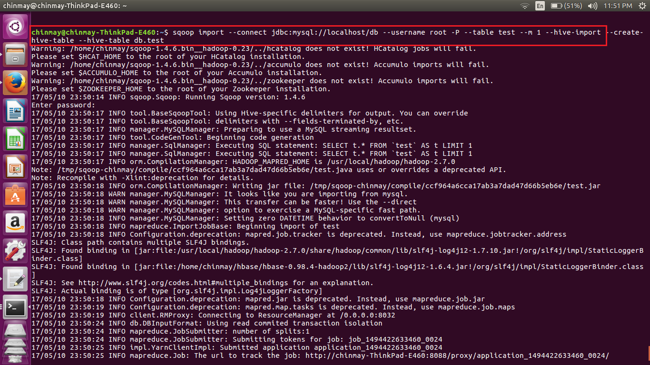

Here we have written the scoop command to get the table from sql to hive

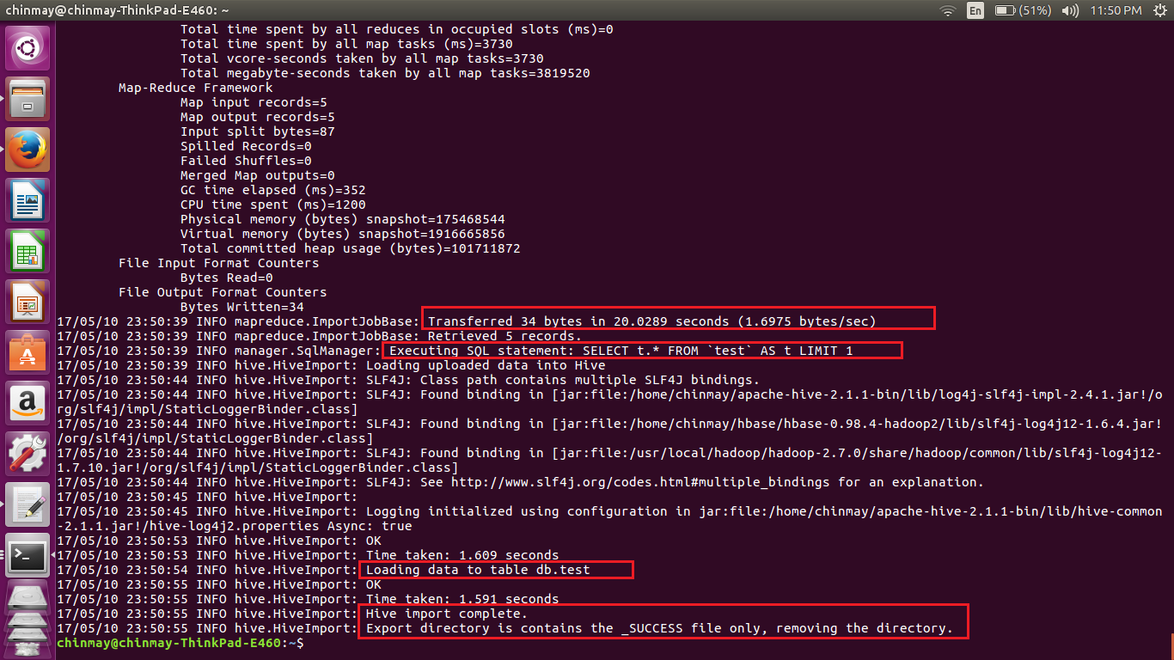

Here is the completion status for taking the data from mysql to hive.

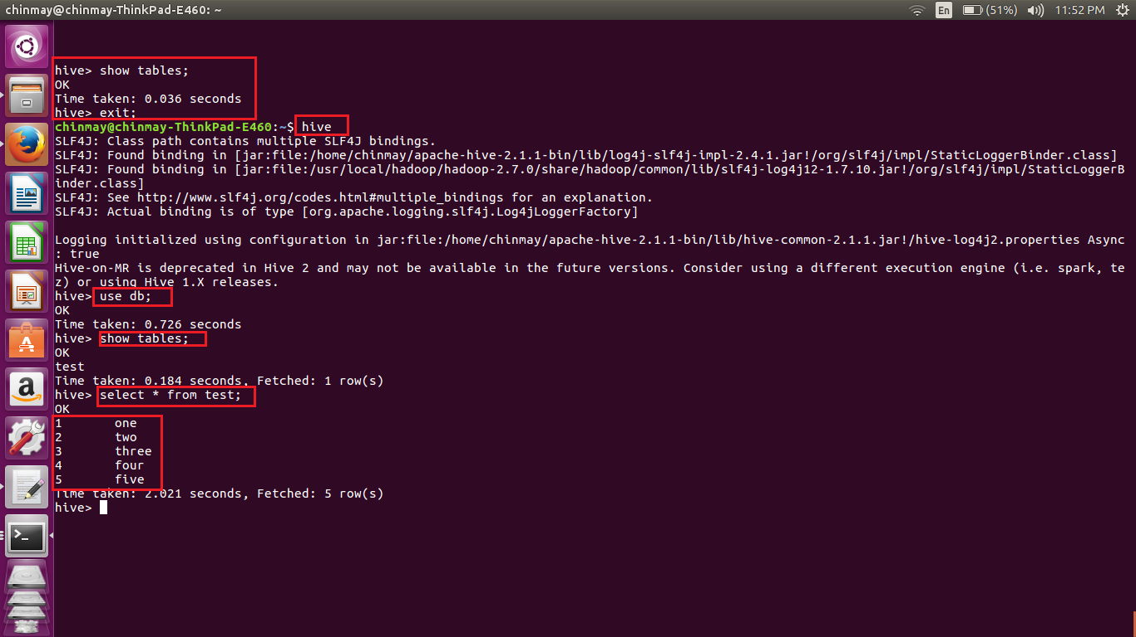

We can see in the first block that when the show tables command was done no tables where formed. No after execution of the sqoop command for importing data from mysql to hive we can see that same show tables command gives us the table called as test which the following values stored in it .

Steps go as follows

1. First create database in hive
2. Exit from hive shell(important to close the hive shell else the sqoop command will give connection error)
3. Execute the sqoop command

**connect** – Provides jdbc string

**username** – Database username

**-P**  – Will ask for the password in console. Alternatively you can use –password but this is not a good practice as its visible in your job execution logs and asking for trouble. One way to deal with this is store database passwords in a file in HDFS and provide at runtime.

**table** – Tells the computer which table you want to import from MySQL. Here, it's customer.

**hive-import** – Import table into Hive (Uses Hive’s default delimiters if none are set.)

**create-hive-table** – Determines if set job will fail if a Hive table already exists. It works in this case.

**hive-table** – Specifies <db_name>.<table_name>. Here it's sqoop_workspace.customers, where sqoop_workspace is my database and customers is the table name.

● Explain and perform Importing table contents from Mysql to HBase using Sqoop.

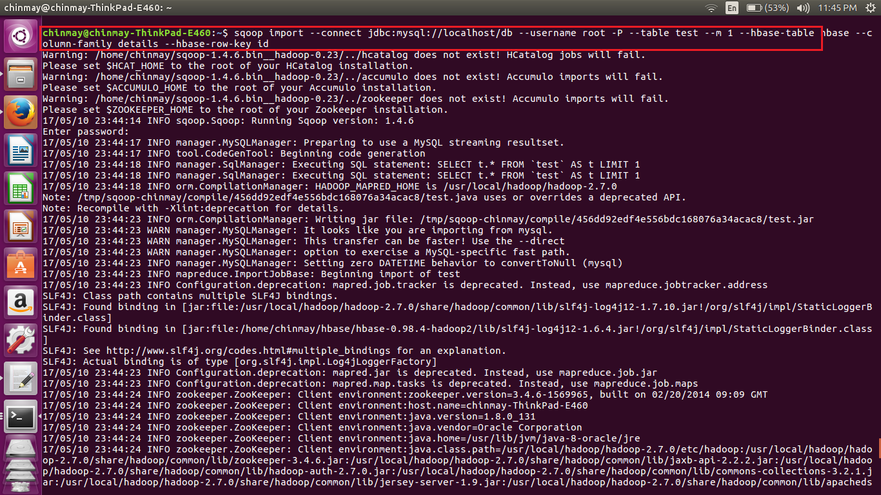

Here we are doing scoop import function to import data from mysql to hbase.

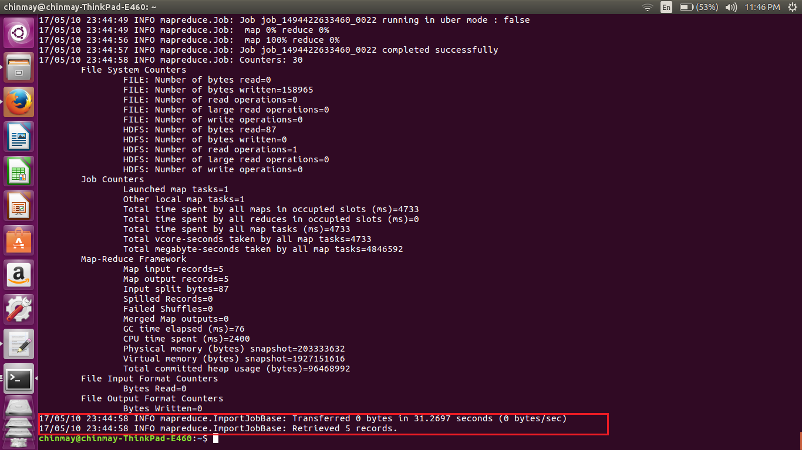

We can see that process is completed of getting values from my sql to hbase

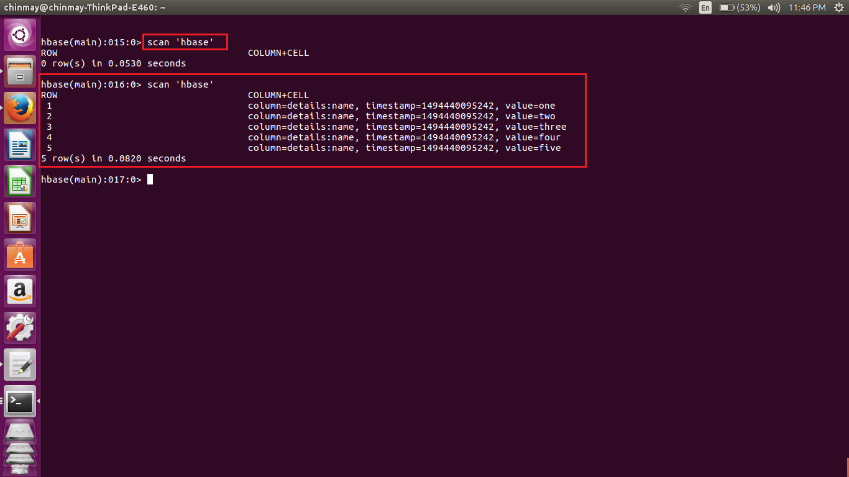

We can see here that if we that scan command done prior to that of the sqoop command gave us no output. After the sqoop command we can get the values in stored in hbase

Steps for the importing data into hbase

1. Create the table
2. Implement the sqoop command and mention the table name in the sqoop command
3. Also mention the column family name in the sqoop table.

**connect** – Provides jdbc string

**username** – Database username

**-P**  – Will ask for the password in console. Alternatively you can use –password but this is not a good practice as its visible in your job execution logs and asking for trouble. One way to deal with this is store database passwords in a file in HDFS and provide at runtime.

**table** – Tells the computer which table you want to import from MySQL. Here, it's customer.

**Hbase-table** – specifies the hbase table

**Column-family** – Set the family name

**Row-key** – set the row key