Interface Control Document

Gas Turbine Propulsion Toolbox

Variable Definitions and Function Input and Output

ICD-GTPT-001

Copyright 2016 Christopher Chinske. This work is licensed under the Creative Commons Attribution-ShareAlike 4.0 International License. To view a copy of this license, visit http://creativecommons.org/licenses/by-sa/4.0/ or send a letter to Creative Commons, PO Box 1866, Mountain View, CA 94042, USA.
Revision Record
LTR | Description | Date
A | Initial Release | February 20, 2016
B | Convert to ODF text document | February 21, 2021

Table of Contents
1 Scope 3
1.1 Scope 3
1.2 Interface Control Document Changes 3
2 Requirements 3
2.1 Interface Identification 3
2.2 Variable Definitions 4
2.2.1 Reference Values 8
2.3 Function Inputs and Outputs 8
2.3.1 IDEAL_TURBOJET 8
2.3.2 IDEAL_TURBOJET_AB 8
2.3.3 IDEAL_TURBOFAN 9
2.3.4 IDEAL_TURBOFAN_OPT 9
2.3.5 IDEAL_TURBOFAN_MIXED 10
2.3.6 IDEAL_TURBOFAN_AB 11
2.3.7 NONIDEAL_TURBOJET 11
2.3.8 NONIDEAL_TURBOFAN 12
2.3.9 NONIDEAL_TURBOFAN2 13
2.3.10 OD_TURBOJET 14
2.3.11 OD_TURBOFAN 15

Scope

Scope
This Interface Control Document (ICD) defines the variables that are common across the Gas Turbine Propulsion Toolbox and the format of inputs and outputs for functions of the Gas Turbine Propulsion Toolbox.
The Gas Turbine Propulsion Toolbox is a GNU Octave software package that implements the equations necessary to perform Ideal Cycle Analysis, Non-Ideal Cycle Analysis, and Engine Off-Design Performance for gas turbine engines.

Interface Control Document Changes
The author of this document is responsible for the basic preparation, approval, distribution, and retention of the ICD. Changes to the approved version of this ICD can be initiated by the author. The approved version of this ICD will be kept under version control by committing it to the master branch of the version control system used for the Gas Turbine Propulsion Toolbox.

Requirements

Interface Identification
Figure 1 captures the interfaces defined in this ICD. The point of demarcation separates the workspace and the functions that form the Gas Turbine Propulsion Toolbox. For the purpose of this ICD, function outputs terminate at the line of demarcation, because the program is designed such that data can be directly shared between internal functions or used independently within the external workspace.
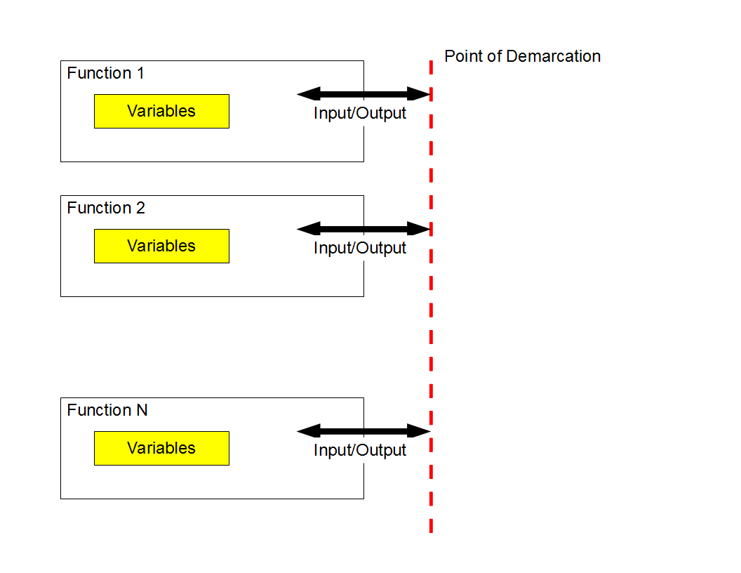Figure 1: Gas Turbine Propulsion Toolbox Variables, Input, and Output

Variable Definitions
Variable | Description | Units | Type
A0 | Speed of sound | m/s | Double
A9_RAT | Ratio | - | Double
AB | Afterburning flag (primary stream) | - | Logical
AB2 | Afterburning flag (secondary stream) | - | Logical
ALPHA | Bypass ratio | - | Double
ALPHA_OPT | Optimal bypass ratio | - | Double
CP | Specific heat of air  1004.9 J/(kg*K) | J/(kg*K) | Double
CP_AB | Specific heat of air, afterburner  (primary stream) | J/(kg*K) | Double
CP_AB2 | Specific heat of air, afterburner  (secondary stream) | J/(kg*K) | Double
CP_C | Specific heat of air, compressor | J/(kg*K) | Double
CP_T | Specific heat of air, turbine | J/(kg*K) | Double
E_C | Polytropic efficiency, compressor  (primary stream) | - | Double
E_C2 | Polytropic efficiency, compressor  (secondary stream) | - | Double
E_T | Polytropic efficiency, turbine | - | Double
ETA_AB | Afterburner efficiency (primary stream) | - | Double
ETA_AB2 | Afterburner efficiency (secondary stream) | - | Double
ETA_B | Burner efficiency | - | Double
ETA_C | Compressor efficiency | - | Double
ETA_C2 | Efficiency, fan, | - | Double
ETA_CH | Efficiency, high-pressure compressor, | - | Double
ETA_M | Mechanical efficiency  0.9 implies the use of drawn-off air for auxiliary power | - | Double
ETA_T | Efficiency, turbine | - | Double
F |  | - | Double
F | Fuel-to-air ratio | - | Double
F_MDOT | Specific thrust | m/s | Double
F_MDOT_OPT | Optimal specific thrust | m/s | Double
F_RAT | Ratio | - | Double
GAM | Ratio of specific heats | - | Double
GAM_AB | Ratio of specific heats, afterburner  (primary stream) | - | Double
GAM_AB2 | Ratio of specific heats, afterburner  (secondary stream) | - | Double
GAM_C | Ratio of specific heats, compressor | - | Double
GAM_T | Ratio of specific heats, turbine | - | Double
H | Fuel heating value  4.4194E7 J/kg = 19,000 Btu/lbm | J/kg | Double
INPUTS | Structure  Fields are the input variables  Field names correspond to the variables defined in this ICD | - | Structure
M0 | Flight Mach number | - | Double
M0U92U0R | Reference  Mach number at secondary nozzle exit | - | Double
M0U9U0R | Reference  Mach number at primary nozzle exit | - | Double
M5 | Mach number at turbine exit | - | Double
MDOT_C_RAT | Ratio | - | Double
P0P0R | Ratio | - | Double
P92P0 | Nozzle exit pressure ratio (secondary stream) | - | Double
P9P0 | Nozzle exit pressure ratio (primary stream) | - | Double
PI_B | Burner pressure ratio | - | Double
PI_C | Compressor pressure ratio (primary stream) | - | Double
PI_C_RAT | Ratio | - | Double
PI_C2 | Compressor pressure ratio (secondary stream) | - | Double
PI_D | Inlet pressure ratio | - | Double
PI_N | Nozzle pressure ratio (primary stream) | - | Double
PI_N2 | Nozzle pressure ratio (secondary stream) | - | Double
R | Gas constant | m^2/(s^2*K) | Double
S | Thrust specific fuel consumption (TSFC) | mg/(N*s) | Double
S_OPT | Optimal TSFC | mg/(N*s) | Double
S_RAT | Ratio | - | Double
T0 | Free-stream temperature | K | Double
T0T0R | Ratio | - | Double
TAU_C | Compressor stagnation temperature ratio | - | Double
TAU_C2 | Compressor stagnation temperature ratio (secondary stream) | - | Double
TAU_LAM | Maximum allowable turbine inlet stagnation enthalpy, | - | Double
TAU_LAM_AB | Similar to TAU_LAM, where the maximum stagnation enthalpy referred to is the stagnation enthalpy following the primary stream afterburner.  For no afterburning, | - | Double
TAU_LAM_AB2 | Similar to TAU_LAM, where the maximum stagnation enthalpy referred to is the stagnation enthalpy following the duct afterburner.  For no afterburning, | - | Double
TAU_R | Recovery stagnation temperature ratio | - | Double
TAU_T | Turbine stagnation temperature ratio | - | Double
TAU_T_OPT | Optimal turbine stagnation temperature ratio | - | Double
VERBOSE | Flag for verbose display | - | Integer

Reference Values
Oates states, “It is usually most convenient to obtain the off-design behaviors in terms of the ratio of the desired parameter to the value of the parameter at on-design.” Reference, or on-design, quantities are denoted by a suffix R. For example, M0 is the flight Mach number, and M0R is the reference flight Mach number. Similarly, TAU_R is the recovery stagnation temperature ratio, and TAU_RR is the reference recovery stagnation temperature ratio.

Function Inputs and Outputs

IDEAL_TURBOJET
INPUTS Structure Fields
T0
GAM
H
CP
TAU_LAM
PI_C
M0

Outputs
F_MDOT
S
INPUTS

IDEAL_TURBOJET_AB
INPUTS Structure Fields
T0
GAM
H
CP
TAU_LAM
TAU_LAM_AB
PI_C
M0

Outputs
F_MDOT
S
INPUTS

IDEAL_TURBOFAN
INPUTS Structure Fields
T0
GAM
H
CP
TAU_LAM
PI_C
PI_C2
M0
ALPHA

Outputs
F_MDOT
S
INPUTS

IDEAL_TURBOFAN_OPT
INPUTS Structure Fields
T0
GAM
H
CP
TAU_LAM
PI_C
PI_C2
M0

Outputs
TAU_T_OPT
ALPHA_OPT
F_MDOT_OPT
S_OPT
INPUTS

IDEAL_TURBOFAN_MIXED
INPUTS Structure Fields
T0
GAM
H
CP
TAU_LAM
PI_C
PI_C2
M0
ALPHA
M5

Outputs
F_MDOT
S
INPUTS

IDEAL_TURBOFAN_AB
INPUTS Structure Fields
T0
GAM
H
CP
TAU_LAM
TAU_LAM_AB
TAU_LAM_AB2
PI_C
PI_C2
M0
ALPHA

Outputs
F_MDOT
S
INPUTS

TAU_LAM_AB = 0 implies no primary stream burning; will be assumed.
TAU_LAM_AB2 = 0 implies no secondary stream burning; will be assumed.

NONIDEAL_TURBOJET
INPUTS Structure Fields
AB
T0
GAM_C
GAM_T
CP_C
CP_T
H
PI_D
PI_B
PI_N
ETA_B
ETA_M
E_C
E_T
P9P0
TAU_LAM
PI_C
M0
GAM_AB
CP_AB
ETA_AB
TAU_LAM_AB

Outputs
F_MDOT
S
INPUTS

NONIDEAL_TURBOFAN
INPUTS Structure Fields
AB
AB2
T0
GAM_C
GAM_T
CP_C
CP_T
H
PI_D
PI_B
PI_N
PI_N2
ETA_B
ETA_M
E_C
E_C2
E_T
P9P0
P92P0
TAU_LAM
PI_C
PI_C2
M0
ALPHA
GAM_AB
CP_AB
ETA_AB
TAU_LAM_AB
GAM_AB2
CP_AB2
ETA_AB2
TAU_LAM_AB2

Outputs
F_MDOT
S
INPUTS

NONIDEAL_TURBOFAN2
INPUTS Structure Fields
T0
GAM_C
GAM_T
CP_C
CP_T
H
PI_D
PI_B
PI_N
PI_N2
ETA_B
ETA_M
E_C
E_C2
E_T
TAU_LAM
PI_C
PI_C2
M0
ALPHA

Outputs
F_MDOT
S
INPUTS

OD_TURBOJET
INPUTS Structure Fields
GAM_C
GAM_T
P0P0R
T0T0R
ETA_M
ETA_C
ETA_T
PI_CR
PI_DR
PI_BR
PI_NR
TAU_LAMR
M0R
PI_D
TAU_LAM
M0

Outputs
F_RAT
S_RAT
A9_RAT
MDOT_C_RAT
PI_C_RAT

OD_TURBOFAN
INPUTS Structure Fields
GAM_T
CP_C
CP_T
ETA_CH
ETA_C2
ETA_B
PI_D
PI_B
PI_N
PI_N2
T0
P0P0R
H
TAU_LAM
M0
M0R
TAU_LAMR
PI_C2R
PI_CR
ALPHAR
ETA_CHR
ETA_C2R
ETA_BR
PI_DR
PI_BR
PI_NR
PI_N2R
T0R
M0U9U0R
M0U92U0R
TAU_TR
ETA_TR
TAU_C2R
FR

Outputs
S
F_RAT

