Interface Control Document

Gas Turbine Propulsion Toolbox

Variable Definitions and Function Input and Output

ICD-GTPT-001

Copyright 2016 Christopher Chinske. This work is licensed under the Creative Commons Attribution-ShareAlike 4.0 International License. To view a copy of this license, visit http://creativecommons.org/licenses/by-sa/4.0/ or send a letter to Creative Commons, PO Box 1866, Mountain View, CA 94042, USA.

|  |  |  |
| --- | --- | --- |
| Revision Record | | |
| LTR | Description | Date |
| A | Initial Release | February 20, 2016 |
|  |  |  |
|  |  |  |
|  |  |  |
|  |  |  |
|  |  |  |
|  |  |  |
|  |  |  |
|  |  |  |
|  |  |  |

**Table of Contents**

1 Scope 3

1.1 Scope 3

1.2 Interface Control Document Changes 3

2 Requirements 3

2.1 Interface Identification 3

2.2 Variable Definitions 4

2.2.1 Reference Values 7

2.3 Function Inputs and Outputs 7

2.3.1 IDEAL_TURBOJET 7

2.3.2 IDEAL_TURBOJET_AB 7

2.3.3 IDEAL_TURBOFAN 8

2.3.4 IDEAL_TURBOFAN_OPT 8

2.3.5 IDEAL_TURBOFAN_MIXED 9

2.3.6 IDEAL_TURBOFAN_AB 9

2.3.7 NONIDEAL_TURBOJET 10

2.3.8 NONIDEAL_TURBOFAN 10

2.3.9 NONIDEAL_TURBOFAN2 11

2.3.10 OD_TURBOJET 12

2.3.11 OD_TURBOFAN 12

# Scope

## Scope

This Interface Control Document (ICD) defines the variables that are common across the Gas Turbine Propulsion Toolbox and the format of inputs and outputs for functions of the Gas Turbine Propulsion Toolbox.

The Gas Turbine Propulsion Toolbox is a GNU Octave software package that implements the equations necessary to perform Ideal Cycle Analysis, Non-Ideal Cycle Analysis, and Engine Off-Design Performance for gas turbine engines.

## Interface Control Document Changes

The author of this document is responsible for the basic preparation, approval, distribution, and retention of the ICD. Changes to the approved version of this ICD can be initiated by the author. The approved version of this ICD will be kept under version control by committing it to the master branch of the version control system used for the Gas Turbine Propulsion Toolbox.

# Requirements

## Interface Identification

Figure 1 captures the interfaces defined in this ICD. The point of demarcation separates the workspace and the functions that form the Gas Turbine Propulsion Toolbox. For the purpose of this ICD, function outputs terminate at the line of demarcation, because the program is designed such that data can be directly shared between internal functions or used independently within the external workspace.

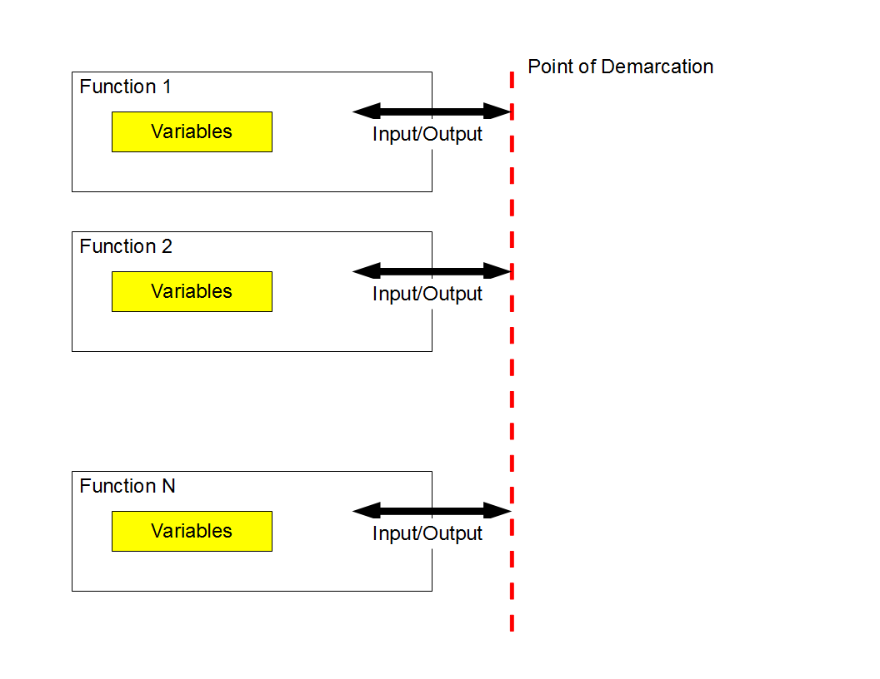

**Figure 1 Gas Turbine Propulsion Toolbox Variables and Input and Output**

## Variable Definitions

|  |  |  |  |
| --- | --- | --- | --- |
| Variable | Description | Units | Type |
| A0 | Speed of sound | m/s | Double |
| A9_RAT | Ratio $$\frac{A_{9}}{A_{9R}}$$ | - | Double |
| AB | Afterburning flag (primary stream) | - | Logical |
| AB2 | Afterburning flag (secondary stream) | - | Logical |
| ALPHA | Bypass ratio | - | Double |
| ALPHA_OPT | Optimal bypass ratio | - | Double |
| CP | Specific heat of air  1004.9 J/(kg*K) | J/(kg*K) | Double |
| CP_AB | Specific heat of air, afterburner  (primary stream) | J/(kg*K) | Double |
| CP_AB2 | Specific heat of air, afterburner  (secondary stream) | J/(kg*K) | Double |
| CP_C | Specific heat of air, compressor | J/(kg*K) | Double |
| CP_T | Specific heat of air, turbine | J/(kg*K) | Double |
| E_C | Polytropic efficiency, compressor  (primary stream) | - | Double |
| E_C2 | Polytropic efficiency, compressor  (secondary stream) | - | Double |
| E_T | Polytropic efficiency, turbine | - | Double |
| ETA_AB | Afterburner efficiency (primary stream) | - | Double |
| ETA_AB2 | Afterburner efficiency (secondary stream) | - | Double |
| ETA_B | Burner efficiency | - | Double |
| ETA_C | Compressor efficiency | - | Double |
| ETA_C2 | Efficiency, fan, $η_{c'}$ | - | Double |
| ETA_CH | Efficiency, high-pressure compressor, $η_{ch}$ | - | Double |
| ETA_M | Mechanical efficiency  0.9 implies the use of drawn-off air for auxiliary power | - | Double |
| ETA_T | Efficiency, turbine | - | Double |
| F | $$f=\frac{\dot{m_{f}}}{\dot{m}}$$ | - | Double |
| F | Fuel-to-air ratio $$\frac{\text{kg fuel / s}}{\text{kg air / s}}$$ | - | Double |
| F_MDOT | Specific thrust $$\frac{F}{\dot{m}}$$ | m/s | Double |
| F_MDOT_OPT | Optimal specific thrust | m/s | Double |
| F_RAT | Ratio $$\frac{F}{F_{R}}$$ | - | Double |
| GAM | Ratio of specific heats | - | Double |
| GAM_AB | Ratio of specific heats, afterburner  (primary stream) | - | Double |
| GAM_AB2 | Ratio of specific heats, afterburner  (secondary stream) | - | Double |
| GAM_C | Ratio of specific heats, compressor | - | Double |
| GAM_T | Ratio of specific heats, turbine | - | Double |
| H | Fuel heating value  4.4194E7 J/kg = 19,000 Btu/lbm | J/kg | Double |
| INPUTS | Structure  Fields are the input variables  Field names correspond to the variables defined in this ICD | - | Structure |
| M0 | Flight Mach number | - | Double |
| M0U92U0R | Reference  Mach number at secondary nozzle exit $${\left(M_{0}\frac{u_{9^{'}}}{u_{0}}\right)}_{R}$$ | - | Double |
| M0U9U0R | Reference  Mach number at primary nozzle exit $${\left(M_{0}\frac{u_{9}}{u_{0}}\right)}_{R}$$ | - | Double |
| M5 | Mach number at turbine exit | - | Double |
| MDOT_C_RAT | Ratio $$\frac{\dot{m_{c}}}{\dot{m_{cR}}}$$ | - | Double |
| P0P0R | Ratio ${p_{0}}/{p_{0R}}$ | - | Double |
| P92P0 | Nozzle exit pressure ratio (secondary stream) $$\frac{p_{9'}}{p_{0}}$$ | - | Double |
| P9P0 | Nozzle exit pressure ratio (primary stream) $$\frac{p_{9}}{p_{0}}$$ | - | Double |
| PI_B | Burner pressure ratio | - | Double |
| PI_C | Compressor pressure ratio (primary stream) | - | Double |
| PI_C_RAT | Ratio $$\frac{π_{c}}{π_{cR}}$$ | - | Double |
| PI_C2 | Compressor pressure ratio (secondary stream) | - | Double |
| PI_D | Inlet pressure ratio | - | Double |
| PI_N | Nozzle pressure ratio (primary stream) | - | Double |
| PI_N2 | Nozzle pressure ratio (secondary stream) | - | Double |
| R | Gas constant | m^2/(s^2*K) | Double |
| S | Thrust specific fuel consumption (TSFC) $$S=\frac{\frac{mg fuel}{s}}{\left(N thrust\right)}$$ | mg/(N*s) | Double |
| S_OPT | Optimal TSFC | mg/(N*s) | Double |
| S_RAT | Ratio $$\frac{S}{S_{R}}$$ | - | Double |
| T0 | Free-stream temperature | K | Double |
| T0T0R | Ratio ${T_{0}}/{T_{0R}}$ | - | Double |
| TAU_C | Compressor stagnation temperature ratio | - | Double |
| TAU_C2 | Compressor stagnation temperature ratio (secondary stream) | - | Double |
| TAU_LAM | Maximum allowable turbine inlet stagnation enthalpy, $C_{p_{t}}T_{t_{4}}$ $$τ_{λ}≡\frac{C_{p_{t}}T_{t_{4}}}{C_{p_{c}}T_{0}}$$ | - | Double |
| TAU_LAM_AB | Similar to TAU_LAM, where the maximum stagnation enthalpy referred to is the stagnation enthalpy following the primary stream afterburner. $$τ_{λAB}=\frac{{C_{p}}_{AB}}{{C_{p}}_{c}}\frac{T_{t_{8}}}{T_{0}}$$ For no afterburning, ${\left(τ_{λAB}\right)}_{min}=τ_{λ}τ_{t}$ | - | Double |
| TAU_LAM_AB2 | Similar to TAU_LAM, where the maximum stagnation enthalpy referred to is the stagnation enthalpy following the duct afterburner. $$τ_{λAB'}=\frac{{C_{p}}_{AB'}}{{C_{p}}_{c}}\frac{T_{t_{8'}}}{T_{0}}$$ For no afterburning, ${\left(τ_{λAB}\right)}_{min}=τ_{r}τ_{c'}$ | - | Double |
| TAU_R | Recovery stagnation temperature ratio | - | Double |
| TAU_T | Turbine stagnation temperature ratio | - | Double |
| TAU_T_OPT | Optimal turbine stagnation temperature ratio | - | Double |
| VERBOSE | Flag for verbose display | - | Integer |

### Reference Values

Oates states, “It is usually most convenient to obtain the off-design behaviors in terms of the ratio of the desired parameter to the value of the parameter at on-design.” Reference, or on-design, quantities are denoted by a suffix R. For example, M0 is the flight Mach number, and M0R is the reference flight Mach number. Similarly, TAU_R is the recovery stagnation temperature ratio, and TAU_RR is the reference recovery stagnation temperature ratio.

## Function Inputs and Outputs

### IDEAL_TURBOJET

|  |
| --- |
| **INPUTS Structure Fields** |
| T0 |
| GAM |
| H |
| CP |
| TAU_LAM |
| PI_C |
| M0 |

|  |
| --- |
| **Outputs** |
| F_MDOT |
| S |
| INPUTS |

### IDEAL_TURBOJET_AB

|  |
| --- |
| **INPUTS Structure Fields** |
| T0 |
| GAM |
| H |
| CP |
| TAU_LAM |
| TAU_LAM_AB |
| PI_C |
| M0 |

|  |
| --- |
| **Outputs** |
| F_MDOT |
| S |
| INPUTS |

### IDEAL_TURBOFAN

|  |
| --- |
| **INPUTS Structure Fields** |
| T0 |
| GAM |
| H |
| CP |
| TAU_LAM |
| PI_C |
| PI_C2 |
| M0 |
| ALPHA |

|  |
| --- |
| **Outputs** |
| F_MDOT |
| S |
| INPUTS |

### IDEAL_TURBOFAN_OPT

|  |
| --- |
| **INPUTS Structure Fields** |
| T0 |
| GAM |
| H |
| CP |
| TAU_LAM |
| PI_C |
| PI_C2 |
| M0 |

|  |
| --- |
| **Outputs** |
| TAU_T_OPT |
| ALPHA_OPT |
| F_MDOT_OPT |
| S_OPT |
| INPUTS |

### IDEAL_TURBOFAN_MIXED

|  |
| --- |
| **INPUTS Structure Fields** |
| T0 |
| GAM |
| H |
| CP |
| TAU_LAM |
| PI_C |
| PI_C2 |
| M0 |
| ALPHA |
| M5 |

|  |
| --- |
| **Outputs** |
| F_MDOT |
| S |
| INPUTS |

### IDEAL_TURBOFAN_AB

|  |
| --- |
| **INPUTS Structure Fields** |
| T0 |
| GAM |
| H |
| CP |
| TAU_LAM |
| TAU_LAM_AB |
| TAU_LAM_AB2 |
| PI_C |
| PI_C2 |
| M0 |
| ALPHA |

|  |
| --- |
| **Outputs** |
| F_MDOT |
| S |
| INPUTS |

TAU_LAM_AB = 0 implies no primary stream burning; ${\left({τ_{λ}}_{AB}\right)}_{\min{}}$ will be assumed.

TAU_LAM_AB2 = 0 implies no secondary stream burning; ${\left({τ_{λ}}_{AB}\right)}_{\min{}}$ will be assumed.

### NONIDEAL_TURBOJET

|  |
| --- |
| **INPUTS Structure Fields** |
| AB |
| T0 |
| GAM_C |
| GAM_T |
| CP_C |
| CP_T |
| H |
| PI_D |
| PI_B |
| PI_N |
| ETA_B |
| ETA_M |
| E_C |
| E_T |
| P9P0 |
| TAU_LAM |
| PI_C |
| M0 |
| GAM_AB |
| CP_AB |
| ETA_AB |
| TAU_LAM_AB |

|  |
| --- |
| **Outputs** |
| F_MDOT |
| S |
| INPUTS |

### NONIDEAL_TURBOFAN

|  |
| --- |
| **INPUTS Structure Fields** |
| AB |
| AB2 |
| T0 |
| GAM_C |
| GAM_T |
| CP_C |
| CP_T |
| H |
| PI_D |
| PI_B |
| PI_N |
| PI_N2 |
| ETA_B |
| ETA_M |
| E_C |
| E_C2 |
| E_T |
| P9P0 |
| P92P0 |
| TAU_LAM |
| PI_C |
| PI_C2 |
| M0 |
| ALPHA |
| GAM_AB |
| CP_AB |
| ETA_AB |
| TAU_LAM_AB |
| GAM_AB2 |
| CP_AB2 |
| ETA_AB2 |
| TAU_LAM_AB2 |

|  |
| --- |
| **Outputs** |
| F_MDOT |
| S |
| INPUTS |

### NONIDEAL_TURBOFAN2

|  |
| --- |
| **INPUTS Structure Fields** |
| T0 |
| GAM_C |
| GAM_T |
| CP_C |
| CP_T |
| H |
| PI_D |
| PI_B |
| PI_N |
| PI_N2 |
| ETA_B |
| ETA_M |
| E_C |
| E_C2 |
| E_T |
| TAU_LAM |
| PI_C |
| PI_C2 |
| M0 |
| ALPHA |

|  |
| --- |
| **Outputs** |
| F_MDOT |
| S |
| INPUTS |

### OD_TURBOJET

|  |
| --- |
| **INPUTS Structure Fields** |
| GAM_C |
| GAM_T |
| P0P0R |
| T0T0R |
| ETA_M |
| ETA_C |
| ETA_T |
| PI_CR |
| PI_DR |
| PI_BR |
| PI_NR |
| TAU_LAMR |
| M0R |
| PI_D |
| TAU_LAM |
| M0 |

|  |
| --- |
| **Outputs** |
| F_RAT |
| S_RAT |
| A9_RAT |
| MDOT_C_RAT |
| PI_C_RAT |

### OD_TURBOFAN

|  |
| --- |
| **INPUTS Structure Fields** |
| GAM_T |
| CP_C |
| CP_T |
| ETA_CH |
| ETA_C2 |
| ETA_B |
| PI_D |
| PI_B |
| PI_N |
| PI_N2 |
| T0 |
| P0P0R |
| H |
| TAU_LAM |
| M0 |
| M0R |
| TAU_LAMR |
| PI_C2R |
| PI_CR |
| ALPHAR |
| ETA_CHR |
| ETA_C2R |
| ETA_BR |
| PI_DR |
| PI_BR |
| PI_NR |
| PI_N2R |
| T0R |
| M0U9U0R |
| M0U92U0R |
| TAU_TR |
| ETA_TR |
| TAU_C2R |
| FR |

|  |
| --- |
| **Outputs** |
| S |
| F_RAT |