
Version 0.1
Prepared by: Chintal Patel
Contributors: Chintal Patel
Ambyint - QA Test Plan

Ambyint

ABOUT THIS DOCUMENT 2
Purpose 2
Distribution 2
Amendments 2
Document Revision History 2
overview of the qa cycle and approach 3
QA PROCESS 4
Discovery 4
Definition 4
Design 4
Development 4
Delivery 4
Testing Lifecycle 4
CONFIGURATION MANAGEMENT DEPLOYMENT PROCESS 5
DEFECT TRACKING MANAGEMENT 6
Overview 6
Defect Severity Classification: 6
Types of Testing To Be Completed 7
Responsibilities 7
TEST REQUIREMENTS 8
Environments 8
Servers 9
Browsers and Platforms 10
Client Side Requirements 10

ABOUT THIS DOCUMENT

Purpose
This document is intended to provide Client with a high-level overview of the Quality Assurance (QA) process and test plan for Client Projects. This plan outlines an overall understanding of maintenance from a testing perspective, and scopes out and addresses all possible testing issues prior to the start of the testing cycle.

An integral part of the Ambyint web development process, the QA Test Plan assesses both the potential risks and the required testing efforts for Client.

This document differs from the test cases (if required), which will be provided at a later date prior to the beginning of the testing cycle. The test cases will outline the actual steps required to complete the testing.

Test Case: A document that describes an input, action, or event and an expected response, to determine if a
feature of an application is working correctly

Distribution
The following stakeholders will receive a version of the Test Plan:

Client(s) | Integrators
Nikhil | Scrum Master
Chintal | QA Developer

Amendments
Upon Client approval, the Test plan will govern the approach for testing Client Projects, post-integration. Amendments to the approved Test Plan can be proposed as needed and should be brought to the attention of the Project Manger(s) and QA Lead.

Document Revision History

Name | Date | What Changed | Version
Chintal | 14 May 2023 | Initial Draft | 0.1
overview of the qa cycle and approach

This section provides an overview of the test processes and approach that Ambyintuses for Client.
The following diagram outlines’s delivery process.

DISCOVERY
- Confirm Needs
- Recommendation
- Schema
- Final SOW

DEFINITION
- Requirements (Gather & Analyze)
• Prioritize Content and Functionality
- Project Plan

DESIGN
- Design Concepts
- Creative Review and Approval

DEVELOPMENT
- Development of Templates
- Platform Implementation
- Quality Assurance Testing

DELIVERY
- Migration to new environment
- Launch of fully functioning site
- Post-launch optimization period
Heavy
Production
Phase

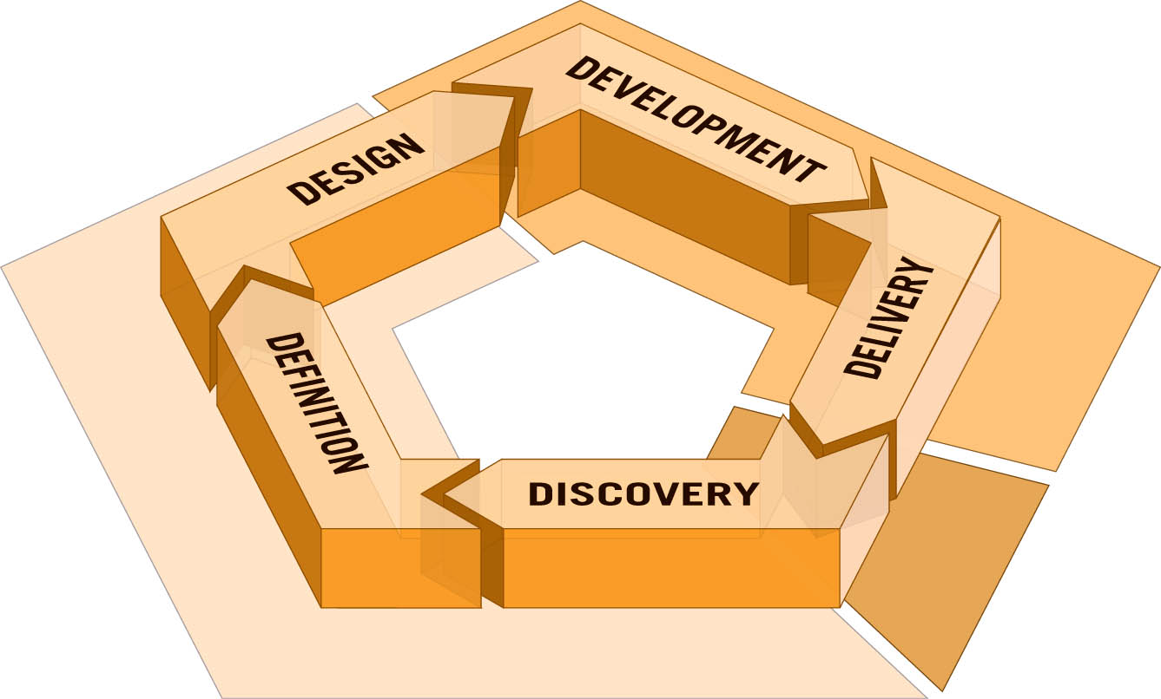

Refine and
Optimize
Tight collaboration
between Client and Ambyint
QA PROCESS

Discovery
In this discovery phase, QA can help review SOW and provide feedback/recommendations based on best practices.

Definition
In this definition phase, QA reviews and participates in a review of the requirements gathering for the Change Requests. If requested, QA also provides estimates on specific Change Requests.

Design
In this phase, application and interface designs are prepared. QA reviews new designs and site functionality with an eye towards usability and user experience factors. Heading off problems before they become real improves quality immediately and reduces problems downstream.

Development
In the Development phase, the QA team focuses on reviewing of all aspects of the system. The QA lead can provide a quick sanity test on a local or dev environment if requested by the Production Lead.

Delivery
When all Change have been tested and passed on the Staging environment, a deployment will be scheduled for the Production environment. The next deployment steps from Staging to Production are handled by Client side IT. In addition to testing the changes on Production, a smoke testing of the site(s) is also conducted by QA.

Testing Lifecycle
QA will execute the following actions during the testing cycle:

- Ensure that the deliverables meet all requirements.
- Report, document, and verify functional and design defects.
- Ensure the product is cross-platform and cross-browser compatible based on specified requirements.

Chintal will execute the following QA testing cycle for Ambyint. Each item is intended to act as checkpoints for each stage of the testing cycle.

- Regression on development server
- Final QA testing/pass on development server
- QA testing/pass and regression on Staging server
- QA testing/pass and regression on Production server

DEFECT TRACKING MANAGEMENT

Overview
The defect management process ensures maximum efficiency for defect recognition and resolution. The objectives of this process are:

- To maintain a defect tracking system to reliably monitor defects and fixes.
- To preserve a history of defects and their fixes.
- To ensure prompt and efficient identification and notification of defects.
- To provide timely fixes and deployment.

QA team will use MS Excel, which will allow Ambyint developers and QA members to carry out a full test cycle: find, log, assign, fix, verify, resolve, and close.

The number of defects that surface during the QA testing period, including their potential impacts and complexity to implement, can be quite unpredictable. The Ambyint Tech Lead will respond to defects in the minimum time possible, and assign fixes to a particular build. Careful review of the impact of an implemented fix will minimize reoccurrence and/or the introduction of new problems.
However, since testing alone cannot fully verify that software is complete and correct, Ambyint takes a comprehensive validation approach. QA processes are integrated into all stages of the Ambyint production from the start of the engagement (e.g., large scale planning, unit testing, etc.).

Defect Severity Classification:

Severity
Severity describes the impact of bugs. Defects will be classified as such by the Project Manager:

Severity | Description | Examples
4 - Low | Cosmetic problems | Misspells  Misaligns
3 - Medium | Non-critical erroneous results or functionality | Incorrect results that doesn’t affect business decisions
2- High | Major loss of functionality  Erroneous results | Incorrect results that can affect business decisions
1 - Critical | Blocks development and/or testing work | System error  Critical error

Business Priority
Priority describes the importance and order in which a bug should be fixed. The available priorities are:

- 4 - Low
- 3 - Medium
- 2 - High
- 1 - Critical

The Project Manager will set the priority of each bug according to Client.

Types of Testing To Be Completed
QA will execute the following types of tests:

Template Testing: Testing of all the development done by Ambyint.

Functional Testing: Including validation of the business rules.

System Testing: Testing conducted on a complete, integrated system to evaluate the system's compliance with its specified requirements.

Smoke Testing: Non-exhaustive Web testing, intended to identify the most crucial functions of a program, on a higher level.

Content Testing: Testing of the content on all site(s)

Regression Testing (Manual): Comprehensive re-test of an entire or partial system after a modification has been made to ensure that no unwanted changes were introduced to the system. Note: Regression will only be required if global elements are modified/added.

Integration Testing: Integration testing is performed on groups of related modules to ensure data and controls are passed properly between modules

Note: We would like to interface with Client IT (acting as QA) to determine best approach to Integration testing i.e. Log bugs on MS Excel or Clients QA’s system (to be determined)

Responsibilities
The following table outlines the post integration responsibilities between Client IT and Ambyint:

Web Layer | Approach | Responsibility
Presentation Layer | Unit Testing-client side codes
Presentation Layer | Design/Layout/Copy verification
Presentation Layer | System/Functional Test
Presentation Layer | Navigation-click path
Presentation Layer | Browser Compatibility Test based on Engineering Requirements. E.g., frame vs. non-frame, cookies.
Presentation Layer | Hyperlinks Validation. Check that all links, internal and external are working.
Presentation Layer | Graphics Link Validation. Check that graphics are linked correctly, close the browser, open a new browser window, and clear cache.
Presentation Layer | Resolution Test. Verify web pages with the monitor set to the following resolutions: 1024 x 768. Verify Web pages with monitor color set to 24-bit color. Verify effect of page layout after changing font settings on the monitor or browser.

TEST REQUIREMENTS

Environments
QA will have an isolated and dedicated QA test environment for QA testing of development code. All development is performed within Ambyint IT environment(s) and testing will take place on those servers

The following is a list of environments at Ambyint:

Client Environments
Clinet QA/Staging
Client Production

Browsers and Platforms

When testing for browser compatibility, Ambyint will examine how the project behaves and appears in browsers, including their “behaviour.”

The table below details a list of basic operating systems, browsers, and browser versions that the QA team recommends for QA site compatibility. Browser matrix has been modified to fit the needs to perform testing.

* X = Not Tested / Supported
P = Supported
N/A = Not Applicable

Browser /OS | Win 10 | Mac OS X
Chrome 113 | P | X
Safari 16.3 | P | X

Email Client

Gmail | nikhil.chullipparambil@ambyint.com
Hotmail
Yahoo Mail

Client Side Requirements
Ambyint QA will adhere to the client side requirements:
- Recommanded Monitor Resolution: 1024 X 768

