Logistics Data Analysis
Week 3: Advanced Data Analysis and Visualization in Logistics
Submitted by: Chintam Ashwitha
Data Analytics Track
Date: August 2026

1. Objective
This report documents Week 3 of the Logistics Data Analysis project: exploratory data analysis (EDA) and visualization of the cleaned shipment-level dataset produced in Week 2. The goal is to move from a clean dataset to concrete operational insight — identifying delivery-time and cost patterns, correlations between key metrics, and bottlenecks — using Python (pandas, seaborn, matplotlib), and to translate those findings into recommendations for logistics decision-making.

2. Dataset Structure
The analysis uses delivery_logistics_cleaned.csv, the Week 2 output: 500 shipment-level records with no missing values and no duplicates. Key variables analyzed in this report:
- distance_km — route distance in kilometres
- delivery_time_hr — total delivery time in hours
- delivery_cost — shipment cost in local currency
- cost_per_km — engineered efficiency metric (cost ÷ distance)
- customer_rating — post-delivery rating (1–5)
- vehicle_type, region, weather_condition — categorical operational context
- order_day_of_week, is_delayed — engineered temporal/operational fields

2.1 A Data Quality Refinement Found During EDA
While profiling the data, a residual issue from the Week 2 outlier-capping step surfaced: the IQR rule capped distance_km using a statistically derived lower bound, which for this column happened to fall below zero — producing a small number of shipments with a negative distance, which is physically impossible and was distorting the cost_per_km feature (division by a near-zero or negative number). This is a useful reminder that statistical outlier rules should be sanity-checked against real-world constraints. It was corrected here by flooring distance_km at a realistic minimum of 0.5 km before recomputing cost_per_km, and is noted for the Week 2 pipeline to be updated with a domain floor going forward.
neg_dist = (df["distance_km"] < 0.5).sum()
df["distance_km"] = df["distance_km"].clip(lower=0.5)
df["cost_per_km"] = (df["delivery_cost"] / df["distance_km"]).round(2)

3. Exploratory Data Analysis

3.1 Descriptive Statistics
Central tendency and spread were computed for all numeric fields. delivery_time_hr (mean 3.57 hr, std 1.20) and distance_km (mean 18.0 km, std 8.1) are both close to symmetric (skew near 0). delivery_cost is mildly left-skewed (−0.08). cost_per_km, by contrast, is strongly right-skewed (skew ≈ 6.1): a small number of short-distance shipments carry a disproportionately high cost per kilometre, consistent with fixed per-shipment costs (loading, last-mile handling) being spread over a very short route.
numeric_cols = ["distance_km", "delivery_time_hr", "delivery_cost",
"customer_rating", "cost_per_km"]
desc = df[numeric_cols].describe().T
desc["skew"] = df[numeric_cols].skew()

3.2 Correlation Analysis
A correlation matrix was computed across the numeric operational fields and visualized as a heatmap, since a heatmap makes the strength and direction of many pairwise relationships scannable at a glance — far faster than reading a numeric table.
corr = df[numeric_cols].corr()
sns.heatmap(corr, annot=True, fmt=".2f", cmap="Blues", square=True)
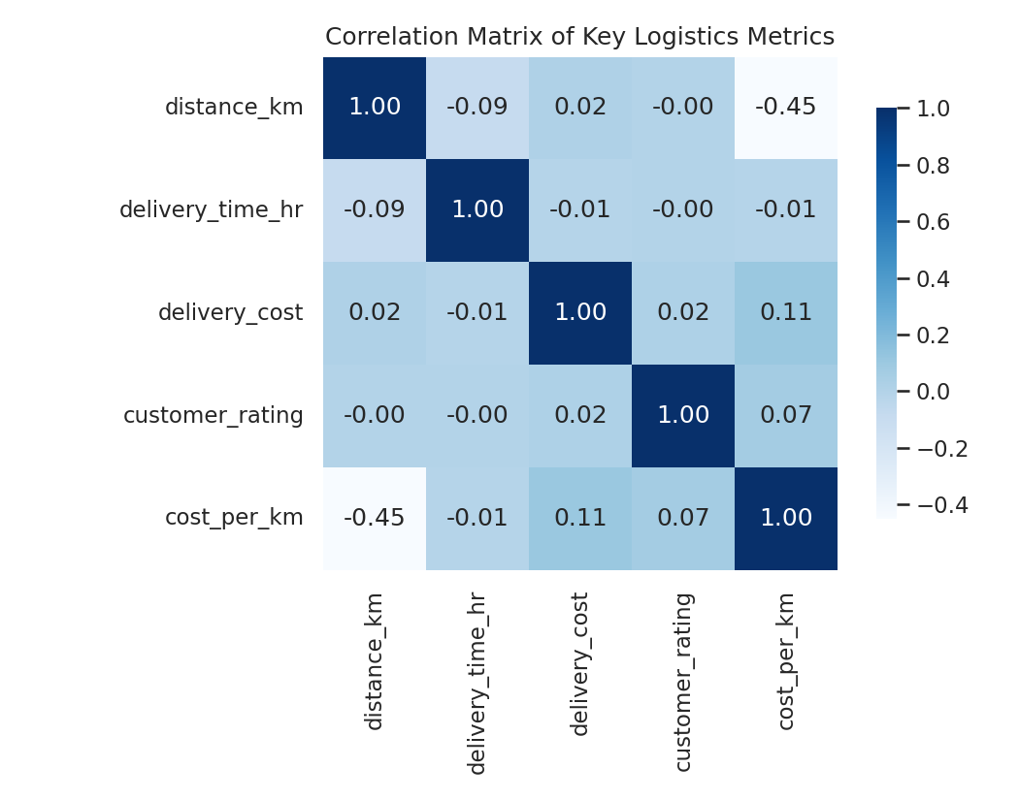
Figure 1: Correlation matrix of key logistics metrics
The clearest relationship is a moderate negative correlation (−0.45) between distance_km and cost_per_km: as routes get longer, the average cost per kilometre falls, an economies-of-scale pattern typical of last-mile logistics where fixed handling costs are amortized over distance. distance_km and delivery_time_hr show a weak negative correlation (−0.09), and delivery_cost correlates only weakly with the other fields — suggesting cost in this operation is driven more by categorical factors (vehicle type, region) than by distance or time alone, which the following breakdowns confirm.

4. Visualizations

4.1 Distribution of Delivery Time
A histogram with a kernel density overlay was chosen to show both the shape of the delivery-time distribution and its central tendency in one view.
sns.histplot(df["delivery_time_hr"], bins=25, kde=True)
plt.axvline(df["delivery_time_hr"].median(), color="red", linestyle="--")
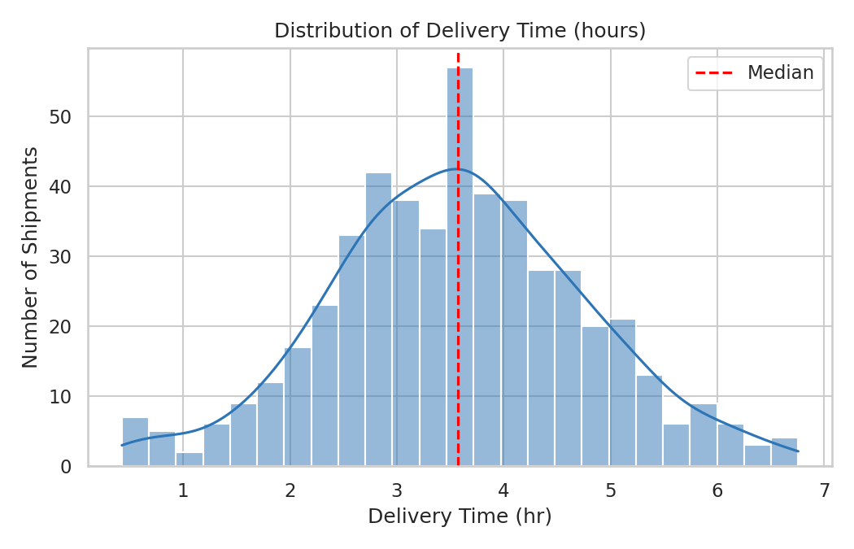
Figure 2: Distribution of delivery time (hours)
Delivery times cluster around the 3–4 hour median with a roughly symmetric spread from just under 1 hour to just under 7 hours. There is no strong secondary peak, indicating a fairly consistent single delivery process rather than two distinct fast/slow populations.

4.2 Delivery Cost by Vehicle Type
A boxplot was used here specifically because it shows the median, interquartile spread, and any remaining outliers per category simultaneously — well suited to comparing a numeric field across several categories at once.
sns.boxplot(data=df, x="vehicle_type", y="delivery_cost")
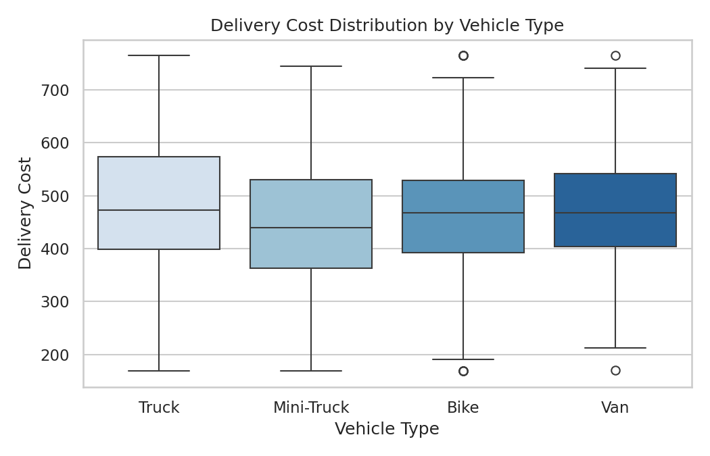
Figure 3: Delivery cost distribution by vehicle type
Median delivery cost is broadly similar across Bike, Van, Mini-Truck, and Truck, but Trucks show a visibly wider spread and the highest-cost outliers, consistent with trucks being used for the occasional large or long-haul shipment alongside routine ones.

4.3 Distance vs Delivery Time by Weather
A scatter plot, colour-coded by weather condition, was chosen to examine whether the relationship between two continuous variables (distance and time) shifts under different operating conditions.
sns.scatterplot(data=df, x="distance_km", y="delivery_time_hr", hue="weather_condition")
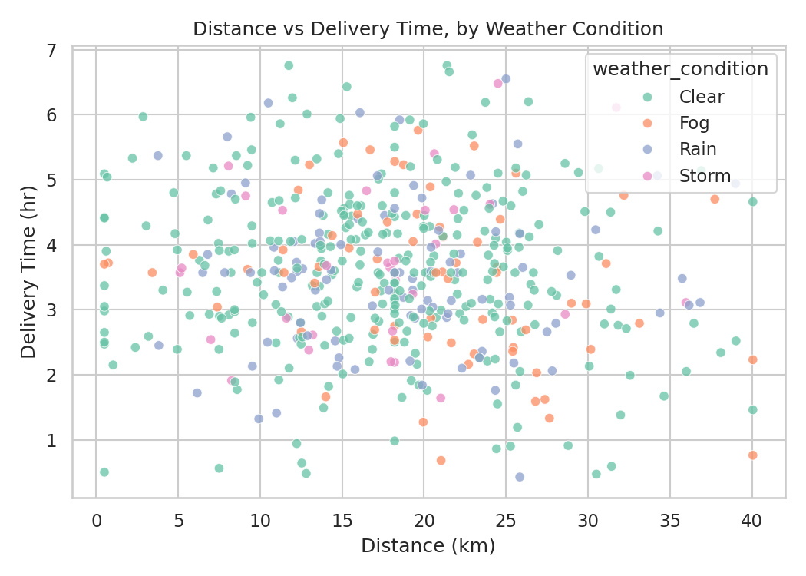
Figure 4: Distance vs delivery time, coloured by weather condition
Points are broadly scattered with no strong linear trend, confirming the weak correlation from Section 3.2 — distance alone is not the main driver of delivery time in this dataset. Rain and Storm points are not visibly concentrated at higher delivery times, though the low count of Storm records limits how much can be concluded from this view alone; the regional and day-of-week breakdowns below add more signal.

4.4 Average Delivery Cost by Region
A bar chart was used to compare a single aggregated metric (mean cost) across a small number of categories (regions) — the clearest way to rank categorical groups.
region_cost = df.groupby("region")["delivery_cost"].mean().sort_values(ascending=False)
sns.barplot(x=region_cost.index, y=region_cost.values)
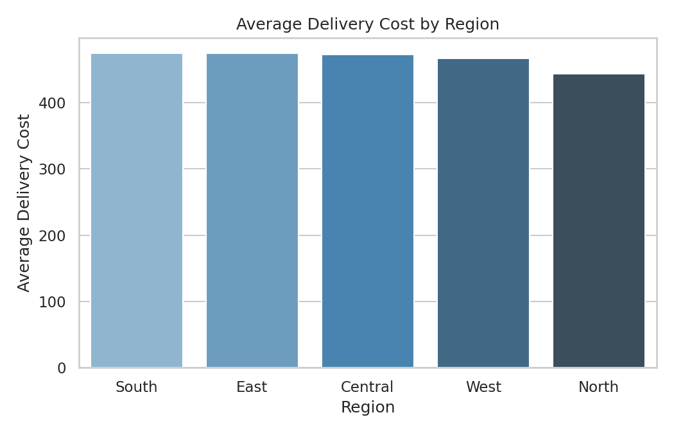
Figure 5: Average delivery cost by region
The South region has the highest average delivery cost (≈ ₹475), noticeably above the other regions. This is the kind of pattern that, if it persists as more data accumulates, would justify investigating routing efficiency or vehicle allocation specifically in the South region.

4.5 Delay Rate by Day of Week
A line chart was chosen because day-of-week is an ordered sequence, and a line makes the week-over-week trend and any weekend effect easy to read.
delay_by_day = df.groupby("order_day_of_week")["is_delayed"].mean().reindex(day_order)
plt.plot(delay_by_day.index, delay_by_day.values, marker="o")
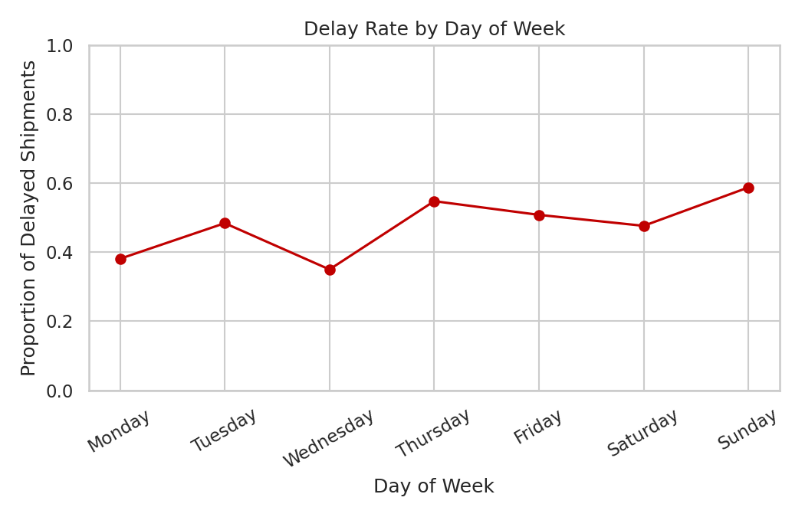
Figure 6: Delay rate by day of week
Delay rates are highest on Sunday (≈ 59%) and Thursday (≈ 55%), and lowest on Wednesday (≈ 35%). The Sunday spike is consistent with reduced staffing/operations on weekends, a common pattern in last-mile logistics; the Thursday peak may warrant investigating whether it coincides with a mid-week demand surge.

4.6 Customer Rating by Weather Condition
A bar chart again suits comparing an aggregated numeric metric (average rating) across a small set of categories.
weather_rating = df.groupby("weather_condition")["customer_rating"].mean().sort_values(ascending=False)
sns.barplot(x=weather_rating.index, y=weather_rating.values)
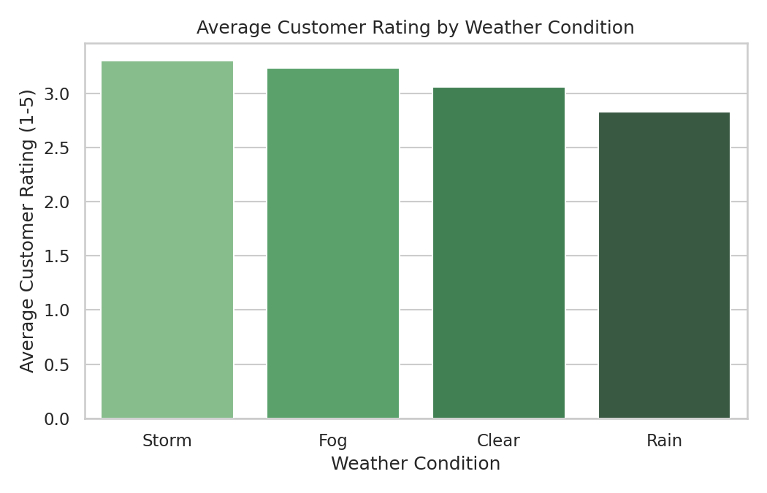
Figure 7: Average customer rating by weather condition
Customer ratings are lowest under Rain (≈ 2.83), while Storm and Fog show slightly higher averages than Clear conditions. Given the small number of Storm records in this sample, the Storm figure should be treated cautiously rather than read as “storms improve satisfaction” — the more reliable signal here is that Rain is consistently associated with lower ratings, and the differences across conditions are modest overall given the 1–5 scale.

5. Analytical Insights and Recommendations
- Cost efficiency scales with distance: short-haul shipments cost more per km, so consolidating nearby short deliveries onto shared routes could reduce cost_per_km.
- Delay risk is highest on Sundays and Thursdays: reviewing weekend staffing levels and mid-week demand planning could directly reduce the overall 48% delay rate.
- The South region carries the highest average cost: a route-efficiency or vehicle-allocation review specific to that region is a reasonable next step.
- Weather has a measurable but secondary effect on customer satisfaction: proactive delay notifications during Rain/Storm conditions may help offset the rating dip.
- Distance alone does not explain delivery time or cost variation well (weak correlations); operational factors like vehicle type, region, and day of week matter more and are better targets for optimization.

6. Conclusion
This Week 3 analysis moved from the clean Week 2 dataset to concrete, visualized operational insight: a correlation study, seven purpose-chosen visualizations (histogram, boxplot, scatter, bar charts, and a line chart), and a set of actionable recommendations around routing, staffing, and regional cost review. It also surfaced and corrected a residual data-quality issue (non-physical negative distances from IQR capping), reinforcing that EDA is itself a data-quality check, not just a reporting step. These findings set up Week 4 for predictive modelling of delay risk and cost drivers.

