HOME ASSIGNMENT-CO3

1.Explain the concept of address-space abstraction and describe how an operating system virtualizes memory for a process.
A. 1. Address-Space Abstraction and Memory Virtualization
Address-Space Abstraction
Address-space abstraction is an operating system concept that gives each process its own private, independent memory space.
A process behaves as if it has its own memory, even though multiple processes share the same physical RAM.
Each process has its own virtual addresses for storing program instructions, variables, stack, and heap.
Memory Virtualization
Memory virtualization is the process by which the operating system provides each process with a virtual memory space and maps its virtual addresses to physical memory.
How it works:
- Each process is given its own virtual address space.
- The CPU generates virtual addresses when the program runs.
- The Memory Management Unit (MMU) translates virtual addresses into physical addresses using page tables.
- The operating system manages memory allocation and protects processes from accessing each other's memory.
- If required, the OS can move some memory pages between RAM and secondary storage.
Example
Suppose two processes, P1 and P2, both use virtual address 1000.
- Process P1's virtual address 1000 may map to physical address 5000.
- Process P2's virtual address 1000 may map to physical address 9000.
Thus, both processes can use the same virtual address without interfering with each other.

2.Explain paging and multi-level page tables with a suitable example. How do multi-level page tables reduce memory overhead?
A. Paging and Multi-Level Page Tables
1. Paging
Paging is a memory management technique in which the operating system divides virtual memory into fixed-size blocks called pages and physical memory into equal-sized blocks called frames.
The OS uses a page table to map virtual pages to physical frames.
Example:
Suppose page size is 1 KB and a process has 4 pages.
Virtual Page | Physical Frame
Page 0 | Frame 3
Page 1 | Frame 7
Page 2 | Frame 1
Page 3 | Frame 5
When the process accesses Page 2, the OS maps it to Frame 1 in physical me mory.
Paging Example
Virtual Pages
Page 0
Page 1
Page 2
Page 3
Physical Frames
Frame 3
Frame 7
Frame 1
Frame 5
Page table maps each virtual page to its corresponding physical frame.
2. Multi-Level Page Tables
A multi-level page table is a page table divided into multiple levels. Instead of maintaining one large page table, the OS uses a hierarchy of smaller tables.
The first-level table points to second-level tables, which contain the actual page-to-frame mappings.
Example:
Suppose a virtual address is divided into three parts:
- Page directory index
- Page table index
- Page offset
The page directory identifies the required page table, and the page table identifies the physical frame.
Virtual Address
Directory | Table | Offset
Level 1: Page Directory
Selects the required page table
Level 2: Page Table
Finds the physical frame number
Physical Address
Frame number + Offset
3. How Multi-Level Page Tables Reduce Memory Overhead
- A single-level page table requires entries for the entire virtual address space.
- Many processes use only a small portion of their available virtual address space.
- Multi-level page tables create lower-level tables only when required.
- Unused portions do not need separate page-table storage, reducing memory consumption.
Example: If a process uses only a few regions of a large virtual address space, multi-level page tables allocate tables for those regions instead of maintaining one large, fully populated table.
Conclusion
Paging divides memory into pages and frames, while multi-level page tables organize page mappings into a hierarchy. They reduce memory overhead by allocating page-table structures only for the portions of virtual memory that are needed.

3. What is a Translation Lookaside Buffer (TLB)? Explain how TLBs improve the speed of virtual-to-physical address translation.
A. Definition
A Translation Lookaside Buffer (TLB) is a small, fast cache inside the Memory Management Unit (MMU) that stores recently used virtual-to-physical address translations.
It helps the CPU translate virtual addresses into physical addresses quickly without accessing the page table every time.
Working of TLB
- The CPU generates a virtual address.
- The MMU checks the TLB for the corresponding physical frame number.
- TLB Hit: If the translation is found, the physical address is obtained quickly.
- TLB Miss: If the translation is not found, the MMU accesses the page table in memory and updates the TLB.
- The physical address is used to access RAM.
Example
Suppose a process accesses virtual page 2, which maps to physical frame 5.
- If the mapping is present in the TLB, the translation is obtained quickly (TLB hit).
- If it is absent, the system checks the page table and stores the mapping in the TLB (TLB miss).
How TLB Improves Speed
- Stores frequently used address translations.
- Avoids repeated page-table accesses when there is a TLB hit.
- Reduces memory access time.
- Improves overall CPU performance.

4.Compare FIFO,LRU and Page Replacement Algorithms.
A. 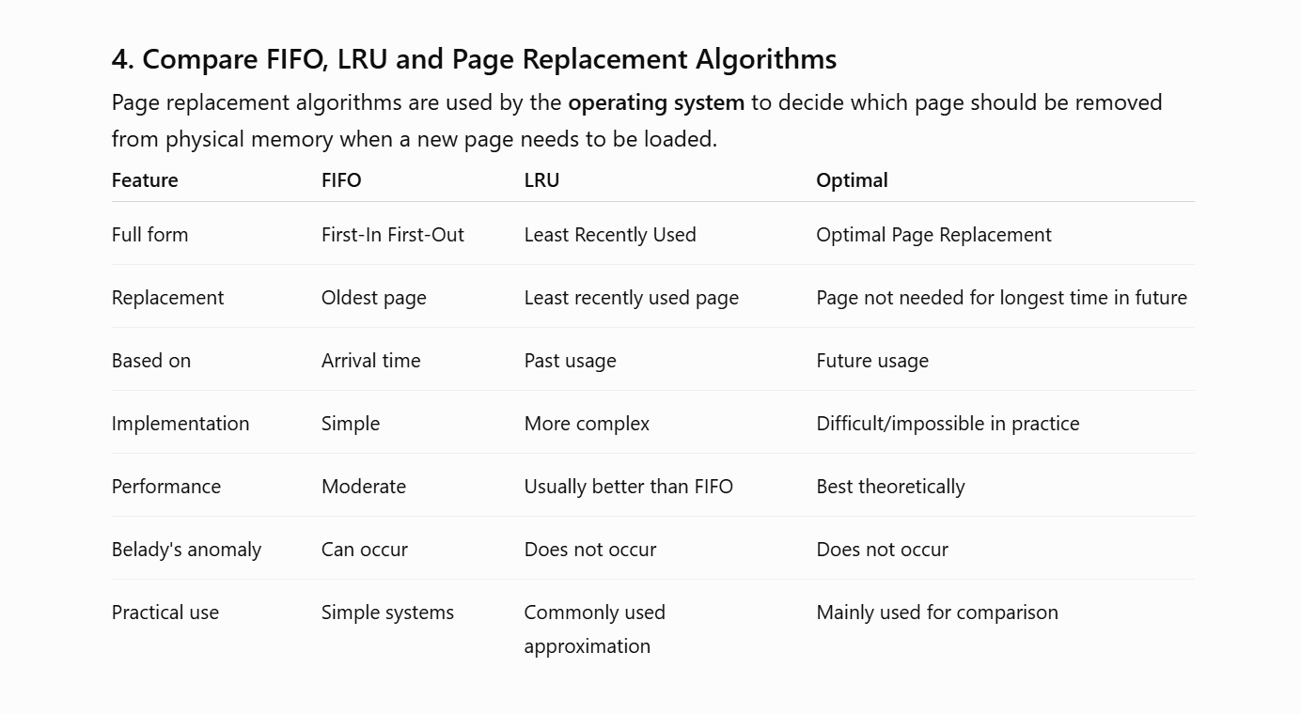
5. Explain the working-set model and thrashing. How can the working-set model be used to estimate the memory requirements of a process and reduce thrashing?
A. Working-Set Model
The working-set model is a memory management technique used by the operating system to identify the set of pages that a process is actively using during a particular period of time.
This set of actively used pages is called the working set.
For example, if a process is frequently using pages 2, 3, 5, 7 during a recent time interval, then its working set is:
W = {2, 3, 5, 7}
The operating system tries to keep these pages in physical memory.
Thrashing :
Thrashing occurs when a process spends more time swapping pages in and out of memory than actually executing.
It usually happens when there is not enough physical memory to hold the pages that processes are actively using.
Example:
If a process needs 6 pages for its current work but only 3 frames are available, pages will be repeatedly removed and loaded. This causes a large number of page faults and reduces CPU performance.
How the Working-Set Model Reduces Thrashing
- The OS observes the pages recently used by each process.
- It calculates the process's working-set size.
- The OS tries to allocate enough frames to hold the working set.
- If enough memory is not available, the OS can reduce the number of active processes.
- This gives remaining processes enough memory and reduces page faults and thrashing.
Estimating Memory Requirement
If:
- Process P1 working set = 4 pages
- Process P2 working set = 5 pages
- Process P3 working set = 3 pages
Then total memory required is approximately:
4 + 5 + 3 = 12 pages
If the system has only 8 available frames, it may need to reduce the number of active processes or otherwise manage memory to avoid excessive paging.

