Manual

1. Run server application on computer.

If you are connecting your app with window operating system, start “AndroidPcServer.jar”; if you are connecting to mac operating system, run “AndroidPcServer.jar” in mac operating system terminal by using below command:

*$java –jar AndroidPcServer.jar*

You will see following window. Then press WI-FI button.

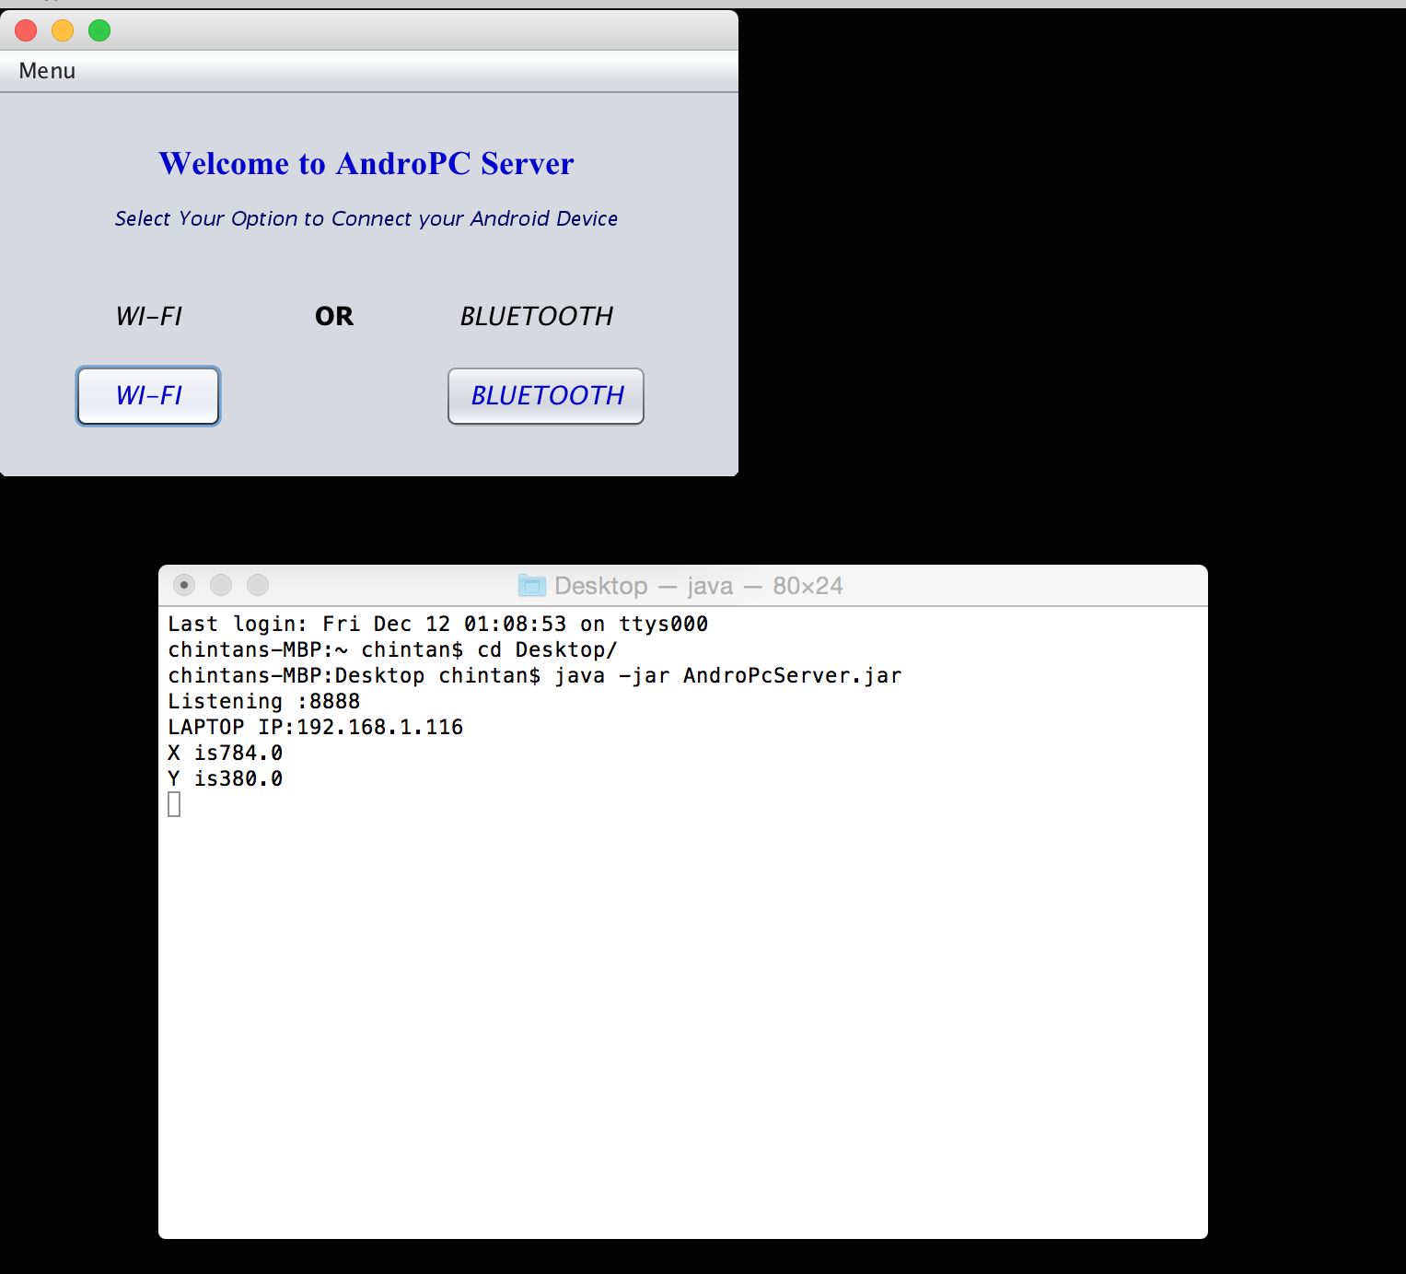

1. Click on Wi-Fi button on server application.

It will show server IP to connect with android device as below screenshot.

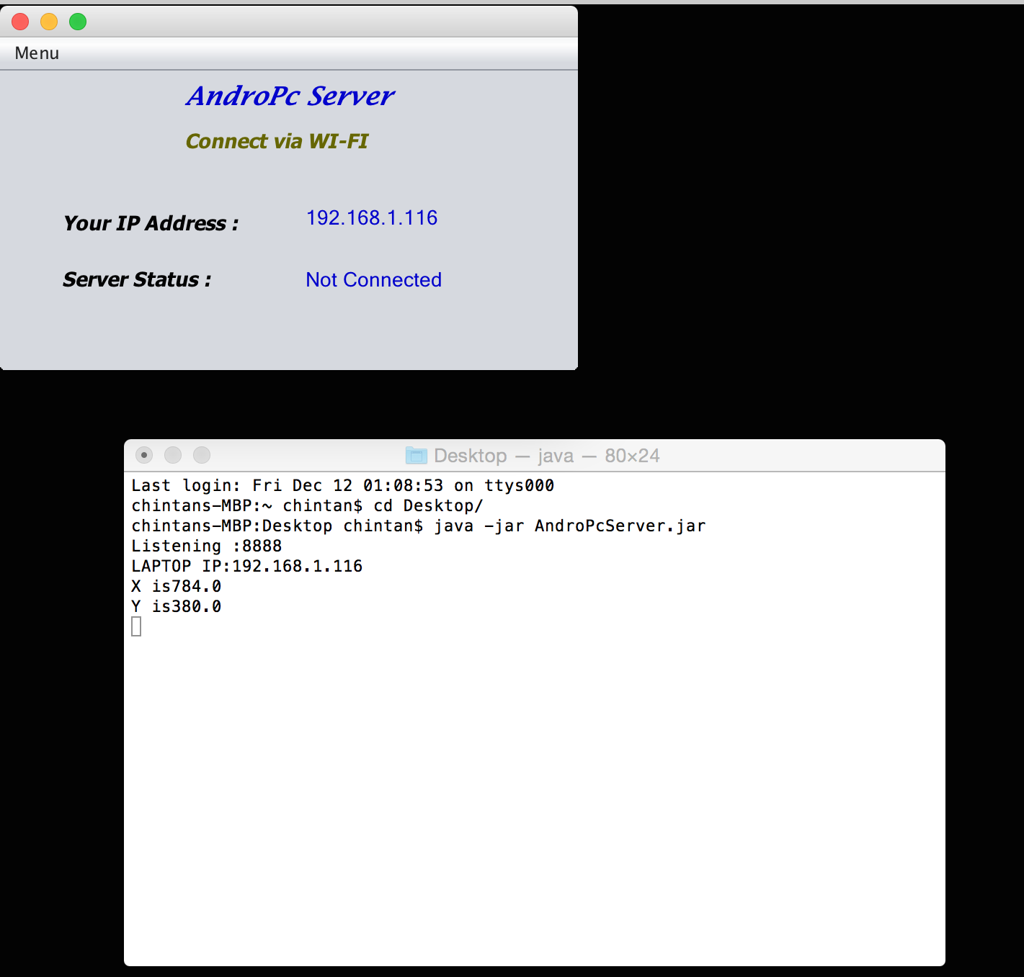

1. Run android app on your phone

Run PC Control on your android device, you will see following screen. You need enter IP showing on server app and press Connect button.

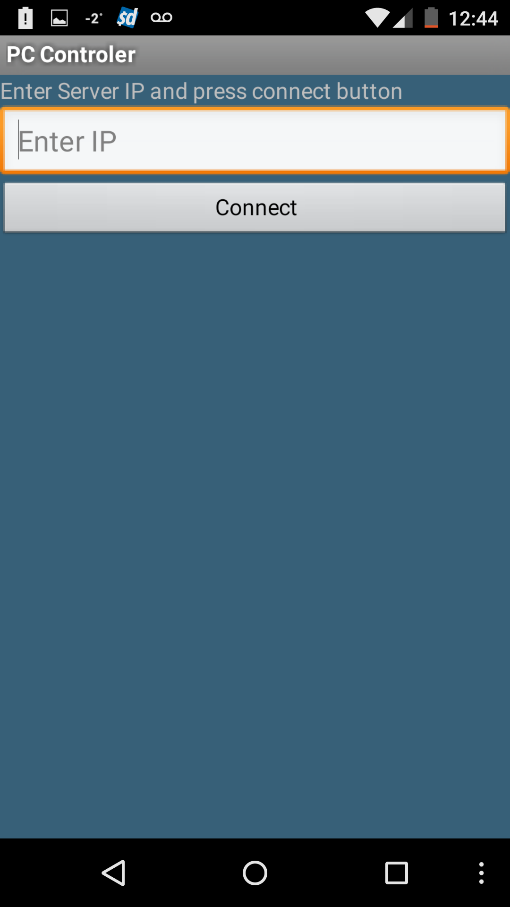

1. Establishing connection.

When the server app successfully connects to android app, in server app server status change to “Connected”.

Mouse Features:

1. Main screen

There is Mouse Control area in main screen layout to control touchpad.

1. Now user can move mouse pointer using device touchscreen.
2. User need to tap the screen to do single click operation.
3. There are two buttons to fulfill double click and right click operation of mouse.
4. User can change color of mouse control area by click on color-change icon.

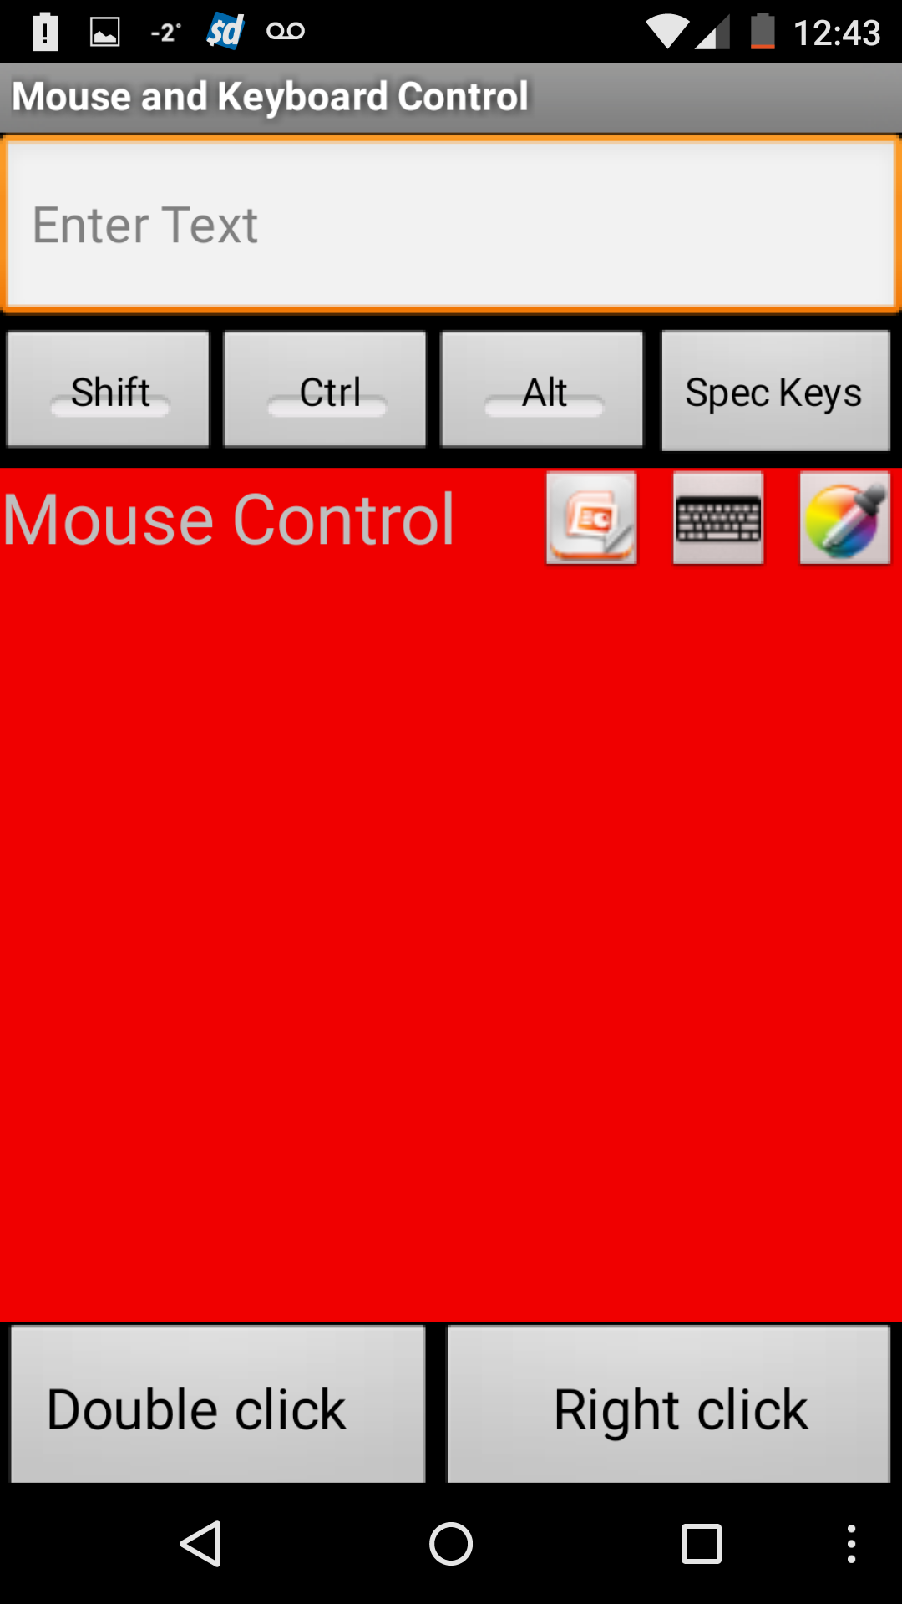 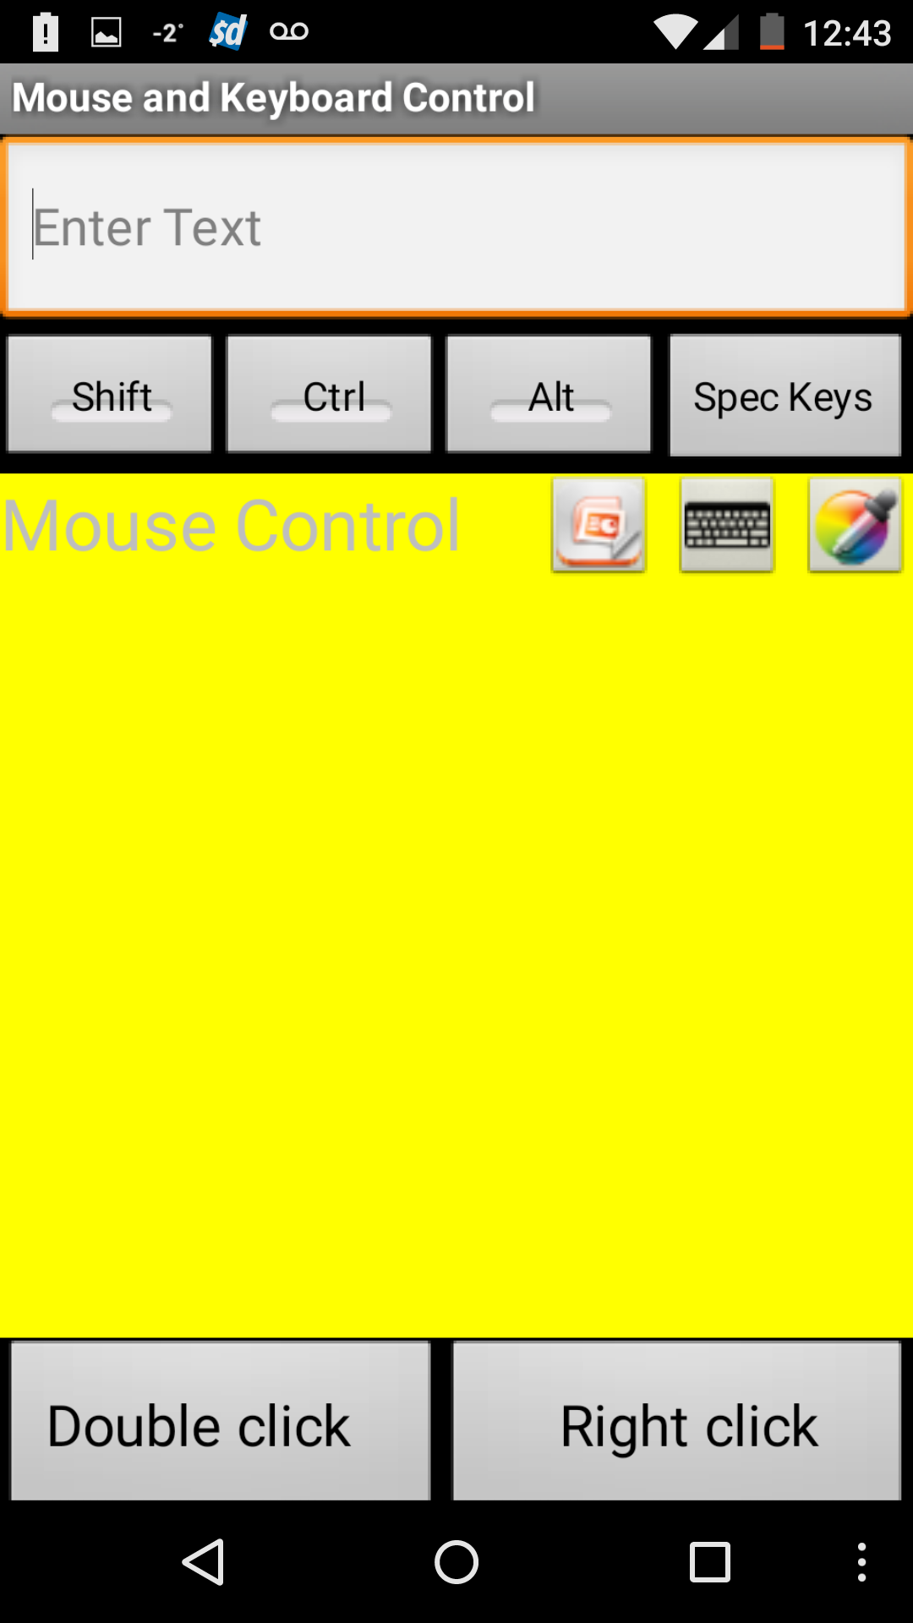

Keyboard Features:

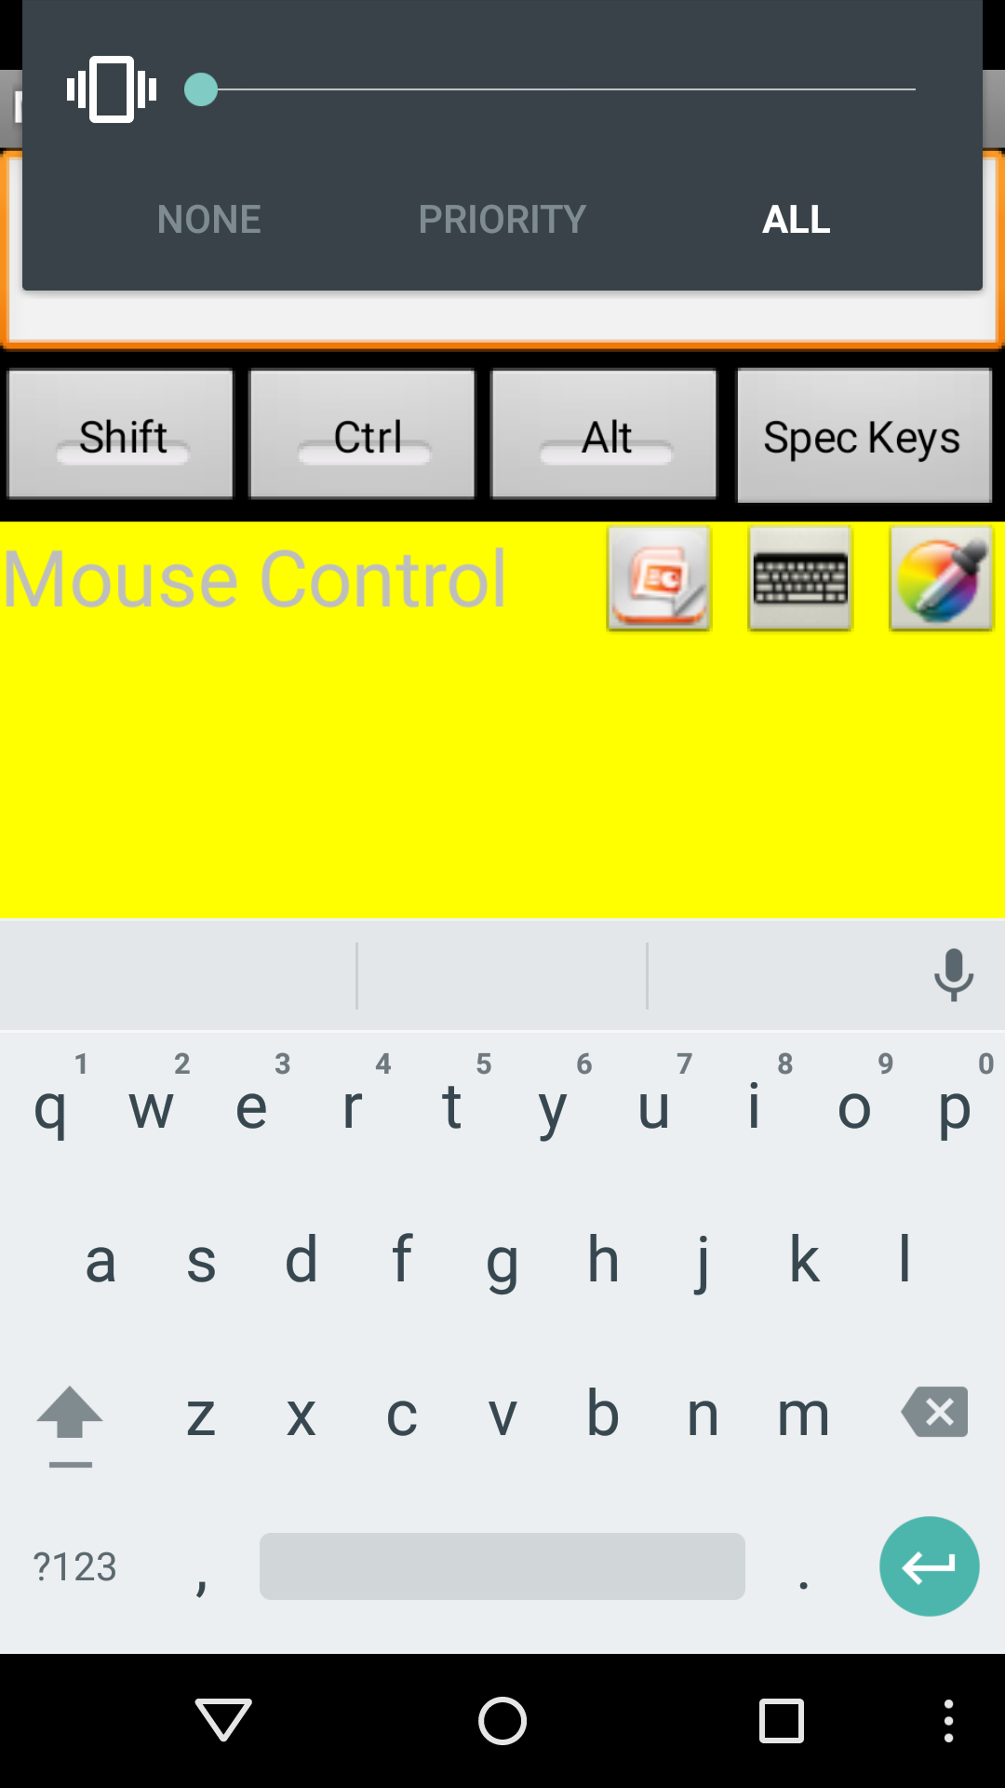

1. Now user can use android device keyboard as read keyboard of pc/laptop.

Start any editor in pc and start typing in Text area of android application as shown in screenshot. It will also write in pc’s editor.

1. Use can hide on screen keyboard by click on keyboard button on Mouse Control area.
2. Now using shift/Ctrl/Alt key user can perform any shortcut in editor. Like, Ctrl+C, Alt+F etc.
3. 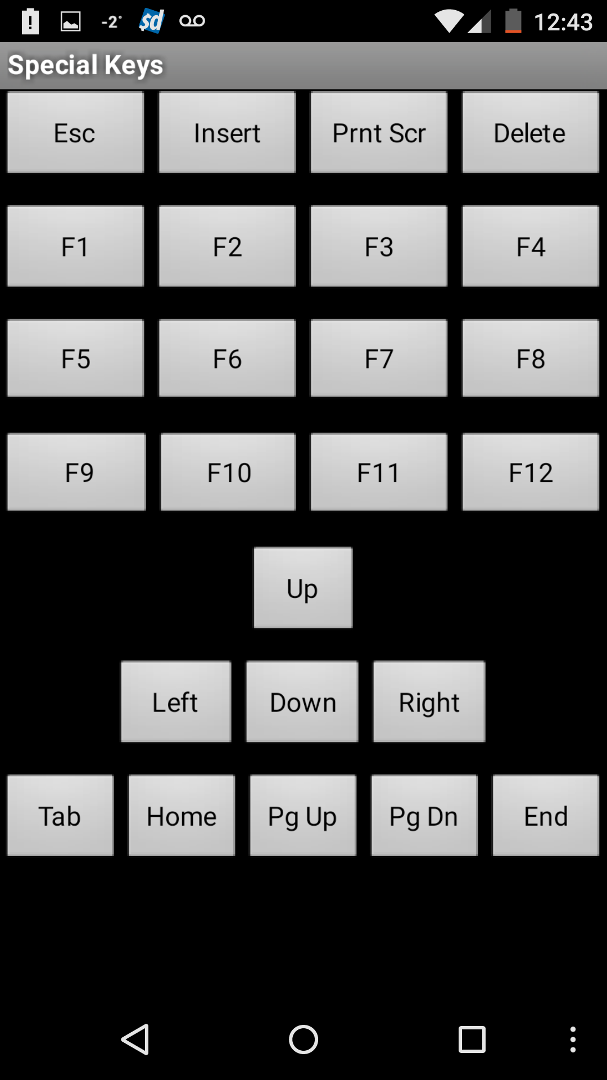Now click on Spec Keys, which will show some of the special keys of keyboard. So, user can access those keys for some special operation. Like, help->F1,

Page up/down/home/end etc.

PPT Control:

1. PPT control

User can start ppt control feature to control slide show by click on ppt control button on Mouse Control area of android application.

1. Now as shown in screen shot user can start/stop slide show. User can go to next/previous/last/first slide.

