**CHAPTER 1**

# INTRODUCTION

## 1.1 Introduction

Introducing "E-shopper," a fashion e-commerce web application designed to provide a seamless and engaging shopping experience for fashion enthusiasts. Built with combination of HTML, CSS, and JavaScript for the front-end, and Django for the backend, E-shopper offers a dynamic and interactive user interface that enhances the online shopping journey. The platform is meticulously crafted for intuitive navigation, and a visually appealing design, making it easy for users to browse and purchase their favourite fashion items with ease. E-shopper leverages the powerful capabilities of Django, a high-level Python web framework, to manage its backend operations.

## 1.2 History

The evolution of fashion e-commerce platforms has seen significant advancements over the years. Initially, fashion databases were static and limited to text-based content. The rise of dynamic web technologies and fashion search, allowing for more interactive and responsive applications.

## 1.3 Application

The "E-shopper" Web-application serves as a tool for users to explore and discover new fashion items. It includes:

* **Search Functionality**: Allows users to search for fashion items based on specific criteria such as category, brand, or style. Additionally, a price filter enables users to find items within their budget.
* **Item Display**: Provides detailed information on each fashion item, including descriptions, sizes, colors, and prices.
* **User Experience**: Designed to be intuitive and responsive, ensuring that users can easily navigate and interact with the application on various devices.

This open website does not include features for saving items or user accounts, focusing solely on providing an accessible fashion search experience.

## 1.4 Problem Statement

In the current digital age, the fashion industry is increasingly shifting towards online platforms to reach a global audience and cater to diverse consumer preferences. However, developing a robust and user-friendly fashion e-commerce web application presents several challenges. The primary challenge is to create an intuitive and engaging user interface that enhances the shopping experience for customers browsing through a wide range of fashion products.

## 1.5 Objectives of the Project

* **Develop a User-Friendly Interface:** Create an intuitive and visually appealing user interface using HTML, CSS, and JavaScript, ensuring that users can easily navigate the website, browse products, and make purchases. Ensure that the E-shopper web application is fully responsive, providing a seamless and consistent user experience across various devices, including desktops, tablets, and smartphones**.**
* **Develop a Robust Backend Functionality:** Utilize Django to develop a secure and efficient backend system that handles user authentication, product management, order processing, and payment integration, ensuring smooth and reliable operations**.**
* **Ensure Database Efficiency:** Use SQLite to design and maintain a well-structured database that supports quick and efficient data retrieval, allowing the application to handle user data and product inventories effectively**.**
* **Developing Advanced Search and Filter Options**: Provide sophisticated search and filtering options, allowing users to easily find products by categories, sizes, colors, materials, and price ranges.

## 1.6 Organization of the Report

The report has several key sections: Chapter 1 Introduction, which givessection outlines the background and objectives of the project, setting the stage for the detailed information that follows.Chapter 2 System Requirements and Specifications here, the essential requirements and detailed specifications for the system are described, covering both hardware and software needs. Chapter 3Design and Implementation, This part details the architectural design and the steps taken to build and deploy the system, including any design decisions and development processes.Chapter 4Results and Snapshots, This section presents the outcomes of the project, showcasing key results and providing visual snapshots to illustrate the system’s performance and functionality.Chapter 5 Conclusion, The concluding section summarizes the project’s achievements, reflects on its success, and may suggest areas for future improvement or development.

**CHAPTER 2**

# SYSTEM REQUIREMENTS AND SPECIFICATION

## Functional Requirements

* **Product Search:** The application must provide a robust search feature enabling users to find fashion items based on various criteria, including categories, brands, styles, and price ranges. This search functionality will be supported by an external fashion API, which will process user queries and return relevant product results. Users should be able to enter multiple keywords or specify particular price filters to refine their search results. The search results should display basic information such as product titles, brief descriptions, and images to help users quickly identify items of interest.
* **Product Viewing:** Once a user selects a product from the search results, the application should display a detailed product page. This page must include comprehensive information such as a complete product description, available sizes and colors, price, customer reviews, and any additional notes or tips provided by the retailer. Users should also have the option to view high-quality images of the product to better understand its appearance and details. The product viewing experience should be designed to facilitate easy reading and navigation, with clear sections and well-organized content.
* **Responsive Design:** To ensure a seamless user experience across different devices, the application must feature a responsive design. This involves creating a layout that automatically adjusts to various screen sizes, including desktops, tablets, and smartphones. Responsive design principles should be applied to all elements of the application, including menus, search bars, and product displays. Media queries, flexible grids, and adaptive design techniques should be used to ensure that the interface remains functional and aesthetically pleasing regardless of the device used to access the application.

## 2.2 Non-Functional Requirements

* **Performance:** The application should provide a smooth user experience, with quick load times for search results and recipe details. It should be capable of handling a reasonable volume of concurrent users without performance issues.
* **Usability:** The user interface should be intuitive and easy to navigate, allowing users to perform searches and view recipes without difficulty. Clear instructions and visual cues should be provided to enhance the user experience.
* **Security**: Although the application does not handle sensitive user data, it includes a functional login system. It is essential to ensure that user credentials are securely managed and stored, and that secure interactions with the server are maintained. Measures should be taken to prevent potential security vulnerabilities, such as implementing HTTPS, using strong password policies, safeguarding against common web security threats like SQL injection and cross-site scripting (XSS), and employing CSRF tokens to protect against cross-site request forgery.

**CHAPTER 3**

# DESIGN AND IMPLEMENTATION

## 3.1 System Design

The "E-shopper" Web application is designed with a modular architecture that separates the front-end and back-end components. This design ensures scalability and maintainability while providing a seamless user experience.

* **Front-End Design:** The front-end is built using HTML for structure, CSS for styling, and JavaScript for dynamic interactions. The user interface includes a search bar, results display area, and recipe detail pages.
* **Back-End Design:** PHP is used to handle server-side interactions, including making API requests and processing responses. Although the application does not involve user accounts or data saving, PHP is crucial for integrating and managing API data.

## 3.2 Tools and Technologies Used

* **HTML:** Provides the basic structure of the web pages, including headers, search forms, and content areas.
* **CSS:** Responsible for styling the application, ensuring that it is visually appealing and responsive. CSS media queries are used to adapt the layout for different screen sizes.
* **JavaScript:** Manages dynamic interactions, such as handling user input, making API calls, and updating the user interface with search results. JavaScript frameworks or libraries may be used to simplify these tasks.
* **Django:** Django is a high-level Python web framework that promotes rapid development and clean, pragmatic design. It includes an ORM for database management, a robust templating system, and built-in authentication**.**
* **ChatGPT:** ChatGPT is an advanced language model developed by OpenAI that uses deep learning to generate human-like text responses. It can assist with a variety of tasks, including answering questions**.**

**3.3 Description of Code**

* **Front-End Code:** Implement the user interface using HTML for structure, CSS for styling, and JavaScript for interactivity and transitions
* **Back-End Code:**
  + **Project Setup**:
    - **settings.py**: Configures the project's settings, including installed apps, middleware, database connections, and static files.
    - **urls.py**: Defines URL patterns for routing requests to appropriate views.
  + **Models**:
    - **Product Model**: Represents products in the store with fields such as name, description, price, and stock quantity.
    - **Category Model**: Categorizes products for easier navigation.
    - **User Model**: Manages user authentication and profile details.
  + **Views**:
    - **Product List View**: Displays a list of products, with optional filters for category and price range.
    - **Product Detail View**: Shows detailed information about a selected product.
    - **User Authentication Views:** Handles user registration, login, and logout.
  + **Forms**:
    - **User Registration Form:** Collects user information for creating a new account.
    - **Login Form:** Authenticates existing users.
  + **URLs**:
    - **Main URLs:** Maps URLs to the corresponding views for displaying products, handling user authentication, and managing the cart.
    - **Product URLs:** Specific URLs for product-related views.

**CHAPTER 4**

# SNAPSHOTS

This Chapter includes visual documentation of the application's functionality. Screenshots and descriptions illustrate how the application performs various tasks:

* **Home Page**: Shows the initial user interface where users can input search queries. The design includes a search bar and options for filtering results**.**

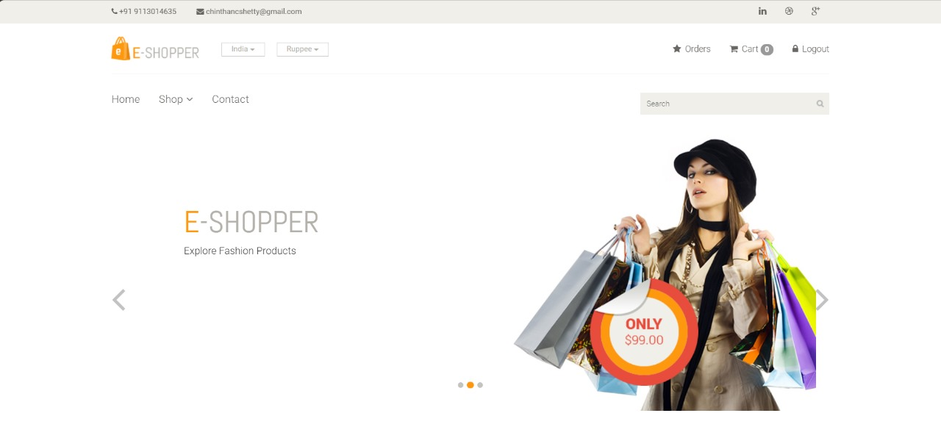

## Figure 4.1. Home Page

* **Product Page**: Shows the initial user interface where users can view products. The design includes a search bar and options for filtering results**.**

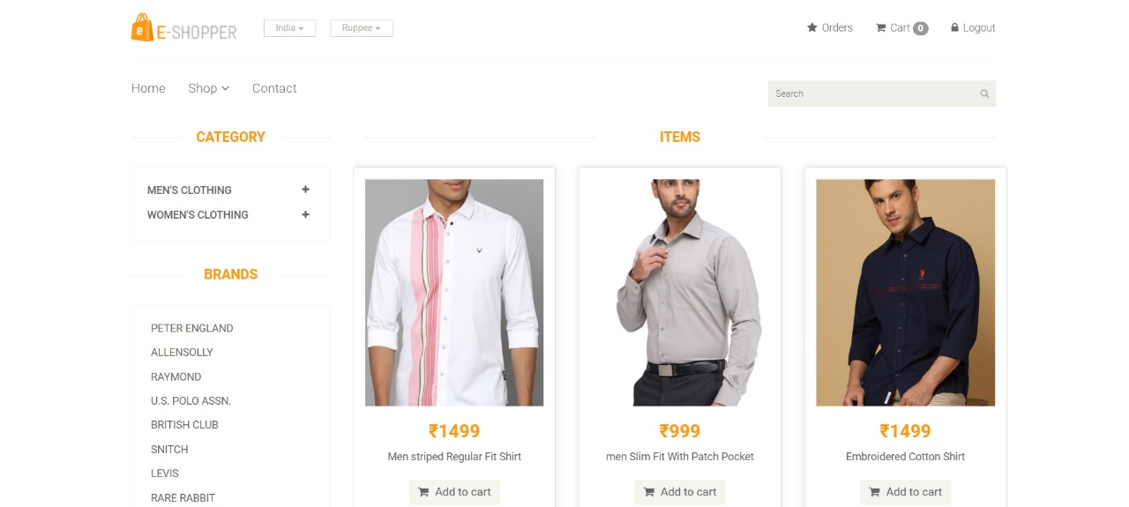

## Figure 4.2 Product Page

* **Cart Details Page**: Shows the items added to the cart and with increment and decrement buttons and with Cart clear button and Checkout button

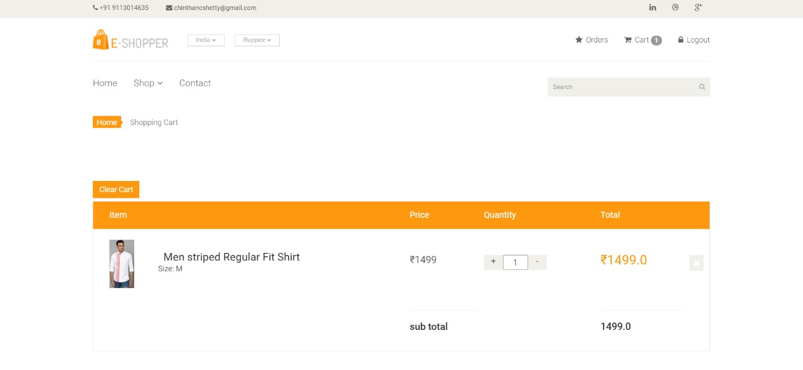

**Figure 4.3 Cart Details Page**

* **Contact Us Page**: This page takes input from user name, mail ,subject ,message and can connect with us.

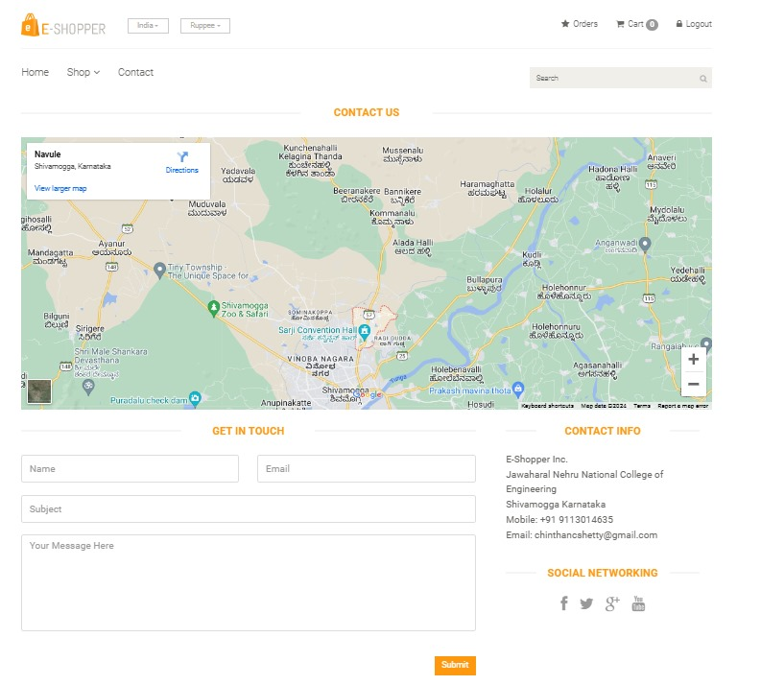

**Figure 4.4 Contact Us Page**

* **Order Details Page**: Shows the Order item and with Cancel button.

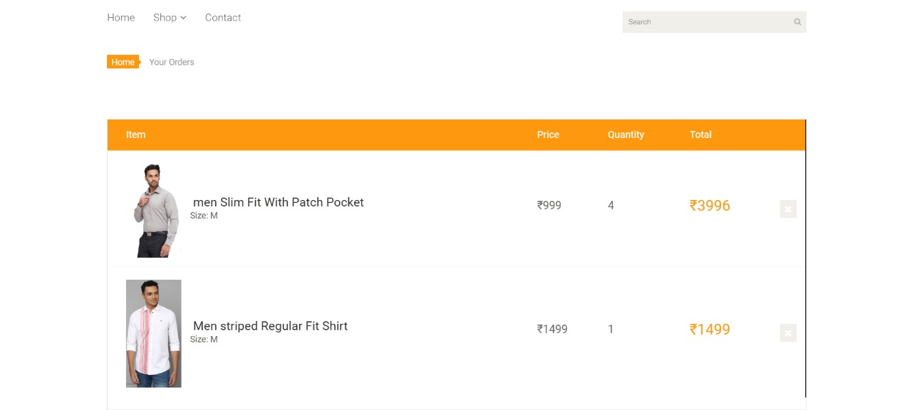

**Figure 4.5 Order Details Page**

* **Admin Panel**: It shows the developers side interface, where he can add Products, Brands, Categories, Sub Categories. The interface is provided by Django framework, not developed by developer.

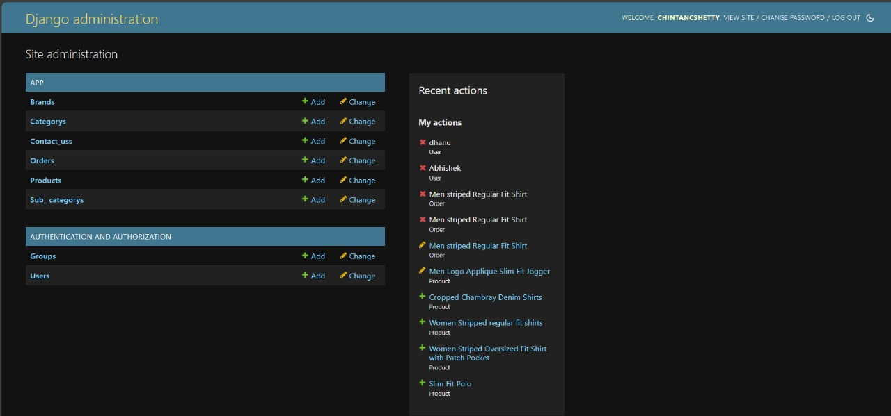

**Figure 4.6 Admin Panel**

**CHAPTER 5**

# CONCLUSION

Developing a successful fashion e-commerce web application necessitates a strong focus on overcoming the primary challenge of crafting an intuitive and engaging user interface. This involves ensuring seamless navigation to provide a smooth and enjoyable browsing experience, implementing efficient product categorization to help users easily locate specific items, and integrating intuitive search functionalities to allow for quick and precise searches. By prioritizing these elements, businesses can significantly enhance the overall shopping experience, making it more enjoyable and straightforward for customers to explore a wide range of fashion products. This, in turn, fosters customer satisfaction, encourages repeat visits. Emphasizing user experience is paramount to standing out in the digital age, where consumer preferences are diverse, and expectations for a streamlined, and functional shopping platform are continually rising.

The future scope of our project, "E-shopper," includes several key enhancements designed to significantly improve the user experience and operational capabilities of the platform. We plan to integrate a seamless payment system that supports various payment methods, ensuring secure and convenient transactions for users. Additionally, we will develop an efficient exchange process to streamline returns and exchanges, enhancing customer satisfaction. To further engage and reward our users, we will implement a discount coupon feature that allows customers to apply promotional codes and enjoy savings on their purchases. Multi-currency support will be introduced to cater to a global audience, enabling users to shop in their local currency with ease. We will also integrate a robust recommendation system that leverages user data to provide personalized product suggestions, helping customers discover items that match their preferences. Finally, we will establish a comprehensive review system, enabling users to share their feedback and experiences, which will foster transparency and trust in our platform. These advancements will collectively enhance the functionality, user engagement, and global reach of "E-shopper".

# REFERENCES

1. Nielsen, J., & Loranger, H. (2006). E-Commerce User Experience: Essential for E-Business Success. New Riders.
2. Felke-Morris, T. (2020). Web Development and Design Foundations with HTML5. Pearson.
3. <https://youtu.be/0OfLZefC478?si=U6JY6kznS9D-y2cD>
4. "Django for Beginners: Build websites with Python and Django" by William S. Vincent.
5. Django Documentation: <https://www.djangoproject.com/>
6. MDN docs:<https://developer.mozilla.org/en-US/docs/Learn/Server-side/Django>