Ass3FINAL.r
chintanjikkar
2025-10-21
library(ggplot2)
library(dplyr)
##
## Attaching package: 'dplyr'
## The following objects are masked from 'package:stats':
##
## filter, lag
## The following objects are masked from 'package:base':
##
## intersect, setdiff, setequal, union
library(corrplot)
## corrplot 0.95 loaded
library(factoextra)
## Welcome! Want to learn more? See two factoextra-related books at https://goo.gl/ve3WBa
library(RColorBrewer)
siva <- read.csv("/Users/chintanjikkar/Desktop/PACE/Fall 25/Visual Analytics/Data/siva.csv", na = c("NA", ""))
str(siva)
## 'data.frame': 53815 obs. of 29 variables:
## $ xgra_n1clb_nbr : int 51407 23460 53417 14382 40539 53945 35983 43669 29279 14254 ...
## $ Siva_Rental_Number : int 67041 56084 70279 15105 49797 71102 43104 54673 33940 14950 ...
## $ rent_area_loc : int 156 204 181 1515 259 165 177 276 2167 953 ...
## $ Date_of_Survey : chr "5/18/2011" "2/5/2011" "6/14/2011" "1/4/2010" ...
## $ Day_of_Week : chr "Wednesday" "Saturday" "Tuesday" "Monday" ...
## $ Time : chr "7:48:30" "22:06:37" "5:35:48" "23:58:56" ...
## $ Survey_Type : chr "SV Web Sol." "SV Web Sol." "SV Web Sol." "SV Web Sol." ...
## $ Purpose_of_Rental : chr "Bus." "Leis. / Pers." "Bus." "Leis. / Pers." ...
## $ Recom_mend_Siva : int 8 8 8 7 9 9 9 6 9 5 ...
## $ Staff_Courtesy : int 9 8 7 8 9 9 9 9 8 7 ...
## $ Speed_of_Service : int 8 8 8 7 9 9 9 8 9 5 ...
## $ Veh_Equip_Condition : int 9 5 8 8 9 9 9 9 8 8 ...
## $ Trans_Billing_as_Expected: int 9 8 8 8 9 9 9 9 9 7 ...
## $ Value_for_the_Money : int 9 7 8 8 9 9 9 6 7 7 ...
## $ Area : chr "01602 - LOVE FIELD AP TX" "07286 - VALLEJO CA OAP" "01850 - RICHMOND VA AP" "05743 - PICO CA OAP" ...
## $ loc_nm : chr "DALLAS LOVE FIELD" "VALLEJO HLE" "RICHMOND INTL AP" "PICO HLE" ...
## $ ga_region_desc : chr "SOUTHWEST REGION" "WESTERN REGION" "MID ATLANTIC REGION" "WESTERN REGION" ...
## $ xgra_ckot_ts : chr "5/15/2011" "1/31/2011" "6/12/2011" "12/23/2009" ...
## $ xgra_ckin_ts : chr "5/17/2011" "2/3/2011" "6/13/2011" "1/3/2010" ...
## $ xgra_vclass_reserv : chr "C" "A" "F" "D" ...
## $ xgra_veh_class : chr "Q4" "B" "YF" "YF" ...
## $ rent_loc_type : chr "AP" "OFF AP" "AP" "OFF AP" ...
## $ cust_tier_code : chr "FG" "N1" "RG" "RG" ...
## $ booking_channel_code : chr "SIVA.COM" "SIVA.COM" "SIVA.COM" "SIVA.COM" ...
## $ col34_total_charges : num 247.3 128 75.8 468.5 42.8 ...
## $ col38_currency : chr "USD" "USD" "USD" "USD" ...
## $ Total_charge_USD : num 247.3 128 75.8 468.5 42.8 ...
## $ Survey_checkout_diff : int 2 3 2 2 2 4 2 2 6 2 ...
## $ booking_channel_dummy : int 1 1 1 1 1 0 0 0 1 1 ...
numerical_vars <- siva %>%
select(
Recom_mend_Siva,
Staff_Courtesy,
Speed_of_Service,
Veh_Equip_Condition,
Trans_Billing_as_Expected,
Value_for_the_Money,
Total_charge_USD,
Survey_checkout_diff
) %>%
mutate(across(everything(), as.numeric))
siva_clean <- na.omit(numerical_vars)
correlation_matrix <- cor(siva_clean)
corr_colors <- colorRampPalette(RColorBrewer::brewer.pal(11, "Spectral"))(200)
corrplot(
correlation_matrix,
method = "color",
col = corr_colors,
addCoef.col = "black",
tl.cex = 0.7,
number.cex = 0.8,
diag = FALSE,
title = "Correlation Matrix of Customer Survey Variables",
mar = c(0, 0, 2, 0)
)
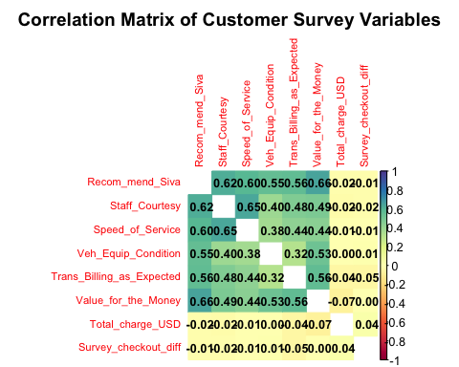
regression_model <- lm(
Recom_mend_Siva ~ Staff_Courtesy + Speed_of_Service +
Veh_Equip_Condition + Trans_Billing_as_Expected +
Value_for_the_Money,
data = siva_clean
)
summary(regression_model)
##
## Call:
## lm(formula = Recom_mend_Siva ~ Staff_Courtesy + Speed_of_Service +
## Veh_Equip_Condition + Trans_Billing_as_Expected + Value_for_the_Money,
## data = siva_clean)
##
## Residuals:
## Min 1Q Median 3Q Max
## -9.0267 -0.5159 0.1299 0.6015 9.1416
##
## Coefficients:
## Estimate Std. Error t value Pr(>|t|)
## (Intercept) -0.409053 0.029629 -13.81 <2e-16 ***
## Staff_Courtesy 0.248569 0.004678 53.13 <2e-16 ***
## Speed_of_Service 0.195483 0.003446 56.72 <2e-16 ***
## Veh_Equip_Condition 0.180413 0.002935 61.48 <2e-16 ***
## Trans_Billing_as_Expected 0.156543 0.003327 47.05 <2e-16 ***
## Value_for_the_Money 0.267408 0.003629 73.69 <2e-16 ***
## ---
## Signif. codes: 0 '***' 0.001 '**' 0.01 '*' 0.05 '.' 0.1 ' ' 1
##
## Residual standard error: 1.28 on 52340 degrees of freedom
## Multiple R-squared: 0.6247, Adjusted R-squared: 0.6247
## F-statistic: 1.743e+04 on 5 and 52340 DF, p-value: < 2.2e-16
siva_clean$Predicted_Recom <- predict(regression_model)
ggplot(siva_clean, aes(x = Predicted_Recom, y = Recom_mend_Siva)) +
geom_point(alpha = 0.6, color = "steelblue") +
geom_abline(intercept = 0, slope = 1, linetype = "dashed", color = "red", linewidth = 1) +
labs(
title = "Regression Model Fit: Actual vs. Predicted Customer Recommendation Score",
x = "Predicted Recommendation Score",
y = "Actual Recommendation Score"
) +
theme_minimal()
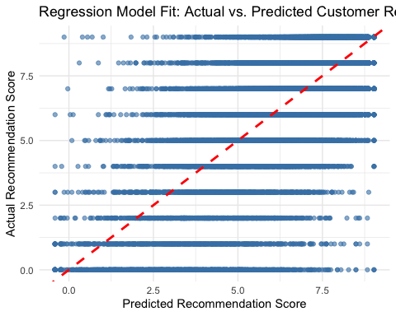
k_value <- 3
cluster_data <- siva %>%
select(Staff_Courtesy, Speed_of_Service, Veh_Equip_Condition,
Trans_Billing_as_Expected, Value_for_the_Money) %>%
na.omit()
scaled_data <- scale(cluster_data)
set.seed(2101)
kmeans_model <- kmeans(scaled_data, centers = k_value, nstart = 25)
fviz_cluster(
kmeans_model,
data = as.data.frame(scaled_data),
ellipse.type = "convex",
geom = "point",
palette = c("#FF6F61", "#FFE082", "#4DB6AC"),
ggtheme = theme_minimal(),
main = paste("Cluster Visualization using Principal Components (k =", k_value, ")")
)
