INDI ASSI 8 Cj
2025-11-07
library(usmap)
library(ggplot2)
library(dplyr)
##
## Attaching package: 'dplyr'
## The following objects are masked from 'package:stats':
##
## filter, lag
## The following objects are masked from 'package:base':
##
## intersect, setdiff, setequal, union
library(scales)
library(reshape2)
library(plotly)
##
## Attaching package: 'plotly'
## The following object is masked from 'package:ggplot2':
##
## last_plot
## The following object is masked from 'package:stats':
##
## filter
## The following object is masked from 'package:graphics':
##
## layout
# Load & join population data
state2025 <- read.csv("/Users/chintanjikkar/Desktop/PACE/Fall 25/Visual Analytics/Data/us-states---ranking-by-population-2025.csv")
state2025_small <- state2025 %>% select(state, pop2025) %>% rename(full = state)
merged_pop <- merge(usmap::statepop, state2025_small, by = "full", all.x = TRUE)
# US map plot
plot_usmap(data = merged_pop, values = "pop2025") +
scale_fill_continuous(name = "2025 Population", label = comma, low = "lightblue", high = "darkblue") +
theme(legend.position = "right") +
labs(title = "US State Populations (2025 Estimates)")
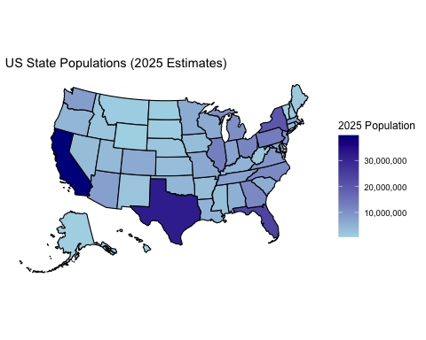
# Load marketing data
campaign <- read.csv("/Users/chintanjikkar/Desktop/PACE/Fall 25/Visual Analytics/Data/marketing_campaign.csv")
campaign$Age <- 2022 - campaign$Year_Birth
# Interactive scatter plot
fig1 <- ggplot(campaign, aes(x = Age, y = Income, color = Education)) +
geom_point(alpha = 0.75, size = 2) +
labs(
title = "Income vs. Age, Colored by Education",
x = "Age",
y = "Income"
) +
theme_minimal(base_size = 14) +
theme(
legend.position = "right"
)
fig1
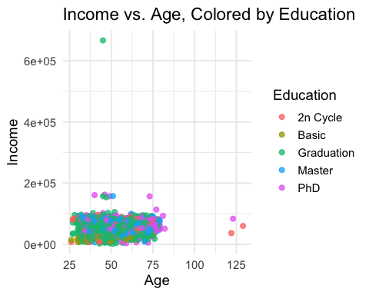
# Static correlation matrix heatmap with custom colors and value labels
numeric_data <- campaign %>% select_if(is.numeric) %>% select(-ID)
cor_mat <- cor(numeric_data, use = "complete.obs")
cor_mat_melt <- melt(cor_mat)
# Set color gradient using same codes as your previous palette
ggplot(cor_mat_melt, aes(x = Var1, y = Var2, fill = value)) +
geom_tile(color = "white") +
geom_text(aes(label = sprintf("%.2f", value)), size = 2.65, color = "black") +
scale_fill_gradient2(
low = "#228B8D",
mid = "#F8C471",
high = "#7D3C98",
midpoint = 0,
limit = c(-1,1),
name = "Correlation"
) +
theme_minimal(base_size = 13) +
theme(
axis.text.x = element_text(angle = 45, vjust = 1, hjust = 1),
legend.position = "right"
) +
labs(
title = "Correlation Matrix of Numeric Variables",
x = NULL,
y = NULL
)
