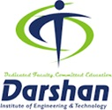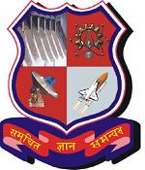

**Darshan Institute of Engineering and Technology, Rajkot**

Rajkot - Morbi Hwy, Rajkot, Gujarat 363650

**CERTIFICATE**

This is to certify that the project report submitted along with the project entitled **Internship Project** has been carried out by **Chintan Kansagara** under my guidance in partial fulfillment for the degree of Bachelor of Engineering in ***Department of Computer Engineering***, 8th Semester of Gujarat Technological University, Ahmedabad during the academic year 2022-23.

|  |  |  |
| --- | --- | --- |
| Internal Guide  Prof. Mayur Padia  CE Department, DIET |  | Head of the Department  Dr. Gopi Sanghani  Professor & Head,  CE Department, DIET |



**Darshan Institute of Engineering and Technology, Rajkot**

Rajkot - Morbi Hwy, Rajkot, Gujarat 363650

**DECLARATION**

We hereby declare that the Internship / Project report submitted along with the Internship / Project entitled **Internship Project** submitted in partial fulfilment for the degree of Bachelor of Engineering in **Computer Engineering** to Gujarat Technological University, Ahmedabad, is a bonafide record of original project work carried out by me at Darshan Institute of Engineering and Technology under the supervision of  **Prof. Mayur Padia** and that no part of this report has been directly copied from any students’ reports or taken from any other source, without providing due reference.

Name of the Student Sign of Student

Chintan Kansagara