**CHAPTER 1 - OVERVIEW OF THE COMPANY**

* 1. **HISTORY**

Technomark started in 2009 at ahmedabad. It is a team of exceptionally talented people set to revolutionize modern-day technology. Our Vision is to be recognized as a dependable outsourced partner to quality conscious and growing businesses globally. Our Mission is to become the successful DNA of any business and to transform them with innovative excellence at the intersection of talent and technology. Our Mission is to work, become the world's leading digital transformation platform, connecting physical, digital and human aspects. It is ensuring committed deliveries of all projects within dedicated timelines. It's primary objective is to cater to high-quality IT solutions and ensure ethics and value in terms of our workflow and strengthened technological backings. It is headquartered in the USA with regional offices in India, Canada, Australia. Building projects with a single source of truth.

**1.2 ­SCOPE OF WORK**

As a leading software development service provider, the company excels in delivering the best-suited software solutions as per the custom needs, be it small start-ups in their ideation phase or mid-size businesses focusing on ­growth or large enterprises actively optimising business processes across varied organizations and industries.

● Fintech & Insurance

● Education

● Energy and Utilities

● Healthcare

● Media & Entertainment

● Oil & Gas Mining

● Retail & Ecommerce

● Logistics & Distribution

● Travel & Hospitality

● Public Sector

**1.3 SERVICES**

TechnoMark provides services like Enterprise Software Solution, Software Development, Mobile App Development, Cloud Native Development, E-commerce Development, Blockchain Development and IoT App Development.

* 1. **FACILITIES**

#### Work from home flexibility

#### Talent-based package

#### Employee bonus

#### Exposure to emerging technologies

#### 5 days working

#### 8:30h shift hours

#### 24 + 10 total leaves

#### Mediclaim benefits

* 1. **SUMMARY**

**Table 1.1: ABOUT TECHNOMARK SOLUTIONS**

|  |  |
| --- | --- |
| **Website** | https://technomark.io/ |
| **Company size** | 850+ employees |
| **Offices’ Location** | Ahmedabad, India  Mumbai, India  Honolulu, USA  Sydney, Australia |
| **Founded** | 2009 |

**CHAPTER-2 : OVERVIEW OF DIFFERENT**

**DEPARTMENT AND LAYOUT**

**2.1 DIFFERENT DEPARTMENTS**

● QA

● PROFESSIONAL SERVICES

● ADMINISTRATION

● SUPPORT

● PRODUCT MANAGEMENT

● DEVELOPMENT

● TECHNICAL OPERATIONS

● HR

● SECURITY

● APPBUILDER

**2.2 TECHNICAL SPECIFICATIONS**

We serve businesses globally with our penchant for highly robust and scalable business solutions. Our commitment to quality has got us clients in the USA, UK, Canada, Australia, India and Other Countries. TechnoMark helps businesses create a unique digital identity through premium services in website design and development, mobile app development and software development. In the last few years, we have turned around ROIs with dynamic, user-friendly android app development and web design. We take pride in our illustrious portfolio and like to show off by saying TechnoMark is the Technology Partner of several award-winning brands.

**CHAPTER-3 : INTERNSHIP MANAGE**

**3.1 INTERNSHIP SUMMARY**

● GTU provides the opportunity to get experience before students step into professional life.

● In January 2023, I began my internship at Technomark Solution. Working out of the Rajkot, ON office, I found inspiration in my everyday journeys thanks to a fantastic work environment. It was an opportunity for me to demonstrate my worth as an employee, a trustworthy coworker, and a dedicated student.

● I have worked across several tools during my course of internship.

● The encouragement and honest responses I received were more than enough to put me at ease. I am really grateful to all my colleagues for giving me the opportunity to grow both professionally and personally.

● During the internship I learned different technologies like Angular.

**3.2 PURPOSE**

● It has been a fantastic learning curve for me as I meet new people and make professional contacts. In today’s employment market, passing examinations with excellent marks and earning a degree do not provide you with the necessary work experience to thrive in the workplace.

● You will be able to obtain real-world experience, expand your knowledge, and access if you are in the proper career sector by participating in an internship.

**3.3 OBJECTIVE**

● One of the main objectives of this internship is to expose myself to a particular job and profession.

● While you might have an idea about what a job is like, you won't know until you actually perform it.

● The main objective is to make the candidate ready for Full-Stack Development. The internship mainly focuses on practical and self-learning.

● Through this training, I aimed to build my programming base strong. From an individual employee’s point of view, the main aims of training are:

1. Be self-confident.

2. Be skillful in one or more areas of expertise.

3. Develop soft skills like taking public speaking initiatives, taking responsibility for some work/task/event, and many more.

**3.4 SCOPE**

● Hands-on working on tools and technologies learned during the internship time span.

● One of the main objectives of this internship is to expose myself to a particular job and profession.

● While you might have an idea about what a job is like, you won't know until you actually perform it.

**3.5 TECHNOLOGY AND LITERATURE REVIEW**

**Front End Tool**:

**Angular:** Angular is an open-source, JavaScript framework written in TypeScript. Google maintains it, and its primary purpose is to develop single-page applications. As a framework, Angular has clear advantages while also providing a standard structure for developers to work with. It enables users to create large applications in a maintainable manner.

**Postman:** Postman is an API (application programming interface) development tool which helps to build, test and modify APIs. Almost any functionality that could be needed by any developer is encapsulated in this tool.

**JavaScript:** JavaScript is a dynamic computer programming language. It is lightweight and most commonly used as a part of web pages, whose implementations allow client-side scripts to interact with the user and make dynamic pages. As a relatively easy-to-learn language with pervasive support, it is well-suited to develop modern applications.

**HTML:** HTML stands for HyperText Mark-up Language. HTML describes the structure of Webpages using mark-up. HTML elements are the building blocks of HTML pages. HTML elements are represented by tags.

**CSS:** CSS stands for Cascading Style Sheets. CSS describes how HTML elements are to be displayed on screen, paper, or in other media. CSS saves a lot of work. It can control the layout of multiple web pages all at once. External style sheets are stored in CSS files.

**Visual Studio Code:** Visual Studio Code is a lightweight but powerful source code editor which runs on your desktop and is available for Windows, macOS and Linux. It comes with built-in support for JavaScript, TypeScript and Node.js and has a rich ecosystem of extensions for other languages (such as C++, C#, Java, Python, PHP, Go) and runtimes (such as .NET and Unity).

**Back End Tool**

Laravel is a popular open-source PHP web application framework, developed by Taylor Otwell in 2011. It follows the Model-View-Controller (MVC) architectural pattern and provides a simple, elegant syntax to build high-quality web applications.

Laravel offers a wide range of features, such as routing, templating, authentication, security, database migrations, and more. It also has a vibrant ecosystem of packages and tools that can be easily integrated into your project.

Some of the key benefits of Laravel include:

1) Easy to use: Laravel provides an intuitive syntax that allows developers to quickly build web applications.

2) Rapid development: Laravel has a vast array of features, pre-built templates, and tools, which make it faster to develop a web application.

3) MVC architecture: Laravel follows the MVC architecture, which separates the application's logic, presentation, and data layers, making the code more organized and maintainable.

4) Database migration: Laravel's database migration system makes it easier to manage database changes and keep the database schema in sync with the application.

5) Community support: Laravel has a large and active community of developers, which provides extensive documentation, tutorials, and support. Overall, Laravel is an excellent framework for building modern, robust, and scalable web applications.

**3.6 Implementation Platform**

**3.6.1 Visual Studio Code**

Visual Studio Code is a lightweight but powerful source code editor which runs on your desktop and is available for Windows, macOS and Linux. It comes with built-in support for JavaScript, TypeScript and Node.js and has a rich ecosystem of extensions for other languages (such as C++, C#, Java, Python, PHP, Go) and runtimes (such as .NET and Unity).

**3.6.2 PostMan:**

Postman is an API platform for building and using APIs. Postman simplifies each step of the API lifecycle and streamlines collaboration so you can create better APIs—faster

**3.6.3 Chrome Google**

Chrome is a cross-platform web browser developed by Google. It was first released in 2008 for Microsoft Windows, built with free software components from Apple WebKit and Mozilla Firefox. It was later ported to Linux, macOS, iOS, and Android, where it is the default browser.

**3.6.4 GitHub**

GitHub is a for-profit company that offers a cloud-based Git repository hosting service. Essentially, it makes it a lot easier for individuals and teams to use Git for version control and collaboration. GitHub’s interface is user-friendly enough so even novice coders can take advantage of Git. Without GitHub, using Git generally requires a bit more technical savvy and use of the command line.

**3.6.5 Git**

Git is a specific open-source version control system created by Linus Torvalds in 2005. Specifically, Git is a distributed version control system, which means that the entire codebase and history is available on every developer’s computer, which allows for easy branching and merging.

**3.7 INTERNSHIP EFFORT AND TIME, COST ESTIMATION**

During the three months of internship this was the schedule.

● First Month: Basics (HTML, CSS, JavaScript)

● Second Month: FrontEnd (Angular)

● Third Month: Frontend (Angular)

**3.7.1 ROLES AND RESPONSIBILITIES**

● Role: Software Trainee

● Responsibilities: Working on FrontEnd

**CHAPTER 4 - LEARNINGS DURING INTERNSHIP**

**4.1 Angular LEARNING**

● Learning Angular is a process of acquiring the skills and knowledge to develop web applications using a popular JavaScript framework.

● To learn Angular, one needs to have a sound knowledge of HTML, CSS, and JavaScript.

● There are different resources and paths for learning Angular, such as the official documentation, books, and online courses.

● Some of these resources cover the basics of Angular, such as components, data binding, services, dependency injection, navigation, and remote data access.

● Others may also include topics such as testing, styling, deployment, and new features of Angular 10.

**4.1 Angular Hook Life Cycle:**

* Understand the different phases an Angular component goes through from being created to being destroyed
* Know how to hook into those phases and run your own code.
* Know the order in which the different phases happen and what triggers each phase.

Phases:

* A component in Angular has a life-cycle, a number of different phases it goes through from birth to death.
* We can hook into those different phases to get some pretty fine grained control of our application.
* To do this we add some specific methods to our component class which get called during each of these life-cycle phases, we call those methods hooks.
* The hooks are executed in this order:

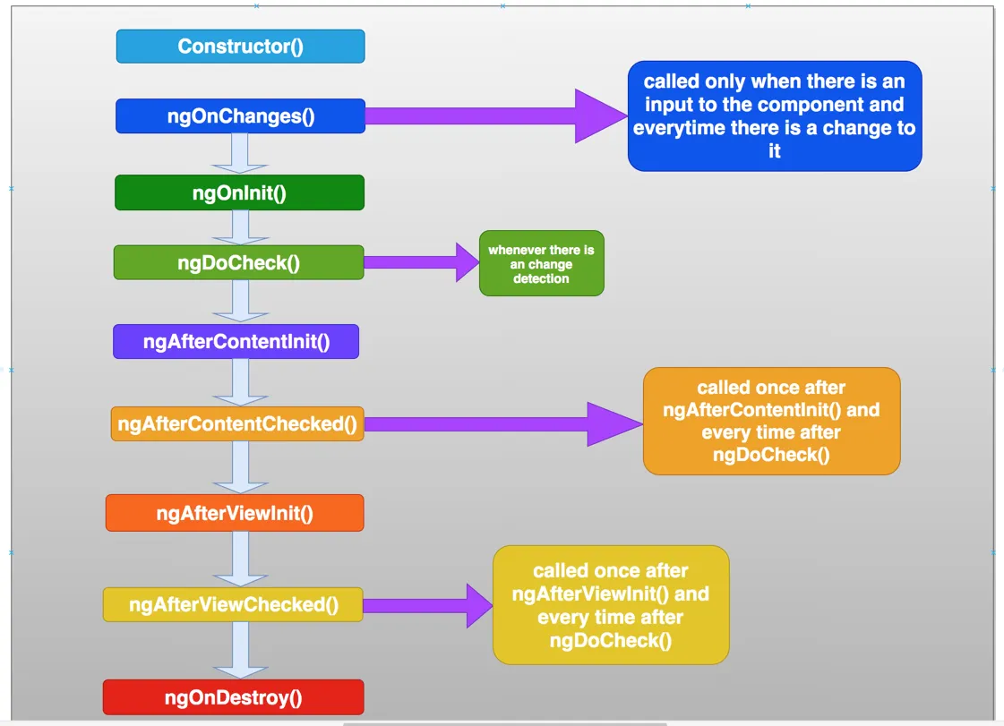

**CHAPTER 5 – Concept Learning and Exercise**

**5.1 Tic Tac Toe**

**Purpose:**

Created a 4x4 Tic Tac Toe game in Angular, this task helped to check the Logical skills and improve the logical skills.

**Functionality:**

This a 4x4 Tic Tac Toe game, which works on click by the user. This is a two Player game which is very entertaining. User can also Register and Login to Play the Game.

**5.2 Realtime Scheduling Task Application**

**Purpose:**

In Realtime Scheduling Task Application we learnt how the scheduling task system works, we learnt how can we create a application by using different libraries in our project, we learned about Gantt-chart and used Gantt-chart in creating this application.

We Performed this task in Angular.

**Functionality:**

In this Realtime Scheduling Task Application user can schedule task based on the day and time whichever he wants to set, User cannot overlap two task in the same time slot, the user has to just drag and drop the time slot in which he wants to schedule his task and has to give a name of the task which he wants to schedule.

**5.3 To-Do List Kanban Board**

**Purpose:**

In this task we created to-do list using HTML, CSS and JavaScript we learnt how the Kanban Board works, which helped to improve our logical skills.

**Functionality:**

This is the task of to-do list in which user can create the task and can assign the person whichever he wants to assign, the tasks can be managed by Kanban Board in which the user can drag and drop the task to columns based on their status, there are three status options in the kanban Board. To-do, In Progress and Done.

**5.4 Crud Operation using JSON Server**

**Purpose:**

In this we learnt how to perform crud operation using JSON Server.

**Functionality:**

Created a student management system in which we can add student store details of the student and display the data od students in table format.

**5.5 Theme Integration**

**Purpose:**

In this task we learned how to integrate API in full fledge theme provided by the client.

The theme is so complex that it’s very difficult to find the components and integrate the API in it.

**Functionality**:

It was a full Ecommerce Website in which user can see the products, can add products in the cart and can Wishlist them. User can apply filter and can sort products based on their own choice.

**5.6 CRUD Operation using Firebase**

**Purpose:**

In this project we learned how to work with firebase which is a no-SQL database. And created a crud application which has a login page and registration page. We learnt login using sign in with google and Email Verification once Registered.

**Functionality:**

The main functionality of this single paged web application was that user can add, delete, update and list the records of the students using Realtime firebase database. The additional functionalities were user can register, login and can also sign up with google account and there was also verification for Email on the registered email id. User can also change the password if needed.

**5.7 Realtime Badge Notification Task using Angular Material**

**Purpose:**

In this project we learned how to implement the Realtime Notifications & also the UI of the Web Application was made using Angular Material.

**Functionality:**

In this project when the user writes some message in the input fields and submits it, then they’ll get the notification, with user adding more messages and submitting it, the notifications will also increase accordingly. The user can also clear all the notifications by clicking on the Clear All button. This could be also called as clone of Notification of social Media Apps.

**5.8 Collaborative Whiteboard**

**Purpose:**

In this project we learned how to implement the Collaborative Whiteboard & also the UI of the Web Application was made using ng-whiteboard

**Functionality:**

In this project the whiteboard allows to write, draw and add images to the whiteboard space area. There are others functionalities like clear button that clears the whole whiteboard on Click and undo redo buttons. In this project the whiteboard can be saved within 4 formats such as png, jpeg, svg and base64 and a selector which can change the background colour of whiteboard.

**REFERENCES**

*The listing of references should be typed 4 spaces below the heading “REFERENCES” in alphabetical order in single spacing left – justified. The reference material should be listed in the alphabetical order of the first author. The name of the author/authors should be immediately followed by the year and other details.*

Website citation has to be very specific not like ‘**google.com**’ or ‘wikipedia.org’.

Figure copied from some paper or website has to be captioned with “**Courtesy of**

**_** ”

A typical illustrative list given below relates to the citation example quoted above.

***Remove this Paragraph and above line after adding List of REFERENCES***