Indigo Mobile App

**Abstract:** This document contains analysis of indigo mobile app from the perspective of human computer interaction. Document is divided into 2 major sections 1st contains information about the current indigo app and the survey report. 2nd contains the low fidelity prototype that we have created in order to complete various tasks.

Team Members

|  |  |  |
| --- | --- | --- |
| **ID** | **Name** | **Contribution** |
| 201412051 | Lakhan | Planning, documenting, presenting, task analysis tree |
| 201412017 | Jenit | Making survey forms and taking survey |
| 201412073 | Nikunj | Making survey forms and taking survey |
| 201412002 | Jaydeep S | Task tree |
| 201412037 | Shubham | Prototype design |
| 201412049 | Sarjak | Prototype design |
| 201412003 | Ravi | Prototype design, task tree, presentation, taking and analysing survey |
| 201412014 | Rahul | Prototype design |
| 201412047 | Deep | Prototype design, taking survey |
| 201412027 | Harsh | Prototype design |
| 201412059 | Karan | Prototype design, taking survey |
| 201412080 | Bhavin | Analysis, reporting, documenting |
| 201412013 | Aditya | Analysis, recording documenting |
| 201412029 | Kishor | Analysis, prototype |
| 201412084 | Ajay | Making survey forms , taking survey and prototype design |
| 201412028 | Chintan | Analysis, reporting, documenting |
| 201412016 | Chirag | Analysis, Prototype design |
| 201412070 | Fenil | Prototype design, taking survey |
| 201412007 | Viraj | Prototype design, taking survey |
| 201412061 | Shashwat | Analysis, Prototype design |
| 201412032 | Dhaval | Prototype design, taking survey |
| 201412004 | Sarjit | Analysis, Survey form analyse |

**Section 1 : Analysis of current indigo application**

We took sample of 20 person and asked them to book flight using current version of mobile application. We recorded the time spent by each person, on each screen that appears during booking flight

So first task we took up was to book flight we had made few assumptions which are listed below

Experiment carried out on : 27th Sept 2015

Book a flight from Ahmedabad to Mumbai/Bombay using Indigo website and mobile app

* Flight Date: 28th Sept 2015
* Sample size: 14
* Age group: 21-22 year
* Ticket for 1 Adult passenger
* Payment process is not completed by any of the user
* Internet connectivity was same for all the user so that delay time is not taken into consideration
* No additional services are to be selected
* One way journey
* Fill only credit/debit card form (no need to proceed after this process)
* Sample people are guest users.

**Sub Tasks carried out**

* Search Flight

- Select source

- Select destination

-Select journey date

- Select journey type

- Select passenger number

* Select flight
* login/signup - optional
* Fill user details
* Select services and seat
* make payment (fill payment form)

**Task Analysis tree**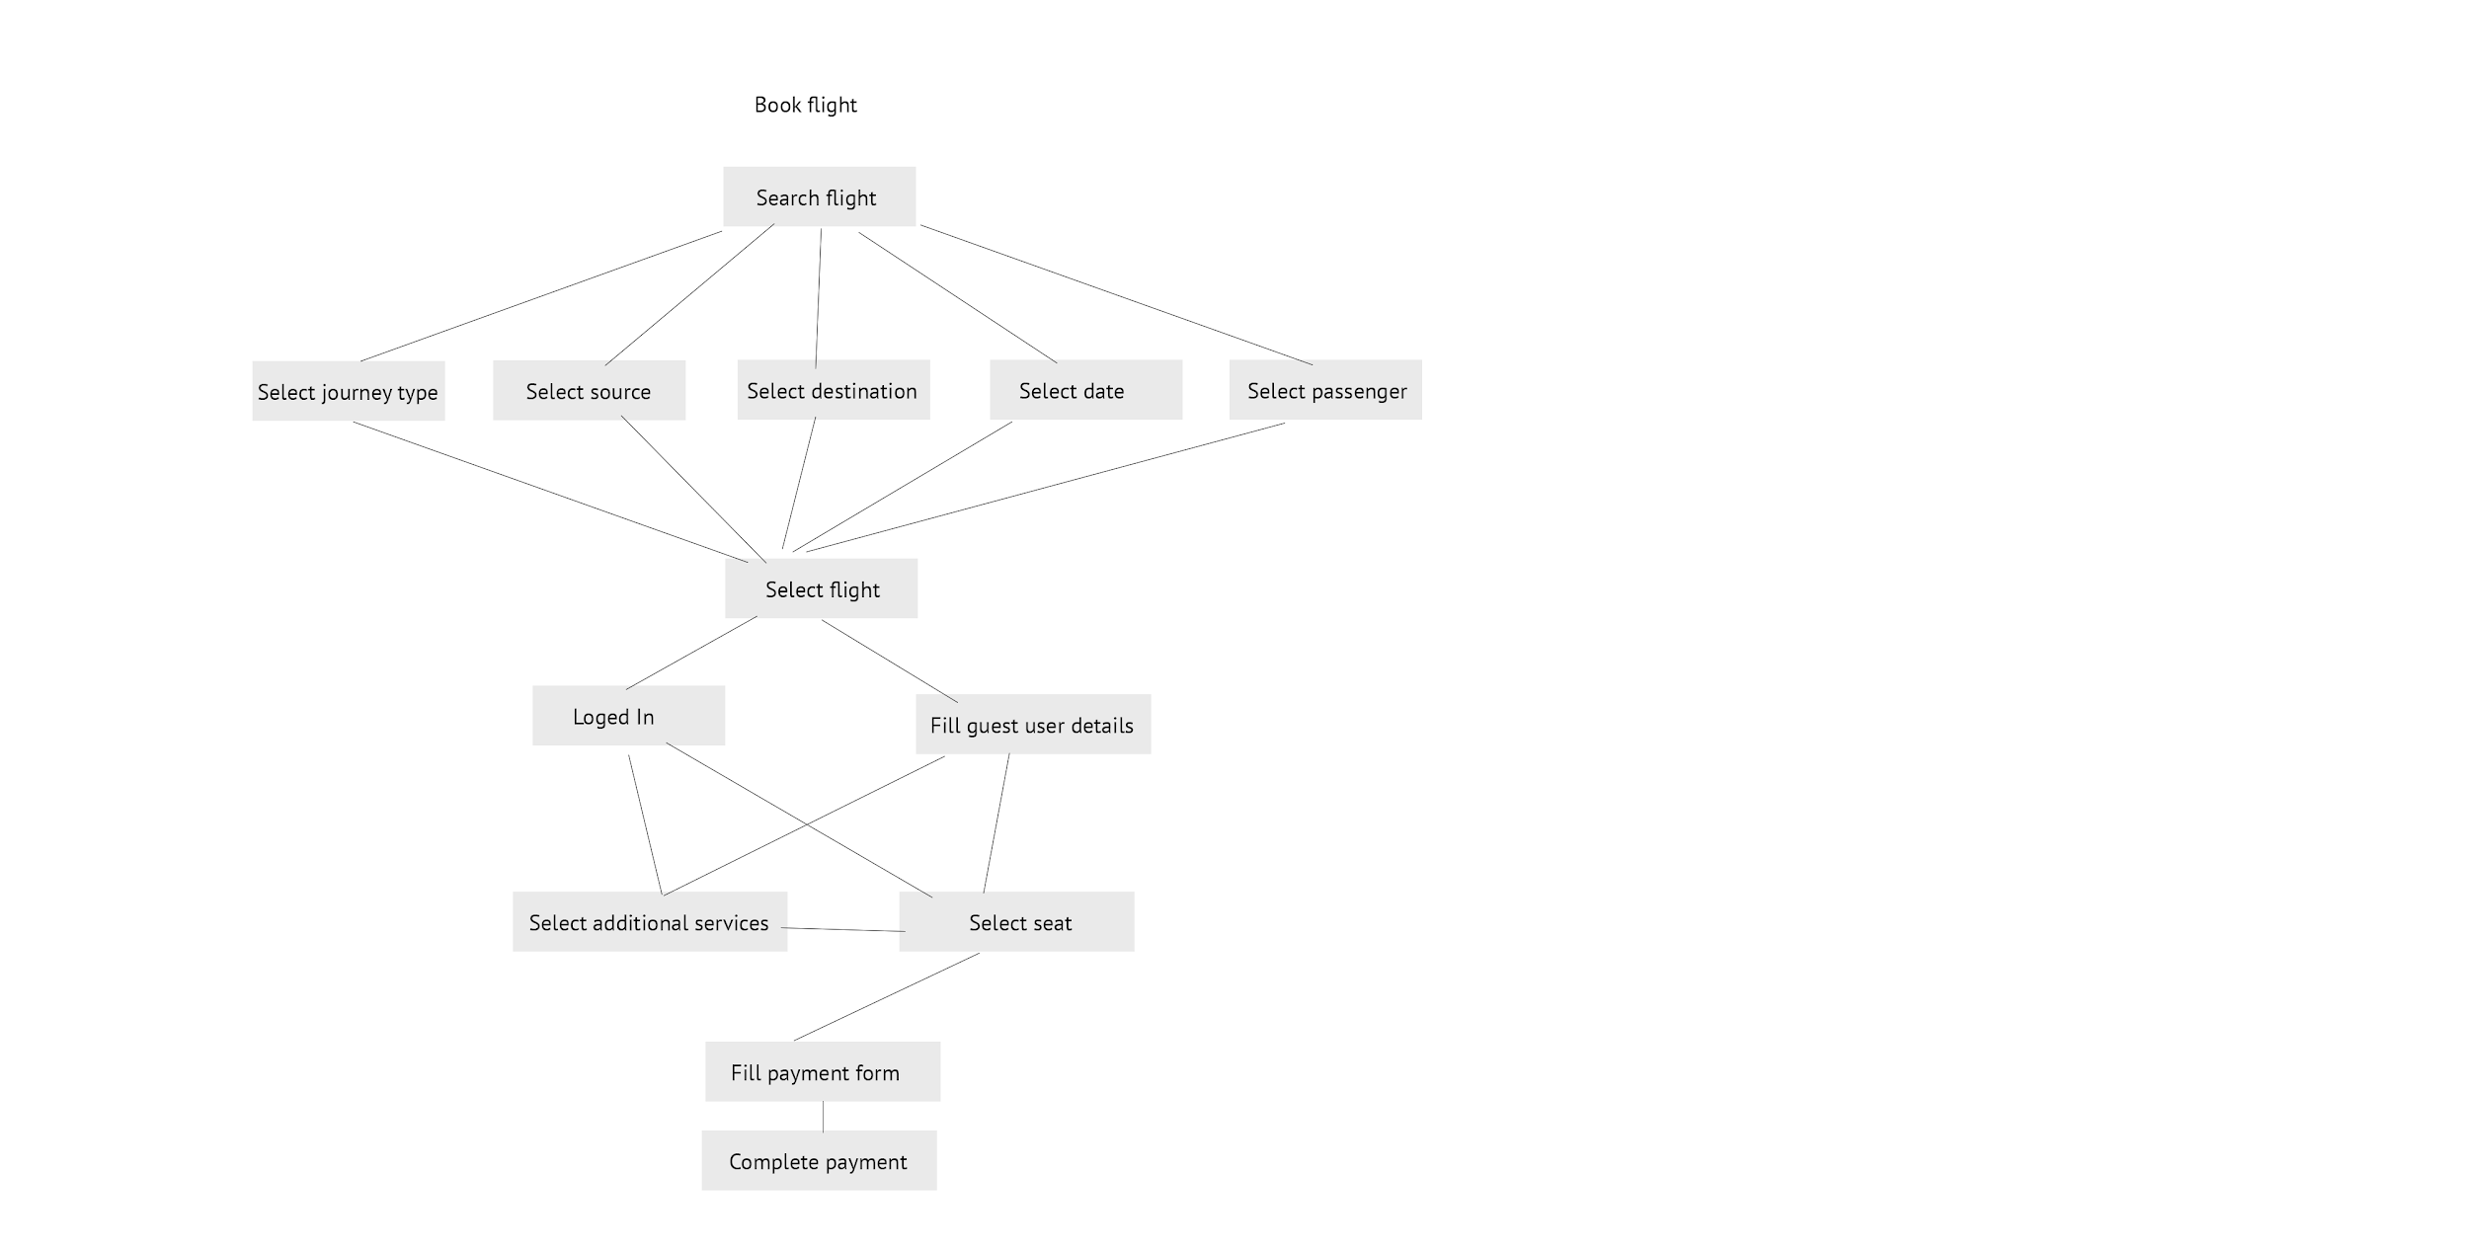

**Path followed in this Experiment**

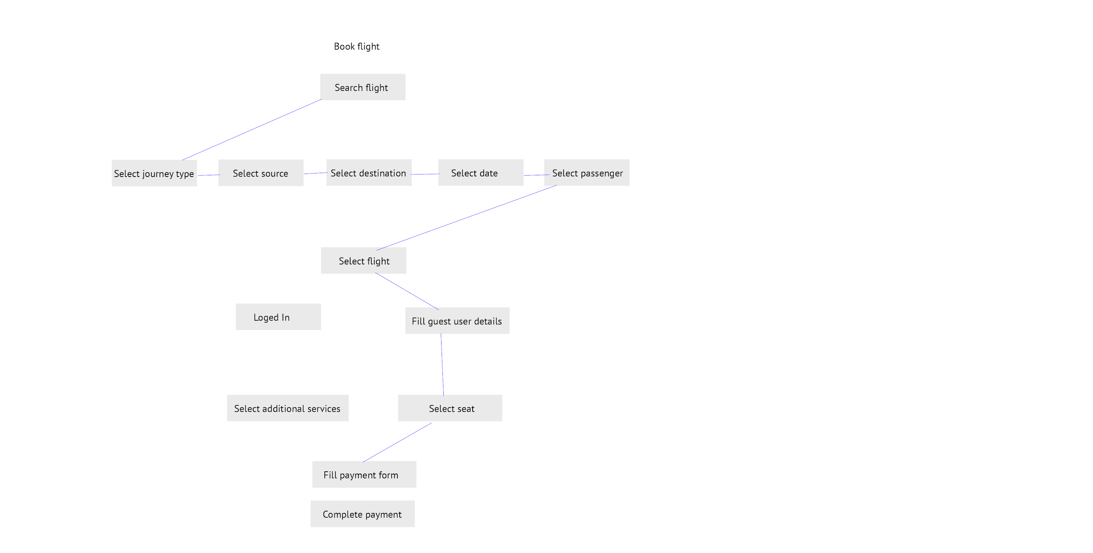

**Mobile Screens**

**Mobile Application Screen Shots**

1. **Home Screen**

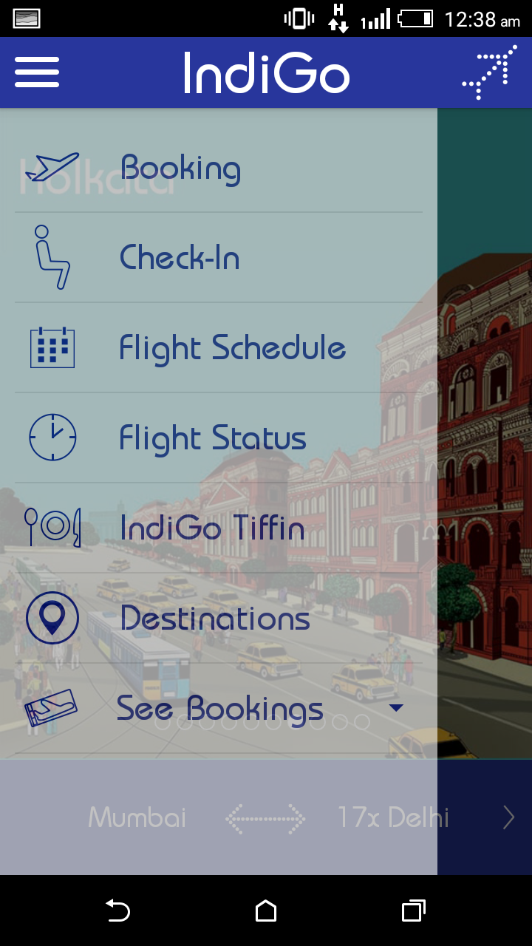

**Description:**

* Different menus available on side menu

1. **Searching for flight**

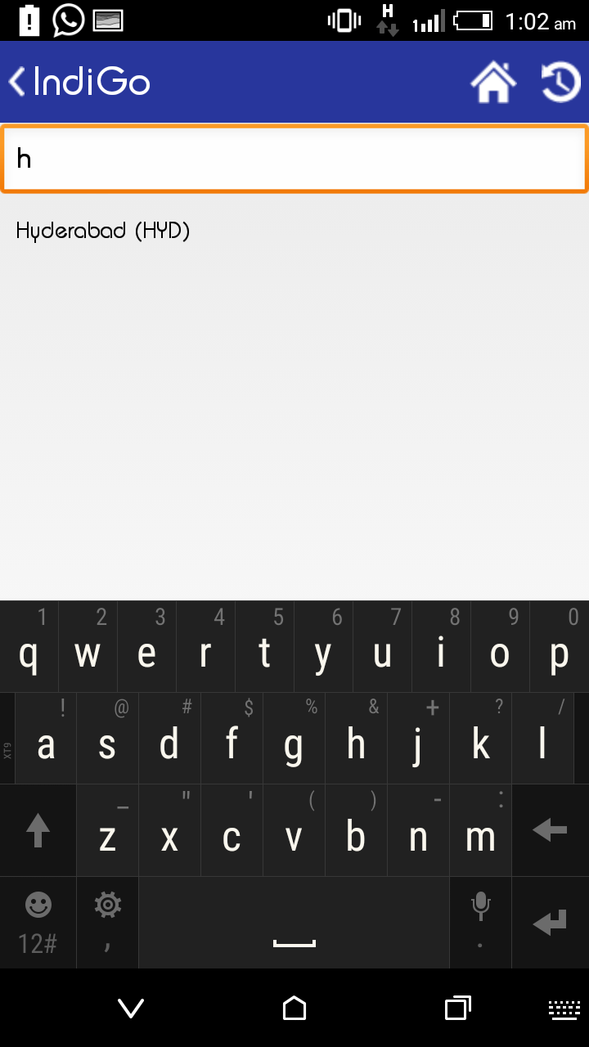

**Description:**

* Searching for flight gives related result of what you typed make selection process easier.

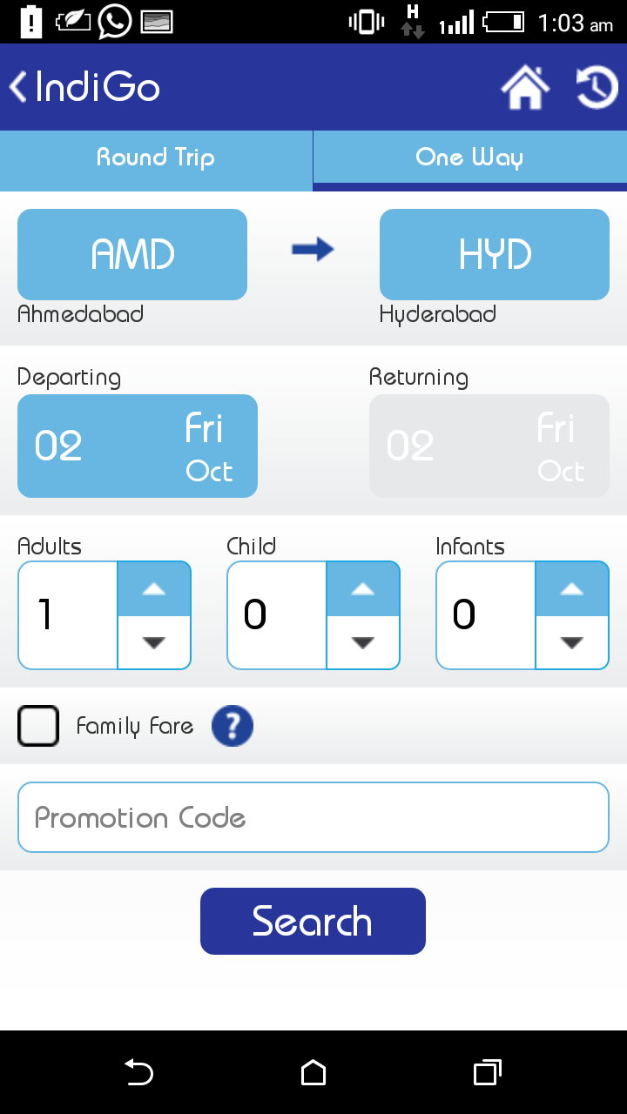

**Description:**

* Selection of source, destination, time and number of person is user centric and quite easy to use.

1. **Selecting flight**

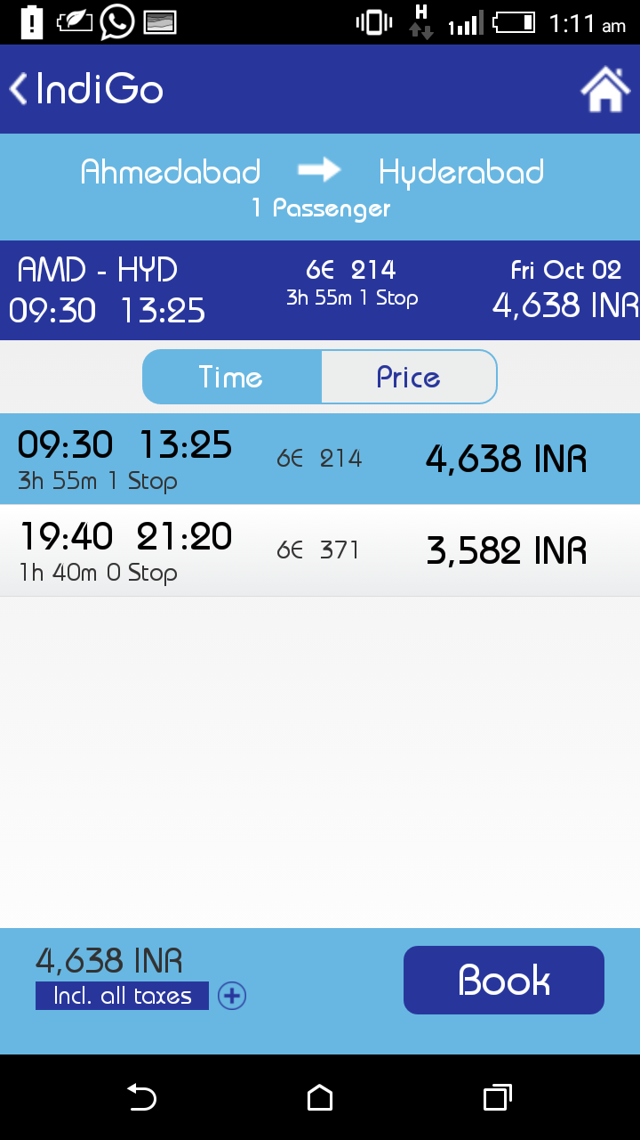

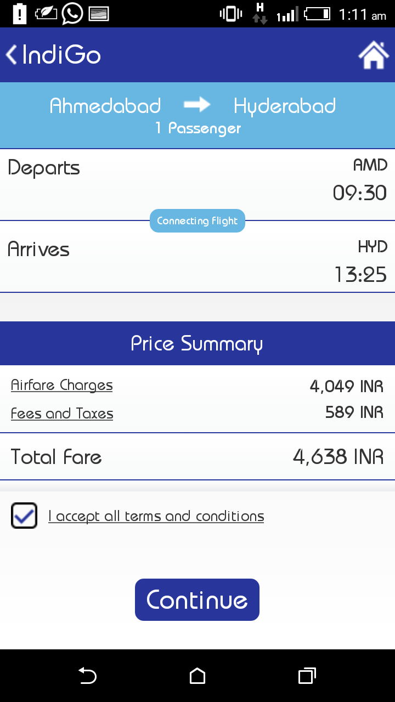

**Description:**

* Showing the list of flights available you
* Unlike web application doesn’t show the extra details regarding flight i.e. charges, halt details etc

1. **Entering user details and selecting additional services**

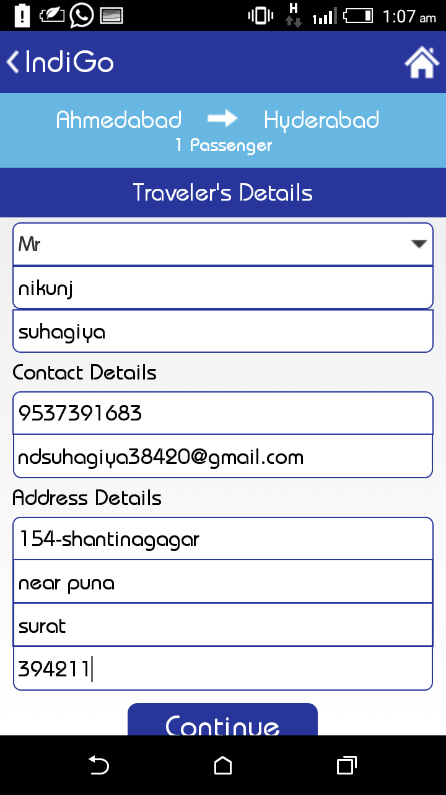

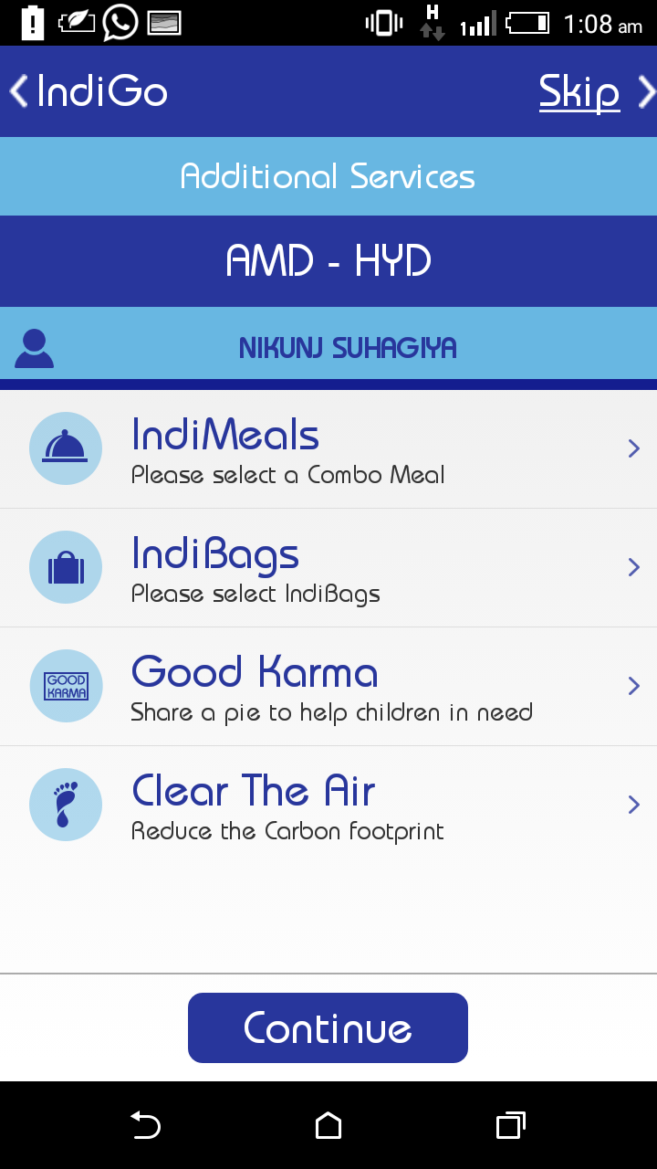

**Description:**

* Entering basic travellers details and selecting additional services to use
* Quite easy then web application

1. **Payment**

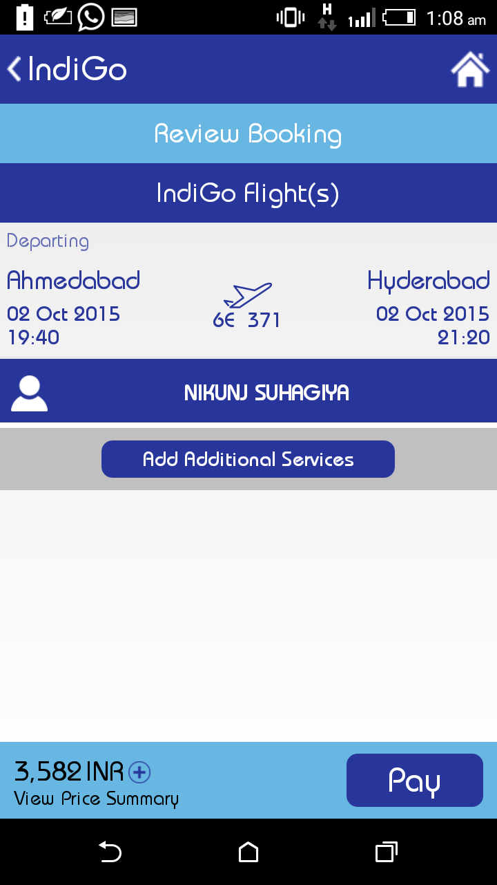

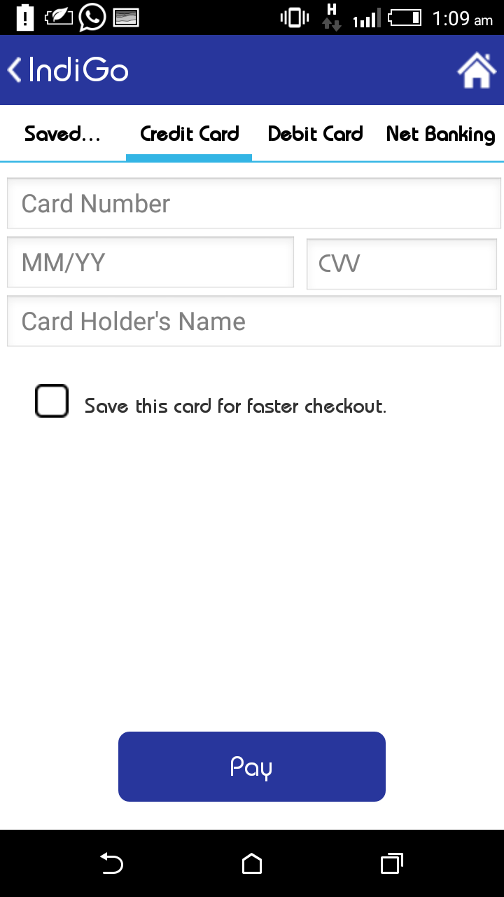

**Description:**

* Reviewing flight booking and paying for it using different option

**Analysis**

|  |  |
| --- | --- |
| **Sub Task** | **Average Time Taken (Seconds)** |
| Search flight | 25.82 |
| Select flight | 18.20 |
| Select Services | 45.07 |
| Payment | 38.27 |
| Search Result Screen | 18.2 |
| Price Summary | 10.79 |
| Travel Detail | 57.2 |
| Review Booking | 10.66 |
| Total Time (Seconds) | 224.21 |
| Standard Deviation of Sub task | 1.46 |

**Analysis and application of HCI laws**

* Confusing because of color combinations(according to research paper in HCI-legibility and contrast)
* Passenger detail form was too long and small in size (Increased motor movement, because of scroll : Fitts law)
* Both having unnecessary information(advertisement because of which motor movement increases: Fitts law + Pareto’s Principle)
* Too many options for additional services (Hicks law)
* Too many screen transition in mobile app (motor movement increased : Fitts law)
* Logo in mobile was similar to position of option (Gestalts Law : Principle of Similarity)

**Section 2: Low Fidelity Prototype**

Task Tree

Book Flight

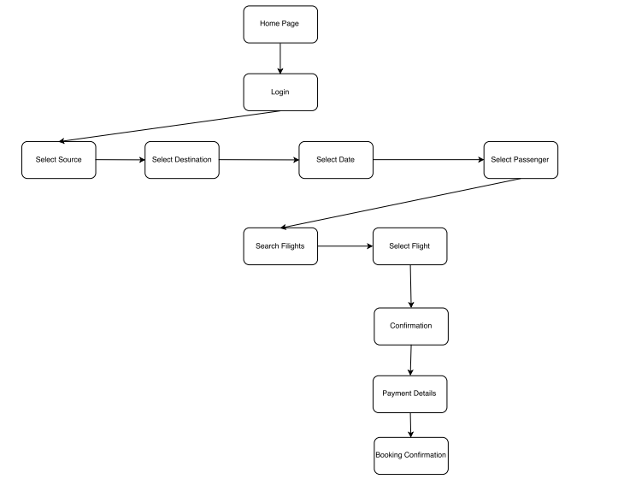

**Cancel Flight**

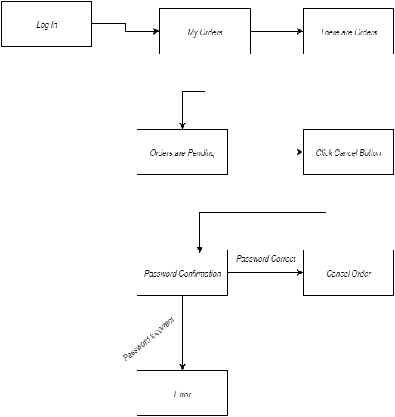

**Application Prototype**

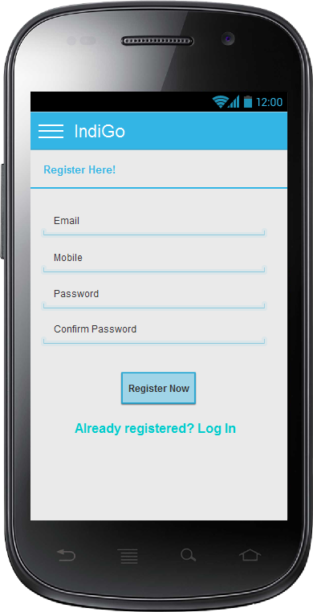

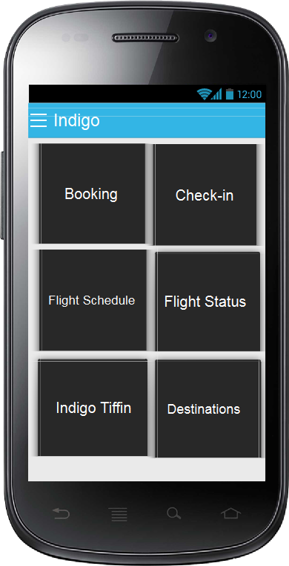

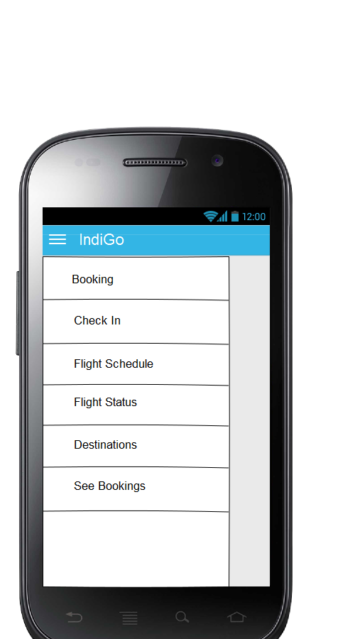

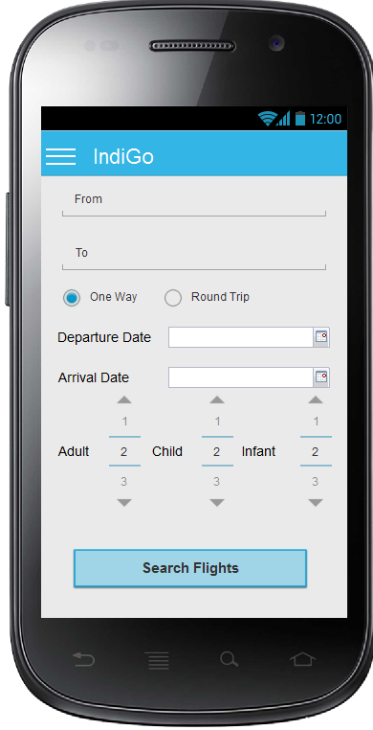

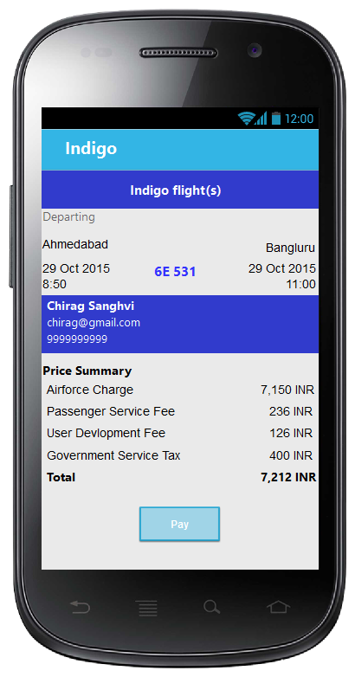

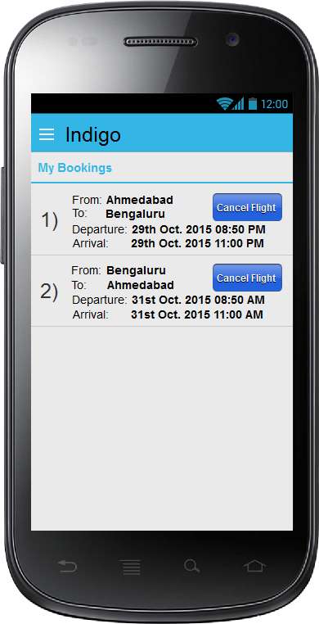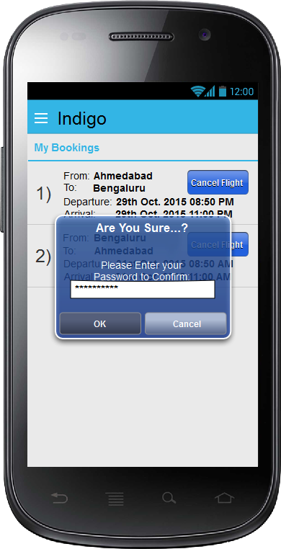

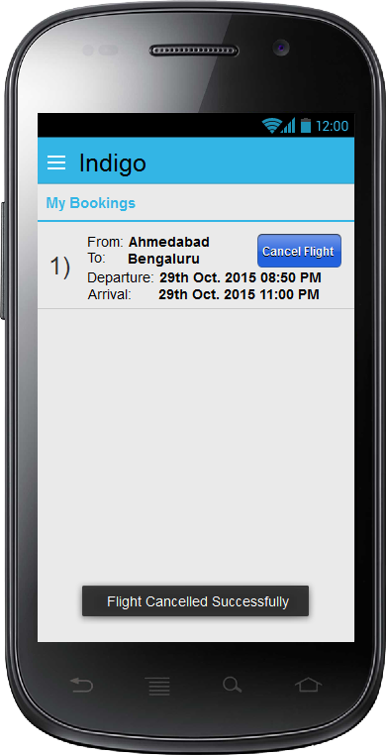

**Time taken to complete tasks:**

|  |  |  |  |  |  |  |  |  |  |
| --- | --- | --- | --- | --- | --- | --- | --- | --- | --- |
| 1. Homescreen | 2. Login | 3.Register | 4. Confirmation | 5. Booking | 6. Sidebar | 7. Payment | 8. Order Pending | 9. Password confirmation | 10. Search flight |
| 18 | 14 | 35 | 54 | 63 | 12 | 52 | 26 | 19 | 8 |
| 11 | 18 | 30 | 20 | 52 | 21 | 49 | 30 | 25 | 15 |
| 9 | 26 | 35 | 16 | 13 | 9 | 18 | 8 | 15 | 30 |
| 8 | 28 | 37 | 15 | 15 | 8 | 15 | 8 | 17 | 28 |
| 9 | 27 | 33 | 17 | 12 | 7 | 21 | 9 | 12 | 28 |
| 8 | 29 | 41 | 15 | 17 | 6 | 23 | 8 | 14 | 24 |
| 12 | 17 | 16 | 10 | 17 | 25 | 31 | 7 | 14 | 20 |
| 7 | 19 | 40 | 18 | 14 | 8 | 29 | 9 | 15 | 29 |
| 5 | 30 | 60 | 60 | 180 | 1 | 360 | 120 | 120 | 120 |
| **9.666666667** | **23.11111111** | **36.33333333** | **25** | **42.55555556** | **10.77777778** | **66.44444444** | **25** | **27.88888889** | **33.55555556** |

**Difference:**

From these differences, We have noticed that as user get more familiar with the app he/she takes less amount of time to perform particular task.

When he/she is totally unaware about anything, he/she gets confused to go in the right path.

So, in new User Interface, We have noticed using Low Fidelity that User has appreciated the new User Interface of Indigo App.

It takes less time to Search Flight, Book Flight, etc. User has ease of access to the function of App compared to Old Indigo App.

In old App, There were too many Transactions to book a ticket. User finds it to be cumbersome. In the new User Interface,

We have made it easy for user so that he/she need to have only those things that are meant to them.

**+**