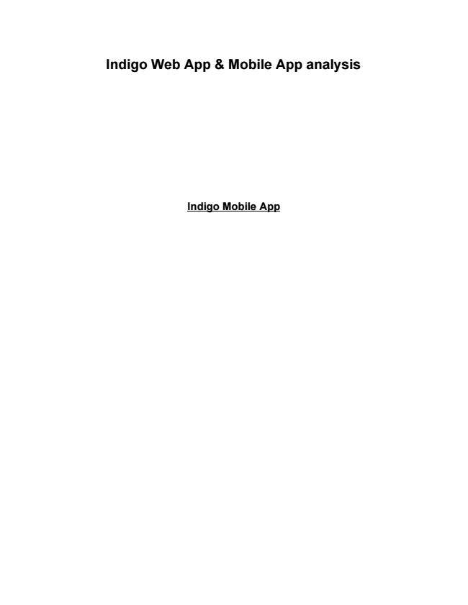

**Indigo Web App & Mobile App analysis**

**Indigo Mobile App**

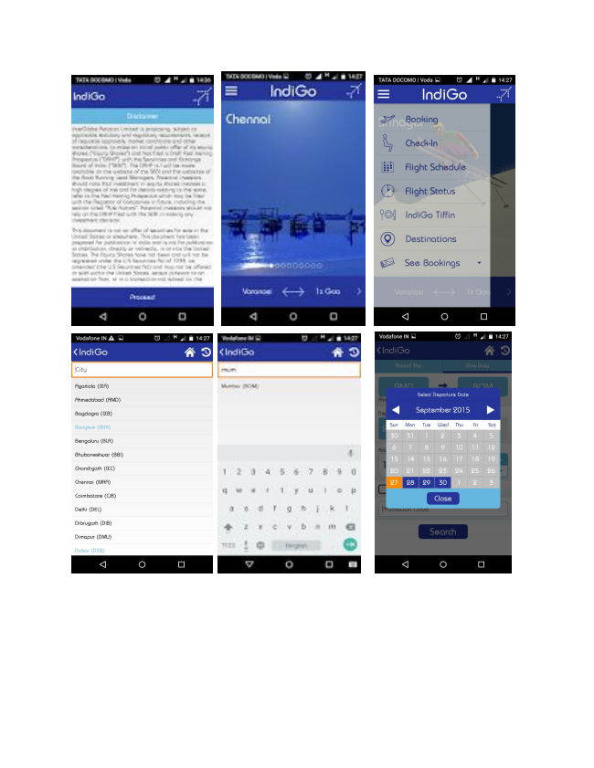

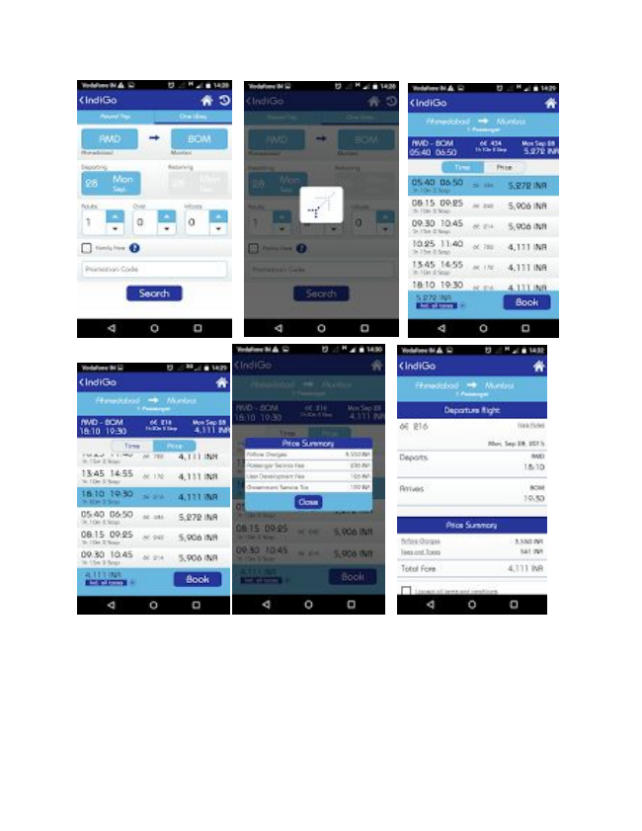

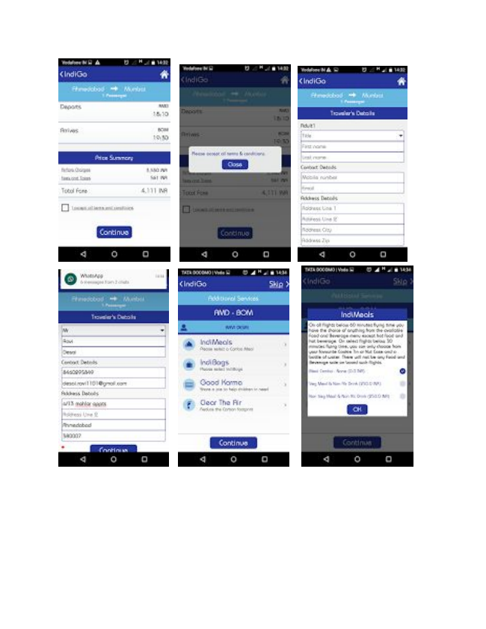

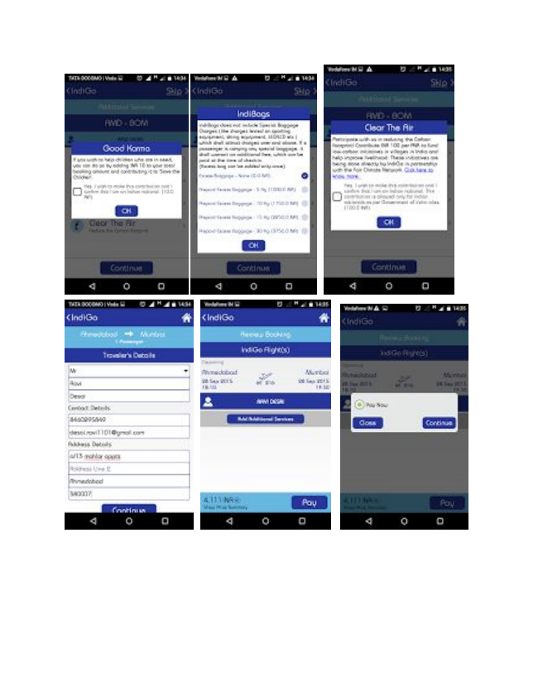

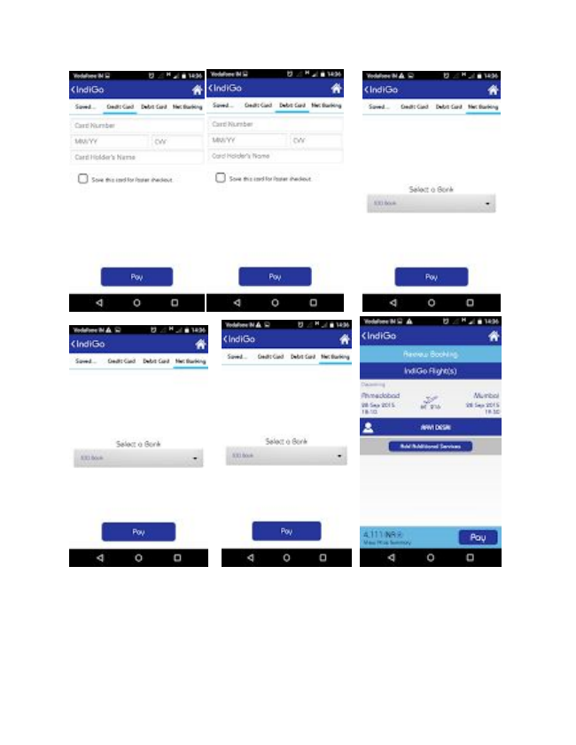

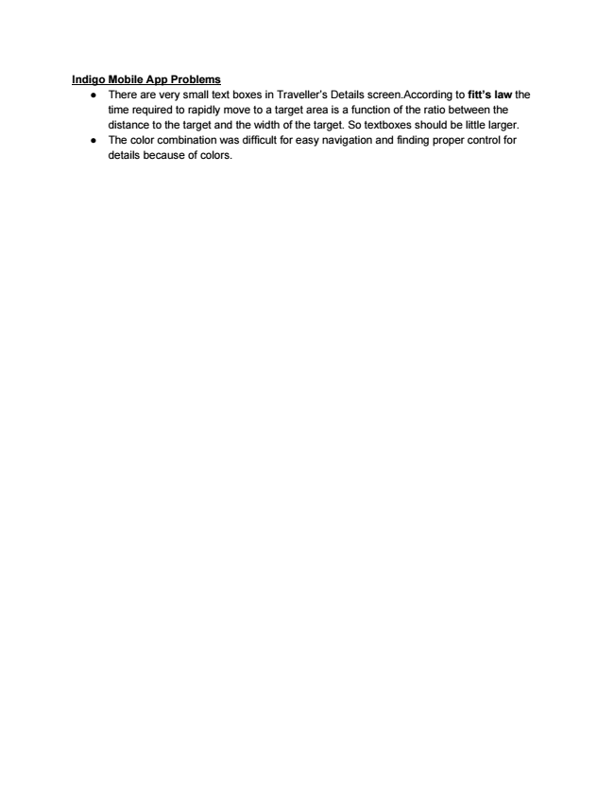

**Indigo Mobile App Problems**

● There are very small text boxes in Traveller’s Details screen.According to ​fitt’s law​ the time required to rapidly move to a target area is a function of the ratio between the distance to the target and the width of the target. So textboxes should be little larger.

● The color combination was difficult for easy navigation and finding proper control for details because of colors.

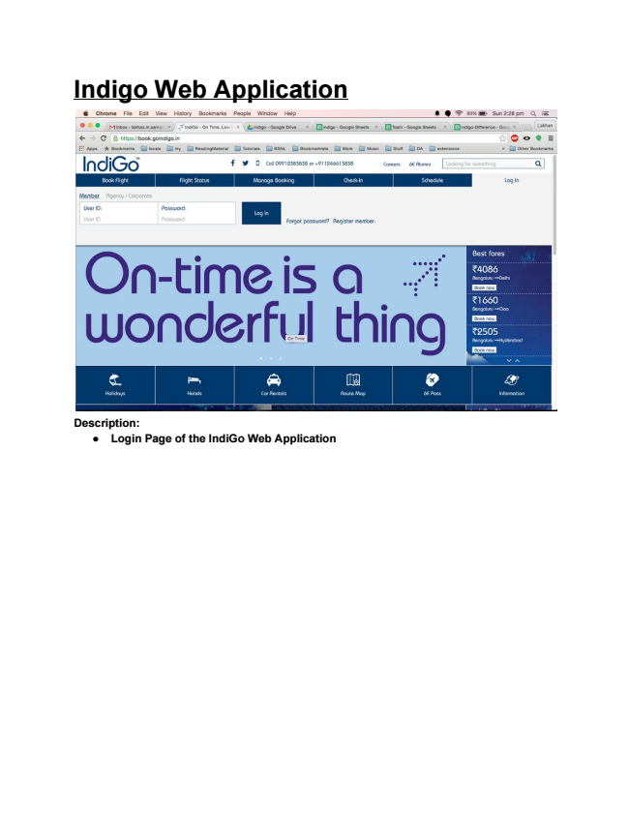

**Indigo Web Application**

**Description:**

**● Login Page of the IndiGo Web Application**

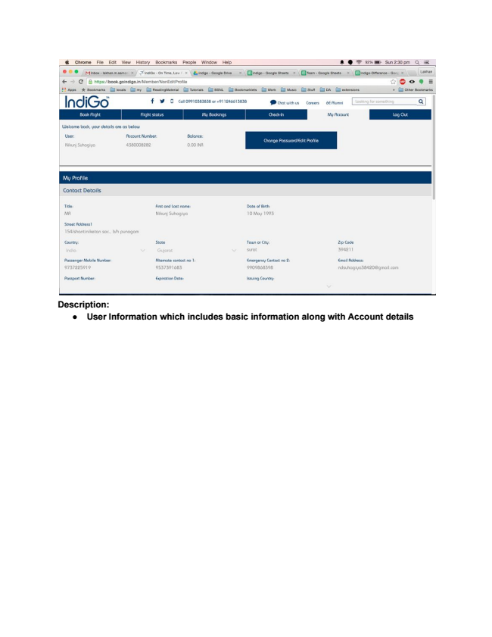

**Description:**

**● User Information which includes basic information along with Account details**

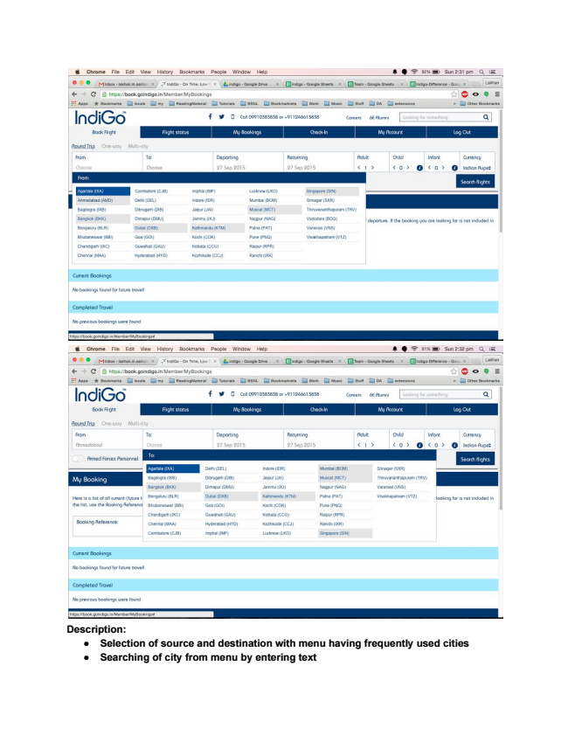

**Description:**

**● Selection of source and destination with menu having frequently used cities**

**● Searching of city from menu by entering text**