10/5/2024

Berkley HAAS

Practical Application Module 5 Analysis

August 2024 Batch

Chintan Gandhi

# Introduction

## Statement

This is project report of analysis done as part of Berkley HAAS ML/AI practical application in Module 5.

## Overview

The goal of this project is to use what you know about visualizations and probability distributions to distinguish between customers who accepted a driving coupon versus those that did not.

## Approach

There were many variables which were analyzed namely income, occupation, weather, time, marital status, co passengers and presence of children and their choice when they pickup coffee house, carry away, and expensive or economic restaurants.

* Parameters like weather, time and occupation where individually analyzed to compare what is the coupon acceptance criteria for different coupon type.
* In second part analysis we picked up each coupon category and dissected it, what influence does income, occupation, marital status, co passengers and presence of children have on preference of that coupon type. Additionally Joint Probability of co-passengers with and without children were also tabulated.

This by no means is an exhaustive list but have tried to common cases that could influence the choice.

* Attempt was made to highlight the difference between some of the coupon types to see the trend and influence.

## Abbreviation

Certain Abbreviation were used in column names to concise the output to be reasonable readable.

As a common denominator, passengers who never visit were filtered out.

|  |  |
| --- | --- |
| Abbreviation | Meaning |
| _sum | Sum of all who have accepted the coupon |
| _size | Total coupons including the once who have rejected the coupon. |
| _pct | Total acceptance “Percentage” of coupon in their individual subcategory |
| _pct_gnrl | This acceptance “Percentage” of the category as compared to whole. |

# Occupation

Comparing the data and its distribution around which occupation’s data is shared, it was evident that the distribution is not evenly distributed. Unemployed, Students, Computer & Mathematical and Sales & Related appeared 1000+, whereas Farming Fishing & Forestry & Grounds Cleaning & Maintenance have less than 50 responses. Thus, while analyzing the data, percentage was calculated in each occupation category for analysis

Analysis is with respect to what questions are we trying to answer

1. Which occupations have accepted the highest number of coupons? In total of how much of total business was from person these occupations?

* 83% of the total coupons were accepted by top 50% occupations. This is valuable as we now know people of which occupation should we focus of more to get highest most result.

* These are top 50% occupation who have accepted highest number of coupons and number of accepted coupons in descending order.
* Out of total of 7210 accepted coupons, 5982 belonged to these occupation’s people

Graph shows the distribution in 5 different eateries for above shortlisted occupation of focus.

* Below Graph, shows that Carry Out and Restaurants < $20 are top choices, Bar is on lowest side.

1. What percentage of coupons were accepted?

* This analysis helps us understand how much efforts will be required to on shortlisted occupation which gives us major business.
  + Unlike previous analysis, Though the number of coupons accepted for "Bar" is less, It still ace the percentage of acceptance, which means, Even though less coupons are given, the acceptance rate of Bar coupon is in top.
  + We still need to be cautious when we present Bar coupons to Students who have highest who have highest acceptance percentage and in list of top occupations who accept coupons.

# Weather

1. Does weather play any influence on number of tickets accepted?

* This analysis helps us understand if weather play any significant role. Do we need to be preparing more on some season.
* Coupon acceptance is 83% Summer season, Rainy and Snowy seasons are around 8% and 9% respectively.

# Time

1. Does time play role any role on coupon acceptance percentage?

* Time does not seem to be playing much significant role, but 7 AM and 10PM have less acceptance as compared to 2:00 PM

# Analysis for each Eatery

## Restaurant $20 to $50

- Alone Passengers who are single or with friends together are ~31% and ~18% likely, leaving passengers with partners or with kids less likely to accept coupons.

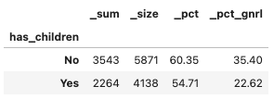- Married and riding with partner (~24%) and single (~22%) prefer eating at expensive restaurants. Divorced and Widowed on the other end tend to avoid.

- Though there is not much significant difference with presence of children, yet passengers without children prefer expensive Restaurants.

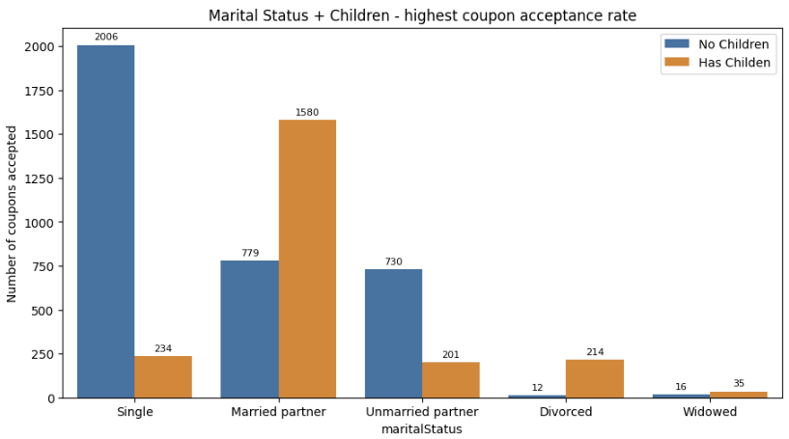- When we see if having children for “married partner” and “single” have any significance, its observed, Person traveling with Family (married partner + children) and single without children ace in prefernce for Expensive restaurants.

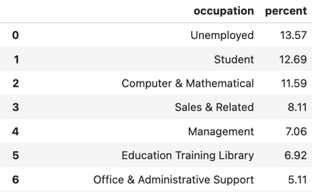

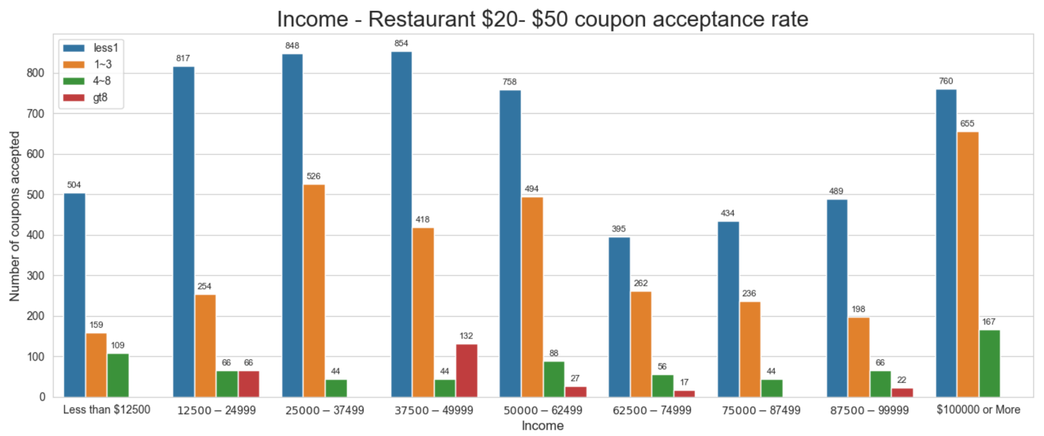- These 7 occupations, in all cover ~60+% of total coupon acceptance share for Expensive restaurants.

- We do observe, in general every income group would eat at expensive restaurant at least once a month.

- Majority of the passengers accept coupons to eat 1 to 3 times at expensive Restaurant. Major folks are from the income $100K+, followed by $25K to 37.5K, 50K to 62.5K and 37.5K to 50K.

## Restaurant Less than $20

- There is no change in percent passangers opting to eat at restaurants less than $20 but overall numbers is up in terms of head count. Eating Alone and with Friends top in the category.

- Same trend was also seen in person who are single, married and are with Partner or Unmarried with partner

- Passengers with children or without children too prefer more of an economic option over Expensive Restaurants

Trend of single without children and passengers with family both opt more to eat at economic Restaurants. Percentage of acceptance remain same but head count has increased by ~400 in both category

- Top Categories preferring to eat at economic restaurants is approximately same.

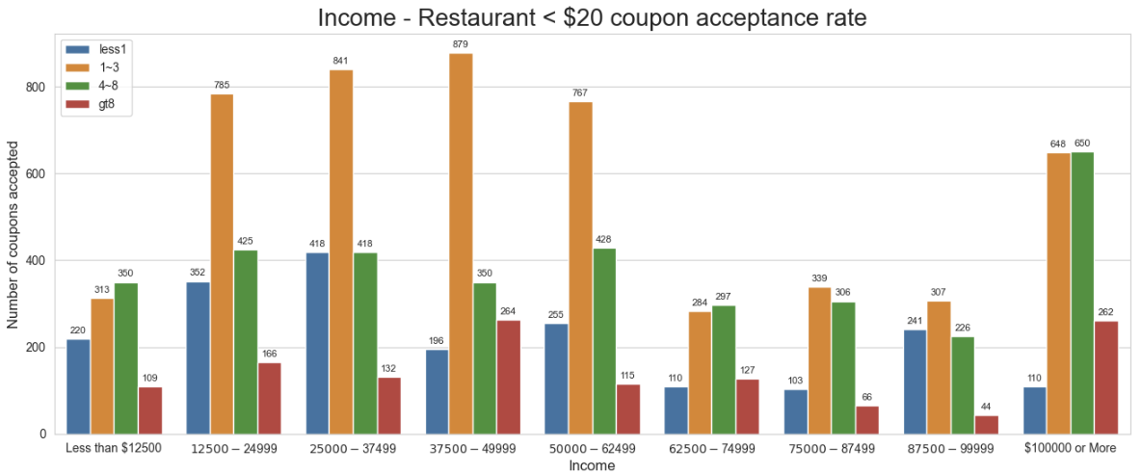

- Unlike expensive restaurant’s majority of folks in almost all income group accepts coupons to eat at economic options.

- Additionally, there is also multifold increase in coupon acceptance higher frequency of 4 to 8 and 8+ times per month at economic restaurant.

- This its very much evident, In general folks would prefer economic restaurant options increase the frequency of visit

## A screenshot of a table Description automatically generatedCarry Out and Take Away

* No Significant variation was noticed in percentages, when passenger is alone or has company
* Same is for the passengers who are travelling with and without children
* And for varied Marital Status too followed the same path as Previous 2

- Occupation Played no impact in preference change w.r.t passengers preferring economic Restaurants.

- The Numbers of Carryout and Restaurant < $20 Match the pattern, and numbers are more than the once preferring expensive restaurant.

- It is observed that number of passengers increased, on both the categories, First, who prefer Carry Away more than 8 times a week and Second those who prefer 4 to 8 times.

- To balance, there is fall in passenger who prefer Carry Away 1 to 3 times as compared to Restaurants < $20.

- Fun Fact is, there were many categories of income group for in Expensive restaurant, which did not have any one preferring 8+ days outside, but with Carry Away its opposite story. The numbers have just increased with increased frequency.

## Coffee House

