Name : Chintan Solanki

Roll No : CE125

1. **To study about the LDAX, STAX, LHLD and SHLD instructions. Study about the jump instructions.**

**LDAX :** this instruction copies the contents of that memory location into the accumulator.

* + - * + B/D Register pair ,Load accumulator.
        + LDAX B

**STAX :** this instruction uses register indirect addressing for specifying the destination. the current content of Accumulator will be written to the memory location as pointed by 16-bit address as stored in the register pair. It occupies only 1-Byte in memory.

* **STAX B :**

1. **LHLD:-** Instruction set LHLD is a mnemonic that stands for Load HL pairusing Direct addressing from memory location whose 16-bit address is denoted as a16. So the previous content of HL register pair will get updated with the new 16-bits value.

* **LHLD 2040H :**

1. **SHLD:-** Instruction set, SHLD is a mnemonic, which stands for Store HL pairusing Direct addressing in memory location whose 16-bit address is denoted as a16. As HL pair has to be stored, so it has to be stored in two consecutive locations starting at the address a16. This instruction uses absolute addressing mode for specifying the destination. It occupies 3-Bytes in the memory.

* **SHLD 2530H :**

**Jump instructions :**

JC Jump if Carry CY = 1

JNC Jump if No Carry CY = 0

JP Jump if Positive S = 0

JM Jump if Minus S = 1

JZ Jump if Zero Z = 1

JNZ Jump if No Zero Z = 0

JPE Jump if Parity Even P = 1

JPO Jump if Parity Odd P = 0

**2.** **Identify the contents of the accumulator/registers and the flag status as the following instructions are executed.**

MVI A,7F

ORA A

CPI A2H

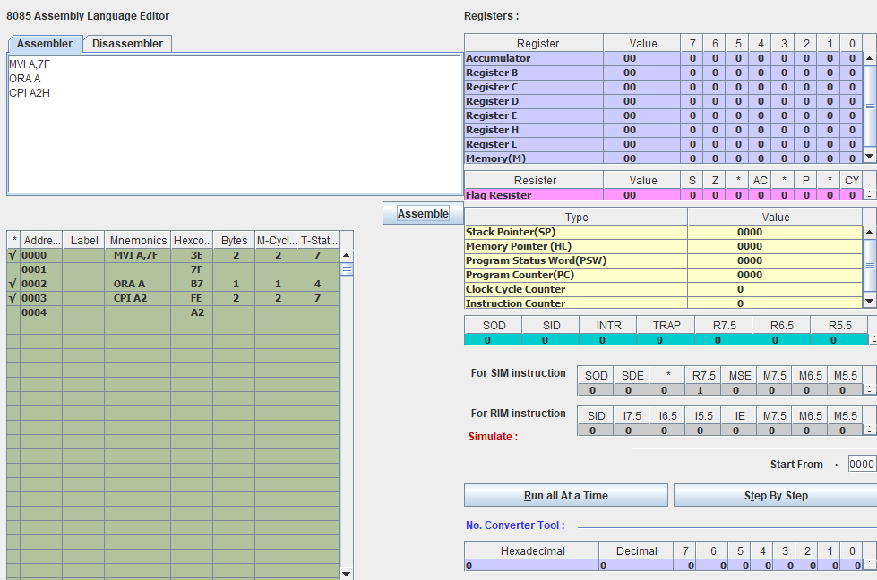

LXI H,2070H

MVI M,64H

MVI A,8FH

CMP M

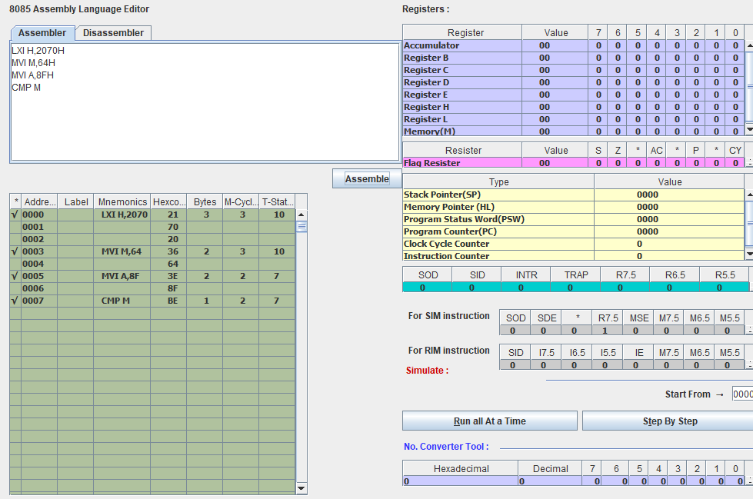

1. **Multiply two numbers given at address 2050H and 2051H respectively.**

MVI A,00H

LXI H,2050H

MOV B,M

INX H

MOV C,M

TOP : ADD B

DCR C

JNZ TOP

INX H

MOV M,A

HLT

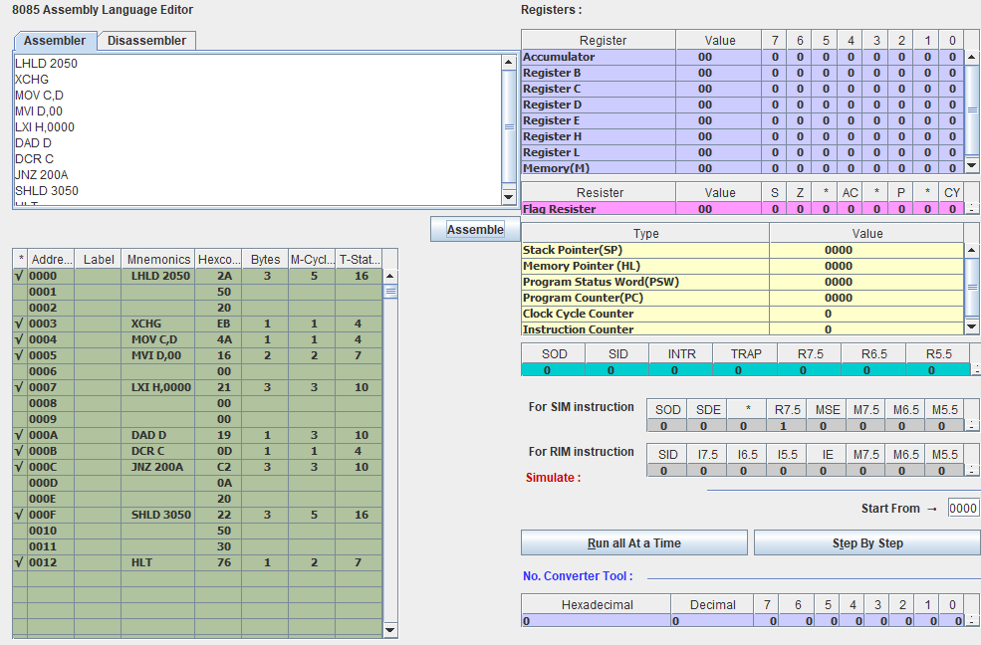

1. **Write a program to add the 5 bytes of data starting at address 2050H and store the result in the DE pair.**

MVI C, 05

LXI H, 2050

LXI D, 2600

ADD M

STAX D

INX H

DCR C

JNZ 0008

HLT



1. **Using the jump instructions transfer block of 8 bytes of data starting from 2055H to 3055H in reverse order.**

MVI C, 08

LXI H, 2055

LXI D, 3055

MOV A,M

STAX D

INX H

DCX D

DCR C

JNZ 0008

HLT

