Name : Chintan Solanki

Roll No : CE125

**Assignment 4 :**

1. A set of eight data bytes are stored in a memory location starting from 2070H. write a program to insert more five bytes of data, it is necessary to shift the data string y five memory locations.

MVI C,08

MVI E,05

LXI H,2071

LXI D,2070

L1: MOV A,M

STAX D

INX H

INX D

DCR C

JNZ L1

LXI H,2071

LXI D,2070

L2: STA 2078

DCR E

JNZ L2

HLT

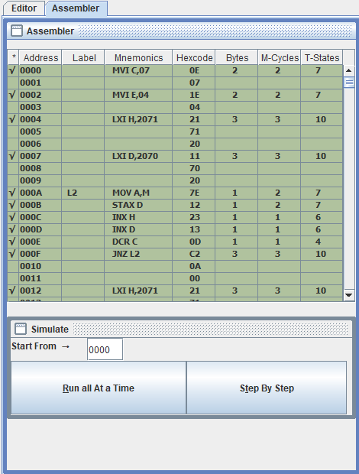

1. A string of six data bytes stored starting from 2050H. the string includes some blanks. Write a program to eliminate blanks from the strings.

MVI C, 06H

LXI H, 2050H

LXI B, 2050H

L2: MOV A, M

CPI 20H

JZ L1

STAX B

INX B

L1: INX H

DCR C

JNZ L2

HLT

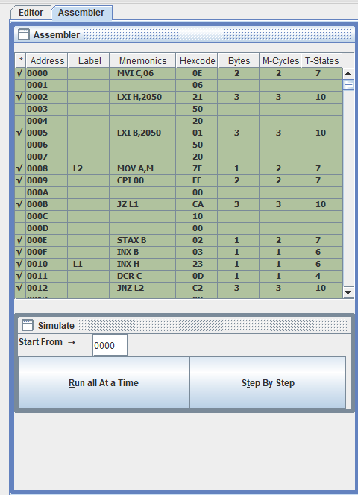

1. A system is designed to monitor the temperature of a furnace. Temperature readings are recorded in 16 bits and stored in memory locations starting at 2060H. The higher order byte is stored first and the lower order byte is stored the next consecutive memory location. The high order byte of all the temperature reading is constant. Write a program to transfer low order readings to consecutive memory locations starting at address 2080H and discard the high order bytes.

LXI H,2061H

LXI D,2080H

MVI B,05H

L: MOV A, M

STAX D

INX H

INX H

INX D

DCR B

JNZ L

HLT

