Name : Chintan Solanki

Roll No : CE125

**CSA Lab 5 :**

1. A set of ten readings is stored in memory location starting at 2070H. Write a program to check whether a byte 40H exists in the set. If it does,stop checking, and save its memory location at address 1000H or else save FFFFH.

LXI B,2070H

LXI H,1000H

MVI D,10

LABEL1: LDAX B

CPI 40H

JZ LABEL2

INX B

DCR D

JNZ LABEL1

JZ LABEL3

LABEL2: MOV A,B

STA 1000H

MOV A,C

STA 1001H

HLT

LABEL3: MVI A,FFH

STA 1000H

STA 1001H

HLT

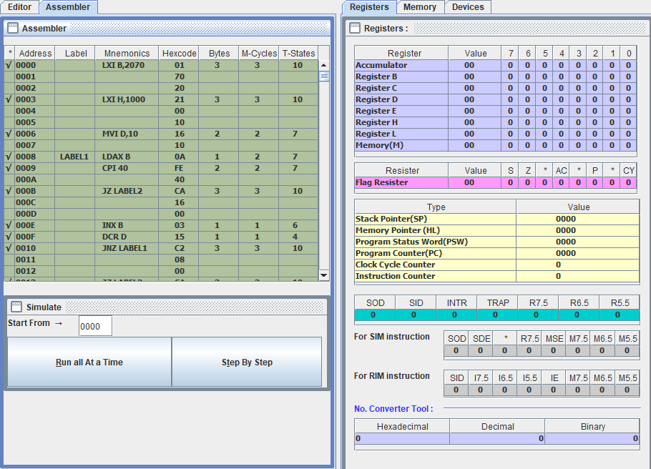

1. Write a program to check whether a given number is prime or not. If it is a prime store 10H at the address 1000H or else store FFH.

LDA 2050H

MVI C, 00H

MOV E, A

MOV B, A

L1: MOV D, E

L2: CMP D

JC L3

SUB D

JNZ L2

L3: CPI 00H

JNZ L4

INR C

L4: MOV A, B

DCR E

JNZ L1

MOV A, C

MVI C, 10H

CPI 02H

JNZ L5

INR C

L5: MOV A, C

STA FFH

HLT

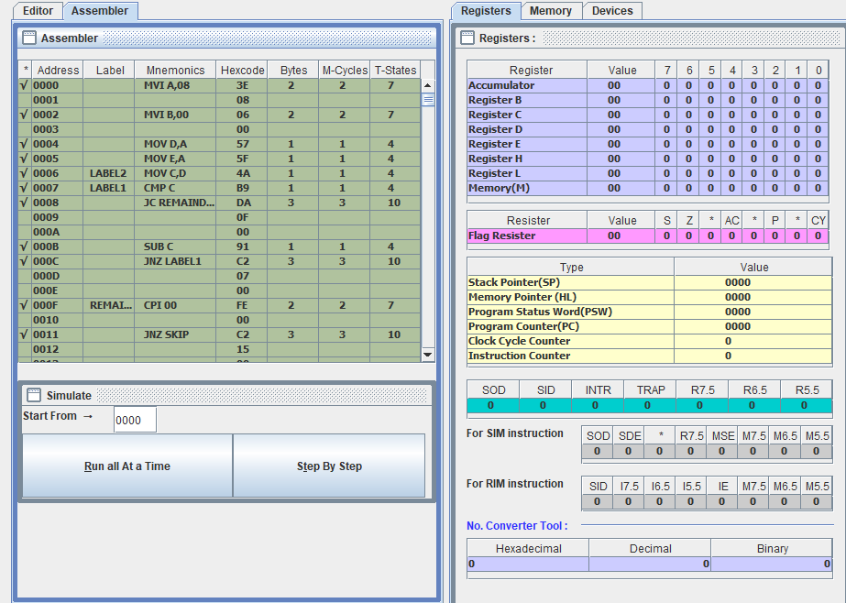

1. A set of ten bytes are stored at address 2050H. Check each data byte whether it is a positive or negative number. Reject all the negative readings and sum all the positive readings.

