Name : Chintan Solanki

Roll no : 125

**Assignment 6 :**

1. **Write an assembly program to find the GCD and LCM of two numbers.**

For LCM:

LXI H,6000

MOV A,M

MOV C,M

MOV D,M

INX H

LOOP1: SUB M

JNC LOOP1

ADD M

CPI 00

JZ LOOP2

MOV A,D

ADD C

MOV D,A

JMP LOOP1

LOOP2: MOV A,D

STA 5050

HLT

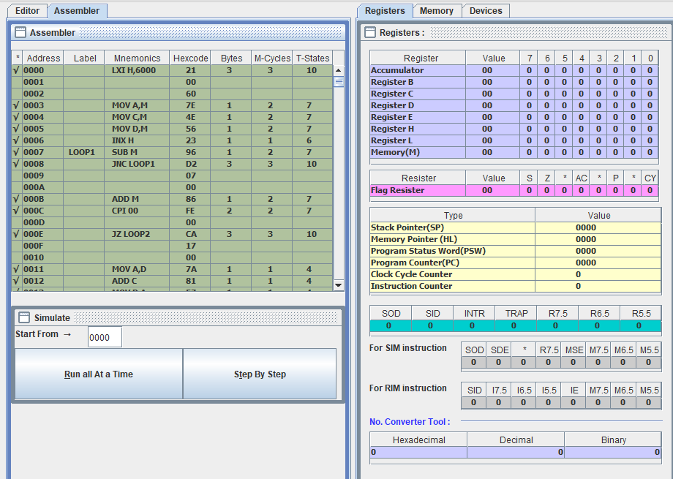

For GCD:

LXI H,6000

MOV A,M

INX H

MOV B,M

LOOP1: CMP B

JZ OUT

JC LOOP2

SUB B

JMP LOOP1

LOOP2: MOV C,B

MOV B,A

MOV A,C

JMP LOOP1

OUT: STA 8003

HLT

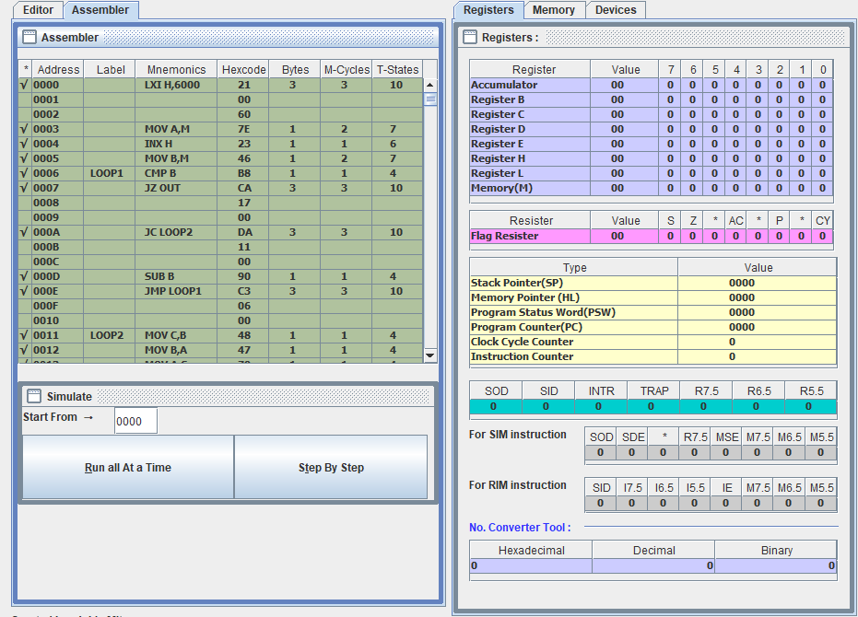

1. **Write a program to sort an array of 10 elements.**

LXI H,6000

MOV C,M

DCR C

REPEAT: MOV D,C

LXI H,5001

LOOP: MOV A,M

INX H

CMP M

JC SKIP

MOV B,M

MOV M,A

DCX H

MOV M,B

INX H

SKIP: DCR D

JNZ LOOP

DCR C

JNZ REPEAT

HLT

