* Introduction:

This e-commerce website is an information technology method in which traders, businesses/distributors/marketers can sell products/services and the customer can purchase on that website electronically by using the internet on the mobile and computer. It means an e-commerce website is an online shop. E means electronic. Commerce means business. Website means the group of HTML web pages and that is created to market/sell information/product/services.

From a bigger perspective, every website on the internet is the e-commerce Website. It can be the platform, it can be a marketplace, it can be a portal, it can be apps and it can be an entertainment website, shopping website, online courses website and online degree college.

* Scope Of Website:

**What e-commerce is?**In simple terms, the scope of e-commerce refers to the buying and selling of goods online or over the Internet users. Their products with prices and descriptions. Shoppers who buy products have multiple payment options such as cash on delivery, e-wallets, online banking, credit cards, and more.

Future **Scope of ecommerce** and Future of Online Shopping.

* Objective Of Website:

One method of surviving is to focus on breaking even over a certain period. This means making enough money to cover the total costs involved in producing and selling the goods or services, and running the business, although there is no profit, no money is lost. Also there are some businesses that only tend to focus on selling as more products as possible in order to expansion in their business.

* Database:

Table: addtocart

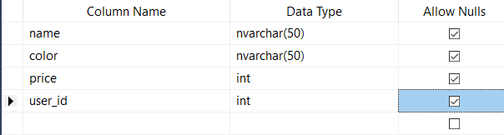

* **Description**: addtocart table store selected items from product table.

Table: admin

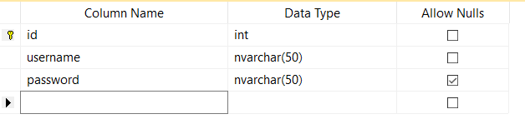

* **Description**: admin table store admin username and password it’s not accessible.

Table: users

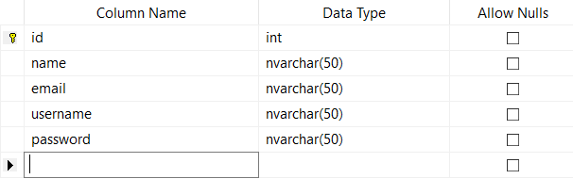

* **Description**: Users table store user information, such as username, password, email, name etc. it’s accessible for users.

Table: Product

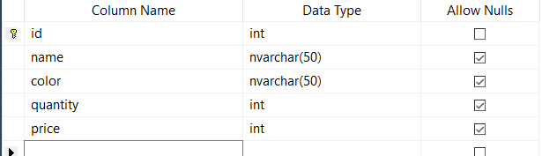

* **Description**: Product table store information about products, such as product name, product color, product quantity etc. it’s not accessible for users.

1. Create a dynamic e-commerce website:

* MasterPage.master
* **Description**: With a predefined layout that can include HTML elements, and headers, footers. The master page is identified by a special @ Master directive.

<%@ Master Language="VB" CodeFile="MasterPage.master.vb" Inherits="MasterPage" %>

<!DOCTYPE html PUBLIC "-//W3C//DTD XHTML 1.0 Transitional//EN" "http://www.w3.org/TR/xhtml1/DTD/xhtml1-transitional.dtd">

<html xmlns="http://www.w3.org/1999/xhtml">

<head runat="server">

<title></title>

<asp:ContentPlaceHolder id="head" runat="server">

</asp:ContentPlaceHolder>

<link rel="stylesheet" href="./css/style.css" />

<link rel="stylesheet" href="./css/bootstrap.min.css" />

<link rel="stylesheet" href="https://netdna.bootstrapcdn.com/font-awesome/4.0.3/css/font-awesome.css" />

<style>

#GridView1 {

border-collapse: collapse;

width: fit-content;

}

th, td {

padding: 1rem 8rem;

text-align: center;

border-bottom: 1px solid #ddd;

}

tr:hover {background-color: coral;}

</style>

</head>

<body class="main-layout">

<form id="form1" runat="server">

<div>

<div class="header">

<div class="container-fluid">

<div class="row">

<div class="col-xl-3 col-lg-3 col-md-3 col-sm-3 col logo_section">

<div class="full">

<div class="center-desk">

<div class="logo">

<a href="#"><img src="images/logo.png" alt="#" /></a>

</div>

</div>

</div>

</div>

<div class="col-xl-9 col-lg-9 col-md-9 col-sm-9">

<nav class="navigation navbar navbar-expand-md navbar-dark ">

<button class="navbar-toggler" type="button" data-toggle="collapse" data-target="#navbarsExample04" aria-controls="navbarsExample04" aria-expanded="false" aria-label="Toggle navigation">

<span class="navbar-toggler-icon"></span>

</button>

<div class="collapse navbar-collapse" id="navbarsExample04">

<ul class="navbar-nav mr-auto">

<li class="nav-item">

<a class="nav-link" href="./Home.aspx">Home</a>

</li>

<li class="nav-item">

<a class="nav-link" href="./Product.aspx">Products</a>

</li>

<li class="nav-item">

<a class="nav-link" href="./About.aspx">About Us</a>

</li>

<li class="nav-item" id="login" runat="server">

<a class="nav-link" href="./Login.aspx">Login</a>

</li>

<li class="nav-item" id="signup" runat="server">

<a class="nav-link" href="./Registration.aspx">Registration</a>

</li>

<li class="nav-item" id="addcart" runat="server">

<a class="nav-link" href="./Cart.aspx">Add cart</a>

</li>

</ul>

</div>

</nav>

</div>

</div>

</div>

</div>

<asp:ContentPlaceHolder id="ContentPlaceHolder1" runat="server">

</asp:ContentPlaceHolder>

<footer style="margin-top:5rem">

<div class="footer">

<div class="container">

<div class="row">

<div class="col-xl-3 col-lg-3 col-md-6 col-sm-6">

<img class="logo1" src="images/logo1.png" alt="#" />

<ul class="social_icon" style="padding-left:0px">

<li><a href="#"><i class="fa fa-facebook" aria-hidden="true"></i></a></li>

<li><a href="#"><i class="fa fa-twitter" aria-hidden="true"></i></a></li>

<li><a href="#"><i class="fa fa-linkedin-square" aria-hidden="true"></i></a></li>

<li><a href="#"><i class="fa fa-instagram" aria-hidden="true"></i></a></li>

</ul>

</div>

<div class="col-xl-3 col-lg-3 col-md-6 col-sm-6">

<h3>About Us</h3>

<ul class="about_us" style="padding-left:0px">

<li>dolor sit amet, consectetur<br> magna aliqua. Ut enim ad <br>minim veniam, <br> quisdotempor incididunt r</li>

</ul>

</div>

<div class="col-xl-3 col-lg-3 col-md-6 col-sm-6">

<h3>Contact Us</h3>

<ul class="conta" style="padding-left:0px">

<li>dolor sit amet,<br> consectetur <br>magna aliqua.<br> quisdotempor <br>incididunt ut e </li>

</ul>

</div>

<div class="col-xl-3 col-lg-3 col-md-6 col-sm-6">

<form class="bottom_form">

<h3>Newsletter</h3>

<input class="enter" placeholder="Enter your email" type="text" name="Enter your email">

<button class="sub_btn">subscribe</button>

</form>

</div>

</div>

</div>

<div class="copyright">

<div class="container">

<div class="row">

<div class="col-md-12">

<p>© 2019 All Rights Reserved. Design by<a href="https://html.design/"> Free Html Templates</a></p>

</div>

</div>

</div>

</div>

</div>

</footer>

</div>

</form>

<script src="./js/bootstrap.bundle.min.js"></script>

<script src="https://ajax.googleapis.com/ajax/libs/jquery/3.5.1/jquery.min.js"></script>

</body>

</html>

* MasterPage.master.vb

Partial Class MasterPage

Inherits System.Web.UI.MasterPage

Protected Sub Page_Load(ByVal sender As Object, ByVal e As System.EventArgs) Handles Me.Load

If (Session("username") = "") Then

login.Visible = True

signup.Visible = True

addcart.Visible = False

Else

login.Visible = False

signup.Visible = False

addcart.Visible = True

End If

End Sub

End Class

* Home.aspx

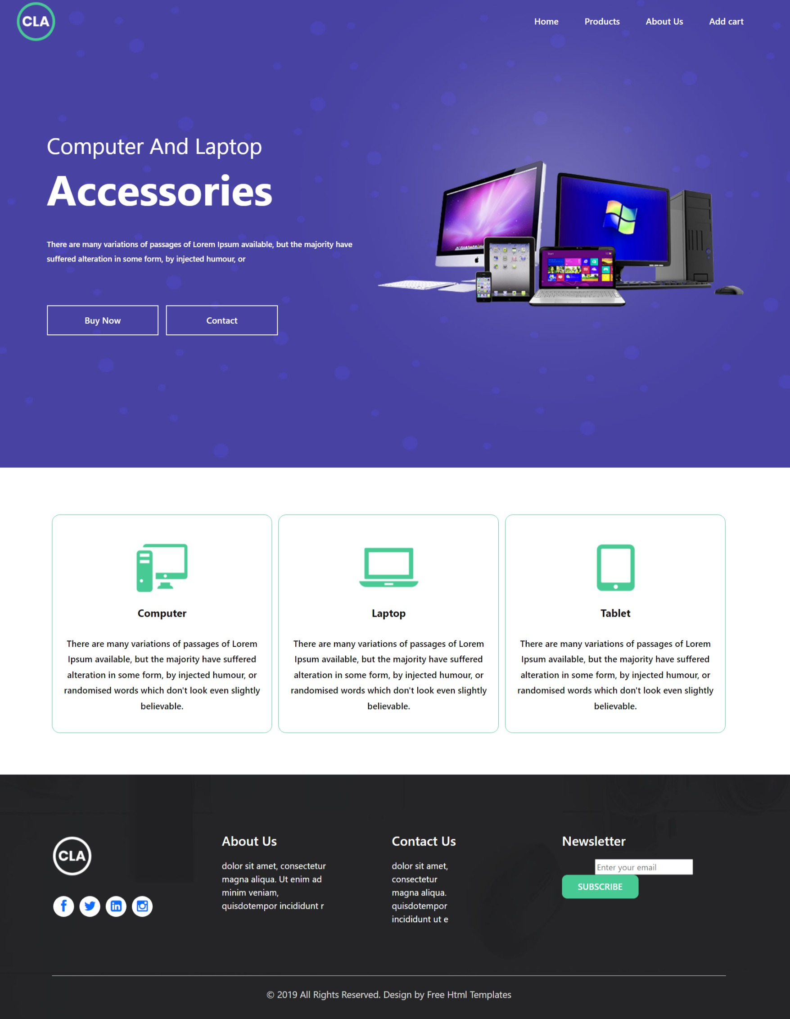

* **Description**: home page should contain captivating images (visuals) that link directly to product and category pages, wherever possible, to capture the visitor’s attention. Use clear and eye-catching Calls-to-Action what you want users to do.

<%@ Page Title="" Language="VB" MasterPageFile="~/MasterPage.master" AutoEventWireup="false" CodeFile="Home.aspx.vb" Inherits="_Default" %>

<asp:Content ID="Content1" ContentPlaceHolderID="head" Runat="Server">

</asp:Content>

<asp:Content ID="Content2" ContentPlaceHolderID="ContentPlaceHolder1" Runat="Server">

<section class="banner_main">

<div class="text-bg">

<span>Computer And Laptop</span>

<h1>Accessories</h1>

<p style="color:#fff;">There are many variations of passages of Lorem Ipsum available, but the majority have suffered alteration in some form, by injected humour, or </p>

<a href="#">Buy Now </a> <a href="#">Contact </a>

</div>

<asp:Image ID="Image1" runat="server" src="./images/pc.png" style="width:70vw;"></asp:Image>

</section>

<div class="three_box">

<div class="container">

<div class="row">

<div class="col-md-4">

<div class="box_text">

<i><img src="images/thr.png" alt="#"/></i>

<h3>Computer</h3>

<p>There are many variations of passages of Lorem Ipsum available, but the majority have suffered alteration in some form, by injected humour, or randomised words which don't look even slightly believable. </p>

</div>

</div>

<div class="col-md-4">

<div class="box_text">

<i><img src="images/thr1.png" alt="#"/></i>

<h3>Laptop</h3>

<p>There are many variations of passages of Lorem Ipsum available, but the majority have suffered alteration in some form, by injected humour, or randomised words which don't look even slightly believable. </p>

</div>

</div>

<div class="col-md-4">

<div class="box_text">

<i><img src="images/thr2.png" alt="#"/></i>

<h3>Tablet</h3>

<p>There are many variations of passages of Lorem Ipsum available, but the majority have suffered alteration in some form, by injected humour, or randomised words which don't look even slightly believable. </p>

</div>

</div>

</div>

</div>

</div>

</asp:Content>

</asp:Content>

* About.aspx



* **Description**: About page should contain company information and this page helps users to understand’s how this website works.

<%@ Page Title="" Language="VB" MasterPageFile="~/MasterPage.master" AutoEventWireup="false" CodeFile="About.aspx.vb" Inherits="Default2" %>

<asp:Content ID="Content1" ContentPlaceHolderID="head" Runat="Server">

</asp:Content>

<asp:Content ID="Content2" ContentPlaceHolderID="ContentPlaceHolder1" Runat="Server">

<section class="vh-100 banner_main">

<div class="about">

<div class="container">

<div class="row d_flex">

<div class="col-md-5">

<div class="titlepage">

<h2>About Us</h2>

<p>Lorem ipsum dolor sit amet, consectetuer adipiscing elit, sed diam nonummy nibh euismod tincidunt ut laoreet dolore magna aliquam erat volutpat.</p>

<a class="read_more" href="#">Read More</a>

</div>

</div>

<div class="col-md-7">

<div class="about_img">

<figure><img src="images/about.jpg" alt="#" /></figure>

</div>

</div>

</div>

</div>

</div>

</section>

</asp:Content>

* Login.aspx

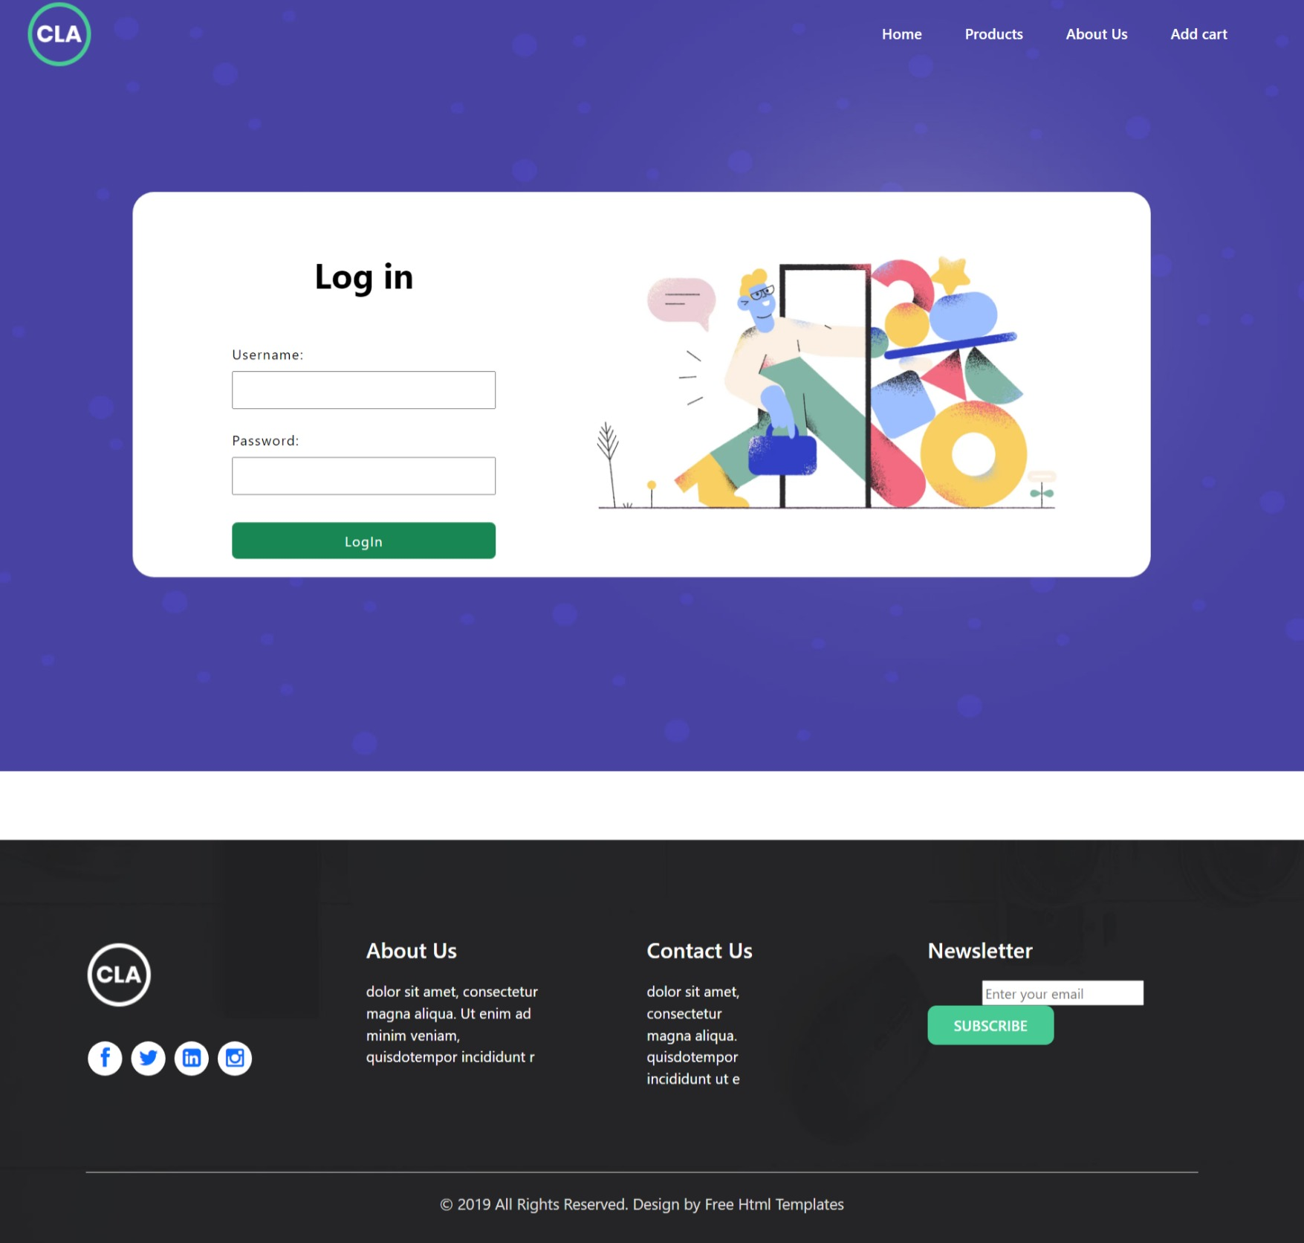

* **Description**: User can buy products after login. After login users can store selected products in there account.

<%@ Page Title="" Language="VB" MasterPageFile="~/MasterPage.master" AutoEventWireup="false" CodeFile="Login.aspx.vb" Inherits="_Default" %>

<asp:Content ID="Content1" ContentPlaceHolderID="head" Runat="Server">

</asp:Content>

<asp:Content ID="Content2" ContentPlaceHolderID="ContentPlaceHolder1" Runat="Server">

<div class="banner_main">

<section class="vh-100">

<div class="container h-100">

<div class="row d-flex justify-content-center align-items-center h-100">

<div class="col-lg-12 col-xl-11">

<div class="card text-black" style="border-radius: 25px;">

<div class="card-body p-md-5">

<div class="row justify-content-center">

<div class="col-md-10 col-lg-6 col-xl-5 order-2 order-lg-1">

<p class="text-center h1 fw-bold mb-5 mx-1 mx-md-4 mt-4">Log in</p>

<div style="display:flex;align-items:center;flex-direction:column;">

<div style="margin-bottom:1rem;">

<label style="display:block;margin:0.5rem 0px;letter-spacing:1px">Username: </label>

<asp:TextBox ID="username" runat="server" style="width:20vw;padding:0.5rem;letter-spacing:1px;"></asp:TextBox>

</div>

<div style="margin-bottom:1rem;">

<label style="display:block;margin:0.5rem 0px;letter-spacing:1px">Password: </label>

<asp:TextBox ID="password" runat="server" style="width:20vw;padding:0.5rem;letter-spacing:1px;"></asp:TextBox>

</div>

<div style="margin:1rem;">

<asp:Button ID="loginBtn" class="btn btn-success" style="width:20vw;padding:0.5rem;letter-spacing:1px;" runat="server" Text="LogIn"></asp:Button>

</div>

</div>

</div>

<div class="col-md-10 col-lg-6 col-xl-7 d-flex align-items-center order-1 order-lg-2">

<img src="https://mdbcdn.b-cdn.net/img/Photos/new-templates/bootstrap-registration/draw1.webp" class="img-fluid" alt="Sample image">

</div>

</div>

</div>

</div>

</div>

</div>

</div>

</section>

</div>

</asp:Content>

* Login.aspx.vb

Imports System.Data

Imports System.Data.SqlClient

Partial Class _Default

Inherits System.Web.UI.Page

Protected Sub Page_Load(ByVal sender As Object, ByVal e As System.EventArgs) Handles Me.Load

End Sub

Protected Sub loginBtn_Click(ByVal sender As Object, ByVal e As System.EventArgs) Handles loginBtn.Click

Dim con As New SqlConnection

Dim da As New SqlDataAdapter

Dim cmd As New SqlCommand

con.ConnectionString = "Data Source=DESKTOP-N5PELIU\sqlexpress;Initial Catalog=ecom;Integrated Security=True"

Dim str As String

str = "SELECT count(username) from users where username ='" & username.Text & "'; "

If (username.Text = "" Or password.Text = "") Then

MsgBox("Plese Enter the field")

Else

cmd = New SqlCommand(str, con)

con.Open()

Dim countData As Integer

countData = 0

countData = cmd.ExecuteScalar()

con.Close()

If (countData = 1) Then

Dim idStr As String

Dim i As Integer

i = 0

idStr = "select id from users where username= '" & username.Text & "';"

con.Open()

Dim dr As SqlDataReader

cmd = New SqlCommand(idStr, con)

dr = cmd.ExecuteReader()

Session("username") = username.Text

While dr.Read()

Session("user_id") = dr.Item(i)

i = i + 1

End While

con.Close()

Response.Redirect("./Home.aspx")

Else

MsgBox("Invalid username")

End If

End If

End Sub

End Class

* Product.aspx

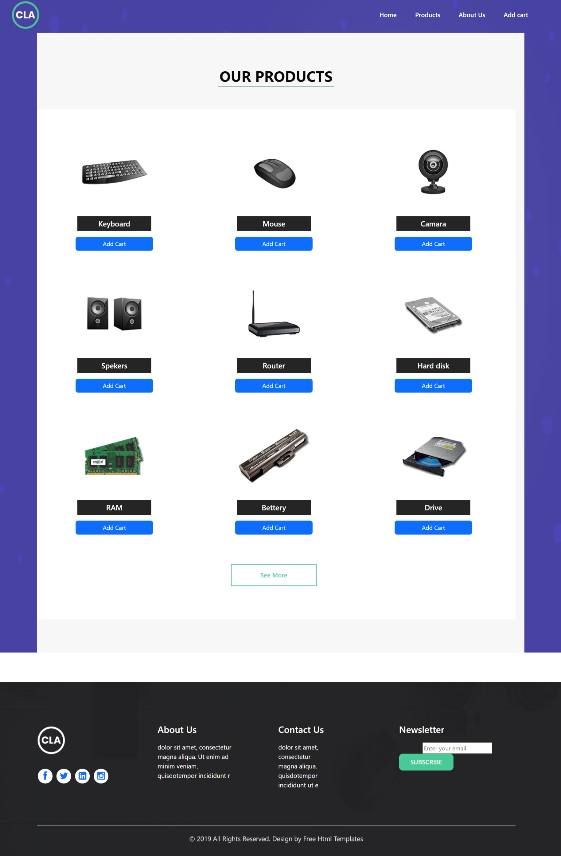

* **Description**: Product page contain all products and details of particular product, this page also contain add to cart button to store product in database.

<%@ Page Title="" Language="VB" MasterPageFile="~/MasterPage.master" AutoEventWireup="false" CodeFile="Product.aspx.vb" Inherits="_Default" %>

<asp:Content ID="Content1" ContentPlaceHolderID="head" Runat="Server">

</asp:Content>

<asp:Content ID="Content2" ContentPlaceHolderID="ContentPlaceHolder1" Runat="Server">

<section class="banner_main">

<div class="products">

<div class="container">

<div class="row">

<div class="col-md-12">

<div class="titlepage">

<h2>Our Products</h2>

</div>

</div>

</div>

<div class="row">

<div class="col-md-12">

<div class="our_products">

<div class="row">

<div class="col-md-4 margin_bottom1">

<div class="product_box">

<img src="images/product1.png" alt="#" />

<h3 runat="server" id="product_1">Keyboard</h3>

<asp:Button ID="Button1" class="btn btn-primary w-50 mt-3" runat="server" Text="Add Cart"></asp:Button>

</div>

</div>

<div class="col-md-4 margin_bottom1">

<div class="product_box">

<img src="images/product2.png" alt="#"/>

<h3 runat="server" id="product_2">Mouse</h3>

<asp:Button ID="Button2" class="btn btn-primary w-50 mt-3" runat="server" Text="Add Cart"></asp:Button>

</div>

</div>

<div class="col-md-4 margin_bottom1">

<div class="product_box">

<img src="images/product3.png" alt="#"/>

<h3 runat="server" id="product_3">Camara</h3>

<asp:Button ID="Button3" class="btn btn-primary w-50 mt-3" runat="server" Text="Add Cart"></asp:Button>

</div>

</div>

<div class="col-md-4 margin_bottom1">

<div class="product_box">

<img src="images/product4.png" alt="#"/>

<h3 runat="server" id="product_4">Spekers</h3>

<asp:Button ID="Button4" class="btn btn-primary w-50 mt-3" runat="server" Text="Add Cart"></asp:Button>

</div>

</div>

<div class="col-md-4 margin_bottom1">

<div class="product_box">

<img src="images/product5.png" alt="#"/>

<h3 runat="server" id="product_5">Router</h3>

<asp:Button ID="Button5" class="btn btn-primary w-50 mt-3" runat="server" Text="Add Cart"></asp:Button>

</div>

</div>

<div class="col-md-4 margin_bottom1">

<div class="product_box">

<img src="images/product6.png" alt="#"/>

<h3 runat="server" id="product_6">Hard disk</h3>

<asp:Button ID="Button6" class="btn btn-primary w-50 mt-3" runat="server" Text="Add Cart"></asp:Button>

</div>

</div>

<div class="col-md-4">

<div class="product_box">

<img src="images/product7.png" alt="#"/>

<h3 runat="server" id="product_7">RAM</h3>

<asp:Button ID="Button7" class="btn btn-primary w-50 mt-3" runat="server" Text="Add Cart"></asp:Button>

</div>

</div>

<div class="col-md-4">

<div class="product_box">

<img src="images/product8.png" alt="#"/>

<h3 runat="server" id="product_8">Bettery</h3>

<asp:Button ID="Button8" class="btn btn-primary w-50 mt-3" runat="server" Text="Add Cart"></asp:Button>

</div>

</div>

<div class="col-md-4">

<div class="product_box">

<img src="images/product9.png" alt="#"/>

<h3 runat="server" id="product_9">Drive</h3>

<asp:Button ID="Button9" class="btn btn-primary w-50 mt-3" runat="server" Text="Add Cart"></asp:Button>

</div>

</div>

<div class="col-md-12">

<a class="read_more" href="#">See More</a>

</div>

</div>

</div>

</div>

</div>

</div>

</div>

</section>

</asp:Content>

* Product.aspx.vb

Imports System.Data

Imports System.Data.SqlClient

Partial Class _Default

Inherits System.Web.UI.Page

Dim con As New SqlConnection

Dim cmd As New SqlCommand

Protected Sub Button1_Click(ByVal sender As Object, ByVal e As System.EventArgs) Handles Button1.Click

con.ConnectionString = "Data Source=DESKTOP-N5PELIU\sqlexpress;Initial Catalog=ecom;Integrated Security=True"

con.Open()

Dim str As String

str = "select * from Product where name='" & product_1.InnerText & "';"

cmd = New SqlCommand(str, con)

Dim dr As SqlDataReader

dr = cmd.ExecuteReader()

dr.Read()

Dim insertQuery As String

insertQuery = "INSERT into addtocart values('" & dr("name") & "','" & dr("color") & "'," & dr("price") & "," & CInt(Session("user_id")) & ")"

con.Close()

con.Open()

cmd = New SqlCommand(insertQuery, con)

cmd.ExecuteNonQuery()

con.Close()

End Sub

Protected Sub Button2_Click(ByVal sender As Object, ByVal e As System.EventArgs) Handles Button2.Click

con.ConnectionString = "Data Source=DESKTOP-N5PELIU\sqlexpress;Initial Catalog=ecom;Integrated Security=True"

con.Open()

Dim str As String

str = "select * from Product where name='" & product_2.InnerText & "';"

cmd = New SqlCommand(str, con)

Dim dr As SqlDataReader

dr = cmd.ExecuteReader()

dr.Read()

Dim insertQuery As String

insertQuery = "INSERT into addtocart values('" & dr("name") & "','" & dr("color") & "'," & dr("price") & "," & CInt(Session("user_id")) & ")"

con.Close()

con.Open()

cmd = New SqlCommand(insertQuery, con)

cmd.ExecuteNonQuery()

con.Close()

End Sub

Protected Sub Button3_Click(ByVal sender As Object, ByVal e As System.EventArgs) Handles Button3.Click

con.ConnectionString = "Data Source=DESKTOP-N5PELIU\sqlexpress;Initial Catalog=ecom;Integrated Security=True"

con.Open()

Dim str As String

str = "select * from Product where name='" & product_3.InnerText & "';"

cmd = New SqlCommand(str, con)

Dim dr As SqlDataReader

dr = cmd.ExecuteReader()

dr.Read()

Dim insertQuery As String

insertQuery = "INSERT into addtocart values('" & dr("name") & "','" & dr("color") & "'," & dr("price") & "," & CInt(Session("user_id")) & ")"

con.Close()

con.Open()

cmd = New SqlCommand(insertQuery, con)

cmd.ExecuteNonQuery()

con.Close()

End Sub

Protected Sub Button4_Click(ByVal sender As Object, ByVal e As System.EventArgs) Handles Button4.Click

con.ConnectionString = "Data Source=DESKTOP-N5PELIU\sqlexpress;Initial Catalog=ecom;Integrated Security=True"

con.Open()

Dim str As String

str = "select * from Product where name='" & product_4.InnerText & "';"

cmd = New SqlCommand(str, con)

Dim dr As SqlDataReader

dr = cmd.ExecuteReader()

dr.Read()

Dim insertQuery As String

insertQuery = "INSERT into addtocart values('" & dr("name") & "','" & dr("color") & "'," & dr("price") & "," & CInt(Session("user_id")) & ")"

con.Close()

con.Open()

cmd = New SqlCommand(insertQuery, con)

cmd.ExecuteNonQuery()

con.Close()

End Sub

Protected Sub Button5_Click(ByVal sender As Object, ByVal e As System.EventArgs) Handles Button5.Click

con.ConnectionString = "Data Source=DESKTOP-N5PELIU\sqlexpress;Initial Catalog=ecom;Integrated Security=True"

con.Open()

Dim str As String

str = "select * from Product where name='" & product_5.InnerText & "';"

cmd = New SqlCommand(str, con)

Dim dr As SqlDataReader

dr = cmd.ExecuteReader()

dr.Read()

Dim insertQuery As String

insertQuery = "INSERT into addtocart values('" & dr("name") & "','" & dr("color") & "'," & dr("price") & "," & CInt(Session("user_id")) & ")"

con.Close()

con.Open()

cmd = New SqlCommand(insertQuery, con)

cmd.ExecuteNonQuery()

con.Close()

End Sub

Protected Sub Button6_Click(ByVal sender As Object, ByVal e As System.EventArgs) Handles Button6.Click

con.ConnectionString = "Data Source=DESKTOP-N5PELIU\sqlexpress;Initial Catalog=ecom;Integrated Security=True"

con.Open()

Dim str As String

str = "select * from Product where name='" & product_6.InnerText & "';"

cmd = New SqlCommand(str, con)

Dim dr As SqlDataReader

dr = cmd.ExecuteReader()

dr.Read()

Dim insertQuery As String

insertQuery = "INSERT into addtocart values('" & dr("name") & "','" & dr("color") & "'," & dr("price") & "," & CInt(Session("user_id")) & ")"

con.Close()

con.Open()

cmd = New SqlCommand(insertQuery, con)

cmd.ExecuteNonQuery()

con.Close()

End Sub

Protected Sub Button7_Click(ByVal sender As Object, ByVal e As System.EventArgs) Handles Button7.Click

con.ConnectionString = "Data Source=DESKTOP-N5PELIU\sqlexpress;Initial Catalog=ecom;Integrated Security=True"

con.Open()

Dim str As String

str = "select * from Product where name='" & product_7.InnerText & "';"

cmd = New SqlCommand(str, con)

Dim dr As SqlDataReader

dr = cmd.ExecuteReader()

dr.Read()

Dim insertQuery As String

insertQuery = "INSERT into addtocart values('" & dr("name") & "','" & dr("color") & "'," & dr("price") & "," & CInt(Session("user_id")) & ")"

con.Close()

con.Open()

cmd = New SqlCommand(insertQuery, con)

cmd.ExecuteNonQuery()

con.Close()

End Sub

Protected Sub Button8_Click(ByVal sender As Object, ByVal e As System.EventArgs) Handles Button8.Click

con.ConnectionString = "Data Source=DESKTOP-N5PELIU\sqlexpress;Initial Catalog=ecom;Integrated Security=True"

con.Open()

Dim str As String

str = "select * from Product where name='" & product_8.InnerText & "';"

cmd = New SqlCommand(str, con)

Dim dr As SqlDataReader

dr = cmd.ExecuteReader()

dr.Read()

Dim insertQuery As String

insertQuery = "INSERT into addtocart values('" & dr("name") & "','" & dr("color") & "'," & dr("price") & "," & CInt(Session("user_id")) & ")"

con.Close()

con.Open()

cmd = New SqlCommand(insertQuery, con)

cmd.ExecuteNonQuery()

con.Close()

End Sub

Protected Sub Button9_Click(ByVal sender As Object, ByVal e As System.EventArgs) Handles Button9.Click

con.ConnectionString = "Data Source=DESKTOP-N5PELIU\sqlexpress;Initial Catalog=ecom;Integrated Security=True"

con.Open()

Dim str As String

str = "select * from Product where name='" & product_9.InnerText & "';"

cmd = New SqlCommand(str, con)

Dim dr As SqlDataReader

dr = cmd.ExecuteReader()

dr.Read()

Dim insertQuery As String

insertQuery = "INSERT into addtocart values('" & dr("name") & "','" & dr("color") & "'," & dr("price") & "," & CInt(Session("user_id")) & ")"

con.Close()

con.Open()

cmd = New SqlCommand(insertQuery, con)

cmd.ExecuteNonQuery()

con.Close()

End Sub

End Class

* Registration.aspx

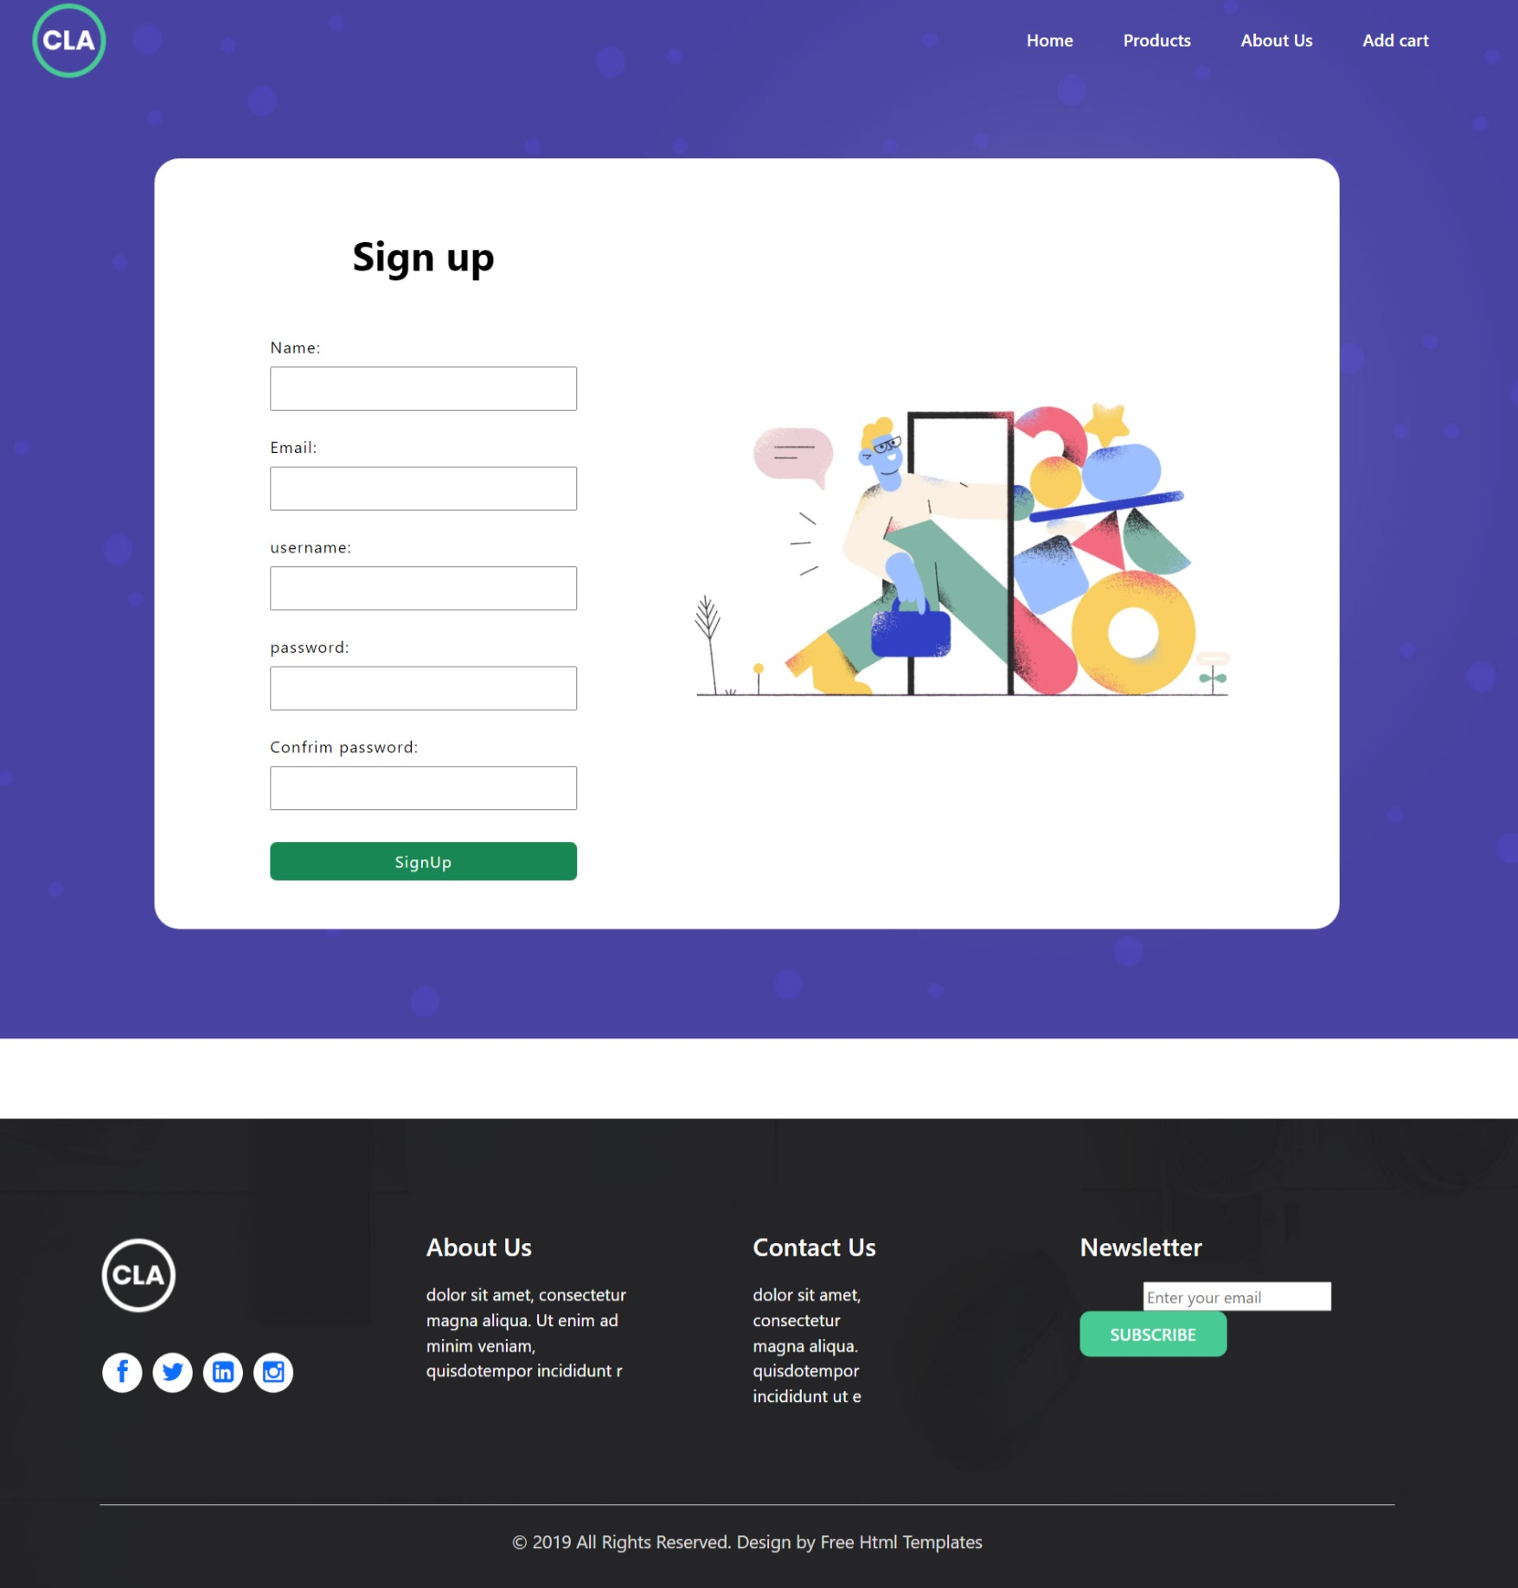

* **Description** In this page users can create accounts for saving and buying some products, users may enters name, email address, username, password and confirm password, if password and confirm password are match also username are not used before than user can create profile.

<%@ Page Title="" Language="VB" MasterPageFile="~/MasterPage.master" AutoEventWireup="false" CodeFile="Registration.aspx.vb" Inherits="_Default" %>

<asp:Content ID="Content1" ContentPlaceHolderID="head" Runat="Server">

</asp:Content>

<asp:Content ID="Content2" ContentPlaceHolderID="ContentPlaceHolder1" Runat="Server">

<div class="banner_main">

<section class="vh-100" style="margin:10rem 0px;">

<div class="container h-100">

<div class="row d-flex justify-content-center align-items-center h-100">

<div class="col-lg-12 col-xl-11">

<div class="card text-black" style="border-radius: 25px;height:107vh;">

<div class="card-body p-md-5">

<div class="row justify-content-center">

<div class="col-md-10 col-lg-6 col-xl-5 order-2 order-lg-1" style="height:auto;">

<p class="text-center h1 fw-bold mb-5 mx-1 mx-md-4 mt-4">Sign up</p>

<div style="display:flex;align-items:center;flex-direction:column;">

<div style="margin-bottom:1rem;">

<label style="display:block;margin:0.5rem 0px;letter-spacing:1px">Name: </label>

<asp:TextBox ID="fullName" runat="server" style="width:20vw;padding:0.5rem;letter-spacing:1px;"></asp:TextBox>

</div>

<div style="margin-bottom:1rem;">

<label style="display:block;margin:0.5rem 0px;letter-spacing:1px">Email: </label>

<asp:TextBox ID="email" runat="server" style="width:20vw;padding:0.5rem;letter-spacing:1px;"></asp:TextBox>

</div>

<div style="margin-bottom:1rem;">

<label style="display:block;margin:0.5rem 0px;letter-spacing:1px">username: </label>

<asp:TextBox ID="username" runat="server" style="width:20vw;padding:0.5rem;letter-spacing:1px;"></asp:TextBox>

</div>

<div style="margin-bottom:1rem;">

<label style="display:block;margin:0.5rem 0px;letter-spacing:1px">password: </label>

<asp:TextBox ID="password" runat="server" style="width:20vw;padding:0.5rem;letter-spacing:1px;"></asp:TextBox>

</div>

<div style="margin-bottom:1rem;">

<label style="display:block;margin:0.5rem 0px;letter-spacing:1px">Confrim password: </label>

<asp:TextBox ID="confrimPassword" runat="server" style="width:20vw;padding:0.5rem;letter-spacing:1px;"></asp:TextBox>

</div>

<div style="margin:1rem;">

<asp:Button ID="signUpBtn" class="btn btn-success"

style="width:20vw;letter-spacing:1px;" runat="server"

Text="SignUp"></asp:Button>

</div>

</div>

</div>

<div class="col-md-10 col-lg-6 col-xl-7 d-flex align-items-center order-1 order-lg-2">

<img src="https://mdbcdn.b-cdn.net/img/Photos/new-templates/bootstrap-registration/draw1.webp" class="img-fluid" alt="Sample image">

</div>

</div>

</div>

</div>

</div>

</div>

</div>

</section>

</div>

</asp:Content>

* Register.aspx.vb

Imports System.Data

Imports System.Data.SqlClient

Partial Class _Default

Inherits System.Web.UI.Page

Protected Sub signUpBtn_Click(ByVal sender As Object, ByVal e As System.EventArgs) Handles signUpBtn.Click

Dim con As New SqlConnection

Dim da As New SqlDataAdapter

con.ConnectionString = "Data Source=DESKTOP-N5PELIU\sqlexpress;Initial Catalog=ecom;Integrated Security=True"

Dim str As String

If (fullName.Text = "" Or email.Text = "" Or username.Text = "" Or password.Text = "") Then

MsgBox("Plese Enter the field")

Else

str = "INSERT INTO users(name,email,username,password) values('" & fullName.Text & "','" & email.Text & "','" & username.Text & "','" & password.Text & "');"

Dim cmd As New SqlCommand(str, con)

con.Open()

cmd.ExecuteNonQuery()

con.Close()

Response.Redirect("./Login.aspx")

End If

End Sub

End Class

* Cart.aspx

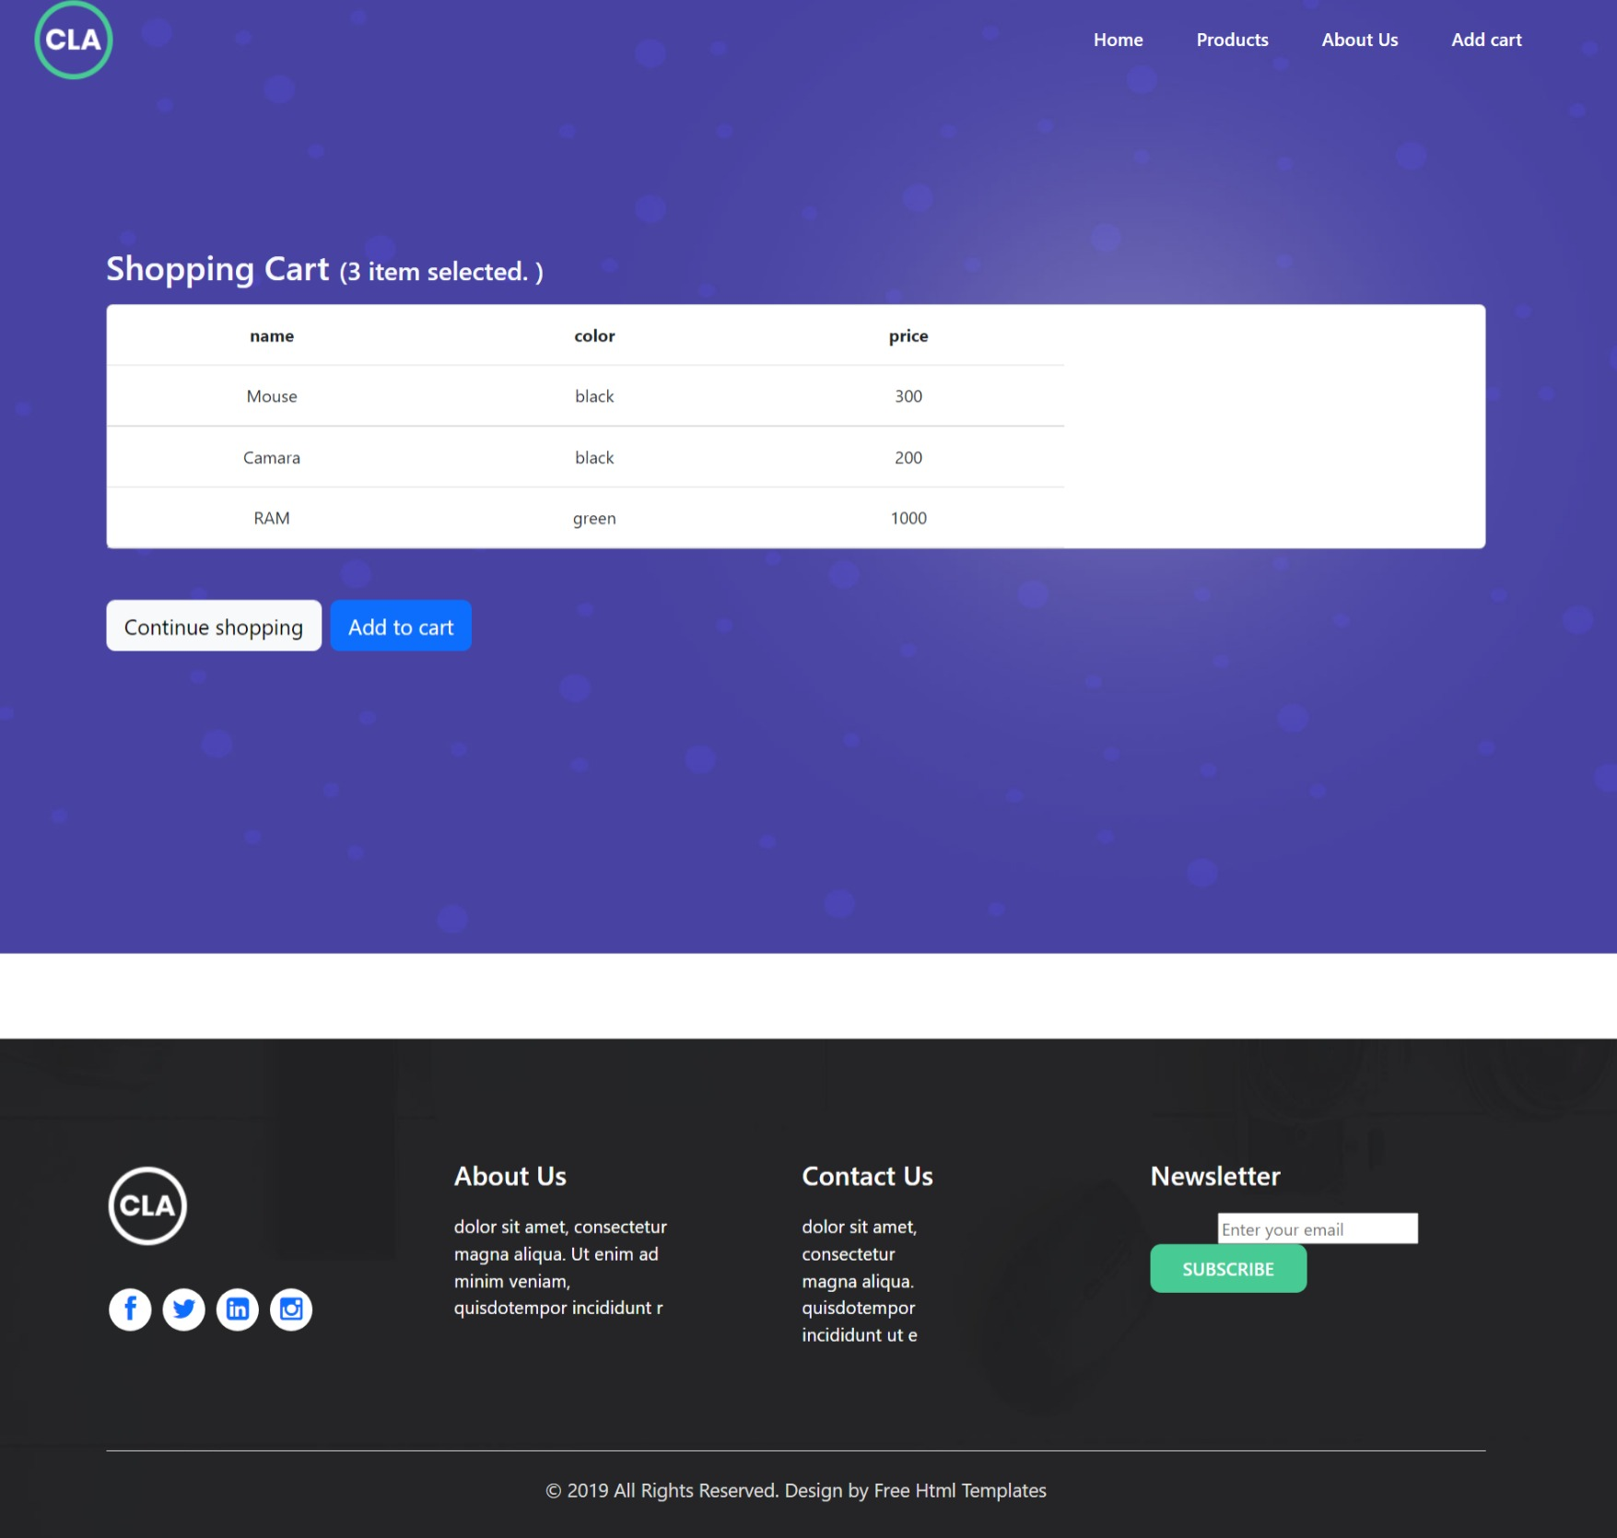

* **Description**: Cart page shows after login, before log in cart page can’t shows, in cart page user can store selected items to purchase it and store it.

+<%@ Page Title="" Language="VB" MasterPageFile="~/MasterPage.master" AutoEventWireup="false" CodeFile="Cart.aspx.vb" Inherits="_Default" %>

<asp:Content ID="Content1" ContentPlaceHolderID="head" Runat="Server">

</asp:Content>

<asp:Content ID="Content2" ContentPlaceHolderID="ContentPlaceHolder1" Runat="Server">

<section class="banner_main m-0 " style="padding:7rem 0px;" >

<div class="container h-100">

<div class="row d-flex justify-content-center align-items-center h-100">

<div class="col">

<p><span class="h2 text-light">Shopping Cart </span><span class="h4 text-light" id="h4" runat="server"></span></p>

<center>

<asp:GridView ID="GridView1" class="card md-4" runat="server"

AutoGenerateColumns="False" DataSourceID="SqlDataSource1">

<Columns>

<asp:BoundField DataField="name" HeaderText="name" SortExpression="name" />

<asp:BoundField DataField="color" HeaderText="color" SortExpression="color" />

<asp:BoundField DataField="price" HeaderText="price" SortExpression="price" />

</Columns>

</asp:GridView>

</center>

<div class="d-flex justify-content-start my-5">

<button type="button" class="btn btn-light btn-lg me-2">Continue shopping</button>

<button type="button" class="btn btn-primary btn-lg">Add to cart</button>

</div>

</div>

</div>

</div>

</section>

<asp:SqlDataSource ID="SqlDataSource1" runat="server"

ConnectionString="<%$ ConnectionStrings:ecomConnectionString %>"

SelectCommand="SELECT [name], [color], [price] FROM [addtocart]">

</asp:SqlDataSource>

</asp:Content>

* Cart.aspx.vb

Imports System.Data

Imports System.Data.SqlClient

Partial Class _Default

Inherits System.Web.UI.Page

Protected Sub Page_Load(ByVal sender As Object, ByVal e As System.EventArgs) Handles Me.Load

Dim con As New SqlConnection

Dim da As New SqlDataAdapter

Dim cmd As New SqlCommand

con.ConnectionString = "Data Source=DESKTOP-N5PELIU\sqlexpress;Initial Catalog=ecom;Integrated Security=True"

con.Open()

cmd = New SqlCommand("select count(*) from addtocart;", con)

h4.InnerText = "(" & Convert.ToString(cmd.ExecuteScalar()) & " item selected. )"

con.Close()

End Sub

End Class

* Admin.aspx

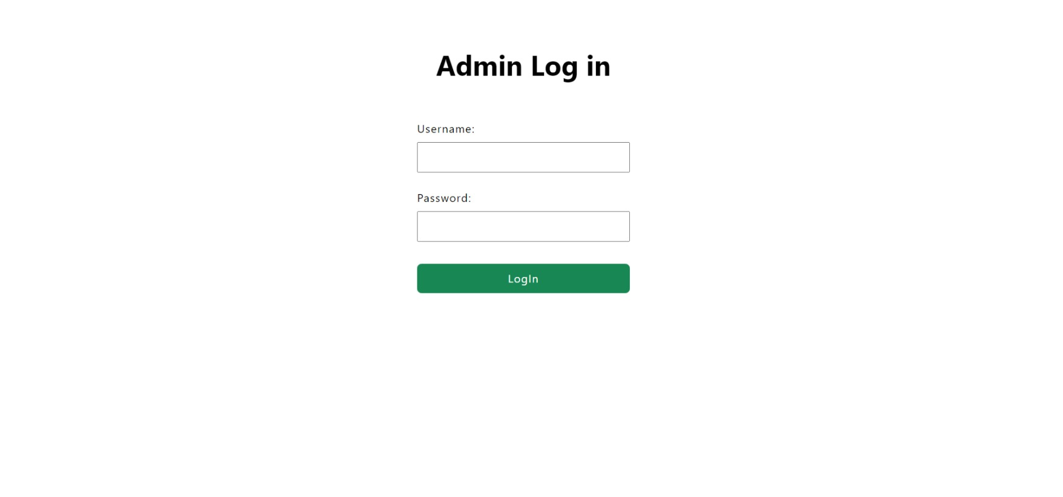

* **Description**: Admin page are not for users, admin page made for admin to manage activates of website’s, Add products and remove products from database.

<%@ Page Language="VB" AutoEventWireup="false" CodeFile="Admin.aspx.vb" Inherits="Admin" %>

<!DOCTYPE html PUBLIC "-//W3C//DTD XHTML 1.0 Transitional//EN" "http://www.w3.org/TR/xhtml1/DTD/xhtml1-transitional.dtd">

<html xmlns="http://www.w3.org/1999/xhtml">

<head runat="server">

<title>Admin Page</title>

<link rel="stylesheet" href="./css/style.css" />

<link rel="stylesheet" href="./css/bootstrap.min.css" />

<link rel="stylesheet" href="https://netdna.bootstrapcdn.com/font-awesome/4.0.3/css/font-awesome.css" />

</head>

<body>

<form id="form1" runat="server">

<div>

<section>

<div>

<div class="row d-flex justify-content-center align-items-center h-100">

<div class="col-lg-12 col-xl-11">

<div class="text-black" style="border-radius: 25px;">

<div class="p-md-5">

<div class="row justify-content-center">

<div class="">

<p class="text-center h1 fw-bold mb-5 mx-1 mx-md-4 mt-4">Admin Log in</p>

<div style="display:flex;align-items:center;flex-direction:column;">

<div style="margin-bottom:1rem;">

<label style="display:block;margin:0.5rem 0px;letter-spacing:1px">Username: </label>

<asp:TextBox ID="username" runat="server" style="width:20vw;padding:0.5rem;letter-spacing:1px;"></asp:TextBox>

</div>

<div style="margin-bottom:1rem;">

<label style="display:block;margin:0.5rem 0px;letter-spacing:1px">Password: </label>

<asp:TextBox ID="password" runat="server" style="width:20vw;padding:0.5rem;letter-spacing:1px;"></asp:TextBox>

</div>

<div style="margin:1rem;">

<asp:Button ID="loginBtn" class="btn btn-success" style="width:20vw;padding:0.5rem;letter-spacing:1px;" runat="server" Text="LogIn"></asp:Button>

</div>

</div>

</div>

</div>

</div>

</div>

</div>

</div>

</div>

</section>

</div>

</form>

</body>

</html>

* Admin.aspx.vb

Imports System.Data

Imports System.Data.SqlClient

Partial Class Admin

Inherits System.Web.UI.Page

Protected Sub loginBtn_Click(ByVal sender As Object, ByVal e As System.EventArgs) Handles loginBtn.Click

Dim con As New SqlConnection

Dim da As New SqlDataAdapter

Dim cmd As New SqlCommand

con.ConnectionString = "Data Source=DESKTOP-N5PELIU\sqlexpress;Initial Catalog=ecom;Integrated Security=True"

Dim str As String

str = "SELECT count(username) from admin where username ='" & username.Text & "'; "

If (username.Text = "" Or password.Text = "") Then

MsgBox("Plese Enter the field")

Else

cmd = New SqlCommand(str, con)

con.Open()

Dim countData As Integer

countData = 0

countData = cmd.ExecuteScalar()

con.Close()

If (countData = 1) Then

Session("admin") = username.Text

Response.Redirect("./panal.aspx")

Else

MsgBox("Invalid username")

End If

End If

End Sub

End Class

* Panel.aspx

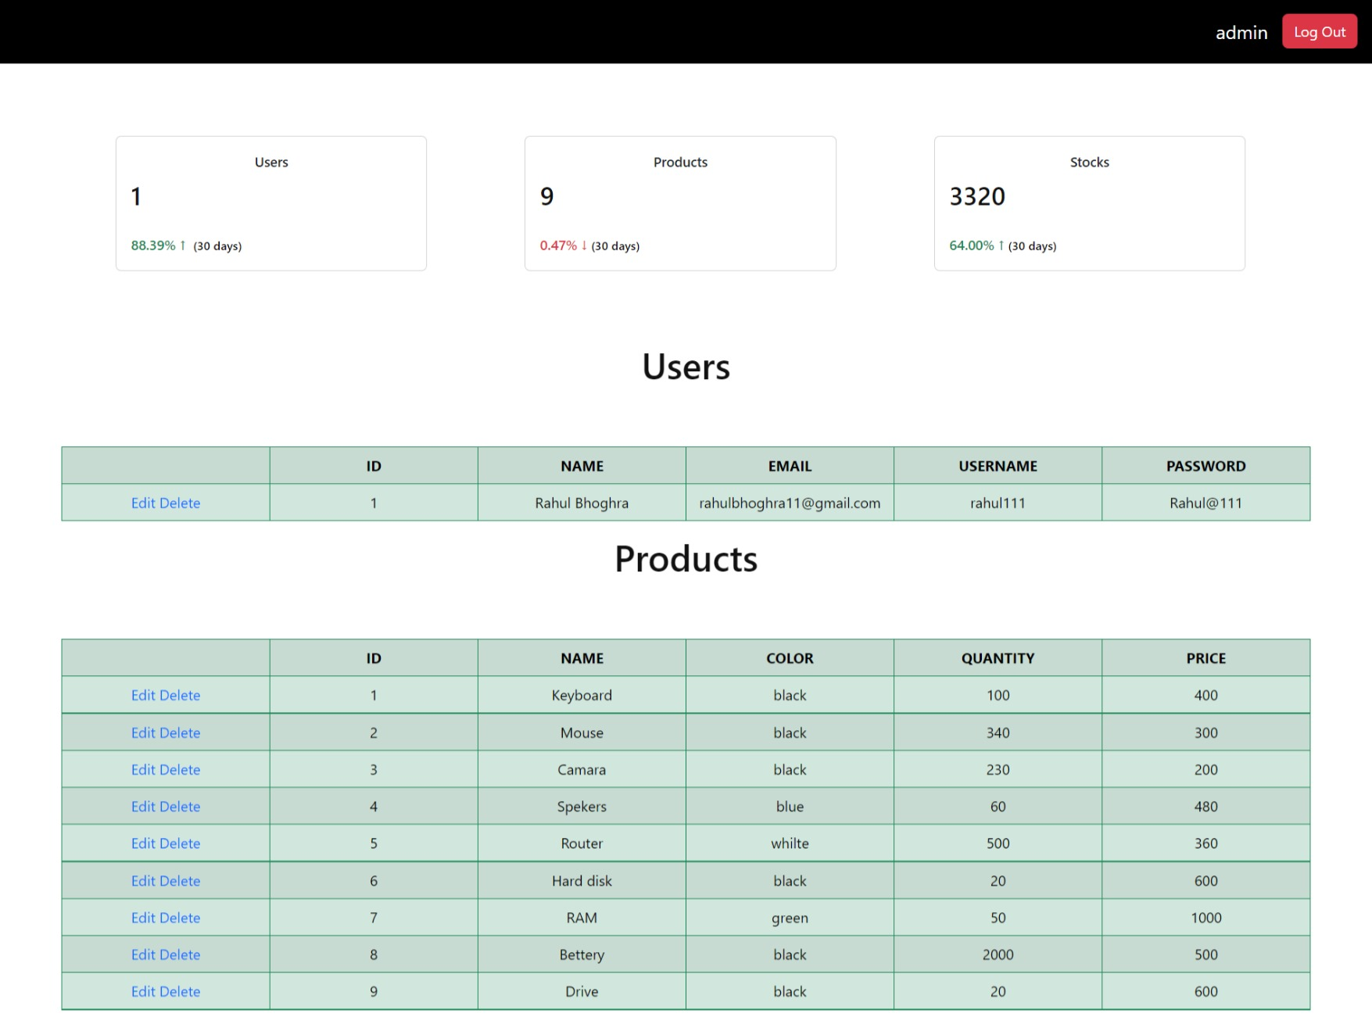

* **Description**: Admin panel use for managing data, and show user activities.it can change and add products. Also add and remove users.

<%@ Page Language="VB" AutoEventWireup="false" CodeFile="panal.aspx.vb" Inherits="panal" %>

<!DOCTYPE html PUBLIC "-//W3C//DTD XHTML 1.0 Transitional//EN" "http://www.w3.org/TR/xhtml1/DTD/xhtml1-transitional.dtd">

<html xmlns="http://www.w3.org/1999/xhtml">

<head runat="server">

<title>Admin Panal</title>

<link rel="stylesheet" href="./css/style.css" />

<link rel="stylesheet" href="./css/bootstrap.min.css" />

<link rel="stylesheet" href="https://netdna.bootstrapcdn.com/font-awesome/4.0.3/css/font-awesome.css" />

<style>

td,th

{

width:15vw;

text-align:center;

}

th

{

text-transform:uppercase;

}

</style>

</head>

<body>

<form id="form1" runat="server">

<div>

<ul class="nav justify-content-end" style="padding:1rem;background:#000;">

<li class="nav-item" style="margin: 4px 1rem;font-size: 1.3rem;">

<asp:Label ID="Label1" runat="server" ForeColor="White"></asp:Label>

</li>

<li class="nav-item">

<asp:Button type="button" class="btn btn-danger" ID="Button1" runat="server" Text="Log Out" />

</li>

</ul>

<div class="row " style="margin:5rem">

<div class="col-md-4 grid-margin stretch-card">

<div class="card" style="margin: 0rem 3rem;">

<div class="card-body">

<p class="card-title text-md-center text-xl-left">Users</p>

<div class="d-flex flex-wrap justify-content-between justify-content-md-center justify-content-xl-between align-items-center">

<h3><asp:Label class="mb-0 mb-md-2 mb-xl-0 order-md-1 order-xl-0" ID="Label2" runat="server" Text=""></asp:Label></h3>

<i class="ti-calendar icon-md text-muted mb-0 mb-md-3 mb-xl-0"></i>

</div>

<p class="mb-0 mt-2 text-success">88.39% ↑ <span class="text-black ms-1"><small>(30 days)</small></span></p>

</div>

</div>

</div>

<div class="col-md-4 grid-margin stretch-card">

<div class="card" style="margin: 0rem 3rem;">

<div class="card-body">

<p class="card-title text-md-center text-xl-left">Products</p>

<div class="d-flex flex-wrap justify-content-between justify-content-md-center justify-content-xl-between align-items-center">

<h3><asp:Label class="mb-0 mb-md-2 mb-xl-0 order-md-1 order-xl-0" ID="Label3" runat="server" Text=""></asp:Label></h3>

<i class="ti-user icon-md text-muted mb-0 mb-md-3 mb-xl-0"></i>

</div>

<p class="mb-0 mt-2 text-danger">0.47% ↓<span class="text-black ms-1"><small>(30 days)</small></span></p>

</div>

</div>

</div>

<div class="col-md-4 grid-margin stretch-card">

<div class="card" style="margin: 0rem 3rem;">

<div class="card-body">

<p class="card-title text-md-center text-xl-left">Stocks</p>

<div class="d-flex flex-wrap justify-content-between justify-content-md-center justify-content-xl-between align-items-center">

<h3><asp:Label class="mb-0 mb-md-2 mb-xl-0 order-md-1 order-xl-0" ID="Label4" runat="server" Text=""></asp:Label></h3>

<i class="ti-agenda icon-md text-muted mb-0 mb-md-3 mb-xl-0"></i>

</div>

<p class="mb-0 mt-2 text-success">64.00% ↑<span class="text-black ms-1"><small>(30 days)</small></span></p>

</div>

</div>

</div>

</div>

<div class="d-flex justify-content-center align-items-center" >

<h1>Users</h1>

</div>

<div class="d-flex justify-content-center align-items-center mt-5">

<asp:GridView ID="GridView1" runat="server"

class="table table-success table-striped table-bordered border-success"

AutoGenerateColumns="False" AutoGenerateDeleteButton="True"

AutoGenerateEditButton="True" DataSourceID="SqlDataSource1"

DataKeyNames="id">

<Columns>

<asp:BoundField DataField="id" HeaderText="id" InsertVisible="False"

ReadOnly="True" SortExpression="id" />

<asp:BoundField DataField="name" HeaderText="name" SortExpression="name" />

<asp:BoundField DataField="email" HeaderText="email" SortExpression="email" />

<asp:BoundField DataField="username" HeaderText="username"

SortExpression="username" />

<asp:BoundField DataField="password" HeaderText="password"

SortExpression="password" />

</Columns>

</asp:GridView>

<asp:SqlDataSource ID="SqlDataSource1" runat="server"

ConnectionString="<%$ ConnectionStrings:ecomConnectionString %>"

SelectCommand="SELECT * FROM [users]"

UpdateCommand="UPDATE [users] SET [name]=@name, [email]=@email, [username]=@username, [password]=@password where [id]=@id"

DeleteCommand="DELETE FROM [users] WHERE [id]=@id"></asp:SqlDataSource>

</div>

<div class="d-flex justify-content-center align-items-center" >

<h1>Products</h1>

</div>

<div class="d-flex justify-content-center align-items-center mt-5">

<asp:GridView ID="GridView2" runat="server"

class="table table-success table-striped table-bordered border-success"

AutoGenerateColumns="False" AutoGenerateDeleteButton="True"

AutoGenerateEditButton="True" DataSourceID="SqlDataSource2">

<Columns>

<asp:BoundField DataField="id" HeaderText="id" SortExpression="id" />

<asp:BoundField DataField="name" HeaderText="name" SortExpression="name" />

<asp:BoundField DataField="color" HeaderText="color" SortExpression="color" />

<asp:BoundField DataField="quantity" HeaderText="quantity"

SortExpression="quantity" />

<asp:BoundField DataField="price" HeaderText="price"

SortExpression="price" />

</Columns>

</asp:GridView>

<asp:SqlDataSource ID="SqlDataSource2" runat="server"

ConnectionString="<%$ ConnectionStrings:ecomConnectionString %>"

SelectCommand="SELECT * FROM [Product]"

UpdateCommand="UPDATE [Product] SET [name]=@name, [color]=@color, [quantity]=@quantity, [price]=@price where [id]=@id"

DeleteCommand="DELETE FROM [Products] WHERE [id]=@id"></asp:SqlDataSource>

</div>

</div>

</form>

</body>

</html>

* Panel.aspx.vb

Imports System.Data

Imports System.Data.SqlClient

Partial Class panal

Inherits System.Web.UI.Page

Dim con As New SqlConnection

Dim cmd As New SqlCommand

Protected Sub Button1_Click(ByVal sender As Object, ByVal e As System.EventArgs) Handles Button1.Click

Session("admin") = ""

Response.Redirect("./Admin.aspx")

End Sub

Protected Sub Page_Load(ByVal sender As Object, ByVal e As System.EventArgs) Handles Me.Load

Label1.Text = Session("admin")

con.ConnectionString = "Data Source=DESKTOP-N5PELIU\sqlexpress;Initial Catalog=ecom;Integrated Security=True"

Dim str1 As String

str1 = "SELECT count(*) from users;"

cmd = New SqlCommand(str1, con)

con.Open()

Label2.Text = cmd.ExecuteScalar()

con.Close()

Dim str2 As String

str2 = "SELECT count(*) from Product;"

cmd = New SqlCommand(str2, con)

con.Open()

Label3.Text = cmd.ExecuteScalar()

con.Close()

Dim str3 As String

str3 = "SELECT sum(quantity) from Product;"

cmd = New SqlCommand(str3, con)

con.Open()

Label4.Text = cmd.ExecuteScalar()

con.Close()

End Sub

End Class