

See discussions, stats, and author profiles for this publication at: [https://www.researchgate.net/publication/354033755](https://www.researchgate.net/publication/354033755_Analysis_of_Serverless_Computing_Techniques_in_Cloud_Software_Framework?enrichId=rgreq-d567393482087cf3eadceac02170382d-XXX&enrichSource=Y292ZXJQYWdlOzM1NDAzMzc1NTtBUzoxMDg4NzYxNjQ3NjM2NTE0QDE2MzY1OTI0MTM4MzM%3D&el=1_x_2&_esc=publicationCoverPdf)

[Analysis of Serverless Computing Techniques in Cloud Software Framework](https://www.researchgate.net/publication/354033755_Analysis_of_Serverless_Computing_Techniques_in_Cloud_Software_Framework?enrichId=rgreq-d567393482087cf3eadceac02170382d-XXX&enrichSource=Y292ZXJQYWdlOzM1NDAzMzc1NTtBUzoxMDg4NzYxNjQ3NjM2NTE0QDE2MzY1OTI0MTM4MzM%3D&el=1_x_3&_esc=publicationCoverPdf)

**Article** *in* Journal of ISMAC · August 2021

DOI: 10.36548/jismac.2021.3.004

CITATIONS

27

READS

1,604

**1 author:**

[Hari krishnan Andi](https://www.researchgate.net/profile/Hari-Andi-2?enrichId=rgreq-d567393482087cf3eadceac02170382d-XXX&enrichSource=Y292ZXJQYWdlOzM1NDAzMzc1NTtBUzoxMDg4NzYxNjQ3NjM2NTE0QDE2MzY1OTI0MTM4MzM%3D&el=1_x_5&_esc=publicationCoverPdf)

[Asia Metropolitan University](https://www.researchgate.net/institution/Asia-Metropolitan-University?enrichId=rgreq-d567393482087cf3eadceac02170382d-XXX&enrichSource=Y292ZXJQYWdlOzM1NDAzMzc1NTtBUzoxMDg4NzYxNjQ3NjM2NTE0QDE2MzY1OTI0MTM4MzM%3D&el=1_x_6&_esc=publicationCoverPdf)

**9** PUBLICATIONS **100** CITATIONS

[SEE PROFILE](https://www.researchgate.net/profile/Hari-Andi-2?enrichId=rgreq-d567393482087cf3eadceac02170382d-XXX&enrichSource=Y292ZXJQYWdlOzM1NDAzMzc1NTtBUzoxMDg4NzYxNjQ3NjM2NTE0QDE2MzY1OTI0MTM4MzM%3D&el=1_x_7&_esc=publicationCoverPdf)

**Some of the authors of this publication are also working on these related projects:**

 SURVIVING THE NARCISSIST’S PSYCHOLOGICAL GAME: DISARMING THE TOXIC WORKPLACE COWORKERS [View project](https://www.researchgate.net/project/SURVIVING-THE-NARCISSISTS-PSYCHOLOGICAL-GAME-DISARMING-THE-TOXIC-WORKPLACE-COWORKERS?enrichId=rgreq-d567393482087cf3eadceac02170382d-XXX&enrichSource=Y292ZXJQYWdlOzM1NDAzMzc1NTtBUzoxMDg4NzYxNjQ3NjM2NTE0QDE2MzY1OTI0MTM4MzM%3D&el=1_x_9&_esc=publicationCoverPdf)

All content following this page was uploaded by [Hari krishnan Andi](https://www.researchgate.net/profile/Hari-Andi-2?enrichId=rgreq-d567393482087cf3eadceac02170382d-XXX&enrichSource=Y292ZXJQYWdlOzM1NDAzMzc1NTtBUzoxMDg4NzYxNjQ3NjM2NTE0QDE2MzY1OTI0MTM4MzM%3D&el=1_x_10&_esc=publicationCoverPdf) on 11 November 2021.

The user has requested enhancement of the downloaded file.

**Analysis of Serverless Computing Techniques in Cloud Software Framework**

**Hari Krishnan Andi**

Centre for Postgraduate Studies, Asia Metropolitan University, Malaysia

**E-mail:** [hari.andi@amu.edu.my](mailto:hari.andi@amu.edu.my)

# Abstract

This paper describes briefly about the concept of serverless cloud computing model, its usage in IT industries and its benefits. In the traditional model the developer is responsible for resource allocation, managing servers and owning of servers, and it included three models based upon the service such as IaaS, PaaS and SaaS. In IaaS (Infrastructure as a Service) the content storage and accessing of network is carried out by the cloud provider, SaaS (Software as a Service) here different software’s are provided to the user as a service, PaaS (Platform as a Service), the developer gets access to certain services for carrying out organizing process and run it accordingly. In serverless cloud computing, the developer need not worry about owning, management, and maintenance of servers as it is carried out by the cloud service provider. Hence by using this model, the time that is needed for a system to reach the market is very much reduced and is cost effective. Serverless architecture includes three categories namely, AWS Lambda, Azure, and Google cloud. It also includes certain challenges such as it cannot be used in the case where a process takes longer time to run and it is discussed below in this paper.

**Keywords:** Serverless cloud computing, traditional model, AWS Lambda, Azure, Google cloud

221

# Introduction

The term Serverless computing is used everywhere in IT industry recent days and the term serverless was been the most searched term in google [1]. Nowadays, all sorts of business involve cloud services, without thinking about the issues in the infrastructure which lead to serverless architecture. The term serverless does not mean it works without any servers, the running of applications is done on servers but managing, owning or maintaining the server is not carried out [2]. Cloud service provider takes care of all those processes including allocating the resources, hence the developer need not worry about it. The billing is carried out on the basis of usage of the resources. When serverless model is proposed, it provides various benefits such as the time required to meet the market is low, cost effective, provides higher efficiency but it can also produce certain risks - the control over the infrastructure is lost, as the cloud service provider takes care of it, we cannot produce any change in infrastructure according to the suitable process [3]. Serverless computing does not provide any solution to problems in IT industry, but it will be the future of most cloud computing solutions [4].

# Background Knowledge

Infrastructure virtualization in software and hardware led to the emerging of cloud computing. Cloud computing is divided into three categories namely SaaS, PaaS and IaaS. SaaS (Software as a Service) as shown in the Figure 1, here various kinds of software is provided by cloud provider as a service to the users [5]. In Figure 1, blue color represents the tasks that are handled by customers and pink color represents the tasks that are handled by vendors. For example, Google provides various services to users like Gmail and Google play. The management and development services are not carried out by the users [5]. In PaaS (Platform as a Service) the services such as accessing network, storage of data is provided by the cloud provider so that the developer can access to the services, organize them, run it accordingly and manage them. Finally,

IaaS (Infrastructure as a Service), the services such as accessing the networks, storage of content are carried over by the cloud providers [7].

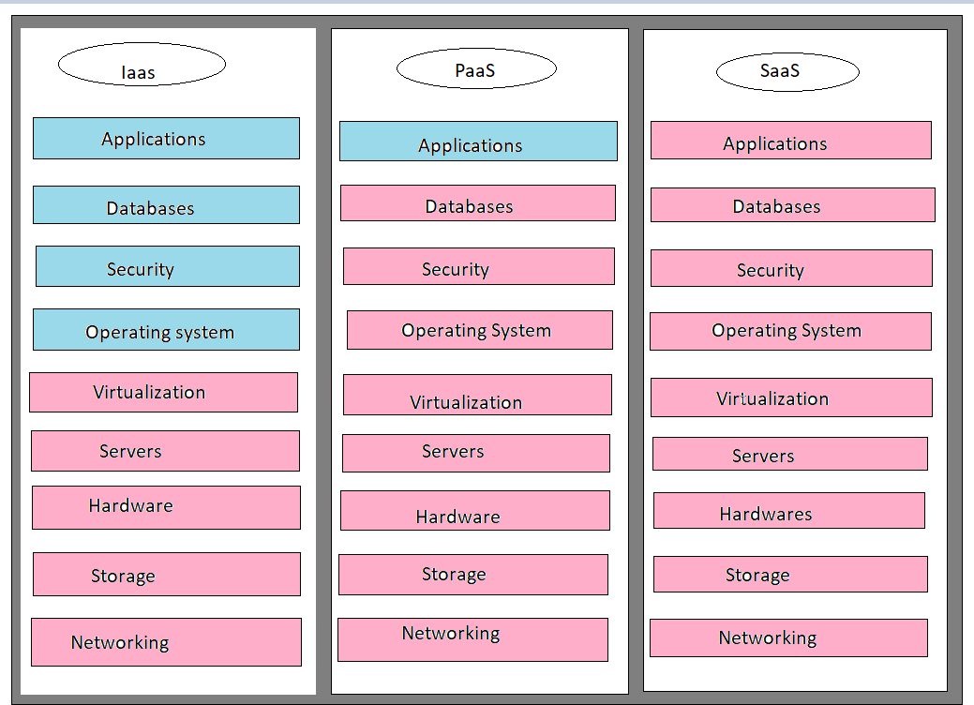

**Figure 1.** Cloud Computing Models

In serverless computing when the particular application is not in use, resources will not be allocated by cloud service provider, hence it is cost efficient as billing is carried out on the basis of usage of resources [8]. Serverless makes the developers to focus completely on the tasks, as managing, owning and maintaining the servers is not carried out by them, instead the cloud service provider takes care of it. Zimki in the year 2006, introduced the serverless method “pay as you go” and this idea was brought into market as a serverless service in the year 2006, the evolution of serverless computing is shown in the Figure 2, here physical machines, virtual machines, containerization are server models and final process is the serverless model [9]. Later in 2014

Amazon proclaimed this technology as AWS Lambda, the exploration of this technology was later done by Microsoft, Google and IBM. After this serverless cloud computing infrastructure was launched by Microsoft.

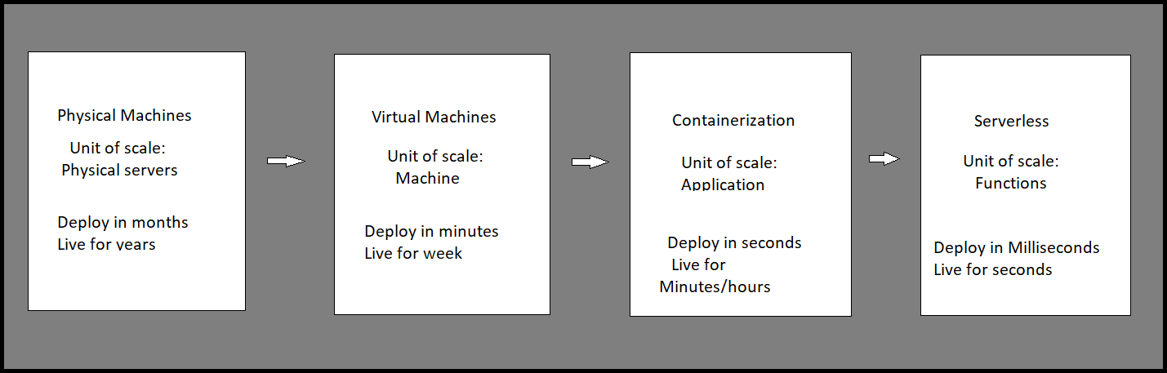

**Figure 2.** Evolution of Serverless Computing

While considering Facebook, this application is used everywhere in the world. The main function of Facebook is to allow the users to upload their pictures or videos and share it to their friends and it is a huge platform with two billion plus users [10]. Hence, scaling of such a big platform is difficult process, but this capability can be seamlessly implemented using serverless computing. This capability can be implemented using Amazon Lambda, Google function or Azure function by which an HTTP end point is exposed so that we can upload the data through that end point [11]. When serverless technology has not existed, the functionalities will take fewer months to get implemented.

# Related Works

Managing the cloud services has not been an easy task. Various challenges have been addressed [12] in the management of cloud services such as balancing the load, scaling, security, etc. These problems directed to the introduction of another method of cloud computing known as serverless cloud computing [13]. This provides two services such as Backend as a Service and Function as a Service as shown in the Figure 3.

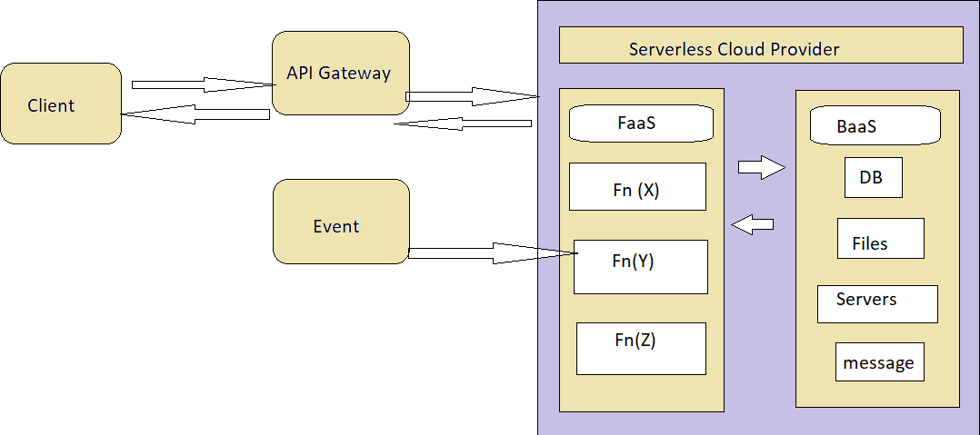

**Figure 3.** Demonstration of FaaS and BaaS

Backend as a Service provides certain services such as content storage, management of users etc. while Function as a Service provides organization of code and executing it. Amazon Lambda introduced the concept of serverless computing in 2014, later the companies Microsoft and Google implemented this method in 2016 [14]. The serverless architecture enhances another layer to the cloud computing model while the management of servers are abstracted from the developers [15]. This model lets the developer to work more on the logic than the other functions

such as resource allocation, owning, and management of servers as they are handled by cloud service providers [16, 17].

Authors in [18] examined how the serverless computing is being practiced in IT industry, and concluded that to operate the tools that are essential for serverless architecture, the developer faces a barrier to implement the right mindset to best operate the tools. In IT industry the serverless architecture is increasing the capabilities, hence it can be used not only for infrastructure enhancement, but can also be used in different kinds of purposes such as big data [19], training of neural networks [20], messaging and processing of videos [21]. The scheduling of tasks was explained by the authors in [22], for the purpose of reducing the time of execution and cost, various scheduling techniques have been described by them. They developed a hybrid model by using IaaS and FaaS, FaaS (Function as a Service) executed smaller tasks that diminishes the cost of execution and longer tasks was based on IaaS (Infrastructure as a Service).

Considering the properties throughput and latency, an efficient model should have higher throughput and lower latency, [23] explains that the serverless computing is mostly used where there must be higher throughput than the lower latency and also used in cases of completing the individual requests in a shorter time. Thus, innovative features take minimal time to reach the market. They also used a case study of Yubl and Mindmup which used serverless platforms to show how their cost reduced up to 66 percentage, and also the disadvantages addressed while adopting it. In deep learning approach, the models were trained using serverless computing [24], here slight modifications were carried out by the researchers due to the challenges faced because of the tightly coupled characteristics of deep learning models.

Some limitations were proposed for the serverless model in [25], it describes that serverless platform cannot be used for all applications. If certain products contain no event-based functions, but the running period of that product is high, then the cost required will be higher, hence it is not

cost effective in this scenario. For serverless computing platform, a resource managing methods was proposed [26] for enhancing the resources, focusing on containers allocation of memory, here a design called Open Lambda is added to the top layer of the serverless platform. A demonstration for the serverless platform is carried out by using AWS Lambda in [27], and it is shown in the Figure 4 below. SNS (Simple Notification Service) is used in the process of delivering bulk messages, IAM (Identity and Access Management) – AWS resources can be assessed securely by using IAM.

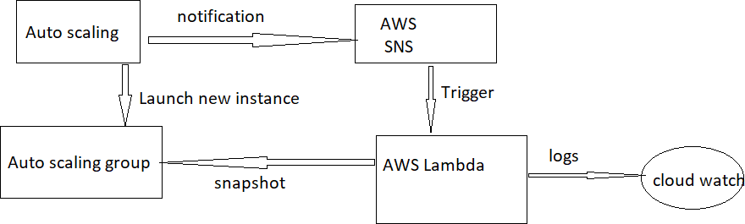

**Figure 4.** Demonstration scenario

Cloud watch is used for receiving and monitoring log files, setting of alarms and respond automatically for the changes produced in resources of AWS, Autoscaling is used for the management of scaling.

# Comparison of Different Models of Serverless Computing

* 1. **Comparison of Azure, AWS and Google cloud serverless computing**

Supporting language: When comparing three models, AWS Lambda model is better because the programming language here is relatively diverse, also more kinds of supporting languages are provided in AWS Lambda. Stateful functions: The stateful function is not supported in AWS Lambda model, but the services that are stored can be accessed [28]. This kind of support is not present in Google cloud model also. Only Azure function provides stateful function support.

Storage: S3 and DynamoDB are used in AWS Lambda model for storage purposes, Azure uses blob and Google cloud uses Cloud SQL, Cloud datastore and Cloud storage.

Number of functions: There is no limited functionality in AWS Lambda and Azure model whereas the Google Cloud have 1000 as a limit for per project.

The growth of different models of serverless computing is shown in the Figure 5.

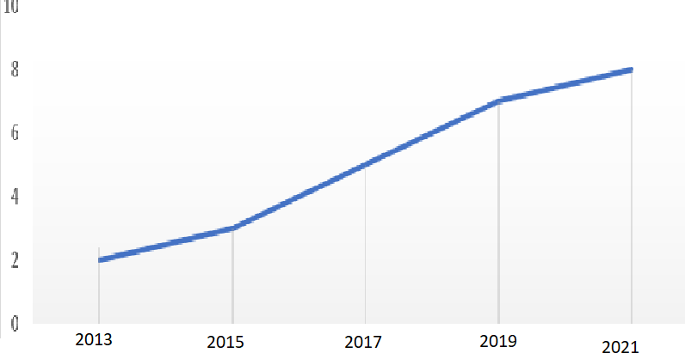

**Figure 5.** Graph that shows the growth of serverless computing

# Serverless Architecture

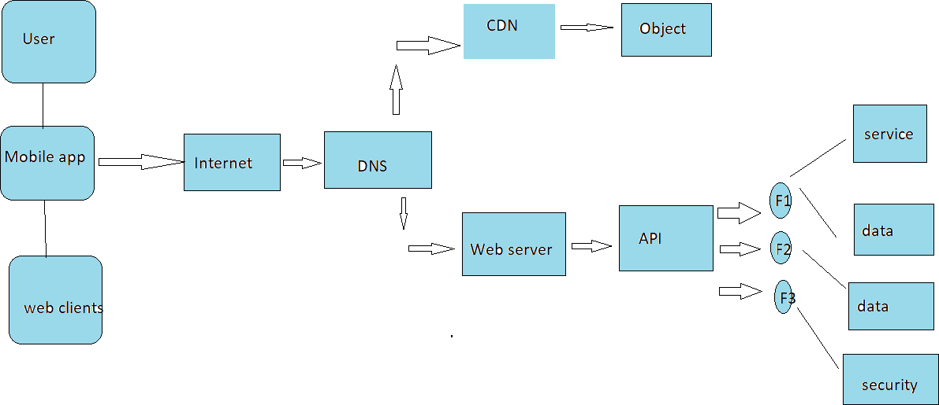

**Figure 6.** Architecture of Serverless Application

The serverless architecture includes basic components such as serverless API gateway, FaaS (Function as a service) and BaaS (Backend as a service). Communication process between first end and FaaS is provided by serverless API gateway. Business related logics are executed in FaaS, BaaS eliminates the burdens of the admin in database. The access to the services is provided by accessing the internet in traditional architecture, for example a machine hosting the websites and delivering it to the browser and its size is bigger. When reducing the size of the machine, the cost of it is very much higher, also the life time of the machine is low. To overcome these issues, serverless model have been introduced. In serverless architecture, AWS Lambda, Azure and Google cloud services are available. The below Figure 6 represents the serverless application architecture. The user gets access to the serverless model through a mobile phone, the HTTP request is passed through the Domain Name Server routing, the request outcome is provided through Content Delivery Network, which communicates to the object store [29]. Runtime data is provided to web server by passing the requests via API gateway which forwards the requests to

many kinds of functions. The first function is used for the purpose of providing service while second one is used for read and write operations and third one is used for state saving.

Thus, from the process involved from the flow chart, we can easily understand that serverless model is an effective and time efficient process which many IT industries follow. Since there is no much burden to the developer such as allocating resources, maintaining servers, and owning servers, the developer can concentrate more on the logic process.

# Conclusion

In IT industry the parameters such as cost, security, efforts, time to reach the markets etc. plays a major role. When we host a scheme by using cloud computing, the time required for hosting the project is low, but the security and cost of maintenance cannot be taken into account. But by using serverless cloud computing the execution time, and cost of maintenance is very much low, also it offers high security. The serverless computing includes various benefits such as maintenance, owning of server, resource allocation is not handled by the developer as the cloud service provider takes care of it. The maintenance cost is low as the pricing is based on how much time the application or resource is used. The serverless cloud computing also includes certain challenges such as for a process which takes longer time period to run, serverless architectures cannot be used, as the pricing is based on how much time the code runs. It also includes certain security concerns as the whole backend is run by vendors.

# References

1. Jonas E, Schleier-Smith J, Sreekanti V, Tsai C-C, Khandelwal A, Pu Q, Shankar V, Carreira J, Krauth K, Yadwadkar N, Gonzalez JE, Popa RA, Stoica I, Patterson DA (2019) Cloud Programming Simplified: A Berkeley View on Serverless Computing.
2. Mugunthan, S. R. "Wireless Rechargeable Sensor Network Fault Modeling and Stability Analysis." Journal of Soft Computing Paradigm (JSCP) 3, no. 01 (2021): 47-54.
3. Ashwini, L., and N. R. Sunitha. "Ranked Keyword Search Result Verification to Detect Misbehaving Cloud Servers." In International Conference on Inventive Computation Technologies, pp. 87-93. Springer, Cham, 2019.
4. Smys, S., and Haoxiang Wang. "Security Enhancement in Smart Vehicle Using Blockchain- based Architectural Framework." Journal of Artificial Intelligence 3, no. 02 (2021): 90-100.
5. Baldini I, Castro P, Chang K, Cheng P, Fink S, Ishakian V, Mitchell N, Muthusamy V, Rabbah R, Slominski A, Suter P (2017) Serverless Computing: Current Trends and Open Problems In: Research Advances in Cloud Computing, 1–20.. Springer, Singapore.
6. Mugunthan, S. R., and T. Vijayakumar. "Design of Improved Version of Sigmoidal Function with Biases for Classification Task in ELM Domain." Journal of Soft Computing Paradigm (JSCP) 3, no. 02 (2021): 70-82.
7. Srikanth, M. S., TG Keerthan Kumar, and Vivek Sharma. "Automatic Vehicle Service Monitoring and Tracking System Using IoT and Machine Learning." In Computer Networks, Big Data and IoT, pp. 953-967. Springer, Singapore, 2021.
8. Adzic G, Chatley R (2017) Serverless computing: Economic and architectural impact In: Proceedings of the 2017 11th Joint Meeting on Foundations of Software Engineering (ESEC/FSE 2017), 884–889.. Association for Computing Machinery, New York.
9. Suma, V. "Community Based Network Reconstruction for an Evolutionary Algorithm Framework." Journal of Artificial Intelligence 3, no. 01 (2021): 53-61.
10. Jambunathan B, Yoganathan K (2018) Architecture decision on using microservices or serverless functions with containers In: 2018 International Conference on Current Trends Towards Converging Technologies (ICCTCT), 1–7.
11. Kumar, T. Senthil. "Study of Retail Applications with Virtual and Augmented Reality Technologies." Journal of Innovative Image Processing (JIIP) 3, no. 02 (2021): 144-156.
12. Leitner P, Wittern E, Spillner J, Hummer W (2019) A mixed-method empirical study of function-as-a-service software development in industrial practice. J Syst Softw 149:340– 359.
13. Jain, Sukrutha A., and Avinash Bharadwaj. "Characterizing WDT subsystem of a Wi-Fi controller in an Automobile based on MIPS32 CPU platform across PVT." Journal of Ubiquitous Computing and Communication Technologies (UCCT) 2, no. 04 (2020): 187- 196.
14. Werner S, Kuhlenkamp J, Klems M, Müller J, Tai S (2018) Serverless big data processing using matrix multiplication as example In: 2018 IEEE International Conference on Big Data (Big Data), 358–365.
15. Kunaraj, K., S. Maria Wenisch, S. Balaji, and FP Mahimai Don Bosco. "Impulse Noise Classification Using Machine Learning Classifier and Robust Statistical Features." In International Conference On Computational Vision and Bio Inspired Computing, pp. 631- 644. Springer, Cham, 2019.
16. Shakya, Subarna. "A Self Monitoring and Analyzing System for Solar Power Station using IoT and Data Mining Algorithms." Journal of Soft Computing Paradigm 3, no. 2: 96-109.
17. Feng L, Kudva P, Da Silva D, Hu J (2018) Exploring serverless computing for neural network training In: 2018 IEEE 11th International Conference on Cloud Computing (CLOUD), 334–341.
18. Hengjinda, P., Dr Chen, and Joy Iong Zong. "An Intelligent Feedback Controller Design for Energy Efficient Air Conditioning System." Journal of Electronics and Informatics 2, no. 3 (2020): 168-174.
19. Ao L, Izhikevich L, Voelker GM, Porter G (2018) Sprocket: A serverless video processing framework In: Proceedings of the ACM Symposium on Cloud Computing (SoCC ‘18), 263– 274.. Association for Computing Machinery, New York.
20. Chen, Joy Iong-Zong, and Lu-Tsou Yeh. "Greenhouse Protection Against Frost Conditions in Smart Farming using IoT Enabled Artificial Neural Networks." Journal of Electronics 2, no. 04 (2020): 228-232.
21. Alqaryouti O, Siyam N (2018) Serverless computing and scheduling tasks on cloud: A review. Am Sci Res J Eng Technol Sci (ASRJETS) 40(1):235–247.
22. Chen, Joy Iong Zong, and Joy Iong Zong. "Automatic Vehicle License Plate Detection using K-Means Clustering Algorithm and CNN." Journal of Electrical Engineering and Automation 3, no. 1 (2021): 15-23.
23. Chard R. (2017) FaaS: The future of computing [Internet] : First international workshop on Serverless Computing(WOSC).
24. Jha, Srirang K., and Shweta Jha. "An Integrated Model of Sustainable Management Systems for Start-ups." In International Conference on Mobile Computing and Sustainable Informatics, pp. 337-342. Springer, Cham, 2020.
25. Mugunthan, S. R. "Decision Tree Based Interference Recognition for Fog Enabled IOT Architecture." Journal of trends in Computer Science and Smart technology (TCSST) 2, no. 01 (2020): 15-25.
26. L.Feng , P.Kudva, Dilma Da Silva, J.Hu (2018) Exploring Serverless Computing for Neural Network Training, pp 1-8.
27. Kazimov, S. Limitations of Serverless Computing.
28. F. Douglis and J. Nieh, "Microservices and Containers," in IEEE Internet Computing, vol. 23, no. 6, pp. 5-6, 1 Nov.-Dec. 2019
29. Dr. R. Arokia Paul Rajan (2018) Serverless Architecture - A Revolution in Cloud Computing: IEEE Xplore.

# Author's biography

**Hari Krishnan Andi** is presently working as the director, Centre for Postgraduate Studies, Asia Metropolitan University, Malaysia. His major area of research includes emotional intelligence, data mining, soft skills, business management, psychological development, and mentoring techniques.