# Introduction

The term Serverless computing is used everywhere in IT industry, recent days and the term serverless was been the most searched term in google. Nowadays, all sorts of

business involve cloud services, without thinking about the issues in the infrastructure which lead to serverless architecture. The term serverless does not mean it works without any servers, the running of applications is done on servers but managing, owning or maintaining the server is not carried out. Cloud service provider takes care of all those processes including allocating the resources, hence the developer need not worry about it. The billing is carried out on the basis of usage of the resources. When serverless model is proposed, it provides various benefits such as the time required to meet the market is low, cost effective, provides higher efficiency but it can also produce certain risks - the control over the infrastructure is lost, as the cloud service provider takes care of it, we cannot produce any change in infrastructure according to the suitable process. Serverless computing does not provide any solution to problems in IT industry, but it will be the future of most cloud computing solutions.

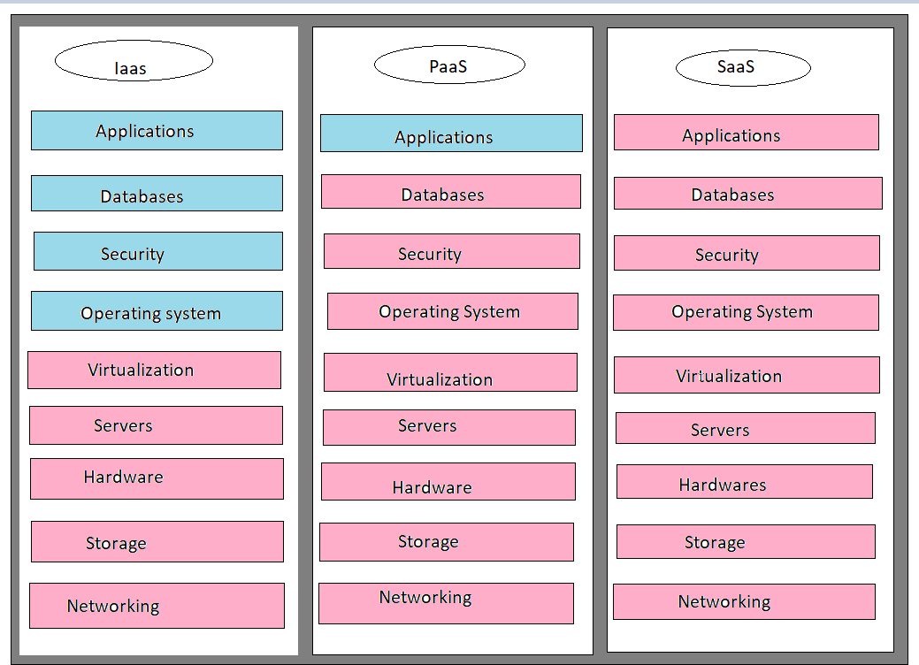

Figure 1

## Background Knowledge

Infrastructure virtualization in software and hardware led to the emerging of cloud computing. Cloud computing is divided into three categories namely SaaS, PaaS and IaaS. SaaS (Software as a Service) as shown in the Figure 1, here various kinds of software is provided by cloud provider as a service to the users. In Figure 1, blue color represents the tasks that are handled by customers and pink color represents the tasks that are handled by vendors. For example, Google provides various services to users like Gmail and Google play. The management and development services are not carried out by the users. In PaaS (Platform as a Service) the services such as accessing network, storage of data is provided by the cloud provider so that the developer can access to the services, organize them, run it accordingly and manage them. Finally, in serverless computing when the particular application is not in use, resources will not be allocated by cloud service provider, hence it is cost efficient as billing is carried out on the basis of usage of resources. Serverless makes the developers to focus completely on the tasks, as managing, owning and maintaining the servers is not carried out by them, instead the cloud service provider takes care of it. Zimki in the year 2006, introduced the serverless method “pay as you go” and this idea was brought into market as a serverless service in the year 2006, the evolution of serverless computing is shown in the Figure 2, here physical machines, virtual machines, containerization are server models and final process is the serverless model [9]. Later in 2014 Amazon proclaimed this technology as AWS Lambda, the exploration of this technology was later done by Microsoft, Google and IBM. After this serverless cloud computing infrastructure was launched by Microsoft.

While considering Facebook, this application is used everywhere in the world. The main function of Facebook is to allow the users to upload their pictures or videos and share it to their friends and it is a huge platform with two billion plus users. Hence, scaling of such a big platform is difficult process, but this capability can be seamlessly implemented using serverless computing. This capability can be implemented using Amazon Lambda, Google function or Azure function by which an HTTP end point is exposed so that we can upload the data through that end point.

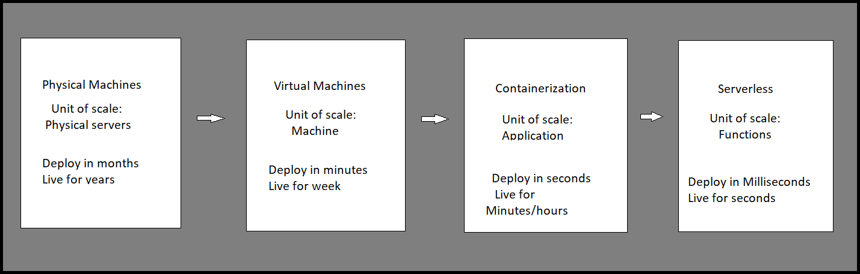

Figure 2

While considering Facebook, this application is used everywhere in the world. The main function of Facebook is to allow the users to upload their pictures or videos and share it to their friends and it is a huge platform with two billion plus users [10]. Hence, scaling of such a big platform is difficult process, but this capability can be seamlessly implemented using serverless computing. This capability can be implemented using Amazon Lambda, Google function or Azure function by which an HTTP end point is exposed so that we can upload the data through that end point [11]. When serverless technology has not existed, the functionalities will take fewer months to get implemented.

# What is Serverless Computing?

Serverless Computing is a cloud computing execution model in which the cloud provider dynamically manages the allocation of machine resources, and bills based on the actual number of resources consumed by an application, rather than billing based on pre-purchased units of capacity. The version of serverless that explicitly uses functions as the deployment unit is also called Function-as-a-Service (FaaS).

The infrastructure-as-a-Service (laaS) model is where the developer has the most control over both the application code and operating infrastructure in the cloud.

The developer is responsible for provisioning the hardware or virtual machines. Can customize every aspect of how an application gets deployed and executed.

On the opposite extreme are the PaaS and SaaS models, where the developer is unaware of any infrastructure. The developer has access to prepackaged components or full applications. The developer is allowed to host code here, though that code may be tightly coupled to the platform.

# Related Works

Managing the cloud services has not been an easy task. Various challenges have been addressed in the management of cloud services such as balancing the load, scaling, security, etc. These problems directed to the introduction of another method of cloud computing known as serverless cloud computing. This provides two services such as Backend as a Service and Function as a Service as shown in the Figure 3.

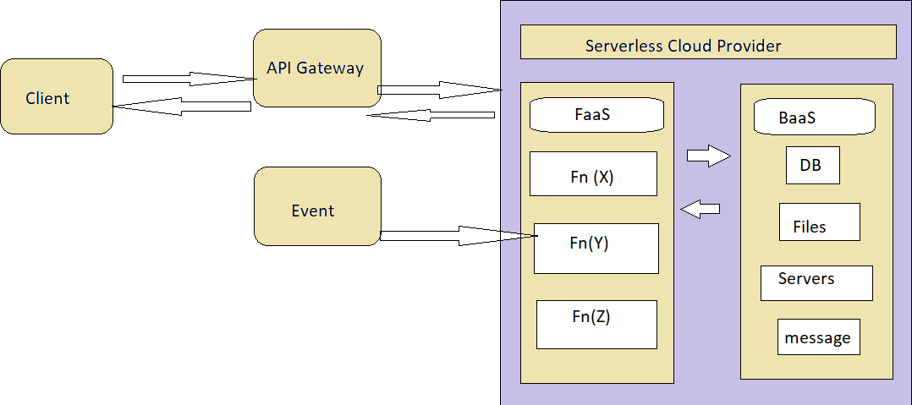

Figure 3

Backend as a Service provides certain services such as content storage, management of users etc. while Function as a Service provides organization of code and executing it. Amazon Lambda introduced the concept of serverless computing in 2014, later the companies Microsoft and Google implemented this method in 2016. The serverless architecture enhances another layer to the cloud computing model while the management of servers are abstracted from the developers. This model lets the developer to work more on the logic than the other functions such as resource allocation, owning, and management of servers as they are handled by cloud service providers.

Authors in examined how the serverless computing is being practiced in IT industry, and concluded that to operate the tools that are essential for serverless architecture, the developer faces a barrier to implement the right mindset to best operate the tools. In IT

industry the serverless architecture is increasing the capabilities, hence it can be used not only for infrastructure enhancement, but can also be used in different kinds of purposes such as big data, training of neural networks, messaging and processing of videos. The scheduling of tasks was explained by the authors in, for the purpose of reducing the time of execution and cost, various scheduling techniques have been described by them. They developed a hybrid model by using IaaS and FaaS, FaaS (Function as a Service) executed smaller tasks that diminishes the cost of execution and longer tasks was based on IaaS (Infrastructure as a Service).

Considering the properties throughput and latency, an efficient model should have higher throughput and lower latency, explains that the serverless computing is mostly used where there must be higher throughput than the lower latency and also used in cases of completing the individual requests in a shorter time. Thus, innovative features take minimal time to reach the market. They also used a case study of Yubl and Mindmup which used serverless platforms to show how their cost reduced up to 66 percentage, and also the disadvantages addressed while adopting it. In deep learning approach, the models were trained using serverless computing, here slight modifications were carried out by the researchers due to the challenges faced because of the tightly coupled characteristics of deep learning models.

Some limitations were proposed for the serverless model in, it describes that serverless platform cannot be used for all applications. If certain products contain no event-based functions, but the running period of that product is high, then the cost required will be higher, hence it is not cost effective in this scenario. For serverless computing platform, a resource managing methods was proposed for enhancing the resources, focusing on containers allocation of memory, here a design called Open Lambda is added to the top layer of the serverless platform. A demonstration for the serverless platform is carried out by using AWS Lambda in, and it is shown in the Figure 4 below. SNS (Simple Notification Service) is used in the process of delivering bulk messages, IAM (Identity and Access Management) – AWS resources can be assessed securely by using IAM.

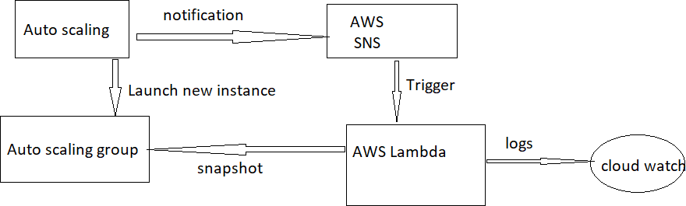Figure 4

Cloud watch is used for receiving and monitoring log files, setting of alarms and respond automatically for the changes produced in resources of AWS, Autoscaling is used for the management of scaling.

# Characteristics

Independent, server-side, logical functions: small, separate, units of logic that take input arguments, process them in some manner, then return the result.

Cost: Typically, its Pay as You Go

Simple Deployment: Thanks to the small size of deployment artifacts, in general, deployments are simple and quick, Deployment artifacts are typically idiomatic of the chosen runtime e.g., NuGet packages, npm packages, JAR files

Ephemeral: Designed to spin up quickly, do their work and then shut down again.

Programming languages: Serverless services support a wide variety of programming languages Node, Python.

Stateless: FaaS are stateless, not storing states, as containers running code will automatically destroy and created by platform. Horizontal Scaling becomes easy...

Event Triggered: Although functions can be invoked directly, they are typically triggered by events from other cloud services, such as incoming HTTP requests,

Simple Deployment Model.

Small Deployable Units and More focus on Business Value.

Managed by third party.

No more "Works on my Machine"

# Benefits

Compared to laaS platforms, serverless architectures offer different tradeoffs in terms of control, cost, and flexibility.

The serverless paradigm has advantages for both consumers and providers.

From the consumer perspective, a cloud developer no longer needs to provision and manage servers, VMs, or containers as the basic computational building block for offering distributed services.

The stateless programming model gives the provider more control over the software stack, allowing them to, among other things, more transparently deliver security patches and optimize the platform.

# Drawbacks

However, drawbacks to both consumers and providers. For consumers, the FaaS model offered by the platform may be too constraining for some applications.

For the provider, there is now a need to manage issues such as the lifecycle of the user's functions, scalability, and fault tolerance in an application-agnostic manner.

# Comparison of Different Models of Serverless Computing

# **Comparison of Azure, AWS and Google cloud serverless computing**

Supporting language:

When comparing three models, AWS Lambda model is better because the programming language here is relatively diverse, also more kinds of supporting languages are provided in AWS Lambda. Stateful functions: The stateful function is not supported in AWS Lambda model, but the services that are stored can be accessed. This kind of support is not present in Google cloud model also. Only Azure function provides stateful function support.

Storage:

S3 and DynamoDB are used in AWS Lambda model for storage purposes, Azure uses blob and Google cloud uses Cloud SQL, Cloud datastore and Cloud storage.

Number of functions:

There is no limited functionality in AWS Lambda and Azure model whereas the Google Cloud have 1000 as a limit for per project.

# Serverless Architecture

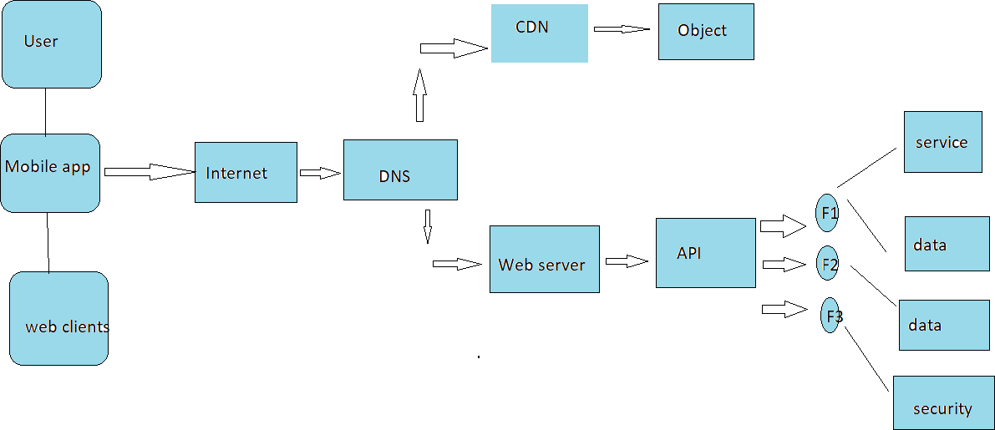

|  |
| --- |
|  |
|  |  |

Figure 5

The serverless architecture includes basic components such as serverless API gateway, FaaS (Function as a service) and BaaS (Backend as a service). Communication process between first end and FaaS is provided by serverless API gateway. Business related logics are executed in FaaS, BaaS eliminates the burdens of the admin in database. The access to the services is provided by accessing the internet in traditional architecture, for example a machine hosting the websites and delivering it to the browser and its size is bigger. When reducing the size of the machine, the cost of it is very much higher, also the life time of the machine is low. To overcome these issues, serverless model have been introduced. In serverless architecture, AWS Lambda, Azure and Google cloud services are available. The below Figure 5 represents the serverless application architecture. The user gets access to the serverless model through a mobile phone, the HTTP request is passed through the Domain Name Server routing, the request outcome is provided through Content Delivery Network, which communicates to the object store. Runtime data is provided to web server by passing the requests via API gateway which forwards the requests to many kinds of functions. The first function is used for the purpose of providing service while second one is used for read and write operations and third one is used for state saving.

This, from the process involved from the flow chart, we can easily understand that serverless model is an effective and time efficient process which many IT industries follow. Since there is no much burden to the developer such as allocating resources, maintaining servers, and owning servers, the developer can concentrate more on the logic process.

# Conclusion

In IT industry the parameters such as cost, security, efforts, time to reach the markets etc. plays a major role. When we host a scheme by using cloud computing, the time required for hosting the project is low, but the security and cost of maintenance cannot be taken into account. But by using serverless cloud computing the execution time, and cost of maintenance is very much low, also it offers high security. The serverless computing includes various benefits such as maintenance, owning of server, resource allocation is not handled by the developer as the cloud service provider takes care of it. The maintenance cost is low as the pricing is based on how much time the application or resource is used. The serverless cloud computing also includes certain challenges such as for a process which takes longer time period to run, serverless architectures cannot be used, as the pricing is based on how much time the code runs. It also includes certain security concerns as the whole backend is run by vendors.