1. **INTRODUCTION**

**1.1 Project Summary**

The "Company Management System" has been developed to override the problems prevailing in the practicing manual system. This software is supported to eliminate and, in some cases, reduce the hardships faced by this existing system.

Moreover, this system is designed for the particular need of the company to carry out operations in a smooth and effective manner. The application is reduced as much as possible to avoid errors while entering the data. It also provides error message while entering invalid data. No formal knowledge is needed for the user to use this system. Thus, by this all it proves it is user-friendly. Company Management System, as described above, can lead to error free, secure, reliable and fast management system. It can assist the user to concentrate on their other activities rather to concentrate on the record keeping.

Thus, it will help organization in better utilization of resources. Every organization, whether big or small, has challenges to overcome and managing the information of Leave, Employee, Expense, Leave Type, Project, Clients, Task. Every Company Management System has different Employee needs. therefore, we design exclusive Company Management System that are adapted to your managerial requirements. This is designed to assist in strategic planning, and will help you ensure that your organization is equipped with the right level of information and details for your future goals.

Also, for those busy executive who are always on the go, our systems come with remote access features, which will allow you to manage your workforce anytime, at all times. These systems will ultimately allow you to better manage resources.

**1.2 Project Technical Profile**

|  |  |
| --- | --- |
| **Project Title:** | Dream Studio Architecture Ltd. |
| **Definition:** | Architecture, the art and technique of designing and building, as distinguished from the skills associated with construction. |
| **Developed For:** | S.D.J. International College, Vesu, Surat |
| **Project Guide:** | Prof. Jaimini Patel |
| **Front End:** | HTML, CSS, Bootstrap, JavaScript |
| **Scripting Language:** | PHP, JavaScript |
| **Back End:** | My SQL, PHP |
| **Operating System:** | Window, Mac OS |
| **Designing Tools:** | Vs code, PHP My Admin, Bootstrap |
| **Tools used for ERD & DFD:** | Wondershare EdrawMax, Xmind |
| **Submitted By:** | 1. Chintan Bhimani A. 2. Pratiksha Chopda B. 3. Jasmin Bhanderi V. |

1. **SCOPES & PLANNING**

2.1 Requirement Analysis

Requirement analysis for a Company Management System would involve identifying the necessary features and functions that the system should have in order to effectively manage employee data and workflows. Here are some key requirements that could be considered:

Employee Information Management: The system should allow for easy storage, retrieval and modification of employee information such as name, contact details, department, job title, employment history, etc.

Leave Management: The system should allow employees to record their leaves, with a dashboard that displays this information to the management.

Benefits: The system should be able to calculate employee salaries based on attendance and other relevant factors. It should also have features for managing employee benefits such as health insurance, retirement plans, etc.

Performance Management: The system should allow managers to set goals, provide feedback, and conduct performance reviews for employees. It should also track and report on employee progress towards their goals.

Training and Development: The system should facilitate employee training and development by providing access to relevant courses, workshops, and other resources.

Communication: The system should enable communication between employees and managers, as well as among employees themselves. It should allow for messaging, file sharing, and other collaborative features.

Security: The system should have strong security measures to protect sensitive employee data. It should also be able to comply with relevant data protection regulations.

Reporting and Analytics: The system should have robust reporting and analytics features to provide insights into employee data, such as attendance trends, performance metrics, and other key performance indicators.

Mobile Compatibility: The system should be accessible on mobile devices, allowing employees and managers to access information and perform tasks on the go.

User-Friendly Interface: The system should have a user-friendly interface that is easy to navigate and use, with clear instructions and helpful features to support users.

**2.2 Technology Details**

* **Hardware Requirements:**

|  |  |  |
| --- | --- | --- |
| Processor | : | Intel(R) Pentium i3 CPU @ 2.30GHz |
| Memory | : | 6 GB |
| Hard Disk | : | 256 GB or Higher |

* **Software Requirements:**

|  |  |  |
| --- | --- | --- |
| Operating System | : | Microsoft Windows 10/11 |
| Front End | : | React.js, HTML |
| Backend | : | Node.js, Express.js |
| Input Device | : | Keyboard, Mouse |
| Output Device | : | Screen |
| Browser | : | All Browser Supported |

1. **DESIGNING**

**3.1 Data Flow Diagram**

**0 Level DFD**

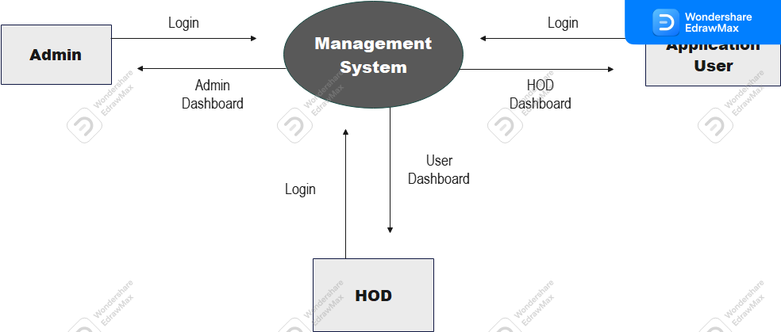

**1st level DFD of Admin Part-1**

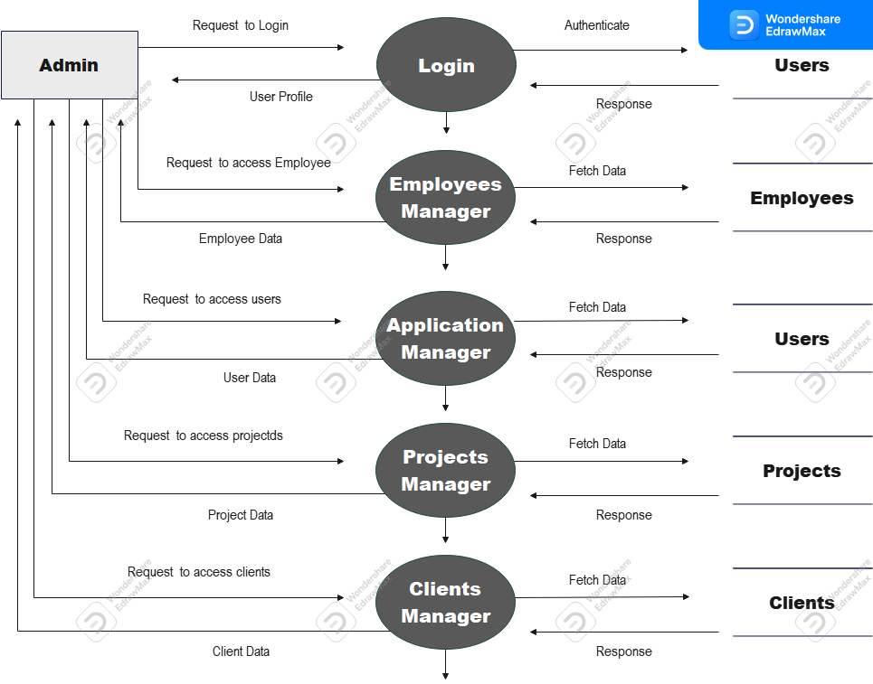

**1st level DFD of Part-2**

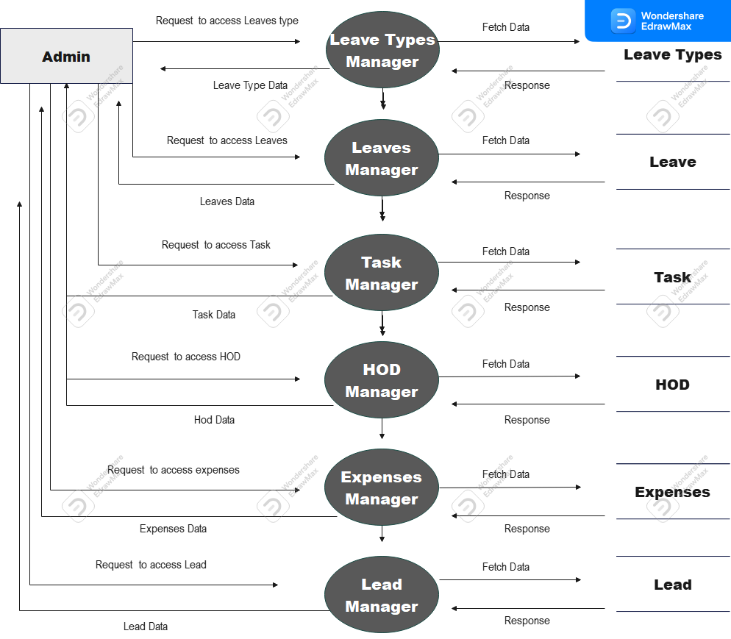

**1st level DFD of HOD Part-1**

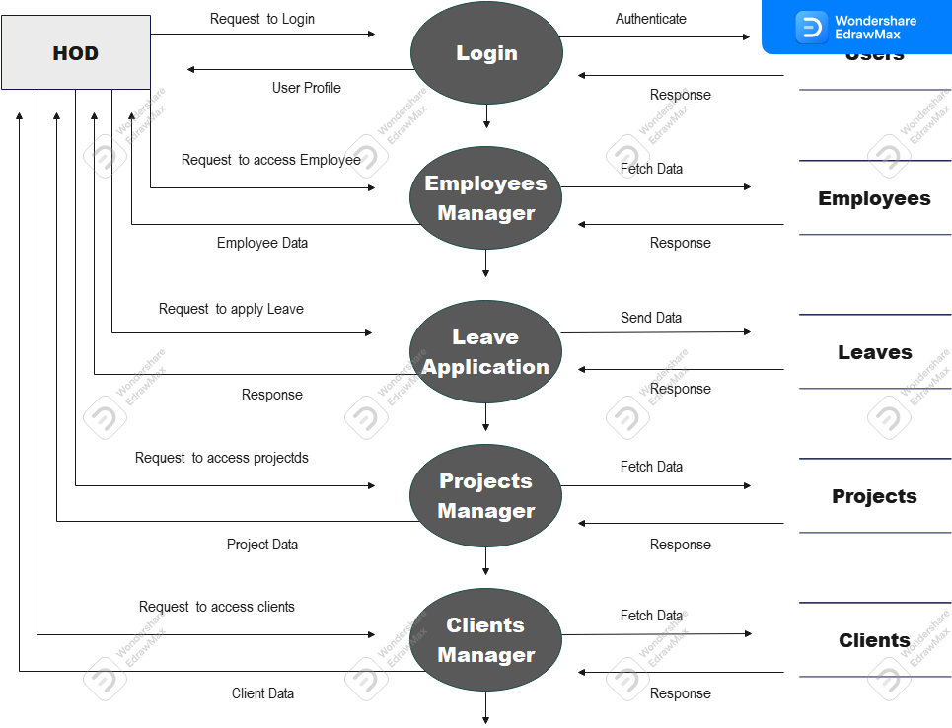

**1st level DFD of HOD Part-2**

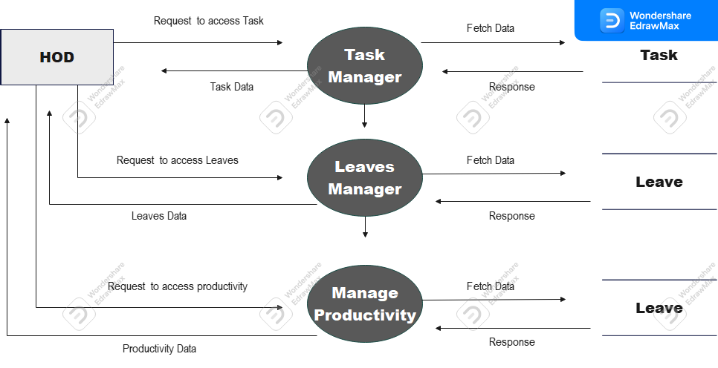

**1st level DFD of Employee**

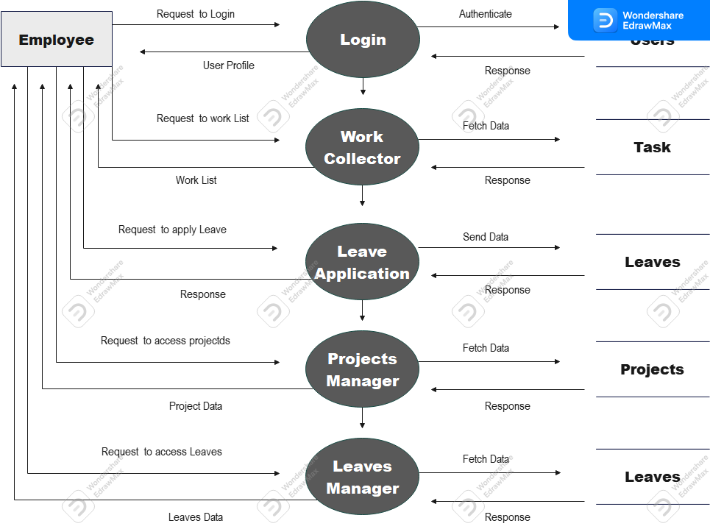

**2nd level DFD of Admin – Application Users**

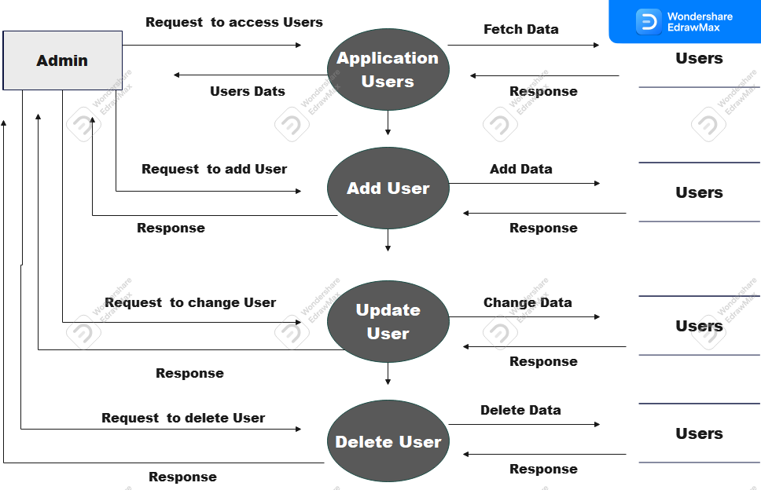

**2nd level DFD of Admin – Task Management**

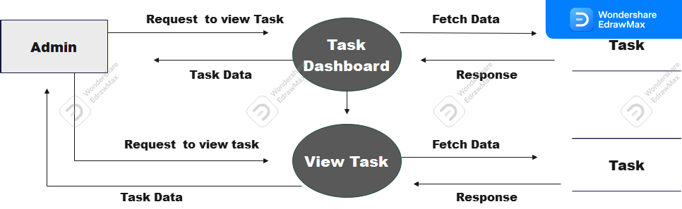

**2nd level DFD of Admin – Project Management**

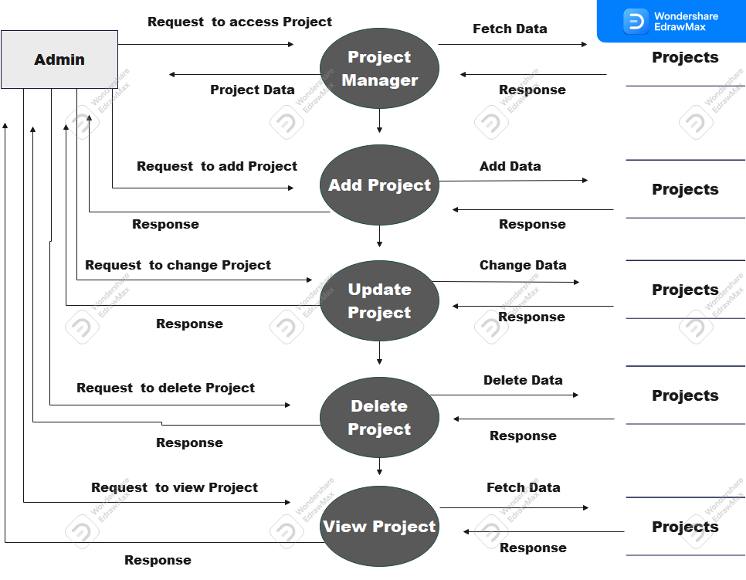

**2nd level DFD of Admin – Profile**

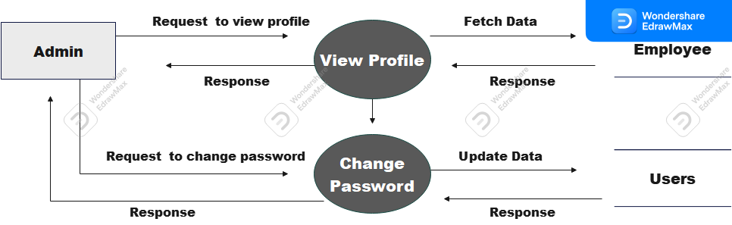

**2nd level DFD of Admin – Leave Types**

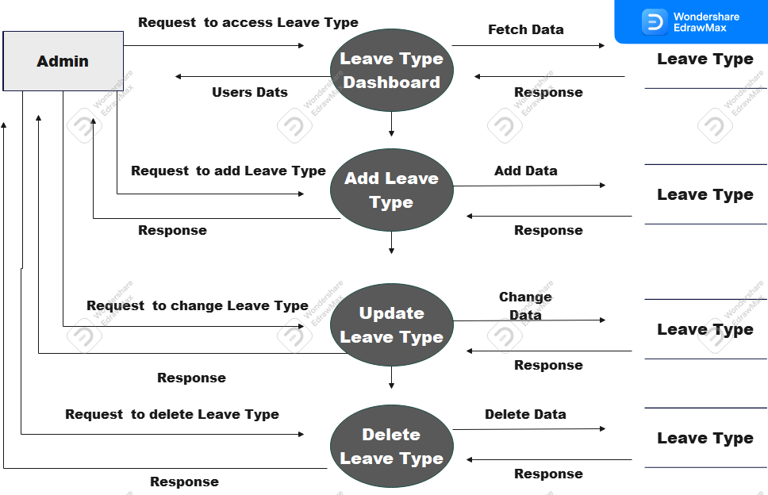

**2nd level DFD of Admin – Leave Management**

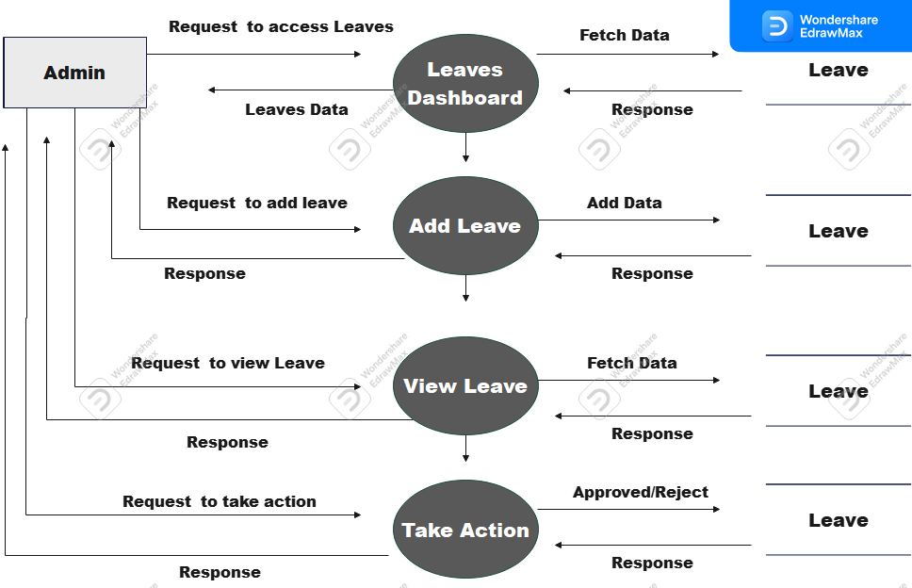

**2nd level DFD of Admin – Leave Management**

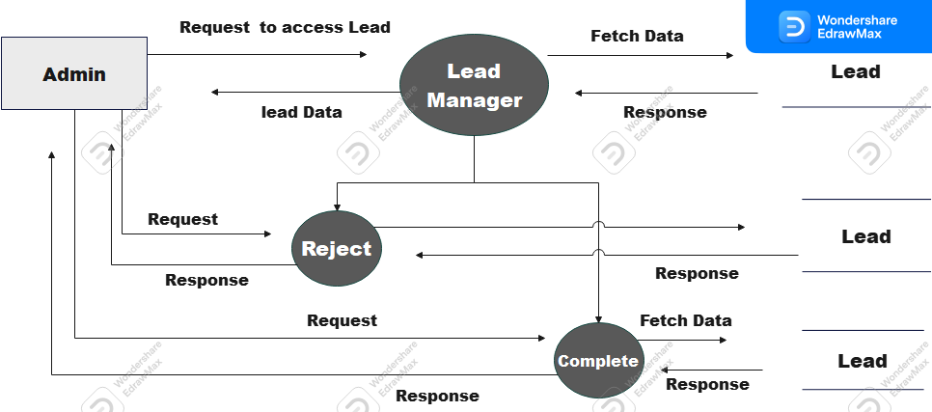

**2nd level DFD of Admin – Expense Management**

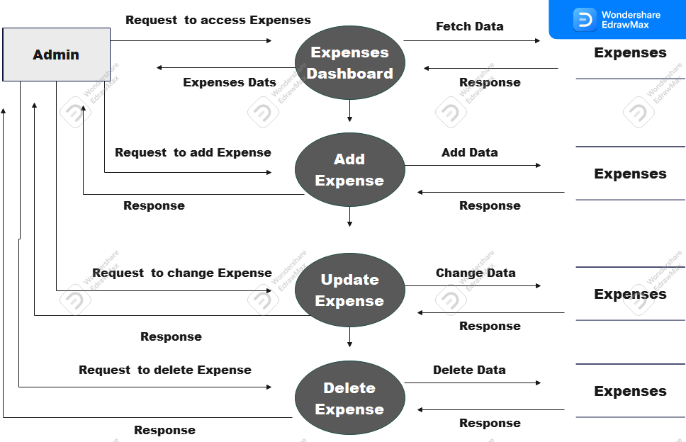

**2nd level DFD of Admin – Client Management**

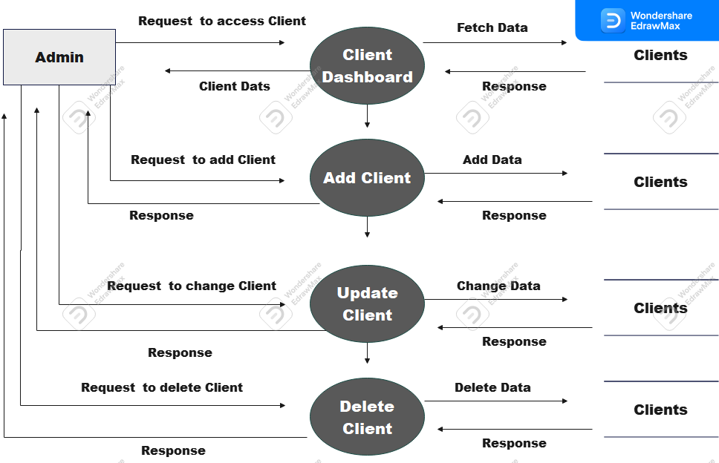

**2nd level DFD of Admin –Employee Management**

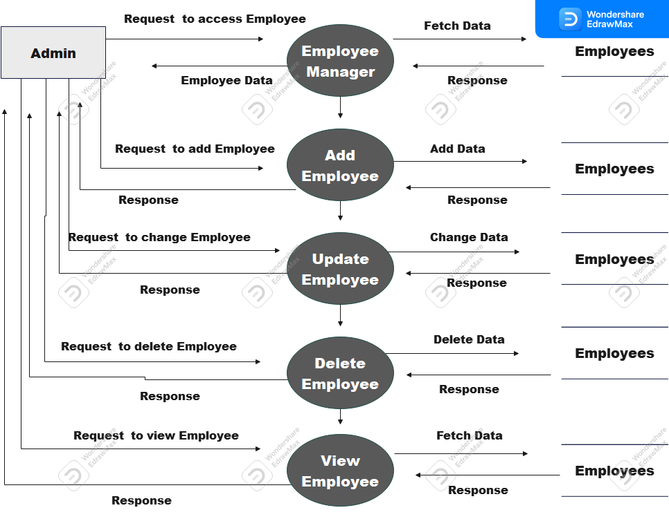

**2nd level DFD of HOD –Project Management**