Name: Thesiya Chintan Dasharthabhai
Roll no: 35
Sub: OBJECT ORIENDTED CONCEPTS AND PROGRAMMING Assignment: 2(Practical)
Date:01/10/2026

Q-1 WAP to use binary operator + add two object of class Numbers having num1 and num2 as its data members and display result.
#include <iostream> using namespace std; class Numbers
{
int n1, n2; public:
Numbers(int x = 0, int y = 0)
{
n1 = x; n2 = y;
}
void input()
{
cout << "Enter first number: "; cin >> n1;
cout << "Enter second number: "; cin >> n2;
}
void display(){
cout << n1 << " " << n2;
}
Numbers operator +(Numbers tmp) { int a1 = n1 + tmp.n1;
int a2 = n2 + tmp.n2; return Numbers(a1, a2);
}
};

int main()
{
int x1, y1, x2, y2;
cout << "--- Enter values for Object 1 ---" << endl; cout << "Enter n1: ";
cin >> x1;
cout << "Enter n2: "; cin >> y1;
Numbers n1(x1, y1);

cout << "\n--- Enter values for Object 2 ---" << endl; cout << "Enter n1: ";
cin >> x2;
cout << "Enter n2: "; cin >> y2;
Numbers n2(x2, y2);

// Adding objects Numbers ans = n1 + n2;

cout << "\nResulting Object (ans): "; ans.display();
cout << endl;

return 0;
}

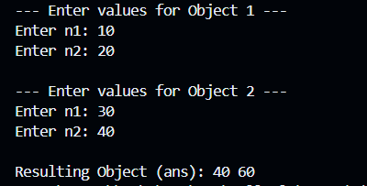
OUTPUT:

Q-2 WAP to overload operator * which multiply a number to each element of an array within a class arrayContainer and display the result.
#include <iostream> using namespace std; class arrayContainer {
int a[10], n; public:
void input() {
cout << "Enter number of elements: "; cin >> n;
cout << "Enter " << n << " elements: "; for (int i = 0; i < n; i++) {
cin >> a[i];
}
}
arrayContainer operator *(int num) { arrayContainer temp;
temp.n = n;
for (int i = 0; i < n; i++) { temp.a[i] = a[i] * num;
}
return temp;
}

void display() {
for (int i = 0; i < n; i++) { cout << a[i] << " ";
}
cout << endl;
}
};

int main() {
arrayContainer arr1, arr2; int num;
arr1.input();
cout << "Enter multiplier: "; cin >> num;
arr2 = arr1 * num; cout << "Result: "; arr2.display();
return 0;
}

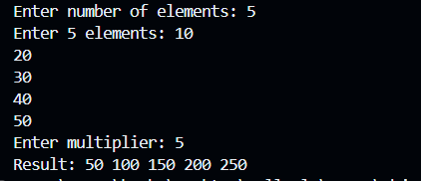
OUTPUT:

Q-3: WAP to Overload the *, +,-, ==, ! = and = operators for the complex class.
#include <iostream> using namespace std;

class Complex { float real, imag;
public:
Complex(float r = 0, float i = 0) { real = r;
imag = i;
}

void input() {
cout << "Enter real and imaginary parts: "; cin >> real >> imag;
}

void display() {
cout << real << " + " << imag << "i\n";
}

// 1. Addition (+)
Complex operator +(Complex c) {
return Complex(real + c.real, imag + c.imag);
}

// 2. Subtraction (-)
Complex operator -(Complex c) {
return Complex(real - c.real, imag - c.imag);
}

// 3. Multiplication (*) : (a+bi)(c+di) = (ac - bd) + (ad + bc)i

Complex operator *(Complex c) {
return Complex(real * c.real - imag * c.imag, real * c.imag + imag * c.real);
}

// 4. Equality (==)
bool operator ==(Complex c) {
return (real == c.real && imag == c.imag);
}

// 5. Not Equal (!=)
bool operator !=(Complex c) { return !(*this == c);
}

// 6. Assignment (=)
Complex operator =(Complex c) { real = c.real;
imag = c.imag; return *this;
}
};

int main() {
Complex c1, c2, res;

cout << "For first complex number:\n"; c1.input();

cout << "For second complex number:\n"; c2.input();

// Addition res = c1 + c2;
cout << "\nSum: "; res.display();

// Subtraction res = c1 - c2;
cout << "Difference: "; res.display();

// Multiplication res = c1 * c2;
cout << "Product: "; res.display();

// Comparison if (c1 == c2)
cout << "c1 is equal to c2\n"; else if (c1 != c2)
cout << "c1 is not equal to c2\n";

// Assignment Complex c3; c3 = c1;
cout << "c3 (assigned from c1): ";

c3.display();

return 0;
}

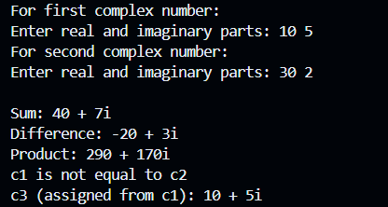
OUTPUT:

Q-4: WAP to define an object m1 of matrix class, use m1<<cout.
#include <iostream> using namespace std; class Matrix {
int m[3][3]; public:
void input() {
cout << "Enter 9 numbers for 3x3 matrix:\n"; for (int i = 0; i < 3; i++) {
for (int j = 0; j < 3; j++) { cin >> m[i][j];
}
}
}

// Overloading << for: m1 << cout
ostream& operator <<(ostream& out) { for (int i = 0; i < 3; i++) {

for (int j = 0; j < 3; j++) { out << m[i][j] << " ";
}
out << "\n";
}
return out;
}
};

int main() { Matrix m1; m1.input();

cout << "\nMatrix output using m1 << cout:\n"; m1 << cout;

return 0;
}

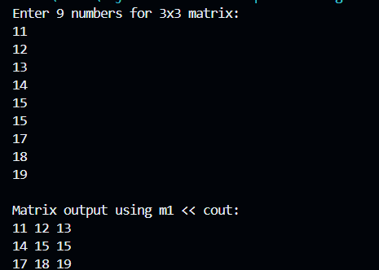
OUTPUT:

Q-5: WAP to define a matrix class and overload the * operator to multiply a number with matrix (Example: 5*Matrix should be possible).
#include<iostream> using namespace std; class Matrix
{
int m[3][3]; public:

void display()
{
for(int i=0;i<3;i++)
{
for(int j=0;j<3;j++) cout<<m[i][j]<<" ";
cout<<"\n";
}
}
void input()
{
cout<<"\n enter num in matrix- "; for (int i = 0; i < 3; i++) {
for(int j=0;j<3;j++) cin >> m[i][j];
}
}
friend Matrix operator *(int num,Matrix obj); friend Matrix operator *(Matrix& obj,int num);
};

Matrix operator *(int num,Matrix obj)
{
Matrix ans; for(int i=0;i<3;i++)
{
for(int j=0;j<3;j++) ans.m[i][j]=obj.m[i][j]*num;
}
return ans;
}
Matrix operator *(Matrix& obj,int num)
{
Matrix ans; for(int i=0;i<3;i++)
{
for(int j=0;j<3;j++) ans.m[i][j]=obj.m[i][j]*num;
}
return ans;
}
int main()
{
Matrix m1; int num; m1.input();
cout<<"\n your matrix is - \n"; m1.display();
cout<<"\n enter num you want to multiply with matrix- ";

cin>>num;
Matrix ans=num*m1;
cout<<"\n your matrix after multiplication is - \n"; ans.display();
}

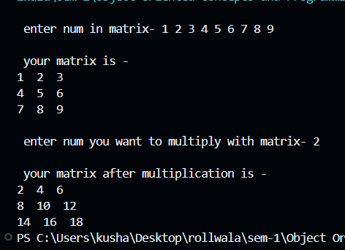
OUTPUT:

Q-6: WAP to define a class Date with properties int month; int day; int year; overload the following operators. 5.1) 5.2) 5.3) 5.4) 5.5) + operator [a+b] (a is of date type and b is an integer), use the assumption that all years all years have 360 days and months 30 days. – operator [a-b(same as above)] = operator <,<=,>,>= ++,--[post and pre both]
#include <iostream> using namespace std;

class Date {
int day, month, year;

// Helper: Convert date to total days int toDays() const {
return year * 360 + month * 30 + day;
}

// Helper: Convert total days back to date void fromDays(int total) {
year = total / 360;

total %= 360; month = total / 30; day = total % 30;
if (day == 0) { day = 30; month--; }
if (month <= 0) { month += 12; year--; }
}

public:
Date(int d = 1, int m = 1, int y = 2000) { day = d;
month = m; year = y;
}

void display() {
cout << day << "/" << month << "/" << year << "\n";
}

// 6.1) a + b (Date + int) Date operator +(int days) {
Date temp;
temp.fromDays(toDays() + days); return temp;
}
// 6.2) a - b (Date - int) Date operator -(int days) {
Date temp;
temp.fromDays(toDays() - days);

return temp;
}
// 6.3) = operator
void operator =(Date d) { day = d.day;
month = d.month; year = d.year;
}
// 6.4) Relational operators (<, <=, >, >=)
bool operator <(Date d) { return toDays() < d.toDays(); } bool operator <=(Date d) { return toDays() <= d.toDays(); } bool operator >(Date d) { return toDays() > d.toDays(); } bool operator >=(Date d) { return toDays() >= d.toDays(); }

// 6.5) ++ and -- operators
// Pre-increment (++d) Date operator ++() {
*this = *this + 1; return *this;
}
// Post-increment (d++) Date operator ++(int) {
Date old = *this;
*this = *this + 1; return old;
}
// Pre-decrement (--d) Date operator --() {

*this = *this - 1; return *this;
}
// Post-decrement (d--) Date operator --(int) {
Date old = *this;
*this = *this - 1; return old;
}
};

int main() {
Date d1(15, 5, 2024), d2(20, 6, 2024);
cout << "Initial Date: "; d1.display();

// 6.1: Date + int Date d3 = d1 + 20;
cout << "After adding 20 days: "; d3.display();

// 6.2: Date - int Date d4 = d1 - 10;
cout << "After subtracting 10 days: "; d4.display();

// 6.3: Assignment Date d5;

d5 = d1;
cout << "Assigned date (d5 = d1): "; d5.display();

// 6.4: Comparison
if (d1 < d2) cout << "d1 is earlier than d2\n"; if (d2 > d1) cout << "d2 is later than d1\n";

// 6.5: Increment / Decrement
++d1; // pre-increment cout << "After ++d1: "; d1.display();

d1++; // post-increment cout << "After d1++: "; d1.display();

--d1; // pre-decrement cout << "After --d1: "; d1.display();

return 0;
}

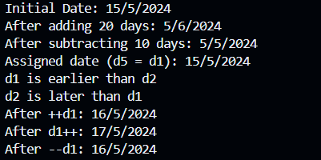
OUTPUT:

Q-7: WAP to define a class Time with properties int hour; int minute; int second; overload the following operators. 6.1) 6.2) 6.3) 6.4) 6.5) + operator [a+b] (a is of time type and b is an integer) – operator [a-b(same as above)] = operator <,<=,>,>= ++,--[post and pre both]
#include <iostream> using namespace std;

class Time {
int hour, min, sec;

// Helper: convert time to total seconds for easy comparison int toSeconds() const {
return hour * 3600 + min * 60 + sec;
}

public:
Time(int h = 0, int m = 0, int s = 0) { hour = h;
min = m; sec = s;
}

void display() {
cout << hour << ":" << min << ":" << sec << "\n";
}

// 7.1) a + b (Time + int seconds) Time operator +(int s) {
Time temp = *this; temp.sec += s;
while (temp.sec >= 60) {

temp.sec -= 60; temp.min++;
}
while (temp.min >= 60) { temp.min -= 60;
temp.hour = (temp.hour + 1) % 24;
}
return temp;
}

// 7.2) a - b (Time - int seconds) Time operator -(int s) {
Time temp = *this; temp.sec -= s;
while (temp.sec < 0) { temp.sec += 60; temp.min--;
}
while (temp.min < 0) { temp.min += 60; temp.hour--;
}
while (temp.hour < 0) { temp.hour += 24;
}
return temp;
}

// 7.3) = operator
void operator =(Time t) { hour = t.hour;
min = t.min; sec = t.sec;
}

// 7.4) Relational operators (<, <=, >, >=)
bool operator <(Time t) { return toSeconds() < t.toSeconds(); } bool operator <=(Time t) { return toSeconds() <= t.toSeconds(); } bool operator >(Time t) { return toSeconds() > t.toSeconds(); } bool operator >=(Time t) { return toSeconds() >= t.toSeconds(); }

// 7.5) Increment (pre and post adds 1 second) Time operator ++() { // Pre (++t)
*this = *this + 1; return *this;
}
Time operator ++(int) { // Post (t++) Time old = *this;
*this = *this + 1; return old;
}

// Decrement (pre and post subtracts 1 second) Time operator --() { // Pre (--t)
*this = *this - 1; return *this;

}
Time operator --(int) { // Post (t--) Time old = *this;
*this = *this - 1; return old;
}
};

int main() {
Time t1(1, 2, 24), t2(2, 0, 0);
int s;

cout << "Initial time: "; t1.display();

// 7.1: Time + seconds
cout << "Enter seconds to add: "; cin >> s;
t1 = t1 + s;
cout << "After addition: "; t1.display();

// 7.2: Time - seconds
cout << "Enter seconds to subtract: "; cin >> s;
t1 = t1 - s;
cout << "After subtraction: "; t1.display();

// 7.3: Assignment Time t3;
t3 = t1;
cout << "Assigned t3: "; t3.display();

// 7.4: Relational
if (t1 < t2) cout << "t1 is earlier than t2\n"; if (t1 > t2) cout << "t1 is later than t2\n";

// 7.5: Increment / Decrement
++t1;
cout << "After ++t1: "; t1.display();

t1--;
cout << "After t1--: "; t1.display();
return 0;
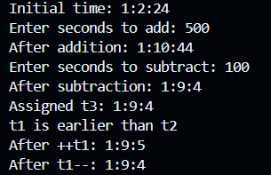
}

OUTPUT:

Q-8: Write a menu driven program that can perform the following functions on strings. (Use overloaded operators where possible).(Do not use predefined string function or class.) 1. Compare two strings for equality (== operator) 2. Check whether first string is smaller than the second (<= operator) 3. Copy the string to another 4. Extract a character from the string (Overload []) 5. Reverse the string 6. Concatenate two strings (+ operator)
#include <iostream>
using namespace std;

class String { char str[100];
public:
// Helper: Find length without strlen() int length() const {
int len = 0;
while (str[len] != '\0') len++; return len;
}
void input() { cin >> str;
}
void display() const { cout << str << "\n";
}
// 1. Equality (== operator)
bool operator ==(const String& s) { int i = 0;
while (str[i] != '\0' && s.str[i] != '\0') {
if (tolower(str[i]) != tolower(s.str[i])) return false; i++;
}
return str[i] == s.str[i]; // true if both ended together

// 2. Smaller or equal (<= operator) - Lexicographical comparison bool operator <=(const String& s) {
int i = 0;
while (str[i] != '\0' && s.str[i] != '\0') { if (str[i] < s.str[i]) return true;
if (str[i] > s.str[i]) return false; i++;
}
return str[i] <= s.str[i];
}

// 3. Copy string to another without strcpy() void copyTo(String& dest) {
int i = 0;
while (str[i] != '\0') {
dest.str[i] = str[i]; i++;
}
dest.str[i] = '\0';
}

// 4. Extract character (overload [] operator) char operator [](int index) {
if (index >= 0 && index < length()) { return str[index];
}
return '\0'; // Invalid index

}

// 5. Reverse the string in-place void reverse() {
int i = 0, j = length() - 1; while (i < j) {
char temp = str[i]; str[i] = str[j];
str[j] = temp; i++;
j--;
}
}

// 6. Concatenate (+ operator) without strcat() String operator +(String& s) {
String result; int i = 0, j = 0;

while (str[i] != '\0') { result.str[i] = str[i]; i++;
}
while (s.str[j] != '\0') {
result.str[i] = s.str[j]; i++;
j++;
}

result.str[i] = '\0'; return result;
}
};

int main() {
String s1, s2, s3; int choice;
do {
cout << "\n--- STRING OPERATIONS MENU ---\n";
cout << "1. Compare two strings for equality (==)\n"; cout << "2. Check if first string is smaller/equal (<=)\n"; cout << "3. Copy string to another\n";
cout << "4. Extract character by index ([])\n"; cout << "5. Reverse string\n";
cout << "6. Concatenate strings (+)\n"; cout << "7. Exit\n";
cout << "Enter your choice: "; cin >> choice;
switch (choice) { case 1:
cout << "Enter first string: "; s1.input(); cout << "Enter second string: "; s2.input();
if (s1 == s2) cout << "Result: Strings are equal.\n"; else cout << "Result: Strings are NOT equal.\n"; break;
case 2:
cout << "Enter first string: "; s1.input();

cout << "Enter second string: "; s2.input();
if (s1 <= s2) cout << "Result: First string is smaller or equal.\n"; else cout << "Result: First string is greater.\n";
break; case 3:
cout << "Enter string to copy: "; s1.input(); s1.copyTo(s2);
cout << "Copied string: "; s2.display(); break;
case 4: { int index;
cout << "Enter string: "; s1.input();
cout << "Enter index (0-based): "; cin >> index; char ch = s1[index];
if (ch != '\0') cout << "Character at index " << index << " is: " << ch << "\n"; else cout << "Invalid index!\n";
break;
}
case 5:
cout << "Enter string to reverse: "; s1.input(); s1.reverse();
cout << "Reversed string: "; s1.display(); break;
case 6:
cout << "Enter first string: "; s1.input(); cout << "Enter second string: "; s2.input(); s3 = s1 + s2;
cout << "Concatenated string: "; s3.display();

break; case 7:
cout << "Exiting program...\n"; break;
default:
cout << "Invalid choice! Try again.\n";
}
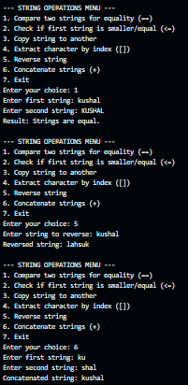
} while (choice != 7); return 0;
}

OUTPUT:

Q-9: WAP to Overload the New and Delete for Stack Class.
#include <iostream>
#include <cstdlib> // For malloc() and free() using namespace std;

class Stack { int arr[10]; int top;

public: Stack() {
top = -1;
}

void push(int val) { if (top == 9) {
cout << "Stack Overflow\n"; return;
}
arr[++top] = val;
}

void pop() {
if (top == -1) {
cout << "Stack Underflow\n"; return;
}
cout << "Popped: " << arr[top--] << "\n";
}
// Overloading new operator
void* operator new(size_t size) {
cout << "Custom new: Allocating memory (" << size << " bytes)\n"; void* ptr = malloc(size);
return ptr;
}

// Overloading delete operator

void operator delete(void* ptr) {
cout << "Custom delete: Freeing memory\n"; free(ptr);
}
};
int main() {
// Dynamically allocate Stack using overloaded new Stack* s = new Stack();
s->push(10);
s->push(20);
s->pop();
// Free memory using overloaded delete delete s;
return 0;
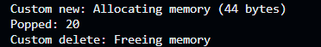
}

OUTPUT:

Q-10: Write a template function to make sum of two numbers.
#include<iostream> using namespace std;
template <typename T> T add(T a,T b)
{
T ans=a+b; return ans;
}

int main()

{
int a,b; float x,y;
cout<<"\n enter two integer nums- "; cin>>a>>b;
cout<<"\n addition of integer is - "<<add(a,b); cout<<"\n enter two float nums- ";
cin>>x>>y;
cout<<"\n addition of float is - "<<add(x,y);
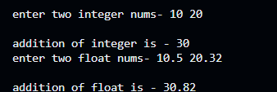
}

OUTPUT:

Q-11: Write a program to generate templates function for swapping values of variables and show its use with integer, float and character type of data as input.
#include <iostream> using namespace std;
// Template function to swap two values of any type template <typename T>
void swapValues(T &a, T &b) { T temp = a;
a = b;
b = temp;
}
int main() {
// 1. Swapping integers int x = 10, y = 20;
cout << "Before swap (int): x = " << x << ", y = " << y << "\n"; swapValues(x, y);

cout << "After swap (int): x = " << x << ", y = " << y << "\n\n";

// 2. Swapping floats
float f1 = 1.5f, f2 = 9.8f;
cout << "Before swap (float): f1 = " << f1 << ", f2 = " << f2 << "\n"; swapValues(f1, f2);
cout << "After swap (float): f1 = " << f1 << ", f2 = " << f2 << "\n\n";

// 3. Swapping characters char c1 = 'A', c2 = 'Z';
cout << "Before swap (char): c1 = " << c1 << ", c2 = " << c2 << "\n"; swapValues(c1, c2);
cout << "After swap (char): c1 = " << c1 << ", c2 = " << c2 << "\n"; return 0;
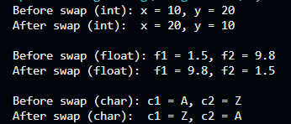
}

OUTPUT:

Q-12: Write an object-oriented program to implement a generic Number Class that can accept either int or float data type and perform basic calculation like +,-,/ and *.
#include <iostream> using namespace std;

// Class template for generic Number operations template <typename T>
class Number { T val;

public:
Number(T v = 0) { val = v;
}

T add(Number n) { return val + n.val; }
T subtract(Number n) { return val - n.val; } T multiply(Number n) { return val * n.val; } T divide(Number n) { return val / n.val; }
};
int main() {
// 1. Working with integers Number<int> int1(20), int2(5);
cout << "--- Integer Calculations ---\n"; cout << "20 + 5 = " << int1.add(int2) << "\n";
cout << "20 - 5 = " << int1.subtract(int2) << "\n"; cout << "20 * 5 = " << int1.multiply(int2) << "\n"; cout << "20 / 5 = " << int1.divide(int2) << "\n\n";

// 2. Working with floats Number<float> f1(12.5f), f2(2.5f);
cout << "--- Float Calculations ---\n";
cout << "12.5 + 2.5 = " << f1.add(f2) << "\n"; cout << "12.5 - 2.5 = " << f1.subtract(f2) << "\n"; cout << "12.5 * 2.5 = " << f1.multiply(f2) << "\n"; cout << "12.5 / 2.5 = " << f1.divide(f2) << "\n"; return 0;
}

OUTPUT: 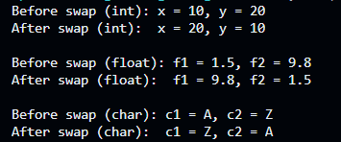

Q-13: Write an object-oriented program to implement a generic Stack. Incorporate all the possible operation on Stack in the program.
#include <iostream> using namespace std; #define MAX 5
template <typename T> class Stack {
T arr[MAX]; int top;
public: Stack() {
top = -1;
}
bool isFull() {
return top == MAX - 1;
}

bool isEmpty() { return top == -1;
}
// 1. Push operation void push(T val) {
if (isFull()) {
cout << "Stack Overflow! Cannot push.\n";

return;
}
arr[++top] = val;
cout << "Pushed: " << val << "\n";
}

// 2. Pop operation void pop() {
if (isEmpty()) {
cout << "Stack Underflow! Nothing to pop.\n"; return;
}
cout << "Popped: " << arr[top--] << "\n";
}

// 3. Peek / Top element void peek() {
if (isEmpty()) {
cout << "Stack is empty.\n"; return;
}
cout << "Top element: " << arr[top] << "\n";
}
// 4. Display stack elements void display() {
if (isEmpty()) {
cout << "Stack is empty.\n"; return;

}
cout << "Stack elements: "; for (int i = top; i >= 0; i--) {
cout << arr[i] << " ";
}
cout << "\n";
}
};
int main() {
// Integer Stack
cout << "=== Integer Stack ===\n"; Stack<int> intStack;
intStack.push(10); intStack.push(20); intStack.push(30); intStack.display(); intStack.peek(); intStack.pop(); intStack.display();
cout << "\n=== String/Char Stack ===\n"; Stack<string> strStack;
strStack.push("Apple"); strStack.push("Banana"); strStack.display(); strStack.pop();
strStack.display(); return 0;
}

OUTPUT: 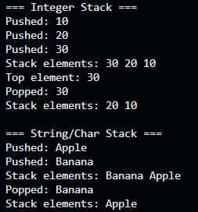

Q-14: Write a generic function that will sort a character string, integer and float value. Create a menu with appropriate options and accept the values from the user.
#include <iostream> using namespace std;

// Generic template function to sort an array of any type template <typename T>
void sortArray(T arr[], int n) { for (int i = 0; i < n - 1; i++) {
for (int j = 0; j < n - i - 1; j++) { if (arr[j] > arr[j + 1]) {
T temp = arr[j]; arr[j] = arr[j + 1]; arr[j + 1] = temp;
}
}
}
}

// Helper template function to display array elements template <typename T>

void displayArray(T arr[], int n) { for (int i = 0; i < n; i++) {
cout << arr[i] << " ";
}
cout << "\n";
}

int main() { int choice;

do {
cout << "\n--- SORTING MENU ---\n";
cout << "1. Sort Integer Array\n"; cout << "2. Sort Float Array\n";
cout << "3. Sort Character Array (String)\n"; cout << "4. Exit\n";
cout << "Enter your choice: "; cin >> choice;

switch (choice) { case 1: {
int n;
cout << "Enter number of integers: "; cin >> n;
int arr[50];
cout << "Enter " << n << " integers: "; for (int i = 0; i < n; i++) cin >> arr[i];

sortArray(arr, n);
cout << "Sorted integers: "; displayArray(arr, n);
break;
}

case 2: { int n;
cout << "Enter number of floats: "; cin >> n;
float arr[50];
cout << "Enter " << n << " floats: "; for (int i = 0; i < n; i++) cin >> arr[i];

sortArray(arr, n);
cout << "Sorted floats: "; displayArray(arr, n);
break;
}

case 3: { int n;
cout << "Enter number of characters: "; cin >> n;
char arr[50];
cout << "Enter " << n << " characters: "; for (int i = 0; i < n; i++) cin >> arr[i];

sortArray(arr, n);
cout << "Sorted characters: "; displayArray(arr, n);
break;
}

case 4:
cout << "Exiting program...\n"; break;

default:
cout << "Invalid choice! Try again.\n";
}
} while (choice != 4);

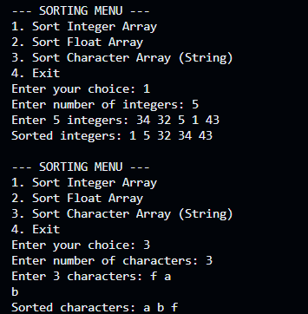
return 0;
}

OUTPUT:

Q-15: Write a template function called find(). This function searches an array for an object. It returns either the index of the matching object (if one is found) or
-1 if not match is found

#include <iostream> using namespace std;
// Template function to search for an element in an array template <typename T>
int find(T arr[], int size, T key) { for (int i = 0; i < size; i++) {
if (arr[i] == key) {
return i; // Found: return index
}
}
return -1; // Not found
}

int main() {
// 1. Searching in an integer array int intArr[] = {10, 25, 30, 45, 50};
int intSize = 5; int intKey = 30;

int intResult = find(intArr, intSize, intKey); if (intResult != -1)
cout << intKey << " found at index: " << intResult << "\n"; else
cout << intKey << " not found\n";

// 2. Searching in a float array
float floatArr[] = {1.2f, 3.4f, 5.6f, 7.8f}; int floatSize = 4;
float floatKey = 9.9f;

int floatResult = find(floatArr, floatSize, floatKey); if (floatResult != -1)
cout << floatKey << " found at index: " << floatResult << "\n"; else
cout << floatKey << " not found\n";

return 0;
}

OUTPUT: 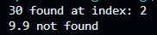

Q:16: WAP to create base class Book having int id and char name as data members and respective functionality, show following types of inheritance and display the details of each kind of books, also calculate the total no of each type of books in proper format. Simple inheritance with derived class Sales Hierarchical inheritance with derived classes academics and thrillers Show use of constructor and destructor in above examples of inheritance.
#include <iostream> #include <cstring>
using namespace std;

// Base class class Book { protected:
int id;
char name[50];

public:
Book(int i = 0, const char n[] = "") { id = i;
strcpy(name, n);
}

void displayBook() {
cout << "Book ID : " << id << endl;
cout << "Book Name : " << name << endl;
}

~Book() {
cout << "Book Destructor called" << endl;
}
};

// Simple Inheritance
class Sales : public Book { private:
float price;

public:
Sales(int i, const char n[], float p) : Book(i, n) { price = p;
}

void display() {
cout << "\n--- Sales Book ---" << endl; displayBook();
cout << "Price : " << price << endl;
}

~Sales() {

cout << "Sales Destructor called" << endl;
}
};

// Hierarchical Inheritance
class Academics : public Book { private:
char subject[30];

public:
Academics(int i, const char n[], const char s[]) : Book(i, n) { strcpy(subject, s);
}

void display() {
cout << "\n--- Academic Book ---" << endl; displayBook();
cout << "Subject : " << subject << endl;
}

~Academics() {
cout << "Academics Destructor called" << endl;
}
};

class Thrillers : public Book {

private:
char author[30];

public:
Thrillers(int i, const char n[], const char a[]) : Book(i, n) { strcpy(author, a);
}

void display() {
cout << "\n--- Thriller Book ---" << endl; displayBook();
cout << "Author : " << author << endl;
}

~Thrillers() {
cout << "Thrillers Destructor called" << endl;
}
};

int main() {

int salesCount = 0;
int academicCount = 0; int thrillerCount = 0;

// Sales books - Simple inheritance Sales s1(101, "Marketing Basics", 450);

Sales s2(102, "Sales Management", 550);

s1.display();
s2.display();

salesCount = 2;

// Academic books - Hierarchical inheritance
Academics a1(201, "C++ Programming", "Programming"); Academics a2(202, "Database Management", "Database");

a1.display();
a2.display();

academicCount = 2;

// Thriller books - Hierarchical inheritance
Thrillers t1(301, "The Silent Patient", "Alex Michaelides"); Thrillers t2(302, "Gone Girl", "Gillian Flynn");

t1.display();
t2.display();

thrillerCount = 2;

// Total count
cout << "\n============================" << endl;
cout << " BOOK SUMMARY" << endl;
cout << "============================" << endl;

cout << "Total Sales Books : " << salesCount << endl;
cout << "Total Academic Books : " << academicCount << endl; cout << "Total Thriller Books : " << thrillerCount << endl;
cout << "Total Books : "
<< salesCount + academicCount + thrillerCount << endl;

cout << "============================" << endl;

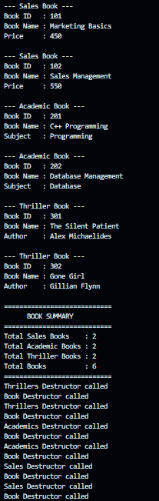
return 0;
}

OUTPUT:

Q-17: WAP to create student having data members (rollno, name, stream) as base class. Derive class subject with marks of 5 subjects and apply respective functionality. Calculate final result and display details of each student from derived class. (multilevel inheritance).
#include <iostream> using namespace std;
// Base class class Student { protected:
int rollno;
char name[50]; char stream[30];
public:
void getStudentDetails() { cout << "Enter Roll No: "; cin >> rollno;
cout << "Enter Name: "; cin >> name;
cout << "Enter Stream: "; cin >> stream;
}
void displayStudentDetails() {
cout << "Roll No : " << rollno << endl; cout << "Name : " << name << endl; cout << "Stream : " << stream << endl;
}
};
// Derived class - Level 2
class Subject : public Student { protected:
float marks[5];

public:
void getMarks() {
cout << "\nEnter marks of 5 subjects:\n"; for (int i = 0; i < 5; i++) {
cout << "Subject " << i + 1 << ": "; cin >> marks[i];
}
}
void displayMarks() { cout << "Marks : "; for (int i = 0; i < 5; i++) {
cout << marks[i] << " ";
}
cout << endl;
}
};
// Derived class - Level 3
class Result : public Subject { private:
float total;
float percentage; public:
void calculateResult() { total = 0;
for (int i = 0; i < 5; i++) { total += marks[i];
}
percentage = total / 5;

}
void displayResult() {
cout << "\n--- STUDENT DETAILS ---\n";
displayStudentDetails(); displayMarks();
cout << "Total : " << total << endl;
cout << "Percentage : " << percentage << "%" << endl; if (percentage >= 40)
cout << "Result : PASS" << endl; else
cout << "Result : FAIL" << endl;
}
};
int main() { Result student;
student.getStudentDetails(); student.getMarks();
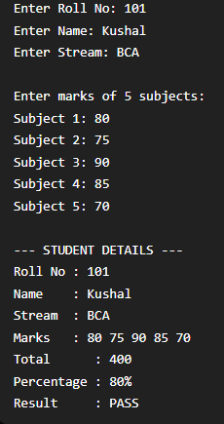
student.calculateResult(); student.displayResult(); return 0;
}

OUTPUT:

Q:18: WAP to create Class Person, Employee and Department and Apply respective functionalities using inheritance.
#include <iostream> using namespace std;

// Base class class Person { protected:
char name[50]; int age;
public:
void getPersonDetails() { cout << "Enter Name: "; cin >> name;
cout << "Enter Age: "; cin >> age;
}
void displayPersonDetails() {
cout << "Name : " << name << endl; cout << "Age : " << age << endl;
}
};

// Derived class
class Employee : public Person { protected:
int empId; float salary;

public:
void getEmployeeDetails() { cout << "Enter Employee ID: "; cin >> empId;
cout << "Enter Salary: "; cin >> salary;
}

void displayEmployeeDetails() {
cout << "Employee ID: " << empId << endl; cout << "Salary : " << salary << endl;
}
};

// Derived class
class Department : public Employee { private:
char deptName[50]; public:
void getDepartmentDetails() { cout << "Enter Department: "; cin >> deptName;
}

void displayDetails() {
cout << "\n--- EMPLOYEE DETAILS ---\n";
displayPersonDetails();
displayEmployeeDetails();

cout << "Department : " << deptName << endl;
}
};

int main() { Department d;
d.getPersonDetails();
d.getEmployeeDetails();
d.getDepartmentDetails(); d.displayDetails();
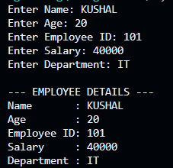
return 0;
}

OUTPUT:

Q:19: An educational institution wishes to maintain a database of its employees. The database is divided into a number of classes that you may identify. You have to take minimum information required for each class. Specify all the classes and define function to create the database and retrieve individual information as and when required. Write parameterized constructor for each class in the hierarchy.
#include <iostream> #include <cstring>
using namespace std;

// Base class class Person { protected:
char name[50];

public:
// Default constructor Person() {
strcpy(name, ""); age = 0;
}

// Parameterized constructor Person(const char n[], int a) {
strcpy(name, n); age = a;
}

void displayPerson() {
cout << "Name : " << name << endl; cout << "Age : " << age << endl;
}
};

// Derived class
class Employee : public Person { protected:
int empId; float salary;

public:
// Default constructor

Employee() : Person() { empId = 0;
salary = 0;
}

// Parameterized constructor
Employee(const char n[], int a, int id, float s)
: Person(n, a) { empId = id; salary = s;
}

void displayEmployee() { displayPerson();
cout << "Employee ID: " << empId << endl; cout << "Salary : " << salary << endl;
}

int getId() { return empId;
}
};

// Derived class
class Faculty : public Employee { private:
char department[50]; char designation[50];

public:
// Default constructor Faculty() : Employee() {
strcpy(department, ""); strcpy(designation, "");
}

// Parameterized constructor
Faculty(const char n[], int a, int id, float s, const char dept[], const char desig[])
: Employee(n, a, id, s) { strcpy(department, dept); strcpy(designation, desig);
}

void display() {
displayEmployee();
cout << "Department : " << department << endl; cout << "Designation: " << designation << endl;
}

void input() {
cout << "\nEnter Name: "; cin >> name;

cout << "Enter Age: "; cin >> age;

cout << "Enter Employee ID: "; cin >> empId;

cout << "Enter Salary: "; cin >> salary;

cout << "Enter Department: "; cin >> department;

cout << "Enter Designation: "; cin >> designation;
}
};

// Create database
void createDatabase(Faculty database[], int &count) {

int n;

cout << "Enter number of employees: "; cin >> n;

for (int i = 0; i < n; i++) {

cout << "\n--- Enter Employee " << i + 1 << " Details ---\n";

database[i].input();

count++;
}
}
// Retrieve employee information
void retrieveEmployee(Faculty database[], int count, int id) { for (int i = 0; i < count; i++) {
if (database[i].getId() == id) {
cout << "\n--- EMPLOYEE INFORMATION ---\n";
database[i].display(); return;
}
}
cout << "\nEmployee not found.\n";
}
int main() {
Faculty database[50]; int count = 0;
// Create database
createDatabase(database, count);
// Retrieve information int id;
cout << "\nEnter Employee ID to retrieve: "; cin >> id;
retrieveEmployee(database, count, id); return 0;
}

OUTPUT: 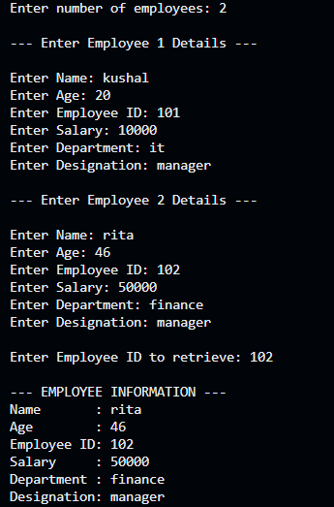

Q-20: Create a class student from which the classes test and sports are derived. The class student has the name and rollno of the student. The class test has the marks of the internal test and the sports class has the marks of the sports test. The class student contains a virtual function display() which are implemented in the classes test and sports. Write a program which will take relative information and display it using pointer of the base class.
#include <iostream> using namespace std;

// Base class class Student { protected:
char name[50]; int rollno;
public:
void getStudentDetails() { cout << "Enter Name: "; cin >> name;

cout << "Enter Roll No: "; cin >> rollno;
}

virtual void display() {
cout << "Name : " << name << endl; cout << "Roll No : " << rollno << endl;
}
};

// Derived class
class Test : public Student { private:
float internalMarks;

public:
void getTestDetails() { getStudentDetails();

cout << "Enter Internal Test Marks: "; cin >> internalMarks;
}

void display() {
cout << "\n--- INTERNAL TEST DETAILS ---\n";
cout << "Name : " << name << endl; cout << "Roll No : " << rollno << endl;

cout << "Internal Marks: " << internalMarks << endl;
}
};

// Derived class
class Sports : public Student { private:
float sportsMarks;

public:
void getSportsDetails() { getStudentDetails();

cout << "Enter Sports Test Marks: "; cin >> sportsMarks;
}

void display() {
cout << "\n--- SPORTS TEST DETAILS ---\n";
cout << "Name : " << name << endl; cout << "Roll No : " << rollno << endl;
cout << "Sports Marks : " << sportsMarks << endl;
}
};

int main() {

Test t;

Sports s;

cout << "--- Enter Internal Test Student Details ---\n"; t.getTestDetails();

cout << "\n--- Enter Sports Student Details ---\n"; s.getSportsDetails();

// Base class pointer Student *ptr;

// Point to Test object ptr = &t;
ptr->display();

// Point to Sports object ptr = &s;
ptr->display();

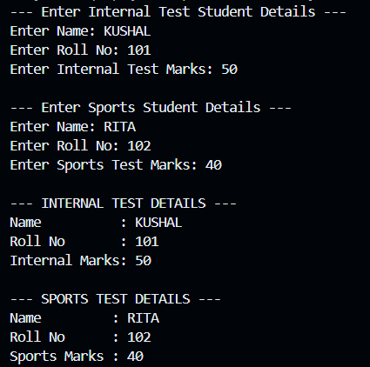
return 0;
}

OUTPUT:

Q-21: Define a class Figure and use inheritance to define the classes Triangle, Square, Circle, and Rectangle. Provide a container class Frame to contain any number of figures, possibly overlapped in position. Provide operations for drawing frames on the screen and for inserting, modifying, and deleting frames and the contents of frames. (Actual drawing is not required).
#include <iostream> using namespace std;

// Base class class Figure { protected:
int id; int x, y;

public:
Figure(int i, int xPos, int yPos) { id = i;
x = xPos; y = yPos;
}

virtual void display() {
cout << "Figure ID: " << id << endl;
cout << "Position : (" << x << ", " << y << ")" << endl;
}

int getId() { return id;
}

virtual void modify() {
cout << "Enter new X position: ";

cin >> x;

cout << "Enter new Y position: "; cin >> y;
}

virtual ~Figure() {}
};

// Triangle
class Triangle : public Figure { private:
float base, height;

public:
Triangle(int i, int xPos, int yPos, float b, float h)
: Figure(i, xPos, yPos) { base = b;
height = h;
}

void display() {
cout << "\n--- Triangle ---\n"; cout << "ID : " << id << endl;
cout << "Position : (" << x << ", " << y << ")" << endl; cout << "Base : " << base << endl;
cout << "Height : " << height << endl;
}

void modify() {
cout << "Enter new Base: "; cin >> base;

cout << "Enter new Height: "; cin >> height;

Figure::modify();
}
};

// Square
class Square : public Figure { private:
float side;

public:
Square(int i, int xPos, int yPos, float s)
: Figure(i, xPos, yPos) { side = s;
}

void display() {
cout << "\n--- Square ---\n"; cout << "ID : " << id << endl;
cout << "Position : (" << x << ", " << y << ")" << endl; cout << "Side : " << side << endl;

}

void modify() {
cout << "Enter new Side: "; cin >> side;

Figure::modify();
}
};

// Circle
class Circle : public Figure { private:
float radius;

public:
Circle(int i, int xPos, int yPos, float r)
: Figure(i, xPos, yPos) { radius = r;
}

void display() {
cout << "\n--- Circle ---\n"; cout << "ID : " << id << endl;
cout << "Position : (" << x << ", " << y << ")" << endl; cout << "Radius : " << radius << endl;
}

void modify() {
cout << "Enter new Radius: "; cin >> radius;

Figure::modify();
}
};

// Rectangle
class Rectangle : public Figure { private:
float length, width;

public:
Rectangle(int i, int xPos, int yPos, float l, float w)
: Figure(i, xPos, yPos) { length = l;
width = w;
}

void display() {
cout << "\n--- Rectangle ---\n"; cout << "ID : " << id << endl;
cout << "Position : (" << x << ", " << y << ")" << endl; cout << "Length : " << length << endl;
cout << "Width : " << width << endl;
}

void modify() {
cout << "Enter new Length: "; cin >> length;

cout << "Enter new Width: "; cin >> width;

Figure::modify();
}
};

// Container class class Frame { private:
Figure* figures[50]; int count;

public: Frame() {
count = 0;
}

// Insert a figure
void insert(Figure* f) { if (count < 50) {
figures[count] = f; count++;

cout << "Figure inserted successfully.\n";
}
else {
cout << "Frame is full.\n";
}
}

// Display all figures void display() {
cout << "\n===== FRAME CONTENTS =====\n";

if (count == 0) {
cout << "Frame is empty.\n"; return;
}

for (int i = 0; i < count; i++) { figures[i]->display();
}
}

// Modify a figure
void modify(int id) {
for (int i = 0; i < count; i++) { if (figures[i]->getId() == id) {
figures[i]->modify();
cout << "Figure modified successfully.\n"; return;

}
}

cout << "Figure not found.\n";
}

// Delete a figure
void remove(int id) {
for (int i = 0; i < count; i++) { if (figures[i]->getId() == id) {

delete figures[i];

for (int j = i; j < count - 1; j++) { figures[j] = figures[j + 1];
}

count--;

cout << "Figure deleted successfully.\n"; return;
}
}

cout << "Figure not found.\n";
}

~Frame() {

for (int i = 0; i < count; i++) { delete figures[i];
}
}
};

int main() {

Frame frame;

int choice;

do {
cout << "\n===== FRAME MENU =====\n";
cout << "1. Insert Triangle\n"; cout << "2. Insert Square\n"; cout << "3. Insert Circle\n"; cout << "4. Insert Rectangle\n"; cout << "5. Display Frame\n"; cout << "6. Modify Figure\n"; cout << "7. Delete Figure\n"; cout << "8. Exit\n";

cout << "Enter choice: "; cin >> choice;

switch (choice) {

case 1: {
int id, x, y; float b, h;

cout << "Enter ID: "; cin >> id;

cout << "Enter X and Y position: "; cin >> x >> y;

cout << "Enter Base and Height: "; cin >> b >> h;

frame.insert(new Triangle(id, x, y, b, h)); break;
}

case 2: {
int id, x, y; float side;

cout << "Enter ID: "; cin >> id;

cout << "Enter X and Y position: "; cin >> x >> y;

cout << "Enter Side: ";

cin >> side;

frame.insert(new Square(id, x, y, side)); break;
}
case 3: {
int id, x, y; float radius;
cout << "Enter ID: "; cin >> id;
cout << "Enter X and Y position: "; cin >> x >> y;
cout << "Enter Radius: "; cin >> radius;
frame.insert(new Circle(id, x, y, radius)); break;
}
case 4: {
int id, x, y;
float length, width; cout << "Enter ID: "; cin >> id;
cout << "Enter X and Y position: "; cin >> x >> y;
cout << "Enter Length and Width: "; cin >> length >> width;
frame.insert(new Rectangle(id, x, y, length, width)); break;

}
case 5:
frame.display(); break;
case 6: { int id;
cout << "Enter Figure ID to modify: "; cin >> id;
frame.modify(id); break;
}
case 7: { int id;
cout << "Enter Figure ID to delete: "; cin >> id;
frame.remove(id); break;
}
case 8:
cout << "Exiting...\n"; break;
default:
cout << "Invalid choice.\n";
}
} while (choice != 8); return 0;
}

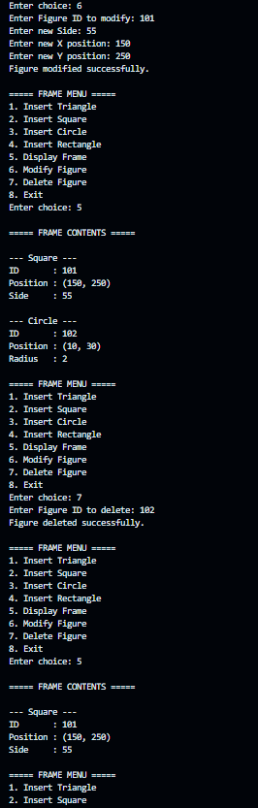
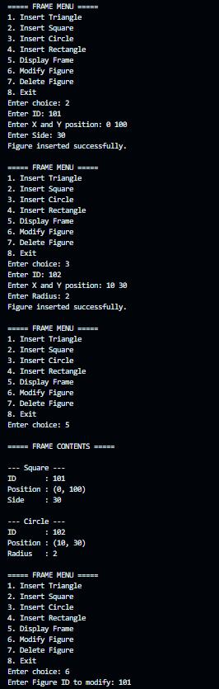
OUTPUT:

Q-22: Define a class Student. Inherit this class into MCAStudent and NonMCAStudent. Also inherit it into Local and NonLocal students. Multiple inherit LocalMCAStudent from Local and MCAStudent. Define five instances of LocalMCAStudent with a constructor, assuming that all classes have a constructor.
#include <iostream> #include <cstring>
using namespace std;

// Base class class Student { protected:
int rollno;
char name[50];

public:
Student(int r, const char n[]) { rollno = r;
strcpy(name, n);
}

void displayStudent() {
cout << "Roll No : " << rollno << endl; cout << "Name : " << name << endl;
}
};

// Derived from Student
class MCAStudent : virtual public Student { protected:
char specialization[30];

public:
MCAStudent(int r, const char n[], const char spec[])
: Student(r, n) {
strcpy(specialization, spec);

}

void displayMCA() {
cout << "Specialization : " << specialization << endl;
}
};

// Derived from Student
class NonMCAStudent : virtual public Student { protected:
char course[30];

public:
NonMCAStudent(int r, const char n[], const char c[])
: Student(r, n) { strcpy(course, c);
}

void displayNonMCA() {
cout << "Course : " << course << endl;
}
};

// Derived from Student
class Local : virtual public Student { protected:

char city[30];

public:
Local(int r, const char n[], const char c[])
: Student(r, n) { strcpy(city, c);
}

void displayLocal() {
cout << "City : " << city << endl;
}
};

// Derived from Student
class NonLocal : virtual public Student { protected:
char state[30];

public:
NonLocal(int r, const char n[], const char s[])
: Student(r, n) { strcpy(state, s);
}

void displayNonLocal() {
cout << "State : " << state << endl;
}

};

// Multiple inheritance
class LocalMCAStudent : public Local, public MCAStudent { private:
int semester; public:
LocalMCAStudent(int r, const char n[], const char c[], const char spec[], int sem)
: Student(r, n),
Local(r, n, c),
MCAStudent(r, n, spec) { semester = sem;
}
void display() {
cout << "\n--- Local MCA Student ---\n"; displayStudent();
displayLocal(); displayMCA();
cout << "Semester : " << semester << endl;
}
};

int main() {
// Five instances of LocalMCAStudent LocalMCAStudent s1(

101, "Rahul", "Ahmedabad",
"Data Science", 1
);
LocalMCAStudent s2( 102, "Priya", "Surat",
"AI", 2
);
LocalMCAStudent s3( 103, "Amit", "Vadodara",
"Cloud Computing", 3
);
LocalMCAStudent s4( 104, "Neha", "Rajkot",
"Data Science", 4
);
LocalMCAStudent s5(
105, "Karan", "Bhavnagar",
"Cyber Security", 2
);

// Display all five students s1.display();
s2.display();
s3.display();
s4.display();
s5.display(); return 0;
}

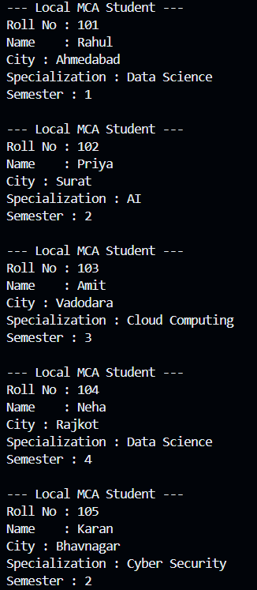
OUTPUT:

Q-23: Define a class Faculty. It contains the following attributes: (a) Name of the faculty (b) Qualification of the faculty (c) Subjects the faculty can teach Inherit the Faculty class into a regular faculty, who (a) is available full time (no consulting time is specified) (b) teaches at least three subjects (c) is part of the institute alone Inherit the Faculty class into visiting faculty, who (a) is available only on two to three days (consulting time is also to be specified) (b) teaches a single subject (c) is part of some other institute Provide virtual functions for reading and writing class objects of the classes given above.
#include <iostream> #include <cstring>
using namespace std;
// Base class class Faculty { protected:
char name[50];
char qualification[50]; public:
virtual void read() {
cout << "Enter Faculty Name: "; cin >> name;
cout << "Enter Qualification: "; cin >> qualification;
}
virtual void write() {
cout << "Name : " << name << endl;
cout << "Qualification : " << qualification << endl;
}
virtual ~Faculty() {}
};

// Regular Faculty
class RegularFaculty : public Faculty { private:
char subjects[3][50]; public:
void read() override {

Faculty::read();

cout << "Enter 3 subjects:\n";

for (int i = 0; i < 3; i++) {

cout << "Subject " << i + 1 << ": "; cin >> subjects[i];
}
}

void write() override {
cout << "\n--- REGULAR FACULTY ---\n";

Faculty::write();

cout << "Type : Full Time" << endl; cout << "Institute : This Institute" << endl;

cout << "Subjects : ";

for (int i = 0; i < 3; i++) { cout << subjects[i];

if (i < 2)
cout << ", ";
}

cout << endl;
}
};

// Visiting Faculty
class VisitingFaculty : public Faculty {

private:
char subject[50]; int days;
char consultingTime[50]; char otherInstitute[50];
public:
void read() override {

Faculty::read();

cout << "Enter Subject: "; cin >> subject;
cout << "Enter Number of Days (2 or 3): "; cin >> days;
cout << "Enter Consulting Time: "; cin >> consultingTime;

cout << "Enter Other Institute: "; cin >> otherInstitute;
}
void write() override {
cout << "\n--- VISITING FACULTY ---\n";

Faculty::write();

cout << "Type : Visiting Faculty" << endl; cout << "Subject : " << subject << endl; cout << "Available Days : " << days << endl;

cout << "Consulting Time : " << consultingTime << endl; cout << "Other Institute : " << otherInstitute << endl;
}
};

int main() {

RegularFaculty regular; VisitingFaculty visiting;

// Base class pointer Faculty *ptr;

cout << "--- Enter Regular Faculty Details ---\n"; ptr = &regular;
ptr->read();

cout << "\n--- Enter Visiting Faculty Details ---\n"; ptr = &visiting;
ptr->read();

// Display using base class pointer
cout << "\n\n===== FACULTY DETAILS =====\n";
ptr = &regular; ptr->write();

ptr = &visiting;

ptr->write(); return 0;
}

OUTPUT: 