Name: THESIYA CHINTANKUMAR DASHARATHBHAI
Roll no: 35
Sub: OBJECT ORIENDTED CONCEPTS AND PROGRAMMING Assignment: 3(Practical)
Date:23/10/2026

- Create a base class called shape. Use this class to store two double type values that could be used to compute the area of figures. Derive three specific classes called triangle, rectangle and circle from the base shape. Add to the base class, a member function get_data( ) to initialize base class data members and another member function display_area( ) to compute and display the area of figures. Make display_area( ) as a virtual function and redefine this function in derived classes to suit their requirements. Using these three classes design a program that will accept dimensions of a triangle or rectangle interactively and store it in one array . After having read all the input display the area of all the figures whose area has been read in the program. Remember the two values given as input will be treated as lengths of two sides in the case of rectangle and as base and height in case of triangle. In case of circle only one value should be accepted which will be taken as the radius and the default value of the next parameter should be 0.

#include <iostream>
using namespace std;

class shape
{
protected:
double value1, value2;

public:
void get_data(double first_value, double second_value = 0)
{
value1 = first_value;
value2 = second_value;
}

virtual void display_area()
{
cout << "Area of shape cannot be calculated." << endl;
}

virtual ~shape()
{
}
};

class triangle : public shape
{
public:
void display_area()
{
double area;
area = 0.5 * value1 * value2;

cout << "Area of Triangle = " << area << endl;
}
};

class rectangle : public shape
{
public:
void display_area()
{
double area;
area = value1 * value2;

cout << "Area of Rectangle = " << area << endl;
}
};

class circle : public shape
{
public:
void display_area()
{
double area;
const double PI = 3.14159;

area = PI * value1 * value1;

cout << "Area of Circle = " << area << endl;
}
};

int main()
{
int number_of_shapes, choice;
double first_value, second_value;
shape *shape_array[100];

do
{
cout << "Enter number of shapes (1 to 100): ";
cin >> number_of_shapes;

if (cin.fail())
{
cin.clear();
cin.ignore(10000, '\n');
number_of_shapes = 0;
}

if (number_of_shapes < 1 || number_of_shapes > 100)
{
cout << "Invalid input! Enter a number from 1 to 100."
<< endl;
}

} while (number_of_shapes < 1 || number_of_shapes > 100);

for (int i = 0; i < number_of_shapes; i++)
{
cout << "\nSelect shape " << i + 1 << ":" << endl;
cout << "1. Triangle" << endl;
cout << "2. Rectangle" << endl;
cout << "3. Circle" << endl;

do
{
cout << "Enter your choice (1-3): ";
cin >> choice;

if (cin.fail())
{
cin.clear();
cin.ignore(10000, '\n');
choice = 0;
}

if (choice < 1 || choice > 3)
{
cout << "Invalid choice! Try again." << endl;
}

} while (choice < 1 || choice > 3);

if (choice == 1)
{
shape_array[i] = new triangle();

do
{
cout << "Enter base: ";
cin >> first_value;

if (cin.fail())
{
cin.clear();
cin.ignore(10000, '\n');
first_value = -1;
}

if (first_value <= 0)
{
cout << "Base must be greater than zero." << endl;
}

} while (first_value <= 0);

do
{
cout << "Enter height: ";
cin >> second_value;

if (cin.fail())
{
cin.clear();
cin.ignore(10000, '\n');
second_value = -1;
}

if (second_value <= 0)
{
cout << "Height must be greater than zero." << endl;
}

} while (second_value <= 0);

shape_array[i]->get_data(first_value, second_value);
}
else if (choice == 2)
{
shape_array[i] = new rectangle();

do
{
cout << "Enter length: ";
cin >> first_value;

if (cin.fail())
{
cin.clear();
cin.ignore(10000, '\n');
first_value = -1;
}

if (first_value <= 0)
{
cout << "Length must be greater than zero." << endl;
}

} while (first_value <= 0);

do
{
cout << "Enter width: ";
cin >> second_value;

if (cin.fail())
{
cin.clear();
cin.ignore(10000, '\n');
second_value = -1;
}

if (second_value <= 0)
{
cout << "Width must be greater than zero." << endl;
}

} while (second_value <= 0);

shape_array[i]->get_data(first_value, second_value);
}
else
{
shape_array[i] = new circle();

do
{
cout << "Enter radius: ";
cin >> first_value;

if (cin.fail())
{
cin.clear();
cin.ignore(10000, '\n');
first_value = -1;
}

if (first_value <= 0)
{
cout << "Radius must be greater than zero." << endl;
}

} while (first_value <= 0);

shape_array[i]->get_data(first_value);
}
}

cout << "\n----- Area of All Shapes -----" << endl;

for (int i = 0; i < number_of_shapes; i++)
{
shape_array[i]->display_area();
}

for (int i = 0; i < number_of_shapes; i++)
{
delete shape_array[i];
}

return 0;
}

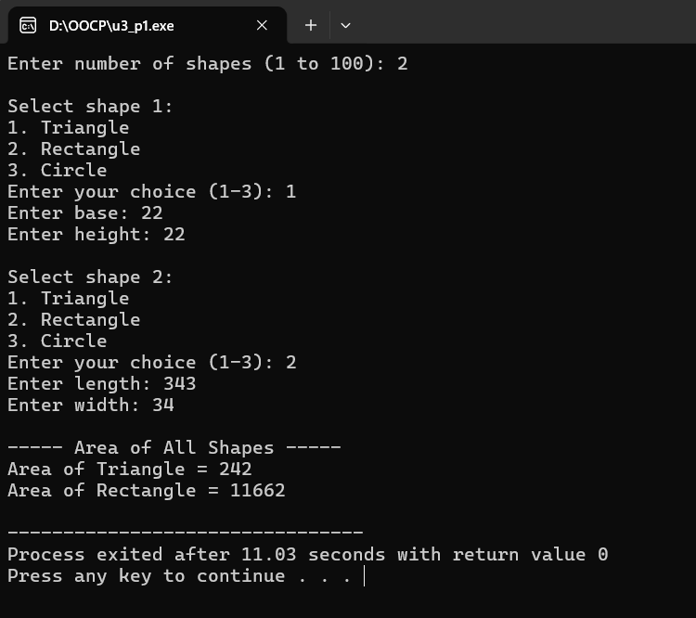

- Consider a class student from which the classes test and sports are derived. The class student has the name and rollno of the student. The class test has the marks of the internal test and the sports class has the marks of the sports test. The class student contains a virtual function display() which are implemented in the classes test and sports. Write a program which will take relative information and display it using pointer of the base class.

#include <iostream>
#include <string>
using namespace std;

class student
{
protected:
string name;
int rollno;

public:
void get_data()
{
cout << "Enter student name: ";
getline(cin >> ws, name);

do
{
cout << "Enter roll number: ";
cin >> rollno;

if (cin.fail() || rollno <= 0)
{
cin.clear();
cin.ignore(10000, '\n');
rollno = 0;
cout << "Invalid roll number! Try again." << endl;
}

} while (rollno <= 0);
}

virtual void display()
{
cout << "Student Name: " << name << endl;
cout << "Roll Number: " << rollno << endl;
}

virtual ~student()
{
}
};

class test : public student
{
private:
float internal_marks;

public:
void get_test_marks()
{
do
{
cout << "Enter internal test marks (0-100): ";
cin >> internal_marks;

if (cin.fail() || internal_marks < 0 ||
internal_marks > 100)
{
cin.clear();
cin.ignore(10000, '\n');
internal_marks = -1;
cout << "Invalid marks! Enter marks from 0 to 100."
<< endl;
}

} while (internal_marks < 0 || internal_marks > 100);
}

void display()
{
student::display();
cout << "Internal Test Marks: " << internal_marks << endl;
}
};

class sports : public student
{
private:
float sports_marks;

public:
void get_sports_marks()
{
do
{
cout << "Enter sports marks (0-100): ";
cin >> sports_marks;

if (cin.fail() || sports_marks < 0 ||
sports_marks > 100)
{
cin.clear();
cin.ignore(10000, '\n');
sports_marks = -1;
cout << "Invalid marks! Enter marks from 0 to 100."
<< endl;
}

} while (sports_marks < 0 || sports_marks > 100);
}

void display()
{
student::display();
cout << "Sports Marks: " << sports_marks << endl;
}
};

int main()
{
test test_student;
sports sports_student;

student *ptr;

cout << "Enter Internal Test Student Details" << endl;
test_student.get_data();
test_student.get_test_marks();

cout << "\nEnter Sports Student Details" << endl;
sports_student.get_data();
sports_student.get_sports_marks();

cout << "\n----- Internal Test Details -----" << endl;
ptr = &test_student;
ptr->display();

cout << "\n----- Sports Test Details -----" << endl;
ptr = &sports_student;
ptr->display();

return 0;
}

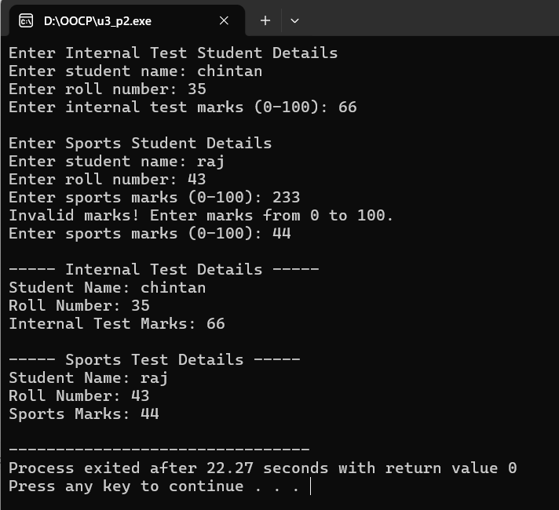

- ABC publishing company markets both book and audio cassette versions of its work. Create a class called publication that stores the title (a string) and price( type float) of a publication. From this class derive two classes : book , which adds a page count (type int); and tape, which adds playing time in minutes (type float). Write a main program that reads both book and tape information in one array. When the user has finished entering data for all books and tapes, displays the resulting data for all the books and tapes entered. Also count no of book and cassette entries in the array using runtime identification feature of C++.

#include <iostream>
#include <string>
#include <limits>
using namespace std;

class publication
{
protected:
string title;
float price;

public:
void get_data()
{
cout << "Enter title: ";
getline(cin >> ws, title);

do
{
cout << "Enter price: ";
cin >> price;

if (cin.fail() || price <= 0)
{
cin.clear();
cin.ignore(numeric_limits<streamsize>::max(), '\n');
price = 0;
cout << "Invalid price! Enter a positive value." << endl;
}
} while (price <= 0);
}

virtual void display()
{
cout << "Title: " << title << endl;
cout << "Price: " << price << endl;
}

virtual ~publication()
{
}
};

class book : public publication
{
private:
int page_count;

public:
void get_book_data()
{
get_data();

do
{
cout << "Enter page count: ";
cin >> page_count;

if (cin.fail() || page_count <= 0)
{
cin.clear();
cin.ignore(numeric_limits<streamsize>::max(), '\n');
page_count = 0;
cout << "Invalid page count! Enter a positive number."
<< endl;
}
} while (page_count <= 0);
}

void display()
{
publication::display();
cout << "Page Count: " << page_count << endl;
}
};

class tape : public publication
{
private:
float playing_time;

public:
void get_tape_data()
{
get_data();

do
{
cout << "Enter playing time in minutes: ";
cin >> playing_time;

if (cin.fail() || playing_time <= 0)
{
cin.clear();
cin.ignore(numeric_limits<streamsize>::max(), '\n');
playing_time = 0;
cout << "Invalid playing time! Enter a positive value."
<< endl;
}
} while (playing_time <= 0);
}

void display()
{
publication::display();
cout << "Playing Time: " << playing_time << " minutes" << endl;
}
};

int main()
{
publication *publication_array[100];
int number_of_entries;
int choice;
int book_count = 0;
int tape_count = 0;

do
{
cout << "Enter number of publications (1 to 100): ";
cin >> number_of_entries;

if (cin.fail())
{
cin.clear();
cin.ignore(numeric_limits<streamsize>::max(), '\n');
number_of_entries = 0;
}

if (number_of_entries < 1 || number_of_entries > 100)
{
cout << "Invalid input! Enter a number from 1 to 100."
<< endl;
}
} while (number_of_entries < 1 || number_of_entries > 100);

for (int i = 0; i < number_of_entries; i++)
{
cout << "\nSelect publication type:" << endl;
cout << "1. Book" << endl;
cout << "2. Tape" << endl;

do
{
cout << "Enter your choice (1-2): ";
cin >> choice;

if (cin.fail())
{
cin.clear();
cin.ignore(numeric_limits<streamsize>::max(), '\n');
choice = 0;
}

if (choice < 1 || choice > 2)
{
cout << "Invalid choice! Select 1 or 2." << endl;
}
} while (choice < 1 || choice > 2);

if (choice == 1)
{
book *book_ptr = new book();
book_ptr->get_book_data();
publication_array[i] = book_ptr;
}
else
{
tape *tape_ptr = new tape();
tape_ptr->get_tape_data();
publication_array[i] = tape_ptr;
}
}

cout << "\n----- Publication Details -----" << endl;

for (int i = 0; i < number_of_entries; i++)
{
cout << "\nPublication " << i + 1 << ":" << endl;
publication_array[i]->display();

if (dynamic_cast<book *>(publication_array[i]) != NULL)
{
book_count++;
}
else if (dynamic_cast<tape *>(publication_array[i]) != NULL)
{
tape_count++;
}
}

cout << "\n----- Publication Count -----" << endl;
cout << "Total Books: " << book_count << endl;
cout << "Total Tapes: " << tape_count << endl;

for (int i = 0; i < number_of_entries; i++)
{
delete publication_array[i];
}

return 0;
}
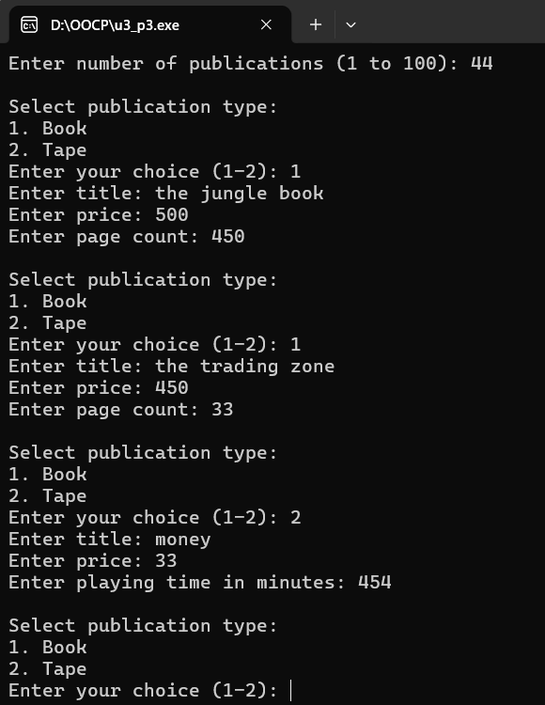

4) Design a manipulator to provide the following output specifications for printing float values
(i) 5 column width
(ii) Right justified
(iii) 2 digits precision
(iv) Right justified 2 digits precision Filling unused spaces with +

#include <iostream>
#include <iomanip>
using namespace std;

int main()
{
float number1, number2, number3;

cout << "Enter three float values: ";
cin >> number1 >> number2 >> number3;

cout << "\nFormatted Output:" << endl;
cout << setfill('+') << right << fixed << setprecision(2);
cout << setw(5) << number1 << endl;
cout << setw(5) << number2 << endl;
cout << setw(5) << number3 << endl;
return 0;
}
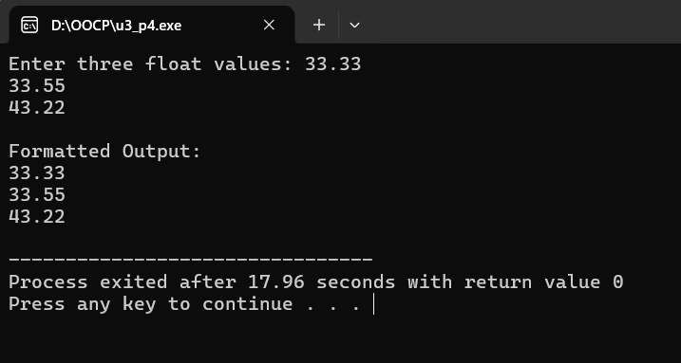

- Define a class marksheet. The class should contain a function PrintMarkSheet such that it prints the marksheet of a given student with three subject names and five marks for each subject. Define manipulators for displaying headings and footnotes. The function should display marksheet with respective headings and class. The marks should be aligned under the headings (Use either ios functions or manipulators).

#include <iostream>
#include <iomanip>
#include <string>
using namespace std;

class marksheet
{
private:
string student_name;
int roll_no;
string class_name;
string subject_name[3];
int marks[3][5];

public:
void get_data()
{
cout << "Enter student name: ";
getline(cin >> ws, student_name);

do
{
cout << "Enter roll number: ";
cin >> roll_no;

if (cin.fail() || roll_no <= 0)
{
cin.clear();
cin.ignore(10000, '\n');
roll_no = 0;
cout << "Invalid roll number! Try again." << endl;
}
} while (roll_no <= 0);

cout << "Enter class: ";
getline(cin >> ws, class_name);

for (int i = 0; i < 3; i++)
{
cout << "Enter subject " << i + 1 << " name: ";
getline(cin >> ws, subject_name[i]);

for (int j = 0; j < 5; j++)
{
do
{
cout << "Enter mark " << j + 1 << " for "
<< subject_name[i] << " (0-100): ";
cin >> marks[i][j];

if (cin.fail() || marks[i][j] < 0 ||
marks[i][j] > 100)
{
cin.clear();
cin.ignore(10000, '\n');
marks[i][j] = -1;
cout << "Invalid marks! Enter marks from 0 to 100."
<< endl;
}
} while (marks[i][j] < 0 || marks[i][j] > 100);
}
}
}

void PrintMarkSheet()
{
int total_marks = 0;

cout << "\n";
cout << setfill('=') << setw(75) << "" << endl;
cout << setfill(' ');

cout << setw(45) << right << "STUDENT MARKSHEET" << endl;

cout << setfill('=') << setw(75) << "" << endl;
cout << setfill(' ');

cout << "Student Name : " << student_name << endl;
cout << "Roll Number : " << roll_no << endl;
cout << "Class : " << class_name << endl;

cout << setfill('-') << setw(75) << "" << endl;
cout << setfill(' ');

cout << left << setw(20) << "Subject";

for (int j = 0; j < 5; j++)
{
cout << right << setw(10) << "Mark " << j + 1;
}

cout << endl;

cout << setfill('-') << setw(75) << "" << endl;
cout << setfill(' ');

for (int i = 0; i < 3; i++)
{
cout << left << setw(20) << subject_name[i];

for (int j = 0; j < 5; j++)
{
cout << right << setw(10) << marks[i][j];
total_marks += marks[i][j];
}

cout << endl;
}

cout << setfill('-') << setw(75) << "" << endl;
cout << setfill(' ');

cout << left << setw(20) << "Total Marks";
cout << right << setw(50) << total_marks << " / 1500" << endl;

cout << left << setw(20) << "Percentage";
cout << right << setw(50) << fixed << setprecision(2)
<< (total_marks / 15.0) << "%" << endl;

cout << setfill('=') << setw(75) << "" << endl;
cout << setfill(' ');

cout << "Footnote: Each mark is out of 100." << endl;
cout << "Maximum Marks: 1500" << endl;

cout << "Result: ";
if (total_marks >= 750)
{
cout << "Pass" << endl;
}
else
{
cout << "Fail" << endl;
}

cout << setfill('=') << setw(75) << "" << endl;
cout << setfill(' ');
}
};

int main()
{
marksheet student;

student.get_data();
student.PrintMarkSheet();
return 0;
}
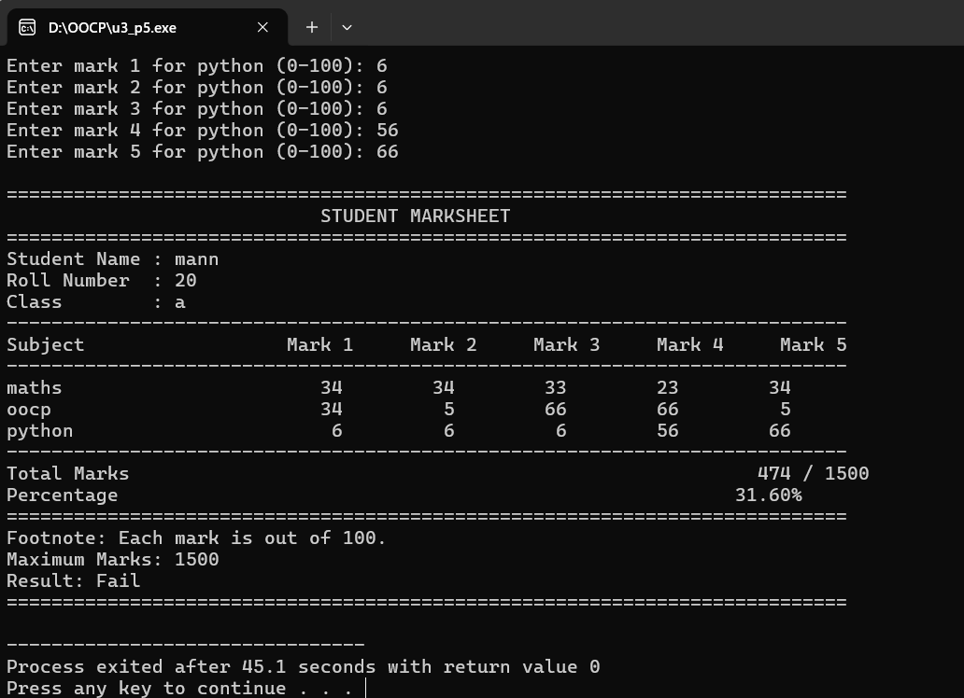

6) WAP to create namespace having function for total_marks. Show its use in class ‘marks’ of students, display total marks of subjects using namespace.

#include <iostream>
using namespace std;

namespace student_data
{
int total_marks(int marks1, int marks2, int marks3)
{
return marks1 + marks2 + marks3;
}
}

class marks
{
private:
string student_name;
int roll_no;
int marks1, marks2, marks3;
int total;

public:
void get_data()
{
cout << "Enter student name: ";
getline(cin >> ws, student_name);

do
{
cout << "Enter roll number: ";
cin >> roll_no;

if (cin.fail() || roll_no <= 0)
{
cin.clear();
cin.ignore(10000, '\n');
roll_no = 0;
cout << "Invalid roll number! Try again." << endl;
}
} while (roll_no <= 0);

do
{
cout << "Enter marks of Subject 1 (0-100): ";
cin >> marks1;

if (cin.fail() || marks1 < 0 || marks1 > 100)
{
cin.clear();
cin.ignore(10000, '\n');
marks1 = -1;
cout << "Invalid marks! Enter marks from 0 to 100."
<< endl;
}
} while (marks1 < 0 || marks1 > 100);

do
{
cout << "Enter marks of Subject 2 (0-100): ";
cin >> marks2;

if (cin.fail() || marks2 < 0 || marks2 > 100)
{
cin.clear();
cin.ignore(10000, '\n');
marks2 = -1;
cout << "Invalid marks! Enter marks from 0 to 100."
<< endl;
}
} while (marks2 < 0 || marks2 > 100);

do
{
cout << "Enter marks of Subject 3 (0-100): ";
cin >> marks3;

if (cin.fail() || marks3 < 0 || marks3 > 100)
{
cin.clear();
cin.ignore(10000, '\n');
marks3 = -1;
cout << "Invalid marks! Enter marks from 0 to 100."
<< endl;
}
} while (marks3 < 0 || marks3 > 100);
}

void display()
{
total = student_data::total_marks(marks1, marks2, marks3);

cout << "\n----- Student Mark Details -----" << endl;
cout << "Student Name: " << student_name << endl;
cout << "Roll Number: " << roll_no << endl;
cout << "Subject 1 Marks: " << marks1 << endl;
cout << "Subject 2 Marks: " << marks2 << endl;
cout << "Subject 3 Marks: " << marks3 << endl;
cout << "Total Marks: " << total << " / 300" << endl;
}
};

int main()
{
marks student;

student.get_data();
student.display();

return 0;
}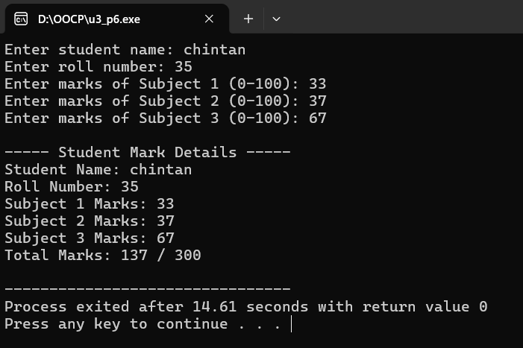

- Write a Program to perform following operation on text file : a) write content in a text file b) read content from file c) count no of word and no of lines in a file d) copy contents of one file to another file

#include <iostream>
#include <fstream>
#include <string>
#include <sstream>
using namespace std;

int main()
{
ofstream output_file;
ifstream input_file;
ifstream read_file;
ofstream copy_file;

string file_name, copy_file_name;
string line;
string word;

int word_count = 0;
int line_count = 0;

cout << "Enter file name: ";
cin >> file_name;

output_file.open(file_name.c_str());

if (!output_file)
{
cout << "Error creating file!" << endl;
return 1;
}

cin.ignore(10000, '\n');

cout << "Enter content for the file." << endl;
cout << "Enter END on a new line to finish:" << endl;

while (getline(cin, line))
{
if (line == "END")
{
break;
}

output_file << line << endl;
}

output_file.close();

cout << "\nContent written successfully." << endl;

input_file.open(file_name.c_str());

if (!input_file)
{
cout << "Error opening file for reading!" << endl;
return 1;
}

cout << "\n----- File Content -----" << endl;

while (getline(input_file, line))
{
cout << line << endl;
}

input_file.close();

read_file.open(file_name.c_str());

if (!read_file)
{
cout << "Error opening file for counting!" << endl;
return 1;
}

while (getline(read_file, line))
{
line_count++;

stringstream line_stream(line);

while (line_stream >> word)
{
word_count++;
}
}

read_file.close();

cout << "\nTotal Lines: " << line_count << endl;
cout << "Total Words: " << word_count << endl;

cout << "\nEnter destination file name for copying: ";
cin >> copy_file_name;

if (file_name == copy_file_name)
{
cout << "Source and destination file names must be different."
<< endl;
return 1;
}

input_file.open(file_name.c_str());
copy_file.open(copy_file_name.c_str());

if (!input_file || !copy_file)
{
cout << "Error opening source or destination file!" << endl;

input_file.close();
copy_file.close();

return 1;
}
while (getline(input_file, line))
{
copy_file << line << endl;
}
input_file.close();
copy_file.close();
cout << "File copied successfully to "
<< copy_file_name << endl;
return 0;
}
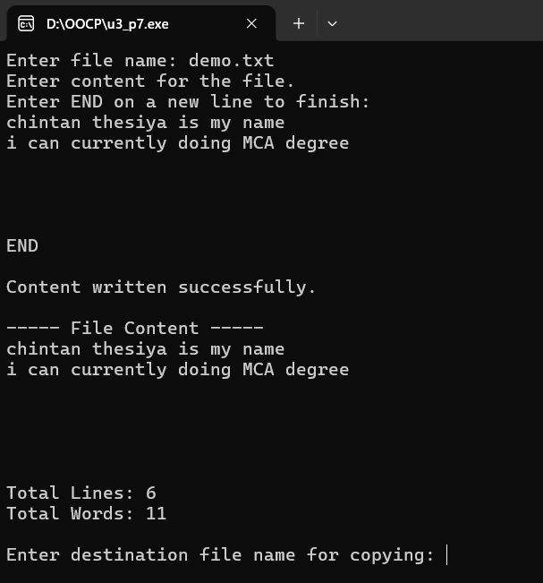
- Write a program to create a file student to store name and marks of 5 students and then display them.

#include <iostream>
#include <fstream>
#include <string>
using namespace std;

int main()
{
ofstream output_file;
ifstream input_file;

string student_name;
float marks;

output_file.open("student.txt");

if (!output_file)
{
cout << "Error creating student file!" << endl;
return 1;
}

cout << "Enter details of 5 students:" << endl;

for (int i = 0; i < 5; i++)
{
cout << "\nEnter name of student " << i + 1 << ": ";
getline(cin >> ws, student_name);

do
{
cout << "Enter marks (0-100): ";
cin >> marks;

if (cin.fail() || marks < 0 || marks > 100)
{
cin.clear();
cin.ignore(10000, '\n');
marks = -1;
cout << "Invalid marks! Enter marks between 0 and 100."
<< endl;
}

} while (marks < 0 || marks > 100);

output_file << student_name << endl;
output_file << marks << endl;
}

output_file.close();

input_file.open("student.txt");

if (!input_file)
{
cout << "Error opening student file!" << endl;
return 1;
}

cout << "\n----- Student Details -----" << endl;

for (int i = 0; i < 5; i++)
{
getline(input_file, student_name);
input_file >> marks;
input_file.ignore(10000, '\n');

cout << "\nStudent " << i + 1 << endl;
cout << "Name: " << student_name << endl;
cout << "Marks: " << marks << endl;
}

input_file.close();

return 0;
}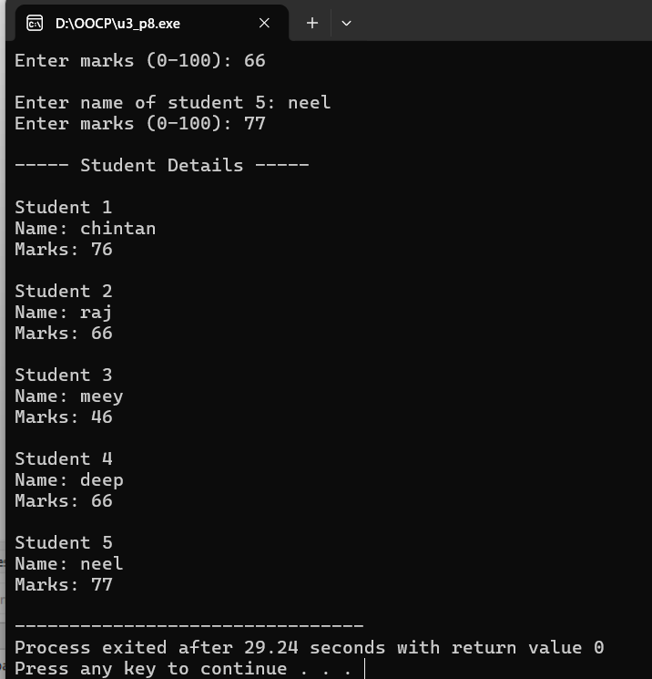

- Define a class Result which contains the result of an MCA written test. It should take merit list from a file and display on the screen such that at a time only ten candidates information is printed on the screen. The headings should be displayed using a manipulator. All the information should be aligned with the headings.

#include <iostream>
#include <fstream>
#include <iomanip>
#include <string>
using namespace std;

class Result
{
private:
int roll_no;
string name;
float marks;

public:
void display_heading()
{
cout << setfill('=') << setw(60) << "" << endl;
cout << setfill(' ');

cout << left << setw(10) << "Roll No"
<< setw(25) << "Candidate Name"
<< right << setw(10) << "Marks" << endl;

cout << setfill('=') << setw(60) << "" << endl;
cout << setfill(' ');
}

void display_candidate(int roll_no, string name, float marks)
{
cout << left << setw(10) << roll_no
<< setw(25) << name
<< right << setw(10) << fixed << setprecision(2)
<< marks << endl;
}

void display_merit_list()
{
ifstream file("merit.txt");

if (!file)
{
cout << "Error: Unable to open merit.txt file." << endl;
return;
}

int count = 0;
char choice;

while (file >> roll_no)
{
file >> ws;
getline(file, name);
file >> marks;

if (file.fail())
{
break;
}

if (count % 10 == 0)
{
if (count > 0)
{
cout << "\nPress Enter to display the next 10 "
<< "candidates, or enter q to quit: ";

cin.get(choice);

if (choice == 'q' || choice == 'Q')
{
break;
}
}

display_heading();
}

display_candidate(roll_no, name, marks);
count++;
}

file.close();

if (count == 0)
{
cout << "No candidate records found in the file." << endl;
}
else
{
cout << "\nTotal candidates displayed: " << count << endl;
}
}
};

int main()
{
Result result;
result.display_merit_list();
return 0;
}
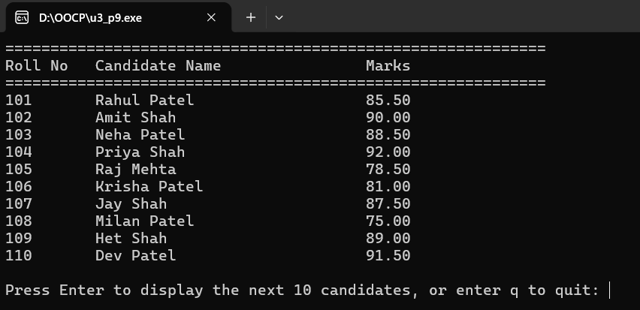

- Write a C++ program that displays a student object read from a file backwards.

#include <iostream>
#include <fstream>
#include <string>
using namespace std;

class student
{
private:
string name;
int roll_no;
float marks;

public:
void get_data()
{
cout << "Enter student name: ";
getline(cin >> ws, name);

cout << "Enter roll number: ";
cin >> roll_no;

cout << "Enter marks: ";
cin >> marks;
}

void write_file()
{
ofstream file("student.txt");

if (!file)
{
cout << "Error creating file!" << endl;
return;
}

file << name << endl;
file << roll_no << endl;
file << marks << endl;

file.close();

cout << "Student details saved successfully." << endl;
}

void display_backwards()
{
ifstream file("student.txt");

if (!file)
{
cout << "Error opening file!" << endl;
return;
}

string content;
string line;

while (getline(file, line))
{
content += line;
content += '\n';
}

file.close();

cout << "\nStudent object displayed backwards:" << endl;

for (int i = static_cast<int>(content.length()) - 1; i >= 0; i--)
{
cout << content[i];
}

cout << endl;
}
};

int main()
{
student s;

s.get_data();
s.write_file();
s.display_backwards();

return 0;
}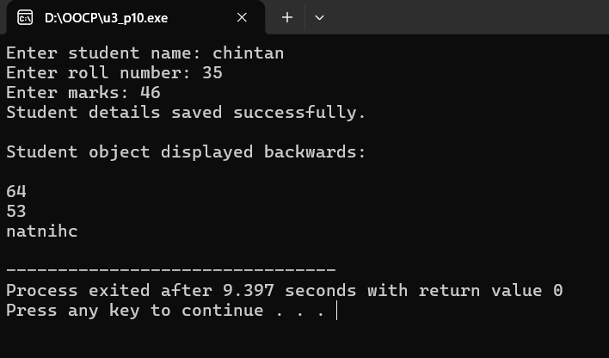
- A file contains name and phone numbers. Name contains only one word and names and telephone numbers are separated by white spaces. Write a program which will include a menu driven functionality for the above file (a) Display 2 column output with names left justified and phone numbers right justified. Name Ram Shyam Rahim Joseph Phone 56789125 34565432 23456789 67213148 (b) Determine the telephone number of a person. (c) Determine the name if the telephone number is known. (d) Update the telephone number. (e) Prefix all the telephone numbers by 2.

#include <iostream>
#include <fstream>
#include <iomanip>
#include <string>
using namespace std;

class Telephone
{
string name, phone;

public:
void create_file()
{
ofstream fout("telephone.txt");

fout << "Ram 56789125" << endl;
fout << "Shyam 34565432" << endl;
fout << "Rahim 23456789" << endl;
fout << "Joseph 67213148" << endl;

fout.close();
}

void display()
{
ifstream fin("telephone.txt");

cout << left << setw(20) << "Name"
<< right << setw(15) << "Phone" << endl;

cout << "-----------------------------------" << endl;

while (fin >> name >> phone)
{
cout << left << setw(20) << name
<< right << setw(15) << phone << endl;
}

fin.close();
}

void search_name()
{
string search;
int found = 0;

cout << "Enter name: ";
cin >> search;

ifstream fin("telephone.txt");

while (fin >> name >> phone)
{
if (name == search)
{
cout << "Telephone number: " << phone << endl;
found = 1;
break;
}
}

fin.close();

if (found == 0)
cout << "Name not found." << endl;
}

void search_phone()
{
string search;
int found = 0;

cout << "Enter telephone number: ";
cin >> search;

ifstream fin("telephone.txt");

while (fin >> name >> phone)
{
if (phone == search)
{
cout << "Name: " << name << endl;
found = 1;
break;
}
}

fin.close();

if (found == 0)
cout << "Telephone number not found." << endl;
}

void update_phone()
{
string search, new_phone;
int found = 0;

cout << "Enter name to update: ";
cin >> search;

ifstream fin("telephone.txt");
ofstream fout("temp.txt");

while (fin >> name >> phone)
{
if (name == search)
{
cout << "Enter new telephone number: ";
cin >> new_phone;
phone = new_phone;
found = 1;
}

fout << name << " " << phone << endl;
}

fin.close();
fout.close();

remove("telephone.txt");
rename("temp.txt", "telephone.txt");

if (found == 1)
cout << "Telephone number updated successfully." << endl;
else
cout << "Name not found." << endl;
}

void prefix_numbers()
{
ifstream fin("telephone.txt");
ofstream fout("temp.txt");

while (fin >> name >> phone)
{
phone = "2" + phone;
fout << name << " " << phone << endl;
}

fin.close();
fout.close();

remove("telephone.txt");
rename("temp.txt", "telephone.txt");

cout << "Prefix 2 added to all telephone numbers." << endl;
}
};

int main()
{
Telephone t;
int choice;

t.create_file();

do
{
cout << "\n===== TELEPHONE DIRECTORY =====" << endl;
cout << "1. Display all records" << endl;
cout << "2. Search telephone number by name" << endl;
cout << "3. Search name by telephone number" << endl;
cout << "4. Update telephone number" << endl;
cout << "5. Prefix all numbers with 2" << endl;
cout << "6. Exit" << endl;
cout << "Enter your choice: ";
cin >> choice;

switch (choice)
{
case 1:
t.display();
break;

case 2:
t.search_name();
break;

case 3:
t.search_phone();
break;

case 4:
t.update_phone();
break;

case 5:
t.prefix_numbers();
break;

case 6:
cout << "Program terminated." << endl;
break;

default:
cout << "Invalid choice. Try again." << endl;
}

} while (choice != 6);

return 0;
}
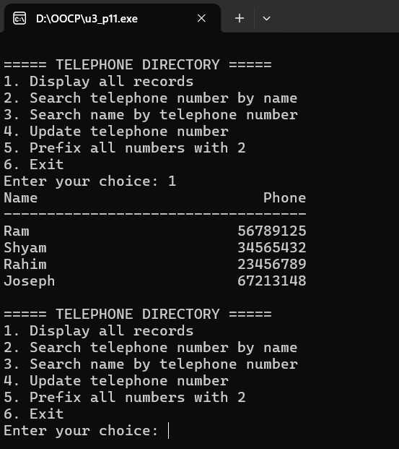
- Use an Employee Class to write records of employee to a file. Include a menu that will allow the user to select any of the following features a. Add a new record. b. Modify an existing record. c. Retrieve and display an entire record for a given name. d. Generate a complete list of all names, addresses and telephone numbers. e. End of the computation.

#include <iostream>
#include <fstream>
#include <iomanip>
#include <string>
#include <cstdio>
using namespace std;

class Employee
{
int id;
string name, address, phone;

public:
void get_data()
{
cout << "Enter employee ID: ";
cin >> id;

cout << "Enter employee name: ";
cin >> ws;
getline(cin, name);

cout << "Enter employee address: ";
getline(cin, address);

cout << "Enter telephone number: ";
cin >> phone;
}

void display()
{
cout << "\nEmployee ID: " << id << endl;
cout << "Name: " << name << endl;
cout << "Address: " << address << endl;
cout << "Telephone: " << phone << endl;
}

void add_record()
{
Employee e;
ofstream fout("employee.txt", ios::app);

e.get_data();

fout << e.id << endl;
fout << e.name << endl;
fout << e.address << endl;
fout << e.phone << endl;

fout.close();

cout << "Employee record added successfully." << endl;
}

void modify_record()
{
int search_id, found = 0;
Employee e;

cout << "Enter employee ID to modify: ";
cin >> search_id;

ifstream fin("employee.txt");
ofstream fout("temp.txt");

while (fin >> e.id)
{
fin.ignore(1000, '\n');
getline(fin, e.name);
getline(fin, e.address);
getline(fin, e.phone);

if (e.id == search_id)
{
cout << "\nEnter new employee details:\n";
e.get_data();
found = 1;
}

fout << e.id << endl;
fout << e.name << endl;
fout << e.address << endl;
fout << e.phone << endl;
}

fin.close();
fout.close();

remove("employee.txt");
rename("temp.txt", "employee.txt");

if (found == 1)
cout << "Employee record modified successfully." << endl;
else
cout << "Employee ID not found." << endl;
}

void search_record()
{
string search_name;
int found = 0;
Employee e;

cout << "Enter employee name: ";
cin >> ws;
getline(cin, search_name);

ifstream fin("employee.txt");

while (fin >> e.id)
{
fin.ignore(1000, '\n');
getline(fin, e.name);
getline(fin, e.address);
getline(fin, e.phone);

if (e.name == search_name)
{
e.display();
found = 1;
}
}

fin.close();

if (found == 0)
cout << "Employee not found." << endl;
}

void display_all()
{
Employee e;
int found = 0;

ifstream fin("employee.txt");

cout << "\n========== EMPLOYEE LIST ==========\n";
cout << left << setw(8) << "ID"
<< setw(25) << "Name"
<< setw(30) << "Address"
<< "Telephone" << endl;

cout << "---------------------------------------------------------------\n";

while (fin >> e.id)
{
fin.ignore(1000, '\n');
getline(fin, e.name);
getline(fin, e.address);
getline(fin, e.phone);

cout << left << setw(8) << e.id
<< setw(25) << e.name
<< setw(30) << e.address
<< e.phone << endl;

found = 1;
}

fin.close();

if (found == 0)
cout << "No employee records found." << endl;
}
};

int main()
{
Employee e;
int choice;

do
{
cout << "\n===== EMPLOYEE RECORD SYSTEM =====" << endl;
cout << "1. Add a new record" << endl;
cout << "2. Modify an existing record" << endl;
cout << "3. Search employee by name" << endl;
cout << "4. Display all employee records" << endl;
cout << "5. Exit" << endl;
cout << "Enter your choice: ";
cin >> choice;

switch (choice)
{
case 1:
e.add_record();
break;

case 2:
e.modify_record();
break;

case 3:
e.search_record();
break;

case 4:
e.display_all();
break;

case 5:
cout << "Program terminated." << endl;
break;

default:
cout << "Invalid choice. Please try again." << endl;
}

} while (choice != 5);

return 0;
}

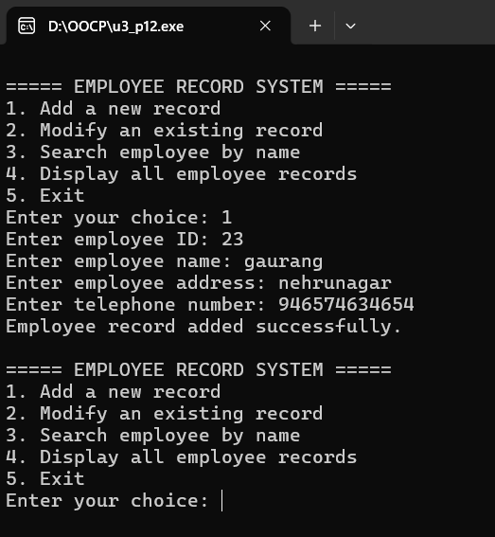
- Write a program that stores and displays the records of the customer from a file the following information for account of the customer is to be stored. Account no, account type, name, old balance, new balance, last payment, date of last payment. Also display the current account status by comparing current payment and previous balance. Also calculate the current balance by subtracting the current payment from the previous balance.

#include <iostream>
#include <fstream>
#include <iomanip>
#include <string>
using namespace std;

class Customer
{
int account_no;
string account_type, name, payment_date;
float old_balance, new_balance, last_payment;

public:
void get_data()
{
cout << "Enter account number: ";
cin >> account_no;

cout << "Enter account type: ";
cin >> account_type;

cout << "Enter customer name: ";
cin >> ws;
getline(cin, name);

cout << "Enter old balance: ";
cin >> old_balance;

cout << "Enter last payment: ";
cin >> last_payment;

cout << "Enter date of last payment (DD-MM-YYYY): ";
cin >> payment_date;

new_balance = old_balance - last_payment;
}

void write_file()
{
ofstream fout("customer.txt", ios::app);

fout << account_no << endl;
fout << account_type << endl;
fout << name << endl;
fout << old_balance << endl;
fout << new_balance << endl;
fout << last_payment << endl;
fout << payment_date << endl;

fout.close();
}

void display()
{
cout << "\nAccount Number : " << account_no << endl;
cout << "Account Type : " << account_type << endl;
cout << "Customer Name : " << name << endl;
cout << "Old Balance : " << fixed << setprecision(2)
<< old_balance << endl;
cout << "Last Payment : " << last_payment << endl;
cout << "Date of Last Payment: " << payment_date << endl;
cout << "Current Balance : " << new_balance << endl;

if (new_balance > 0)
cout << "Account Status : Payment Due" << endl;
else if (new_balance == 0)
cout << "Account Status : Fully Paid" << endl;
else
cout << "Account Status : Credit Balance" << endl;
}

void read_file()
{
ifstream fin("customer.txt");

if (!fin)
{
cout << "Customer file not found." << endl;
return;
}

while (fin >> account_no)
{
fin.ignore(1000, '\n');
getline(fin, account_type);
getline(fin, name);
fin >> old_balance;
fin >> new_balance;
fin >> last_payment;
fin.ignore(1000, '\n');
getline(fin, payment_date);

display();
cout << "-----------------------------------" << endl;
}

fin.close();
}
};

int main()
{
Customer c;
int choice;

do
{
cout << "\n===== CUSTOMER ACCOUNT SYSTEM =====" << endl;
cout << "1. Add customer record" << endl;
cout << "2. Display customer records" << endl;
cout << "3. Exit" << endl;
cout << "Enter your choice: ";
cin >> choice;

switch (choice)
{
case 1:
c.get_data();
c.write_file();
cout << "Customer record saved successfully." << endl;
break;

case 2:
c.read_file();
break;

case 3:
cout << "Program terminated." << endl;
break;

default:
cout << "Invalid choice. Please try again." << endl;
}

} while (choice != 3);

return 0;
}

