
ISTS WOMEN'S ENGINEERING COLLEGE
Department of Computer Science and Engineering

PROJECT REPORT
ON
SMART TO-DO LIST, CALCULATOR &
STUDENT REGISTRATION
WEB APPLICATIONS
HTML | CSS | JavaScript
Submitted By
NAME: CHINTHA DEEVENA
ROLL NO: 246W1A05F2
SECTION: CSE-D1
YEAR: 3/4

Under the Guidance Of Ms. Hema Devi
Academic Year 2024-28

INDEX

S.NO | NAME OF PROGRAM | PAGE NO | SIGNATURE
1 | Certificate | 3
2 | Declaration | 4
3 | Acknowledgement | 5
4 | Abstract | 6
5 | Calculator-HTML Code | 7
6 | Calculator-CSS Code | 8
7 | Calculator-JavaScript Code | 9
8 | Calculator-Output | 10
9 | To-Do List-HTML Code | 11
10 | To-Do List-CSS Code | 12-14
11 | To-Do List-JavaScript Code | 15-18
12 | To-Do List -Output | 19
13 | Student Registration-HTML Code | 20-21
14 | Student Registration-CSS Code | 22-26
15 | Student Registration-JavaScript Code | 27-28
16 | Student Registration-Output | 29

CERTIFICATE

This is to certify that the project entitled “Smart To-Do List, Calculator and Student Registration Web Applications Using HTML, CSS and JavaScript” is a bona fide work carried out by CHINTHA DEEVENA as part of the B.Tech academic mini project at ISTS Women's Engineering College.
The work presented in this report demonstrates the design, implementation and testing of three browser-based front-end applications using HTML, CSS and JavaScript.

____________________________ | ____________________________
Project Guide | Head of Department

DECLARATION

I, CHINTHA DEEVENA, hereby declare that the project report entitled “Smart To-Do List, Calculator and Student Registration Web Applications Using HTML, CSS and JavaScript” is prepared as part of my B.Tech mini project work.
The design, implementation, code presentation, testing description and documentation in this report are organized for academic presentation. The HTML, CSS and JavaScript for each program are presented separately for clarity.
I further declare that this report has not been submitted in the same form for the award of any other qualification.
Signature: ____________________

ACKNOWLEDGEMENT

I express my sincere gratitude to the management and faculty of ISTS Women's Engineering College for providing the opportunity and academic environment to complete this project.
I thank my project guide and faculty members for their guidance, suggestions and encouragement during the planning, coding, testing and documentation stages of the project.
I also thank my classmates, friends and family for their support and motivation. This project helped me strengthen practical skills in HTML, CSS and JavaScript and understand how browser-based applications are designed, tested and presented.

ABSTRACT

This project presents three browser-based applications: a Calculator, a Smart To-Do List and a Student Registration Form. Each application is developed using HTML for structure, CSS for visual presentation and JavaScript for interactivity.
The Calculator supports arithmetic operations, delete, clear and percentage functions. The To-Do List supports task entry, date, priority, search, filter, edit, completion and deletion. The Student Registration form collects student details and performs phone-number and password validation before displaying a successful registration result.
For clarity in the project report, the integrated programs are separated into HTML, CSS and JavaScript sections. Sample output pages are included to demonstrate that each program runs successfully.

PROGRAM 1: CALCULATOR
HTML CODE - index.html

<!DOCTYPE html>
<html lang="en">
<head>
<meta charset="UTF-8">
<meta name="viewport" content="width=device-width, initial-scale=1.0">

<title>Calculator</title>

<link rel="stylesheet" href="calculator.css">

</head>

<body>

<div class="calculator">

<h2 class="title">Calculator</h2>

<input type="text" id="dis" readonly>

<div class="buttons">

<button class="clear" onclick="clearall()">AC</button>

<button class="delete" onclick="deleteLast()">DEL</button>

<button class="operator" onclick="insert('/')">÷</button>

<button class="operator" onclick="insert('*')">×</button>

<button onclick="insert('7')">7</button>
<button onclick="insert('8')">8</button>
<button onclick="insert('9')">9</button>
<button class="operator" onclick="insert('-')">−</button>

<button onclick="insert('4')">4</button>
<button onclick="insert('5')">5</button>
<button onclick="insert('6')">6</button>
<button class="operator" onclick="insert('+')">+</button>

<button onclick="insert('1')">1</button>
<button onclick="insert('2')">2</button>
<button onclick="insert('3')">3</button>
<button class="equal" onclick="calculate()">=</button>

<button class="zero" onclick="insert('0')">0</button>

<button onclick="insert('.')">.</button>

<!-- Button below = -->

<button class="percentage" onclick="percentage()">%</button>

</div>

</div>

<script src="calculator.js"></script>

</body>
</html>

PROGRAM 1: CALCULATOR
CSS CODE - calculator.css

body {
background-color: #f2f2f2;
font-family: Arial, sans-serif;
display: flex;
justify-content: center;
align-items: center;
height: 100vh;
}

.calculator {
background-color: #222;
padding: 20px;
width: 280px;
border-radius: 10px;
}

.title {
color: white;
text-align: center;
margin-bottom: 15px;
}

#dis {
width: 100%;
height: 50px;
margin-bottom: 15px;
font-size: 25px;
text-align: right;
padding: 5px;
box-sizing: border-box;
}

.buttons {
display: grid;
grid-template-columns: repeat(4, 1fr);
gap: 8px;
}

button {
height: 50px;
font-size: 18px;
border: none;
border-radius: 5px;
background-color: #555;
color: white;
cursor: pointer;
}

button:hover {
background-color: #777;
}

.operator {
background-color: orange;
}

.clear {
background-color: red;
}

.delete {
background-color: #d88a00;
}

.equal {
background-color: green;
}

.percentage {
background-color: #008cba;
}

.zero {
grid-column: span 2;
}

PROGRAM 1: CALCULATOR
JAVASCRIPT CODE - calculator.js

let exp = "";

function insert(val) {
exp = exp + val;
document.getElementById("dis").value = exp;
}

function calculate() {
try {
if (exp === "") {
return;
}

exp = eval(exp);

document.getElementById("dis").value = exp;

} catch (error) {
document.getElementById("dis").value = "Error";
exp = "";
}
}

function clearall() {
exp = "";
document.getElementById("dis").value = "";
}

function deleteLast() {
exp = exp.slice(0, -1);
document.getElementById("dis").value = exp;
}

function percentage() {
try {
if (exp === "") {
return;
}

exp = eval(exp) / 100;

document.getElementById("dis").value = exp;

} catch (error) {
document.getElementById("dis").value = "Error";
exp = "";
}
}

PROGRAM 1: CALCULATOR
OUTPUT - Sample Working Result

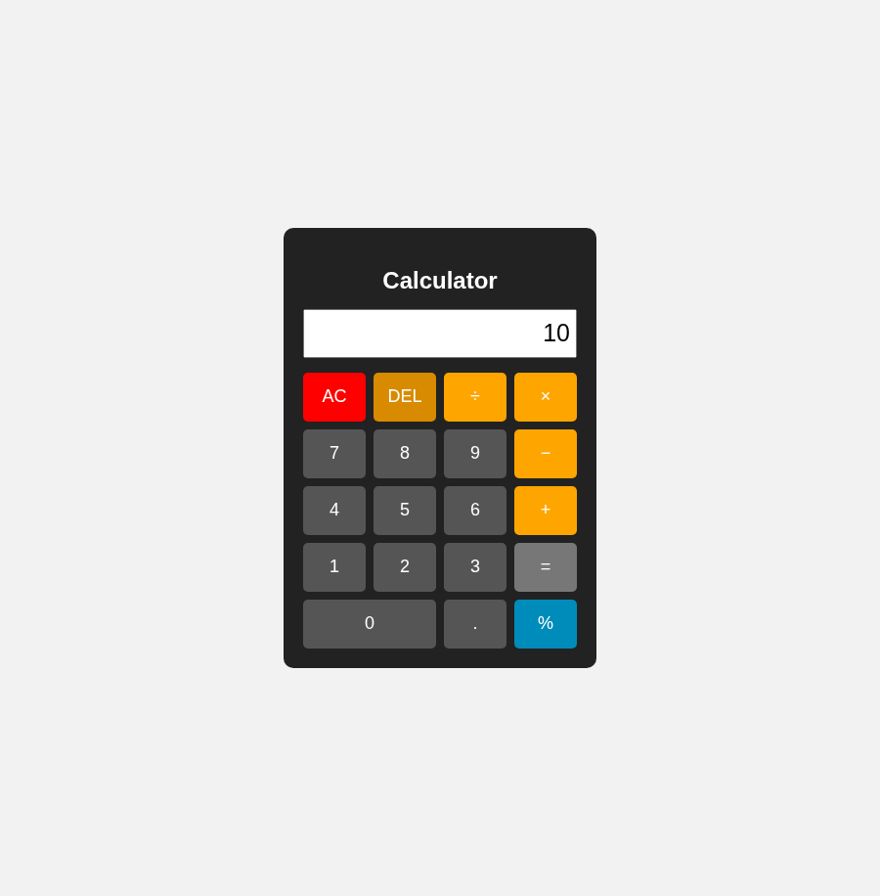
Calculator Output
Sample test shown: 7 + 3 = 10.

PROGRAM 2: TO-DO LIST
HTML CODE - index.html

<!DOCTYPE html>
<html lang="en">
<head>
<meta charset="UTF-8">
<meta name="viewport" content="width=device-width, initial-scale=1.0">
<title>Colorful To-Do List</title>

<link rel="stylesheet" href="style.css">

</head>

<body>

<div class="container">

<h1>🌈 To-Do List</h1>

<p class="subtitle">
✨ Plan Today • Complete Tomorrow ✨
</p>

<input
type="text"
id="taskInput"
placeholder="Enter your task">

<input
type="date"
id="taskDate">

<select id="priority">
<option value="High">🔴 High</option>
<option value="Medium">🟠 Medium</option>
<option value="Low">🟢 Low</option>
</select>

<button id="addBtn">
➕ Add Task
</button>

<button id="clearBtn">
🗑 Clear All
</button>

<br><br>

<input
type="text"
id="searchInput"
placeholder="🔍 Search task">

<select id="filter">
<option value="all">All Tasks</option>
<option value="pending">Pending</option>
<option value="completed">Completed</option>
</select>

<h3 id="counter">
Total: 0 | Completed: 0 | Pending: 0
</h3>

<ol id="taskList"></ol>

</div>

<script src="script.js"></script>

</body>
</html>

PROGRAM 2: TO-DO LIST
CSS CODE - style.css

*{
box-sizing:border-box;
}

body{
margin:0;
min-height:100vh;
padding:35px 15px;
font-family:Arial,sans-serif;
text-align:center;
background:linear-gradient(
135deg,
#ff9a9e,
#fad0c4,
#a1c4fd,
#c2e9fb,
#d4fc79
);
background-size:300% 300%;
animation:bgMove 10s infinite alternate;
}

@keyframes bgMove{
from{background-position:left;}
to{background-position:right;}
}

.container{
max-width:900px;
margin:auto;
padding:30px;
border-radius:25px;
background:rgba(255,255,255,0.88);
box-shadow:0 15px 40px rgba(0,0,0,0.20);
}

h1{
margin-top:0;
font-size:42px;
color:#6c5ce7;
text-shadow:2px 2px 5px #ddd;
}

.subtitle{
color:#e84393;
font-weight:bold;
margin-bottom:25px;
}

input,
select{
padding:12px;
margin:7px;
border-radius:12px;
font-size:15px;
outline:none;
transition:0.3s;
}

#taskInput{
border:3px solid #ff7675;
background:#fff0f0;
}

#taskDate{
border:3px solid #0984e3;
background:#eef7ff;
}

#priority{
border:3px solid #fdcb6e;
background:#fff9e8;
}

#searchInput{
border:3px solid #00b894;
background:#edfff9;
}

#filter{
border:3px solid #a29bfe;
background:#f5f0ff;
}

input:focus,
select:focus{
transform:scale(1.04);
box-shadow:0 0 12px rgba(108,92,231,0.4);
}

button{
padding:12px 18px;
margin:7px;
border:none;
border-radius:12px;
color:white;
font-weight:bold;
cursor:pointer;
transition:0.3s;
}

button:hover{
transform:scale(1.07);
}

#addBtn{
background:linear-gradient(90deg,#00b894,#00cec9);
}

#clearBtn{
background:linear-gradient(90deg,#ff4757,#fd79a8);
}

#counter{
max-width:550px;
margin:25px auto;
padding:15px;
border-radius:15px;
color:#2d3436;
background:linear-gradient(
90deg,
#ffeaa7,
#fab1a0,
#81ecec
);
box-shadow:0 5px 15px rgba(0,0,0,0.15);
}

ol{
padding:15px 35px;
text-align:left;
}

li{
margin:15px 0;
padding:16px;
border-radius:15px;
background:linear-gradient(
90deg,
#ffffff,
#f7f0ff,
#ecffff
);
border-left:6px solid #6c5ce7;
box-shadow:0 5px 14px rgba(0,0,0,0.12);
}

li:hover{
transform:translateY(-2px);
}

.completed{
text-decoration:line-through;
color:#888;
}

.high{
color:#d63031;
background:#ffe4e4;
padding:4px 8px;
border-radius:8px;
font-weight:bold;
}

.medium{
color:#e17000;
background:#fff0bf;
padding:4px 8px;
border-radius:8px;
font-weight:bold;
}

.low{
color:#00a878;
background:#dffff3;
padding:4px 8px;
border-radius:8px;
font-weight:bold;
}

li button{
padding:8px 12px;
font-size:13px;
}

li button:nth-of-type(1){
background:#00b894;
}

li button:nth-of-type(2){
background:#0984e3;
}

li button:nth-of-type(3){
background:#d63031;
}

@media(max-width:650px){
h1{
font-size:30px;
}

input,
select,
#addBtn,
#clearBtn{
width:90%;
}

.container{
padding:20px;
}

ol{
padding:10px 25px;
}
}

PROGRAM 2: TO-DO LIST
JAVASCRIPT CODE - script.js

let taskInput =
document.getElementById("taskInput");

let taskDate =
document.getElementById("taskDate");

let priority =
document.getElementById("priority");

let addBtn =
document.getElementById("addBtn");

let clearBtn =
document.getElementById("clearBtn");

let searchInput =
document.getElementById("searchInput");

let filter =
document.getElementById("filter");

let taskList =
document.getElementById("taskList");

let counter =
document.getElementById("counter");

let tasks = [];

let editIndex = -1;

addBtn.addEventListener(
"click",
function(){

let task =
taskInput.value.trim();

if(task === ""){
alert("Please enter a task!");
return;
}

if(editIndex !== -1){

tasks[editIndex].name =
task;

tasks[editIndex].date =
taskDate.value;

tasks[editIndex].priority =
priority.value;

editIndex = -1;

addBtn.textContent =
"➕ Add Task";

}else{

tasks.push({

name:task,

date:taskDate.value,

priority:priority.value,

completed:false

});
}

taskInput.value = "";

taskDate.value = "";

priority.value = "High";

displayTasks();
});

function displayTasks(){

taskList.innerHTML = "";

let search =
searchInput.value.toLowerCase();

let selected =
filter.value;

tasks.forEach(
function(task,index){

if(
!task.name
.toLowerCase()
.includes(search)
){
return;
}

if(
selected === "pending"
&&
task.completed
){
return;
}

if(
selected === "completed"
&&
!task.completed
){
return;
}

let li =
document.createElement("li");

let name =
document.createElement("span");

name.textContent =
task.name + " ";

if(task.completed){
name.classList.add(
"completed"
);
}

let p =
document.createElement("span");

p.textContent =
"[" + task.priority + "] ";

p.classList.add(
task.priority.toLowerCase()
);

let date =
document.createElement("span");

if(task.date !== ""){
date.textContent =
" 📅 " + task.date + " ";
}

let completeBtn =
document.createElement("button");

completeBtn.textContent =
task.completed
? "↩ Undo"
: "✅ Complete";

completeBtn.onclick =
function(){

task.completed =
!task.completed;

displayTasks();
};

let editBtn =
document.createElement("button");

editBtn.textContent =
"✏ Edit";

editBtn.onclick =
function(){

taskInput.value =
task.name;

taskDate.value =
task.date;

priority.value =
task.priority;

editIndex =
index;

addBtn.textContent =
"Update Task";
};

let deleteBtn =
document.createElement("button");

deleteBtn.textContent =
"🗑 Delete";

deleteBtn.onclick =
function(){

tasks.splice(
index,
1
);

displayTasks();
};

li.append(
name,
p,
date,
completeBtn,
editBtn,
deleteBtn
);

taskList.appendChild(li);

});

updateCounter();
}

function updateCounter(){

let total =
tasks.length;

let completed =
tasks.filter(
task => task.completed
).length;

let pending =
total - completed;

counter.textContent =
"Total: " + total +
" | Completed: " +
completed +
" | Pending: " +
pending;
}

clearBtn.onclick =
function(){

tasks = [];

editIndex = -1;

addBtn.textContent =
"➕ Add Task";

displayTasks();
};

searchInput.oninput =
displayTasks;

filter.onchange =
displayTasks;

taskInput.addEventListener(
"keydown",
function(event){

if(event.key === "Enter"){
addBtn.click();
}

});

PROGRAM 2: TO-DO LIST
OUTPUT - Sample Working Result

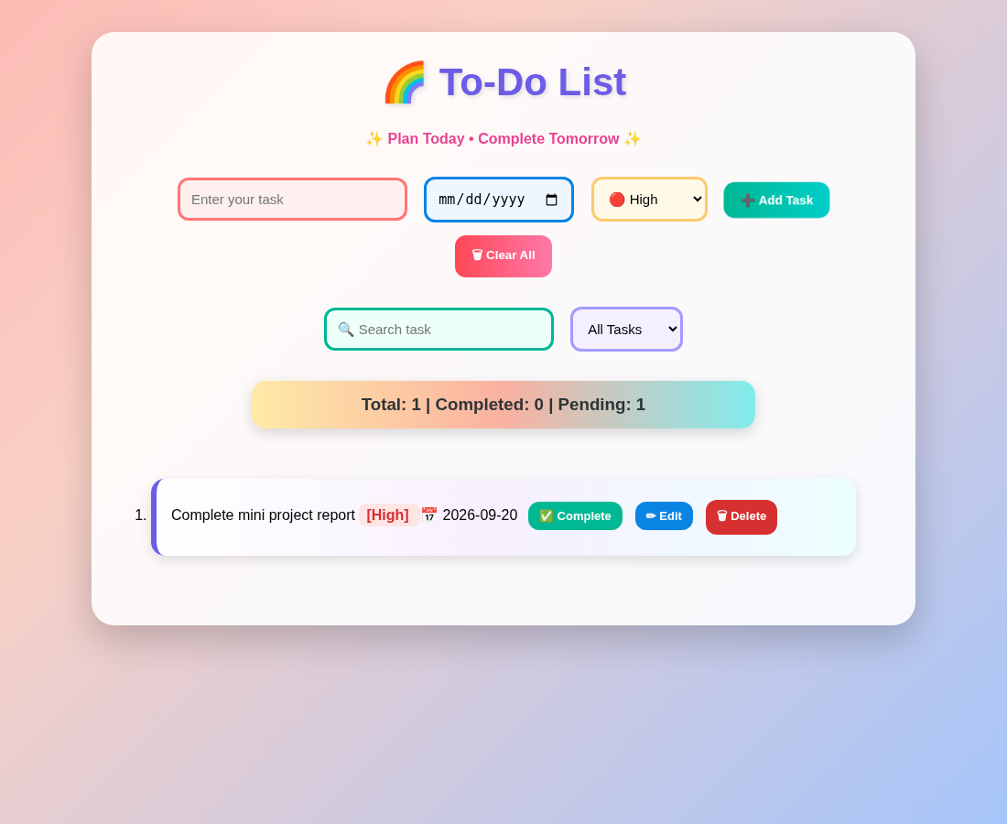
To-Do List Output
Sample task added successfully. Counter displays Total: 1, Completed: 0, Pending: 1.

PROGRAM 3: STUDENT REGISTRATION
HTML CODE - index.html

<!DOCTYPE html>
<html lang="en">
<head>
<meta charset="UTF-8">
<meta name="viewport" content="width=device-width, initial-scale=1.0">
<title>Student Registration</title>

<link rel="stylesheet" href="style.css">

</head>

<body>

<div class="container">

<h1>🌈🎓 Student Registration</h1>

<p class="subtitle">
✨ Register Your Student Details ✨
</p>

<form id="studentForm">

<label>👤 Student Name</label>
<input
type="text"
id="name"
placeholder="Enter your full name"
required
>

<label>📧 Email</label>
<input
type="email"
id="email"
placeholder="Enter your email"
required
>

<label>📱 Phone Number</label>
<input
type="tel"
id="phone"
placeholder="Enter 10-digit phone number"
required
>

<label>⚧ Gender</label>
<select id="gender" required>
<option value="">Select Gender</option>
<option value="Male">Male</option>
<option value="Female">Female</option>
<option value="Other">Other</option>
</select>

<label>🎓 Course</label>
<select id="course" required>
<option value="">Select Course</option>
<option value="CSE">Computer Science Engineering</option>
<option value="ECE">Electronics and Communication</option>
<option value="EEE">Electrical and Electronics</option>
<option value="Civil">Civil Engineering</option>
<option value="Mechanical">Mechanical Engineering</option>
</select>

<label>📅 Year</label>
<select id="year" required>
<option value="">Select Year</option>
<option value="1st Year">1st Year</option>
<option value="2nd Year">2nd Year</option>
<option value="3rd Year">3rd Year</option>
<option value="4th Year">4th Year</option>
</select>

<label>🔐 Password</label>
<input
type="password"
id="password"
placeholder="Minimum 6 characters"
required
>

<button type="submit">
🌟 Register Now 🌟
</button>

</form>

<div id="result"></div>

<div class="footer">
🌈 Student Registration System 💻
</div>

</div>

<script src="script.js"></script>

</body>
</html>

PROGRAM 3: STUDENT REGISTRATION
CSS CODE - style.css

* {
box-sizing: border-box;
}

body {
margin: 0;
font-family: Arial, sans-serif;
min-height: 100vh;

background: linear-gradient(
120deg,
#ff4b5c,
#ff9f43,
#feca57,
#1dd1a1,
#48dbfb,
#5f27cd,
#ff6b81
);

background-size: 400% 400%;
animation: backgroundMove 12s ease infinite;

display: flex;
justify-content: center;
align-items: center;

padding: 20px;
}

@keyframes backgroundMove {
0% {
background-position: 0% 50%;
}

50% {
background-position: 100% 50%;
}

100% {
background-position: 0% 50%;
}
}

.container {
width: 450px;
max-width: 100%;

background: linear-gradient(
145deg,
#ffffff,
#fff0f6,
#f0f8ff
);

padding: 30px;

border-radius: 25px;

border: 5px solid transparent;

background-clip: padding-box;

box-shadow:
0 0 15px #ff6b6b,
0 0 25px rgba(72, 219, 251, 0.7),
0 15px 35px rgba(0, 0, 0, 0.25);
}

h1 {
text-align: center;

font-size: 30px;

background: linear-gradient(
90deg,
#ff1744,
#ff9100,
#00b894,
#0984e3,
#6c5ce7,
#e84393
);

-webkit-background-clip: text;
-webkit-text-fill-color: transparent;

margin-bottom: 8px;
}

.subtitle {
text-align: center;

color: #6c5ce7;

font-size: 15px;

margin-bottom: 25px;

font-weight: bold;
}

label {
display: block;

margin-top: 15px;
margin-bottom: 6px;

font-weight: bold;
}

label:nth-of-type(1) {
color: #e84393;
}

label:nth-of-type(2) {
color: #0984e3;
}

label:nth-of-type(3) {
color: #00b894;
}

label:nth-of-type(4) {
color: #6c5ce7;
}

label:nth-of-type(5) {
color: #ff7675;
}

label:nth-of-type(6) {
color: #e67e22;
}

label:nth-of-type(7) {
color: #8e44ad;
}

input,
select {
width: 100%;

padding: 12px;

font-size: 15px;

outline: none;

border-radius: 12px;

background: white;

transition: 0.3s;
}

#name {
border: 2px solid #ff6b81;
background-color: #fff0f5;
}

#email {
border: 2px solid #54a0ff;
background-color: #eef7ff;
}

#phone {
border: 2px solid #1dd1a1;
background-color: #effff9;
}

#gender {
border: 2px solid #a55eea;
background-color: #f8f0ff;
}

#course {
border: 2px solid #ff9f43;
background-color: #fff8ee;
}

#year {
border: 2px solid #feca57;
background-color: #fffbea;
}

#password {
border: 2px solid #ee5253;
background-color: #fff0f0;
}

input:focus,
select:focus {
transform: scale(1.02);

box-shadow:
0 0 6px #ff6b6b,
0 0 12px #48dbfb,
0 0 18px #5f27cd;
}

button {
width: 100%;

padding: 15px;

margin-top: 25px;

border: none;

border-radius: 15px;

background: linear-gradient(
90deg,
#ff1744,
#ff9100,
#fdd835,
#00c853,
#00b0ff,
#651fff,
#d500f9
);

background-size: 300%;

color: white;

font-size: 18px;

font-weight: bold;

cursor: pointer;

transition: 0.4s;

animation: buttonColor 5s linear infinite;
}

@keyframes buttonColor {
0% {
background-position: 0%;
}

100% {
background-position: 300%;
}
}

button:hover {
transform: scale(1.05);

box-shadow:
0 0 10px #ff1744,
0 0 20px #00b0ff,
0 0 30px #651fff;
}

#result {
margin-top: 25px;
}

.success {
padding: 20px;

border-radius: 18px;

background: linear-gradient(
135deg,
#ffecd2,
#fcb69f,
#a1c4fd,
#c2e9fb
);

border: 3px solid #00b894;

box-shadow:
0 8px 20px rgba(0, 0, 0, 0.2);
}

.success h2 {
text-align: center;

color: #00a86b;

text-shadow:
1px 1px 2px white;
}

.success p {
background: linear-gradient(
90deg,
#ffffff,
#f8f9ff
);

padding: 10px;

border-radius: 10px;

margin: 9px 0;

border-left: 5px solid #6c5ce7;

color: #333;
}

.success p:nth-child(2) {
border-left-color: #ff6b81;
}

.success p:nth-child(3) {
border-left-color: #54a0ff;
}

.success p:nth-child(4) {
border-left-color: #1dd1a1;
}

.success p:nth-child(5) {
border-left-color: #a55eea;
}

.success p:nth-child(6) {
border-left-color: #ff9f43;
}

.success p:nth-child(7) {
border-left-color: #feca57;
}

.footer {
text-align: center;

margin-top: 20px;

font-size: 14px;

font-weight: bold;

background: linear-gradient(
90deg,
#ff4757,
#5f27cd,
#00b8d4
);

-webkit-background-clip: text;
-webkit-text-fill-color: transparent;
}

@media(max-width: 500px) {
.container {
padding: 22px;
}

h1 {
font-size: 25px;
}
}

PROGRAM 3: STUDENT REGISTRATION
JAVASCRIPT CODE - script.js

document.getElementById("studentForm")
.addEventListener("submit", function(event) {

event.preventDefault();

let name =
document.getElementById("name").value;

let email =
document.getElementById("email").value;

let phone =
document.getElementById("phone").value;

let gender =
document.getElementById("gender").value;

let course =
document.getElementById("course").value;

let year =
document.getElementById("year").value;

let password =
document.getElementById("password").value;

if (phone.length !== 10 || isNaN(phone)) {

alert(
"Please enter a valid 10-digit phone number"
);

return;
}

if (password.length < 6) {

alert(
"Password must contain at least 6 characters"
);

return;
}

let result =
document.getElementById("result");

result.className = "success";

result.innerHTML = `

<h2>🎉 Registration Successful! 🎉</h2>

<p>
<b>👤 Name:</b> ${name}
</p>

<p>
<b>📧 Email:</b> ${email}
</p>

<p>
<b>📱 Phone:</b> ${phone}
</p>

<p>
<b>⚧ Gender:</b> ${gender}
</p>

<p>
<b>🎓 Course:</b> ${course}
</p>

<p>
<b>📅 Year:</b> ${year}
</p>
`;

document.getElementById("studentForm").reset();

});

PROGRAM 3: STUDENT REGISTRATION
OUTPUT - Sample Working Result

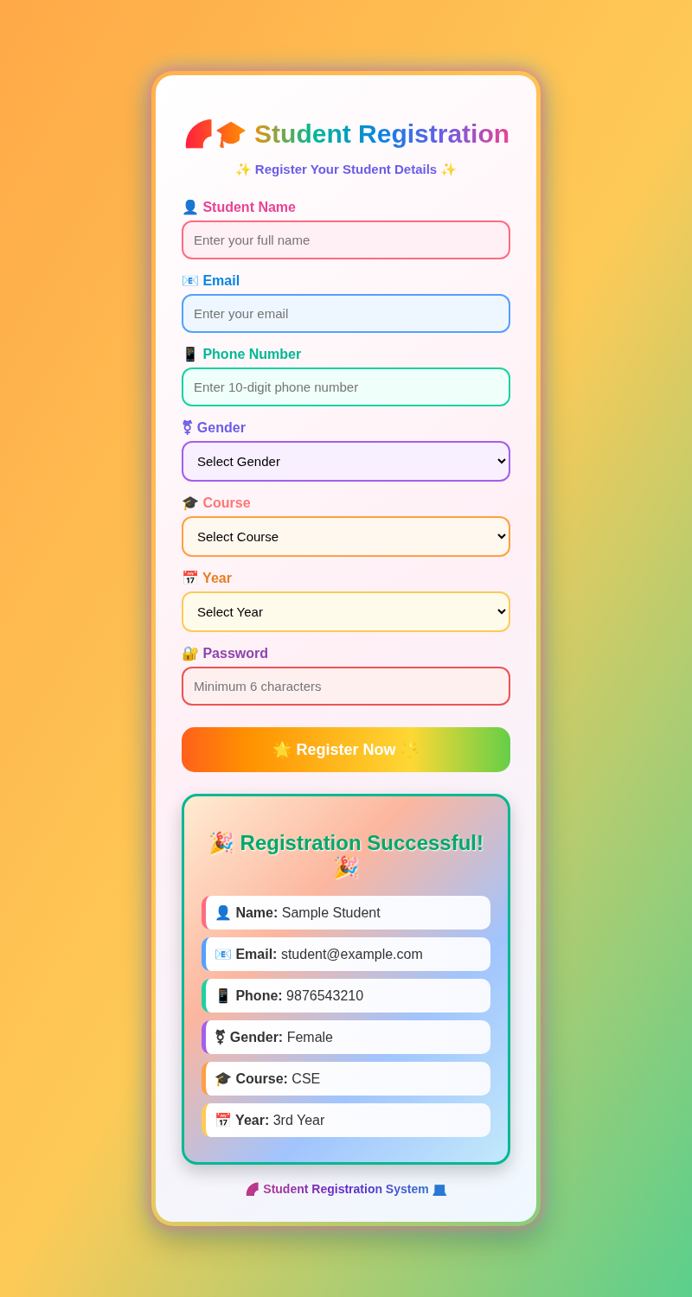
Student Registration Output
Sample valid registration displays “Registration Successful!” after validation.

