# Week4: Deployment on Flask

Name: J.M.T Chinthaka Jayaweera

Batch code: LISUM04

Submission date: 22/11/2021

Submitted to: Data Glacier

Step 01: “main.py” file has shown in following figure. This will create a “model.pkl” file.

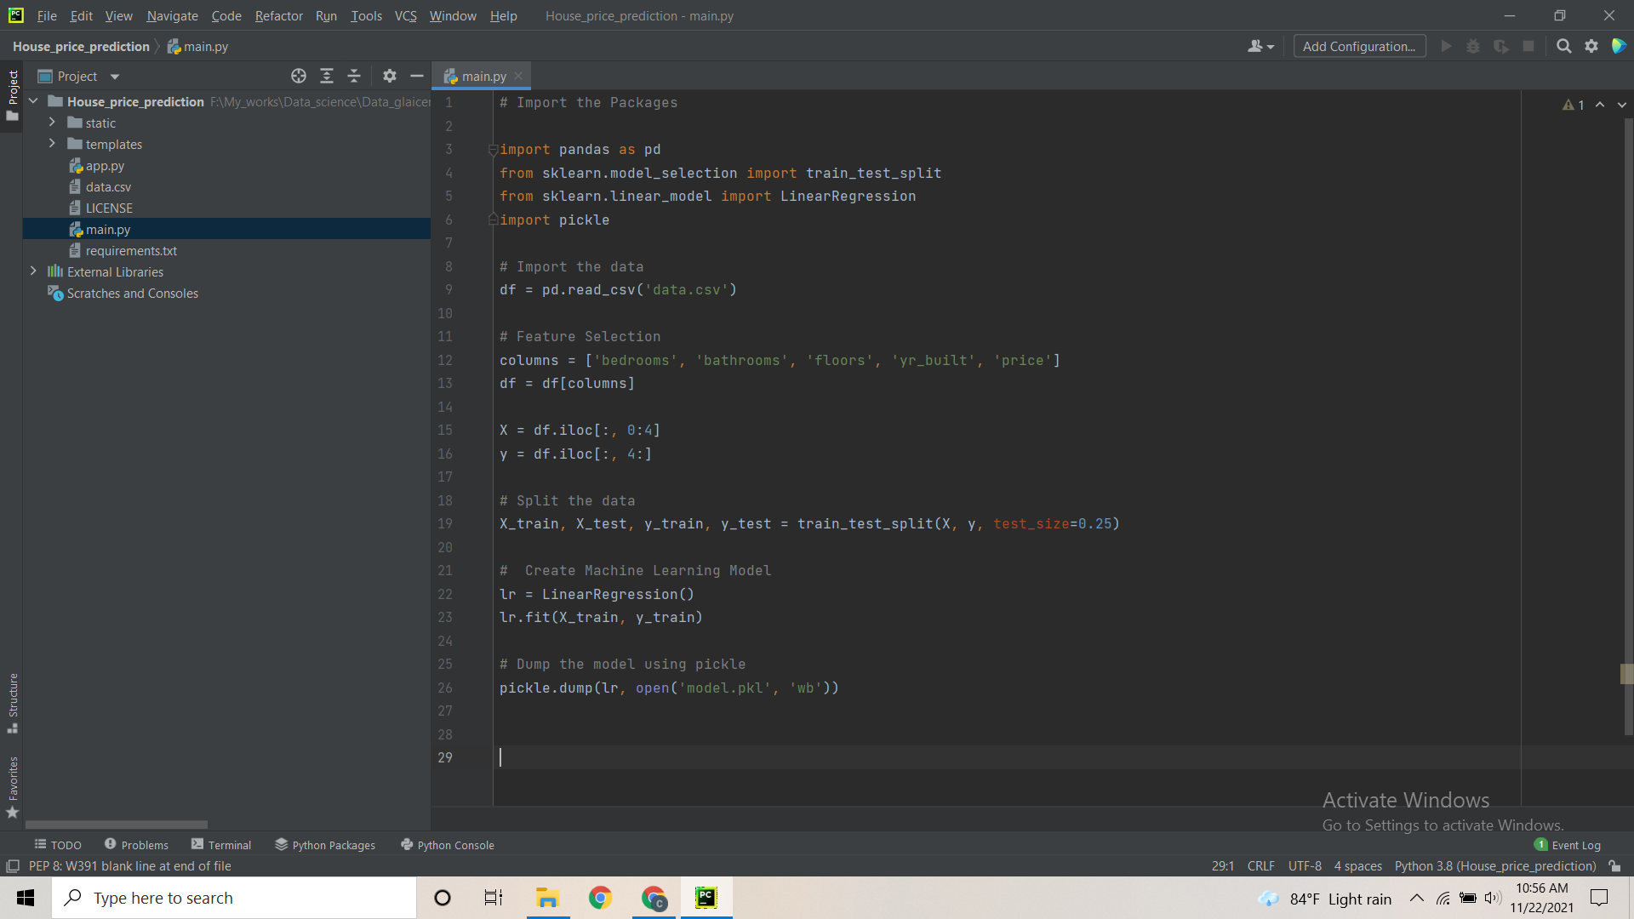

After running the main.py, It creates the model.pkl file in the working directory.

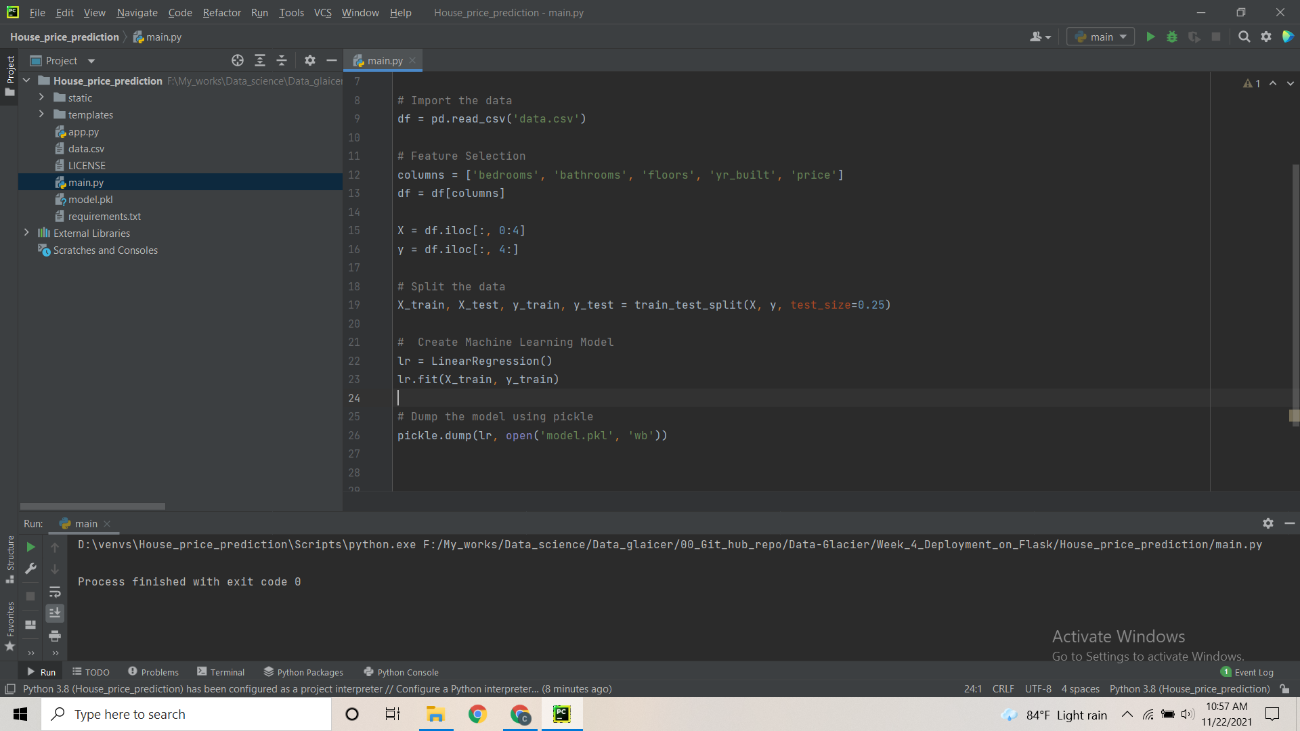

The app.py has shown in the following figure. After running it We can get the local link of running model.

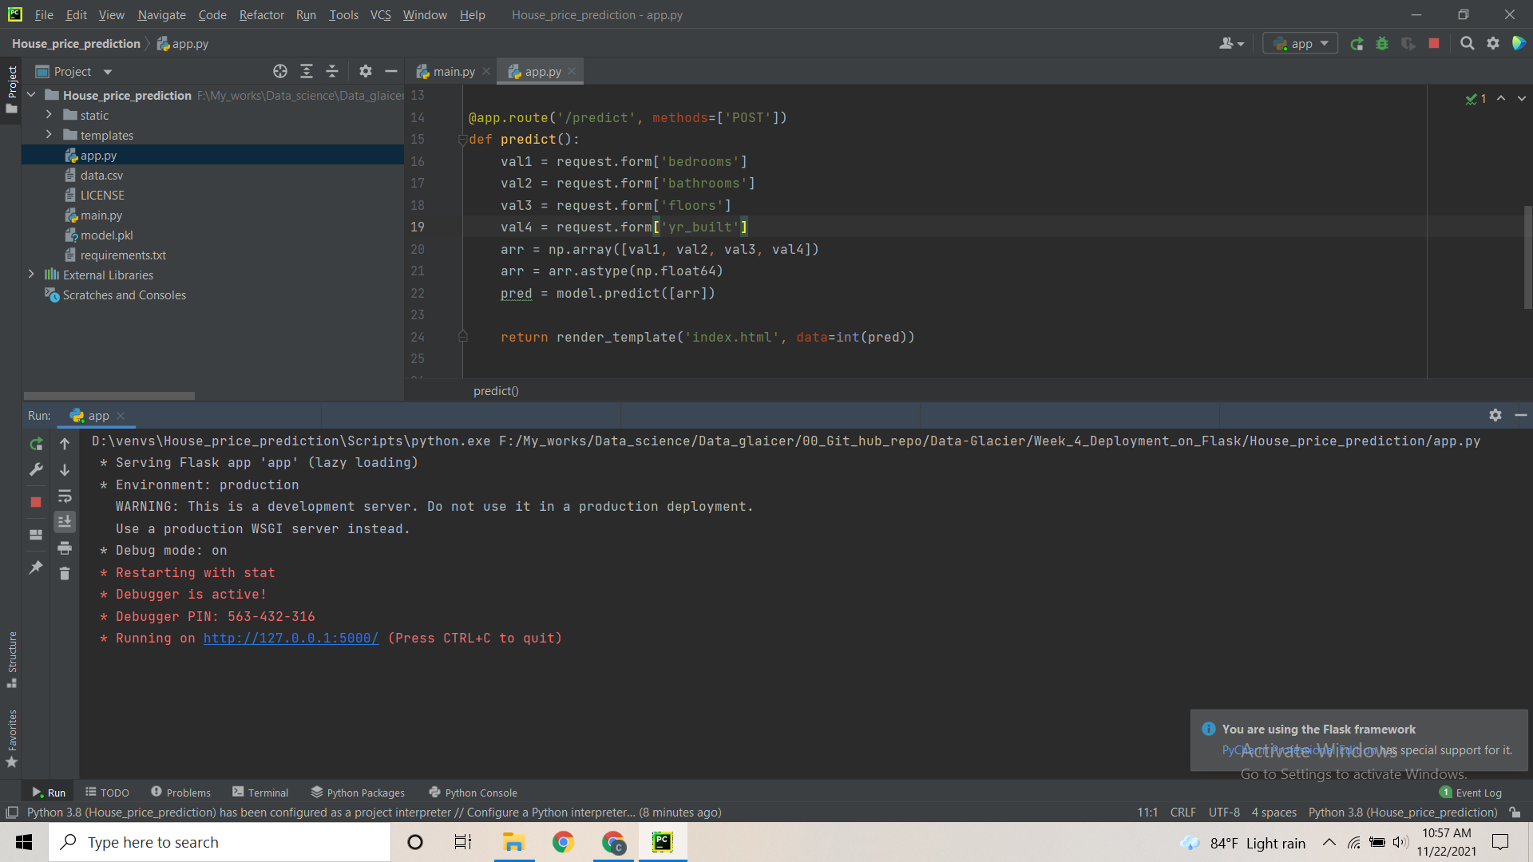

The running app has shown in following figure.

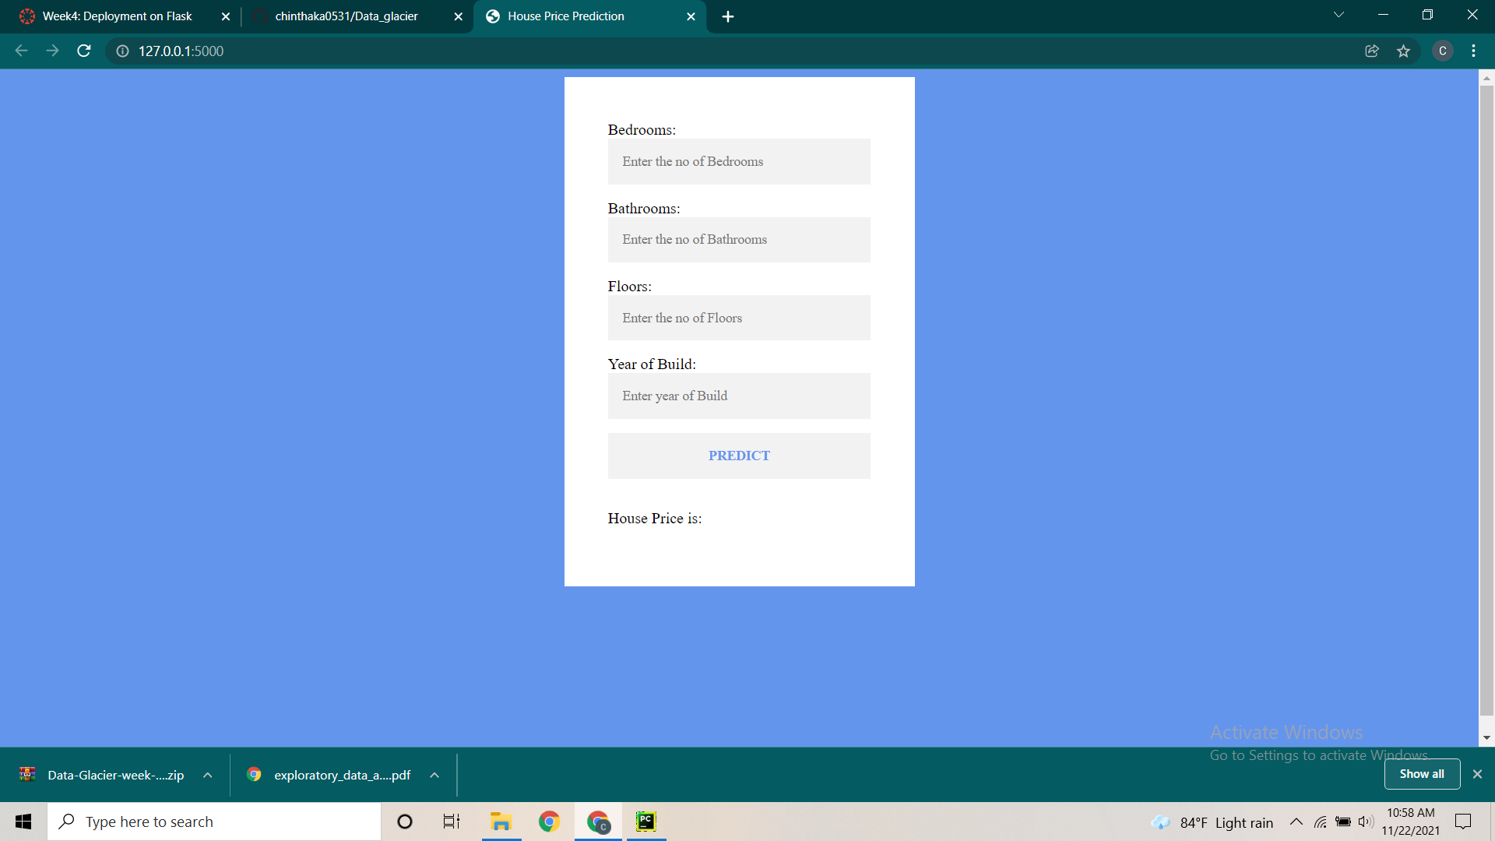

Let’s test it.

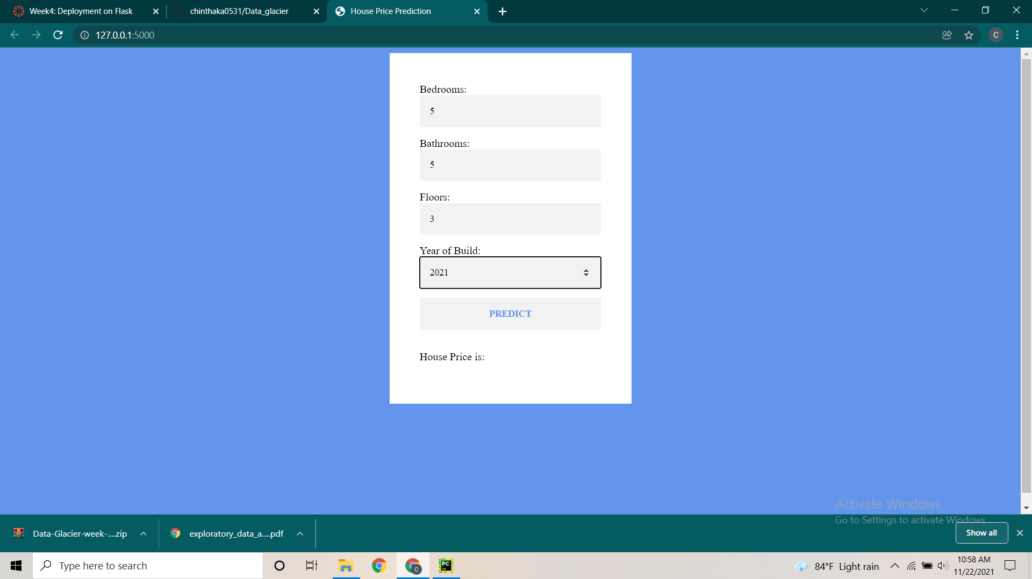

The output for the given data was 1314703 USD.

