# [Week 5: Cloud and API deployment](https://canvas.instructure.com/courses/3494200/modules/items/53840410" \o "Week 5: Cloud and API deployment)

Name: J.M.T Chinthaka Jayaweera

Batch code: LISUM04

Submission date: 22/11/2021

Submitted to: Data Glacier

Step 01: Uploaded the project files into github repository

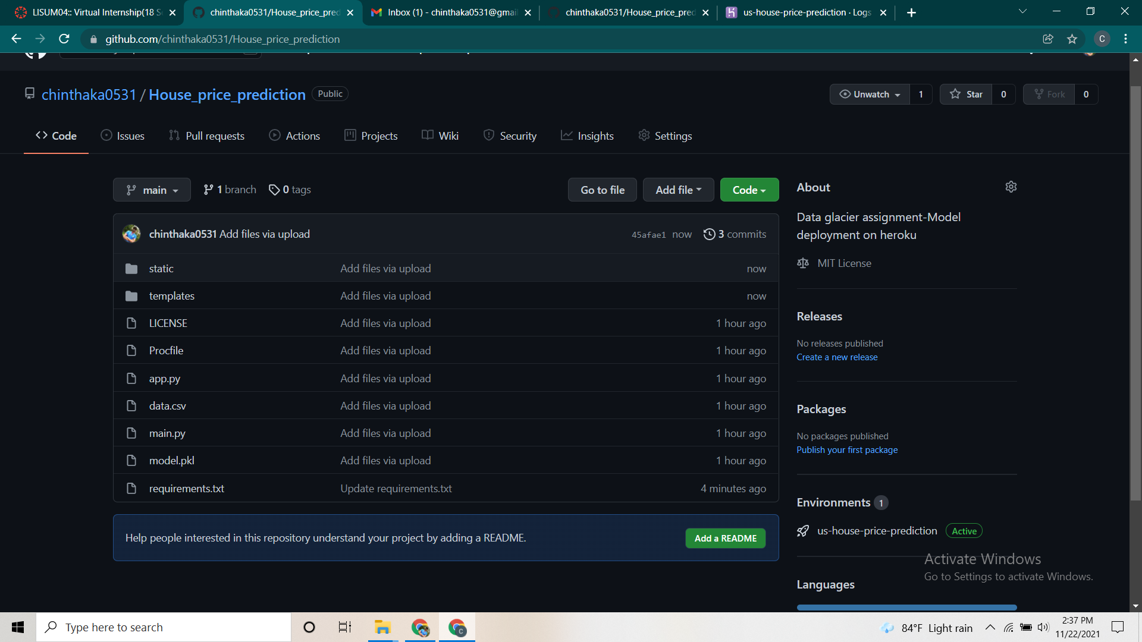

Step 2: Created a Heroku account and created a new app

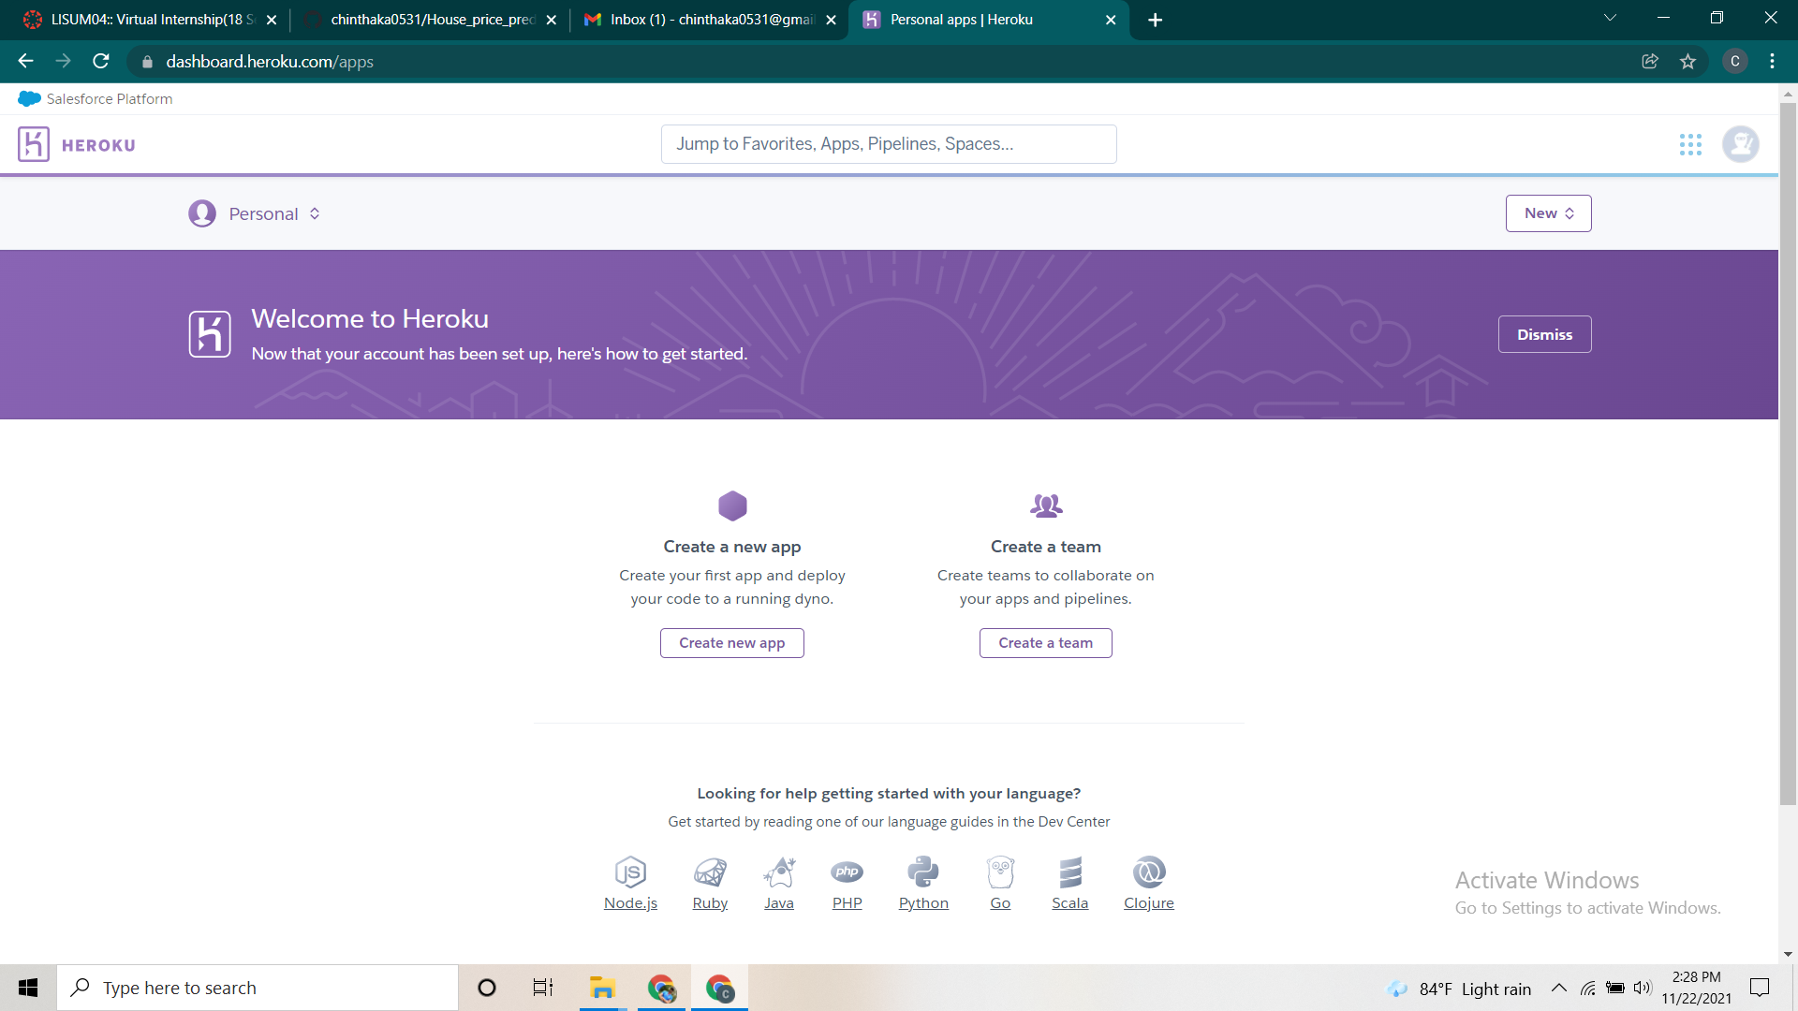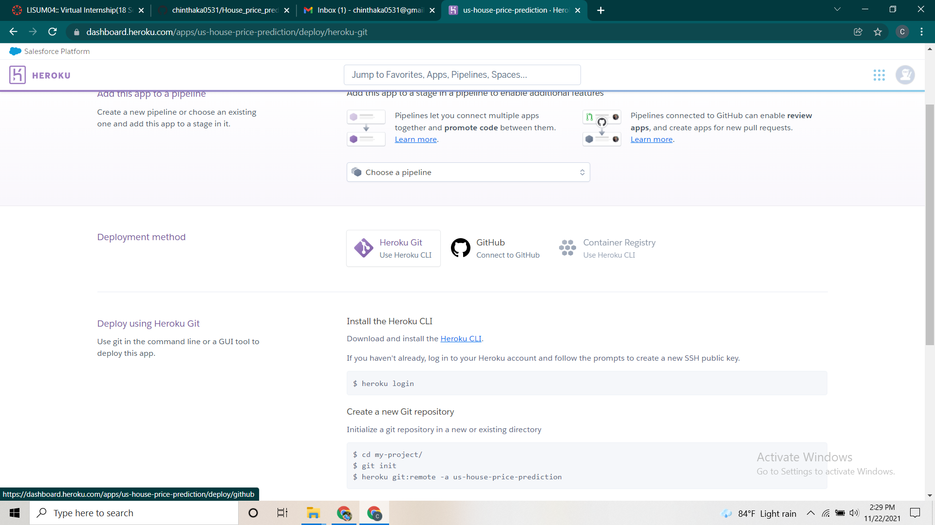

Step 03: Connected the github repository to the Heroku

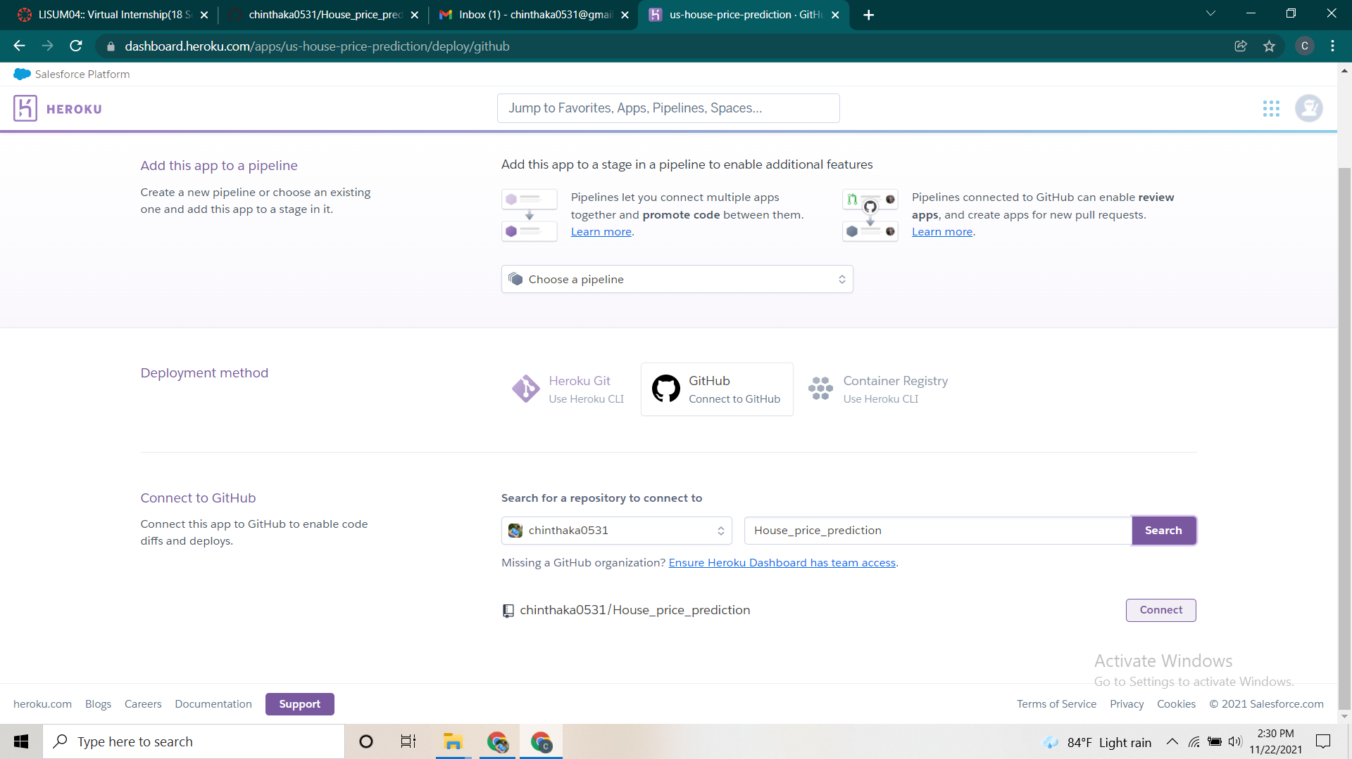

Step 04: Deployed the main branch

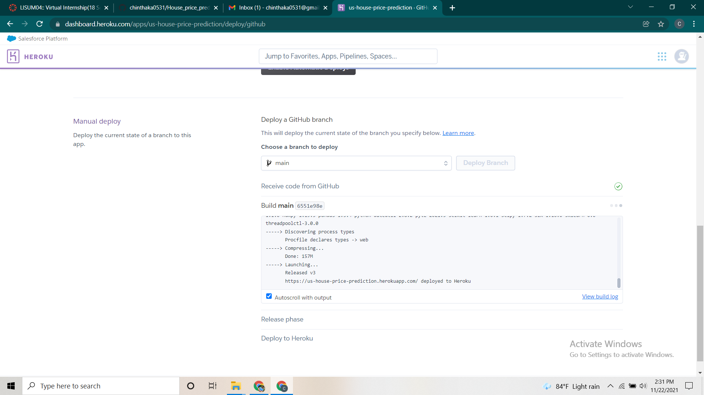

Step 05: Here is the running app on Heroku.

