**IN2901 - Software Development Project**

**Project Proposal**



Department of Information Technology

Faculty of Information Technology

University of Moratuwa

2023

|  |  |  |
| --- | --- | --- |
| **Group Name** | Cloud 5 | |
| **Project Name** | Artista | |
| **Client’s name and**  **address** | 4 Axis Solutions (Pvt) Ltd,  422 R. A. De Mel Mawatha,  Colombo 00300 | |
| **Group Members** | Index No | Name |
| 214029P | Bandara H.R.B.G.M. |
| 214091V | Jayathissa K.D.G.S |
| 214099D | Karunarathna R.M.D.R.R |
| 214140X | Nethma L.H.K |
| 214202P | Siriwardane A.J.U |
| **Supervisors’ names** | 1. Mrs. K A Dilini T Kulawansa        1. Dr. C R J Amalraj | |

**Table of content**

**1. Introduction 4**

**2. Background & Motivation 5**

**3. Problem in brief 6**

**4. Aim and Objectives 7**

**4.1 Aim 7**

**4.2 Objectives 7**

**5. Proposed Solution 8**

**6. Resource requirements 9**

**7. References 10**

**8. Appendix 11**

**9. Signatures of the Group Members 12**

**10. Supervisors’ declaration 13**

# Introduction

Digital art is a modern form of artistic expression that uses digital technologies as a medium [8] and because of that, it includes a wide range of styles and techniques such as digital painting, 3D modeling, animation, generative art, AR/VR artworks, and more.

In a world where digital creativity is increasing, the demand for a dedicated platform that enables artists to showcase their talents and enables art lovers to grasp their desired creations has never been more evident. Online digital art marketplaces provide a valuable platform for artists to showcase their work to a global audience [9]. They offer opportunities for exposure and possibly generating income from their creations. These platforms often foster communities of artists and art enthusiasts, allowing for networking, collaboration, and feedback that can be invaluable to artists' growth. [10]

While online digital art marketplaces offer numerous benefits, they also have potential drawbacks. Competition can be fierce, and not all artists achieve significant sales. Platform fees and transaction costs may also eat into earnings. Difficulties that buyers face when seeking a desired art. Difficulties when choosing an artist for a particular job. Copyright issues. Difficulties in communication between artists and buyers. An oversaturated market makes it challenging for artists to stand out and get jobs [11] [12].

However, these platforms encourage community, innovation, and collaboration among creatives, provide inspiration and learning opportunities, and contribute to the growth of the digital art market. Online digital art marketplaces play a crucial role in democratizing art and creating a more inclusive art world.

# Background & Motivation

## Background

The digital art world is in the midst of a profound transformation, as artists increasingly harness the creative potential of digital technologies to push the boundaries of artistic expression. This evolution has given rise to a growing demand for online platforms where artists can showcase their innovative works, while art enthusiasts can engage with and appreciate these digital creations. The intersection of technology and art has opened up new frontiers, ushering in a digital renaissance where creativity knows no bounds.

Online digital art marketplaces have emerged as the answer to this demand, reshaping the landscape of art consumption and creation. These platforms democratize the art world, offering artists a global stage to exhibit their talents and providing exposure and income opportunities previously unattainable. However, as digital art continues to flourish, these platforms confront a series of pressing challenges that require innovative solutions.

## Motivation

Our motivation comes from a strong desire to make the digital art world more inclusive and reachable. We want to overcome the current challenges in the digital art marketplace. Most of the online digital art marketplaces focused only on buying and selling artworks. Our solution, 'Artista,' is designed to address the issues of these marketplaces and empower both artists and art enthusiasts.

Our user-friendly chatbot aims to improve the user experience by providing quick and effective assistance, replacing inefficient help centers on most websites. 'Artista' also offers 3D viewing features that allow artists to showcase their work creatively.

We are committed to establishing fair artist rankings based on merit, which will improve collaboration quality and fairness in the marketplace as our website promotes better interaction between artists and users, enhancing community and customization options.

To protect artists' intellectual property, our platform uses blockchain technology, ensuring creators maintain control over their work and receive proper recognition. Our motivation extends to inspiring and empowering artists while enriching the digital art world, creating an environment where innovation and artistic excellence flourish without limits.

# Problem in brief

Online digital art marketplaces provide a platform for artists and art enthusiasts to engage with and appreciate a wide range of digital art forms. However, these platforms come with their fair share of challenges that require attention.

Firstly, traditional help centers often fall short of addressing user concerns effectively. Users are frequently directed to links and articles that prove insufficient and irrelevant for resolving their issues. [13]

Another issue is the limited 3D art viewing options on most platforms. As digital art evolves, especially in areas like 3D modeling and AR/VR art, the absence of 3D viewing features hampers artists' abilities to showcase their work comprehensively.

Some platforms base artist rankings on financial contributions rather than artistic merit. This practice can mislead users, as these rankings do not accurately reflect an artist's skills, project history, or user feedback.

Limited artist-user interaction is another challenge. Many platforms lack direct communication channels between artists and art enthusiasts, hindering effective interaction, customization options, and insights into the creative process.

Another problem is that artists often face restrictions when customizing their profiles and showcasing their skills, limiting their ability to stand out in a crowded marketplace and secure job opportunities.

A critical concern in digital art marketplaces is the protection of artists' copyrights. Artists should undoubtedly maintain ownership and control over their creations, preventing unauthorized copying or transfer of ownership to others. Blockchain technology offers a robust solution to establish and enforce these rights, yet many digital art marketplaces have yet to adopt such mechanisms, placing artists at a disadvantage in safeguarding their intellectual property [13]

# Aim and Objectives

## Aim

The aim of this project is to establish an inclusive online digital art marketplace that encourages artists and enables art enthusiasts worldwide to connect, collaborate, explore, and appreciate digital creativity with the use of ReactJS, Flutter,Three.js, etc.

## Objectives

In order to achieve the above-mentioned aim, the following objectives have been defined:

* Study of the Online Digital Art Marketplaces.
* Identify and thoroughly analyze the specific issues encountered by artists, art enthusiasts, and the platforms themselves within the digital art marketplace
* Research Relevant Technologies.
* Design and Development of solutions
* Prioritize the development of solutions that align with the needs and preferences of both artists and art enthusiasts
* Evaluation of proposed solutions
* Addressing copyright and legal issues
* Explore strategies to ensure the long-term viability and growth of the digital art marketplace, including revenue models, fee structures, and future plans.

# Proposed Solution

In response to the challenges faced by users and artists on existing digital art marketplaces, we present Artista, an innovative Online Digital Art Marketplace designed to elevate the art-buying experience and empower artists. At the core of the Artista project is the Artista Marketplace. Artista addresses these challenges with a comprehensive set of features. Artista is an online marketplace where artists can display their digital art and offer various creative services. It's like a lively center for art lovers and buyers who want to purchase amazing artworks or request one-of-a-kind projects from artists.

We are introducing a user-friendly chatbot powered by GPT models to directly address user concerns and guide them to relevant articles or solutions as an excellent solution to the challenge of ineffective help centers. This chatbot can act as a virtual assistant, providing immediate and personalized assistance to users, which can significantly enhance their experience on our web application, improving interactiveness and responsiveness, and making them feel heard and supported.

Using technologies like Three.js and WebGL to create a 3D art viewer with zooming, panning, and rotating capabilities, we are addressing the issue of limited 3D art viewing options on most platforms which allows users to observe and interact with 3D artworks conveniently.

We are introducing a voting system for each art or collection of arts, along with artist profiles that include followers and view counts, is an effective solution to address the issue of artist rankings being based solely on financial contributions rather than artistic merit, which allows users to select the most recognized or talented artists for their jobs.

Enabling artists to maintain comprehensive profiles with contact details, direct messaging functionality, personal details, project history, and offered services will be an excellent solution to address the challenge of limited artist-user interaction on digital art marketplace platforms.

Implementing blockchain technology to protect the copyrights and transactions within our digital art marketplace is an excellent solution to address the critical concern of artists' intellectual property rights. This empowers artists to maintain ownership and control over their creations, effectively preventing unauthorized copying or transfer. This not only protects artists' intellectual property but also enhances the overall trust and integrity of our platform.

# Resource requirements

1. Computer with 512MB RAM
2. 2GHz or more processing power
3. Windows OS
4. Visual Studio
5. Android Studio
6. Internet connectivity
7. AWS or Firebase Database
8. Any web browser
9. Mobile device with Android or IOS OS

# References

|  |  |
| --- | --- |
| [1] | "Behance," [Online]. Available: http://www.behance.net. |
| [2] | K. Mustatea, "Who Buys Digital Art—And Why," 19 April 2019. [Online]. Available: https://medium.com/edgecut/who-buys-digital-art-and-why-cd872b870089. |
| [3] | "niftygateway," [Online]. Available: https://www.niftygateway.com/marketplace/. |
| [4] | M. Gonzalez, "Using Blockchain to Protect Artists and Manage Intellectual Property Law," 25 June 2019. [Online]. Available: https://medium.com/gochain/using-blockchain-to-protect-artists-and-manage-intellectual-property-law-124b5774ea8f#:~:text=GoChain%20offers%20the%20use%20of%20blockchain%20technology%20as,digital%20content%20from%20music%20to%20pieces%20of%20art.. |
| [5] | "Dribbble," [Online]. Available: https://dribbble.com. |
| [6] | "v-art," [Online]. Available: https://v-art.digital/. |
| [7] | "ArtMo," [Online]. Available: https://artmo.com/. |
| [8] | H. Gong, "29 Digital Art: A New Form of Artistic Expression," 2010. [Online]. Available: https://asmedigitalcollection.asme.org/ebooks/book/148/chapter-abstract/29947/Digital-ArtA-New-Form-of-Artistic-Expression?redirectedFrom=fulltext. |
| [9] | M. R. a. S. Heidenreich, "What the Art World Can Do to Make Art Accessible to More People," 3 November 2019. [Online]. Available: https://www.artsy.net/article/artsy-editorial-art-art-accessible-people. |
| [10] | FINMODELSLAB, "Online Digital Art Marketplace Business SWOT Analysis," finmodelslab, [Online]. Available: https://finmodelslab.com/products/online-digital-art-marketplace-swot-analysis. |
| [11] | A. Yakovleva, "How To Sell Digital Art: 20 Best Places To Sell Digital Art Online," The Designest, 2 June 2023. [Online]. Available: https://thedesignest.net/sell-digital-art-online/. |
| [12] | Coinpedia, "How To Sell Digital Art, What Are The Best Online Marketplaces?," CoinPedia, 16 September 2021. [Online]. Available: https://coinpedia.org/guest-post/ways-to-sell-your-nft-and-digital-art/. |
| [13] | A. Bansal, "Online Marketplace: New challenges to overcome," Jungleworks.com, 30 July 2018. [Online]. Available: https://jungleworks.com/online-marketplace-new-challenges-to-overcome/#:~:text=Largely%20dependent%20upon%20technology%20Higher%20transparency%20of%20price,update%20the%20technology%20Buyer%20personal%20information%20security%20issues. |

# Appendix

*Plan of action*

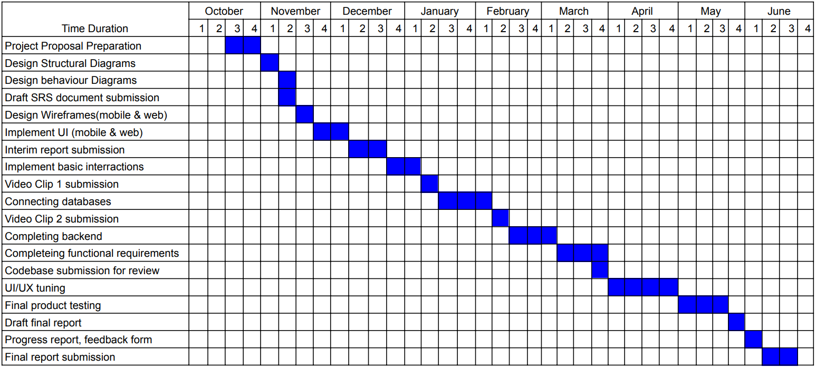

# Signatures of the Group Members

|  |  |  |
| --- | --- | --- |
| **Index No** | **Name** | **Signature** |
| 214029P | Bandara H.R.B.G.M. |  |
| 214091V | Jayathissa K.D.G.S |  |
| 214099D | Karunarathna R.M.D.R.R |  |
| 214140X | Nethma L.H.K |  |
| 214202P | Siriwardane A.J.U |  |

# Supervisors’ declaration

I hereby declare that I have checked this project and, in my opinion, this project is adequate in terms of scope and quality

1. Name of Supervisor: Mrs. K.A. Dilini T Kulawansa

Designation: Senior Lecturer

Date: 01/10/2023

Signature: 

Any further comments

1. Name of Supervisor: Dr. C R J Amalraj Designation: Senior Lecturer

Date:

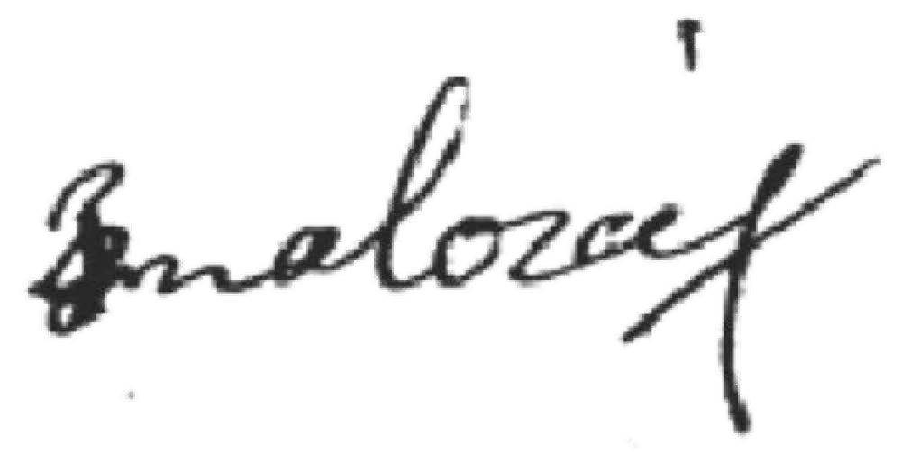01/10/2023

Signature:

Any further comments: