CHINTHKUNTA SUDARSAN REDDY

27, Mangalam Palli(v), Rachapalli(p), Rama Puram (m),Annamayya
dist,516504
Contact no - 8374095032 chinthakuntasudharshanreddy@gmail.com https://www.linkedin.com/in/sudharshan-reddy-
chinthakunta-357746315
OBJECTIVE

To be a successful professional in a globally respected company and to achieve the objectives of the company with honesty and fairness and to continuously upgrade my knowledge and skills.
EDUCATION

Course | Institution | Board/ University | Year of Completion | CGPA
B. Tech (ECE) | S. V. College of Engineering, Kadapa | JNTUA  Ananthapuramu | 2024 | 7.3
Intermediate (MPC) | Vijaya Krishana Junior College, Tirupathi | BIE | 2020 | 7.2
Secondary School | Nalanda High school, Tirupathi | SSE | 2018 | 8.8

TECHNICAL SKILLS
Programming Languages : Java Data base : My SQL
Web Technologies : HTML,CSS

Operating System : Windows 10
PROJECTS

Title: LIBRARYMANAGEMENTSYSTEM WITH SQL DATABASE
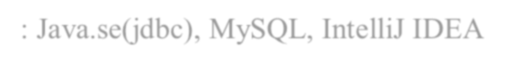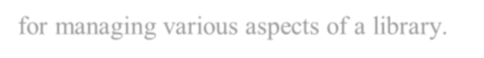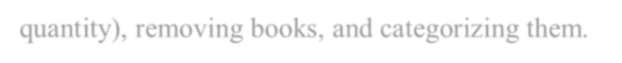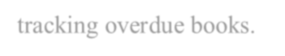
Tools Used: Java.se(jdbc), MySQL, IntelliJ IDEA
Description: A Library Management System (LMS) is a software application designed to automate and streamline library operations, making it more efficient for both librarians and patrons. Implementing an LMS using a MySQL database provides a robust and scalable solution for managing various aspects of a library.
Book Management: Adding new books, updating existing book information (title, author, genre, quantity), removing books, and categorizing them.
Borrower Management: Registering new members, maintaining user profiles (including personal details and borrowing history), and managing membership status.
Circulation Management: Recording book borrowing and return dates, managing renewals, and
tracking overdue books.
Fine Management: Calculating and applying fines for overdue books, notifying users about pending dues, and tracking payment history.
Reporting and Analytics: Generating reports on various aspects like library usage, popular books.

CERTIFICATES
Certification on Java Course in TAP ACADEMY
Certification on Introduction to Internet of Things in NPTEL
Certification on Introduction to Digital Image Processing in NPTEL

STRINGTHS
Communication Skills Time management and Adaptive Problem solving, self-management
PERSANOL DETAILS
Name : Chinthakunta Sudarshan Reddy
Date of Birth : 22-06-2003 Father’s name : C. Naga Bhushan
Hobbies : Reading, listening music Nationality : Indian
Languages Known : English, Telugu, Hindi
DECLARATION
I do hereby confirm that the information given above is true to the best of my knowledge

Date:
Place: Bangalore (C. Sudarsan Reddy)

