Name: C.PAVANI Roll.no:2022MCA16017

Assignment : Creatting a Database Using MongoDB and Mongosh.

1.insetOne():

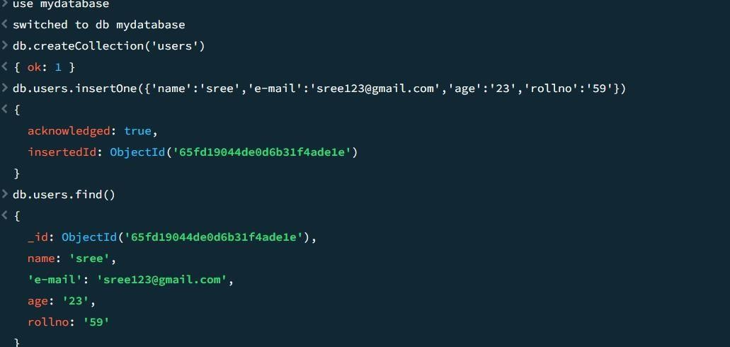

insert maany()

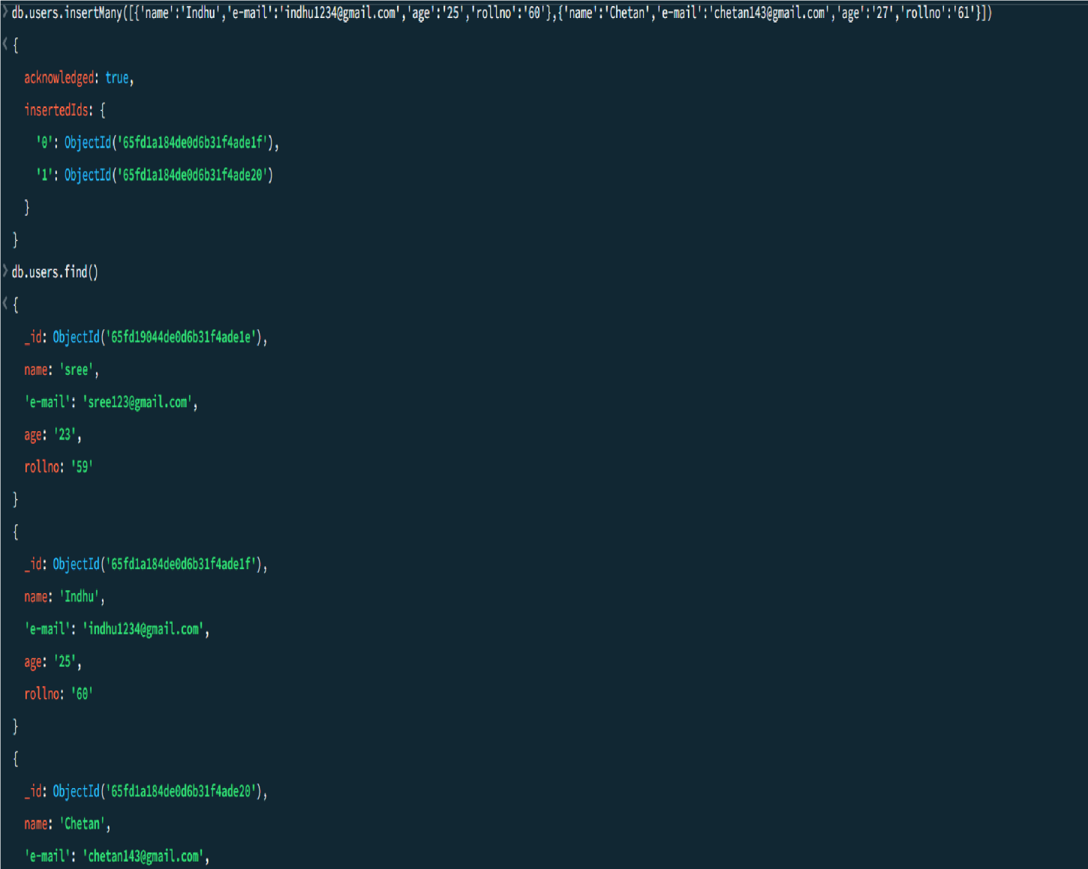

2.Read():

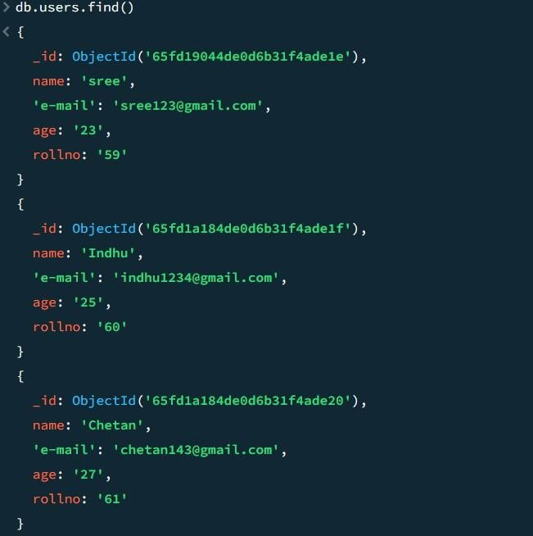

3.Update():

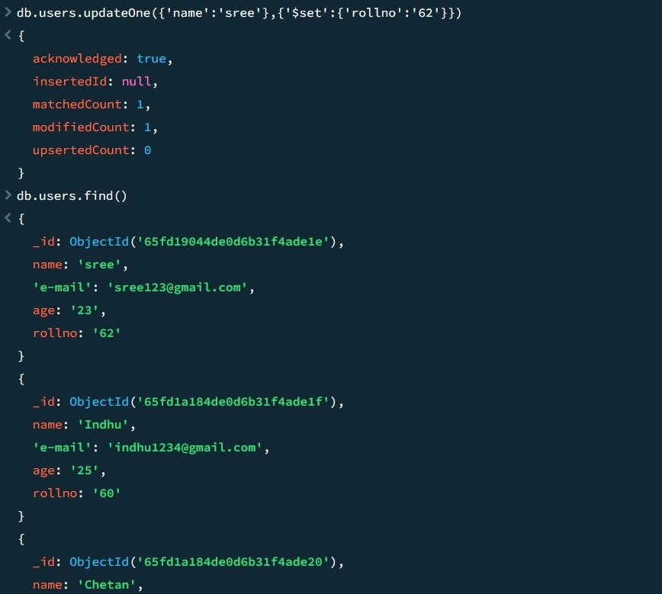

4.Delete():

DeleteOne():

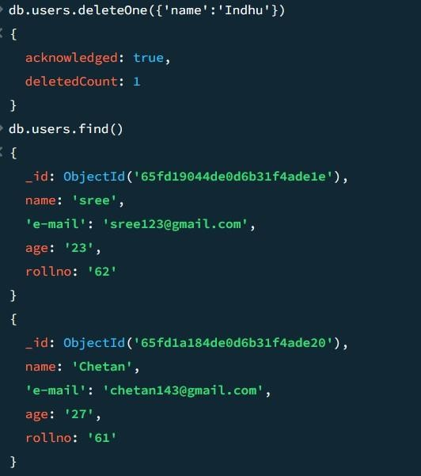

DeleteMany():

