Developing plug-ins for QueryCommander

Table of content
Overview 2
Choosing Interface 2
Create a new project 2
Add a new Class 3
Implement an interface 3
Add your code 4
The Execute method 4
Define ExecutionType 4
Using QueryCommander parameters 5

Overview
If you want users to be able to save the query result to a text- or Excel file, or if you what to execute the query in multiple databases, this and many other features could be done through developing a QueryCommander plug-in.
A plug-in is like any other class library project assembly, but where one or more classes implements any of the interfaces in the QueryCommander.PlugIn.Core.Interfaces namespace.

Choosing Interface
There are three interfaces to choose from. The one you choose depends on when you want your Plug-in to be triggered.
Interface | Description
IPlugin_OnAfterQueryExecution1 | Triggers after the user has executed the query
IPlugin_OnBeforeQueryExecution1 | Triggers before the user has executed the query
IPlugin_OnMenuClick1 | Triggers when the user clicks the menu item

All interfaces look basically the same, except for IPlugin_OnMenuClick1 which has the MenuItemName property

Create a new project
- Choose the Class Library template.
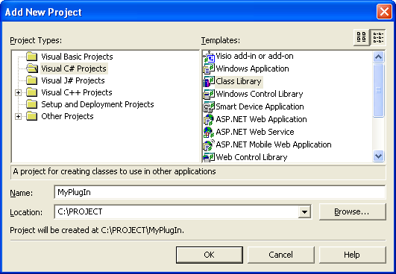

- Add reference to QueryCommander.PlugIn.Core.dll

Add a new Class
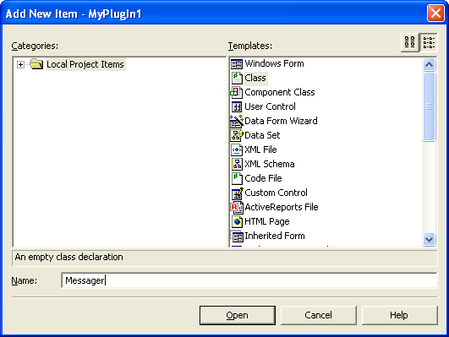

Implement an interface
The sample below would instruct QueryCommander to add a MenuItem and to respond on clicking on it.
using System;
using QueryCommander.PlugIn.Core.Interfaces;

namespace MyPlugIn
{
public class Messager : IPlugin_OnMenuClick1
{
}
}

Add your code

The Execute method
The Execute method is the method called upon when QueryCommander is instructed to trigger the plug-in. This is where you add your code. The Execute method returns a string or null.
The sample below would show a messagebox when the plug-in were triggered.
public object Execute(QueryCommander.PlugIn.Core.CallContext callcontext,
System.IntPtr handle)
{
System.Windows.Forms.MessageBox.Show("Hello world");
return null;
}

Define ExecutionType
The ExecutionType property is where you instruct QueryCommander what to do with the result. There are four different kinds of ExecutionTypes to be found in the QueryCommander.PlugIn.Core.Common class.
ExecutionType | Description
None | Do nothing, ignore return value
InsertAtPoint | Insert the return value at the current cursor position
InsertToNewQueryWindow | Insert the return value in a new query window
ReplaceToQueryWindow | Replace the current content of the active query window

The sample below would instruct QueryCommander to ignore the return value.

public QueryCommander.PlugIn.Core.Common.ExecutionTypes ExecutionType
{
get
{
return QueryCommander.PlugIn.Core.Common.ExecutionTypes.None;
}
}

Using QueryCommander parameters
There are two parameters in the Execute method. CallContext and IntPtr. IntPtr is the handle of the active query window. The CallContext parameter has three properties:
Interface | Type | Description
DbConnection | System.Data.SqlClient.SqlConnection | Active Database connection
QueryWindowContext | System.string | Active query window content
ResultDataSet | System.Data.DataSet | Resultset

The sample below would show a messagebox showing the executing query.

public object Execute(QueryCommander.PlugIn.Core.CallContext callcontext,
System.IntPtr handle)
{
System.Windows.Forms.MessageBox.Show(callcontext.QueryWindowContext);
return null;
}

