**Arduino EDID Editor**

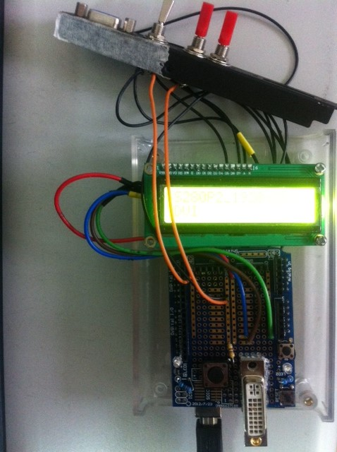

Ver. 1.1

Creator: ChinTsung Tseng

Date: 2014/02/12

Revision History

|  |  |  |
| --- | --- | --- |
| Date | Author | Remark |
| 2014/02/12 | ChinTsung | First version |
| 2015/03/30 | ChinTsung | Update Hardware connection illustration. |

1. Purpose

Provide an easy-to-get/develop/use EDID tool. Let the TV/monitor developer can focus on the development and do not spend times on EDID editor.

1. HW/SW environment
2. HW
3. Arduino Uno R3 board (ref. <http://arduino.cc/en/Main/ArduinoBoardUno> ), 816NT x1

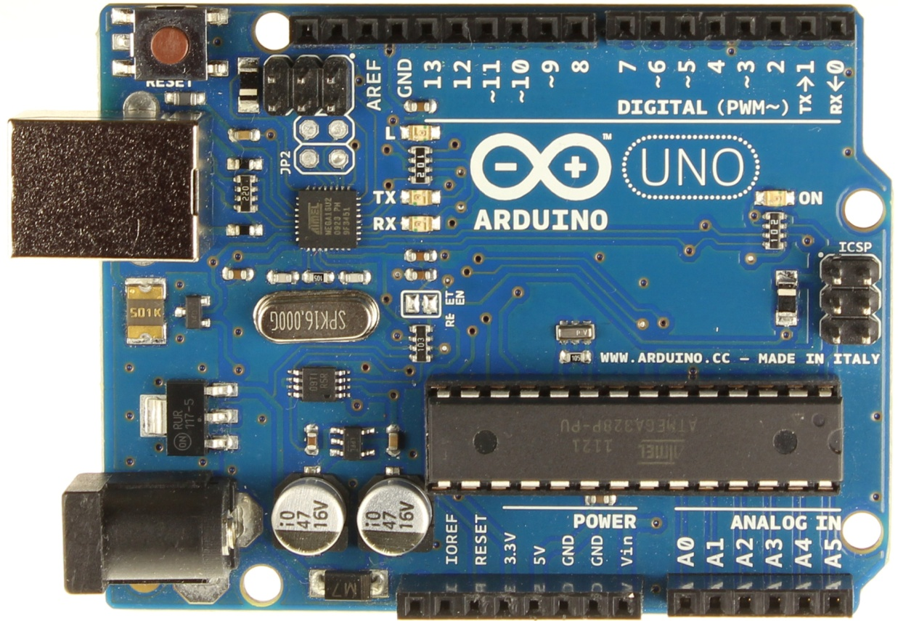

1. USB cable, 32NT x1
2. Arduino Prototype Shield v.5, 252NT x1 (<http://www.playrobot.com/cart/shop.php?id=852&factory=&header=&sub=&ctype2=&typeid=12&pagename=&Fno=&date_buy>=)
3. I2C alphanumeric LCD, 200NT x1

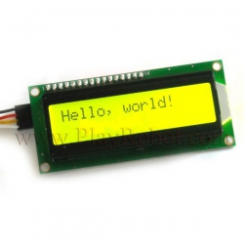

1. 6 Pins, 2 Position toggle switch, 33NT x1
2. 2 Pins, 2 Position toggle switch, 25NT x2
3. VGA connector, 18NT x1
4. DVI connector
5. Arduino 透明外殼, 350NT x1

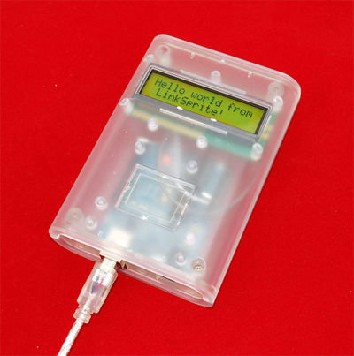

1. SW
2. Sketches.
   1. You can get more detail info in <http://arduino.cc/en/Guide/Environment>.
   2. You can download the Arduino IDE in <http://arduino.cc/en/Main/Software>.
3. Hardware connection illustration

Yellow: SDA

Purple: SCL

Green: GND

Red: VCC

Blue: CONTROL LINE

1. FW development notes
2. I2C LCD
3. We use an I2C LCD to show some messages in read/write EDID. We only need 2 lines (I2C) to display information to prevent out of pins while using a normal LCD shield.
4. We need to download the appropriate library rather than the original LiquidCrystal Library as sourced in the Arduino SDK for it. Please refer <http://forum.arduino.cc/index.php/topic,128635.0.html>.
5. Store data in flash (program) memory instead of SRAM.
6. There are 3 pools of memory in the avr-based Arduino boards, if you are not familiar with them, please refer <http://arduino.cc/en/Tutorial/Memory>.
7. We have much data to store, such as some strings to show on LCD and the EDID info, etc. And there is only 2KB SRAM available to use in Arduino Uno board. We may probably run out of SRAM. Consequently, I store them in flash (program) memory to reduce consuming too much SRAM.
8. The basic concept and use about store data in flash memory or retrieve them from it, please refer <http://www.arduino.cc/en/Reference/PROGMEM>. But I do not know why the article advises that “The PROGMEM keyword is a variable modifier, it should be used only with datatypes defined in pgmspace.h.” We should store anything in flash memory even structure.
9. Following provides some further reading, hope they can help you.
10. [Storing and Retrieving Strings in Program Memory.](https://www.inkling.com/read/arduino-cookbook-michael-margolis-2nd/chapter-17/recipe-17-4)
11. [Define new variable type in pgmspace for PROGMEM: structure in FLASH.](http://forum.arduino.cc/index.php?topic=104321.0)
12. [Optimizing Arduino Memory Use](http://www.sumidacrossing.org/LayoutElectricity/Arduinos/ArduinoMemory/).
13. Circuit diagram