# EXPERIMENT-3(a)

Aim:Controlling actuators relay state based on ambientlight levelusingLDRsensor:

##### Experiment-

###### S.no Component Description PortNames Board

1. 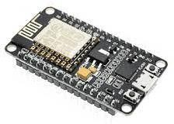ESP-32 ESP-32 Controlunit Development

board

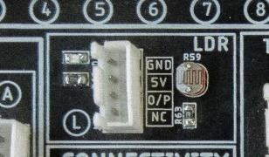2 LDR module Light dependent LDR(L) Resistor

1. 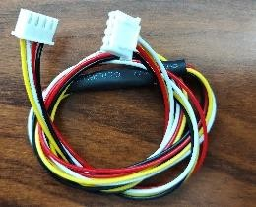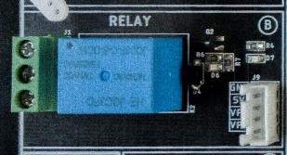Relay HEJQC3FC RELAY(B)
2. connecting wires two - 4 port JST connectingwires

##### AbouttheExperiment-

HerewecontrolRelayswitch(ON/OFF)basedon ambientlightintensitylevelusingLDRsensor.

##### InterfacingonAcenAArIOTtrainerkit-

* + Connectthemicro-USBcableto theESP-32IOTmoduleavailableonAcenaarIoT kit,and

**UPLOAD**thewritten C++codeusingArduino IDE.

* + **Connectionoftheperipherals:**1.FromESP32IoTModule“**ADC**”toAcenaarIoTKitLDR**(L)**

1. FromESP32 IoTModule “**GPIO**”toAcenaarIoTKit RELAY**(B)**
2. fromEsp32IOTModule“**LCD**”to AcenaarIOTkit

Displayunit**(O)**

**OUTPUT:**

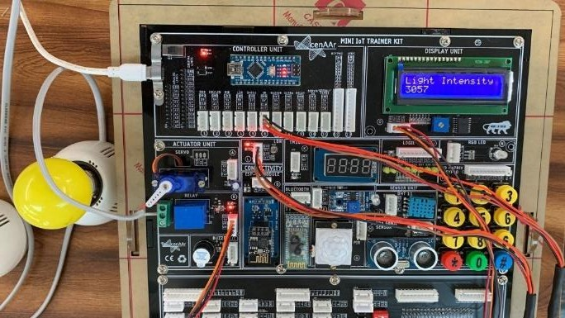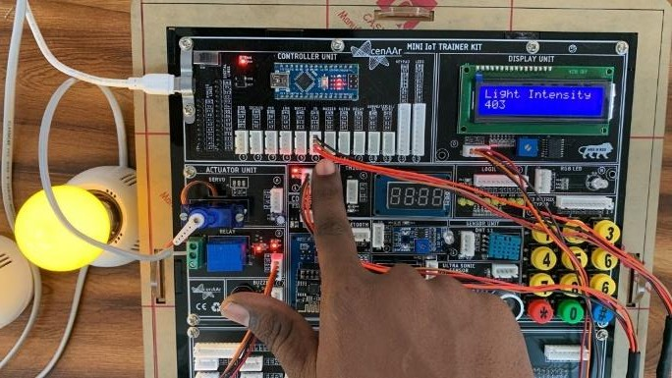

**RESULT: Hence, Controlling actuators relay state based on ambient light level using LDR sensor done successfully.**

# EXPERMENT-3(b)

### Aim: DisplayinghumidityandtemperaturevaluesonLCD:

## Experiment:

###### Listof components



1.

unit

Arduinonano

ArduinoNano

Control

Development

board

1. 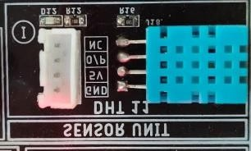DHT-11module DHT11Sensor DHT11(I)
2. 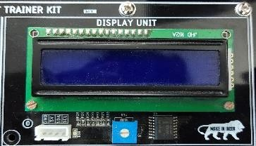DisplayUnit JHD 162A Displayunit(O)
3. connecting wires Two - 4 port JST connectingwires

##### AbouttheExperiment-

Herewemeasure theTemperatureandtheHumidityusingtheDHT-11sensorandrepresent the values on the Display unit LCD.

##### InterfacingonAcenAArIOTtrainerkit-

* + Connectthemicro-USBcabletotheESP-32IOT Module availableon AcenaarIoTkit,and

**UPLOAD**thewritten C++codeusingArduino IDE.

* + **Connectionoftheperipherals:1.**FromAcenaarIoTKitDisplayUnit**(O)**toESP32IoT

Module"**LCD**".

**2.**FromESP32IoTModule"**GPIO**"toAcenaarIoTKit"DHT 11**"(I).**

**OUTPUT:**