TYCE (Semester 6) Chemical Engineering Lab
Index

1. | Residence Time Distribution in PFR and CSTR | 1
2. | Liquid holdup and axial dispersion in packed column | 6
3. | Kinetics of PFR and CSTR | 11
4. | Dynamics of first order systems | 15
5. | Interacting tanks in series | 24
6. | Dynamics of non-interacting tanks | 31
7. | Dynamics of overdamped and underdamped systems | 39
8. | Linearization of dynamics of tapering tank | 50
9. | Fin efficiency | 61
10. | Finned tube heat exchanger | 72
11. | Heat transfer by natural convection | 80
12. | Shell and tube heat exchanger | 90
13. | Unsteady state heat transfer | 97
14. | Vacuum drying | 107
15. | Hydrodynamics of static mixer | 112
16. | Hydrodynamics of bubble column | 117
17. | Mixing time studies in bubble column | 133
18. | Single stage adsorption | 136
19. | Estimation of thermodynamic properties of liquid mixtures | 145
20. | Cooling tower analysis | 149
21. | Photocatalysis | 152
22. | Vapor Liquid Equilibrium | 154

Chemical Engineering Laboratory Manual
Semester VI

1. RESIDENCE TIME DISTRIBUTION IN PFR & CSTR

1. Aim: To find the residence time distribution for a plug flow reactor and find the axial dispersion coefficient. To find the mean residence time and dead volume in CSTR.

2. Apparatus: An acrylic pipe of 1 in. inner diameter having length 7.7m, CSTR of capacity of 7 liter, injection mechanism [consisting of a piston or syringe] to insert the tracer element, flow control valve.

3. Theory: Deviation from the two ideal flow patterns can be caused by channelling of fluid, by recycling of fluid or by creation of stagnant regions in the vessel. So to make up the contacting or flow pattern, we have to have the understanding of three inter-related factors: RTD, state of aggregation and earliness of mixing. These factors ultimately affect the conversion in a non-ideal flow reactor. In this experiment we’ll be trying to find the residence time distribution for a plug flow and CSTR.

The time taken by a molecule to pass through a reactor is called its Residence Time t. The Residence Time Distribution Function is the fraction E_{t} of the outlet stream that has a residence time less than t.

The Residence Time Distribution for a given reactor and flow rate can be established from response type experiments. In these experiments the concentration of an inert tracer is perturbed in the feed stream and its effect on the outlet stream is measured.

Measurement of the RTD: The RTD is determined experimentally by injecting an inert chemical, molecule or atom, called a tracer, into the reactor at some time t=0 and then measuring the tracer concentrations C in the effluent stream as a function of time. In addition to being a no reactive species that is easily detectable, the tracer should have physical properties similar to those of the reacting mixture and be completely soluble in the mixture. It also should not adsorb on the wall or other surfaces in the reactor. The latter requirements are needed so that the tracer’s behavior will honestly reflect that of the two most common types of tracers. The two most used the methods of injections are pulse input and step input.

RTD for Plug Flow Reactor: This motor. is characterized by a uniform velocity profile and no axial mixing. These conditions require that the residence time is constant and the distribution function to be a Dirac delta function at t.

ence Time, v - Volume and Q – Volumetric flow rate

But the RTD of a real reactor deviates from that of a ideal reactor depending on the hydrodynamics of the vessel.

1

Chemical Engineering Laboratory Manual
Semester VI

Pulse [square] Input Method: In this method, to determine Residence Time Distribution, a quantity of the tracer is injected into an ongoing stream for a period of time which is very short, at θ = 0. The concentration of the tracer in the outlet stream from the moment of addition of the tracer until it is no longer detectable is monitored. In our case, conductivity at the outlet is measured and indicated on a chart recorder.

The total number of molecules of the tracer introduced would be:

ΔT₀- interval during which tracer is introduced C₀ - Total concentration of the tracer molecules

where for turbulent flow

Tracer measurement:
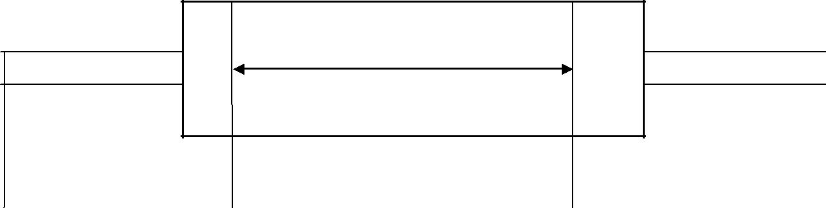

E(t)

x(t) y(t)
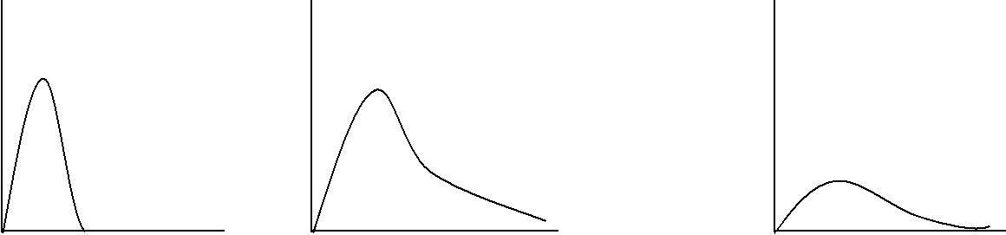
c

t | t | t
Pulse | First measuring | Second measuring
Pulse | point | point
 | (Input function) | (Output function)

Chemical Engineering Laboratory Manual
Semester VI

Tracer properties:
- Inert

- Non adsorbable

- Easily measurable

- Real time, on-line at low concentrations determinations.

4. Procedure:

Part I: Plug Flow Reactor

- The reactor fluid, i.e.water in this case, is allowed to flow through the pipes and the valve is adjusted to control the flow rate.

- The tracer element i.e. 4N NaCl is injected into the pipe. About 10ml of the tracer is added as quickly as possible. The time at this point is taken as zero[t=0] and the chart recorder is switched on.

- The chart recorder is switched off when the plot indicates a zero concentration after indicating a peak i.e. after attaining steady state.

- Repeat the same procedure for different flow rates. Take 7-8 flow rate readings.

Part II: Continuous Stirred Tank Reactor
- Keep a certain flow rate of water and allow it to flow into continuous stirred tank.

- Once the steady state height is reached, inject 5ml of 4N NaCl solution at once and switch on the chart recorder.

- Wait until the chart recorder shows initial value of conductivity.
- Now change the flow rate keeping RPM of CSTR constant and repeat the above procedure.

- Data:

Diameter of the pipe – 25 mm
Length of the pipe – 7.7mm
Chart speed of the recorder – 0.2 cm/sec

6. Sample Calculation for PFR and CSTR:
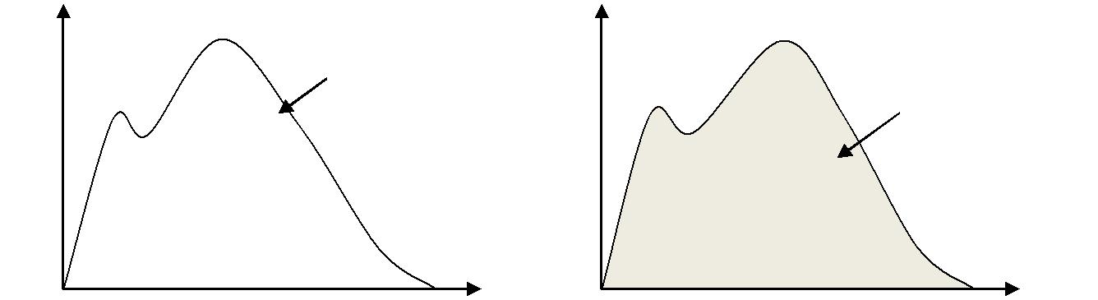

 |  | Et= (Q/M)*C
C | Area=M/Q | Et
 | Area=M/Q | Area = 1

t t

The curve of concentration C_{Pulse} vs. Residence Time t is obtained directly from the chart recorder. We find area under the curve using Trapezoidal Rule/Simpson’s rule:

3

Chemical Engineering Laboratory Manual
Semester VI

Now the curve Et vs. t is plotted where Et values are calculated from the formula.

Et- Residence Time Distribution Function C(t) - Concentration of tracer at time t.

Area under the curve which can be calculated using Simpson’s Rule. Mean residence time,

The variance is given by,

The Peclet no. is given by

And

Levenspiel correlation for the dispersion of fluids flowing in pipes

Where Sc=Schmidt no. =

And D= diffusivity
Di =Dispersion Coefficient

7. Calculation Table:
Time | C(t) | E(t) | t*E(t) | *E(t)dt

4

Chemical Engineering Laboratory Manual
Semester VI

- Results:

- Comments:

- References:
- Chemical Reactor Minibook – Levenspiel
- Chemical Engineering Kinetics – J.M. Smith
- Chemical Reaction Engineering – Levenspiel
- Chemical Reaction Theory –Denbigh
- Chemical Engineer’s Handbook- Perry
- Elements of Chemical Reaction Engineering – H.Scott Fogler

5

Chemical Engineering Laboratory Manual
Semester VI

2. LIQUID HOLDUP AND AXIAL DISPERSION IN PACKED COLUMN
1. Aim: To find the liquid holdup [h_{t}] (static [h_{s}] and dynamic [h_{d}]) and axial dispersion in a packed column

- Apparatus: Column, Packings, chart recorder, conductivity meter, rotameter, etc.
- Chemicals used: Na₂CO₃ (tracer).
- Theory: Packed columns are used extensively in the chemical industry. They find uses in

unit operations such as absorption, distillation, humidification, etc. Under normal operating conditions the liquid flows as a film or rivulets over the packing surface.

Part I: LIQUID HOLDUP
What does one mean by liquid holdup?

The amount of liquid present in the packed column at any instant of time is defined as the liquid holdup. (Imagine taking a snapshot of the column: the liquid contained inside the column in the snapshot is the holdup).This holdup can be broken into two parts:

- Static Holdup: The static liquid holdup in a packed bed is defined as the volume fraction of liquid, referred to total bed volume that remains in the bed after complete draining. The liquid that remains in the bed is prevented from draining by a balance between gravitational and surface tension forces. (The liquid adhered to the packings post drainage).Can be measured by wet weight of column-dry weight.

- Dynamic Holdup: The liquid flowing at an instant minus the static holdup. (Total holdup - static holdup). It is the liquid that drains from the column.

Part II: AXIAL DISPERSION

It is a well-known fact that flow of gas and liquid through a packed bed does not confirm to plug flow. The assumption of ideal plug flow may lead to serious under design. The dispersion affects concentration profiles reducing the concentration driving force.
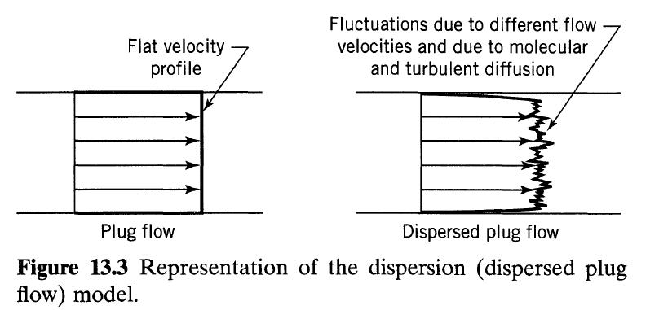

The axial dispersion model superimposes a diffusion like process on the plug flow:
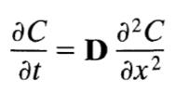

Where D is the axial dispersion coefficient.

6

Chemical Engineering Laboratory Manual
Semester VI

Let us define D/uL as the dispersion number. (u=fluid velocity; L=characteristic length) As D/uL → 0 there is negligible dispersion;

As D/uL → ∞ there is large dispersion, implying mixed flow; uL/D = Peclet Number =
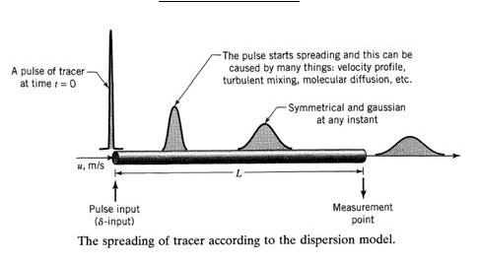

5. Procedure: (If no chart recorder is available take readings at a time interval of 5 seconds)

- First check all the connections of the experimental setup.
- Connect the water and tracer inlet to any one of the packed column.
- Adjust the water flow rate using the water rotameter at a fixed value.
- Open the tracer valve to keep the tracer solution not more than 10% of total solution flow rate.
- Irrigate the column till it shows a constant reading in the conductivity meter.
- This reading is recorded on the plotter as the maximum concentration reading (C_{max}).

- Now switch off the tracer valve from the main flow and instantaneously switch on the chart recorder.

- Now note down the conductivity of the outlet liquid with respect to time till there is no change in conductivity.

- Then switch off the chart recorder.
- Repeat the procedure by varying the liquid flow rate in the range 0-0.006 m/s.
- Repeat the above procedure with the other column.

6. Observations:
Diameter of the packed column | : |  |  | cm
Height of the packed column | : |  |  | cm

7

Chemical Engineering Laboratory Manual
Semester VI

Observation Table:
SR.NO. | TIME | TRACER
 |  | CONCENTRATION

7. Calculations:
The chart recorder gives us a plot of conductivity against time: This conductivity is proportional
to the concentration w.r.t the calibrated equation :( r2=0.99354)
Concentration (gmol/L) =8.6004*10⁻³ * Conductivity (mmho) + 2.9963*10⁻⁴ | (1)

- CALCULATION OF HOLDUP:

  - Using eqn (1) calculate the respective concentrations at different times from the conductivity vs. time data. Now make it dimensionless by taking the ratio of concentration with the maximum concentration i.e:

C’ =

8

Chemical Engineering Laboratory Manual
Semester VI

- Plot a graph of ln (C’) vs time and C’ vs time
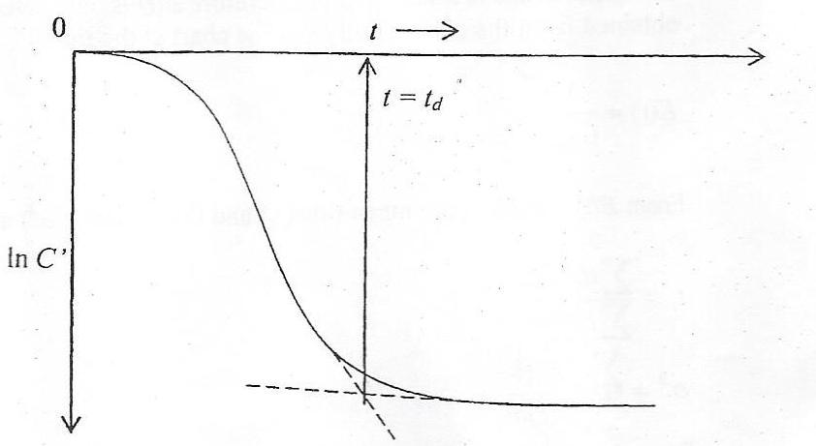

Fig. 1: Graph of ln (C’) vs time (intersection of tangents t_{d})
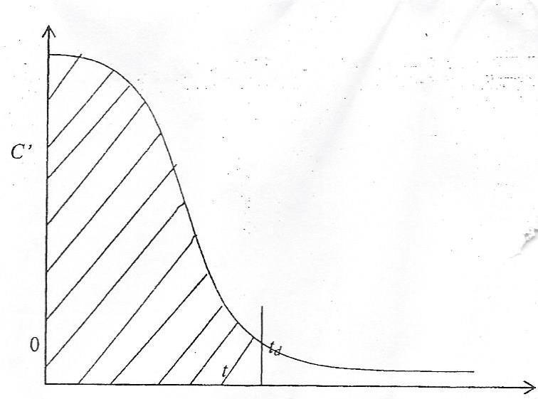

Fig. 2: Graph of C’ vs time

  - Estimate the area under the curve of Fig. 2 until t=t_{d} & t = ∞

  - h_{t} = Area ( until t = ∞ ) * (

  - h_{d} = Area ( until t = t_{d} ) * (

  - h_{s}=h_{t}-h_{d}

  - Holdup ratio [φ] = h_{s}/ h_{d}

NOTE: t_{d} is the dead time post which we assume static holdup .i.e. post t_{d} the volume elements coming out have a residence time far greater than the mean time and so they contribute to the static holdup

- PECLET NUMBER CALCULATION:

The disturbance is a step change therefore E (t) is calculated from the slope obtained from the concentration vs time chart at time ‘t’ i.e.:

E (t) =

9

Chemical Engineering Laboratory Manual
Semester VI

From E (t) calculate the mean time (t_{c}) and the variance (σ²) as follows:

t_{c} =

σ² = -t_{c}²

Peclet number (Pe) = 2 t_{c}²/ σ²

CALCULATION TABLE:
SR.NO. | VELOCITY | h_{t} | h_{d} | h_{s} | φ | Pe

8. Graphs:
a.) h_{d} vs Liquid velocity b.) h_{t} vs Liquid velocity c.) φ vs Liquid velocity d.) Pe vs Liquid velocity

- Results:

- Comments:

- References:
  - Chemical Reaction Engineering by Octave Levenspiel

  - Elements of Chemical Reaction Engineering by H. Scott Fogler

  - Continuous flow systems(distributions of residence times) by PV Danckwerts, Chemical Engineering Science Vol 2.,1953

10

Chemical Engineering Laboratory Manual
Semester VI

3. KINETICS OF PFR AND CSTR

- Aim :

  - To study the saponification of ethyl acetate by sodium hydroxide in a tubular flow reactor and continuous stirred tank reactor.

  - To determine the percentage conversion obtained in each case experimentally and compare with that predicted from theory.

- Apparatus: Plug flow reactor and CSTR reactor setup, rotameter etc.

- Chemicals: 0.5N Ethyl Acetate, 0.1N NaOH, 0.5N NaOH, 0.1N Acetic acid, 0.2 N Oxalic

acid etc.

4. Theory :

Two types of commonly used industrial reactors are CSTRs and PFRs. A CSTR or Continuous-Stirred Tank Reactor operates at steady state by feeding the reactants into the reactor and continuously withdrawing the products. Ideally, a CSTR is perfectly well mixed and has no spatial variation in concentration or temperature. Since temperature and concentration are identical at all points in the reactor, they are also the same at point of discharge from the tank. Other advantages are a wide temperature and pressure range and the ability to control temperature. A disadvantage of the CSTR is that the conversion of reactant per unit volume of the reactor is smallest among the flow reactors.
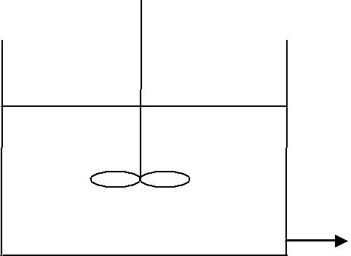

CAi

CAo

Figure 1: CSTR

A PFR, or Plug Flow Reactor, is a tubular flow reactor that typically consists of a long cylindrical pipe where the reactants are fed into one end and the products are withdrawn at the other end. The reactants are continuously consumed as they flow through the reactor, thus the concentration varies in an axial direction. Radial gradients are usually small and can be ignored.

A few advantage of using PFR rather than a CSTR are higher production rates and higher conversion.

11

Chemical Engineering Laboratory Manual
Semester VI
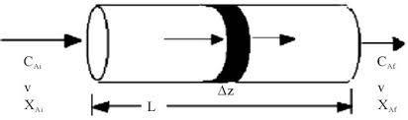

Figure 2: Tubular reactor

Flow reactor is most efficient i.e. it permits the greatest degree of conversion for a given reactor volume when no backmixing is permitted to occur within it as the reactant stream passes through it. This zero backmixing condition is approximately when the reactants flow through a tubular reactor under the condition of turbulent flow. However, disadvantage encountered in the use of tubular reactor at high flow rate arises from the fact that these high flow rates are apt to force the use of an extremely long reactor to assure that sufficient retention time is provided in the reactor.

The reaction being carried out in this experiment is known as saponification reaction. This reaction is irreversible reaction. The reaction is as follows:

CH₃COOC₂H₅ + NaOH | C₂H₅OH | + CH₃COONa.
Ethyl Acetate | Ethyl alcohol | Sodium Acetate
- Procedure:

  - First carry out the standardization of feed NaOH with 0.2N oxalic acid.

  - Titrate 25mL of 0.1N acetic acid against 0.1N NaOH.

Part 1:

- Connect the flow of ethyl acetate and NaOH to the CSTR by adjusting the three way valve.

- Find the volumetric flow rate for ethyl acetate and NaOH assuming different assuming different residence time, i.e., 30s, 60s, 90s and 120s. (Note that the total flow through the tubular reactor must be divided by 2 to find the individual reactant flow).

- Start the magnetic stirrer at some speed.

- Adjust the flow rate for ethyl acetate and NaOH to the calculated value and wait for steady state.

- Now collect 25mL of the sample at the outlet of the CSTR.

- Add exactly 25mL of 0.1N acetic acid to the sample and titrate the excess of acetic acid with 0.1N NaOH.

Part 2:
- Connect the flow of ethyl acetate and NaOH to the PFR by adjusting the three way valve.

- Find the volumetric flow rate for ethyl acetate and NaOH assuming different assuming different residence time, i.e., 30s, 60s, 90s and 120s. (Note that the total flow through the reactor must be divided by 2 to find the individual reactant flow).

- Repeat the steps 4, 5, and 6 as discussed in Part 1.

12

Chemical Engineering Laboratory Manual
Semester VI

6. Data:

Rate constant for saponification reaction: 0.218 L/mol-s.
Density of ethyl acetate: 0.9 g/cc.
Volume of CSTR:
Diameter of tubular reactor: 8 mm.

7. Observations:

Length of tubular reactor:
Titration reading for feed NaOH:
Titration reading for acetic acid (Ti):

8. Observation Table:

 |  | Flow rate (mL/s) |  | Titration reading (T)
Type of reactor | Residence time (s) | Ethyl |  | Titration reading (T)
Type of reactor | Residence time (s) | Ethyl | NaOH | (mL)
 |  | acetate | NaOH | (mL)
 | 30
CSTR | 60
CSTR | 90
 | 120
 | 30
Tubular turbulent | 60
Tubular turbulent | 90
 | 120

9. Sample Calculation:

1. Standardization of feed NaOH

i.e Concentration of feed NaOH (C_{Bf}) gmol/lit

2. Concentration of NaOH (C_{Bo}) and Ethyl acetate (C_{Ao}) at reactor inlet
Concentration of feed ethyl acetate (C_{af}) |  | - | gmol/lit
Volumetric flow rate of Ethyl Acetate (V_{A}) - |  |  | lit/sec
Volumetric flow rate of NaOH (V_{B}) |  | - | lit/sec
C_{BO} = (C_{Bf} | V_{B} ) /(V_{A}+V_{B}) gmole/lit
C_{AO} = (C_{Af} | V_{A} ) /(V_{A}+V_{B}) gmole/lit

3. Concentration of NaOH (C_{B}) and Ethyl Acetate (C_{A}) at reactor outlet C_{B} = (T-T_{i}) Normality of NaOH / vol. of sample ( gmole/lit)
C_{A}= C_{Ao}- (C_{Bo}- C_{B}) (gmole/lit)

13

Chemical Engineering Laboratory Manual
Semester VI

- Find conversion of ethyl acetate (X) at reactor outlet X= (C_{Ao}- C_{A}) / C_{Ao}

- Calculation for Residence time in a reactor (t)
  - = V_{R} / (V_{A}+V_{B})

- Theoretical conversion A. CSTR
X= 1/2 {[1/ Kt C_{AO} + C_{BO}/ C_{AO} + 1] – ([1/ Kt C_{AO} + C_{BO}/ C_{AO} + 1]^(2) – 4 C_{BO} /C_{AO} )^(0.5) }

K being the rate constant

B. Plug flow reactor

t = 1/K(C_{BO}-C_{AO}) |  |  |  | ln[(1-X) | C_{BO} / (C_{BO} - C_{AO} X)]
10. Calculation Table:
 | V_{A} | V_{B} |  | CAO | CBO | C_{A} |  | C_{B} | Xexp | Xth | T
Reactor
 | (l/s) | (l/s) |  | (gmol/s) | (gmol/s) | (gmol/s) |  | (gmol/s) |  |  | (s)
CSTR
PFR

- Conclusions:

- Comments:

Rotameter calibration
NaOH

Y=0.6022 X + .62727
Y is NaOH flow rate in ml/s , X is rotameter reading
Ethyl Acetate
Y=0.55 X – 1.22
Y is Ethyl Acetate flow rate in ml/s, X is rotameter reading

14

Chemical Engineering Laboratory Manual
Semester VI

4. DYNAMICS OF FIRST ORDER SYSTEMS

- Aim: To study the dynamics of first order tank and thermometer.

- Apparatus: Rotameter, Thermometer, Flask filled with ice, etc.

- Theory: A first order system is one whose output is modeled by first order differential

equation. Consider a continuous flow tank as shown in the figure below.

TANK:

Fi
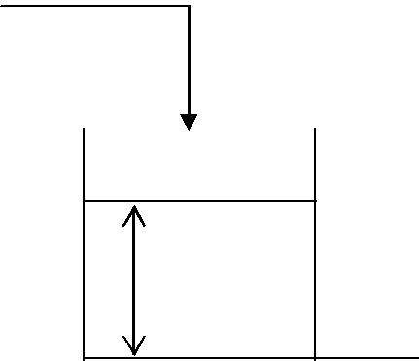

h

R
Fo

F_{i} : Input flow rate (lit/min)

F_{o} : output flow rate (lit/min)

R: resistance

h: liquid level in tank

ρ: density of the liquid

Overall Mass Balance:

(Rate in) – (rate out) + (rate of generation) = (rate of accumulation)

Fi * ρ − Fo * ρ + 0 = | ∂(v * ρ) | (1)
∂t

Assumptions:

Density is constant.

No generation.

Therefore;

15

Chemical Engineering Laboratory Manual
Semester VI

Fi − Fo = | ∂(v)
Fi − Fo = | ∂t

As we know that;

V = A * h

Where ‘A’ is the cross sectional area of the tank

Therefore;

Fi − Fo = | ∂( A * h)
Fi − Fo = | ∂t
As ‘A’ is constant;
Fi − Fo = A* |  | ∂(h)
 |  | ∂t

At (t=0) disturbance is taking place.

Therefore at steady state (i.e. t<0);

Fis − Fos = 0

Subtracting equation 6 from 5 we get

( Fis | - Fi ) - ( Fos − Fo ) = A* | ∂(h)
( Fis | - Fi ) - ( Fos − Fo ) = A* | ∂t

Since F ∝ h |  |  |  |  |  |  |  |  | ; therefore |  |  |  | F = |  | h
 |  |  |  |  |  |  |  |  |  |  |  |  | F = |  | R
( Fis |  |  | - Fi ) - |  |  |  |  | hs − h |  |  |  | = A* | ∂(hs − h)
 |  |  |  |  |  |  |  |  | R |  |  | = A* | ∂t
In terms of deviation variables
 |  |  |  |  | h |  | = A * |  | ∂h
 | Fi -
 |  |  |  |  |  |  |  |  | ∂t
 |  |  |  | R

Now taking Laplace transform of above we get

 |  |  |  |  |  |  |  |  | h(s)
Fi(s) - |  |  |  |  |  |  |  |  |  |  |  | = A * [sh(s) − h(0)]
 |  |  |  |  |  |  |  |  | R
 |  |  |  |  |  |  |  |  | h(s)
Fi(s) - |  |  |  |  |  |  |  |  |  |  |  | = A * s * h(s)
 |  |  |  |  |  |  |  |  | R
 | h(s) |  |  |  |  | = |  |  | R
 |  |  |  |  |  |  |  |  | ARs + 1
 | Fi(s)

16

(2)

(3)

(4)

(5)

(6)

(7)

(8)

(9)

(10)

(11)

(12)

Chemical Engineering Laboratory Manual
Semester VI

h(s) ⁼ G(s) Fi(s)

Where G(s) is called as ‘Transfer function’ and is defined as the function which relates output to the input in simple algebraic form

 |  |  |  |  | F_{i} | (s) | Process | h(s)
 |  |  |  |  | Input |  |  | output
G(s) = |  |  |  | Kp |  |  |  | (13)
 |  |  | τs + 1 |  |  |  |  | (13)
Where Kp = R & τ = AR
Let Fi(t) = a is step input.
 |  |  |  | a |  | for t>0
f (t) =
 |  |  | 0 |  |  | for t<0
The graph of such a function will be as shown below,
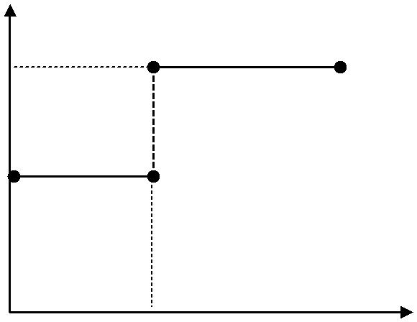

A

Step function of size A

F (t)

0

time

 |  |  |  |  |  |  |  |  |  |  |  |  |  | a
By using Laplace Transform; |  |  |  |  |  |  |  |  |  |  |  | Fi(s) =
 |  |  |  |  |  |  |  |  |  |  |  |  |  | s
Therefore from equation (13)
 |  | (s) = |  | a | * |  |  |  | R
 | h |  |  | a
 |  |  |  | s |  |  |  | Ars +1
 |  |  |  | aR |  |  |  |  | (a * A * R^2)
h(s) = |  |  |  |  |  |  | − |  |  |  |  |  |  | (14)
 |  |  |  | s |  |  |  |  | ARs +1
 |  |  |  |  |  |  |  |  |  |  |  |  |  | 17

Chemical Engineering Laboratory Manual
Semester VI

Taking inverse Laplace of (14); you get

 |  | (15)
h(t) = aR(1 − e^−t / AR) |  | (15)

B. Thermometry:

Consider a thermometer located in a fluid for which the temperature ‘T’ varies with time.

Assumptions:

- All the resistance to the heat transfer resides in the film surrounding the bulk (that is the resistance offered by the glass and Hg are neglected).

- All the thermal capacity is in the Hg. Further at any instant Hg assumes uniform temperature throughout.

- Glass wall containing Hg does not expand or contract during the transient response.

- Thermometer is initially at steady state.

Let

T: temperature of surrounding t: temperature of thermometer

θ: time

Cp: specific heat

Take heat balance:

(Heat in)- (heat out) + (heat generation) = (rate of heat accumulation)

hAT − hAt + 0 = m * Cp * |  |  |  |  |  |  |  |  |  |  |  |  |  |  |  |  |  |  |  |  |  | ∂t |  | (16)
 |  |  |  |  |  |  |  |  |  |  |  |  |  |  |  |  |  |  |  |  |  | ∂θ |  | (16)
At steady state;
hAT_{s} |  |  |  |  |  |  |  |  |  |  |  | − hAt _{s} = 0 |  |  |  |  |  |  |  |  |  |  |  | (17)
Now equation in terms of deviation variables;
 |  |  |  |  |  |  |  |  |  |  |  |  |  |  |  |  |  | ∂t |  |  |  |  |  | (18)
hAT − hAt = m * Cp * |  |  |  |  |  |  |  |  |  |  |  |  |  |  |  |  |  |  |  |  |  |  |  | (18)
 |  |  |  |  |  |  |  |  |  |  |  |  |  |  |  |  |  | ∂θ |  |  |  |  |  | (18)
Taking Laplace;
hAT (s) − hAt(s) = m * Cp * s * t
 |  | t(s) |  |  |  |  |  |  |  |  |  | = |  |  |  |  | hA
 |  |  |  |  |  |  |  |  |  |  |  | = | (hA + m * Cp * s)
 | T (s)
 |  | t(s) |  |  |  |  |  |  |  |  |  | = | 1
 |  |  |  |  |  |  |  |  |  |  |  | = | τs +1
 | T (s) |  |  |  |  |  |  |  |  |  |  | =
 |  |  |  |  |  |  |  |  |  |  |  |  |  |  |  |  |  |  |  |  |  |  |  | 18

Chemical Engineering Laboratory Manual
Semester VI
^{τ} ⁼ m * Cp
Where;
h * A

We are using Mercury because it has High thermal conductivity, High thermal coefficient of expansion. Shines, doesn’t stick to the wall and High boiling point.

4. Procedure:

A. Tank:

- Adjust the flow rate in the input.

- Measure input and output flow rate after each short interval of time. When both are equal first steady state is reached.

- Note this height as hs . Here t = 0.

- Give an up/down change to increase (or decrease) the flow rate.

- Measure the tank height ( h ) Vs time. Initially measure the height for each 30 seconds and then for each minute until no perceptible change occurs in the tank level.
- Note down this new steady state height as hs _{2.}

B. Thermometer:

- Allow the temperature of the thermometer to reach that of surrounding temperature (i.e. temperature of boiling water or of ice in whichever it is kept).
- Note down this temperature as initial steady state temperature T _{0.} Here t = 0.

- Once the steady state is reached quickly remove the thermometer, start the stopwatch & wipe the dripping water off the thermometer quickly within 1-2 seconds.

- Hold thermometer firmly by the stem in stagnant air and note down temperature ( T ) until it approaches a steady state (i.e. nearly equal to room temperature).

- Note this new steady state temperature as Ts .

Precautions:

1. While taking the readings of the thermometer from B.P. to R.T, after taking it out from the boiling water bath, the dripping water should immediately be dried or wiped out with cloth. This is necessary because, water forms a film surrounding the thermometer. Thermal conductivity of water being high, resistance to the flow decreases immediately and reading may be lower than expected.

19

Chemical Engineering Laboratory Manual
Semester VI

2. The fluid in which the thermometer is kept must be stagnant. May be the thermometer can be held in a closed beaker taking care that the bulb does not touch the bottom or the walls so that stagnant conditions of air are maintained.

5. Observations:

Tank:

Initial steady state height ( hs₁ ) |  |  |  | = | cm
Final steady state height ( hs ₂) |  |  |  | = | cm
Initial steady state flow rate (Fs₁) |  |  |  | = | ml/s
Final steady state flow rate (Fs₂) |  |  |  | = | ml/s
Sr no. | Time | Height (h) |  | h - h_{S} |  | ⎛ | hs₂ | − h | ⎞
 | (sec) | (cm) |  | (cm) |  | ln⎜ |  |  | ⎟
 | (sec) | (cm) |  | (cm) |  | ⎜ |  |  | ⎟
 |  |  |  |  |  | ⎝ ^{hs}2 |  | − hs ⎠

Thermometer:
Initial steady state temperature ( T ₀ ) = |  |  |  |  | ˚C
Final steady state temperature ( T _{s} ) |  |  |  | = | ˚C
 | Time | Temperature |  | T-T₀ |  | ⎛ | T_{s} | − T | ⎞
Sr no. |  |  |  |  |  | ln⎜ |  |  | ⎟
 | (sec) | (°C ) |  | (°C) |  | ⎜ | T_{s} | − T₀ | ⎟
 | (sec) | (°C ) |  | (°C) |  | ⎝ | T_{s} | − T₀ | ⎠

6. Formulae:

A. Tank:

q_{i} | − q = A ⋅ |  |  | dh
q_{i} |  |  |  | dt
q_{i} | − | h | = A ⋅ |  | dh
q_{i} | − | R |  |  | dt

At steady state,

20

Chemical Engineering Laboratory Manual
Semester VI

hs ^{q}i ⁼ _{R}²
 |  |  | hs₂ |  |  |  |  |  |  |  |  |  |  |  |  | h |  |  |  |  |  |  |  |  |  |  |  | dh
∴ |  |  |  |  |  |  |  |  |  | − |  |  |  |  |  |  |  |  | = A ⋅
 |  |  |  | R |  |  |  |  |  |  |  |  |  |  | R |  |  |  |  |  |  |  |  |  |  |  | dt
 |  |  | dh |  |  |  |  |  |  |  |  |  |  | = (A ⋅ R)⁻¹ ⋅ dt
 | hs₂ |  |  |  | − h
− ln(hs₂ − h) = |  |  |  |  |  |  |  |  |  |  |  |  |  |  |  |  |  |  |  |  |  |  |  |  |  |  |  | t |  |  | + c
 |  |  |  |  |  |  |  |  |  |  |  |  |  |  |  |  |  |  |  |  |  |  |  |  |  | AR
at...t = 0,...h = h_{s}
 |  |  |  | ⎛ |  |  |  | hs |  |  |  |  |  | 2 |  |  | − h ⎞ |  |  |  |  |  |  |  |  |  |  |  | − t
∴ln⎜ |  |  |  |  |  |  |  |  |  |  |  |  |  |  |  |  |  |  |  |  | ⎟ |  |  | =
 |  |  |  | ⎜ |  |  |  |  |  |  |  |  |  |  |  |  |  |  |  |  | ⎟ |  |  |  |  |  |  |  | AR
 |  |  |  | ⎝ ^{hs}2 |  |  |  |  |  |  |  |  |  |  |  | − hs ⎠
B. Thermometer:
mc_{p} |  |  |  |  |  |  |  | dt |  |  |  |  |  |  | = h ⋅ A ⋅ (Ts − T )
 |  |  |  |  |  |  | dθ
 | dT |  |  |  |  |  |  |  |  |  | = |  |  |  |  |  |  | h ⋅ A |  |  |  |  |  |  | dθ
 | T_{s} |  | − T |  |  |  |  |  |  |  |  |  |  |  |  |  | m ⋅ c _{p}
− ln(T_{s} |  |  |  |  |  |  |  |  |  |  | − T ) = |  |  |  |  |  |  |  |  |  |  |  | h ⋅ A ⋅θ |  |  |  |  |  |  |  |  |  | + c
 |  |  |  |  |  |  |  |  |  |  |  |  |  |  |  |  |  |  |  |  |  |  |  |  | m ⋅ c _{p} |  |  |  |  |  |  |  | + c
at...θ = 0..,T = T₀
 | ⎛ |  |  | T − T ⎞ |  |  |  |  |  |  |  |  |  |  |  |  |  |  |  |  |  |  | − h ⋅ A ⋅θ
ln⎜ |  |  |  |  |  |  | s |  |  |  |  |  |  |  |  |  |  |  | ⎟ | =
 | ⎜ |  |  |  |  |  |  |  |  |  |  |  |  |  |  |  |  |  | ⎟ |  |  |  |  |  |  | m ⋅ c _{p}
 | ⎝ ^{T}s ⁻ ^{T}0 ⎠
τ = |  |  |  |  | m ⋅ c _{p}
 |  |  |  |  |  | h |  |  |  | ⋅ A
 | T_{s} |  | − T |  |  |  |  |  |  |  |  | = exp (−^{θ} |  |  |  |  |  |  |  |  |  |  |  |  |  |  |  |  |  | )
 |  |  |  |  |  |  |  |  |  |  |  |  |  |  |  |  |  |  |  |  |  |  |  |  |  |  |  |  | τ
 | T_{s} |  | − T₀ |  |  |  |  |  |  |  |  |  |  |  |  |  |  |  |  |  |  |  |  |  |  |  |  |  | τ
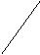
To = Initial steady state temperature

Ts = Final steady state temperature

T = Temperature at time t

21

Chemical Engineering Laboratory Manual
Semester VI

7. Sample Calculations:

A. Tank:

1. Find resistance (R)
R1 = ^{hS1} s/cm²
^{F}S1
Also calculate resistance R₂ for second steady flow rate and take the average resistance (R) 2. Find the step change given to the tank (a)

a = (Fs₂ – Fs₁) ml/s

3. Now Find time constant (T)

ˆ | ⎛ | − e | ^{−t} _{T} ⎞
h(t) = aR 1 |  | − e | ⎟
 | ⎜ |  | ⎟
 | ⎝ |  | ⎠
 |  |  | ˆ |  |  | −t |  | ⎛ aR ⎞
 |  |  | dh
Hence, |  |  |  | = e |  |  | T ⎜ |  |  | ⎟
 |  |  | dt |  |  |  |  | ⎝ | T ⎠
At time t=0,
 | ˆ |  |  | ⎛ aR ⎞
⎛ dh ⎞
⎜ |  | ⎟ | = | ⎜ |  |  | ⎟
⎜ | dt | ⎟ |  | ⎝ T ⎠
⎝ | dt | ⎠t=0
Now plot a graph of (h-hs) Vs time

The slope at time t = 0 will give the value of

⎛ aR ⎞ ⎜ ⎟ ⎝ T ⎠

Put the value of a and R, find the time constant

 | ⎛ | hs₂ | − h ⎞
4. For tank plot | ln⎜ |  |  | ⎟ | Vs time (t)
 | ⎜ | hs₂ |  | ⎟
 | ⎝ | hs₂ | − hs ⎠

Slope of line will give the value of
1

T

Take the average of the two time constants.

B: Thermometer:
⎛ | T_{s} | − T | ⎞
For thermometer plot ln⎜ |  |  | ⎟ | Vs time (t).
⎜ |  | − T₀ | ⎟
⎝ ^{T}s |  | − T₀ | ⎠
The slope of the graph will be –1/τ. From this the time constant (τ) can be found out.

Practically, there will be not a single line but combination of two lines which are at some angle with each other. The geometric mean of slopes of those two lines is taken as the slope of the

22

Chemical Engineering Laboratory Manual
Semester VI

graph and the time constant is calculated. Analytically the slope of the line can be found by

linear regression.

8. Results:

 | Time Constant | % of Ultimate response
 | (Sec)
Tank | (Sec) | τ | 2τ | 3τ | 4τ
Thermometer
0 to RT
B.P. to RT

- Conclusions:

- Comments:

- References:

- Stephanopolous, G. (2000) Chemical Process Control, pp.128-130, pp.173-183, Prentice-Hall of India Private Ltd., New Delhi.

- Coughanowr, D.R., Koppel, L.B. (1965) Process Systems Analysis and Control, pp.13-22, pp.45-81, McGraw-Hill Inc., New York.

23

Chemical Engineering Laboratory Manual
Semester VI

5. INTERACTING TANKS IN SERIES

- Aim: To study the dynamic response of the two first order interacting tanks in series.

- Equipment: Two interconnected tanks made of transparent material (lined with scales),

Water source, pump, stopwatch.

3. Theory:

Second Order Systems-:

A second order system is the one whose output, y (t) is described by the solution of a second order differential equation

a₂ | d ² y | + a₁ | dy | + a₀y = b f (t)
a₂ | dt ² | + a₁ | dt | + a₀y = b f (t)

If a₀ is not equal to zero, then we can get

₂ d ² y |  | + 2ξτ | dy | + y = K_{p} f (t) | …(1)
τ |  | + 2ξτ |  | + y = K_{p} f (t) | …(1)
τ | dt ² | + 2ξτ | dt | + y = K_{p} f (t) | …(1)

Where,

τ² = a₂/ a₀ 2ξτ = a₁/ a₀ K_{p} = b/ a₀

Here

τ= natural period of oscillation of the system

ξ= damping factor

K_{p}= steady state, static or simply gain of the system.

If eqn. (1) is in the form of deviation variables, initial conditions are zero and it’s Laplace transform yields the following transfer function:

G(s) = K_{p}/(τ²s²+2ξτs+1)

Systems with second or higher order dynamics can arise from several physical situations. These can be classified into three categories:

- Multicapacity processes: two or more capacities (first-order systems) in series. e.g. flow through two or more tanks in series.

- Inherently second order processes: systems that possess inertia or are subjected to acceleration.

24

Chemical Engineering Laboratory Manual
Semester VI

e.g. movement of stem of pneumatic valve with pressure.

- A processing system with controller. e.g. An integral controller increases the order of a system by 1
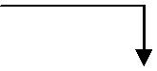

Fi
 |  | h₁ |  |  | h₂
 |  |  |  | R₁ |  | R₂
 |  |  |  | F₁ |  | F₂
 |  | Tank 1 |  |  | Tank 2
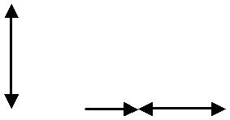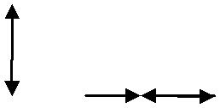

If the tanks connected in series affect the dynamic behaviour of each other, it is called as interacting system. In the above diagram, the flow rate coming out from the first tank always depends upon the heights of both the tanks. The interacting system is always referred to as

loading. The second tank is said to load first tank.
Mass balances for the two tanks give:
Accumulation= Input - Output
For the first tank,
A_{1.} (dh₁/dt) = F_{i} - F₁
We assume linear variation of flow rate with height i.e. F₁ = (h₁ - | h₂) / R₁
A_{1.} (dh₁/dt) = F_{i} - (h₁ - h₂) / R₁ | (1)
For the second tank,
A₂ . (dh₂/dt) = F₁ - F2
= (h₁ – h₂)/R₁ - (h₂/R₂) | (2)
By taking the Laplace transforms for (1) & (2), we get
h₁(s) = {(R₁.F_{i} (s)) / (τ₁s+1)} + {(h₂(s) / (τ₁s+1)} | (1a)
h₁(s) = (R₁/R₂).h₂(s). {(τ₂s + 1) + R₂/R₁ } | (2a)

Where τ₁ = A₁. R₁ (Time constant of tank 1) and τ₂ = A_{2.} R₂ (Time constant of tank 2). τ₁ And τ₂ are constants for a given system.

Where variables having bar on the head indicate deviation variable. From (1a) and (2a), eliminating h₁(s) transfer function can be obtained as follows.

25

Chemical Engineering Laboratory Manual
Semester VI

h₂(s)/ F_{i}
h₂(s)/ F_{i} | (s)) = R₂ / [τ₁. τ₂.s² + (τ₁ + τ₂ + A₁R₂).s + 1] |  |  |  | (3)

This equation gives us the variation in the height of the second tank with change in the inlet flow rate to the first tank. The term may A₁R₂ be thought as the interaction factor and indicates interaction between the two tanks. The larger the value of A₁R_{2,} the larger is the interaction between the two tanks.

CHARACTERSITICS OF INTERACTING TANKS:

So as to study characteristics of interacting tanks findings poles of the transfer function. τ₁.

τ₂.s² + (τ₁ + τ₂ + A₁R₂).s + 1= 0
(h₂(s)/ F_{i} (s)) = (R₂ / (τ₁. τ₂) (s-P1) (s-P2)) | (4)
P1 = (- (τ₁ + τ₂ + A₁R₂) + ((τ₁ + τ₂ + A₁R₂)²-4. τ₁. τ₂ )^{0.5} )/ (2.τ₁. τ₂) |  | &
P2 = (- (τ₁ + τ₂ + A₁R₂) - ((τ₁ + τ₂ + A₁R₂) ²-4. τ₁. τ₂ )^{0.5} )/ (2.τ₁. τ₂)
Where P1 and P2 are poles of the transfer function for given system.
1. The response of 2 interacting tanks in series is always overdamped second order.
Since,
(τ₁ + τ₂ + A₁R₂)² - 4. τ₁. τ₂ > 0.
2. Form equation (4) we get,
τ₁ = -1/P1
τ₁ = -1/P2
Equation (4) and above time constants implies that the interacting tanks in series can |  | be viewed
as noninteracting capacities but with modified effective time constants.

3. Interaction results in one tank becoming faster and the other tank being slower. Since the overall response of h₂(t) is affected by both tanks, the slower tank becomes the controlling and the overall response becomes more sluggish due to the interaction. Therefore, interacting tanks are more sluggish than noninteracting.

26

Chemical Engineering Laboratory Manual
Semester VI
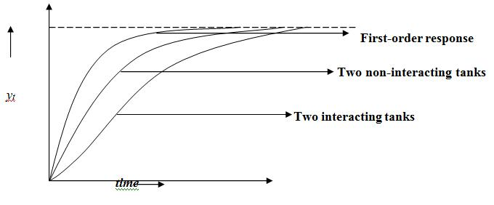

K_{p} is final gain of the system and A is the magnitude of the step change.

Interacting Tanks:

The significance of the interaction is that it changes the effective time constants of the individual capacities. The magnitude of change is striking.

The following general rules apply to the principle of interaction.

- The degree of interaction is proportional to the ratio of smaller to the larger time constants.

- The cases where this ratio is low (less than 0.1), the capacities may be assumed not to interact.

- Interaction always works towards increasing the larger time constant and decreasing the smaller one.

- For behaviour of systems with equal time constants τ, of equal capacity, the effect is

the combination of one large and the other small time constants.

Notations Used:

- τ_{1:} Time constant of tank 1

- τ_{2:} Time constant of tank 2

- A_{1:} Cross sectional area of tank 1

- A_{2:} Cross sectional area of tank 2

- R_{1:} Resistance offered by valve 1

- R_{2:} Resistance offered by valve 2

- h_{1:} Height of liquid in tank 1

- h_{2:} Height of liquid in tank 2

27

Chemical Engineering Laboratory Manual
Semester VI

  - F_{i:} Input flow rate to tank 1

  - F_{1:} Flow rate from tank 1 to tank 2

  - F_{2:} Output flow rate of tank 2

  - t: Time variable

  - s: Laplace variable

- Experimental Setup:

- Procedure:

- Adjust the inlet flow rate of tank one. For steady state to be reached quicker, refer the steady state readings; i.e. the flow rate and the heights from the chart. Thus by manually filling the tanks one can achieve initial steady state quickly.

- Allow the system to come to a steady state. Note down the first steady state heights of both tanks. Measure the steady state flow rate of second tank (F_{i} = F_{s1} = F_{ss1})

- Now give a positive or negative step change (preferably small value) so that final steady state will be reached quickly. Note down the time for a fixed change in water level (say 1mm). Thus go on noting height of water stepwise for both the tanks till final steady state is attained. Observe

final level for 15 minutes to ensure attainment of steady state.

Note down the second steady state height of tank 2 h_{ss,2} and flow rate at the steady state. F_{ss,2.}

6. Precautions:

- While first steady state is being approached, care should be taken that the Input flow rate is maintained constant. Failing so, the first steady state will occur after a considerable period of time. Thus while doing the experiment keep an eye on flow rate.

- When the step input is given, it should be instantaneous and the Rotameter Reading should remain constant till the second steady state is reached. In case of fluctuations in flow rate adjust the rotameter to maintain steady input flow rate.

- Magnitude of step change is very important. Very large step change will take longer time to attain steady state. Very large positive step change can overflow tank 1.Also very low flow rate

28

Chemical Engineering Laboratory Manual
Semester VI

will bring down levels in both the tanks very much close to bottom. Thus give a small step change.

4. For steady state, the level in the tank should remain the same for 15 to 20 minutes.

7. Observations:

1. | Initial steady state height in tank 2 (h_{s2}) | - | cm
2. | Initial steady state height in tank 1 (h_{s1}) | - | cm
3. | Initial steady state flow rate (F_{s1}) | - | ml/s
4. | Second steady state flow rate (F_{ss2}) | - | ml/s
5. | Second steady state height in tank 2 (h_{ss2}) - |  | cm
6. | Area of the first tank (A₁) | - | cm²
7. | Area of the second tank (A₂) | - | cm²

8. Observation Table:

Sr. | Time | Water Level in tank2 | Deviation
No. | Time | (h₂) | (h2-hss,1)

9. Sample Calculations:

1. Find resistance offered by valve 1 (R₁)

R |  | = | (h _{S1} | − h _{S2} | ) | S/cm2
R | 1 | = |  | ^{F}S1 |  | S/cm2
2. Find the time constant for tank 1 (τ₁)

τ₁ = A₁ × R₁ Sec

3. Also find resistance offered by valve 2 (R₂) and time constant for tank 2 (τ₂).
R |  |  | = | ^{h} S2 |  |  | S/cm |  |  |  | 2
R | 2 |  | = | ^{F}SS1
τ ₂ |  |  | = A₂ |  | × R₂ |  |  |  | Sec
 |  |  |  |  |  |  |  |  |  |  |  |  |  |  | ˆ | (t))
4. Find the analytical height (h ₂
ˆ |  | (t) = |  |  |  | aR ₂ |  |  | ⎡ |  | 1 | + |  | 1 |  |  |  |  | P₁t | + |  | 1 |  |  |  | P₂ t ⎤
h ₂ |  |  |  |  |  | τ τ |  |  | ⎢ |  |  | + |  | (P | − P | ) |  | e |  | + | P | (P | − P ) |  | e | ⎥
 |  |  |  |  |  |  |  | 2 | ⎣ | P PP |  |  |  | (P | − P |  |  |  |  |  | P | (P |  |  |  | ⎦
 |  |  |  |  | 1 |  |  | 2 | ⎣ | 1 2 |  | 1 1 |  |  | 2 |  |  |  |  | 22 |  |  | 1 |  |  | ⎦
 |  |  |  |  |  |  |  |  |  |  |  |  |  |  |  |  |  |  |  |  |  |  | 29

Chemical Engineering Laboratory Manual
Semester VI

Find the step change in the flow rate (a)

a = (Fss₂-F_{S1}) ml/s

Find the poles P₁ and P₂
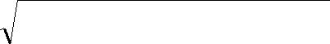
 | − (τ + τ |  | + A | R |  | )± | (τ + τ |  |  | + A | R |  | ) | 2 | − 4τ τ
 | − (τ + τ | 2 | + A | R | 2 | )± |  |  | 2 | + A | R | 2 | ) |  | − 4τ τ | 2
^{P}1/ 2 ⁼ | 1 | 2 | 1 |  | 2 |  | 1 |  | 2 | 1 |  | 2 |  |  | 1 | 2
^{P}1/ 2 ⁼ |  |  |  |  |  |  | 2τ τ | 2
 |  |  |  |  |  |  | 1 | 2

10. Graph:

Plot a graph of Time Vs height both analytical and experimental.

11. Result:

R₁ | - | s/m²
R₂ | - | s/m²
τ₁ | - | sec
τ ₂ | - | sec

- Conclusions:

- Comments:

- References:

1. George Stephanopoulos,(1984),”Chemical Process Control-An Introduction to Theory and

Practice”,” Chapter 11-Dynamic Behavior of Second Order Systems”,12th printing, Prentice-Hall India, 193-201.

2. D.R Coughanowr & L.B Koppel,(1965), Process Systems Analysis and Control”, McGraw-Hill Book Co.

30

Chemical Engineering Laboratory Manual
Semester VI

6. DYNAMICS OF NON-INTERACTING TANKS

- Aim: To study the dynamic behavior of the non- interacting tanks in series.

- Apparatus: Two tanks connected in series such that they form a non interacting system.

- Theory:

A system whose output y(t) can be described by the solution of nth order differential equation is called nth order system.

First order linear system:

A system whose output y(t) can be described by the solution of a 1st order differential equation is called first order system.

a₁ ^{dy}_{dt} + a₀ y = b * f (t)

τ _{p} ^{dy} + y = K _{p} f (t) dt

Second order linear system:

Similarly, a second order system is given by

a |  | d ² y |  | + a | dy | + a |  | y = b * f (t)
a | ² dt |  |  | + a |  | + a |  | y = b * f (t)
 |  |  | 2 | ¹ dt |  |  | 0

If a₀ is not equal to zero, rearranging,

τ | ₂ d ² y |  |  | + 2ζτ | dy | + y = b * f (t)
τ |  | dt | 2 | + 2ζτ | dt | + y = b * f (t)

τ - natural period of oscillation

ζ - damping factor

K_{p} - steady state or static gain of the system.

Writing in terms of deviation variables

31

Chemical Engineering Laboratory Manual
Semester VI

τ | 2 |  | d ² y |  | + 2ζτ |  |  | dy | + y = b * f (t)
τ |  |  | dt ² |  |  |  |  | dt
Applying Laplace transform,
τ ² |  | [s ² y(s) − sy(0) − y(0)]+ 2ζτ [sy(s) − y(0)]+ y(s) = K_{P} * f (s)
Rearranging,
G(s) = |  |  |  |  |  | y(s) |  | = |  | ^{K} p
 |  |  |  |  |  | f (s) |  | = | τ ² s ² | + 2ζτs +1

Dynamic response of second order system:

Let us analyze the dynamic response for unit step change.

We have |  | f ( s) =1/s.
The poles of |  |  |  | above equation are,
p₁ = − ^{ζ} |  | ζ |  | 2 | −1 |  |  |  | ζ |  |  | ζ | 2 | −1
p₁ = − ^{ζ} | + |  |  |  |  |  | , p | ₂ = − | ζ | − |  | ζ
p₁ = − ^{ζ} | + |  |  | τ |  |  | , p | ₂ = − | τ | − |  |  | τ
τ |  |  |  | τ |  |  |  |  | τ |  |  |  | τ
Case A: when ζ >1, we have distinct and real poles.

System gives overdamped response.

Case B: when ζ <1, we have two complex poles.

System gives underdamped response.

Case C: when ζ =1, we have two equal poles.

System gives critically damped response.

Some physical situations where second order systems can arise:

- Multicapacity processes: Processes that consist of two or more capacities (first order in series) through which material or energy flows.

- Inherent second order systems: such as the fluid or mechanical solid components of a process that possess inertia and are subjected to acceleration. Such systems are rare in chemical processes.

- A processing system with controller: it may exibit second or higher order dynamics. This is because the controller installed introduces additional dynamics which when coupled with the dynamics of the unit increases the order of the system.

32

Chemical Engineering Laboratory Manual
Semester VI

Non Interacting Capacities:

It is a multicapacity system. Non interacting capacities are represented by set of first order linear differential equations.

- p1

- p 2

^{dy1} + y1 = K p1 * f (t) ….. Capacity 1 dt

^{dy2} + y2 = K p 2 * f (t) …..Capacity 2 dt

The nth capacity affects the n+1th capacity by output and can be affected by output of n-1th capacity and not by n+1th capacity.

Consider two non interacting capacities:

f₁(s) | G₁(s) |  |  | y₁(s) |  |  |  |  |  | G₂ (s) |  |  |  |  | y₂(s)
 |  |  |  | y (s) |  |  |  |  |  | ^{K} p1
Transfer function of first capacity, G₁ (s) = |  |  |  | 1 |  |  | =
 |  |  |  | ^{f}1 | (s) |  | 1 |  |  | +τ₁ s
Transfer function of second capacity, G₂ |  | (s) = |  |  |  | y₂ | (s) |  | = |  |  | ^{K} p 2
 |  |  |  |  |  | y₁ | (s) |  |  | 1 |  | +τ ₂ s
The overall transfer function of the system (relation between y₂ (s) & f₁ (s))
 |  |  |  | y | 2 | (s) |  |  |  |  |  | y | 2 |  | (s) |  |  |  | y (s) |  |  |  |  |  |  |  | ^{K} p1 |  |  | ^{K} p 2
G |  | = |  |  | 2 |  |  | = |  |  |  |  |  |  |  |  |  | * | 1 |  |  | = G (s) * G |  |  | (s) = |  |  | *
G | 0 |  |  |  |  |  |  |  |  |  |  |  |  |  |  |  |  | * |  |  |  |  |  | 2 | (s) = |  |  | *
 | 0 |  |  | ^{f}1 |  | (s) |  |  |  |  |  | y₁ (s) |  |  |  |  |  |  | f₁ (s) |  |  | 1 |  | 2 | 1 |  | +τ₁ s 1 |  |  | +τ ₂ s
G₀ |  | = |  | y(s) |  |  |  | = |  |  |  |  |  |  |  |  |  | K _{p}
 |  | = |  | f (s) |  |  |  | = | τ |  |  | 12 |  | s |  | 2 |  | 1 |  | 1 | s +1
 |  |  |  |  |  |  |  |  |  |  |  |  |  |  |  |  | + 2ζ τ
Where |  |  |  |  |  | _{τ}12 |  |  |  | = τp1 * τp2
 |  |  |  |  |  | 2ζ¹τ¹ = τ_{p1 +} τ_{p2}
 |  |  |  |  |  | K_{P} |  |  |  | = Kp1 * Kp2

The poles of the equation are p₁ = -1/ τ_{1, p2} = -1/τ_{2.} The poles of the equation are real and distinct. Therefore the system is never underdamped. It shows always overdamped system and when the poles are equal it becomes critically damped system.

33

Chemical Engineering Laboratory Manual
Semester VI

Derivation of the transfer function relating head to flow:
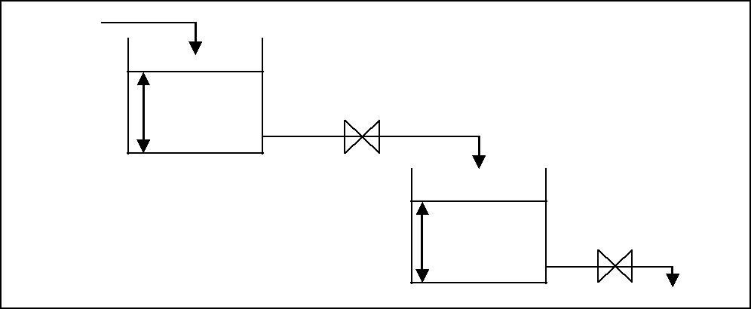
fi
h1 | R1 | f₁
 |  | h2 | R2
 |  |  | f_{o}
Assumptions:

- The output flowrate has a linear relationship with the height in the tank.

- Density of liquid is constant.

- The tanks have uniform cross section.

Mass balance for first tank:

Accumulation of mass = flow of mass into the system + flow of mass out of system

^{d} ^{(ρV} ⁾ = ρF_{i} − ρF₁ dt

A₁ ^{dh1} = F_{i} − F₁ dt

From the first assumption, F₁ = H₁ / R₁

Substituting and taking Laplace and rearranging,

G₁ (s) = | H₁ | (s) | = |  | R_{i}
G₁ (s) = | fi(s) |  | = | 1 + ( A₁ R₁ )s
Transfer function of first tank, G₁ |  |  |  |  |  |  | (s) = | H₁ (s) |  | = |  | ^{K} p1
 |  |  |  |  |  |  |  | f_{i} | (s) | 1 |  | +τ₁ s
Where K_{p1} = R₁ |  |  |  |  | & τ₁ = A₁R₁
Similarly, for tank 2

A₂ ^{dh2} = F₁ − F₀ dt

34

Chemical Engineering Laboratory Manual
Semester VI
Transfer function of second tank, G₂ |  |  |  |  |  |  |  |  |  |  |  |  |  |  |  |  |  |  |  |  |  |  |  |  |  |  |  |  |  |  |  |  |  |  |  | (s) = |  |  | H ₂ (s) |  |  | = |  |  |  |  | ^{K} p 2
 |  |  |  |  |  |  |  |  |  |  |  |  |  |  |  |  |  |  |  |  |  |  |  |  |  |  |  |  |  |  |  |  |  |  |  |  |  |  |  | F₁ (s) |  |  |  | 1 |  |  | +τ ₂ s
Where K_{p2} = R₂ |  |  |  |  |  |  |  |  |  |  |  |  |  |  |  | & |  |  |  |  |  |  |  | τ₂ = A₂*R₂
Therefore |  |  |  |  |  |  |  |  | G₀ |  |  |  | = |  |  | H ₂ (s) |  |  |  |  |  |  |  |  |  |  | = |  | H ₂ (s) |  |  |  |  | * | ^{F}1 |  | (s) | = |  | H ₂ (s) |  |  | * |  |  | H₁ (s) |  |  | * | 1
 |  |  |  |  |  |  |  |  |  |  |  |  |  |  |  |  | F_{i} |  | (s) |  |  |  |  |  |  |  | = |  | F₁ (s) |  |  |  |  | * | F_{i} |  | (s) | = |  | F₁ (s) |  |  | * |  |  | F_{i} (s) |  |  | * | R₁
 | R₁ * | H |  | ₂ (s) |  |  |  |  | = |  |  |  | ^{K} p1 |  |  |  |  |  |  | * |  |  |  |  |  | ^{K} p 2
 | R₁ * | F_{i} (s) |  |  |  |  |  |  |  |  |  |  |  |  |  |  |  |  |  |  |  |  |  |  |  | +τ ₂ s
 |  |  |  |  |  |  |  |  |  |  | 1 +τ₁ s 1
 | H ₂ (s) |  |  | = |  |  |  |  | 1 |  |  |  |  | * |  |  | ^{K} p 2
 | F_{i} (s) |  |  | = | 1 +τ₁ s |  |  |  |  |  |  |  |  |  |  | 1 +τ ₂ s
Consider a step change of a units,
Then |  |  |  |  |  | F_{i}(s) = ℒ[a] = a/s.
 | H ₂ (s) |  |  | = |  | a |  |  | * |  |  |  | 1 |  |  |  |  | * |  |  |  |  |  | ^{K} p 2
 | F_{i} (s) |  |  |  |  | s |  |  | * | 1 +τ₁s |  |  |  |  |  |  |  |  |  |  |  | 1 +τ ₂ s
 | Splitting into partial fractions (factorizing),
 | H ₂ (s) |  |  | = |  | x |  |  | + |  |  |  |  | y |  |  |  |  |  | + |  |  |  |  |  |  | z
 | K _{p} ₂ a |  |  |  |  | s 1 |  |  |  |  |  |  | +τ₁s 1 |  |  |  |  |  |  |  |  |  |  |  |  | +τ ₂ s
Solving,
 |  |  |  |  |  |  |  |  |  | τ |  |  | 2 |  |  |  |  |  |  |  |  |  |  |  |  |  |  |  |  |  | τ |  |  | 2
 | x = 1, y = |  |  |  |  |  |  |  |  |  |  |  | p1 |  |  |  |  |  |  |  | , z = |  |  |  |  |  |  |  |  |  |  |  | p 2
 |  |  |  |  |  |  | (τ _{p} ₂ −τ _{p1} ) |  |  |  |  |  |  |  |  |  |  |  |  |  |  |  |  |  |  |  |  |  | (τ _{p} |  |  | 1 | −τ _{p} ₂ )

Therefore substituting in above equation,

And take Laplace inverse of equation to get H₂ (t).

 |  | _{⎡(τ e}^{−t} ^{τ}1 |  | −τ | p 2 | _{e}^{−t} ^{τ}2 | ) ⎤
h (t) = aK |  | 1+ | 1 |  | p 2 |  |  | ⎥
h (t) = aK | p 2 | 1+ |  |  |  |  |  | ⎥
2 | p 2 | ⎢ | (τ | ₂ −τ₁ ) |  |  |  | ⎥
 |  | ⎢ | (τ |  |  |  |  | ⎥
 |  | ⎣ |  |  |  |  |  | ⎦

35

Chemical Engineering Laboratory Manual
Semester VI

Characteristics of non interacting capacities:

- The response of the over damped multicapacity system to step input change is S-shaped. (i.e. initially changes slowly and then it picks up speed). This is in contrast to a first order response which has the largest rate of change at the beginning. This sluggishness or delay is also known as transfer lag and is characteristic of multicapacity systems.

- As the number of capacities in series increases, the sluggishness of initial response is more pronounced.

For n capacities in series,

 | Y_{n} | (s) | i=n | K_{i}
 | Y_{n} | (s) | = ∏ | K_{i}
 | Y₀ (s) |  | = ∏ | (1+τ_{i} s)
 |  |  | i=0
Notations Used:
τ₁ |  | : Time Constant for Tank 1, s
τ₂ |  | : Time Constant for Tank 2, s
_{τ}12 |  | : Overall Time Constant, s
ζ¹ |  | : Damping Factor.
K_{p1}: Static Gain of Tank 1, s/cm²

K_{p2}: Static Gain of Tank 2, s/cm² h_{1 :} Height in tank 1, cm

h_{2 :} Height in tank 2, cm

H₁(t) : Deviation variable of h₁, cm H₂(t) : Deviation variable of h₂, cm R₁ : Resistance of Tank 1, s/cm²

R₂ : Resistance of Tank 2, s/cm²

F_{i} : Input flowrate to tank 1, cm³/s

F₁ : Output flowrate from tank 1, cm³/s F_{o} : Output flowrate from tank 2, cm³/s

4. Experimental setup:

36

Chemical Engineering Laboratory Manual
Semester VI

5. Procedure:

- First check all the connections and draw experimental setup.

- Adjust a certain input flowrate of water in tank 1 with the help of rotameter and keep it constant.

- Let the steady state be attained. Then note the heights of both the tanks.

- Now give a step change in the flowrate and note the new flowrate. (Care should be taken so that flowrate does not fluctuate).

- Monitor the height of tank 2 and note the change in height for every 2-5 min, and tabulate to make height-time data for the system.

- Continue till the second steady state is reached. Also note the final flowrate.

6. Data:
Area of tank (A₁) = cm²

Area of tank (A₂) = cm²

7. Observations:
1. | Flow rate of water at Initial steady state (F_{1S}) | - | ml/s.
2. | Initial staedy height in tank 1(h_{S1}) | - | cm
3. | Initial steady height in tank 2 (hs₂) | - | cm
4. | Second steady state height of tank 2 (h_{SS2}) | - | cm
5. | Flow rate of water at final steady state (F_{2S}) | - | ml/s.

8. Observation Table:

Sr. No. | Time | Height in 2nd Tank | Height in 2nd Tank
Sr. No. | (min) | Experimental (cm) | Analytical (cm)
9. Sample Calculations:

37

Chemical Engineering Laboratory Manual
Semester VI

- Find the initial and final steady flow rate (ml/s) from rotameter calibration chart.

- Find the Resistances (R)

  - R₁ = ^{hS1} s/m² ^{F}1S

  - R ₂ = ^{h} ^{S2} s/m² ^{F}1S

- Find Time constant (τ):

  - τ₁ = A₁ R₁ sec

  - τ ₂ = A₂ R₂ sec

- Find the height analytically
 | ⎡ |  | _{(τ} _{e}^{−t} ^{τ}1 | −τ | 2 | _{e}^{−t} ^{τ}2 | ) ⎤
h (t) = aK | 1 | + | 1 |  | 2 |  |  | ⎥
2 | p 2 ⎢ |  | (τ ₂ | −τ₁ ) |  |  |  | ⎥
 | ⎣ |  | (τ ₂ |  |  |  |  | ⎦
10. Graph:

Plot a graph of Time vs. Height, both analytical and experimental.

11. Result:
R₁ | - | s/m²
R₂ | - | s/m²
τ₁ | - | sec
τ ₂ | - | sec

- Conclusions:

- Comments:

- References:

1. George Stephanopoulos, Chemical process control, Dynamic Response of Second Order System pp.193-200, Prentice-Hall, New Delhi.

2. Coughanowr and Koeppel Process systems analysis and control.

38

Chemical Engineering Laboratory Manual
Semester VI

7. DYNAMICS OF OVERDAMPED AND UNDERDAMPED SYSTEMS

- Aim: To study the dynamics of underdamped and overdamped systems.

- Apparatus: Compressor, two manometers with adjusted resistance so that one is

underdamped and other is overdamped, ruler, stopwatch etc.

3. Theory: Systems with 1st order dynamic behavior are not the only ones encountered in a chemical process. An output may change, under the influence of an input, in a drastically different way from that of the 1st order systems, following higher order dynamics. We will be analyzing the characteristics of overdamped and underdamped manometers.

A second order system is one that is modeled by a second order ordinary differential equation (ODE). Consider a system which has an input function f(t) and an output function y(t). We have to study the variation in y(t) for a certain input or forcing function. The physical characteristics of the system are such that the function y(t) is described by the solution of a second order ODE.

τ | ₂ d ² y |  |  | + 2ξτ | dy | + y = K _{p} | f (t) | (1)
τ |  | dt | 2 | + 2ξτ | dt | + y = K _{p} | f (t) | (1)

Where,

τ = natural period of oscillation of system

ξ = damping factor

K_{p} = steady state, or static, or gain of the system

Expressing (1) in terms of deviation variables and taking its Laplace transformation we obtain the expression,

τ ² {s ² y(s) − sy(0) − y'(0)} + 2ξτ {sy(s) − y(0)} + y(s) = K |  |  |  |  |  |  |  |  |  |  |  |  |  |  |  |  |  |  |  | (2)
 |  |  |  |  |  |  |  |  |  |  |  |  |  |  |  | p | f (s) |  |  | (2)
Since, the initial conditions are zero,
so,
y(0) = 0 & y’(0) = 0 |  |  |  |  |  |  |  |  |  |  |  |  |  |  |  |  |  |  |  | (3)
so we have,
τ ² s ² y(s) + 2ξτsy(s) + y(s) = K |  |  |  |  |  |  |  |  |  |  |  |  |  |  |  |  |  |  |  | (4)
 |  |  |  |  |  |  |  |  |  | p | f (s) |  |  |  |  |  |  |  |  | (4)
Now,
 | Δ(output ) |  |  |  |  |  |  |  | K _{p}
G(s) = | Δ(output ) | = |  | y |  | (s) | = |  | K _{p} |  |  |  |  | = |  |  |  |  |  | (5)
 | Δ(input ) |  |  | f (s) |  |  |  | τ ² s ² + 2ξτs +1
 |  |  |  |  |  |  |  |  |  |  | 39

Chemical Engineering Laboratory Manual
Semester VI

G(s) = standard transfer function for 2nd order system

Second order systems arise from the following physical situations:

- Multi-capacity processes: Processes that consists of two or more capacities (first order system) in series, through which material or energy must flow.

- Inherently second order systems: These systems are those which contain fluid or mechanical solid components that possess inertia and are subjected to acceleration. Such systems are rare in chemical processes.

- A processing system with its controller: These may exhibit second or higher order dynamics. In such cases, the controller which has been installed on a processing unit introduces additional dynamics, which when coupled with the dynamics of the unit, gives rise to second or higher order behavior.

A list of actual systems which show second order behavior:

  - Non-interacting tanks

  - Interacting tanks

  - Tank-controller system

  - Pneumatic valve

  - Simple manometer

All the systems mentioned above will be modeled by (1) but each of them will have τ

and ξ defined by various parameters of the system like mass, spring constant, height of mercury in the manometer tube etc. But the dynamic behavior of all these systems will be the same. It must be noted that the characterizing parameters for the system are only two- τ and ξ. K_{p} is not a characterizing parameter of the system.

Dynamics:

For a unit step change, equation (5) becomes,

y(s) = |  | K _{p} |  | (6)
y(s) = | s(τ ² s ² | + 2ξτs +1) |  | (6)
because |  | 1/ s for step change.

The two poles (roots) of the second order transfer function are given by roots of polynomial,

(τ ² s ² + 2ξτs +1) = 0 | (7)

Using the above equation (3) becomes,

40

Chemical Engineering Laboratory Manual
Semester VI

 | K _{p}
 | τ | 2
y(s) = | τ |  |  | Where p₁, p₂ are poles | (8)
 | s(s − p₁ )(s |  | − p₂ )
Overdamped response (ξ > 1), we have two distinct and real poles.
Inversion of (3) by partial fraction yields-
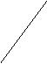
⎡ | −ξt ⎛ | ⎧ |  |  |  |  | t ⎫ |  |  |  |  | ξ |  |  | ⎧ |  |  |  | t ⎫ |  | ⎞⎤
y(t) = K _{p} ⎢1 − e | τ ⎜ | ⎧ |  | 2 |  |  |  |  |  |  |  | ξ |  |  | ⎧ | 2 |  |  |  |  | ⎟ | ⎥(9)
y(t) = K _{p} ⎢1 − e | τ ⎜ | cosh⎨ | ξ |  | −1 * |  |  | ⎬ | + |  |  |  |  |  | sinh⎨ | ξ | −1 * |  |  | ⎬ | ⎟ | ⎥(9)
y(t) = K _{p} ⎢1 − e |  | cosh⎨ | ξ |  |  |  |  | ⎬ | + |  |  | 2 |  |  |  |  |  |  |  |  |  | ⎥(9)
⎢ | ⎜ | ⎩ |  |  |  | τ ⎭ |  |  |  | ξ |  | 2 | −1 |  | ⎩ |  |  | τ ⎭ |  |  | ⎟⎥
⎣ | ⎝ |  |  |  |  |  |  |  |  |  |  |  |  |  |  |  |  |  |  |  | ⎠⎦
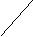
If we plot a graph of y(t)/ K_{p} vs. t, it can be observed that the response is much like that of a first-order system to a unit step input, except that it is rather sluggish. The system initially delays to respond. It becomes more sluggish as ξ increases. Thus, ξ is called as ‘damping factor ’. As time tends to infinity, y(t)/ K_{p} tends to unity; thus there is an asymptotic approach to the ultimate value.

Underdamped response (ξ < 1), we have two complex conjugate poles. Inversion of (3) by partial fraction yields-

⎡ |  | 1 |  |  |  |  | −ξt
⎢ |  |  |  |  |  |  | τ
y(t) = K _{p} 1 | − |  |  | 2 |  | e
⎢ |  | 1 − ξ |  | 2
⎣
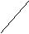

 | ⎛
 | ⎛ | 1 |  | − ξ | 2
sin | ⎜ |  |  | − ξ
sin | ⎜ |  |  | τ
 | ⎝

⎡ | 1 | − ξ | 2
* t + tan⁻¹ ⎢ | 1 | − ξ
* t + tan⁻¹ ⎢ |  | ξ
⎢ |  | ξ
⎣
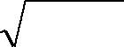
⎤ ⎞⎤ ⎥ ⎟⎥ (10)

⎥ ⎟⎥ ⎦ ⎠⎦

If we plot a graph of y(t)/ K_{p} vs. t, it is observed that we get an oscillating response.

Characteristics of Underdamped System:

  - The underdamped response is initially faster than that of critically damped or overdamped systems.

  - Although the underdamped response is initially faster and reaches its ultimate value quickly, it does not stay there, but its start oscillating with progressively decreasing amplitude.

  - The oscillatory behavior is more pronounced with lower values of ξ.

- Overshoot. It is the ratio A/B, where B is ultimate value of response &A is the maximum amount of the response exceeding the ultimate value.

 | A |  | ⎛ |  | − πξ |  |  | ⎞
Overshoot = | A | = exp | ⎜ |  | − πξ |  |  | ⎟ | (11)
Overshoot = | B | = exp | ⎜ | 1 − ξ |  | 2 |  | ⎟ | (11)
 |  |  | ⎝ |  |  |  |  | ⎠
Overshoot increases with decrease in ξ.

41

Chemical Engineering Laboratory Manual
Semester VI

2. Decay Ratio. It is the ratio C/A (the ratio of the amounts above the ultimate value of two

successive peaks.)

 | C | ⎛ | − 2πξ | ⎞
Decay _ ratio = | C | = exp ⎜ | − 2πξ | ⎟ = (overshoot)2 | (12)
  - ⎜ ₁ ₋ _{ξ} ² ⎟ ⎝ ⎠

- Period of oscillation. The radian frequency of the oscillations of an underdamped response is given by,
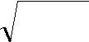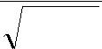
1 − ξ ²
ω = radian _ frequency = ⁽¹³⁾
τ

The period of oscillation T is given by,

T = |  | 2πτ |  |  | (14)
T = | 1 − ξ |  | 2 |  | (14)
4. Natural period of oscillation. A 2nd order system with ξ =0 is a system free of any damping. It has 2 purely imaginary poles. It will oscillate continuously with constant amplitude and a natural frequency. The corresponding cyclical period T_{n} is given by,

T_{n} = 2πτ | (15)

5. Response time. The response of an underdamped system will reach its ultimate value in an oscillatory manner as t→∞. However for practical purposes the time needed for the response to reach within 5% of its final value & stay there is called the response time.

6. Rise Time. This term is used to characterize the speed with which an underdamped system responds initially. It is defined as the time required for the response to reach its final value for the first time. Smaller the value of ξ, shorter is the rise time.

Derivation:

Consider a simple U-tube manometer. When the pressures at the top of two legs are equal, the two liquid levels are at rest at the same horizontal plane. Assume that suddenly a pressure difference, ΔP = P₁ – P₂ is imposed on the two legs of the manometer.

42

Chemical Engineering Laboratory Manual
Semester VI

 | P1 |  | P2
Leg 1 |  |  |  | Leg 2
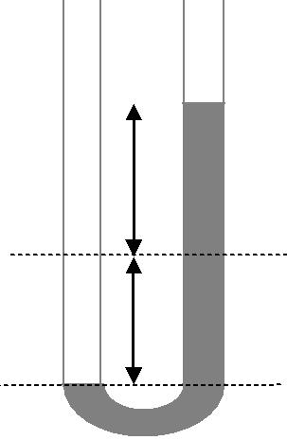

- Plane of initial rest
h | (P₁ = P₂)

Plane C

MANOMETER

Applying Newton’s law on the plane C of the manometer, we take

(Force due to pressure P₁ acting on leg 1) – (Force due to pressure P₂ acting on leg 2)

– (Force due to liquid level difference in the two legs) – (Force due to fluid friction) = (mass of liquid in tube) * (acceleration)

P A − P A − ρ |  |  |  | g | A (2h) − (Force due to fluid friction) = | m |  | dν |  | (16)
1 | 1 | 2 | 2 | ^{g}c | 2 | ^{g} c |  | dt
where,
ρ |  | = density of manometric liquid
P₁, P₂ |  | = pressures at top of legs 1 & 2 respectively
A1, A2 |  | = cross-sectional area of legs 1 & 2 respectively A₁ = A₂ = A.
m |  | = mass of liquid in manometer = ρAL
v |  | = average velocity of liquid in tube
h |  | = deviation of liquid level from initial plane of rest.
L |  | = length of liquid in the manometer.

Hagen- Poiseuille's equation for laminar flow in a pipe can be used to relate the force due to fluid friction with the flow velocity.

Vol. Flow rate = A | dh | = | πR ⁴ | ΔP | (17)
Vol. Flow rate = A | dt | = | 8μ | L | (17)

where, R = radius of the pipe through which liquid flows

μ = viscosity of the flowing fluid L = length of the pipe

ΔP = pressure drop due to fluid friction along the length of the tube of length L 43

Chemical Engineering Laboratory Manual
Semester VI

Applying Poiseuille's equation to the flow of liquid in manometer,

{Force due to fluid friction}= |  |  |  |  |  |  |  |  |  |  | ΔPπR ² |  |  | = A |  | 8μL |  |  |  | dh
 |  |  |  |  |  |  |  |  |  |  | g | c |  |  |  | R | 2 _{g} | c |  | dt
where ΔP = P₁ - P₂
fluid velocity, v = |  |  | dh |  |  |  |  |  |  |  | and
 |  |  | dt |  |  |  |  |  |  |  | and
acceleration, | dv |  | = |  | d ² h
acceleration, | dt
 |  |  |  |  |  | dt ²
Putting (18) & (19) in (16) and take,
ΔPA − 2ρgAh − A |  |  |  | 8μL dh |  |  |  |  |  | = ρAL |  |  | d ² h
 |  |  |  | _{R} 2 |  |  |  | dt |  |  |  |  | dt ²

(18)
(19)

(20)

(21)

(22)

Dividing both sides by 2ρgA, we get

⎛ |  |  | L ⎞ d ² h |  |  |  |  |  |  |  |  |  |  |  |  |  |  |  |  | 4μL dh |  |  |  |  |  |  |  |  |  | g |  | c
⎜ |  |  |  |  |  |  |  | ⎟ |  |  |  |  |  |  |  |  |  |  | + |  |  |  |  |  |  |  |  | + h = |  |  |  |  |  | ΔP |  |  |  | (23)
 |  |  |  |  |  |  |  |  |  |  |  |  |  |  | 2 |  |  |  | + |  | 2 |  |  |  |  |  |  |  |  |  |  |  |  |  |  |  |  | (23)
⎜ |  |  |  |  |  |  |  | ⎟ |  |  | dt |  |  |  |  |  |  |  |  | R | 2 | gρ dt |  |  |  |  |  |  |  | 2ρg
⎝ |  | 2g ⎠ |  |  |  |  |  |  |  |  |  |  |  |  |  |  |  |  |  | R
Comparing with
τ |  |  | ₂ d ² h |  |  |  |  |  |  |  |  |  |  |  |  | + 2ξτ |  |  |  |  |  |  | dh |  |  | + h = K _{p} ΔP |  |  |  |  |  |  |  |  |  |  |  | (24)
 |  |  |  |  |  | dt ² |  |  |  |  |  |  |  |  |  |  |  |  |  |  |  |  | dt |  |  |  |  |  |  |  |  |  |  |  |  |  |  | (24)
we get,
τ |  | ² = |  |  |  |  |  |  |  |  | L |  |  |  |  | , |  |  |  |  | 2ξτ = |  |  |  |  |  |  | 4μL | , |  | K _{p} |  |  | = |  | 1 |  | (25)
 |  |  |  |  |  |  |  |  |  | 2g |  |  |  |  |  |  |  |  |  |  |  |  |  |  |  |  |  |  |  |  |  |  |  |  | 2ρg |  |  | (25)
 |  |  |  |  |  |  |  |  |  |  |  |  |  |  |  |  |  |  |  |  |  |  |  |  |  |  | ρgR ²
Transfer function between 'h' & 'ΔP',
 |  |  |  |  |  |  |  |  |  |  |  |  |  |  |  |  |  |  |  |  |  |  | K _{p}
 |  | h (s) |  |  |  |  |  |  |  |  |  |  | = |  |  |  |  |  |  |  |  |  |  |  |  |  |  |  |  |  |  |  |  |  |  |  |  | (26)
 |  |  |  |  |  |  |  |  |  |  |  |  |  |  |  |  |  |  | s(τ ² s ² + 2ξτs +1) |  |  |  |  |  |  |  |  |  |  |  |  |  |  |  |  |  |  | (26)
 | ΔP (s) |  |  |  |  |  |  |  |  |  |  |  |  |  |  |  |  |  |  |  |  |  |  |  |  |  |  |  |  |  |  |  |  |  |  |  |  | (26)
 |  |  |  |  |  |  |  |  |  |  | K_{p} |  |  |  |  |  |  |  |  |  | steady state, or static, or gain of the system

Thus we fine that our previous discussion applies equally well to the manometer. The

actual nature of the system (overdamped or underdamped) will depend upon various parameters, e.g. the manometer which we use for the overdamped system has a small constriction at the bottom which increases the resistance and hence the damping coefficient increases beyond 1.

4. Experimental setup:

44

Chemical Engineering Laboratory Manual
Semester VI

5. Procedure:

Over damped Manometer.

It is required to calculate ξ for the system. For this it is essential to find the variation of liquid

level with time.

- Mark the initial level as the zero level.

- Start the compressor.

- Close the bypass tube with your thumb partly and control the bypass so that you get the liquid level say 25 cm above the zero mark.

- When we leave the bypass tube, the liquid level slowly reaches zero. It is not possible

to find the time required to fall 5 cm, 10 cm, 15 cm, in a single run. So, we find only the time required to fall by 5 cm in the first run.

- Repeat step 3 with the same height, and step 4 for the distance 10 cm and so on.

- Plot Δh v/s t.

- Find out ξ and τ.

Under damped Manometer.

This manometer oscillates about the zero level when we release the bypass tube. We desire to find the heights and times for all the maxima and minima.

- Increase the pressure so that the level in the low pressure arm is around 25 cm higher than the zero level.

- Set this height as the initial steady state level. All deviations would be measured from this level.

- After raising to this height suddenly reduce the pressure.

- Note the time required for the column to reach the lowest level in the column. Also measure the height difference (Δh). This is the 1st maxima.

- Again repeat step 3 and 4, but now note down time required and (Δh) to reach the highest level (after it has gone through the lowest level) in the column. This is the 1st minima.

- Repeat the above steps to find the consecutive maxima and minima till we reach 95 % of the value of the next steady state.

- Plot Δh v/s time.

- Calculate ξ and τ.

45

Chemical Engineering Laboratory Manual
Semester VI

- Precautions:

  - Choose any one of the legs of the manometer and take readings for that leg only.

  - Start the compressor, only after that should you read the value of h_{f} after the mercury stabilizes.
  - Do not cover the valve completely; else mercury will spill out of the manometer leg.

  - Call the laboratory assistant to attach the pipe to the manometers.

- Observations:

Over damped Manometer.
1. Length of liquid column in over damped manometer |  |  |  |  |  | - |  | cm
2. | First steady state height (h_{S1}) |  |  |  |  | - |  | cm
3. | Second steady state height (h_{S2}) |  |  |  |  | - |  | cm
S. No. |  | Height |  | Time | |Δh|=h_{s1} | – | h
 |  | H (cm) |  | t (s) | (cm)

Under damped Manometer
1. Length of liquid column in under damped manometer- |  |  |  |  |  |  |  |  | cm
2. | First steady state height (h_{S1}) |  |  |  |  |  |  | - | cm
3. | Second steady state height (h_{S2}) |  |  |  |  |  |  | - | cm
 |  | Maxima |  |  |  | Minima
S. No.
 |  | H |  | t (s) | |Δh| | h (cm) | t (s) | |Δh|
 |  | (cm) |  | t (s) | (cm) | h (cm) | t (s) | (cm)

9. Sample Calculations:

A. Overdamped Manometer

1. Calculate natural period of oscillation of system (τ).

46

Chemical Engineering Laboratory Manual
Semester VI
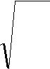
τ = |  | L | Seconds
 |  | 2g
2. Assume various values of damping factor (ξ) such that
ξ > 1 (ξ= 1.1, 2, 2.1, 2.2, … , 3, 3.1, …, 4,etc.)
3. | At each ξ calculate |  |  | y(t) | using following formula:
 |  |  |  | K _{p}

 | y(t) | ⎡ | −ξt ⎛ | ⎧ |  |  |  |  |  | t ⎫ |  |  |  | ξ |  |  | ⎧ |  |  |  | t ⎫ |  | ⎞⎤
 | y(t) | = ⎢1 − e | τ ⎜ | ⎧ |  |  | 2 |  |  |  |  |  |  | ξ |  |  | ⎧ | 2 |  |  |  |  | ⎟ | ⎥
 |  | = ⎢1 − e | τ ⎜ | cosh⎨ | ξ |  |  | −1 * |  |  | ⎬ + |  |  |  |  |  | sinh⎨ | ξ | −1 * |  |  | ⎬ | ⎟ | ⎥
 |  | = ⎢1 − e |  | cosh⎨ |  |  |  |  |  |  | ⎬ + |  |  | 2 |  |  |  |  |  |  |  |  |  | ⎥
 | K _{p} | ⎢ | ⎜ | ⎩ |  |  |  |  | τ ⎭ |  |  |  | ξ | 2 | −1 |  | ⎩ |  |  | τ ⎭ |  |  | ⎟⎥
 |  | ⎣ | ⎝ |  |  |  |  |  |  |  |  |  |  |  |  |  |  |  |  |  |  |  | ⎠⎦
At |  | ξ = 1.1,
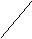Find ^{y(t)} putting for different time
K _{p}

4. Calculate ΔH_{err} as,

 | ⎛ | y(t) |  | H | ⎞
^{ΔH} err | = ⎜ |  | − |  | ⎟
 | ⎜ | K _{p} |  |  | ⎟
 | ⎝ | K _{p} |  | ^{H} end ⎠
H_{end} = h_{S1} – h_{S2} cm

H = h_{S1} – h cm

Find the ΔH² _{err}, for different values of ξ

- Plot (ΔH²_{err}) vs ξ

- The graph gives a minimum ΔH²_{err} at some value of ξ, which is the ξ of the overdamped manometer.

- Find the value of height analytically putting the value of ξ, τ for different time using formula mentioned at sample no. 3

- Plot the graph between Δh vs t. both analytical and experimental.

B. Underdamped Manometer

- Plot Δh v/s time

  - Get values of A, B, C from graph as:

- - Maximum amount by which response exceeds ultimate value.

- - Ultimate value of response.

- - Amount by which response exceeds the ultimate value in adjoining peak.

47

Chemical Engineering Laboratory Manual
Semester VI

3. Calculate,

Overshoot = A/B Decay ratio = C/A

(Overshoot)² ~ Decay ratio

4. Calculate ξ using Decay ratio & Overshoot

 |  |  |  |  |  | A |  |  |  | ⎛ |  |  | − πξ |  |  |  |  |  | ⎞
 |  |  |  |  |  |  |  |  |  | ⎜ |  |  |  |  |  |  |  |  | ⎟
Overshoot = |  |  |  |  |  |  | = exp |  |  | ⎜ |  |  |  |  |  |  |  |  | ⎟ | ,
 |  |  |  |  |  |  |  |  |  | ⎜ |  |  |  |  |  |  |  |  | ⎟ | ,
 |  |  |  |  |  | B |  |  |  |  |  | 1 − ξ |  |  |  |  | 2 |  | ⎟
 |  |  |  |  |  |  |  |  |  | ⎝ |  |  |  |  |  |  |  |  | ⎠
 |  |  |  |  |  |  |  | C |  |  |  |  |  | ⎛ | − |  | 2πξ |  |  |  |  | ⎞
Decay _ ratio = |  |  |  |  |  |  |  | C | = exp |  |  |  |  | ⎜ |  |  |  |  |  |  |  | ⎟ | = (overshoot) | 2 | ,
 |  |  |  |  |  |  |  | A |  |  |  |  |  | ⎜ | 1 − ξ |  |  |  |  | 2 |  | ⎟ | = (overshoot) |  | ,
 |  |  |  |  |  |  |  |  |  |  |  |  |  | ⎝ |  |  |  |  |  |  |  | ⎠
Get average value of ξ,
5. Calculate τ
τ = |  | L |  | s
 |  | 2g
6. Calculate period of oscillation; analytically

^{T}anal. ⁼ |  | 2πτ |  |  | s
^{T}anal. ⁼ | 1 − ξ |  | 2 |  | s
T _{graphical} is mean of peak to peak distance between successive oscillations.

- Calculate t_{response} graphically as time for ± 5% of final value of response.

- Calculate t_{rise} as time required for response to reach its final value for the first time.

10. Calculation Table:

Overdamped manometer:

S.No. | t (sec) | ΔH²_{err} | @ | ΔH²_{err} | @ | ΔH²_{err} | @ | ΔH²_{err} | @ | ΔH²_{err} @
 |  | ξ=1.1 |  | ξ=2 |  | ξ=2.8 |  | ξ=3 |  | ξ=4

Sr. No. | Time | Y(t)analytical
Sr. No. | (sec) | (cm)

48

Chemical Engineering Laboratory Manual
Semester VI

11. Results:

1. Damping factor for overdamped manometer,

- -

2. Damping factor for underdamped manometer,

- -

3. | Time period of oscillation for underdamped manometer,
T analytical |  |  | - | s
T graphical |  |  | - | s
4. | Response time for underdamped manometer,
t response |  |  | - | s
5. | Rise time for underdamped manometer,
t rise |  | - | s

- Conclusion:

- Comments:

- References:

1. Stephanopoulos G., 'Chemical Process Control: An Introduction to theory and practice’, 14th

Indian Reprint, February 2003, Prentice-Hall of India Private Limited, ISBN-81-203-0665-1.

2. Coughanowr D. R. and Koppel L. B, 'Process Systems Analysis and Control', International Student Edition, 1965, McGraw-Hill Kogakusha, Limited, Library of Congress Catalog Number 64-23273.

49

Chemical Engineering Laboratory Manual
Semester VI

8. LINEARIZATION OF DYNAMIC BEHAVIOR OF TAPERING TANK

1. Aim: 1.To linearize the dynamic behavior of the given tapering tank to setup a mathematical model describing the system.

2. To compare the actual behavior with the predicated behavior.

- Equipment: Rotameter, tapering tank, pump, measuring cylinder, stopwatch.

- Theory:

First order systems:

A first order system is one whose output y(t) is modeled by first order differential equation. Thus in the case of linear (or linearized) system, we have

dy | + a | y = bf (t)
a1 _{dt} | + a | y = bf (t) | (1)
Where f(t) is input (forcing function). If a_{ο} ≠ o, then equation (1) yields;
a₁ |  | dy | + y = | b | f (t) | (2)
a |  | dt | + y = | a | f (t) | (2)
Where,

^{a1} =τ p = time constant of the process. a

^{b1} = kp = steady state gain of the process. a

First order processes are characterized by:

- Their capacity to store material, energy and momentum.

- The resistance associated with the flow of mass, energy or momentum in reaching the

capacity.

Linearization: Linearization of the process by which we approximate non-linear systems with linear ones.

Options available with us when confronted with non-linear systems:

Simulate the non-linear system in a computer and compute the solution using various numerical methods.

Transfer the non-linear system in to a linear one by appropriate transformation of variables. Develop a linear model that approximates the dynamic behavior of a non-linear system in neighborhood of specified operating conditions.

50

Chemical Engineering Laboratory Manual
Semester VI

Alternative (2) can be used in very few cases, while (1) & (3), in principle, are always feasible. We perform linearization because:

We can have closed form, analytic solution for linear systems. Thus we have complete and general picture of process’s behaviour independently of particular value of the parameters and input variables.

This is not possible for non-linear systems and computer stimulation provide us with the behavior of the system at specified values of inputs and parameters.

All the significant developments towards the design of effective control systems have been limited to linear processes.

Procedure of Linearization:

As mentioned above, we must convert rigorous non-linear differential equations describing the system into linear differential equations if we are to be able to use the powerful linear mathematical techniques.

A Linear differential equation is basically one that contains variables only to first power in any one term of the equation. If square root, squares, exponentials, products of variables, etc., appears in the equation, it in non-linear.

Mathematically, a linear differential equation is one for which the following two properties hold: If X (t) is solution, then CX(t) is also solution, where c is constant.
If X₁ is solution and X₂ is also a solution , then X₁ + X₂ is a solution.

Linearization is quite straightforward. All we do is to take the non-linear functions, expand them in Taylor series expansions around the steady state operating level, and neglect all terms after the 1st partial derivatives.
Let us assume we have a non-linear function f of the process variables x₁ and x₂ i.e f(x₁,x₂).

For the steady values of these variables, we use an overscore. Now we expand the function

f(x₁,x₂) around its steady state f (x₁, x₂)

 |  |  |  |  |  |  |  |  |  | ⎛ df |  |  | ⎞
f (x , x |  | ) = | f (x , x |  |  |  | ) + (x − x ) ⎜ |  |  |  |  |  | ⎟ |  |  |  |  |  | +
f (x , x | 2 | ) = |  |  | 2 |  |  |  |  |  |  |  | ⎟ | (x , x |  |  |  | ) | +
1 | 2 |  | 1 |  |  |  | 1 | 1 |  | ⎝ | dx |  | ⎠ |  |  |  |  | )
 |  |  |  |  |  |  |  |  |  |  | 1 |  |  | 1 |  | 2

- ₋ ₎⎛ df ⎞
  - x ⎜ ⎟
² ² ⎝ dx₂ ⎠

 |  |  |  |  |  | 2 | ⎛ d ² f
 |  |  | + | (x1 − x1)
(x , x |  | ) | + |  |  |  | ⎜
(x , x |  | ) | + | 2 |  |  | ⎜ | dx | 2
(x , x |  | ) |  | 2 |  |  | ⎝ | dx | 2
1 | 2 |  |  | 2 |  |  | ⎝ | dx

⎞
⎟ (x , x )
⎠ 1 2

Linearisation consists of truncating the series after the first partial derivatives.

 |  |  |  |  |  |  |  |  |  | ⎛ df |  |  | ⎞ |  |  |  |  |  |  |  |  |  |  | ⎛ df |  |  | ⎞
f (x , x |  | ) = | f (x , x |  |  |  | )+ (x − x ) ⎜ |  |  |  |  |  | ⎟ |  |  |  |  |  | + (x |  | − x ) ⎜ |  |  |  |  |  | ⎟
1 | 2 |  | 1 |  | 2 |  | 1 | 1 |  | ⎝ dx₁ |  |  | ⎠ | (x , x |  |  |  | ) |  | 2 | 2 |  |  | ⎝ | dx |  | ⎠ |  | (x , x |  | )
 |  |  |  |  |  |  |  |  |  |  |  |  | ⎠ |  |  |  |  | ) |  |  |  |  |  |  |  | 2 | ⎠ |  | (x , x |  | )
 |  |  |  |  |  |  |  |  |  |  |  |  | 1 |  |  | 2 |  |  |  |  |  |  |  |  |  | 2 |  | 1 |  | 2

In the essence, we are approximating the real function by a line function.

51

Chemical Engineering Laboratory Manual
Semester VI

Mathematical modeling of the given system:

₁₅ cm
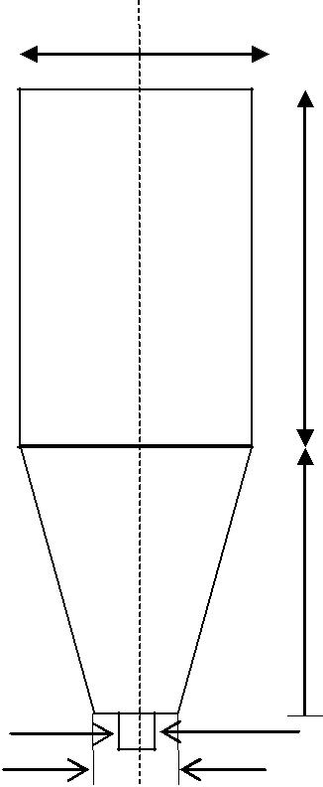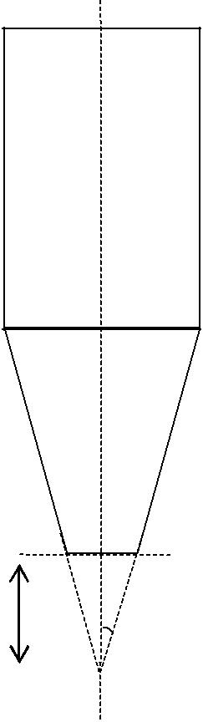

30 cm

 | 30 cm
 |  | h
0.75 cm |  | ∝
 | 4.5 cm | ∝
 | 4.5 cm | h₁

Fig-1

The tank shown in the above schematic diagram is used in the experiment. The construction at lower end constitutes the resistance offered by the system to the flow of water.

Symbols used:

^{q}i | = | Input flow rate.
^{q}0 | = | Output flow rate.
A | = | Area of cross-section.
h | = | height of the liquid level from the bottom of tank + height of remaining | part of
truncated cone (h₁).
r | = | radius of conical portion of tank at height ‘h’.
hs₁ | = | first steady state height.
hs₂ | = | second steady state height.

- = Angle made by tapering cone surface with axis.

From the geometry of fig.1, radius of the tank is given by: 52

Chemical Engineering Laboratory Manual
Semester VI

r = h tanα

Let us assume a simpler linear model for the resistance ‘R’ of the tank as:

R = ah+ b (1). Where, a and b are constants.

Volume of the conical part is,

V = |  |  | π | r²h − |  |  | π |  | r | 2_{h}
 |  |  | 3 |  |  |  | 3 |  | 1 |  | 1
 |  |  | π |  | 2 |  |  | 2 |  |  |  | π2 |  |  |  | 2
V = |  |  | 3 ^{h} |  |  | tan |  | α.h − |  |  |  | ₃ ^{h}1 |  |  | tan | α.h₁
V = |  |  | π |  |  | 2 |  | (h³ |  | − h |  | 3 |  | )
 |  |  |  | tan α
 |  |  | 3 |  |  |  |  |  |  |  | 1
 | dv |  |  |  |  | 2 |  |  |  | 2 | dh
 |  | = π tan α..h .
 | dt |  |  |  |  |  |  |  |  |  | dt

An elementary material balance gives.

^{dv} = q_{i} − q dt

Using, q = _{R}^{h} we get,

 | dv |  | = q_{i} |  | − |  | h
 | dt |  |  |  | − | R
from eqn. (3),
 |  |  |  |  |  |  | dv
 | dh
 | dh |  | = |  |  |  | dt
 | dt |  | = |  |  | 2 |  |  |  | 2
 | dt |  |  | π tan α.h

Now substituting, value of ^{dv}_{dt} from eqn. (4),

 |  | q_{i} | − | h
dh |  | q_{i} | −
dh | = | q_{i} | − | R
dt | = |  | 2 |  |  | 2
dt |  | π tan α.h

(2)

(3)

(4)

(5)

PART 1: Determination of the resistance offered For draining experiment-
q_{i}= 0

53

Chemical Engineering Laboratory Manual
Semester VI

 |  |  | − |  | h
 | dh |  | −
 | dh | = | − |  | R
 | dt | = | π tan | 2 |  |  | 2
 | dt |  | π tan |  | α.h
Thus |  |  | R = |  |  |  |  | −1
 |  |  | R = |  |  |  | 2
 |  |  |  |  | π tan |  |  | α.h.(dh / dt)

PART 2: For dynamic response

 |  |  | q_{i} | − | h
 | dh |  | q_{i} | −
 | dh | = | q_{i} | − | R
 | dt | = |  | 2 |  |  | 2
 | dt |  | π tan α.h
Fitting R= ah+b
 |  |  | q_{i} − |  | h
 | dh |  | q_{i} −
 | dh | = | q_{i} − | ah + b |  |  |  |  | = f (q , h)
 |  | = |  | 2 |  |  |  |  | = f (q , h)
 | dt |  |  | 2 |  |  |  |  | i
 | dt |  | π tan α.h² |  |  |  |  |  | i
Linearization gives,

(6)

Where qi and h are deviation variables.

(7)

 |  |  |  |  |  | ⎛ | (ah + b)q_{i} |  |  |  | − h |  |  |  | ⎞
∂f |  |  |  |  | d | ⎛
 |  |  | = |  |  | ⎜ |  |  |  |  |  |  |  |  | ⎟ |  | = P
 |  |  |  |  |  | ⎜ |  | 2 |  | ' |  |  |  |  |  |  | = P
 |  |  |  |  |  | ⎜ |  | 2 |  | ' |  |  |  | 2 ⎟
∂h |  | q_{i} |  |  | dh ⎝ |  | π tan |  | α(ah |  | + b)h |  |  |  | ⎠
∂f |  |  | = | 1 |  |  |  |  |  |  |  |  | {2a(1 |  |  | − aq )h² |  |  | +[b(aqi −1) − 3abq |  | −2b(aq |  | −1)]h − 2b² q }
 |  |  | = |  |  |  |  |  |  |  |  |  |  |  |  |  |  |  |  |  |  | i | −1)]h − 2b² q }
∂h |  |  |  |  | π tan² α(ah + b)² h³ |  |  |  |  |  |  |  |  |  |  | i |  |  | i |  |  | i | i
∂h |  | qi
 |  |  | = |  | Ah ² + Bh + C |  |  |  |  |  |  |  | = P
 |  |  | = | π tan² α(ah + b)² h³ |  |  |  |  |  |  |  |  |  |  |  |  |  |  |  |  | (8)

A = 2a(1− aq_{i} )

- = b(1− 4aq_{i} )

- = −2b² q_{i}

 | dh | = Qqi + Ph
 | dt |  |  |  |  |  |  |  |  |  |  |  |  | (9)
Where, P = |  |  | Ah ² |  |  | + Bh + C |  |  |  | ,Q = |  | 1
 |  |  | π tan | 2 | α(ah + b) |  | 2 | h | 3 | ,Q = | 2 | π tan | 2 | α
 |  |  | π tan |  |  |  |  | h |  |  | h | π tan

Taking Laplace transformation of equation (9)

sh(s) = Qq(s) + Ph(s)

54

Chemical Engineering Laboratory Manual
Semester VI
h(s) = ^{Qq(s)}
s − P

Since we are giving a step input, therefore the deviation q=a (step change)

q(s)=a/s

h(s) = | Qa | = | − Qa ⎧1 |  |  | − | 1 ⎫
h(s) = |  | = |  | ⎨ |  | − |  | ⎬
h(s) = | s(s − P) | = | P | ⎨ |  | − |  | ⎬
 | s(s − P) |  | P | ⎩s s − P ⎭

h(t) = ^{aQ}_{P} (e^{Pt} −1)
~
Note : h v is written as h for simplicity

4. Process Flow Diagram:
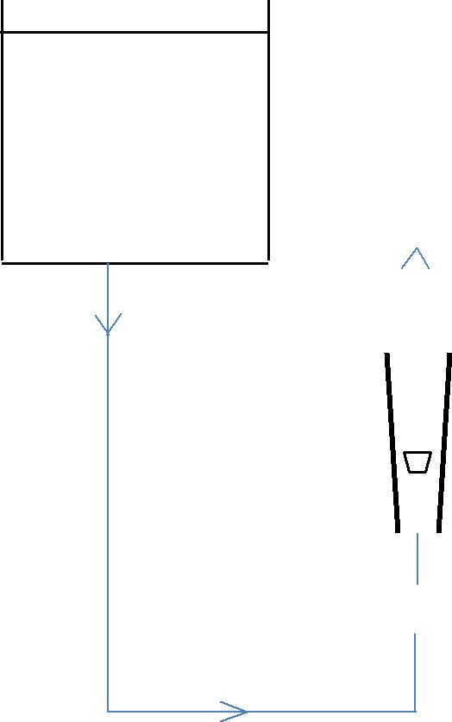

Storage Tank
Rotameter |  |  |  |  |  |  |  | Tapering Tank
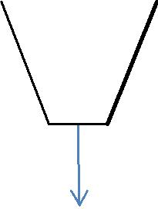
Rotameter valve 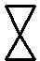

5. Procedure:

PART 1: Determination of the resistance offered by the outlet of the tank to the flow.

A] Resistance offered when the liquid level is in the cylindrical portion of the tank.

1. Fill the tank to a definite level in the cylindrical portion (say 50 cm), closing the outlet by plugging it with a finger.

55

Chemical Engineering Laboratory Manual
Semester VI

- Open the outlet and simultaneously start a stopwatch. No liquid enters the tank after the stopwatch is started.

- Note down the height from the scale on the tank after every 15 seconds.

- Continue taking reading till the liquid level comes to the bottom of the cylindrical portion.

B] Resistance offered when the liquid level is in the tapering portion.

- Fill the tank to the certain height, which lies within the tapering portion.

- With inlet flow equal to zero, drain the tank completely noting the height of liquid level after every 15 seconds.

PART 2: For dynamic response

- Open the valve connected to the rotameter by a definite amount and note down the rotameter reading.

- Wait till the steady state is reached i.e. there is no change in the liquid level height for a sufficiently large amount of time. (Say 15 min.)

- Measure flow rate after steady state has reached using measuring cylinder and stopwatch.

- This is the flow rate at the 1st steady state.

- Now, give a step input change to the flow-rate and note down corresponding rotameter reading.

- Start the stopwatch as soon as the step input is given, and note down the liquid level after every 15 seconds.

- Continue taking the readings till steady state is reached.

- Measure the flow rate using measuring cylinder and a stopwatch.

6. Precautions:

As we want to see the dynamics of the tank in tapering portion, care should be taken that the level obtained after steady state lies well within the tapering portion.

The step input change should be such that it is not very large so that the tank almost drains completely or second steady state lies in cylindrical portion. Nor is it so small that 2nd steady state lies very close to the first one and we don’t have sufficient data points.

The step input change should be given positive or negative based on first steady state height of liquid level obtained.

56

Chemical Engineering Laboratory Manual
Semester VI

7. Data: 1.Dimensions of the tank:

¹⁵ cm
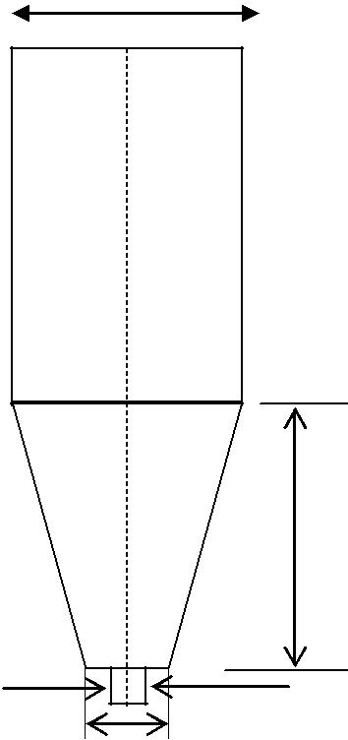

30 cm

0.75 cm

4.5 cm

8. Observations:

I] Resistance in the cylindrical portion and tapering portion q_{in} = O

Initial height = |  | cm
Obs. No. | Time t (sec) |  | Height h_{s} (cm)

II] Dynamic response of the system:

Initial steady state flow rate (q_{S1}) |  | - | cm³ / sec.
Final Steady state flow rate (qs₂) |  | - | cm³ / sec.
Obs. No | Time t (sec) | Height h_{s} (cm)

57

Chemical Engineering Laboratory Manual
Semester VI

9. Sample Calculations:

A. Find the resistance offered by the tapering tank (R)

For tapering portion, we have time-height data while draining the tank. (to calculate resistance offered when liquid is in tapering portion.)

But it must be noted that it is slant height, what we measures and it needs to be converted into vertical height.

From tank geometry,

Vertical height (h_{v}) = h_{s}. cos∝

Where, h_{s}-height (slant) we measured from scale on tank. (for tapering section)

i) To calculate angle ∝:

7.5cm
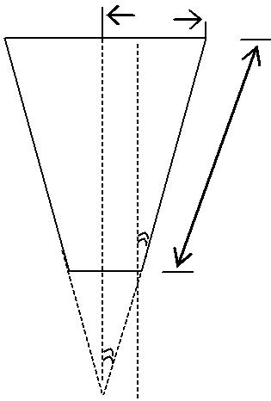P

C D

30 cm

∝

A B

∝

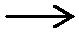_{O} 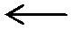2.25cm

Above is the diagram showing only tapering section of tank with its dimensions.

It can be easily shown, that OAB & BCD are similar ones and ∠AOB = ∠CBD = ∝

Also sin α |  | = |  |  | CD |  |  | = | PD − PC |  | = | 7.5 − 2.25
 |  |  |  |  | DB |  |  | = | DB |  | = | 30
∴α = Sin | − 1⎛ |  | 5.25 |  |  |  | ⎞
∴α = Sin |  | ⎜ |  |  |  |  | ⎟ or α = 10.08 º
 |  | ⎝ |  | 30 |  |  | ⎠

ii) Now we have data of time and vertical height (h). From this, a graph of h Vs time is plotted. At different h values slope is found out by drawing a tangent to curve at that point. This slope will be dh/dt.
 |  |  | q_{i} | − | h
 | dh |  | q_{i} | −
 |  |  | q_{i} | − | R
We have, |  | =
We have, |  | = |  | 2 |  |  | 2
 | dt |  | π tan α.h

Now q_{i} = 0

58

Chemical Engineering Laboratory Manual
Semester VI

hence R = |  |  | 1
hence R = |  | ⎛ dh ⎞ |  |  | 2
 | − | ⎜ |  | πh tan |  | α
 |  | ⎜ |  | ⎟
 |  | ⎝ dt ⎠

Where h = h_{v} + h₁

Now plot a graph of R Vs h

Since we are assuming, resistance (R) offered to be linear function of h,

i.e. R = ah + b

Where a & b are constants.

Slope = a & intercept = b

B. Dynamic response of tapering tank:

Knowing a, b, q_{i} and q_{S2,} we can calculate,

- = 2a (1-a q_{i})

- = b (1- 4aqi)

- = -2b² qi
Where qi = q_{s2}

iv) Final steady state after step change in flow rate is h_{s2} which is equal to h_{v (s2)} into vertical one. But in this bottom height of truncated portion h₁ ₍Ref. fig.1) needs to be added.

∴ ^{h}S2 ⁼ ^{h} _{v(s2)} ⁺ ^{h}1

For this h_{s2,} R should be calculated as

R = ah_{s2} + b

Now,

h(t) = ^{aQ} (e^{pt} - 1) P

From this equation, theoretically, values of liquid level heights are predicted at different time intervals and can be compared with observed heights on same graph paper by plotting h vs time. But while plotting h vs time for observed data, height plotted should be total height measured (vertical) from the tip of the cone.

10. Results:

1. Equation obtained for theoretical prediction of liquid level height

i.e. h(t) = ^{aQ} (e^{pt} - 1) P

With numerical values of P & Q

59

Chemical Engineering Laboratory Manual
Semester VI

- hs₂ - experimentally observed (graphically) hs₂ - theoretically predicted (graphically)

- Conclusion:

- Comments:

- References:

1. Chemical Process control, Stephanopoulous, G.C.; (Prentice-hall India, 2001); chapter no.6; page no. 113-118.

60

Chemical Engineering Laboratory Manual
Semester VI

9. FIN EFFICIENCY

1. Aim: To find the fin efficiency (η) at different points on the fin when air at high speed is passed over it.

2. Theory :

In designing and construction of various types of Heat Transfer Equipments (HTE), simple shapes, such as cylinders/bars are used to implement the flow of heat between Source and Sink. They provide heat ‘Absorbing’ / ‘Rejecting’ surfaces and each is known as ‘Prime Surfaces’. When

Prime Surface is extended by appendages, intimately connected with it, such as metal tape & spine on the tube, the additional surface with base is known as ‘Extended Surface’. The elements used for extending prime surfaces are referred to as ‘Fins’.

Extended or Finned Surfaces :

The overall heat transfer resistance of a plane wall is determined by the ‘greatest partial resistance’. If this is one of the ‘convective resistances’, the heat transfer rate can be increased by providing extra surface for convection. The surface for heat transfer can be increased by placing fins on the surface where the great resistance occurs. Such finned heating surfaces are widely used as economizers in steam boilers, as radiators for steam and hot-water heating systems on electric transformers, for the cylinders of air-cooled combustion engines, etc.

It is of primary interest to note the conditions for which the finned surface has advantages over the plane wall. Obviously, fins are advantageous for the case where the heat flow through a fin increases with increased fin height. If the heat flow decreases with increased fin height it is advantageous to make the fin as low as possible or finally to omit them.

When fins are advantageous, the heat transfer is increased by placing them as near each other as possible. But there is a limit for the distance between two fins for the heat transfer coefficients (h.t.c., ‘h’) decrease when the boundary layers which occur on the surfaces of the fin mutually influence each other. The distance between two fins must not be much smaller, therefore, than twice the boundary layer thickness.

Generally the fins are placed at the side where h.t.c. is low. Or in other words, keeping fins on the side where h.t.c. is high will not help the purpose.

Extended or finned surfaces are often used when one film coefficient is substantially lower than the other as when steam condensing in a pipe is being used to heat air.

Finned heating surfaces are of value, in increasing the rate of heat transfer per unit length substantially.

Types of Fins

Two common types of extended surfaces are available: a. Longitudinal fins,

b. Transverse fins.

61

Chemical Engineering Laboratory Manual
Semester VI

Longitudinal fins are used when the direction of the flow of the fluid is parallel to the axis of the tube; transverse fins are used when the direction of the fluid is across the tubes.

Spikes, pins, studs or spines are also used to extend surfaces and tubes carrying these can be used for either direction of flow.

In all types, it is important that the fin be in tight contact with the tube, both for structural reasons and to ensure good thermal contact between the base of the fin and the wall.

Derivation of fin efficiency:

The simplest fin from the standpoint of manufacture as well as mathematics is the fin of uniform thickness.

For the derivation of its characteristics it is necessary to impose the limitations and assumptions given by Murray and Gardner; which are as listed below :

1. The heat flow and temperature distribution throughout the fin is independent of time i.e. heat flow is steady.

2. The fin material is homogeneous.

3. There is no heat source in the fin itself.

4. The heat flow to or from the fin surface at any point is directly proportional to the temperature difference between the surface at that point and the surrounding fluid.

5. The thermal conductivity of the fin is constant.

6. The heat transfer coefficient is the same over the entire fin surface. 7. The temperature of the fluid surrounding the fin is uniform.

8. The temperature of the base of the fin is uniform.

9. The fin thickness is so small compared with the height that the temperature gradient across the width of the fin may be neglected.

10. The joint between the fin and the tube is assumed to offer no bond resistance.

Let us consider the one-dimensional heat transfer through fin, by conduction, exposed to a surrounding fluid, as shown in the figure, and loses heat also from its surface, by convection.
Let the temperature of the base of the fin be ‘T_{b}’ (°C).

Let the temperature of the surrounding fluid be ‘T∞’ (°C).

Now taking Heat/Energy Balance across the differential element, we get,

Heat conducted in |  | Heat conducted out |  | Heat convected from
the differential |  | = of the differential volume |  | + the differential volume
volume at ‘X’. |  | at ‘X+ΔX’. |  | of length ‘ΔX’.
i.e. (q_{x}) | = | (qX+ΔX) | + | (qconv.).

62

Chemical Engineering Laboratory Manual
Semester VI

Diagram:
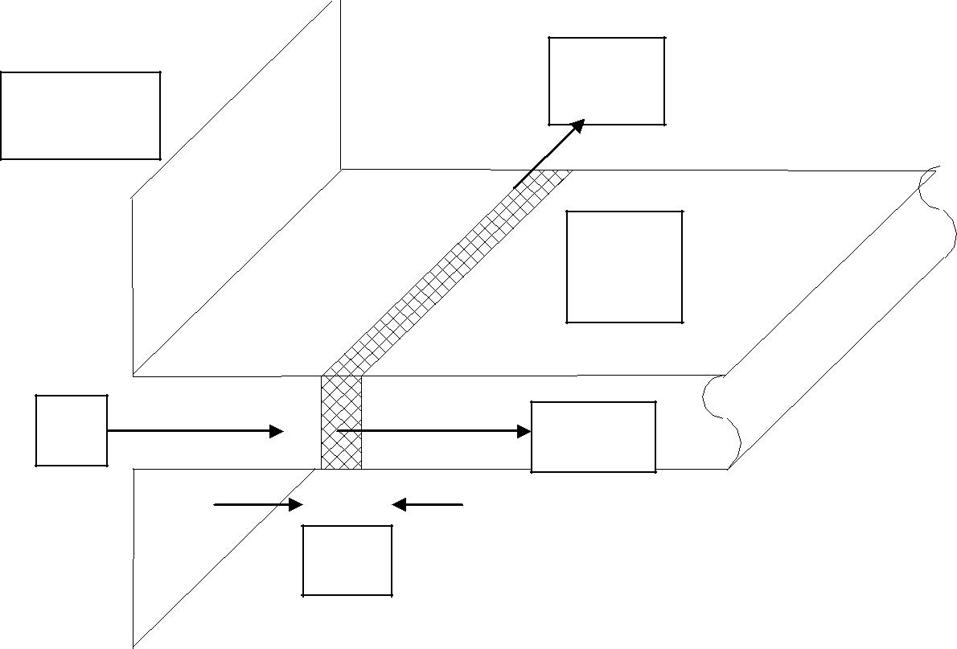

qconv
BASE

FIN

qx | qx+dx

dX

Applying Fourier’s law for conduction and Newton’s law for cooling, we get,

-K * A * dT |  | = -K * A * dT | +h * P * ΔX * [T(X) - T∞ ]
dX | X | dX | X+ΔX

Where,
K ⇒ Thermal conductivity of fin material (W/m.°C);
A ⇒ Area of cross section of fin (m²);

h | ⇒ Heat transfer coefficient (W/m².°C );
T | ⇒ Temperature of fin (°C);
T∞ | ⇒ Temperature of surrounding fluid | (°C);
P | ⇒ Perimeter of the fin (m);
X | ⇒ Distance from the base (m);
ΔX | ⇒ Length of the differential element | (m).

Now, dividing by ΔX and taking Limit as ‘ΔX → 0’, we get,

63

Chemical Engineering Laboratory Manual
Semester VI

d²T | - ( h * P ) * ( T(X) - T∞ ) = 0
dX² | ( K * A )

LET T - T ∞ = θ

^{h} * ^{P} _{=m}2 K * A
We observe that group, ( h*P*L²/K*A ) is a ‘Dimensionless’ group.
This group is commonly known as ‘BIOT NUMBER’ ( Bi ).

Now,

d²θ - m² *θ = 0 dX²

We know, the solution of this Differential Equation is, θ = C₁ . exp [ - m* x] + C₂ . exp [ m*x]

( ℜ )
To solve this equation, we need two Boundary Conditions,
- We have the first Boundary condition as,

T = T_{b}atX = 0 | ( 1 )
- The second B.C. can be one of the following three most popular ones,

a. Very long fin ( L→ ∞ ) and hence the temperature of the fin tip reaches the ambient temperature of fluid; we say it is ‘ Infinitely Long Fin ‘.

T ( L→ ∞ ) = T∞ ,
( 2 )
θ ( X ) = 0,

c₁=θ₀=T_{b} - T∞ c₂=0;

∴θ = θ ₀ e^{-mx}

64

Chemical Engineering Laboratory Manual
Semester VI

b. A fin where the tip is insulated at X = L, i.e. ‘Fin with Insulated Tip‘:

 | dT |  |  | = |  |  | 0
 | dX | X = L
 |  |  |  |  |  |  | ( 3 )
OR | dθ |  |  | = |  |  | 0
 | dX | x=L
Hence
 |  |  |  |  |  |  | θ
 |  | C₂ | = |  |  |  | 0
 |  | C₂ |  |  |  |  | ₊ _{e}2mL
 |  |  |  | 1
 |  |  |  |  | θ * e^{2mL}
 |  | C₁ = |  |  |  |  | 0
 |  |  |  | 1 |  |  | ₊ _{e}2mL
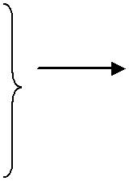
Hence

  - ₌ cosh[m(L − X )]
- ₀ cosh(mL)
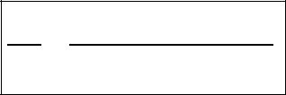
Heat lost from fin is given by

q =− KA | dT |  | X =0
q =− KA | dX |  | X =0

 | dθ |  | X =0 | =− mθ₀ tanh(mL)
 | dX |  | X =0 | =− mθ₀ tanh(mL)
Hence
q = KAmθ₀ tanh(mL) |  |  |  |  | (1)

Assuming the entire fin is at temp T₀ q_{max} =hA(T₀ −T∞ )

q_{max} =hPLθ₀ | (2)

Now the FIN EFFICIENCY can be defined as,

η_{fin} = Actual heat transferred by fin .
Heat that would be transferred if entire fin area is at T_{b}

ηfin = qactual / qideal .

65

Chemical Engineering Laboratory Manual
Semester VI

where qactual = | − KA | dT |  | _{X} ₌₀ by Fourier’s law;
where qactual = | − KA | dX |  | _{X} ₌₀ by Fourier’s law;
dT
where _{dX} _{X} ₌₀ is found from graph of T vs. X

q_{ideal =} h.A.( Tx - T ∞ )

_{ηfin} ₌ ^{KAθ}0^{mtanh}(^{mL}) ……… _{by (1) and (2).} hPLθ₀

_{ηfin} ₌ tanh(mL) mL

Where, m² = (h. P / K. A)

3. | Experimental Setup :
 | B
 | A |  | C
 |  | E
 | F
 |  | D | G
 |  |  | H
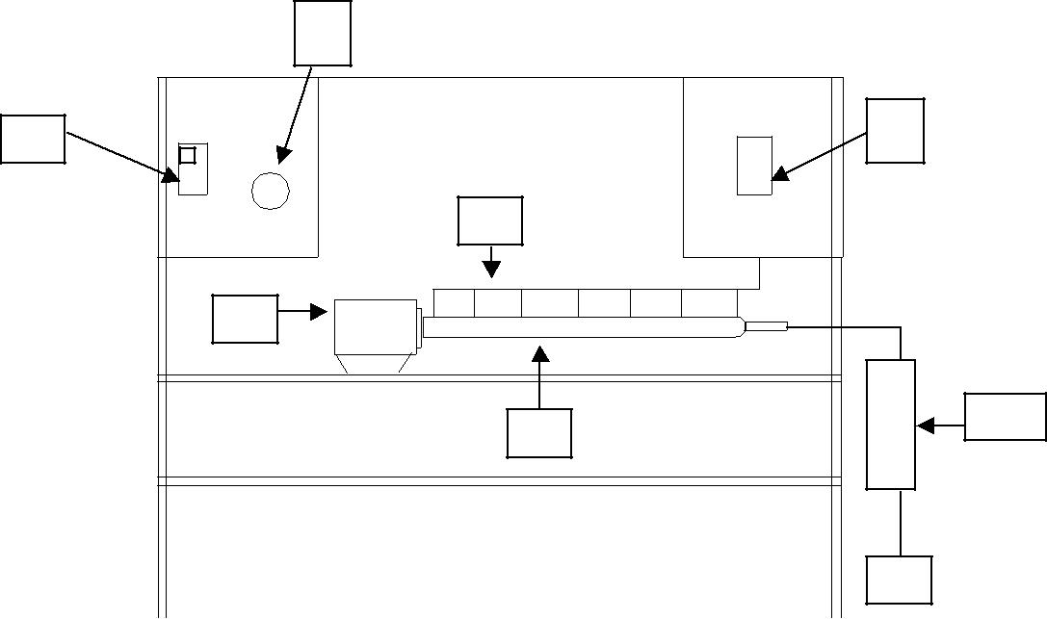

A : Main switch, B : Current controller to heater,

C : Temperature meter , D : Fin with covering,

E : Thermocouples, F : Heating element,

G : Rotameter, H : Air from Compressor.

66

Chemical Engineering Laboratory Manual
Semester VI

4. Procedure :

- Measure the distances of each thermocouple position from the last thermocouple. Each thermocouple is considered as base while calculating its efficiency and the fin is one with the insulated tip.
- Start switches 'A' and the ‘Air compressor ’.
- With the current knob 'B' adjust the current input to the heater.

- Air is passed over the heated fin and out through the holes provided on the fin covering. The air flow rate once set should not be altered.

- Note down the inlet and outlet temperatures of air.

- At different points on the fin, with the help of the ‘Thermocouples’ temperatures are measured and can be seen on ‘C‘.

- When temperatures at every point set to a constant steady value, steady state is reached and at this point temperatures are noted down to get steady state temperature profile.

Note:

One may heat the fin initially, by keeping regulator to maximum with low air flow rates. As temperature of first ‘Thermocouple ‘reaches at about 70-75 °C, the air flow rate is adjusted to required value (high value) and kept unaltered throughout. Also then the regulator knob is so adjusted that we get the steady state.

Also as air temperature is changing along the length of the fin, we have to apply the correction as assumption of T∞ to be constant does not hold good. As a result of which the temperature gradient available for convective heat transfer changes continuously as a function distance.

For simplicity we can assume the surrounding temperature of fin to be constant and equal to the average temperature of inlet and outlet temperatures of air.

Caution:

Care should be taken that; temperature of fin should not exceed 100 °C, to avoid fouling of the fin material or to avoid damage to the fin.

- Observations:
  - Circumference of the fin covering = 19.6 cm,
  - Outer diameter of cover = 6.239 cm,
  - Thickness of cover = 0.3 cm,
  - Inner diameter of cover = 5.639 cm,
  - Diameter of fin = 1inch = 2.54 cm,

vi. | Inlet temperature of air = | °C,
vii. | Outlet temperature of air = | °C,
viii. | Average temperature of air = | °C.

67

Chemical Engineering Laboratory Manual
Semester VI

Observation Table:

Obs. | Distance from last | Temperature
No. | thermocouple | ( °C )
 | (cm )
1 | 0
2

- Calculations:
  - Find the equivalent diameter,
De_{w} = D² – d²
D+d
Where, D = Inner diameter of the fin covering,
And d = Diameter of fin.

2. | U = |  |  | A ( m³ / hr ) | . |  |  | 1 (hr / S).
 |  | [ π . ( D² - d² ) / 4 ] |  |  | ( m² ) |  | 3600
3. | Re = De_{w} . U . ρ / μ
Where, De = Equivalent diameter,
 | U |  | = Average velocity of air,
 | ρ = |  |  | Density of air = 1.165 |  |  | ( kg / m³ ),
 | μ |  | = | Viscosity of air | = 0.185 * 10⁻⁴ ( Pa . S ).
4. | Pr = C_{p} . μ / K
Where, C_{p} = Specific heat = 1007 ( J / kg . °C ),
And K = Thermal conductivity = 0.0263 ( W / m . °C ).

De_{h}= |  | D² − d ²
 |  | d
5. If Re>4000;
Nu = h . De_{h} / K |  |  |  |  |  | = 0.027 . ( Re )^{0.8} . ( Pr )^{0.33}
6. If Re<2100;
Graetz no. is defined as
Gz= | Re.Pr.D
 |  | L
For Gz <100;
 |  |  |  |  | .085.Gz |  |  |  | ⎛ | μ |  | ⎞ | 0.14
 |  |  |  |  |  |  |  |  | ⎛ | μ | b | ⎞
Nu=3.66+ |  |  |  |  |  |  |  | * | ⎜ |  | b | ⎟
 |  |  |  |  |  |  | 0.66 | * | ⎜ |  | b | ⎟
 |  | 1 + 0.047.Gz |  |  |  |  | 0.66 |  | ⎜ |  |  | ⎟
 |  |  |  |  |  |  |  |  | ⎝ | ^{μ}w ⎠
For Gz>100;

68

Chemical Engineering Laboratory Manual
Semester VI

⎛ | μ |  | ⎞ | 0.14
⎛ | μ | b | ⎞
Nu=1.86.Gz^{.33}. ⎜ |  | b | ⎟
⎜ | μ |  | ⎟
⎝ | μ | w ⎠
7. h = Nu . K / De.

The heat transfer coefficient h can also be found by other methods
One such method is by finding J_{H} (KERN:CHAP 6: Counterflow :Double pipe Exchangers)

8. Here we consider that the fin is with Insulated Tip, m² = (h. P / K. A)

To find 'Efficiency ' at any particular position on the fin, we consider that fin is insulated at that position, for simplicity.
% η_{fin X} = tanh [mx ] * 100
[mx ]

Hence at any X we can calculate ' Efficiency ' of the fin.

- Also we can calculate “ m” by following method
By taking heat balance between a finite element of fin (see derivation)

^{d} ^{2T} =m² (T − T∞ ) dX ²
Thus plot graph of | d ²T | vs.T and calculate m
 | dX ²
Using this m calculate efficiency and compare with theoretical efficiency.

- The average ' Efficiency ' then can be calculated.
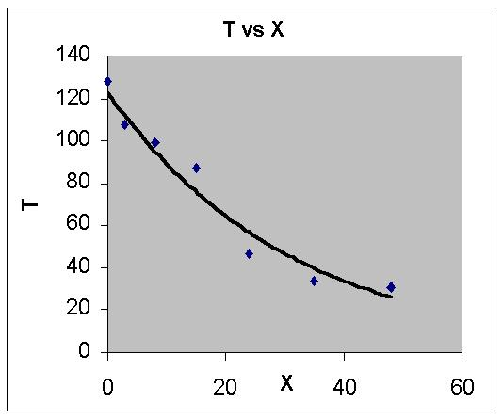

69

Chemical Engineering Laboratory Manual
Semester VI

- Conclusion:

- Applications:
Finned surfaces are widely used in,
- Economizers on steam power plants,
- Convectors for steam and hot water heating systems,
- Electric transformers,
- For the cylinders of aircraft engines.

- Extended or finned surfaces are often used when one film coefficient is substantially lower than the other the goal being to make,

ho . Aoe = hI . AI
- Generally, longitudinal fins are used in double pipe exchangers.
- Transverse fins are used and Shell and tube configurations.
- High transverse fins are used generally with low pressure gases.

- Low fins are used for boiling and condensation of non-aqueous streams as well as for sensible heat transfer.

- Finned surfaces should not be used for severely fouling services, especially if mechanical cleaning is required or for streams carrying large amounts of particulate matter. The area of fin is not as efficient for heat transfer as bare tube surface owing to resistance to conduction through the fin. The effective heat transfer area is:

Ase = Auf + Af

Maintenance and Fabrication problems of fins :

- The Fins are fabricated in many ways –welded, extruded, embedded, wrapped on, cold rolled or machined from thick stock.

- Since fins perform important work of providing greater heat transfer surface for better heat transfer and they ate relatively thin the properties of material surface are of utmost importance.
- Generally for fabricating purpose we may use either of cold working or hot working
operations.

- Where fins are produced by cold rolling, the differential cold work may cause / produce serious non-uniform grain growth with possible adverse effects on properties.

- Welding:-The alloy selection must take into account the availability of matching electrodes, otherwise the design must accommodate reduced mechanical or corrosion performance of the weld metal and the hea affected zone.

Welding slag can adversely affect the corrosion resistance of the component. To avoid this careful interpass cleaning is necessary when coated electrodes are used.

Besides these more attention should be given to
  - technique
  - use of approved welders.
  - interstage inspection.
- Carburisation: This is severe attack of the metal by the internal fluid.

Eg. In thermal cracking of Ethylene, at working temperature above 1000⁰C, due to incomplete oxidation of gases severe carburisation of the alloy steel tubes occurs. As a

70

Chemical Engineering Laboratory Manual
Semester VI

result carbon content increases rapidly at the surface and by diffusion the carbon gradually penetrates the entire wall thickness.

  - When cold working finned surfaces attention must be given to the removal of lubricants to avoid surface carburisation during assembly stages.

  - Chromium depletion-Higher Cr levels give rise to higher corrosion resistance to the fin alloy. But during operation Cr depletion may adversely affect the corrosion resistance.

- References:

    - Chem. Engg. Handbook – Perry
    - Heat Transfer – J.P.Holman.
    - Unit operations of C.E. – McCabe.
    - Analysis of heat and mass transfer – Eckert.
    - Process heat transfer – Kern.
    - Heat transfer – Jacob.
    - High temperature equipment - A.E.Sheindlin.
    - Heat transfer - White
    - Introduction to the transfer of heat and mass – Echert.
    - Extended surface heat transfer – D. Q. Kern

71

Chemical Engineering Laboratory Manual
Semester VI

10. FINNED TUBE HEAT EXCHANGER

1. Aim:

1. To determine the efficiency of given longitudinal fin and compare it with the

theoretical value for the given fin.

  - To determine fin effectiveness for the given arrangement.

- Apparatus: Longitudinal fins, bare pipe, steam generator, measuring cylinder, thermometer

and pressure gauge mounted etc.

3. Theory:

When additional metal piece are attached to ordinary heat transfer surfaces such as pipes or tubes, they extend the surface available for heat transfer and hence are called extended surfaces. Fins are one the many types of the extended surfaces. Fins and other extended surfaces are generally extended to the fluids of lower heat transfer co-efficient so as to increase the heat transferred.

Assumptions:

- The heat flow and the temperature distribution through the fin is independent of time, i.e. heat flow is steady.

- The fin materials are homogeneous and isotopic.

- There is no heat source in the fin itself.

- The heat flow to or from the fin surface at the point and the surrounding fluid.

- The thermal conductivity of fin is the constant.

- The heat transfer coefficient is same over the entire fin surface.

- The temperature of fluid surrounding the fin is uniform.

- The temperature of the base of the fin is uniform.

- The fin thickness is so small compared with its height that temperature gradient across width of fin may be neglected.

- The heat transfer through the outermost edge of fin is negligible compared with that passing into the fin through its sides.

- The joint between fin and the tube is assumed to offer no bond resistance.

72

Chemical Engineering Laboratory Manual
Semester VI

Derivation:
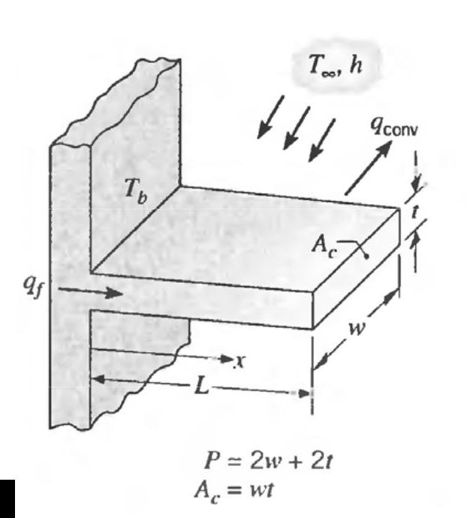

Consider the thickness dx, taking energy balance,

Energy in left face = Energy in right face + Energy lost by convection Energy in left face is given by


Energy out of the right face is given by


Energy Lost by convection 

Here differential surface area 

On combining the quantities we get,


Let,

73

Chemical Engineering Laboratory Manual
Semester VI


Differential equation can be written as,


Solution of the equation is


Boundary conditions 1. 

Considering insulated tip of the fin,


At x= L

Substituting both boundary conditions and solving for constants C₁ and C₂ and substituting back in General Solution,


All of the heat lost by the fin must be conducted from the base at x = 0.

Using the equations for temperature distribution, we can compute the heat lost using Fourier’s

Law


Solving,


Fin Efficiency =

Where,

q - Actual heat transferred,

q₀ - Heat which would be transferred if entire fin were at base temperature


74

Chemical Engineering Laboratory Manual
Semester VI

Fin Effectiveness = Q₁/Q₂

Q₁ ₋ Heat transferred through the finned tube heat exchanger,

Q₂ - Heat transferred through the bare tube,

The fins are said to be effective when fin effectiveness is greater than 2

Conditions when fins do not help

If the value of convective heat transfer coefficient is large (Boiling Liquids or High Velocity Fluids),

The fins may produce reduction in heat transfer because of conduction resistance it represents a larger impediment to the heat flow than the convective resistance.

4. Experimental setup:
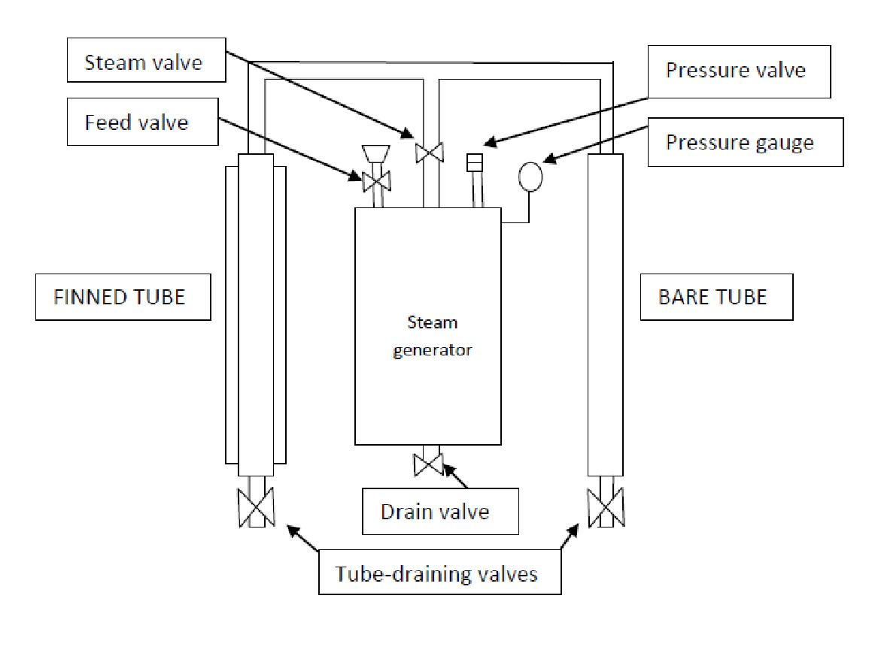

75

Chemical Engineering Laboratory Manual
Semester VI

5. Procedure:

- First drain out water from the steam generation pot through drain valve.

- Fill approximately four liters of water in it.

- Close the steam valve at the top of the generator.

- Start the electric heater to begin heating the water. Wait until the steam pressure inside the pot becomes equal to some pre-decided value.

- Close both bare and finned tube-draining valves.

- Open the steam valve at the top of the generator and keep it open for sometime so that both the tubes get heated properly.

- Now close the steam valve at the top of the generator and drain the liquid inside the tubes through the tube-draining valves.

- Open the steam valve at the top of the generator and keep it open for 15 minutes. Maintain the steam pressure constant.

- Close the steam valve at the top of the generator and subsequently open both the tube-draining valves to collect condensed liquid from each tube using measuring flasks.

- Note the temperature at which steam is generated.

- Repeat the above procedure for 4 more sets of observations and for another constant value of pressure.

NOTE: No in the brackets indicate valve number in the diagram.

6. Precautions:

Care must be taken that there is no direct exit for steam i.e. valve on the top of steam generation pot and any of the draining valve must not be open at the same time.

7. Data:

A. Finned tube:
Length of the tube (L) | - 0.68 m
Height of the fin (l) | - 0.60 m
Width of the fin (w) | - 0.05 m
Thickness of the fin (b) | - 0.002 m
No. of fins (N) | - 4
Outer diameter of fin tube (D) | - 0.043 m
Thermal conductivity of the fin (k) | - 206.5 kcal/hr.m.⁰C
 | 76

Chemical Engineering Laboratory Manual
Semester VI

B. Bare Tube:

Length of tube (L) | - 0.63 m
Outer diameter of the tube (D) | - 0.043 m
Reference Diagram:
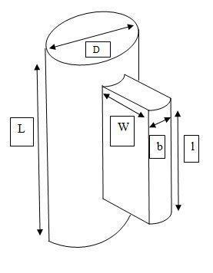

7. Observation Table:

Pressure | Obs. | Surrounding | Steam | ∆T =(T - | Condensate | Flowrate
 |  | Temperature | Temperature | T_{s}) | (kg/hr)
 | No. | T (°C) | T_{s} (°C) | (⁰C) | Finned (m₁) |  | Bare (m₂)

77

Chemical Engineering Laboratory Manual
Semester VI

8. Sample Calculation:

- Condensate flow rate (kg/hr) =

- Latent heat of Vaporization (ΔH): Refer attached steam table at T_{s}

- Perimeter in fin, P = 2 (l + b) m

- Cross sectional area of fin  m²
- Fin area available for heat transfer  m²

- Tube area available for heat transfer in finned tube heat exchanger

- Total area of the finned tube heat exchanger

 m²

h. Heat given out by steam through finned tube heat exchanger (Q₁) and bare tube (Q₂),

Q₁ = m₁ Χ ΔH Q₂ = m₂ Χ ΔH

i. Film heat transfer coefficient for finned tube (h₁) and bare tube (h₂)


kcal/hr.m².⁰C and | kcal/hr.m².⁰C

j.

k. Calculate m.w l. 

m. Amount of heat dissipated by fin, if fin were ideal, Q_{F1} = A_{f}.h₁. ∆T kcal/hr

- Heat dissipated by fin, Q_{F} = (Q₁- Q₂ ₎ kcal/hr

- %η_{ACTUAL} = Q_{F}*100/Q_{F1}

- Fin effectiveness =
78

Chemical Engineering Laboratory Manual
Semester VI

Notations Used:

L.H. | - Latent heat of vaporization,
T | - temperature, °C
P | - perimeter of the fin, m
l | - length of the fin; m
b | - thickness of the fin; m
W | - width of the fin; m
L | - length of the tube; m
N | - number of tube; m
D | - diameter of tube; m
Ac | - cross sectional area of fin; m²
A_{f} | - surface area of fin; m²
A_{b} | - surface area of tube; m²
A_{t} | - total surface area of fin tube heat exchanger; m²
k | - thermal conductivity of metal; kcal/ hr m ⁰C
Q₁, Q₂ | - heat given out by steam through fin tube heat exchanger, bare pipe; kcal hr⁻¹
m1, m2 | - mass of water collected per unit time for fin tube heat exchanger, bare pipe; kg hr⁻¹
h | - film heat transfer coefficient; kcal/hr.m².⁰C

- - efficiency; dimensionless

9. Result:

1. | Fin efficiency | -
a. Actual |  | -
b. Theoretical |  | -
2. | Fin effectiveness | -

- Conclusion:

- Comments:

- Reference: HEAT TRANSFER, by Holman J. P., Page No. 44-48

79

Chemical Engineering Laboratory Manual
Semester VI

11. HEAT TRANSFER BY NATURAL CONVECTION

1. Aim: To find heat transfer coefficient for natural convective heat transfer to ambient air from vertical and horizontal cylinders.

2. Apparatus: Steam generator with temperature indicator, presser gauge, and safety valve, two cylinder test sections, one in horizontal position, other in vertical, Stopwatch and measuring cylinder

3. Theory: The mechanism of heat transfer in physical equipment is quite complex; but three basic modes of heat transfer can be distinguished:

a. Conduction b. Convection c. Radiation

Convection: Convection is the mode of heat transfer with actual migration of fluid particles. The energy transfer in convection is predominantly due to the bulk motion of the fluid particles, though the molecular conduction within the fluid itself also contributes to some extent.

It is mainly due to density variations associated with the temperature gradient within fluid, the heat transfer is said to be due to natural or free convection. On the other hand if this motion is induced by external agency such as fan, blower or a pump the heat transfer is said to be due to forced convection.

In many cases heat transfer involving either a liquid or gas, convection is an important mode. In majority of heat transfer cases in industry; heat is being transfer from one fluid to another through a solid wall in a heat exchanger.
Assume a hot fluid at temperature t₁, on one side of a solid wall and a cold fluid at t₇ flowing past other to which a scale of thickness x_{s} adheres (Fig.1). For turbulent flow of fluid past a solid in an immediate neighbourhood of the surface, a relatively quite zone, called film, exists. As one approaches the wall from the core of the fluid, flow becomes less turbulent and develops into laminar immediately adjacent to the wall. The film consists of that portion of the flow which is essentially laminar called laminar sub layer. Heat is transferred through this layer by molecular conduction.

Turbulent core and buffer layer between laminar sub layer and turbulent core each offers resistance to the heat transfer, which depends on the turbulence and the thermal properties of the fluid (Perry R.H. et al, [1]).

80

Chemical Engineering Laboratory Manual
Semester VI

Individual Coefficient of Heat Transfer:

Local heat transfer rate between fluid and the solid is defined by the equations: dq = h_{i} dA_{i} (t₁ − t₃ ) = h_{o} dA_{o} (t₅ − t₇ )

Where h_{i} and h_{o} are local heat transfer coefficients inside and outside respectively of the wall.

Overall Heat Transfer Coefficient:

While testing commercial heat transfer equipment, measurement of t₃ or of t₄ is not convenient. Instead overall performance is expressed as a overall heat transfer coefficient, U based on convenient area dA, which may be dA_{i} or dA_{o} or average.

dq = U.dA(t₁ − t₇ )

Where U - overall heat transfer coefficient
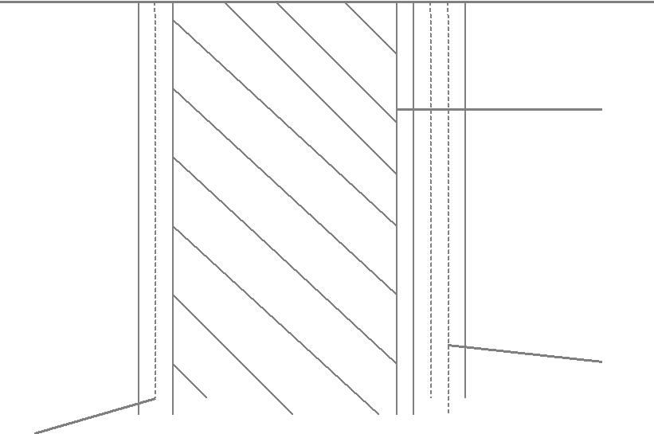

Bulk fluid 1 | t₁ |  | Scale
 | t₂
 | t₃ |  | Bulk fluid 2
(Turbulent core) |  | t₄ | (Turbulent core)
 | Solid | t₅ | laminar sublayer
 |  | t₆
Laminar sublayer |  |  | t₇

Conduction through tube wall and scale deposit (or dirt) is given by dq = k.dA_{avg.} (t₃ − t₄ )/ x = h_{d} .dA_{d} .(t₄ − t₅ )

Subscript d stands for dirt, x represents thickness of the solid.

Eliminating t₃, t₄, t₅ from equations 1, 2, 3 and the energy equations, steady rate of heat flow from fluid 1 to other fluid is:
dq = |  |  | (t₁ | − t₇ | ) | = U.dA.(t₁ | − t₇ )
dq = |  | .dA_{i} | + x / k.dA_{avg} | +1/ h_{d} .dA_{d} +1/ h_{o.} dA_{o} |  | = U.dA.(t₁ | − t₇ )
1/ h_{i} |  | .dA_{i} | + x / k.dA_{avg}

Thus, U is a complicated function of inner film, wall and outer film heat transfer coefficients, and rigorous theoretical determination of U is difficult. (Perry et al, [1])

81

Chemical Engineering Laboratory Manual
Semester VI

Factors Affecting Heat Transfer By Natural Convection:

The free convection heat transfer coefficient depends on following factors:

Sr. No | Variable | Symbol | Dimension
1. | Fluid density | ρ | ML⁻³
2. | Fluid viscosity | μ | _{ML}-1_{T}-1
3. | Specific heat of fluid | C_{p} | _{L}2_{T}2_{θ}-1
4. | Thermal conductivity | K | _{MLT}-3_{θ}-1
5. | Acceleration due to gravity | G | LT⁻²
6. | Coefficient of expansion | β | -1
6. | Coefficient of expansion | β | θ
7. | Temperature difference | ΔT | θ
8. | Significant length | L | L
9. | Heat transfer coefficient | H | _{MT}-3_{θ}-1

The dimensionless numbers important in the analysis of free convection are: 1. Nusselt number
Nu = ^{hD}
k

Where h - heat transfer coefficient

D - Length or diameter

K - Thermal conductivity 2. Prandtl number

_{Pr} ₌ ^{C} p ^{μ} k
Where C_{p} - specific heat

  - - Viscosity

- Grashoff number
_{Gr} ₌ β.g.ΔT.D³ .ρ ²
_{μ} 2

Where β - coefficient of thermal expansion

g - Acceleration due to gravity

82

Chemical Engineering Laboratory Manual
Semester VI

D - Diameter (or length)

ΔT - Temperature difference between solid and fluid

ρ - Density of fluid

Some co-relations also employ Rayleigh number given by
_{Ra} ₌ g.β ΔT.D³

vα

v - Kinematic viscosity = viscosity/ density

α - Thermal diffusivity = k / ρ.C_{p}

Dimensional analysis proves to be useful tool in determining the nature and the constants in these co-relations.

Pi Theorem:

One of the important mathematical proofs of dimensional analysis is attributed to Buckingham. He deduced that the number of dimensionless groups required to describe a physical phenomenon is equal to the difference between the number of variables and the number of dimensions used to describe them.

Dimensional constants are also included as variables.

Designating dimensionless groups by π₁,π₂,... the complete physical statement of a phenomenon can be expressed by
φ (π₁,π₂,...) = 0

where the total number of ‘π’ terms or dimensionless groups equals the number of variables minus the number of dimensions.

Out of the nine terms in the table, normally β,ΔT and g are clubbed together. Thus, we have seven variables and four dimensions, viz. M, L, T andθ.

So, by the Pi theorem, 7- 4=3 dimensionless groups would be required to describe heat transfer by natural convection.

In the present experiment, the inner film resistance (for steam) is assumed to be negligible since heat transfer coefficients associated with condensation of steam are amongst the higher studied so far¹ ≈ 1500 Btu / hr.ft².°F.

The conductivity of metals is also very high, hence the dominant resistance is that offered by air side. So we assume that entire resistance is offered by the air side and heat transfer is air side controlled.

83

Δt d_{o}

Where, h_{c}
Chemical Engineering Laboratory Manual
Semester VI

There are some simple co-relations for finding heat transfer coefficients from the dimensions of the equipment and the temperature gradient across the surface.

1. Horizontal pipes:

h | ⎛ | ΔT ⎞ | 0.25
h | = 0.5⎜ | ⎟
c | ⎜ | ⎟
 | ⎝ | ^{d}o ⎠
2. Vertical pipes:

h | ⎛ | ΔT ⎞ | 0.25
h | = 0.4⎜ | ⎟
c | ⎜ | ⎟
 | ⎝ | ^{d}o ⎠

- convective heat transfer coefficient; Btu / hr.ft².°F.

- Temperature difference between hot solid and air, ºF - outside diameter, inches

Co-relations in terms of dimensionless numbers express Nusselt’s number as function of Grashof and Prandtl (or Rayleigh) numbers:
Nu = φ(Gr, Pr)

Apart from above co-relations, the methods of estimating the heat transfer coefficients for various geometries are given below:

A. Vertical cylinders:

Nu = | hD
Nu = | k
= 0.6(Ra.D / L)^{0.25} |  |  | Ra.D / L ≥ 10⁴
= 1.37(Ra.D / L)^{0.16} |  |  | 0.05 ≤ Ra.D / L < 10⁴
= 0.93(Ra.D / L)^{0.05} |  |  | Ra.D / L < 0.05

Where

Ra = Rayleigh number = g.β.ΔT.D³ / v.αi

D = cylinder diameter

L = cylinder length

ΔT = (T_{s}-T∞), T_{s} being temperature of hot solid and T∞ that of bulk air. Assuming ideality of air, β is given by

β = 1/ T∞

84

Chemical Engineering Laboratory Manual
Semester VI

The fluid properties are evaluated at the average temperature of the solid ( which is assumed to be the same as the temperature of the heating medium, steam), and air i.e. at T = (Ts + T∞) / 2.

B. Horizontal cylinders:
For 10⁻⁵ < Ra < 10¹²
 | ⎡ |  |  | [0.387Ra^{1 / 6} | ] |  | ⎤
Nu = | ⎢0.6 | + |  |  |  |  | ⎥^ (2)
Nu = | ⎢0.6 | + | [1 | + (0.559 / Pr)^{9 / 16} |  | 8 / 27 | ⎥^ (2)
 | ⎢ |  | [1 |  |  | ] | ⎥
 | ⎣ |  |  |  |  |  | ⎦

The heat transfer coefficients can also be estimated by the Nusselt’s equation: Nusselt’s equation:

Nu = a(Gr.Pr)^{m}

h.L | ⎧ | (L ³ | .ρ ² .g.β.Δt) C _{p} μ ⎫ |  |  |  | m
1 | = a⎨ | 1 |  | ( |  | )⎬
k | = a⎨ |  | k | ( | k | )⎬
k | ⎩ |  | k |  | k | ⎭

Let Y = Gr. Pr

(Perry’s handbook, 7:pp5-12 to5-17)

Values of a and m for Various Values of Y:

Type | Y | a | m
Vertical | < 10⁴ | 0.13 | 1/3
Vertical | 10⁴-10⁹
L₁ = vertical dimension< 3 ft | 10⁴-10⁹ | 0.59 | ¼
L₁ = vertical dimension< 3 ft | > 10⁹ | 1.36 | 1/6
 | <10⁻⁵ | 0.49 | 0
 | 10⁻⁵-10⁻³ | 0.71 | 1/25
Horizontal | 10⁻³-1 | 1.09 | 1/16
L₁= diameter | 1-10⁴ | 1.09 | 1/5
 | 10⁴-10⁹ | 0.53 | ¼
 | >10⁹ | 0.13 | 1/3

85

Chemical Engineering Laboratory Manual
Semester VI

4. Experimental setup:
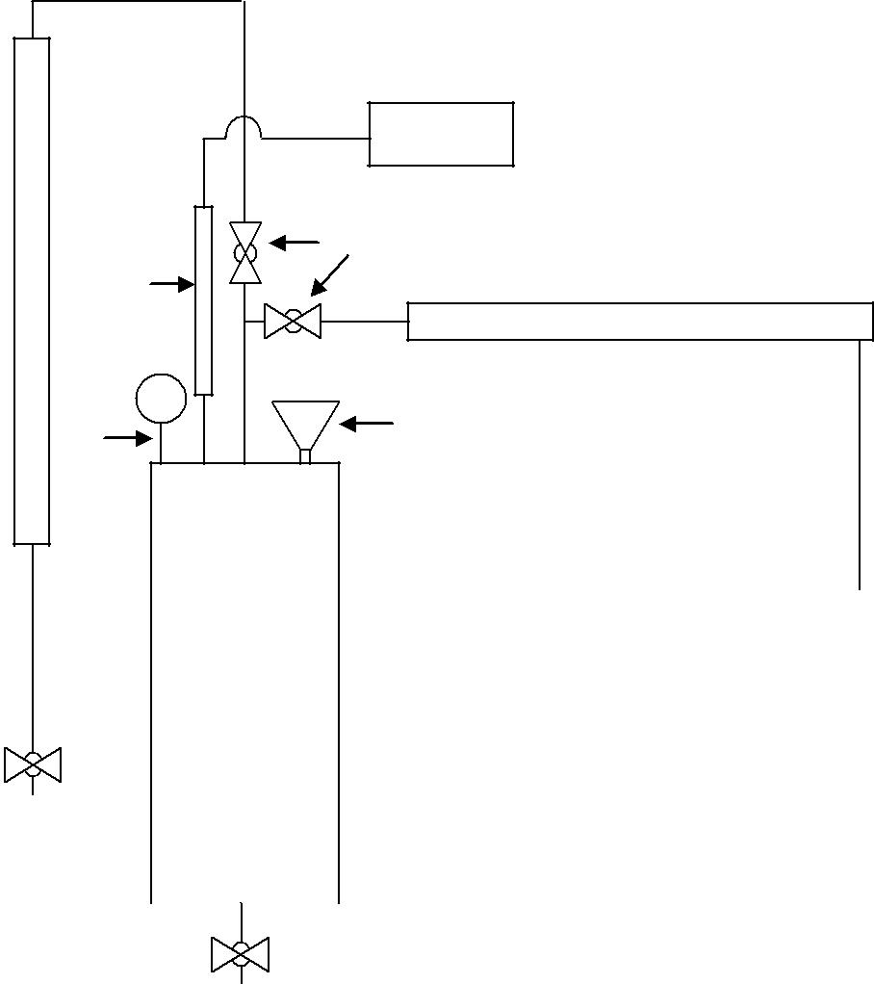

 |  | TI
 |  | SV
Vertical | TS | Horizontal cylinder
cylinder | TS | Horizontal cylinder
 | PG | WI

OV

 | Steam
 | generator
OV
OV |  |  | WI: Water inlet
 |  |  | PG: Pressure gauge
 |  |  | TS: Temperature sensor
 |  |  | TI: Temperature indicator
 |  |  | SV: Steam valve
 |  |  | OV: Outlet Valve
 | OV |  | OV: Outlet Valve

Schematic diagram of heat transfer by natural convection

5. Procedure:

- Drain the steam generator completely by opening the drain valve provided at the bottom. While draining the steam generator keep the valve on the charging line completely open.

- Close the drain valve and fill 4 litres of water through water charging line. While charging the steam generator keep dead weight safety valve open. Charging four litres of water is very essential otherwise electrical heater may get permanently damaged.

- Switch on the electrical supply to the heater of the steam generator. Initially supply full voltage to the heater for faster steam generation. During this time keep the steam supply valve to one of the test sections open and also keep open the outlet valve of the test section. It will take about 30 minutes for generating sufficient steam.

86

Chemical Engineering Laboratory Manual
Semester VI

- After sufficient steam is generated (i.e. required pressure is obtained) close the drain valve of the test section.

- Control the supply of the heater changing so that the desired pressure is maintained. Allow the sufficient time for test section to get heated.

- Open the drain valve on the test section very slowly and allow all the accumulated condensate to drain completely. This is indicated by slow discharge of steam through the drain line.

- Close the valve on the drain line, simultaneously starting the stopwatch. Wait for 15 minutes. Open the drain valve of the test section carefully and collect the condensate and measure its volume.

- Repeat the procedure two more times.

- Repeat step 5 to 8 for second test section.

6. Data:

1. | Outside diameter of horizontal pipe [D₁] | - 0.063 m
2. | Length of the horizontal pipe [L₁] | - 0.655m
3. | Outside diameter of vertical pipe [D₂] | - 0.063m
4. | Length of vertical pipe [L₂] | - 0.635 m

7. Observation:

1. Ambient temperature during the experiment, T∞ - |  |  |  | °C
Observation Table:
 | Pipe | Steam temperature | Amount of condensate
Ob. No. | Pipe | during run | collected in 15 minutes
Ob. No. | position | during run
 | position | T (ºC) |  | W (gms)
1.
2. | Horizontal
3.
1.
2. | Vertical
3.

87

Chemical Engineering Laboratory Manual
Semester VI

8. Sample Calculation:

1. Find the area of horizontal and vertical pipe

A = 2π.r.l m²

2. Find the heat given by steam (Q_{overall})

Calculate H₁ and H₂ from steam stable

Q_{overall} = (H₁ − H ₂ )m J/s

3. Find overall heat flux (q)

q = | Q | J/m²s
q = | A | J/m²s

4. Find the heat loss by the radiation (q_{rad})

4 | 4 | ) | 2 | s
q_{rad} = ε ×σ × (T_{s} | −T∞ | ) | J/m | s
5. Find the heat transfer by convection (q_{conv.})

q_{conv} = (q_{overall} − q_{rad} ) J/m²s

6. Find the heat transfer coefficient (h)

q_{conv} = h(T_{s} −T∞ ) J/m²s
h = ( ^{qconv} ) J/(m²sºK)
T_{s} − T∞

Repeat same calculation for vertical pipe

7. Find theoretical heat transfer coefficient (h_{c}) for both the pipes

^{h}c

h_{c}

⎛ | ΔT ⎞ |  | 0.25
= 0.5⎜ |  | ⎟
⎜ | d_{o} | ⎟
⎝ | d_{o} | ⎠
⎛ | ΔT ⎞ |  | 0.25
= 0.4⎜ |  | ⎟
⎜ | ^{d}o | ⎟
⎝ | ^{d}o | ⎠

- For Horizontal pipe

- For Vertical pipe

Here h_{c} is in Btu / hr.ft².°F

So convert it into w/m²k by multiplying conversion factor 5.677

Notations Used:

A - Surface area of pipe; m² r - Radius of pipe; m

- - Length of pipe; m

- - Mass flow rate; kg hr⁻¹

- - Emissivity,

88

Chemical Engineering Laboratory Manual
Semester VI

- - Stefan’s constant; W m⁻²k⁻⁴
T_{s} | - Temperature of steam; ⁰C
T∞ | - Ambient temperature; ⁰C
h_{c} | - heat transfer coefficient; Btu / hr.ft².°F.

H₁, H₂ - enthalpies of steam and water at experimental temp and pressure; J g⁻¹

ΔT - Temperature difference between hot cylinder and air; ºF
d₀ - diameter of pipe; inch

9. Result:

1. | Average value of the heat transfer coefficient for vertical tube
 | a. Theoretical | - | (W / m² | K)
 | b. Experimental | - | (W / m² | K)
2. | Average value of the heat transfer coefficient for horizontal tube
 | a. Theoretical | - | (W / m² | K)
 | b. Experimental | - | (W / m² | K)

- Conclusion:

- References:

- Perry R.H. et al, Perry’s Chemical Engineers’ handbook, 7: 5-12 to 5-17

- Bird RB et al, Transport phenomenon, 432, 389-425

89

Chemical Engineering Laboratory Manual
Semester VI

12. SHELL AND TUBE HEAT EXCHANGER

1. Aim: To find out the effect of change of flow rates of shell side and tube side fluid on the heat transfer coefficient of a shell and tube heat exchanger (STHE).

- Apparatus: STHE, pump, heater PC, etc.

- Theory:

Heat exchangers are devices in which heat is transferred from one fluid to another fluid. Since the fluids are separated from each other by heat transfer surfaces they do not mix. If the fluids are immiscible, the separating wall may be eliminated and interface between two fluids serve as heat transfer surface.

Classification of heat exchangers

- Based on transfer process

  - Direct contact
  - Indirect contact

- Based on construction

      - Tubular

      - Plate
      - Extended surface
      - Regenerate

- Based on flow arrangement

    - Single Pass
    - Multiple Pass
Single pass is further classified into parallel flow, cross flow and counter flow.

- Based on surface compactness

    - Compact surface

    - Non-compact surface

- Based on number of fluids

  - Two fluids
  - N-fluids

The tubular types of heat exchangers are further classified as

- Double pipe
- Shell and tube
- Spiral

A shell and tube heat exchanger is in the form of a tube arrangement. One fluid flows through the inner tubes and the other through the shell surrounding it. Large heat transfer

90

Chemical Engineering Laboratory Manual
Semester VI

surfaces can be best obtained by means of STHE. Hence they are called workhorses of chemical industry.

Types of shell and tube heat exchangers

- The STHE in which the shell-side fluid flows in one pass and the tube side flows in two or more passes is 1-2 exchanger.

A typical heat exchanger is as shown below:
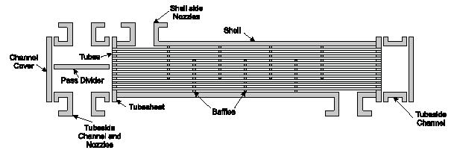

- Fixed tube sheet 1-2 exchanger.
- Fixed head 1-2 exchanger.
- Pull through floating head exchanger.
- Floating head exchanger.

Mechanism of heat transfer in heating surface
Concept of film coefficients:

The resistance offered by the fluids on both the sides of a heat transfer surface is conveniently expressed in terms of inside and outside heat transfer coefficients. This concept assumes that the total resistance of the fluids to heat transfer is concentrated in a definite film of liquid. The film coefficient h is reciprocal to the resistance term. There exist two such films of fluids on either sides of the metallic heat transfer surface having definite values of the film coefficients. Generally the resistance offered by the wall of metal viz. (x/K) is assumed to negligible on account of high value of K for metals.

The overall coefficient U is given by

The heat duty performed by any exchanger is given by

91

Chemical Engineering Laboratory Manual
Semester VI

The individual film coefficients depend upon following factors:

- The viscosity (μ)
- Equivalent diameter (D_{e})
- The conductivity (K)
- The heat capacity (C_{P})

- The fluid velocity (V)

The principle formulae for the HTCs in case of a STHE
On the tube side:

- μ

μ μ

On the shell side:
 |  |  |  |  | μ |  | μ
 |  |  | μ |  |  |  | μ
Where:
D_{e} = |  | equivalent length on the shell side
G_{s} = |  | mass velocity per unit area
C = |  | heat capacity
μ = |  | viscosity
k = |  | thermal conductivity

Correction factor F_{T}

In case of a STHE the log mean temperature difference LMTD calculated assuming a complete countercurrent flow does not truly represents the actual temperature driving force, as in this case the flow is partly countercurrent, cocurrent and partly cross-flow.

Hence a correction factor must be applied to the LMTD. It a complicated function of R and S, which are defined as, follows.

Where,
T₁ = hot fluid inlet temp. T₂ = hot fluid outlet temp. t₁ = cold fluid inlet temp. t₂ = cold fluid outlet temp.

The value of F_{T} is found from the graphs of F_{T} against S with R as a parameter. Now the heat transfer Q is given by

Exchangers using water

Cooling operations using water in tubular equipment is common. Despite its abundance the heat transfer characteristics of water separate it from all other fluids. It is corrosive for steel

92

Chemical Engineering Laboratory Manual
Semester VI

particularly when tube wall temperature is high and dissolved air is present and many industrial plants use non-ferrous tubes exclusively for heat transfer services involving water. Since shells are usually fabricated with steel water is best handled in tubes. When water flows in tubes there is no serious problem of corrosion of channels or head covers as these parts are made of cast iron or steel.

When water travels slowly through a tube, dirt and slime resulting from microorganic action adheres to the tubes. It could be carried away if the flow is turbulent. Hence, as a standard practice cooling water less than 3 fps should be avoided. When water of average mineral and air content is brought to a temperature in excess of 120 F, it is found that the tube action becomes excessive. Hence, an outlet-water temperature above 120 F should be avoided.

Optimum outlet water temperature

In using water as a cooling medium for a given duty, it is possible to:

- Circulate a large quantity of water with a small temperature range; OR
- Circulate a small quantity of water with a large temperature range.

Temperature range has an effect on Log Mean Temperature Difference (LMTD). Option 1 will give large LMTD and hence area required will be smaller. Although this will reduce the original investments and fixed charges, the operating cost will increase owing to greater quantity of water.

Derivation for the optimum T_{outlet}

If we assume full countercurrent flow (F_{T} =1) and pressure on water line is sufficient to
overcome the ΔP_{exchr.} Also the overall heat transfer coefficient is constant. Then, equating the first derivative of the total cost (fixed cost + operating cost of water) to zero we get the following

relationship:

(U*H*C_{W}) (T₁ |  | - t | 2 | - Dt | ₂)² = ln[(T₁ - T₂)/ (Dt₁)] | -[1 - 1/[(T₁ - T₂)/Dt₁]]
 | (C_{F}* C) (t₂ - t₁)²
Where,
H = annual operating hours
U | = overall HTC
C_{W} = cooling water cost
C_{F} | = fixed cost
All Ts have their usual meaning.

This equation is plotted by Colburn with Dt₂/Dt₁ on Y-axis and (U*H*C_{W})/(C_{F}*C) on log-X axis with (T₂ - T₁)/Dt₁ as parameter.

Analysis of performance of existing 1-2 Exchanger

Criteria:

1. What clean coefficient the two fluids can perform as the result of their flow and individual film coefficients.

93

Chemical Engineering Laboratory Manual
Semester VI

- From actual temperatures and the equation Q = U_{D}*A*LMTD,U_{D} is obtained. U_{C} must exceed UD by sufficient extent so that the dirt factor, a measure of excess surface will permit operation for a reasonable period of service.

- The allowable pressure drop for two streams should not be exceeded.

- Flow Diagram:
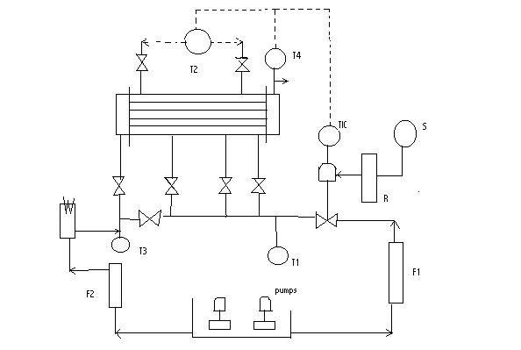

5. Procedure:

- Understand the flow diagram for the adjustment of various valves.
- Start the tap water and the pump to ensure that the tank is filled.
- After the tank is half full switch ON the mains switch.
- Now put on the heater.

- Select a definite value of heating efficiency. While adjusting the heating rate, the temperature of inlet of hot water should not go above 80⁰C as that may lead to vaporization.

- By selecting proper valves put the hot fluid on the shell side and the cold fluid on the tube side.

- Note down the temperatures T₁, T₂, T₃, and T4 from the indicator only after waiting for sufficient time for steady state is reached.

- Repeat the procedure for varying flow rates of hot fluid and constant flow rate of cold fluid.
- Repeat the same procedure with hot fluid on tube side.
- Calculate the heat transfer coefficients for both the set of readings.

94

Chemical Engineering Laboratory Manual
Semester VI

6. Data:

Inner diameter of tube Outer diameter of tube Inner diameter of shell Length of tube Number of tubes

- 10.13 mm
- 16.38 mm
- 110.25 mm
- 420 mm
- 19

7. Observations:

Sr. no | Flow rate | Flow rate | Cold fluid | Shell | Hot fluid | Tube
 | of hot | of cold | inlet | outlet | inlet | outlet (T₄)
 | fluid | fluid | temp. | temp | temp.
 | (LPH) | (LPH) | (T₁) | (T₂) | (T₃)
1
2
3
1
2
3

8. Formulae:

1.

2.

3. LMTD =

- Sample calculations:

1. Calculate the amount of heat transferred watt watt

- Calculate the log mean temperature difference

LMTD =

95

Chemical Engineering Laboratory Manual
Semester VI

- Calculate the overall heat transfer coefficient

- Find the equivalent diameter (D_{H}) D_{H} =
- Find the velocity on shell side (V_{s}) and tube side (V_{t})

V_{t} = m/s Flow area per tube

a_{t} =

 | V_{s} =
6. | Find tube side (Re_{t}) and shell side (Re_{s}) Reynolds number
 | Re_{t} = |  |  |  |  |  | and Re_{s} =
7. | Find Nusselt number for shell side (Nu_{s}) and tube side (Nu_{t})
 | Nu_{t} =1.86 |  |  |  |  |  |  |  |  |  | and Nu_{t} =1.86
8. | Find h _{o} and h_{i}
 | Nu_{t} = |  |  |  | and Nu_{s} =
9. | Find overall heat transfer coefficient (U).

Compare experimental and theoretical value

- Conclusions:

- Comments:

96

Chemical Engineering Laboratory Manual
Semester VI

13. UNSTEADY STATE HEAT TRANSFER

1. Aim:

To study the effect of impeller speed and cooling water flow rate on heat transfer coefficient for the coil.

- Equipment: Oil bath, impeller, heaters, stop watch, manometers etc.

- Theory:

Unsteady state heat transfer processes are those in which at any fixed given point the heat flow, temperature or both vary with time. Batch heat transfer process are typically unsteady state process, in which there is heat transfer to specific quantity of material such as heating a given quantity of liquid in a tank or when a cold furnace is started up. In batch process for the heating of liquids the time requirement for heat transfer can usually be modified by increasing the circulation of the batch fluid, the heat transfer fluid or both.

The common reasons for using a batch process rather than a continuous heat transfer operation are as follows:

- The liquid being processed is not continuously available.
- The heating or cooling medium is not continuously available.
- The requirement of reaction time or treating time necessitates holdup.

- The economics of intermittently processing a large batch justifies the accumulation of a small continuous stream.

- Cleaning or regeneration is a significant part of the total operating period.
- The simplified operation of most batch processes is advantageous.

Various correlations have been proposed for various types of situations. For this experiment we have a vessel with mechanical agitation and cooled by submerged tube coils as shown in figure.
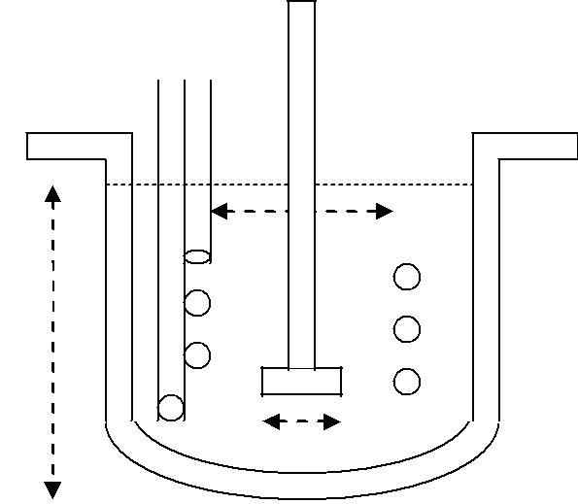

D_{H}

z

B

Figure 1

97

Chemical Engineering Laboratory Manual
Semester VI

Outside heat transfer coefficient is given by (Kern, “Proc. Heat Trans.”, p722)

h D | ⎛ | L² Nρ ⎞ |  | 2 / 3 | ⎛ | cμ | ⎞ | 1/ 3 | ⎛ | μ | ⎞ | 0.14
ci | ⎜ |  | ⎟ |  | ⎛ |  | ⎞ |  | ⎜ |  | ⎟ | (1)
 | ⎜ |  | ⎟ |  | ⎜ |  | ⎟ |  | ⎜ |  | ⎟ | (1)
 | = 0.87 |  | ⎟ |  | ⎜ |  | ⎟ |  | ⎜ |  | ⎟
k | ⎜ | μ | ⎟ |  | ⎝ k |  | ⎠ |  | ⎜ |  | ⎟
k | ⎝ | μ | ⎠ |  |  |  | ⎠ |  | ⎝ | ^{μ}w ⎠
Where,

h_{c} = Outside film heat transfer coefficient. D_{i} = Vessel diameter.

L = Length of agitator. N = Agitation speed.

Because of increase in turbulence it is to be expected that the tube side coefficient for coiled tube will be greater for given weight flow than straight tube. For ordinary use McAdams (Kern,

“Proc. Heat Trans.”, p155) suggest that straight tube heat transfer coefficient to be multiplied by 1+3.6(1-D/D_{H})*(D/D_{H})^{0.8}.

For water as coolant heat transfer coefficient can be obtained from the graph of heat transfer coefficient versus velocity trough tubes (Kern, “Proc. Heat Trans.”, p825).

Derivation
For the derivation we make the following assumptions (Kern, “Proc. Heat Trans.”, p626-28)

- U is constant for the process and over the entire surface.
- Liquid flow rates are constants.
- Specific heats are constant for the process.
- The cooling medium has a constant inlet temperature.
- Agitation produces a uniform batch fluid temperature.
- No partial phase change occurs.
- Heat losses are negligible.

The system consists of a pre-heated oil, which is cooled by cold water flowing through the coil. An agitator provides mixing of the oil to maintain uniform temperature through the bath.
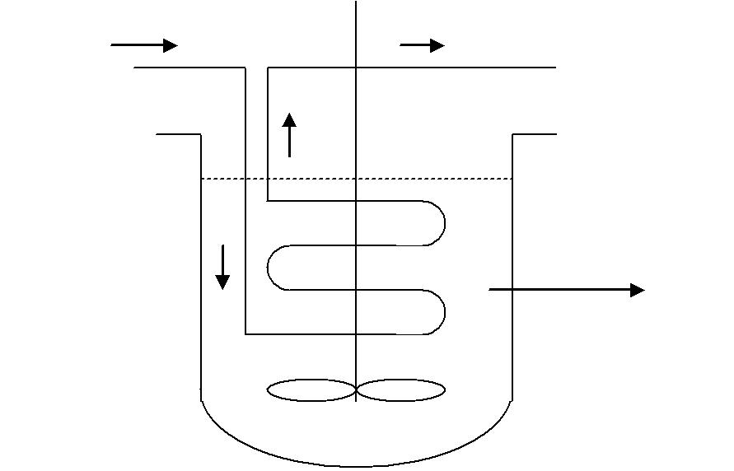

Water | Water
tin | tout
 | Oil
 | T

Figure 2

98

Chemical Engineering Laboratory Manual
Semester VI

Now at any time θ,
Heat gained by the cooling water = m_{w} c_{pw} (t_{in}- t_{out})

Heat lost by the oil = ^{dQ} = −m_{o} c _{po} ^{dT} dθ dθ
Oil is the bath element of the system and water is the continuous element. by energy balance we have

 | dQ | = m_{w} c _{pw} (t_{out} − t_{in} ) = −m_{o} c _{po} |  |  |  |  |  |  |  |  |  |  |  |  |  |  |  |  |  |  |  |  |  |  |  |  |  |  |  |  |  | ⎛ dT ⎞ |  |  | = UA(ΔT )_{LM}
 |  |  |  |  |  |  |  |  |  |  |  |  |  |  |  |  |  |  |  |  |  |  |  |  |  |  |  |  |  |  |  | ⎜ |  | ⎟ | = UA(ΔT )_{LM}
 | dθ |  |  |  |  |  |  |  |  |  |  |  |  |  |  |  |  |  |  |  |  |  |  |  |  |  |  |  |  |  |  | ⎜ |  | ⎟ | = UA(ΔT )_{LM}
 | dθ |  |  |  |  |  |  |  |  |  |  |  |  |  |  |  |  |  |  |  |  |  |  |  |  |  |  |  |  |  |  | ⎝ dθ ⎠
From definition of |  |  |  |  |  |  |  |  |  |  |  |  |  |  |  |  |  |  |  |  | (ΔT)_{LM} we have
(ΔT )_{LM} |  |  |  |  |  | = |  |  |  | [(T − t_{in} )− |  |  |  |  |  |  |  |  |  |  |  | (T − t_{out} |  |  |  |  |  |  |  | )]
 |  |  |  |  |  |  |  |  |  |  |  |  |  |  |  | ⎧ T − t_{in} |  |  |  |  |  |  |  |  |  |  |  | ⎫
 |  |  |  |  |  |  |  |  |  |  |  |  | ln⎨ |  |  |  |  |  |  |  |  |  |  |  |  |  |  | ⎬
 |  |  |  |  |  |  |  |  |  |  |  |  |  |  |  | ⎩^{T} ⁻ ^{t}out ⎭
putting above equation in equation (3) we have
UA |  | [(T − t_{in} |  |  |  |  |  |  |  |  | )− (T − t_{out} |  |  |  |  |  |  |  |  |  |  |  |  | )] |  | = m_{w} c _{pw} (t_{out} − t_{in} )
 |  |  |  |  |  |  |  | ⎧ T − t_{in} ⎫
 |  |  |  |  |  | ln
 |  |  |  |  |  |  |  | ⎨ |  |  |  |  |  |  |  |  |  |  | ⎬
 |  |  |  |  |  |  |  | ⎩^{T} ⁻ ^{t}out ⎭
Simplifying above equation
 | T − t_{in} |  |  |  |  |  |  |  |  |  |  |  | ⎛ |  |  |  | UA |  |  |  |  |  |  | ⎞
 |  |  |  |  |  | = exp |  |  |  |  |  |  | ⎜ |  |  |  |  |  |  |  |  |  |  | ⎟
 | ^{T} ⁻ ^{t}out |  |  |  |  |  |  |  |  |  |  |  | ⎜ |  |  |  |  |  |  |  |  |  |  | ⎟
 |  |  |  |  |  |  |  |  |  |  |  |  | ⎝ ^{m}w ^{c} pw ⎠
 |  |  |  |  |  |  |  |  |  |  | ⎛ |  | UA |  |  |  |  |  |  |  | ⎞
Put |  |  |  |  |  | exp ⎜ |  |  |  |  |  |  |  |  |  |  |  |  |  |  | ⎟ | = β
 |  |  |  |  |  |  |  |  |  |  | ⎜ |  |  |  |  |  |  |  |  |  | ⎟
 |  |  |  |  |  |  |  |  |  |  | ⎝ ^{m}w ^{c} pw ⎠
^{t}out |  | = T − |  |  |  |  |  |  | T − t_{in} |  |  |  |  |  |  |  |  |  |  |  |  |  |  |  |  |  |  |  |  |  |  |  |  |  | (4)
 |  |  |  |  |  |  |  |  |  |  | β |  |  |  |  |  |  |  |  |  |  |  |  |  |  |  |  |  |  |  |  |  |  |  | (4)
From (2) we have
 | dT |  | ⎡ |  |  | − m_{w} c _{pw} |  |  |  |  |  |  |  |  |  | ⎤
 |  | = | ⎢ |  |  |  |  |  |  |  |  |  |  |  |  | ⎥(t_{out} |  |  |  |  |  | − t_{in} )
 | dθ | = |  |  |  |  | ^{m}o ^{c} po
 | dθ |  | ⎢ |  |  |  |  |  |  |  |  |  |  |  |  | ⎥
 |  |  | ⎣ |  |  |  |  |  |  |  |  |  |  |  |  | ⎦
 | Substituting for t_{out} from (4) we get,
 | dT |  | ⎡ |  |  | − m_{w} c _{pw} |  |  |  |  |  |  |  |  |  | ⎤⎛ |  |  |  |  |  |  |  |  | T − t_{in} |  |  |  |  |  |  |  | ⎞
 |  | = | ⎢ |  |  |  |  |  |  |  |  |  |  |  |  |  | ⎜T − |  |  |  |  |  |  |  |  |  |  |  |  | − t |  |  | ⎟
 | dθ |  |  |  |  |  | ^{m}o ^{c} po |  |  |  |  |  |  |  |  | ⎥⎜ |  |  |  |  |  |  |  |  |  |  | β |  |  |  | in ⎟
 | dθ |  | ⎢ |  |  |  |  |  |  |  |  |  |  |  |  | ⎥⎝ |  |  |  |  |  |  |  |  |  |  |  |  |  |  |  |  | ⎠
 |  |  | ⎣ |  |  |  |  |  |  |  |  |  |  |  |  | ⎦
 | dT |  | ⎡ |  |  | ⁻ ^{m}w ^{c} pw |  |  |  |  |  |  |  |  |  | ⎤⎛ (T − t_{in} )(β −1)⎞
 |  | = | ⎢ |  |  |  |  |  |  |  |  |  |  |  |  |  | ⎜ |  |  |  |  |  |  |  |  |  |  |  |  |  |  | ⎟
 | dθ |  |  |  |  |  | ^{m}o ^{c} po |  |  |  |  |  |  |  |  | ⎥⎜ |  |  |  |  |  |  |  |  |  |  | β |  |  |  |  | ⎟
 | dθ |  | ⎢ |  |  |  |  |  |  |  |  |  |  |  |  | ⎥⎝ |  |  |  |  |  |  |  |  |  |  |  |  |  |  |  | ⎠
 |  |  | ⎣ |  |  |  |  |  |  |  |  |  |  |  |  | ⎦
 | dT |  |  |  |  |  | ⎡ |  |  | − m_{w} c _{pw} |  |  |  |  |  |  |  |  |  | ⎤⎛ |  | β −1 |  |  |  |  |  |  | ⎞
 |  |  |  |  | = |  | ⎢ |  |  |  |  |  |  |  |  |  |  |  |  |  | ⎜ |  |  |  |  |  |  |  | ⎟dθ
 | T − t_{in} |  |  |  |  |  |  |  |  |  | ^{m}o ^{c} po |  |  |  |  |  |  |  |  | ⎥⎜ |  |  |  |  | β |  |  |  | ⎟
 |  |  |  |  |  |  | ⎢ |  |  |  |  |  |  |  |  |  |  |  |  | ⎥⎝ |  |  |  |  |  |  |  |  | ⎠
 |  |  |  |  |  |  | ⎣ |  |  |  |  |  |  |  |  |  |  |  |  | ⎦
Now integrating from θ = 0, to θ = θ and T = T₁ to T = T₂ 99

(1)

(2)

Chemical Engineering Laboratory Manual
Semester VI

⎛ T − t |  |  | in | ⎞ |  | ⎡ | − m_{w} c _{pw} ⎤⎛ β −1⎞
ln⎜ | 2 |  | in | ⎟ | = | ⎢ |  | ⎜ |  | ⎟θ | (5)
⎜ |  | − t_{in} |  | ⎟ |  | ⎢ | ^{m}o ^{c} po | ⎥⎜ | β | ⎟
⎝ ^{T}1 |  |  |  | ⎠ |  | ⎢ | ^{m}o ^{c} po | ⎥⎝ | β | ⎠
 |  |  |  |  |  | ⎣ |  | ⎦

Now β = exp (UA / m_{w} c_{pw})
Hence knowing T₁, T₂, t_{in}, m_{w}, c_{pw}, m_{o} and c_{po}, β can be calculated.
From β we can calculate the value of U i.e. overall heat transfer coefficient.

In forced convection the rates of heat transfer increase with the levels of turbulence.

This is because with higher velocities or greater agitation, the thickness of the fluid film is reduced and thus resistance to heat transfer also decreases. We have to verify this by studying the effects of impeller speed and cooling water velocity on the heat transfer coefficient.

- Procedure:

  - Insert the immersion heaters into the oil vessel and start the heaters. Wait for oil temperature to reach about 90-95ºC.
  - After that switch off the heaters and carefully remove them.

  - Start the impeller and the flow of the cooling water through the coil. Ensure that the flow is turbulent(i.e. above 80ml/s)

  - To take readings, start the stop watch when the thermometer reads (accurately) some temperature (say 92ºC) and then go on noting the time and cooling water temperatures (inlet and outlet), for every degree fall in temperature, until temperature falls by 10-12ºC.

  - Measure the flowrate and impeller speed.
  - Take five sets of reading for varying flowrate and varying impeller speed.
  - Plot ln(h_{i}) vs. ln(flowrate) to study the effect of flowrate on heat transfer coefficient.

  - Plot ln(h_{o}) vs. ln(impeller speed) to study the effect of impeller speed on heat transfer coefficient.

- Data:
1. | D_{H} = diameter of coil |  |  |  | = |  | .267m.
2. | N = number of turns |  |  |  | = |  | 6.
3. | D_{c} | =Outer diameter of coil |  |  | = |  | .0214m.
4. | D_{i} | =Inside diameter of coil = |  |  |  |  | .018cm.
5. | L | =Length of coil =πD_{c}N = |  |  |  |  | 5.033m.
6. | A_{c} | = Area of cross section = π/4*D_{i}² = 2.545*10⁻⁴m².
7. | A =Area of heat transfer=πD_{c}L= |  |  |  |  |  | 0.337m².
8. | mo | =mass of oil |  |  | = |  | 55Kg.
9. | Cp_{o} =Specific heat of oil |  |  |  | = |  | 2.511KJ/Kg-ºC.
10. | Cp_{w}=Specific heat of water |  |  |  | = |  | 4.186KJ/Kg-ºC.
11. | Conversion factors
 |  |  | a. | m/s to ft/s |  | =3.281.
 |  |  | b. | ft/s to m/s |  | =.3048.
 |  |  | c. | Btu/ft²-h-ºF to KW/m²-ºC |  | =5.676*10⁻³.

100

Chemical Engineering Laboratory Manual
Semester VI

6. Observation Table
Set I.
Operating conditions, for example.
- At θ = 0, T₁ = 85ºC.

- Water flow rate m_{w} = 125 cm³/s.
- Impeller speed N = 66rpm.

4. | Manometer reading H = 61.8cm.
5. | Inlet temperature of cooling water t_{in} = 27ºC.

SN. | Time | Temp of oil
 | θs. | T₂ | o_{C}

⎛ T |  | − t | in | ⎞
ln⎜ | 2 |  | in | ⎟
⎜ | T₁ |  |  | ⎟
⎝ | T₁ | ⁻ ^{t}in ⎠

Equations

 |  |  |  |  |  |  |  |  |  |  |  |  | ⎛ T |  |  | − t | in | ⎞
1. from graph of |  |  |  |  |  |  |  |  |  |  |  | ln⎜ |  | 2 |  |  | in | ⎟ |  | vs θ
 |  |  |  |  |  |  |  |  |  |  |  |  | ⎜ |  |  |  |  | ⎟
 |  |  |  |  |  |  |  |  |  |  |  |  | ⎝ ^{T}1 |  |  | ⁻ ^{t}in ⎠
 | slope = |  |  |  | ⎡ |  |  | − m_{w} c _{pw} |  |  |  |  |  |  | ⎤⎛ | β −1⎞
 |  |  |  |  | ⎢ |  |  |  |  |  |  |  |  |  | ⎜ |  |  |  | ⎟
 |  |  |  |  |  |  |  |  | ^{m}o ^{c} po |  |  |  |  |  | ⎥⎜ | β |  |  | ⎟
 |  |  |  |  | ⎢ |  |  |  |  |  |  |  |  |  | ⎥⎝ |  |  |  | ⎠
 |  |  |  |  | ⎣ |  |  |  |  |  |  |  |  |  | ⎦
 |  |  |  |  | ⎛ |  |  |  | UA |  |  |  | ⎞
 | β = exp ⎜ |  |  |  |  |  |  |  |  |  |  |  | ⎟
 |  |  |  |  | ⎜ |  |  |  |  |  |  |  | ⎟
 |  |  |  |  | ⎝ ^{m}w ^{c} pw ⎠
2. | 1 |  | = | 1 |  | + |  |  | 1
2. | U |  | = | h_{i} |  |  |  |  |  | h_{o}

Variables used are
T₂ = Temperature at time θs. T₁ = Temperature at time θ=0. t_{in} = inlet temperature of water. m_{w} = mass flow rate of water m_{o} = mass of oil.

c_{po} = specific heat of oil. c_{pw} = specific heat of water. A = Total heat transfer area.

U = overall heat transfer coefficient.
h_{i} = heat transfer coefficient from water side. h_{o} = heat transfer coefficient from oil side.

101

Chemical Engineering Laboratory Manual
Semester VI

- Graphs

  - plot

⎛ T |  | − t | in | ⎞
ln⎜ | 2 |  | in | ⎟ | vs θ
⎜ | T₁ |  |  | ⎟
⎝ | T₁ | ⁻ ^{t}in ⎠

  - plot ln(h_{i}) Vs ln(flow rate)
  - plot ln(h_{o}) Vs ln(impeller speed)

- Sample calculation
  - Mass flow rate of water = m_{w} =
Volumetric flow rate*density

 |  | =125 |  |  | cm³ |  | ×10 |  |  |  |  | ₋₆ m³ |  |  |  | ×1000 |  |  |  |  | Kg
 |  |  |  |  | s |  |  |  |  |  |  |  | cm³ |  |  |  |  |  |  |  | _{m}3
 |  | =0.125 Kg/s
 |  |  |  |  |  |  |  |  |  | ⎛ T |  |  | − t |  | in |  |  | ⎞
2. | Slope of graph of ln |  |  |  |  |  |  |  |  | ⎜ | 2 |  |  |  |  |  |  | ⎟ | vs θ
 |  |  |  |  |  |  |  |  |  | ⎜ |  |  | − t_{in} |  |  |  |  | ⎟
 |  |  |  |  |  |  |  |  |  | ⎝ ^{T}1 |  |  |  |  |  |  |  | ⎠
 |  |  |  | s = |  |  |  | ⎡− m_{w} c _{pw} |  |  |  |  |  |  |  |  |  | ⎤⎛ |  | β −1 |  |  | ⎞
 |  |  |  |  |  |  |  |  |  |  |  |  |  |  |  |  |  | ⎜ |  |  |  |  | ⎟
 |  |  |  |  |  |  |  | ⎢ |  |  |  |  |  |  |  |  |  | ⎜
 |  |  |  |  |  |  |  |  |  | ^{m}o ^{c} po |  |  |  |  |  |  |  | ⎥⎜ |  | β |  |  | ⎟
 |  |  |  |  |  |  |  | ⎢ |  |  |  |  |  |  |  |  |  | ⎥⎝ |  |  |  |  | ⎠
 |  |  |  |  |  |  |  | ⎣ |  |  |  |  |  |  |  |  |  | ⎦
 | Therefore |  |  | -0.00112s⁻¹ = |  |  |  |  |  |  |  |  |  |  |  |  | ⎡− 0.125 × 4.186 ⎤⎛ |  |  |  |  |  |  |  | β −1 | ⎞
 |  |  |  |  |  |  |  |  |  |  |  |  |  |  |  |  | ⎢ |  |  |  |  |  | ⎜ |  |  | ⎟
 |  |  |  |  |  |  |  |  |  |  |  |  |  |  |  |  |  |  |  | 55 × |  |  | ⎥⎜ |  | β | ⎟
 |  |  |  |  |  |  |  |  |  |  |  |  |  |  |  |  | ⎣ |  |  |  |  |  | 2.511 ⎦⎝ |  | β | ⎠
 | from above β = 1.42
 | ⎛ UA ⎞
3. | β = exp ⎜ |  |  |  |  | ⎟
 | ⎜ |  |  |  |  | ⎟
 | ⎝ ^{m}w ^{c} pw ⎠
 |  |  | ⎛ | U × 0.337 |  |  |  |  |  |  |  |  |  | ⎞
 | 1.42 = exp ⎜ |  |  |  |  |  |  |  |  |  |  |  |  | ⎟
 |  |  | ⎝ | 0.125 × 4.186 ⎠
therefore U = 0.545 KW/m²-ºC
- For graph of h_{i} Vs velocity through tubes
For evaluating the properties temp of water should to be taken as average of inlet and
_{maximum outlet temperature.} tout = T − ^{T} ⁻ ^{tin}
β

velocity through tubes = volumetric flow rate / Cross sectional area.
in this case t_{avg} = 35 ºC = 95ºF.
velocity trough tubes = 125/2.545=49.12 cm/s = 1.612 ft/s

therefore from graph h = 470.4 Btu/hr-ft²-ºF = 470.4*5.676*10⁻³ KW/m²-ºC. =2.67 KW/m²-ºC.

h_{i} = graph h*(1+3.5D_{i}/D_{H}). = 3.3KW/m²-ºC.
5. ¹ = ¹ + ¹
U h_{i} h_{o}

therefore h_{o} = .6521 KW/m²-ºC.

102

Chemical Engineering Laboratory Manual
Semester VI

Table of calculated values

u m/s | t_{avg} ºC | U KW/m²-ºC | h_{i} KW/m²-ºC | h_{o} KW/m²-ºC

Table from graph points

1. Graph of ln(h_{i}) Vs ln(flow rate)
Set | Flow rate | h_{i} | ln(h_{i}) | ln(flow rate)
 | cc/s | KW/m²-ºC

2. Graph of ln(h_{o}) Vs ln(impeller speed)

Set | Impeller speed | h_{o} | ln(h_{o}) | ln(Impeller
 | rpm | KW/m²-ºC |  | speed)

9. Result table

set number | flow rate | Impeller | U | h_{i} | h_{o}
 | cc/s | speed | KW/m²-ºC | KW/m²-ºC | KW/m²-ºC
 |  | rpm

103

Chemical Engineering Laboratory Manual
Semester VI

Expected trend
Value of h_{o} obtained can be compared with experimental correlation (Kern, “Proc. Heat Trans.”, p722) available for h_{o}

h D | ⎛ | L² Nρ ⎞ |  | 2 / 3 | ⎛ | cμ | ⎞ | 1 / 3
ci | ⎜ |  | ⎟ |  | ⎛ |  | ⎞ | (1)
 | ⎜ |  | ⎟ |  | ⎜ |  | ⎟ | (1)
 | = 0.87 |  | ⎟ |  | ⎜ |  | ⎟
k | ⎜ | μ | ⎟ |  | ⎝ | k ⎠
k | ⎝ | μ | ⎠ |  | ⎝

For 500<Re<100,000

Where,
_{Re} ₌ L² Nρ
μ

h_{c} = Outside film heat transfer coefficient. D_{i} = Vessel diameter.

L = Length of agitator. N = Agitation speed. Expected trends of graph
 |  |  |  |  | ⎛ T₂ | ⁻ ^{t}in | ⎞ | Vs θ
 |  |  |  |  | ln⎜ |  | ⎟
 |  |  |  |  | ⎜ | − t_{in} | ⎟
 |  |  |  |  | ⎝ ^{T}1 | − t_{in} | ⎠
 |  |  | 0.3
 |  |  | 0.25
⎛ T |  | − t | ⎞
ln⎜ | 2 |  | in ⎟
⎜ |  |  | ⎟
⎝ ^{T}1 |  | ⁻ ^{t}in ⎠
 |  |  | 0.1
 |  |  | 0.05
 |  |  | 0
 |  |  | 0 | 50 | 100 |  |  | 150 | 200 | 250 | 300
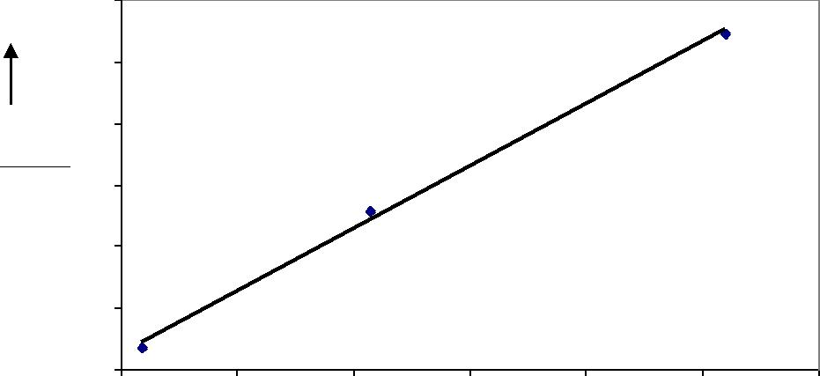
θ (sec)

104

Chemical Engineering Laboratory Manual
Semester VI

 |  |  |  | ln(ho) | Vs ln(Impeller speed)
 | 0.2
 | 0
 | 0 | 10 | 20 | 30 | 40 | 50 | 60 | 70 | 80 | 90 | 100
ln(h_{o} ) | -0.2
 | -0.4
 | -0.6
 | -0.8
 | -1
 |  |  |  |  | ln(N)
 |  |  |  | ln(h ) | Vs ln(Flow rate)
 |  |  |  | i
 | 1.1
 | 1
 | 0.9
 | 0.8
ln(h_{i} ) | 0.7
 | 0.6
 | 0.5
 | 0.4
 | 0.3
 | 0.2
 | 4.55 |  | 4.6 | 4.65 |  | 4.7 |  | 4.75 | 4.8 |  | 4.85
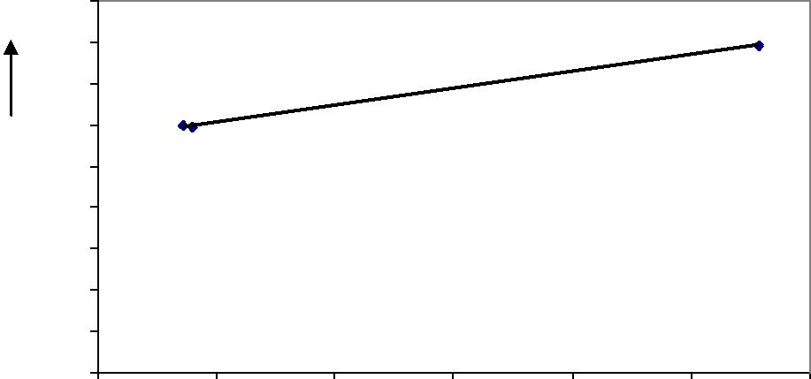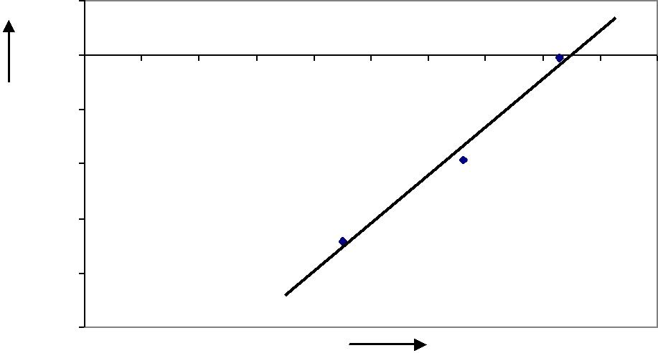
ln(flow rate)

- Precautions
  - While heating, take care not to dip the base of the heater into the oil.
  - Ensure that the impeller is not moved while heating.

  - Avoid touching the equipment while heating, to prevent a shock due to any possible leakage of current.

  - Stand away from the vessel, as there may be some initial over spilling of the hot oil.

  - While noting the temperature of the oil, keeps the thermometer towards the circumference of the vessel to avoid contact of thermometer with impeller leading to its breakage.
  - Maintain turbulent flow in the coil throughout.
  - Also a very high impeller speed causing spillage of oil should be avoided.

- Reference

Kern, D.Q., “Process Heat Transfer,” McGraw-Hill Book Company, New York, 1950, pg 625-29.

105

Chemical Engineering Laboratory Manual
Semester VI
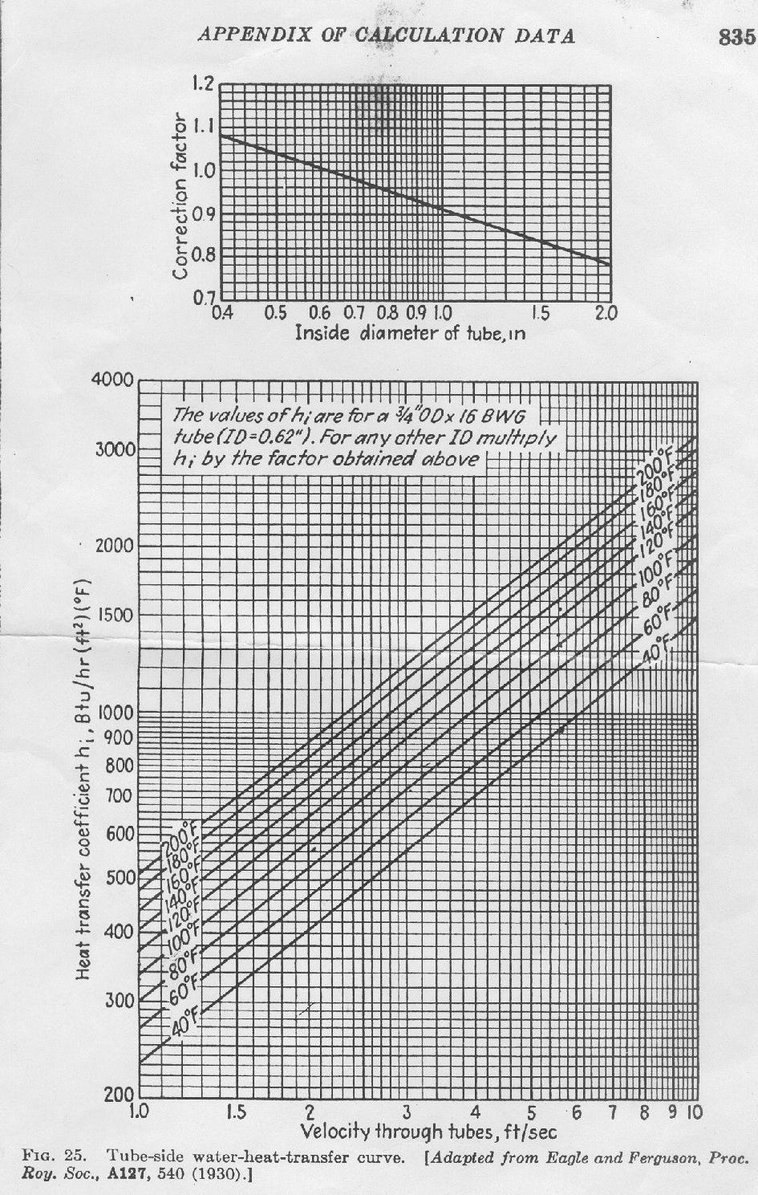

106

Chemical Engineering Laboratory Manual
Semester VI

14. VACUUM DRYING

- Aim: To establish the drying characteristics of given solids in the available vacuum dryer.

- Apparatus: Vacuum drying unit, condenser, vacuum pump, collector, stop watch etc.

- Theory:

Drying generally refers to removal of liquid from solid by evaporation. Mechanical methods for separating a liquid from a solid are not generally considered as drying, although they often precede a drying operation, since it is less expensive and frequently easier to use mechanical methods than to use thermal methods. Solids to be dried may be of different forms – flakes, granules, crystals, powders, slab, or continuous sheet. The liquid to be vaporized may be on the surface of the solids as in the drying of crystals, it may be inside the solid: as in solvents removal from a sheet of polymers or it may be partly inside or outside. The moisture content is usually expressed as a percentage of dry material, the moisture may be present in two forms:

- Bound moisture: This is the water retained in such a way that it exerts a vapour pressure much less than that of free water at the same temperature. Such water may be retained in small capillaries, adsorbed on surfaces or as a solution in cell walls.
- Free moisture: This is the water which is in excess of the equilibrium moisture content.

Drying involves the removal of free moisture from the surface and also moisture from the interior. Rate of drying can be evaluated by measuring the change in the moisture content with time. The form of drying rate curves varies with structure and type of material. There are two types of curves. This is shown in the plot below.

In the following plot, there are two zones. The first zone is the constant rate drying zone and second is one which there is steady fall in the rate of drying as the percentage moisture reduces.
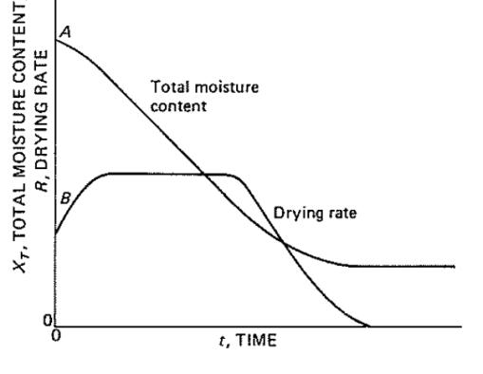

Following plot has three well defined stages. The first stage represents the constant drying rate period, the second stage is first falling rate period and the third stage is second falling rate period.

- Constant-rate period: It is found that the evaporation rate from the drying bed is similar to that of the solvent alone from a free liquid surface under the same conditions, indicating that the evaporation takes place from the wet surface of the solid, and that the surface remains wet in this period as a result of the liquid being replaced from below as

107

Chemical Engineering Laboratory Manual
Semester VI

fast as it is vaporized. Controlling factors in this period are the rate at which heat can be transferred and the rate of removal of the vapor.

- First falling-rate period: As moisture is removed from the surface, a point will be reached when the rate of vaporization is insufficient to saturate the air in contact with the surface. Under these conditions, the rate of drying will be limited by the rate of capillary transfer of the liquid to the surface of the wet bed, and this becomes increasingly difficult as the bed dries, the solvent level decreases and thus has further to travel to the point of evaporation. Consequently, the rate of drying decreases continuously.

- Second falling-rate period: Any moisture that remains within the drying bed at the end of the first falling –rate period is unable to move, so that drying cannot take place on the surface. i.e. the drying rate depends on the movement of the vapour through the pores of the bed to the surface, in general by molecular diffusion.
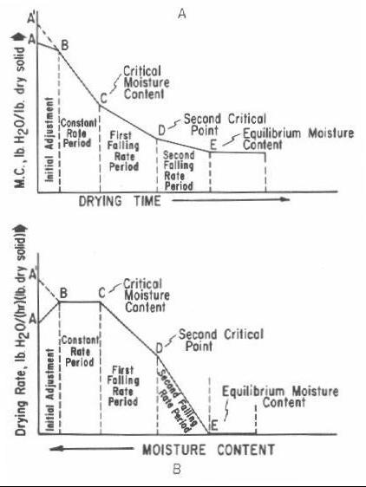

Mechanism of Drying: The mechanism in the constant drying rate is the diffusion of water vapor for a saturated surface of the material through a stationary film into the air stream. The moisture at the end of the constants rate is called as the critical moisture content. The second stage is called as the first falling rate period. In this stage the surface is devoid of free moisture from inside the material is transferred to the surface. After the first falling rate the surface is assumed to be dry. The third stage is called second falling rate period. In this case evaporation will take place from with-in the solid and the vapor reaches the surface by molecular diffusion.

Industrial application: Drying is the final operation prior to packing, but in case of paper making and timber seasoning drying becomes an integral part of the manufacturing process. Drying is carried out for the following reason:

- To reduce transportation cost.

- To make material more suitable for handling e.g. soap, powder, dyestuff.

- To provide definite properties e.g. maintaining free flow of natural salt.

108

Chemical Engineering Laboratory Manual
Semester VI

- To avoid the presence of moisture which may lead to corrosion e.g. drying of coal gases or drying of benzene prior to chlorination.

Drying equipment: There are two classes of drying equipment: 1. Dryers for rigid or granular solids and semisolid pastes:

The typical dryers for these types of materials include tray and screen – conveyor dryers for materials which cannot be agitated and towers, rotary, screw- conveyors, fluidized bed and flash dryers where agitation is permissible.
2. Dryers for slurry and liquid feeds:

The typical dryers for these types of materials include spray dryers, thin-film dryer and drum dryer.

4. Procedure:
- Weigh 350 gm of saw dust and add 0.8 gm of water per gm of saw dust.

- Spread the saw dust evenly on the two trays and put the two trays in the dryer. Seal the dryer using nuts and bolts.

- Start the cooling water flow in the condenser and also start the heating.
- Set the temperature of the dryer.
- Now apply the vacuum corresponding to mm of Hg.

- Start the stop watch as soon as the first drop appears. Note the time required for every 10 ml and continue till volume is 250 ml.

Precaution:
- Prepare a homogenized mixture of saw dust and water and spread it evenly in the tray.
- Keep the temperature of drying constant.

5. Observations:
Vacuum | - | mm of Hg
Temperature of dryer | - | °C
Amount of Saw Dust | - | gm
Amount of water | - | gm
Observation table:
Obs. No. |  | Time | Volume (ml)

Formulae:

1.

2.

109

Chemical Engineering Laboratory Manual
Semester VI

Notations used:
X - Moisture content; kg of water / kag of dry solid
W₀ - Initial weight of water, kg
- - Density of water, kg/m³
V - Volume of water collected, m³
W_{s} - Weight of the solid, kg
D₁ - Diffusion of water through solid layer, m²/s
D - Thickness of layer, m
X_{e} - Equilibrium moisture content

- Sample calculation:

  - Find moisture content (X) using the equation-

2. Plot a graph of X Vs t & find out at various values of X 3. Find the Diffusion of water through solid layer (m²/s)
Plot a graph of Vs X

Find the slope in falling rate zone.

Calculation Table:

Sr. No. Time | X
(sec) | (kg of water / kg of saw dust)
(kg of water/kg of saw dust / s)

110

Chemical Engineering Laboratory Manual
Semester VI

7. Results:

The diffusivity of water through saw dust bed of 1.5m -
The equilibrium moisture content -
The rate of drying in constant rate zone -
The rate of drying in falling rate zone -
The critical moisture content -

- Conclusion:

- Comments:

- References:
McCabe smith, Unit operations of chemical engineering- Chapter 24 Drying of solids

111

Chemical Engineering Laboratory Manual
Semester VI

15. HYDRODYNAMICS OF STATIC MIXER

1. Aim: To study the hydrodynamics in static mixer by studying the variation of friction factor with Reynolds number with static mixer & without static mixer during flow through pipe.

2. Apparatus & Chemicals: Empty pipe, pipe with static mixer, stopwatch, measuring cylinder, U-tube manometer (Chloroform and Mercury), Pump

3. Theory:

Static mixer is a precision engineered device for the continuous mixing of fluid materials & is found in wide range of applications. Normally the fluids to be mixed are liquid, but static mixers can also be used to mix gas streams or disperse gas into liquid. They are also used for both laminar and turbulent mixing of miscible liquids, in laminar flow heat exchangers, for laminar & turbulent homogenization, & for interphase mass transfer between immiscible phases. All static mixers will consume energy and result in a pressure drop across the static mixer.

Main types of static mixers:
- Turbulent blending
- Laminar blending
- Liquid-liquid dispersion

- Gas-liquid dispersion

The two main variables for a static mixer are the mixer size and the series of stationary elements which are inserted end to end in a pipe. Mixing takes place due to shear & radial motion of the fluid across the pipe. Here, power required is the external pumping power that propels the fluid through the mixer. Lightnin static mixer consisted of 42 elements & each one of them had 3 different blades, helix is produced by regular assembly of seven elements. The helixes were placed so that the first element of a left-hand helix straddled the final element of right-hand helix & this was obtained by indexing the blade edges 60 deg with each other. The characteristics of the elements of this static mixer made it possible to adapt Configuration1 of the mixer to every specific application. The helixes were placed so that the first element of a left hand helix straddled the final element of right hand helix. Configuration2 composed of 4 helixes of 7 elements in which each of the first 3 helixes was followed by 4 elements. These 4 elements were placed in such a way that ana angle of 60˚ was formed between 2 consecutive elements.

In Configuration 3, all elements were placed in such a way that an angle of 60˚ formed between 2 consecutive elements.
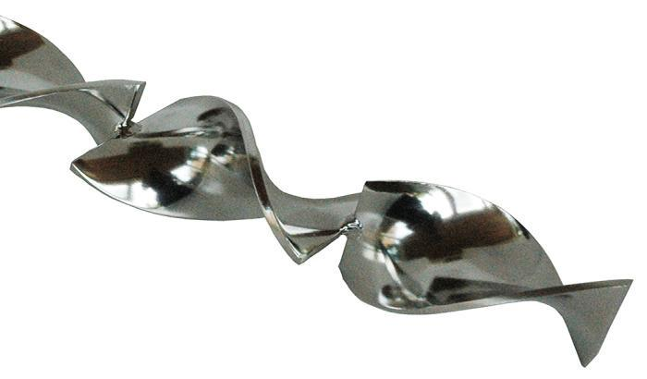

Static mixer element

112

Chemical Engineering Laboratory Manual
Semester VI

Mixing plays an important role in industrial processes in which chemical reaction or physical operations such as mass transfer are involved. Controlled and thorough mixing is not only promotes chemical and physical operations but also minimizes energy and raw material consumption. Mixing has traditionally been carried out in stirred tanks but the recent trend has been towards design of machines for performing specific, mixing task or blending specific materials.

One such device is motionless inline mixer, which is especially useful for blending of medium to high viscosity materials. This type of device is different from the commercially available mixers in that there are no moving parts in the mixer. The energy imparted to the materials in pumping them is used to achieve mixing. There are several designs of static mixers but they rely on cutting and reorientation of streams to achieve spatial distribution of components.

Pressure drop:

Pressure drop was measured using a manometer connected to a computer. Pressure drop measurements were taken at points 12.5mm before the first element at the inlet and 12.5mm after the last element at the outlet, resulting in an effective length of 52cm for the pressure drop. This pressure drop was measured for different liquid flow rates.

The pressure drop is the most important design criterion for static mixer. It permits to quantify the dissipated power in static mixer. The pressure drops is also a decisive factor for the estimation of the efficiency of static mixers. It depends on the following parameters,

- Liquid flow rate

- Type of fluid

- Type, number and arrangements of elements of static mixer.

Mixing is achieved by three mechanisms: 1. Flow reversal –

It is caused by opposite pitch of successive elements, which causes the bulk flow to reverse its rotational direction at each element function.

2. Flow division –

The processed flow divides at each element and follows the channel created by element shape. At each succeeding element, the two element are further divided, resulting in exponential increase in stratification.

3. Radial mixing –

After the flow is divided, it follows the contour of the helical element resulting in rotational circulation in each channel. The rotational circulation virtually eliminates radial gradients in the temperature, concentration and other physical properties.
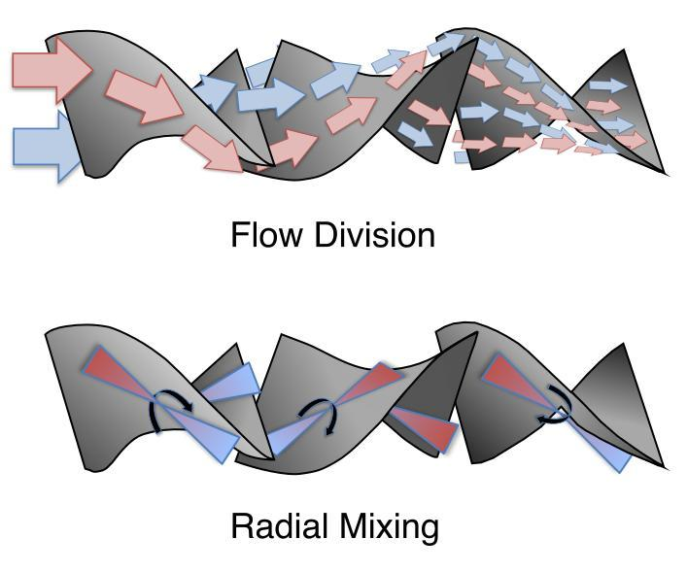

The striation thickness is a degree of the mixed ness in laminar mixing. For a given volume, reduction in striation thickness is associated with generation of new interfacial area and hence

113

Chemical Engineering Laboratory Manual
Semester VI

better mixing. Flow division and radial mixing reduces striation thickness and hence increases the interfacial area of the component to be mixed. Energy required is the power to overcome the pressure drop.

Remixing of the material as occurs in a dynamic mixer is decreased in static mixer, resulting in considerable saving of power consumption. Power required is less than dynamic mixer. Advantages of static mixer:

1.) Can be built into an existing pipeline, thereby significantly reducing the built up area 2.) No rotating parts(investment costs are reduced)

3.) If properly installed, have less energy consumption compared to rotating agitators

Disadvantages of static mixer: 1.) Short residence time

2.) Difficult to process extremely viscous fluids

3.) Difficulty in mechanical cleaning

4.) Lack of flexibility

4. Process flow diagram:


114

Chemical Engineering Laboratory Manual
Semester VI

5. Procedure:
To obtain plot of friction factor vs Reynolds number:

  - Pass water through the empty pipe at various flow rates and measure the pressure drop by measuring the difference in heights of the liquid in the two limbs of the manometer. Vary the flow rates over wide range. From the pressure drop, calculate Reynolds number. Using the measured flow rates, calculate the friction factor.

  - Now insert the mixer into the pipes, and carry out similar runs, varying flow rates. Plot a graph of friction factor vs. Reynolds number.

- Observation table:

 |  | EMPTY PIPE |  |  |  |  |  | PIPE WITH MIXING ELEMENTS
LAMINAR |  |  | TURBULENT |  |  |  |  | LAMINAR |  |  |  | TURBULENT
FLOW |  | Δh(cm) | FLOW |  |  | Δh(cm) |  | FLOW |  | Δh(cm) |  | FLOW |  |  |  | Δh(cm)
RATE(ml/s) |  |  | RATE(ml/s) |  |  |  |  | RATE(ml/s) |  |  |  | RATE(ml/s)
 | (Take5-6 readings in both laminar and turbulent regime)
 | Diameter of empty pipe (d1)= |  |  |  | m
 | Diameter of pipe with mixing elements (d2)= |  |  |  |  |  |  |  | m
 | Length of the pipe across pressure drop is measured (for empty pipe)= |  |  |  |  |  |  |  |  |  |  |  | m
 | Length of the pipe across pressure drop is measured (for pipe with elements)= |  |  |  |  |  |  |  |  |  |  |  |  |  | m

7. Data:

Density of mercury = 13600kg/m³ Density of water = 1000kg/m³ Density of chloroform = 1487kg/m³ Viscosity of water = 10⁻³ Pa.s

8. Sample calculations:
(For both pipes)

Area of pipe(A)= π×d²/4 ...m²

Velocity through pipes(V)=flow rate/area of pipe ...m/s

Reynolds number=(ρ×V×d)/µ

Pressure drop ΔP= Δh×Δρ×g... Pa

Friction factor (f)=(ΔP×d)/2×ρ×V²×L......(Perry’s handbook-Fluid and particle dynamics) (This formula is applicable for all types of flows)

115

Chemical Engineering Laboratory Manual
Semester VI

9. Calculation table:

FOR EMPTY PIPE:

LAMINAR REGIME
Velocity(m/s) | Reynolds number | Pressure drop(Pa) | Friction factor
TURBULENT REGIME

Prepare similar observation table for pipe with mixing elements

10. Graphs:
Plot a graph of friction factor vs Re for both pipes on same graph paper.

- Conclusion:

- Comment:

- References:
Perry’s handbook-Fluid and particle dynamics (6-32)

116

Chemical Engineering Laboratory Manual
Semester VI

16. HYDRODYNAMICS OF BUBBLE COLUMN

- Aim: To study the hydrodynamics of a bubble column

- Apparatus: Columns, a rotameter, air compressor, pinch cocks, measuring cylinders, NaCl
salt (solid), distilled water, and vernier calipers.

3. Theory:

Bubble column is a contactor in which a discontinuous gas phase, in the form of bubbles move relative to continuous phase, which can either be liquid or homogeneous slurry. Bubble columns are mass transfer and reaction devices in which one or several gases are brought in contact and react with liquid phase itself or with a component dissolved or suspended in it .It is a simple and relatively economic means of achieving excellent contacting between a gas and a liquid. Simple bubble column is a vertical cylinder. The gas enters at the bottom through the distributor, which may vary in design. The gas is dispersed as bubbles and rises through a deep pool of liquid, creating a large interfacial area of contact. The bubble column reactor is characterized by the lack of any mechanical means of agitation, hence gas is distributed more evenly in the liquid phase .The liquid is often stagnant (batch operation), but could also move cocurrently or countercurrently with respect to the gas flow (continuous operation).

The bubble column cannot handle high throughput rates like the packed column. However, it has found increasing applications as a gas absorber with or without chemical or biological reaction, primarily because of its excellent characteristics.
- Simple operation due to the absence of moving parts.
- Lesser capital and operating cost and can be built in large sizes.
- High interfacial area per unit volume.
- High liquid phase residence time.
- Temperature uniformity within the column.
- Lesser maintenance.
- Slow reactions can be carried out due to high liquid residence time.
- Higher heat transfer rates can be obtained.
- Solids can be handled without erosion or plugging.
- Lesser floor space.

The main disadvantages of the bubble column are:
- Low gas phase throughputs.
- High pressure drop.
- High degree of backmixing.

Some of these disadvantages can be overcome by proper design. Where narrow liquid residence time is required, the column can be subdivided into stages or be packed with solid internals. If more intense recirculation of the liquid is required, a tube may be incorporated either inside or outside the column to form the so-called loop reactor.

117

118

D_{t}

DL D_{L}

Bubble flow regime Heterogeneous flow regime Slug flow regime

D_{t}² _{Dt}1.5

Flow regimes
In BCs, the hydrodynamics, mixing and transport characteristics depend strongly on the flow regime. Therefore it is necessary to present the possible flow regimes in BC. The flow regime is an important consideration in design as it strongly affects the hydraulics as well as transport phenomena in bubble columns. For example, column diameter has been reported to have a distinctly different effect on the axial dispersion coefficient depending upon the flow regime as shown below: -
D_{L} α
α
α

Chemical Engineering Laboratory Manual Semester VI
Sparger
A sparger is a device for introducing a stream of gas into a continuous liquid in the form of small bubbles. The purpose of sparging is to provide either an excellent interphase contact or simply an agitation of the liquid to various degrees. Spargers have a substantial influence on gas hold up, interfacial area and level of mass transfer.
Sieve trays or perforated plates are often used for this purpose although recent reports have shown the advantages of using jet devices. Porous plates are the other means for dispersing gases, particularly in sewage and waste treatment tanks. Bubbles thus generated are generally small, with the actual area determined by the pore opening and the pressure drop across the septum.
Types of gas distributors: 1. Static:
a) Perforated plate b) Sintered plate c) Simple tube
d) Ring type 2. Dynamic: a) Venturi jet b) Slit jet
c) Ejector nozzle d) Injector nozzle
Three Regions of Bubble Column:
In the first region near the gas distributor (sparger), the behavior and the properties of the bubbles are determined by the distributor and the gas flow rate. Hence this region may be called the sparger region. The bubble size generated at the distributor (d_{in}) may be called the primary/ initial bubble size. The second region above the first, occupies large fraction of column volume. In this region, the bubble properties are determined by the liquid flow pattern and the liquid properties. This region may be called as bulk region. The equilibrium bubble size generated in this region may be called the secondary bubble size (d_{vs}). In the third region, close to the top, bubble coalescence occurs. The positions of the regions are affected by the superficial gas velocity and the difference between d_{in} and d_{vs}. The existence of these regions has been determined in columns of small and large diameters.

Chemical Engineering Laboratory Manual
Semester VI

1. Bubbly flow regime or Quiescent flow regime

This, usually occurring at low gas flow rates is characterized by the appearance of an almost ordered chain bubbling with very little visually observable agitation (Fig. 2a). Bubbles rise independently with fairly uniform spacing between them. Uniformly sized bubbles with equal radial distribution. There is little or no interaction between the bubbles. On increasing the gas velocity, the no. of bubbles increase as well and at the same time their rise velocity falls. Consequently gas hold up increases, with increasing gas velocity. This regime occurs if the superficial gas velocity is less than 0.05 m/second and rise velocity of bubbles lies between 0.18 to 0.30 m/second, although this value may change with surface active agents or column geometry.

2. Churn turbulent or heterogeneous regime

The bubbles coalesce and form large spherical caps that rise much faster through the column. Large bubble sizes (0.08 to 0.15 m)

Rise velocity > than 0.8 m/second.

There is small increase in gas holdup with large increase in gas velocity. In this regime the contribution of small bubbles to gas holdup remains practically constant.

A pressure drop results in the direction of center of rotation, resulting in small bubbles being pulled in from the surrounding region and hence in a volume increase of large bubbles. Also, in this regime, the rising bubbles transport liquid in their wakes from the bottom to the top of the column. Therefore for continuity, liquid must flow downwards. This results in a circulation of liquid within the column, which leads to pronounced liquid velocity profiles. The liquid circulation causes a nonuniformity of the gas holdup at any cross-section. The voidage is usually very large at center of column. The circulation velocity increases with increasing gas throughput. Therefore the heterogeneous flow is also called the recirculating flow regime (Fig. 2b and 2c). Close to the upper limit of the regime (Fig. 2c. and 2d) a symmetrical two loop liquid circulation, upward in the centre and downward near the wall, is well established with large eddies superimposed.

3. Slug flow

In small columns at high gas flow rates, the gas bubbles coalesce to form large slugs, stabilized by wall effects and having a parabolic outline at the front. Bubble slugs have been observed in column diameter up to 0.15 m. If the liquid phase is highly viscous, slug flow occurs at low velocities.

119

Chemical Engineering Laboratory Manual
Semester VI
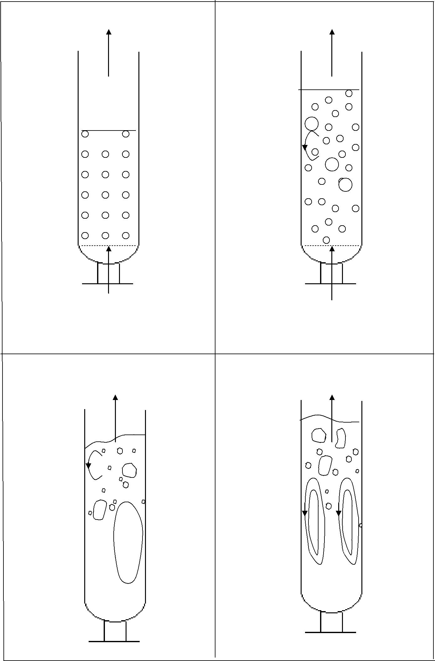

Fig. 2A | Fig. 2B
Bubble flow | Transitional flow

Transitional flow | Churn turbulent flow

120

Chemical Engineering Laboratory Manual
Semester VI
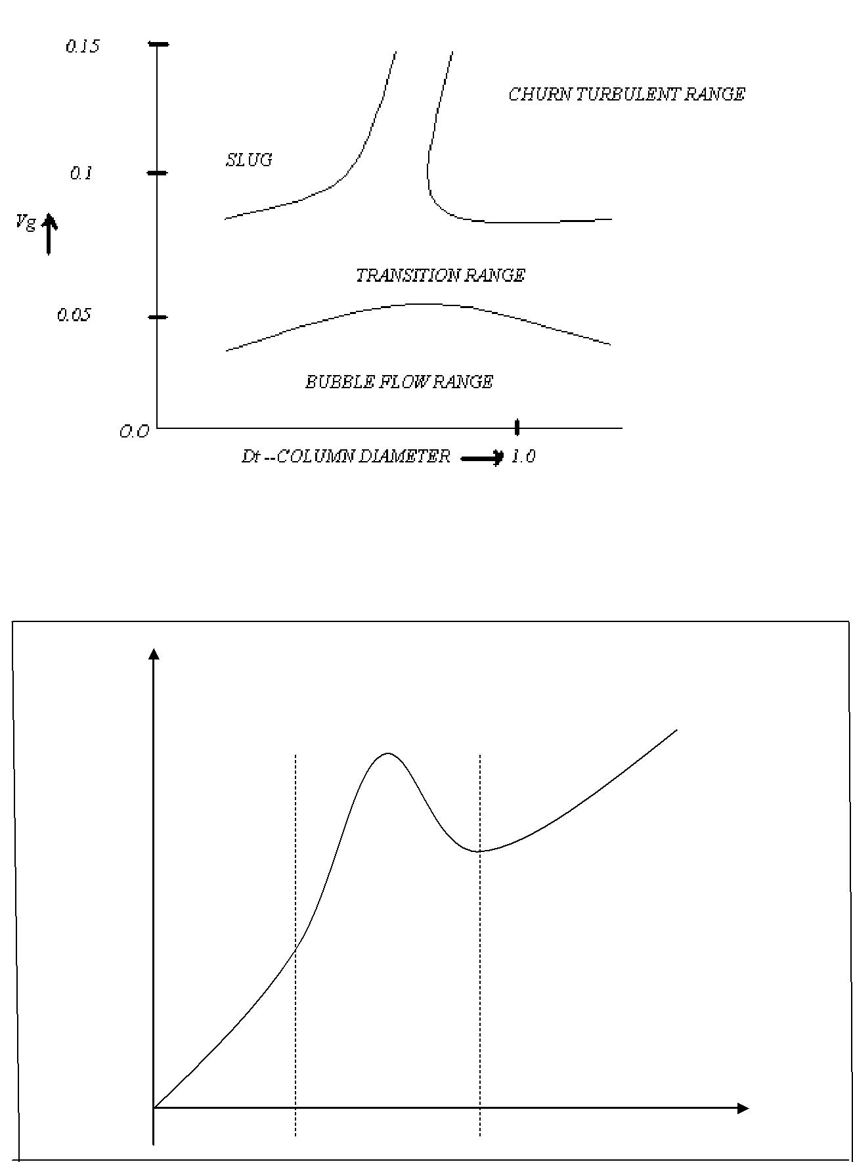

Homogeneous Heterogeneous

E_{g}

Transition

V_{g}

A plot showing the change from the homogeneous phase to the heterogeneous phase through a transition region.

121

Chemical Engineering Laboratory Manual
Semester VI

Slip velocity:

The relative velocity between the bubble and the liquid is called as slip velocity. If the bubble is moving in an infinite medium the slip velocity is numerically equal to bubble rise velocity (V_{B}∞)

In the homogeneous regime slip velocity is equal to or less than terminal value. In heterogeneous regime slip velocity is equal to or higher than terminal value.

In the bubble column if all the bubbles are of uniform size the slip velocity of swarm of the bubble is same as the slip velocity of any bubble in the swarm.

Slip velocity between the gas bubble and the liquid is given by

Us = | u_{G} | ± |  | ^{u}L
 | ε_{G} | (1 |  | − ε_{G} )
(+) - For co current

(-) - For counter current

Gas Holdup:

The gas holdup refers to the volume fraction of the gas liquid mixture, which is occupied by the gas. It is an important design and operating parameter frequently used to describe the hydrodynamics of bubble columns. Gas holdup is one of the most important and frequently used parameter to characterize BC. It is used to compute the residence time of each phase and evaluate interfacial area and subsequently overall mass and heat transfer rates between gas and liquid phase.

ƐG α VGn (0.4 < n < 1.1)

n=f(physicochemical properties, geometrical design of reactor, gas distributor and regimes of operation)

For bubble flow regime, n is nearly 1.
For heterogeneous flow regime, n<1.

For single orifice system, holdup can be calculated as follows:

ε_{G} |  |  | = 0.27V d |  | −0.08 _{ρ} 0.04_{μ} |  | −0.15_{σ} −0.22 _{D} −0.08
 |  |  | = 0.27V d | o | −0.08 _{ρ} 0.04_{μ} | L | −0.15_{σ} −0.22 _{D} −0.08
(1 − ε | G ) | 4 | G | o |  | L | T

122

Chemical Engineering Laboratory Manual
Semester VI

Methods of Measurement:

The following methods of measurement are commonly employed to determine the average gas holdup -

- Bed expansion method:

If Z and Z₀ are the aerated liquid height and the initial liquid height (unaerated) respectively, the average gas holdup is Ɛ :-
_{ε =} Z − Z0
Z
- Manometric method

The average gas holdup is determined by measuring the static pressures at several points along the column height. This method neglects the pressure drop due to fluid friction, acceleration and deceleration occurring within the bubble column.

ε = | 1 | ⎛ | − | dP ⎞
ε = |  | ⎜ | − |  | ⎟
 | ρLg ⎝ |  |  | dx ⎠

Factors influencing Gas Holdup

Three different types of parameters, which may influence the gas holdup, are

- Column geometry including column diameter and the nature of gas sparger.
- Operating parameters such as pressure drop and flow rates.
- Physical properties of the phases.

It has been found that the effect of column diameter on gas holdup is negligible when the column diameter is greater than 0.15 m. Results from other experiments indicate that wall effects increase gas holdup for diameters up to 0.075 m., and for column diameters greater than 0.075 m gas holdup is independent of diameter. Thus a critical column diameter should exist, and the generally accepted value of critical column diameter is 0.15 m.

Gas holdup is also dependent on the type of gas distributor. For the same value of u_{G}, Ɛ_{G} increase in the following order

Perforated Plate < Sintered Plate < Injector Nozzle < Ejector Nozzle

Bubble behaviors associated with the use of different gas spargers has been investigated and it has been established that is the distributor openings are larger than 0.5-1 mm in size, then the gas holdup is not influenced by the nature of the sparger used.
Gas flow rates generally have the effect on gas holdup as shown below

ε u_{G} ^{m1}

123

Chemical Engineering Laboratory Manual
Semester VI

The value of m₁ depends on a number of factors. Flow regime, column diameter, and fluid properties may all contribute to the variation of m₁. For air-water systems and column diameter of 0.075 m, the approximate variation of m₁ is given in the following table.

For pure liquids or dilute aqueous solutions of non-electrolytes, a large majority of the investigators have reported a negligibly small effect of viscosity in churn-turbulent regime. A small influence of surface tension on gas holdup has been consistently found. In most cases, the gas holdup increases with decreasing surface tension in accordance with following relation:

 | ε σ | −m2
Where m₂ lies between 0.1 and 0.2.
Flow index (m₁) | Flow regime |  | u_{G}, m/s
1.0 | Bubble flow |  | <=0.05
0.75 | Transitional flow |  | <=0.20
0.55 | Churn turbulent |  | <=0.40
0 | Blow-off |  | > 13.5

Bubble Dynamics:

Gas Bubble Diameter:

The size of the gas bubbles depends upon the rate of flow through the orifices, the orifice diameter the fluid properties, and the extent of turbulence prevailing in the liquid. What follows is for cases in which the turbulence within the liquid is solely generated by the rising bubbles and the orifice is horizontal and sufficiently spaced so that the bubbles from adjacent orifices do not intermingle.

Very low gas flow rates:

For water-like liquids the diameter of the bubble can be estimated by equating the effective buoyant force of the bubble, which tends to force the bubble away from the orifice, to the surface tension, which tends to hold the bubble on to the orifice.
This provides

⎛ | 6doσgc ⎞ |  | 1 / 3
db = ⎜ |  | ⎟
⎜ | gΔp | ⎟
⎝ | gΔp | ⎠
which has been tested for orifice diameters up to 10 mm.

d_{b} = …….for low gas flow rates

REFERENCE: http://web.mit.edu/andrew3/Public/Papers/2005/Kantarci/2005_Process%20Biochemistry_Bubbl e%20column%20reactors_Kantarci.pdf

124

Chemical Engineering Laboratory Manual
Semester VI

Intermediate flow rates (Re_{o}<2100):

These bubbles are larger than those described above, although still uniform, and they form in chains rather than separately. For air-water system,

d_{b} = 0.0287d_{o}^{1/ 2} Re_{o}^{1/ 3}

where Re_{o} | = | d_{o}V_{o} ρ | G | μ
where Re_{o} | = |  |  | μ | G
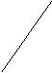Large gas rates (Re_{o}=10000 to 50000):

Jets of gas, which rise from the orifice, break into bubbles at some distance form the orifice. The bubbles are smaller than those described above and are non-uniform in size.

d_{b} = 0.0071Re_{o} ^{−0.05}
with d_{b} in metres. For the transition range, (Re_{o} = 2100 to 10000) there is no correlation of data. It is suggested that the correlation may be approximated by the straight line on log-log coordinates between the points given by d_{p} at Re_{o} = 2100 and at Re_{o} = 10000.

Bubble size is determined in any one of the following ways
- Photographic techniques.
- Light reflection.
- Light scattering.
- Depolarization.

Effect of Salt Addition:

The coalescence properties depend upon added salts and organic substances present. If a bubble is generated, the concentrations of the electrolyte at the interface and in the bulk are same initially. However, ions have tendency to move away from the interface. This results in an enrichment of liquid phase accompanied by an increase in surface tension. Since transport of ions in bulk liquid requires more time, coalescence hindering action is only pronounced at low residence times of the bubble. Therefore large effects of added electrolytes on mean bubble diameter and therefore the interfacial area a and volumetric mass transfer coefficients can be observed in stirred vessels and in multistage columns where life expectancy of the bubble is short. If the residence time is long (as in tall single stage columns), effect of added electrolyte is less pronounced.

As salt is added, the surface tension of the solution changes (increases). Due to this the gas bubbles formed are smaller and the residence time increases. This increases the gas holdup with increasing concentrations.

According to experiments performed by Richard R. Lessard and Stefan A. Ziemenski, the extent of coalescence (i.e. the percentage of successful coalescences on contacting) between two bubbles in a given medium depends upon

- Charge on the ions in the electrolyte
- Radius of the ions
- Concentration of the ions
- Viscosity of the medium.

125

Chemical Engineering Laboratory Manual
Semester VI

Process flow diagram:
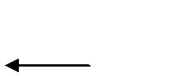

Air + CO₂ mix
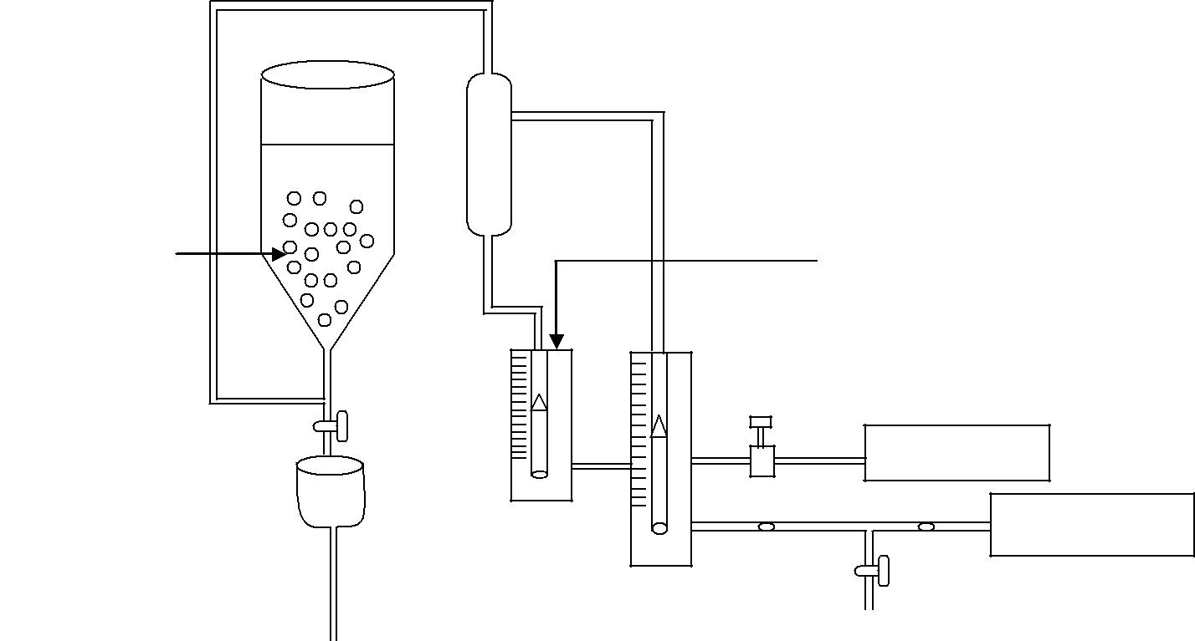

Nacl solution 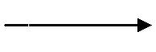

Bubbles | CO₂ rotameter

Bubble column
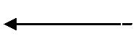 Air rotameter

CO₂ cylinder

Air compressor

Process flow diagram: Hydrodynamics of Bubble Column

- Procedure:
  - Fill the liquid in the column upto a certain mark say 30cm.
  - Start the gas flow.
  - Start from the minimum gas flow rate and gradually increase flow rate in steps.

  - For each gas flow rate measure the height of dispersed column of liquid. Height of the dispersed column be calculated as

Height = (Min. Ht. + Max Ht. + 2*Avg. Ht.)/4; Since the upper surface is very wavy.

  - Repeat the same procedure with 0.1%, 1.0%, 5.0%, 10.0%(w/w) of NaCl solution.
  - Plot the graph of Ɛ_{G} Vs. V_{G} (experimental and analytical).

  - Plot V_{G} /Ɛ_{G} Vs. V_{G}.

Precautions:
  - The gas flow rate fluctuates a lot and hence is maintained at a particular value.

- Data:

  - Radius of bubble column = 4.07cm.
  - Cross sectional area = 52.04 sq.cm.
  - Diameter of the orifice = 2 mm.

  - Equations for different physical properties for NaCl solutions
    - µ= 0.001 exp (0.0158C)

126

Chemical Engineering Laboratory Manual
Semester VI

- ρ= 7.1868C + 998.18

- σ = 72.543 exp (0.0048C)

Where µ = viscosity (Pa.s) ρ = density (kg/m³)

σ= surface tension (dynes/cm) C = conc. of the soln. (wt %)

Table for the values of these properties at the required concentrations:
Conc. | 0.1% | 1% | 5% | 10%
µ (Pa.s) | 0.001 | 0.001 | 0.001 | 0.001
ρ (kg/m³) | 998.19 | 998.25 | 998.54 | 998.89
σ (dynes/cm) | 72.543 | 72.546 | 72.560 | 72.578

- Observations:
  - Initial volume of water = 1500 ml.

  - Initial height of water = 28.7 cm.
  - Concentration of soln.= 0%

Table:
Sr.No. | Gas Flow Rate (*10⁶) | Height
 | (m³/s) | (cm.)
1. | 91.67 | 29.8
2. | 100 | 30.4
3. | 111.7 | 30.6
4. | 125 | 31.3
5. | 133.3 | 31.6
6. | 141.7 | 32
7 | 163.3 | 32.5
8. | 180 | 33.4
9. | 205 | 34.2
10. | 236.7 | 35
11. | 251.7 | 35.5

7. Sample Calculation:

Pure water
Q = 91.67*10⁻⁶ m³/sec
V_{G} = Q/A = .018 m/sec
Height of column = 29.8 cm

Fractional gas hold up = (H-Ho)/H = 0.0369
V_{G} *= V_{G} /Ɛ_{G}
V_{G} *=0.488 m/sec

127

Chemical Engineering Laboratory Manual
Semester VI

Calculation table:
Sr.No. | V_{G}(m/s) | Ɛ_{G} | V_{G}/Ɛ_{G}(m/s)
1. | 0.018 | 0.0369 | 0.488
2. | 0.0198 | 0.056 | 0.354
3. | 0.022 | 0.062 | 0.355
4. | 0.025 | 0.083 | 0.301
5. | 0.026 | 0.092 | 0.283
6. | 0.028 | 0.103 | 0.272
7. | 0.032 | 0.117 | 0.273
8. | 0.036 | 0.141 | 0.255
9. | 0.041 | 0.161 | 0.254
10. | 0.047 | 0.18 | 0.261
11. | 0.049 | 0.19 | 0.258

Similar calculations are done for the different concentrations of NaCl.

Theoretical calculations:
Using the formula:
 |  | ε_{G} |  | = 0.27V d |  | −0.08 _{ρ} 0.04 | μ |  | −0.15_{σ} −0.22 _{D} −0.08
 |  |  |  |  |  | −0.08 _{ρ} 0.04 | μ | L
 |  | (1 − ε_{G} ) | 4 | G |  | o |  | L |  | T
Sr.No. | V_{G}(m/s) |  |  |  |  | Ɛ_{G} |  |  |  | V_{G}/Ɛ_{G}(m/s)
1. | 0.018 |  |  |  |  | 0.0546 |  |  |  | 0.32967
2. | 0.0198 |  |  |  |  | 0.059 |  |  |  | 0.335593
3. | 0.022 |  |  |  |  | 0.064 |  |  |  | 0.34375
4. | 0.025 |  |  |  |  | 0.0708 |  |  |  | 0.353107
5. | 0.026 |  |  |  |  | 0.0729 |  |  |  | 0.356653
6. | 0.028 |  |  |  |  | 0.0772 |  |  |  | 0.362694
7. | 0.032 |  |  |  |  | 0.0852 |  |  |  | 0.375587
8. | 0.036 |  |  |  |  | 0.0927 |  |  |  | 0.38835
9. | 0.041 |  |  |  |  | 0.1015 |  |  |  | 0.403941
10. | 0.047 |  |  |  |  | 0.1114 |  |  |  | 0.421903
11. | 0.049 |  |  |  |  | 0.1145 |  |  |  | 0.427948

128

Chemical Engineering Laboratory Manual
Semester VI

Other formulae: 1)
= 0.45 * * *

Where,

Ga is Galileo Number

Ga =

Fr is Froide Number

Fr =

Reference: Abraham, M. (1990) Mass transfer and hydrodynamic characteristics of gas and liquid contactors. Ph.D. Thesis: UDCT

2)

= 0.25 * * * (

Gas feed line: do= 0.5 mm dR= 15.2-60 cm

ug= 0.5-42 cm/s

do= diameter of orifice dR= diameter of column u_{g}= gas velocity

ρ_{l}= Density of liquid

Reference: Deckwer,W.D.(1985). Bubble column reactors. John Wiley and sons publ.

129

Chemical Engineering Laboratory Manual
Semester VI

8. Graphs:
i) Plot of Ɛ_{G} vs.V_{G} for 0% NaCl
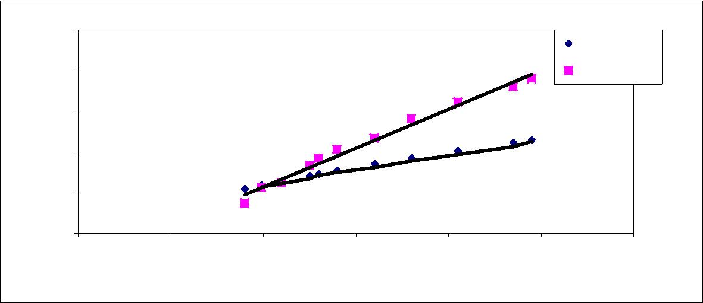
0.25
 |  |  |  |  |  | Theoretical
0.2 |  |  |  |  |  | Experimental
0.15
G
ε
0.1
0.05
0
0 | 0.01 | 0.02 | 0.03 | 0.04 | 0.05 | 0.06
 |  |  | ^{V}G
ii) Plot of V_{G}/Ɛ_{G} vs V_{G}
0.6 |  |  |  |  |  | Theoretical
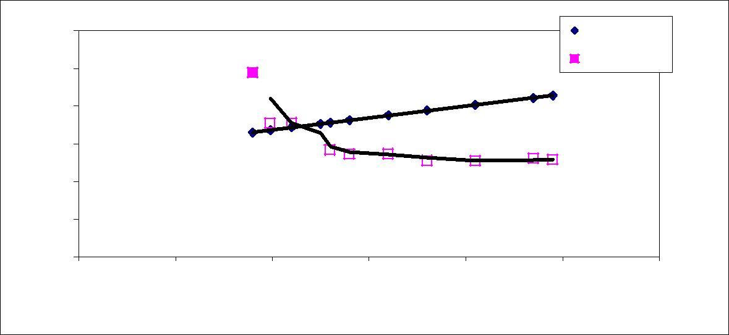
Experimental
0.5

 | 0.4
G
ε/ | 0.3
G | 0.3
V | 0.2
 | 0.1
 | 0

0 0.01 0.02 0.03 0.04 0.05 0.06

V_{G}

Expected trends:
i) Plot of Ɛ_{G} vs.V_{G} for increasing conc. of NaCl
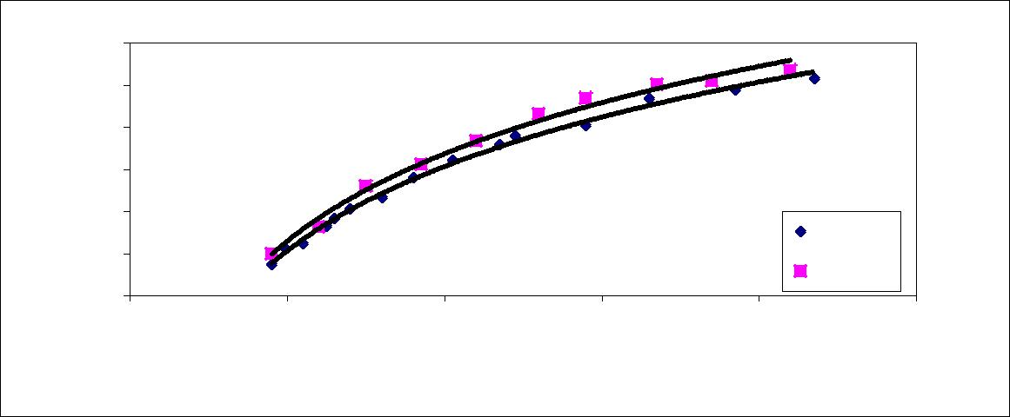
 | 0.3
 | 0.25
 | 0.2
G | 0.15
ε | 0.15
 | 0.1
 |  |  |  |  |  | 0% NaCl
 | 0.05 |  |  |  |  | 1% NaCl
 | 0
 | 0 | 0.02 | 0.04 | 0.06 | 0.08 | 0.1
 |  |  |  | V_{G}

130

Chemical Engineering Laboratory Manual
Semester VI

ii) Plot of V_{G}/Ɛ_{G} vs V_{G} showing transition velocity(intersection point)
 | 0.8
 | 0.7
 | 0.6
G | 0.5
ε/ | 0.4
G | 0.4
V
 | 0.3
 | 0.2
 | 0.1
 | 0
 | 0 | 0.01 | 0.02 | 0.03 | 0.04 | 0.05 | 0.06 | 0.07 | 0.08 | 0.09 | 0.1
 |  |  |  |  |  | ^{V}G
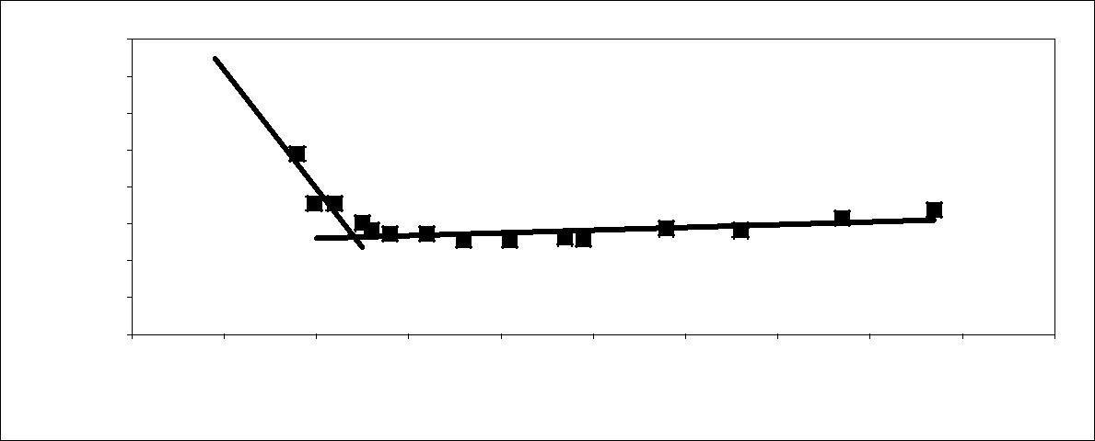
9. Results:

Conc. of NaCl (wt.%) | 0 | 0.1 | 1.0 | 5.0 | 10.0

Transition velocity(m/s)

10. Conclusions:

- With increase in the gas flow rate, the gas holdup increases.

- As the NaCl content of the solution increases, the gas holdup increases.

3. As the NaCl content of the solution increases, the velocity at which the transition of flow regime (homogeneous to heterogeneous) should take place at a higher velocity

11. Comments:

Since the column diameter is less, wall effects exist which are not considered. Therefore, if we use column with a diameter = 15cm. these effects will be eliminated.

12. Applications:

- In partial oxidation of ethylene to acetaldehyde (wacker-hoechst process)

Bubble column reactors are used for partial oxidation of ethylene to acetaldehyde with aq. Palladium (II) chloride solution as a catalyst.
C₂ H | PdCl₂ +H₂O
C₂ H | ₄ + 0.5O₂ ⎯⎯⎯⎯→CH ₃CHO ΔH_{R} = -244 KJ/mol

- Isobutene separation from C₄ cracking
Gases from thermal and catalytic cracking contains C₄ fractions from which butadiene is separated and 2/3 rd is mono olefins. More than 1/3rd of mono olefins is isobutene. The method uses fact that that isobutene has high rate of hydration than n-butene. Industrial method uses single or double stage bubble columns.

131

Chemical Engineering Laboratory Manual
Semester VI

- Production of dichloroethane.

Dichloroethane is used in manufacture of vinyl chloride, which is an important monomer in polymer industry. It is manufactured by 2 methods.

1. Direct Chlorination: --

It is carried out at 90⁰ c and elevated pressure. Heat of reaction is removed by allowing some fluid to vaporize. The selectivity of the process is about 97 %.

CH ₂ = CH ₂ + Cl₂ ⎯⎯→Cl − CH ₂ − CH ₂ − Cl ΔH_{R} = -180 KJ/mol

2.Kellogg's oxychlorination: --

It is carried out in adiabatic mode. Heat of reaction is drawn off with products and some heat is lost through water evaporation .The selectivity of the process is about 99%. However method is not popular because of corrosion problems.

CH ₂ = CH ₂ + 2HCl + 0.5O₂ ⎯⎯→Cl − CH ₂ − CH ₂ − Cl + H ₂O ΔH_{R} = -239 KJ/mol

The main reason behind use of bubble column reactors in manufacture of dichloroethane is temp. Control of the highly exothermic reaction.

- Benzene hydrogenation: --

Benzene is hydrogenated over suspended Raney nickel to yield cyclohexane (>99.8 %). Reaction is carried out at 180º c & at 50-bar pressure. The method uses bubble column reactor since it is economical to run and gives highly pure products. Plants of capacity up to 200,000 TPA are in use.

- Biotechnological processes: --

Bubble column reactors when used for biological effluent treatment are called as bioreactors. In these the effluent is added at the bottom of reactor and passes the aerated reactor containing mixed bacterial culture, which breaks down the impurities biologically. They are more economical and occupy less floor space than conventional wastewater treatment plants. Also can be constructed to large sizes up to 1000 to 3000 m³. Units with capacities up to 50,000TPA are in use.

- References:

  - Abraham, M. (1990). Mass transfer and hydrodynamic characteristics of gas liquid contactors. Ph.D. Thesis: UDCT

  - Deckwer, W.D. (1985). Bubble column reactors. John Wiley and sons publ.

132

Chemical Engineering Laboratory Manual
Semester VI

17. MIXING TIME STUDIES IN BUBBLE COLUMN

1. Aim: To investigate the effect of gas superficial velocity on the mixing time in bubble column at different conditions of initial liquid height (two liquid heights).

2. Apparatus: Bubble column with continuous gas phase and batch liquid phase, 0.05M NaCl solution.

3. Theory: Bubble columns are a class of multiphase reactor in which the liquid phase is the discontinuous phase. Bubble columns are widely used as reactors for its simplicity of construction and inexpensive means of achieving intimate gas-liquid contact.

Mixing in reactor is obtained from the sparging action of the gas alone. Sparged contactors can be divided in to three regions. In the first region near the sparger, the behavior and the properties of the bubbles are determined by the sparger design and the gas flow rate. In the second region, the bubble properties are determined by the liquid flow pattern. The second region occupies most of the column volume. In the third region bubble coalescence and escape occurs and this occupies only few millimeters from the top surface.

Mixing in bubble columns is due to the liquid circulation induced by the rise of bubbles through the liquid phase. During the bubble rise, some liquid is carried in the wakes of bubbles. The liquid thus entrained is released when bubbles collapse at the top and flows downward in the free region. In the case of small bubbles, which rise almost vertically, the liquid down flow is relatively well defined. As a result, a liquid circulation is developed. In the case of oscillating bubbles, which are of relatively large sizes (greater than 2mm) well-directed liquid circulation does not exist. The liquid circulation velocities are of the order of 0.3 to 3m/sec depending upon the superficial gas velocity and column diameter. These liquid velocities are one to two orders of magnitude higher than the usual superficial liquid velocities used in the bubble column operations.

Mixing-time is an important design parameter when the bubble columns are operated in a semi-batch manner. Knowledge of mixing-time gives the information regarding the liquid-phase back mixing and flow pattern and the knowledge of flow pattern helps in the determination of overall rates of reaction and transport processes in estimation of wall heat and mass transfer co-efficient in bubble columns. The mixing-time is strongly influenced by the superficial gas velocity, type of sparger, height to diameter ratio and physical properties of the liquid phase (through its coalescing or non-coalescing property). Hence it is necessary to investigate the effect of these parameters on mixing-time.

Mixing-time defined as the time interval between the start of mixing operation and that when a required uniformity of composition has been achieved. Complete mixing is achieved when there is an observed uniformity of composition with in the fluid. No alteration is then produced in the fluid composition by additional mixing. Phase-phase interaction affects the mixing performance of the bubble column. The performance of short bubble columns is intermediate between the horizontal sparged contactors and tall bubble columns. The mixing times are very important in determining the performance of bubble column reactor, especially when the values of mixing-time and reaction time are comparable. In both the cases, it is desired that the expected degree of mixing be achieved. In this case, the improper mixing may result into undesirable selectivity.

133

Chemical Engineering Laboratory Manual
Semester VI

Measurement Techniques of Mixing-time:

Mixing-time measurements are helpful in the development of correlations for the prediction of mixing-time and different techniques are used to measure mixing-time. The commonly employed techniques in the determination of mixing-time are as follows,

- Conductivity Method
- Dye Addition Method
- Chemical Reaction Method
- Radio tracer Method
- Decolourisation Method

In the present experiment, Conductivity method will be used for the determination of mixing time.

Conductivity Method

This method involves addition of an electrolyte to the liquid and measuring conductivity of solution. Recorder is connected to probe which records and plots conductivity with time. Mixing time is the time required by the electrolyte to get distributed uniformly throughout the column. When electrolyte is added recorder is switched on immediately, at starting it shows increase in conductivity of liquid and over a period of time electrolyte gets mixed completely and conductivity of the liquid becomes constant. Mixing time can be read from plot as time interval between onset of increase in conductivity and the onset of constant conductivity. This method prevents measurement of mixing time with stopwatch as both conductivity as well as time are recorded and plotted

- Procedure:
  - Charge approximately 3 liters of water in the bubble column.

  - Adjust the gas velocity to certain predefined value and wait for some time for the system to achieve steady state.

  - Add fixed quantity (25mL) of 0.05M NaCl and at the same time switch on the chart recorder which will give variation in the conductivity with respective to time.

  - When the recorder shows constant conductivity stop the recorder. Calculate the mixing time from this chart.

  - Repeat steps 1-4 for another set with different gas flow rate and then with approximately to 2 liters of water.

  - Plot the graph of observed mixing times with superficial gas velocity for all the sets.

  - Comment on the variation of mixing time with the superficial gas velocity, clear liquid height/diameter of the column ratio, and calculate the dispersion coefficient.

134

Chemical Engineering Laboratory Manual
Semester VI

5. Observations:

Diameter of the column = Initial height of the liquid =
Liquid taken in the bubble column =
Sr. No. | Gas flow rate (cm/s) | Mixing time (sec)
1
2
3
4

Prepare different observation tables for each set.

6. Graphs:

Plot a graph of mixing time Vs. superficial velocity of air for each set i.e without sieve plate and with sieve plate.

- Result:

- Conclusions:

- Comments:

- Diagram:
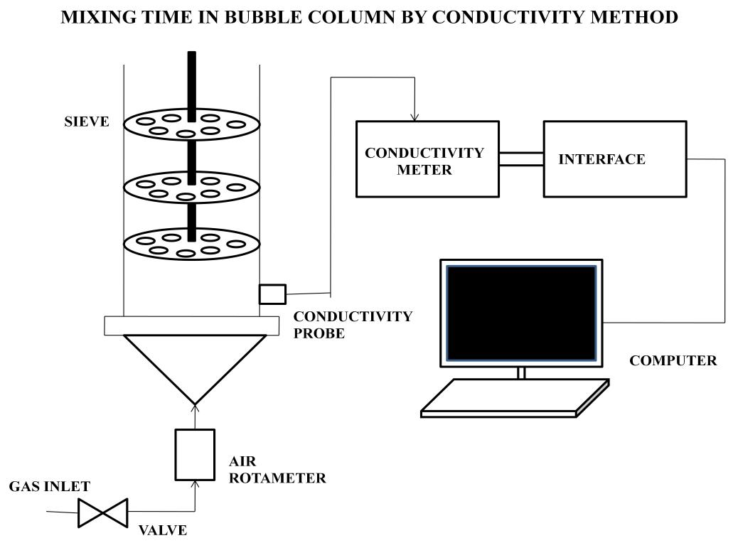

135

Chemical Engineering Laboratory Manual
Semester VI

18. SINGLE STAGE ADSORPTION

- Aim: To study the adsorption characteristics

- Apparatus: Burette, pipette, stoppered conical flask, weighing machine, bottles.

- Analytical methods: Volumetric titration using phenolphthalein indicator

- Chemicals: NaOH, 0.1 N NaCl, oxalic acid 0.2 N, phenolphthalein indicator

- Theory:
Adsorption:

The concentration or accumulation of a substance on the surface of some other substance is called as adsorption. The substance which gets adsorbed is called adsorbate and the substance on whose surface the adsorbate gets adsorbed is called adsorbent.

The adsorbents are natural or synthetic polymers of microcrystalline structure whose internal pore surfaces are accessiblefor selective combination of solid and solute. Usually the attractive forces are weaker and less specific than those of chemical bonds. Hence adsorption is usually analogous to condensation of gas molecules or to crystallization from a liquid. Its selective action is most pronounced in monomolecular layer next to the solid surface but at times selectivity may persist upto three or four molecular layers. This effect is identified as physical adsorption. The adsorption capacity of a solid for solute tends to increase with the fluid phase concentration of the solute.

Adsorbents used in large scale use include activated carbon, silica gel, activated alumina, fullers earth and other clays.

Molecular sieves are an important class of the synthetic adsorbent are aluminosilicates that have undergone heating to remove water of hydration .They possess high porosity with pores ( in reality they are lattice vacancies) of uniform size and essentially molecular dimensions. The pore size may be even 4 to 5 Aº.

At high temperatures (above 400ºF) the adsorption may occur through a true reaction or chemical bonding and it is termed as chemisorption.

Ion exchange:

In this a solid phase is used that contains bound groups that carry an ionic charge either positive or negative accompanied by free ions of opposite charge that can be displaced . Early ion exchange resins were inorganic silicate polymers of microcrystalline type zeolite or greensands related to molecular sieves. These were followed by oxidisded or the sulfonated coals. Most ion exchangers currently in large scale use are based on synthetic resin usually polystyrene copolymerized with divinyl benzene (to provide requisite amount of cross linking); they are permeable only at molecular dimensions, except when a network of coarser pores is deliberately superimposed.

Ion exchange based processes:

These are divided into following three categories: 1) Substitution:

A valuable ion can be recovered from solution and replaced by a valueless one. Similarly a toxic ion (e.g. cyanide) can be removed from solution and replaced by a non-toxic one.

136

Chemical Engineering Laboratory Manual
Semester VI

2) Separation:

A solution containing number of ions is passed through a column containing beads of an ion exchange resin; the ions are separated and emerge in order of their increasing affinity for the resin. The ion having maximum affinity is adsorbed first.

3) Removal:

By using a combination of a cationic resin (in the H⁺ form) and an anionic resin (in the OH– form), all ions are removed or replaced by water (H⁺OH⁻). The solution is thus demineralized.

Structure of ion exchange resin:

An ion exchange resin consists of a polymer matrix and functional group that interacts with ions. Commonly used polymer matrices are:

- Polystyrene matrix: The polymerization of styrene (vinylbenzene) under the influence of catalyst yields linear polystyrene to which some percentage of divinylbenzene (DVB) is added to get a highly crosslinked completely insoluble polymer.

- Polyacrylic matrix: These matrices are obtained by polymerization of acrylate, methacrylate or an acrylonitrile any of which can be crosslinked with DVB.

- Other matrices: Chief among other matrices used are :
  - phenol formaldehyde
  - polyalkylamine,etc.

Factors affecting performance of sorbent:

The performance of solid sorbent in the treating of a liquid or gas feed depends upon four factors which are as follows:

- The ultimate capacity of the sorbent for the solute which may or may not be fully utilized under actual process conditions,

- The phase equation which influences the efficiency with which the capacity is reached in many cases( adsorption ,absorption ,extraction) controls the actual capacity of the sorbent

- The rate behaviour and mechanism and resistance controlling the rate
- The process arrangement with its consequences for the material balances.

Ion exchange equilibrium:

Dissociation of acid group in cation exchange resin is described by equilibrium reaction _{R} – _{H} ←→ _{R}⁻ _{+ H} ⁺
Where R⁻ is the co –ion .The acidity of the resin is defined by the degree of dissociation at

equilibrium K = [R⁻][H⁺]
[RH]
Coulomb’s law can be used to predict the force of attraction between an ion exchange site of
charge q_{(resin)} and an oppositely charged ion with a charge q_{(ion)} which are separated by a distance
‘r’.

_{F} ∝ ^{q}re sin ^{xq}ion ^{r}hydrated² ion

137

Chemical Engineering Laboratory Manual
Semester VI

If the charge on the ion is assumed to be located at the center of the hydrated ion in the solution, the distance of the closest approach between the ion exchange site and the ion is approximately equal to the radius of the hydrated ion ‘ r(hydrated ion)’.From the above equation , the force of attraction between a specific ion exchange resin and an ion increases as the charge on the ion increases but decreases with an increasing radius of hydrated ion. The more is the force of attraction , more is the retention time of the ion on an ion exchange column e.g. Na⁺,Ca⁺², La⁺³

and Th⁺⁴ all the four ions have nearly the same radius but the order of attraction to a resin is Th⁺⁴> La⁺³ > Ca⁺²> Na⁺ .

Flexibility in the use of resin:-

When an expensive adsorbent is needed to bring about the full extent of purification that is desired, it is sometimes possible to reduce the costs by combining its use with a less expensive material.
e.g.

- For a solvent rich air stream that also contains water vapours , it is advantageous to dry air the air with a separate selective adsorbent rather than being allowed to foul the surface of the high cost ion exchange resin .

- Suspended colloidal material in an aqueous feed should be coalesced onto gravel; and inexpensive adsorbent rather than being allowed to foul the surface of high cost ion exchange resin particles.

Single stage adsorption :

The single stage operation is either batch or continuous. It is similar to single stage gas absorption. G_{s} lb is unadsorbable substance (solvent) and adsorbable solute concentration in G_{s} is decreased from Y₀ to Y₁ lb/lb of solvent .The adsorbent is added to the extent of Ls lb/lb of adsorbate free solid. The solute adsorbate concentration increases from X₀ to X₁ lb/lb of adsorbent.
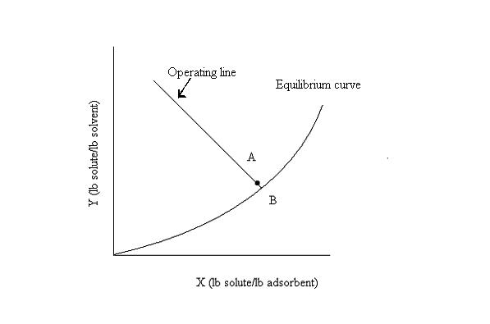

138

Chemical Engineering Laboratory Manual
Semester VI

The equilibrium curve is what the process tends to approach. The balance on a single stage gives
G_{s} (Y₀-Y₁) = L_{s} (X₁- X₀)

Hence the slope of the operating line is (–Ls/Gs). If a long time is provided the adsorption system will reach point B on the equilibrium curve. In case of a shorter residence time ,the system will reach some point A on the operating line.

Applications:
1) Softening of hard water :-

The hardness of the water is due to presence of Ca++, Mg++ and other divalent ions. These ions may be removed by passing hard water through cation exchanger charged with Na+ then the following reaction takes place

Na_{n}R + n Ca⁺² |  | ←→ Ca_{n}R₂ |  | + 2nNa⁺
Resin | hard water |  | resin | solution
This is an exchange reaction

The Ca⁺² and Mg⁺² ions are retained in the column whereas Na+2 ions are passed into solution .These Na+ ions are harmless for washing purpose. After using ion exchanger for long time it becomes inactive.

So to receive its activity again we have to percolate it through a concentrated solution of NaCl when following reaction takes place

Ca_{n}R₂ + 2nNa⁺ |  | ←→  _{nCa}⁺²  ₊ | 2Na_{n}R
Resin | solution | solution | regenerated

2) Lanthanide separation:-

A solution of lanthanide ions when comes into contact with synthetic resin (HR) containing –COOH or –SO₃H group undergoing proton exchange and the following equilibrium is established

Now the radii of lanthanide element decreases from left to right and the radii of hydrated ions increases from left to right

The force of electrostatic attraction of the hydrated ions by resin depends upon radii of the hydrated ions .In other words the strength by which the lanthanide ion will be bound to resin will decrease from left and right i.e. from La+3 to Lu+3. When the element is passed through the exchanger the less strongly bound lanthanide will be eluted first and the most strongly bound lanthanide will be eluted last. Thus the Lu⁺³ ion will separate first followed by Yb⁺³ ……. La⁺³ ions.

Since ion exchange is fractional method total separation of lanthanide ions do not take place in one turn so the process is repeated several times after elution.

6. Process flow diagram:
In this process no flow occurs, hence no flow diagram is provided.

139

Chemical Engineering Laboratory Manual
Semester VI

- Procedure :

  - Standardize NaOH solution used for the titration by using 0.2 N oxalic acid.

  - Weigh out 1.5 g, 2.0g , 2.5g ,of the resins and pour 50,100,150ml of o.1 N NaCl solution in it.

  - Now stir the flasks for 90 min continuously

  - After stirring , check if equilibrium is reached by titrating 5 ml solution from a flask with NaOH using phenolphthalein as indicator. When equilibrium is reached ,the titre reading will remain constant.

  - At equilibrium obtain the normality of the solution and concentration of moles of Na+ in the solution .

  - Calculate the gram equivalent per gram of resin.

  - Plot a graph of gram equivalent of HCl per gram of resin (x/m) against the concentration of moles of Na+ in the solution.

  - Plot a graph of (m/x) vs 1/c.
  - From the graphs calculate the constants n, k₁, k₂.

Precautions:

- Standardize NaOH carefully. Titrate NaOH 2-3 times and take the mean as normality.

- If during titration of the sample the burette reading is around 1-2 ml, dilute the NaOH ten times and then use the diluted NaOH for obtaining the normality of the solution. This is to reduce errors in readings.
- The samples should be shaken vigorously for 90 min.

Data: No physical data is required for calculations hence no data for adsorption is provided.

8. Observations:

No. | Amount of resin | Amount of 0.1 N | Strength of HCl
 |  | NaCl
 | gm | ml | N
1 | 1.5 | 50
2 | 1.5 | 100
3 | 1.5 | 150
4 | 2.0 | 50
5 | 2.0 | 100
6 | 2.0 | 150
7 | 2.5 | 50
8 | 2.5 | 100
9 | 2.5 | 150

140

Chemical Engineering Laboratory Manual
Semester VI

EQUATIONS:

Freundlich Isotherm:

Over a small concentration range and for dilute solution ,generally the adsorption can be described by the Fruendlich isotherm.

x/m = k . c ^(1/n) where,

x/m = amount adsorbed per unit mas of adsorbent c = equlibrium concentration

k,n = constants
Taking logarithm on both sides,
log (x/m) = log k +(1/n) log c

This is equation of a straight line with log k as intercept (1/n) as slope when log (x/m) is plotted against log c.

Langmuir Isotherm :
(x/m) = (k₁c) (1+k₂c)
where ,

(x/m) is amount adsorbed per unit mass of adsorbent c is equilibrium concentration

(m/x ) = (1/ k₁c ) + (k₂/k₁)

This is equation of a straight line with slope = (1/k₁) and intercept = (k₂/k₁).

141

Chemical Engineering Laboratory Manual
Semester VI

- Graphs:

  - log (x/m) vs log c
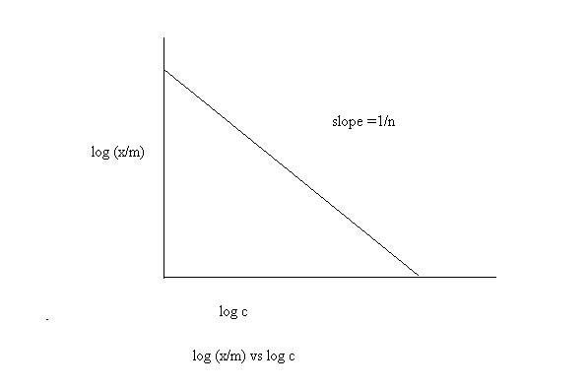

2. log (m/x) vs 1/c
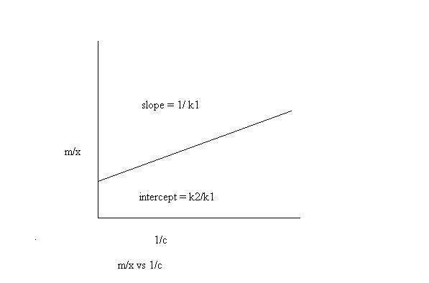

142

Chemical Engineering Laboratory Manual
Semester VI

10. Calculations:
Standardization of NaOH:

N₁ = normality of NaOH
N₂ = normality of Oxalic acid
V₁ = burette reading
V₂ = volume of oxalic acid

N1*V1 = N2* V2
N1 = (N2 *V2) / V1

To determine strength of HCl:
Let N1=normality of NaOH

N2 = normality of mixture
V1 = burette reading
V2 = volume of mixture titrated

Strength of HCl = N2 = (N1*V1)/ V2 Let x be gram equivalents of HCl formed

x = (N2/1000 ml) * volume of NaCl initially taken in ml (volume of NaCl is either 50, 100 0r 150 ml)

(x/m) = (gram equivalents of HCl) (mass of resin in grams)

(Mass of resin is either 1.5, 2.0 or 2.5 gm)

Concentration of NaCl at equilibrium is c
c = 0.1 – N₂ CALCULATIONS TABLE:

No. | x | x/m | c | 1/c | m/x | log c | log x/m
 | gram eqvt | gm eqvt/gm |  |  | gm/gm eqvt
 |  |  | N | 1/N

11. Results:

(Trends not available in literature) k =

n =
k₁ = k₂ =

12. References:

- Treybal R.E.; Mass transfer operations, 2nd edition pp. 447-523
- Perry, J.H.; Perry’s Chemical Engineering Handbook 6th edition Ch.16 pp.5-6

143

Chemical Engineering Laboratory Manual
Semester VI

13. Annexure:

SUGGESTIONS FOR IMPROVEMENT:

- Use of a shaker can help in increasing accuracy of the results obtained. It can also help in reducing time required for the experiment.

- If a shaker is used, it will be possible to take a large number of readings and a wider range of starting amounts of resin can be used.

MODIFICATIONS IN EXISTING EXPERIMENT:

As we are using 0.1 N NaCl with 1.5 g, 2.0 g and 2.5 g of resin , we can also use a salt like CuSO₄ similarly as a separate set and exchangeability of Na⁺ and Cu ⁺² can be compared. The same experiment can also be carried out using FeCl₃ solution.

The observations in this case will be:

No. | Weight | Volume | Strength | Volume of | Strength | Volume | Strength
 | of resin | of NaCl | of HCl | Cu SO₄ | of | of FeCl₃ | of HCl
 |  |  |  |  | H₂SO₄
 | gm | ml | N | ml | N | ml | N
1 | 1.5 | 50 |  | 50 |  | 50
2 | 1.5 | 100 |  | 100 |  | 100
3 | 1.5 | 150 |  | 150 |  | 150
4 | 2.5 | 50 |  | 50 |  | 50
5 | 2.5 | 100 |  | 100 |  | 100
6 | 2.5 | 150 |  | 150 |  | 150

144

Chemical Engineering Laboratory Manual
Semester VI

19. ESTIMATION OF THERMODYNAMIC PROPERTIES OF LIQUID MIXTURES

1. Aim: To estimate the molar volume, apparent molar volume and partial volume of liquid mixtures.

- Apparatus: Densitometer, syringe.

- Chemicals: Water, Methanol, Ethanol, Propanol, Butanol.

- Theory:

Since very few data on volume changes exist, they could be obtained from a study of partial volumes of alcohol-water solutions. By studying a homologues series of alcohols, it should be possible to subtract the effect of polar group and obtain the contribution of non-polar group. This approach is based on the assumption that the contributions of the polar and the non-polar parts of alcohol are additive in both the pure alcohol solution and the infinitely dilute aqueous solution, an assumption the validity of which we cannot establish. However this assumption could be valid as the length of the non-polar part increases. Consequently, we have to make density measurements of pure alcohols and alcohol-water solutions and partial molar volumes can be computed.

The apparent molar volume of the alcohol is related to the densities by the equation:
∅ = M/ρ = (1000×(ρ-ρ_{H2O}))/(m×ρ×ρ_{H2O}) Where,

M- Molecular Weight of solute ρ- Density of mixture
ρ_{H2O} - Density of water at same temperature
m – Molality of solution [moles of solute/ kg of solvent]

The partial molal volume of alcohol, v, is related to ø by the equation:

Where, the number of moles of water, n, is kept constant. Experimentally, when ø is plotted against m and extrapolated to zero concentration, the intercept is equal to v at infinite dilution.

Since the molar volume of pure alcohol is, v⁰ is v⁰= ρ_{a}
Where, ρ_{a} is the density of pure alcohol, the volume change Δv, upon transfer of 1 mole of

alcohol from pure alcohol to the infinitely dilute aqueous solution, is given by v⁰

If it is assumed that Δv contains additive contributions from the polar and non-polar parts of alcohol, then a subtraction of two values of Δv for two different alcohols should give the volume change for the transfer of the non-polar part from a non-polar medium into infinitely dilute aqueous solution; e.g., the contribution of methylene group may be obtained by subtracting data for n-propyl an ethyl alcohols.

∆vCH2 = ∆vCH3CH2CH2OH - ∆vCH2CH2OH

A theoretical value, with which to compare this experimental value, may be obtained by a similar subtraction data for the corresponding hydrocarbons, i.e.

∆vCH2 = ∆vCH2CH2CH2 - ∆vCH2CH2

145

Chemical Engineering Laboratory Manual
Semester VI

Relation between Partial Volume, Mixture Volume & Pure Component Volume:
For a binary mixture the summability relation is valid, given by

V = x₁V₁+x₂V₂ 1 - Water

2 – Other component. From eqn. (1),
dV = x₁dV₁+V₁dX₁+x₂dV₂+V₂dx₂

From above eqn. it is clear that M can be expressed as function of x₁ at constant T& P. Gibbs-Duhem eqn. gives;
x₁dV₁+x₂dV₂ = 0 This gives eqn. (2) as,
dV = V₁dX₁ + V₂dx₁

Since x₁ + x₂ = 1; thus >>> dx₁= -dx₂ Thus we get,
dV = V₁dX₁ - V₂dx₁
dV/dx₁ = V₁-V₂
V₁ = V+x₂ dV/dx₁ | V₂ = V-x₁ dV/dx₂ | (6)

Thus from eqn. (6) it is seen that partial properties can be calculated directly from an expression for the solution property as an function of composition at constant T & P
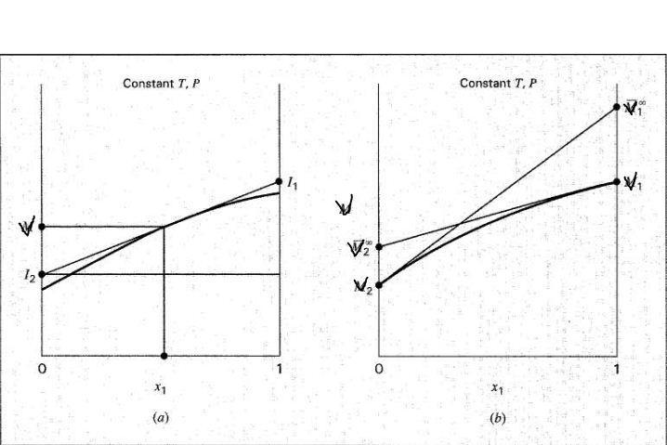

Plot of V vs. x1 for binary mixture

At any point x1 we get partial volume of components by drawing tangent at x1. When x₁=1; I₁ – partial volume of component 1 (water),

When x₁=0; I₂ – partial volume of component 2 Slope of tangent;

146

Chemical Engineering Laboratory Manual
Semester VI

dV/dx₁ = V-I₂/x₁-0 | & | dV/dx₁ = I₁-I₂/1-0 = I₁-I₂
Solving above eqn. for I₂ & I₁ respectively.
I₂ = V- x₁ dV/dx₁ | & | I₁ = V + (1-x₁) dV/dx₁
Thus,
I₁ = V1 | & | I₂ = V₂

From the extrapolation of partial volumes vs. x1 at 0 & 1 and drawing tangents to them, we will get partial volume at infinite dilution. Practically we can conclude that;

Vinfinite-1 = Vpure-2 & Vinfinite-2 = Vpure-1

- Procedure:
  - Make mixtures of water & other components taking fixed moles of water (Say 10 ml).

  - Take readings for all compounds covering range of x from 0 to 1 i.e. by adding increasing amount of the liquids to 10ml of water. (10, 20, 30….).

  - Calculate values of partial volumes, pure component volume and molar volume.
  - Plot V vs. x₁

- Data:
Sr. No. | Compound | Molecular Weight | Density
1 | Methanol | 32 | 717
2 | Ethanol | 46 | 666
3 | Propanol | 60 | 644
4 | Butanol | 74 | 810

7. Observation table:
% vol. per vol. of | Methanol | Ethanol | Propanol | Butanol
water | g/cc | g/cc | g/cc | g/cc
100
90
80
70
60
50
40
30
20
10
0

- Sample calculations Part A

  - Calculate molarity
m=(V₁*ρ₁)/(V₂*ρ₂*M₁) in gm/kg of solvent
2) Calculate the Apparent mixture volume (phi)
ø=(M/ρ) –((1000*(ρ-ρ_{H2O})/(m*ρ* ρ_{H2O})) Where

M- mol. wt.of solute ρ- density of mix.

147

Chemical Engineering Laboratory Manual
Semester VI

ρ_{H2O} - density of water m- molality of solution

3) Calculate Partial molar volume:

Plot a graph of ø vs. m to get ø/ |  | m and find v (partial molar vol.)
v = ø + m × ( ø/ m) at const. T, P, n in cc/gmol
4) Plot a graph of v vs. X₁ to get ( |  | v/ X₁) then find V₁
V₁ = v + x ₂ ( v/ x₁)
V₂ = v- x₁ ( v/ x₂) | both in cc/gmol

- Molar volume of pure alcohol v₀= M/ρ_{a} in cc/gmol

- Plot graph of ø vs x₁
Draw a tangent at x₁=0 and x₁=1 to get the value of partial volumes at infinite dilution. Get value of volume of pure component by correlation:

Vinfinite-i = Vpure-j

9. Graphs:

Plot: ø vs. m Plot: v vs. x₁

10. Calculation table
V₁ | ρ₁ | m | Ø | ø/ m | V | X₁ | v/ x₁ | V₁ | V₂ | ∆V
10
20
30
40
50
60
70
80
90
100

11. Result

Compound | V(pure alcohol) | V (infinite)
 | (m³/mol) Theoretical | (m³/mol) Graphical
MeOH
EtOH
Propanol
sButOH
12. Conclusion:
13. Comments:
 | 148

Chemical Engineering Laboratory Manual
Semester VI

20. COOLING TOWER ANALYSIS
- Aim: For a cooling tower, find:

  - Number of transfer units,

  - Height of a transfer unit,

  - Overall gas side mass transfer coefficient.

- Apparatus: Cooling tower, fan, thermometers, Hygrometer, water heater, buckets.

- Theory:
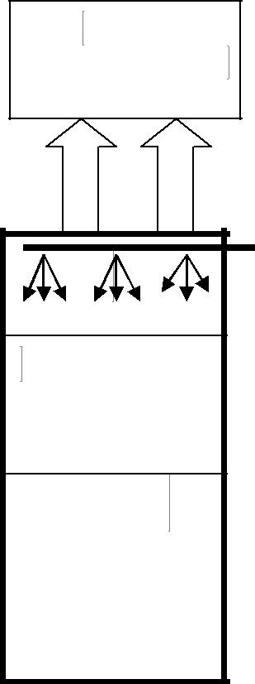
Air out
T_{G1}, G₁, %RH₁
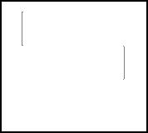

Water in
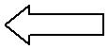T_{L1}, L

Cooling

tower
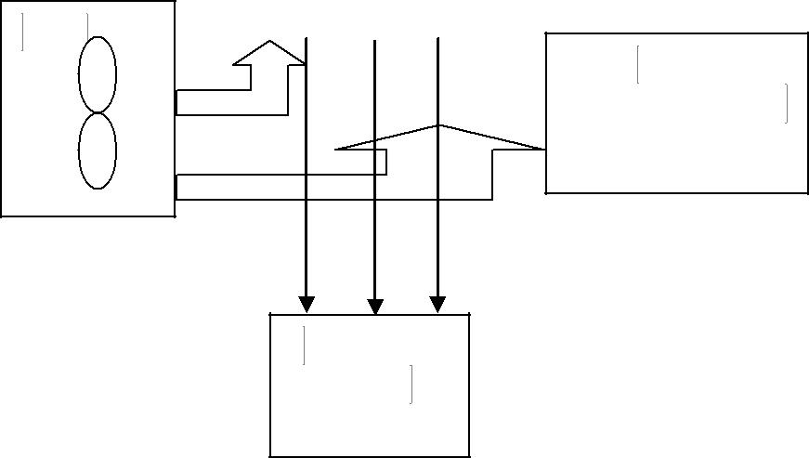

Fan
Air in
T_{G2}, G₂, %RH-2

Water out
T_{L2}, L

149

Chemical Engineering Laboratory Manual
Semester VI

The heat balance over the column gives the operating line is given by

The total sensible heat transfer from liquid bulk to interface = latent heat to vaporize the liquid + sensible heat change in gas

Height of the column Z = NTU*HTU Number of transfer units (NTU) =

Height of a transfer unit (HTU) =

G_{S}: Gas flow rate per unit cross-section (kg/m²-s)
H_{Y}: Enthalpy of air along with water vapour (kJ/kg dry air)
K_{Y}: Overall gas side mass transfer coefficient (kg/m²-s-∆H)
H: Humidity (kg water vapour/ kg dry air)
T_{L}: Liquid temperature (K)
H_{Y}*: Saturated gas Enthalpy (KJ/kg dry air)

4. Procedure:

- Switch on the heater, to heat the inlet water to about 50ºC, which would take ~20mins. In the time being plot the equilibrium curve (H_{Y} vs. T_{L}).

- Adjust the liquid flow-rate (keep as small as possible). Measure the flow rate using a measuring cylinder.

- Switch on the fan at full speed (regulator).
- Note down the temperature of inlet water (T_{L1}).

- Take a mug and collect the water coming down from the column and measure its temperature (T_{L2}).

- Find the humidity (%RH₁) and temperature (T_{G1}) of the ambient air.

Note: Response time of the hygrometer is 30 sec. Please be patient for the reading. Don’t touch the tip of the hygrometer or blow air into it by mouth and don’t allow direct water contact.
- Find the humidity (%RH₁) and temperature (T_{G1}) of the outlet air.

- Vary the fan speed and repeat steps 4-7 at same liquid flow-rate.

5. Data:
λ₀= 2501.4 kJ/kg
C_{p air} = 1.005 kJ/kg-K
C_{p water vapour} = 1.88 kJ/kg-K

150

Chemical Engineering Laboratory Manual
Semester VI

6. Observations:

Height of the column: _________ cm. Diameter of column: _________ cm.

Obs. | Fan speed | Inlet | Outlet | %RH₁ | %RH₂ | Outlet | Inlet | Liquid
No. |  | water | water |  |  | Gas | Gas | Flow-rate
 |  | temp. | temp. |  |  | temp. | temp | L (ml/s)
 |  | T_{L1} (K) | T_{L2} (K) |  |  | T_{G1}(K) | T_{G2}(K)
7. Calculations:

- From volume flow-rate L (ml/s) calculate mass flow-rate L’ (ml/s)*1(g/ml); hence calculate mass flux (kg/m²s).
2. Calculate the Gas flow rate per cross-sectional area by energy balance:

3. Plot the equilibrium curve and the operating curve. Divide the range between the inlet and outlet temperatures into adequate intervals. At each temperature, find the corresponding enthalpy H_{Y} on the operating line and the H_{Y}* on the equilibrium curve. Note: We are evaluating the overall gas side transfer co-efficient, hence the tie-lines are vertical.

4. Evaluate the integral . This is the gas-phase enthalpy transfer units (NTU).

- We know height of the column (Z) so now HTU=Z/NTU
- HTU=G_{S}/K_{Y}a; hence find K_{y}a.

Obs. | T_{L} | H_{Y} | H_{y}* | H_{y}*-H_{y} | ( H_{y}*-H_{y})⁻¹ | dH_{y}/( H_{y}*-H_{y})
No.

8. Graphs:
Plot H_{Y} vs. T_{L} (equilibrium line and operating line)

- Conclusions and comments:

- References:

  - Dutta, B. K. (2007). Principles of Mass Transfer and Separation Processes. New Delhi: PHI Learning.

  - McCabe, W. L., Smith, J. C., & Harriott, P. (2005). Unit Operations of Chemical Engineering (7th ed.). McGraw Hill.

151

Chemical Engineering Laboratory Manual
Semester VI

21. PHOTOCATALYSIS

- Aim: To study the photocatalytic degradation for water treatment

  - Apparatus: Photocatalytic reactor setup, centrifuge tubes, UV-Vis spectrophotometer, dye,
TiO₂, micropipette, etc

3. Theory: Environmental pollution is a serious day-to-day problem faced by the developing and the developed nations in the world. Air, water and solid waste (plastics) pollution due to the anthropogenic sources contribute a major share to the overall imbalance of the ecosystem. The common pollutants include toxic organic compounds like chlorinated and non-chlorinated aliphatic and aromatic compounds, dyes, detergents and surfactants, agro wastes like insecticides, pesticides and herbicides, disinfection byproducts, volatile organic compounds, plastics, inorganic compounds like heavy metals, noxious gases like NOx, SOx, CO and NH₃, and pathogens like bacteria, fungi and viruses. Hence, strict environmental legislations on the use of these recalcitrant pollutants and their safe disposal drives the research community to develop clean and green processes to degrade the pollutants before they are admitted into the atmosphere and water bodies.

Photocatalysis refers to the acceleration of the rate of chemical reactions (oxidation/reduction) brought about by the activation of a catalyst, usually a semiconductor oxide, by ultraviolet (UV) or visible radiation.

The mechanism of UV photocatalysis involves the generation of valence band (VB) holes and conduction band (CB) electrons, when a semiconductor photocatalyst absorbs light photon of energy greater than or equal to its band gap. The holes mediate the oxidation of organic compounds by the formation of hydroxyl radicals, and the electrons mediate reduction and oxidation reactions by the formation of superoxide radicals. Several metal oxides (TiO₂, ZnO, MoO₃, ZrO₂, WO₃, α-Fe₂O₃, SnO₂, SrTiO₃) and metal chalcogenides (ZnS, CdS, CdSe, WS₂, MoS₂) can be used as photocatalysts.

Dyes find numerous applications in our daily life in clothing, food, paper, leather, cosmetics, plastics, drugs, electronics and printing. Nearly 80% of the synthetic dyes produced in the world are consumed by the textile industry. One of the major bottlenecks in the textile industry is the dye fixation, i.e., spent dye baths, residual dye liquors and water from washing operations contain dye in the hydrolyzed and unfixed form. Nearly 10% of the dyes are discharged into the effluent as a result of this process. Conventional treatment of waste water like neutralization of acidic and alkaline liquors, flocculation and chemical oxidation result in 70–80% of decolorization, while still maintaining the organic carbon load in the effluent.

The present experiment aims at studying the photocatalysis process. The effect of various parameters on the reaction will be studied in this experiment.

Caution: Do not perform the experiment without safety glasses. UV is dangerous for eyes.

152

Chemical Engineering Laboratory Manual
Semester VI

Photocatalytic reactor setup

To electric supply
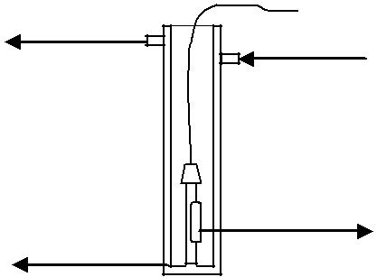
Water | Water
out | Water
out | in
Quartz | mercury vapor
tube | mercury vapor
tube | lamp
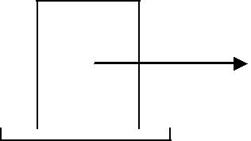
dye +

Catalyst suspension

Magnetic stirring Magnetic bar
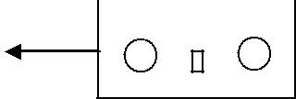
stirrer

4. Procedure:
- Prepare a stock solution of 1000 ppm.

- Before performing the degradation experiment, prepare a calibration plot of known concentrations

- Take 100 ml of dye solution (of known concentration, parameter A) and add a known amount of catalyst (parameter B) into it.

- Start the magnetic stirrer and stir the above mixture for 10 min
- Start water pump and then whitch on the UV lamp. Allow 5 min to glow the lamp completely
- Pippette out the sample after each regular interval of time and note down the absorbance
- Calculate the concentration using calibration curve
- Plot a graph of concentration (y) vs time (x)
- Use power law kinetics to determine the rate constant and order of reaction

Parameter A (ppm) | 100 | 50 | 30 | 20 | 10
Parameter B (g/L) | 0 | 0.2 | 0.5 | 1 | 1.5

5. Observation table:

Concentration (ppm)

Time (min)

6. References:

R. Vinu and Giridhar Madras, Environmental remediation by photocatalysis, Journal of the Indian Institute of Science VOL 90:2 Apr–Jun 2010

153

Chemical Engineering Laboratory Manual
Semester VI

22. VAPOUR LIQUID EQUILIBRIUM

1. Aim: To study the equilibrium between liquid phase and vapour phase of acetic acid-water

system.

- Equipment: Distillation setup, two thermometers, burette and pipette.

- Chemicals: NaOH solution (2N), phenolphthalein indicator, acetic acid and water.

- Theory: Vapour Liquid Equilibrium (VLE) relationships are needed for design of

equipment like distillation, absorption, etc. At Equilibrium, we have:

f _{i}^{v} = f _{i}^{L}

For low pressure vapor – liquid equilibrium, we can write:

f _{i}^{v} = y_{i}φ_{i}^{v} P

f _{i}^{v} = x_{i} γ _{i} f_{i}

where φi = fugacity coefficient

γ_{i} = activity coefficient

f_{i}° = fugacity of standard state The equilibrium criterion becomes
x | γ | i | f |  | = y | φ ^{v} P
i |  | i | i |  | i | i
Now f_{i} |  |  |  | ° | ≡ fugacity of pure liquid i at system temperature and pressure
f_{i} |  | = P_{vp}φ_{i}^{s} |  |  |  | exp [P_{vp} ∫(v_{i}^{l} RT )dP]
 |  |  |  |  | where P_{vp} = Vapour Pressure at temperature T
 |  |  |  |  |  | φ_{i}^{s} | = Fugacity coefficient
 |  |  |  |  |  | v_{i}^{l} | = Molar Liquid Volume
Thus we have,
y_{i}φ_{i}^{v} P = x_{i} γ _{i} P_{vp}φ_{i}^{s} exp [P_{vp} ∫(v_{i}^{l} RT )dP] |  |  |  |  |  |  |  | (1)
At low pressure (like this experiment), the Poynting correction factor is negligible. Normally the values of φ_{i}^{v} and φ_{i}^{sat} are close to unity and can be neglected for low pressure VLE, like this experiment. The peculiar situation here is that Acetic acid being a highly polar molecule

154

Chemical Engineering Laboratory Manual
Semester VI

undergoes dimerization owing to hydrogen bonding in the vapor phase. It has also been found that it can undergo tetramerization.
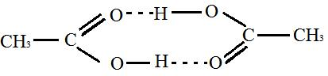

Dimer of Acetic acid

When the gas phase samples are measured by titration, we measure the total acetic acid concentration (monomer + dimer + tetramer). Whereas, the equality of fugacity coefficients in both the phases is valid for monomeric species of acetic acid. The, ‘y’ that we measure in eq. no

(1) is the total acetic acid concentration in the vapor phase. This needs to be corrected to represent the monomeric acetic acid. This is done by calculating the fugacity coefficient for acetic acid as well as water in the vapor phase as well as for acetic acid at the saturation pressure.

Derivation of fugacity coefficients considering the Dimerization of Acetic Acid in the Vapor

Phase

Let p_{m} = partial pressure of monomer acetic acid in vapor phase p_{D} = partial pressure of dimer acetic acid in vapor phase
p_{w} = partial pressure of water in vapor phase

^{pD} = K ₂ p_{m}²

Where, K₂, Equilibrium constant is given by:

log₁₀ K ₂ = | 3164 | −10.4184, where K2 has units of mmHg | −1 | (2)
log₁₀ K ₂ = | T | −10.4184, where K2 has units of mmHg |  | (2)

Fugacity coefficient at saturation pressure for pure acetic acid:

p_{AcOH}^{sat} = p_{m} + p_{D}

p_{AcOH}^{sat} = p_{m} + K₂ p_{m}²

1 = | p_{m} | + K |  | p_{m}² | _{p} sat
1 = |  | + K | ² _{p} sat² |  | _{p} sat
 | p_{AcOH}^{sat} |  |  |  | AcOH
 |  |  |  | AcOH

Define fugacity coefficient at saturation pressure as:

φ | sat | = |  | p_{m}
φ | AcOH | = | _{p} sat
 |  |  |  | AcOH
 |  | sat |  |  |  |  | sat | 2 | sat
1 = φ |  |  |  | + K ₂ |  | (φ | sat | ) | sat
 |  | AcOH |  |  |  | (φ | AcOH | ) | ^{p}AcOH

155

Chemical Engineering Laboratory Manual
Semester VI

sat | 2 | sat | sat
^{K}2 (^{φ}AcOH | ) | ^{p}AcOH | ^{+ φ}AcOH | −1 = 0

Solving the above equation we get φ^{sat}_{AcOH} , which is to be used in RHS of equation (1)

φ | sat |  | = |  |  | −1+ 1 + 4K ₂P_{AcOH}^{sat}
φ | AcOH |  |  |  |  |  | 2K ₂P_{AcOH}^{sat}
Fugacity Coefficient for Acetic acid in Vapor Phase
^{y} AcOH |  | = |  |  |  |  | p_{m} + 2 p_{D} |  |  |  | gives the mole fraction of acetic acid in the vapor phase
 |  | = |  |  | p_{m} |  | + 2 p_{D} |  | + p_{w}
P = p_{m} + p_{D} + p_{w} |  |  |  |  |  |  |  |  | gives the total pressure P (1 atm abs in our experiment)
p_{w} = P − p_{m} − p_{D}
^{y} AcOH |  | = |  |  |  |  | p_{m} + 2 p_{D}
 |  | = |  |  | ^{p}m |  | + 2 p_{D} |  | + P − p_{m} − p_{D}
^{y} AcOH |  | = |  |  | p_{m} + 2 p_{D}
 |  | = |  |  |  | P + p_{D}
y_{AcOH} (P + p_{D} ) = p_{m} + 2 p_{D}

y_{AcOH} (P + K₂ p_{m}² )= p_{m} + 2K₂ p_{m}²

y_{AcOH} P + y_{AcOH} K₂ p_{m}² = p_{m} + 2K₂ p_{m}²

p_{m}² (2K₂ − y_{AcOH} K₂ )+ p_{m} − y_{AcOH} P = 0

Define φ |  |  | v |  | = | p_{m} |  | = fugacity coefficient in the vapor phase
 |  |  | AcOH |  | = | ^{Py} AcOH
 |  |  |  |  |  |  |  |  | v |  | 1
v | 2 | (2K ₂ |  |  |  |  | )+ |  | ^{φ}AcOH |  | 1
^{φ}AcOH |  |  |  | ⁻ ^{y} AcOH ^{K} 2 |  |  |  |  |  | − |  |  | = 0
^{φ}AcOH |  |  |  |  |  |  |  |  | ^{Py} AcOH | − | ^{y} AcOH ^{P} |  | = 0
v | 2 | ^{Py} AcOH |  |  |  |  |  |  | v |  | −1 = 0
^{φ}AcOH |  |  |  |  | ^{K}2 (² ⁻ ^{y}AcOH )^{+φ}AcOH |  |  |  |  |  | −1 = 0

 |  |  |  | v
Solving this equation we get φ_{AcOH} , which is to be used on LHS of equation (1)
φ | v | = | −1+ 1+ 4K ₂ P y_{AcOH} (2 − y_{AcOH} )
φ | AcOH | = | 2 K ₂ P y_{AcOH} (2 − y_{AcOH} )
Fugacity Coefficient for Water in Vapor Phase
 |  |  | 156

(3)

(4)

Chemical Engineering Laboratory Manual
Semester VI

- v ₌ ^{p}w ^{w} Py _{w}

- v ₌ ^{P} ⁻ ^{p}m ⁻ ^{p}D ^{w} Py_{w}

 |  |  |  | v |  |  | v |  | 2
 |  |  | P − (φ | v | ^{Py} AcOH | )− (φ | v | ^{Py} AcOH | ) K₂
φ | v | = | P − (φ | AcOH | ^{Py} AcOH | )− (φ | AcOH | ^{Py} AcOH | ) K₂ |  | (5)
φ | w | = |  |  |  | Py_{w} |  |  |  |  | (5)

Using these fugacity coefficients correct values of γ_{i} need to be calculated.

A point to be noted here is that the pressure is close to 1 atmosphere, and the true pure component fugacity coefficients as well as fugacity coefficients in mixture of gases should be almost unity. The fugacity coefficients that we are actually calculating in (3) and (4) are the effective value to be used owing to fact that we are measuring total acetic acid concentration (monomer + dimmer) in the vapor phase. The fugacity coefficients calculated in equations (3) and (4) are in fact a correction factor that relate the monomeric acetic acid concentration in the vapor phase to the total acetic acid concentration in the vapor phase.

For testing the thermodynamic consistency we plot the graph of ln(γ₁/γ₂) vs. x₁ or x₂. These are found to be symmetric and the sum of areas under the curves is equal to zero.

A1 ⁺ A2 ⁼ ⁰
1 | ⎛ | γ |  | ⎞
 | ⎛ | γ | 1 | ⎞
This is obtained from the Gibb’s Duhem equation: | ln⎜ |  | 1 | ⎟dx |  | = 0
∫ | ⎜ | γ |  | ⎟ | 1
0 | ⎝ | γ | 2 | ⎠

This equation is valid only for constant ‘T’ and ‘P’. The experiment has been performed at constant ‘P’ but ‘T’ is varied. Thus, the activity coefficients calculated using equation (1) need to be converted to standard state 25°C isothermal basis. Only then the thermodynamic consistency can be checked. Activity coefficients at different temperatures are related (to 25°C standard state) by the following expression:

⎛ | γ _{i} |  | ⎞ | T |  |  | E
 |  |  |  |  |  | Hi
⎜ |  |  | ⎟
⎜ |  |  | ⎟ | = − ∫ |  |  |  | ₂ dT |  | (6)
ln⎜ | γ | ⎟ |  | = − ∫ | RT |  |  |  |  | (6)
⎝ | γ | i | ⎠ | 298

157

Chemical Engineering Laboratory Manual
Semester VI

The enthalpy of mixing data is:

xwater | ∆H^{mix} (cal/gmol)
0 | 0
0.05 | + 37.4
0.1 | + 60.6
0.2 | + 80.9
0.3 | + 84.1
0.4 | + 80.9
0.5 | + 73.5
0.6 | + 60.2
0.7 | + 39.1
0.8 | + 12.8
0.9 | - 8.1
0.95 | - 9.7
1.0 | 0

Using this Hi ^{E} can be calculated for water as well as acetic acid and then the activity coefficients can be converted to a standard state of 25ºC.
5. Procedure:

- Decide upon a mixture of acetic acid and water of a known concentration in the still keeping in mind its capacity (take mixtures so that the liquid phase mole fractions at equilibrium would be around 0.1, 0.3, 0.5, 0.7, 0.9. This will ensure that the data covers the whole range, especially important for Thermodynamic consistency check).

- Heat the mixture till equilibrium is reached. Steady temperatures of both the liquid and vapour indicate this. The still temperatures are actually slightly higher than the condensate temperature. This is due to the fact that the condensate thermometer actually measures the temperature of the vapour condensing on it. According to the TXY diagram, this temperature is lower than still temperature.

- Note the temperature at equilibrium in the still.

- Withdraw samples (2-5 ml) from the still and the condenser and titrate it against standardized NaOH.

158

Chemical Engineering Laboratory Manual
Semester VI

- Repeat steps 2-4 for other data points such that sufficient range of mole fraction (0.1 to 0.9) is covered.

- Check the data for consistency and using this data, fit a suitable equation for correlating the activity coefficient data.

- Propose a suitable correlative model for standard state activity coefficients γ_{i}

6. Data:

1. Molecular weight of acetic acid =60g/gmole

- Density of acetic acid = 1.038g/cm³

- Density of water = 1g/cm³

- Molecular weight of water = 18g/gmole

- Antoine Constants

For water
A |  | = 18.3036
B |  | = 3816.44
C |  | = - 46.13
For acetic acid
A |  | = 16.808
B |  | = 3405.57
C |  | = - 56.34
 |  |  | Acetic Acid | Water
 | Tc K |  | 594.4 | 647.3
 | Pc atm. |  | 57.1 | 217.6
 | Vc cm³/gmol |  | 171 | 56
 | Tb K |  | 391.1 | 373.2

159

Chemical Engineering Laboratory Manual
Semester VI

7. Calculations:

As per standard notations: subscript 1 indicates the more volatile component (water) and subscript 2 indicates the less volatile component (Acetic acid).

 |  |  |  |  |  |  |  |  | φ | sat | φ | v | φ | v
 |  |  |  |  |  | _{p}sat | _{p}sat |  | φ | 2 | φ |  | φ
Sr No | T | x₁ | x₂ | y₁ | y₂ | _{p}sat | _{p}sat | K₂ |  | 2 |  | 2 | 1 |  | γ₁ | γ₂
 |  |  |  |  |  | 1 | 2 |  | Eq.(3) |  | Eq.(4) |  | Eq.(5)
1
2
3
4
5
6
7
8
9
Further data analysis:

- Compare the T-x-y data that you obtain with the values reported in the literature (Perry) by plotting T-x-y curves.
- Using eq. no (6) convert the γ_{1,} γ₂ values to γ₁°, γ₂°.

1 | ⎛ | γ |  | ⎞
3. Check the thermodynamic consistency. | ⎛ | γ | 1 | ⎞ |  | = 0
3. Check the thermodynamic consistency. | ln⎜ |  | 1 | ⎟dx |  | = 0
∫ | ⎜ | γ |  | ⎟ | 1
0 | ⎝ | γ | 2 | ⎠

- Calculate (g^{E}/RT) from γ₁° and γ₂°.

- Fit a suitable model for correlating the activity coefficients data in the standard state.

- Conclusion:

- Comments:

- References:

- Sandler S. I., (1989), “Chemical and Engineering Thermodynamics”, “Chapter 7. The Estimation of the Gibbs Free Energy and Fugacity of a Component in a Mixture”, 2nd

Edition, John Wiley and Sons, 305-380.

160

Chemical Engineering Laboratory Manual
Semester VI

- Sebastiani, E., Lacquaniti, L., (1967), “Acetic acid – water system thermo dynamical correlation of vapor – liquid equilibrium data”, Chemical Engineering Science 22, 1155 –

1162.

- Prausnitz, John, M., Lichtenthaler, Rudiger, N., Azevedo, Edmundo Gomes de, (2008),

“Molecular Thermodynamics of Fluid Phase Equilibria”, Prentice Hall.

161

