Project Name : ReportBox
Name : Chinmaya Malla
Track : Personal Assistance
- Problem Statement:
Modern businesses often face challenges in bridging the gap between business reporting needs and the technical implementation required to deliver them. Business users typically express reporting requirements in natural language, while technical teams must translate these into structured specifications aligned with available data models. This translation process is time-consuming, error-prone, and requires constant back-and-forth communication.
The proposed agent aims to automate and streamline this workflow by performing the following sequence:
- Requirement Intake: Accept reporting requirements directly from business users in natural language.
- Technical Translation: Interpret the requirement in the context of available data models and convert it into a structured technical specification.
- SQL Generation: Automatically generate valid SQL queries based on the technical requirement and schema metadata.
- Data Retrieval: Execute the SQL queries using MCP tools to fetch the relevant dataset.
- Visualization & Delivery: Pass the retrieved data to an LLM or visualization engine to produce clear, user-friendly outputs such as graphs, dashboards, or reports.
This agent will act as a bridge between business intent and technical execution, reducing dependency on manual translation, improving accuracy, and accelerating the delivery of insights. By combining reasoning loops, memory, and external tool integration, the agent ensures that reporting requirements are consistently transformed into actionable, data-driven outputs.
- Benefits of the Proposed Agent System
- Multi-Dimensional Insights
- Lower Development Costs
- Faster Development Cycles
- Consistency and Accuracy
- Scalability
- User Empowerment
- Cost Efficiency in Maintenance
- Action of a multi-agent workflow:
Agent A: Requirement interpreter (business → technical).
Agent B: SQL generator (technical → query).
Human in the loop – Approval of the Query: Yes or No ( if No then rewrite )
MCP: Executor (query → data).
Agent C: Visualizer (data → report).
Agent D: Final verification between Sql results vs Visualizer (Avoid Hallucination)
Final report delivery
Modular LLM Uses :
- Structure your system so the LLM connection is modular, meaning it’s only active during the development and refinement phase of the report, then safely removed or disabled once the report logic is finalized.
Development Phase | Use LLM
UAT Phase | Use LLM | No LLM
Prod Phase |  | No LLM
System Diagram:
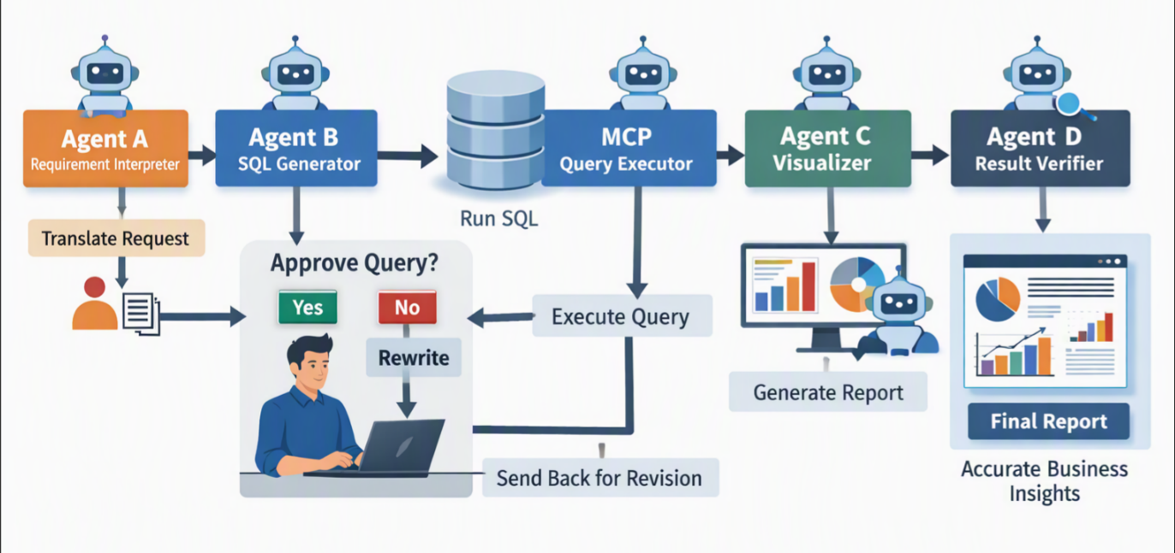
- Environment:
- Python /Lang graph Orchestration
- MCP - Tool Integration
- Post grace Database - Storage
- PDF /Weblinks
- LLM - Any Frontier LLM recommended
- How feedback guides the agent
Feedback as each step output is a input to the next agent
- Requirement Clarification
- SQL Query Refinement
- Visualization Adjustments
- Continuous Improvement
Disclaimer: The architecture and workflow design presented here are my original ideas. I used AI tools to help refine the language and presentation, so the description reads more naturally and professionally.

