**Academic Year:** 2024-2025 **Name of Student: Radhika Pradhan**

**Semester:** IV **Student ID: 22107005**

**Branch:** CSE(DS) **Date Of Performance: 7/1/25**

**Subject:** SEPM **Date Of Submission: 7/1/25**

**Name of Instructor: Prof. Harsha Zope**

Experiment No. 1

Aim:- To Implement a Github account and a repository using different commands.

Output

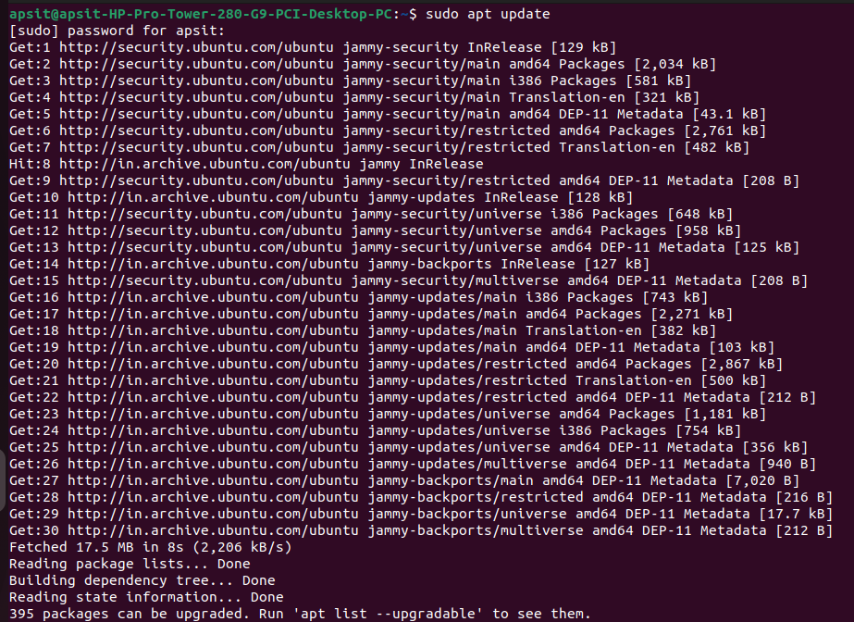1. Install Git

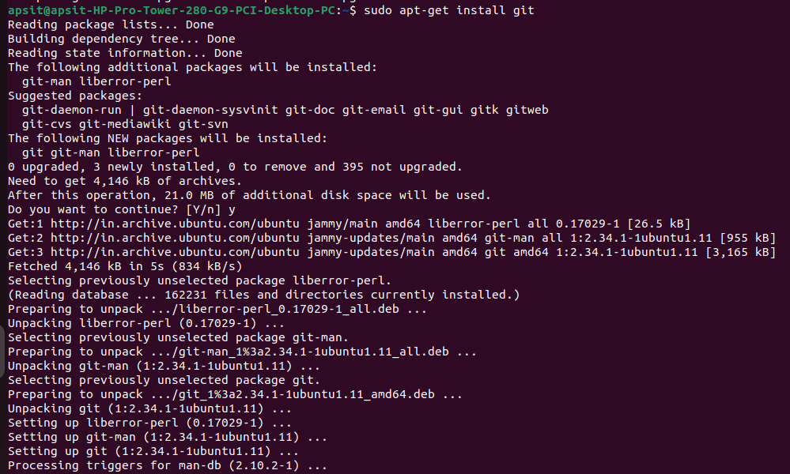

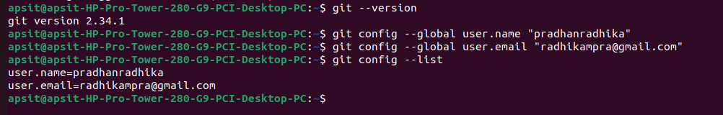

2. Login Github and Create new repository

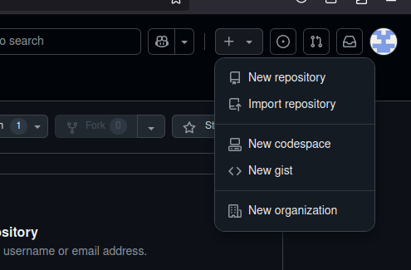

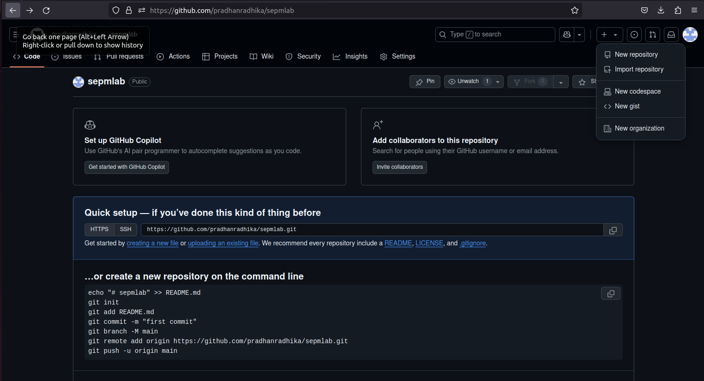

3. Create new folder



4. Git Initialize

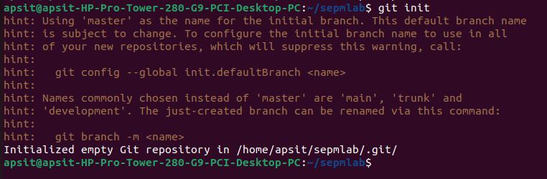



5. Create a file

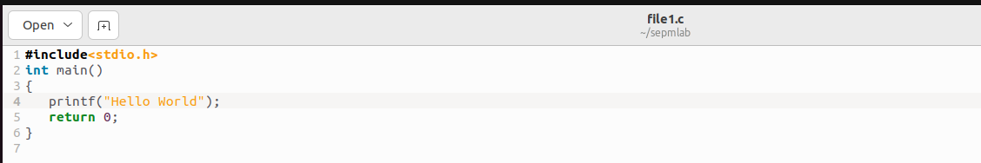

6. Add and Commit changes

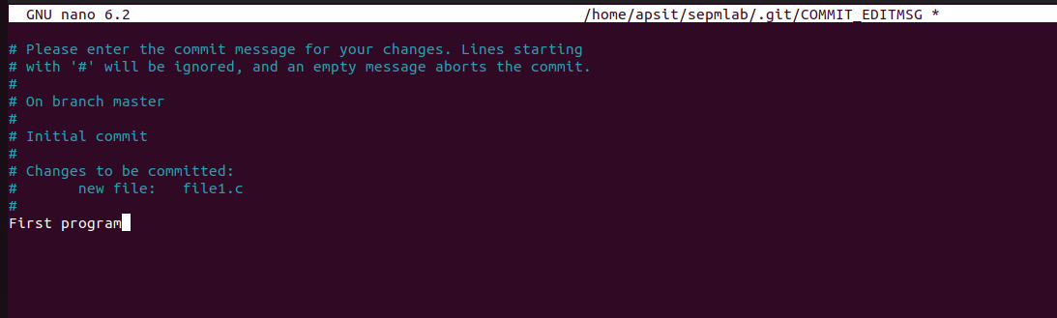

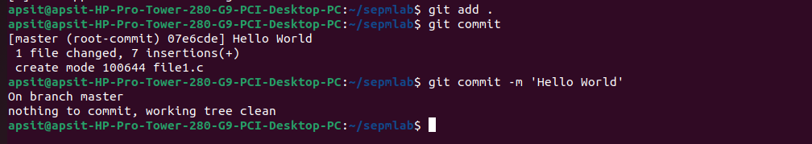

Conclusion: Hence successfully implemented Github account and a repository using different commands.