DATA ANALYTICS PORTFOLIO PROJECT

Customer Retention & Revenue Intelligence:
SQL Analysis of E-Commerce Behaviour
Chinwoke Uba
Tool: MySQL Workbench | Dataset: Online Retail (Kaggle)

Introduction & Business Context
A UK-based online gift retailer has asked its analytics team to explain why revenue growth stalled in the second half of 2011. Leadership suspects that rising cancellation rates and poor customer retention are the cause, but they need evidence and want to know which customer segments or product categories are driving the problem.
I am acting as the analyst supporting the Head of Commercial Strategy. Using SQL in MySQL Workbench, I analysed 541,909 transaction lines covering 1 December 2010 to 9 December 2011 to answer four questions:
- What does monthly revenue look like across the full period, and where did growth stall?
- Which customers have the highest lifetime value, and how recently did they last purchase?
- How significant is the cancellation problem, and which products or months are most affected?
- What does customer retention look like when measured by purchase cohort?
The report follows the order of the work: data inspection, database design, cleaning, four analyses, and an executive summary. All SQL is annotated and included in the appendix.

Dataset Summary & Data Quality Notes
The dataset is the Online Retail transaction file from Kaggle. Each row is one product line on an invoice, with eight columns: InvoiceNo, StockCode, Description, Quantity, InvoiceDate, UnitPrice, CustomerID and Country. It holds 541,909 rows covering 1st, December 2010 to 9th, December 2011. After cleaning, there are 4,338 identified customers and 3,664 distinct products.

Data quality observations:
Before writing any SQL I inspected the raw file in Excel and recorded the following:
- Date format. InvoiceDate is stored as text in M/D/YYYY H:MM format (for example 12/1/2010 8:26). Excel displayed it as 12.01.10 08:45. It must be converted to a proper DATETIME before any monthly analysis.
- Cancellations and bad rows. 10,624 rows have a negative Quantity. Most are cancellations, identified by an InvoiceNo beginning with "C" (for example C536379). A few negative rows, such as invoice 536589 with Quantity -10 and a blank Description, have no "C" prefix and are data errors rather than returns.
- Missing customers. 135,080 rows (24.9% of the file) have no CustomerID. These sales cannot be attributed to a customer, so they are excluded from all customer-level analysis.
- Zero prices and blank descriptions. Some rows have a UnitPrice of 0 and a blank Description (for example StockCode 22139 on invoice 536414), which are not genuine sales.
- Non-product codes. Several StockCodes are not merchandise: D (Discount), M (Manual), POST (postage), CRUK (charity), BANK CHARGES and AMAZONFEE. They distort product rankings and had to be handled separately in the cancellation analysis.
- Extreme quantities. Quantities of 80,995 and 74,215 units appear as single orders that were immediately cancelled. These are outliers, not normal demand.
- Import warnings. The MySQL import wizard stopped early (about 38,000 rows), so I reloaded the file with LOAD DATA. The load reported 4 "data truncated" warnings across 541,909 rows. I judged this negligible and did not investigate further.

Import verification
The raw_transactions table loaded all 541,909 rows, matching the brief, and 135,080 CustomerID values were converted to NULL, matching the Excel. 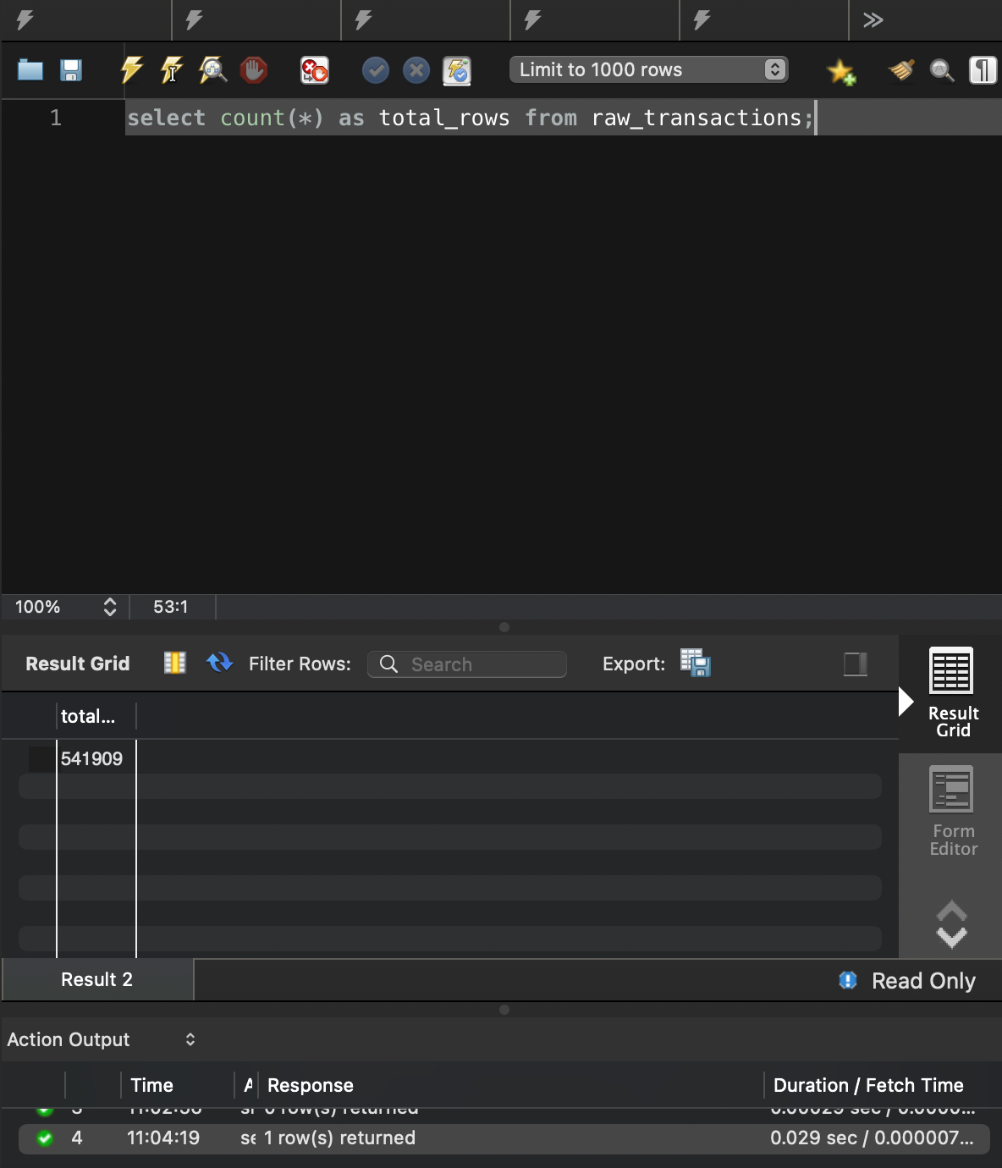
Row count after import.
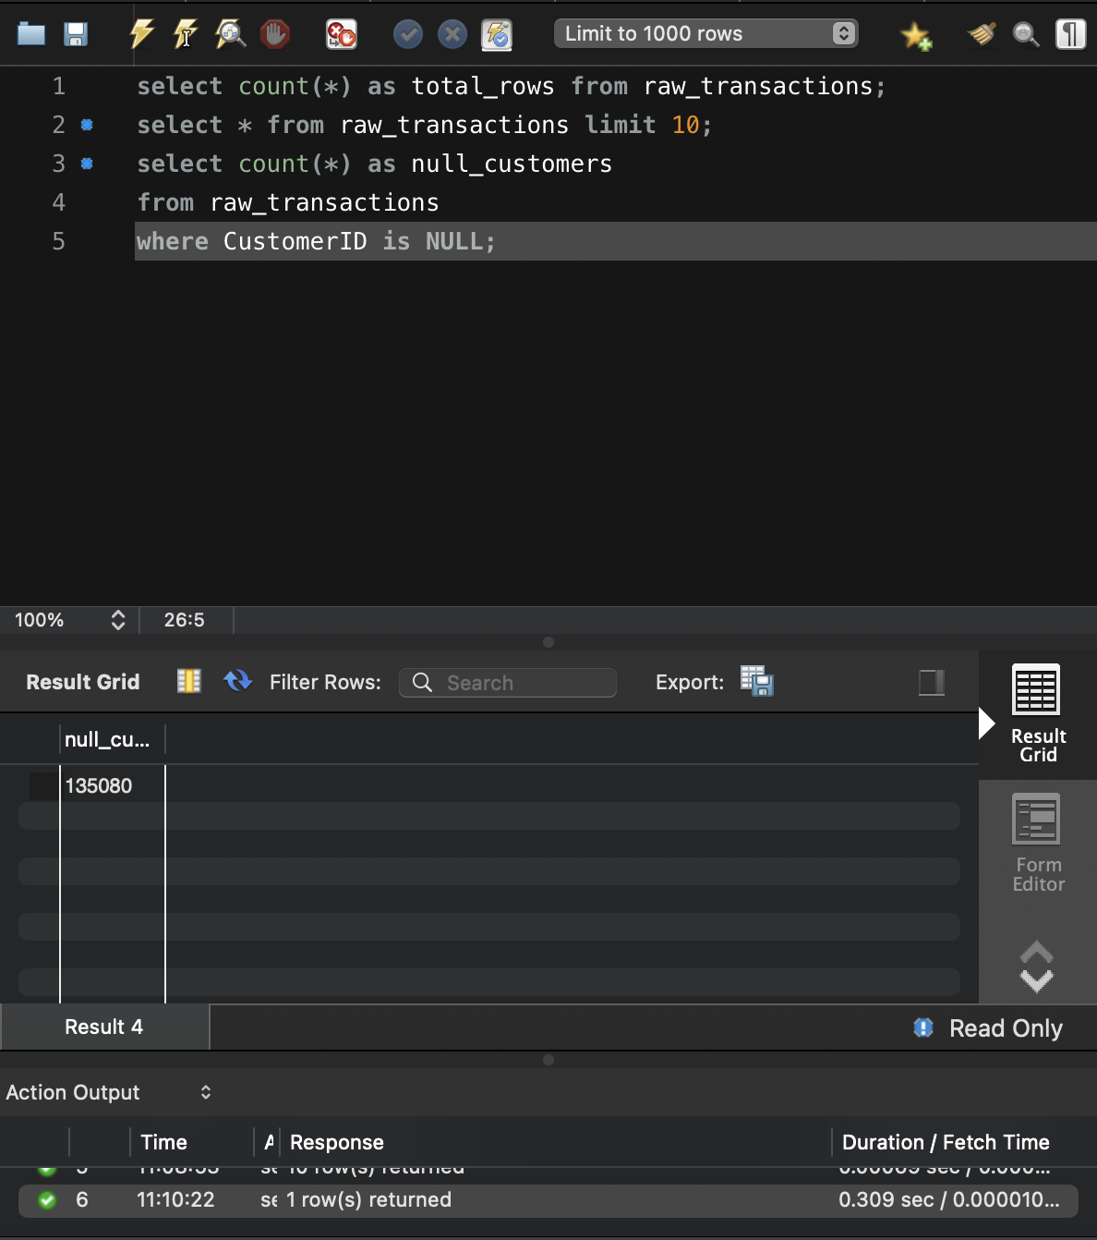
Null CustomerID count.

Database Schema & ERD
All work is in the ecommerce_analysis schema. raw_transactions holds the untouched CSV. The cleaned data is split into separate tables so that queries use JOINs, as they would in a real database.
Table | Rows | Purpose
raw_transactions | 541,909 | Unmodified copy of the CSV (source of truth).
clean_transactions | 397,880 | Valid sales only, with a real DATETIME date.
cancellations | [insert count] | Invoices beginning with "C" (negative quantities).
customers | 4,338 | One row per customer. Primary key: CustomerID.
products | 3,664 | One row per product. Primary key: StockCode.

Relationships
- customers.CustomerID has a one-to-many relationship with clean_transactions.CustomerID: one customer, many transaction lines.
- products.StockCode has a one-to-many relationship with clean_transactions.StockCode: one product appears on many lines.
- cancellations links to customers and products through the same two columns.
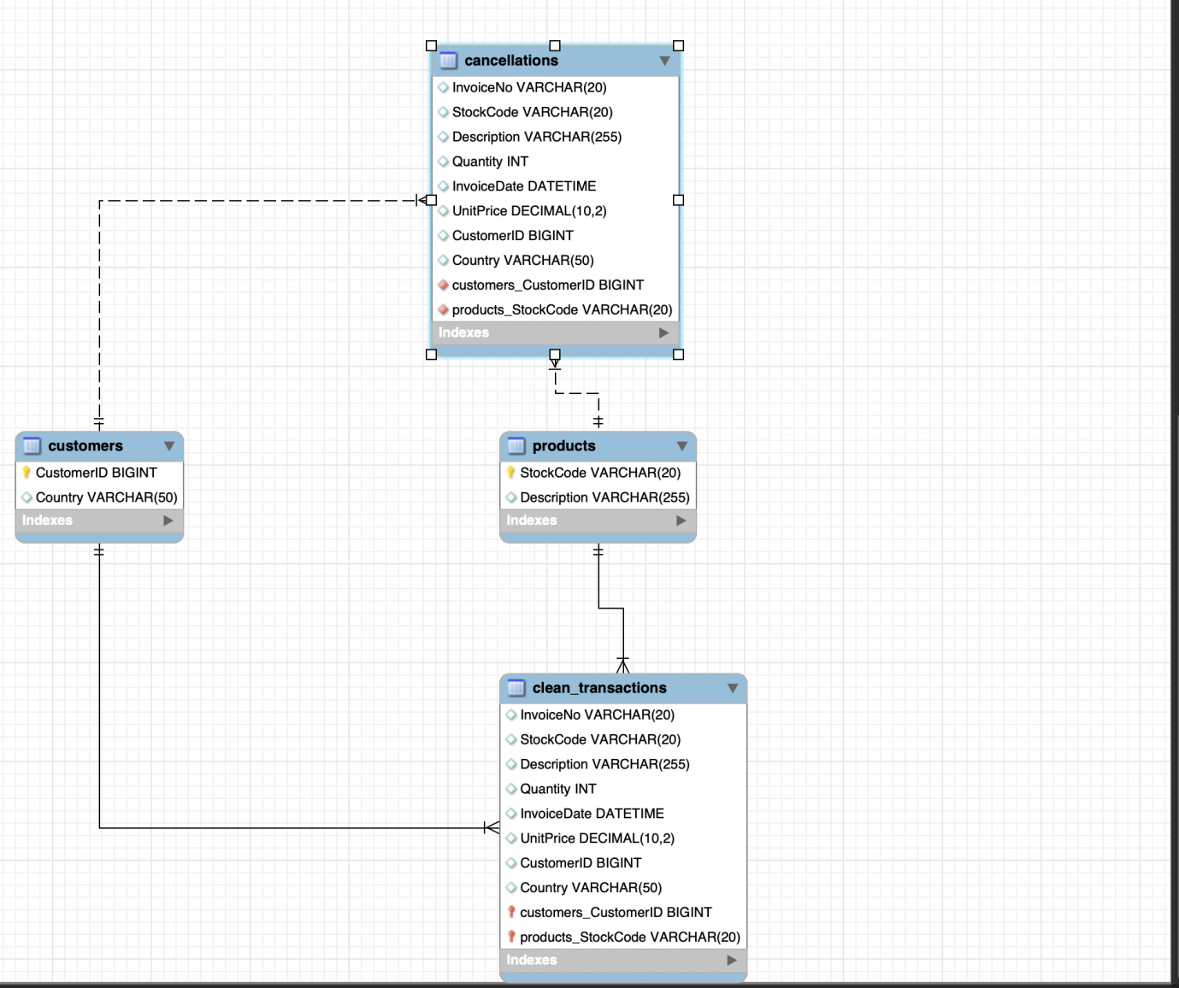 Entity relationship diagram(ERD). The relationships are modelled in the diagram only; they are not enforced as foreign keys in MySQL.

Data Cleaning Approach
The cleaning logic creates two tables from raw_transactions in a single pass:
- clean_transactions keeps rows where CustomerID is not NULL, Quantity > 0, UnitPrice > 0 and InvoiceNo does not start with "C". InvoiceDate is converted with STR_TO_DATE using the pattern %m/%d/%Y %H:%i.
- cancellations keeps rows where InvoiceNo starts with "C", so they can be analysed separately rather than discarded.
The cleaning removed 144,029 of 541,909 rows (26.6%), leaving 397,880 valid sales lines. The first and last invoice dates in the clean table are 2010-12-01 and 2011-12-09.
Two judgement calls are worth noting. First, rows with a negative or zero Quantity that do not start with "C" are neither valid sales nor genuine cancellations, so they appear in neither table. Second, the cancellations table keeps all "C" invoices, including those with no CustomerID and those for fee or adjustment codes. I deal with those in Section 7 rather than hiding them at this stage.
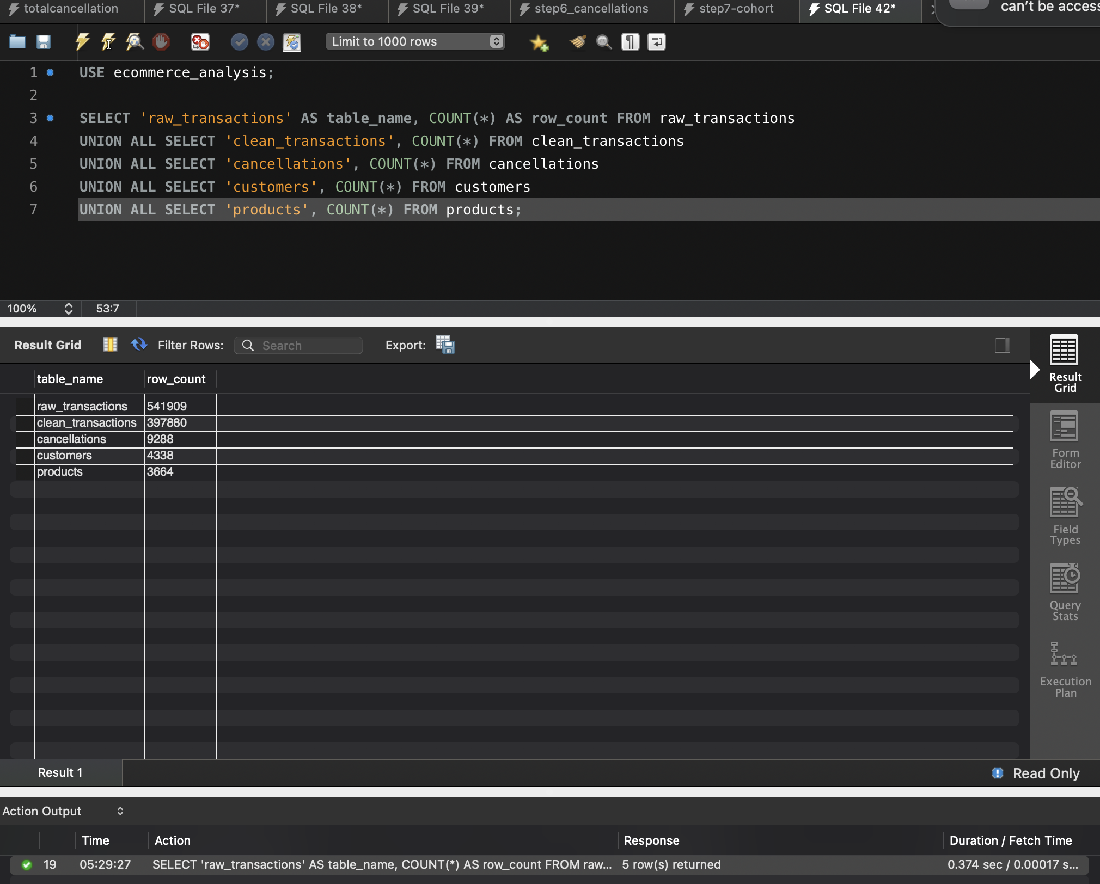Cleaned table row counts

Revenue Trends

Monthly Revenue Summary
Revenue is SUM(Quantity x UnitPrice) from clean_transactions, grouped by month. Orders are counted as distinct invoices. LAG() supplies the previous month so each row shows the month-on-month change and percentage growth.
Month | Revenue (£) | Orders | MoM change (£) | MoM growth (%)
2010-12 | 572,713.89 | 1,400 | - | -
2011-01 | 569,445.04 | 987 | -3,268.85 | -0.57
2011-02 | 447,137.35 | 997 | -122,307.69 | -21.48
2011-03 | 595,500.76 | 1,321 | +148,363.41 | +33.18
2011-04 | 469,200.36 | 1,149 | -126,300.40 | -21.21
2011-05 | 678,594.56 | 1,555 | +209,394.20 | +44.63
2011-06 | 661,213.69 | 1,393 | -17,380.87 | -2.56
2011-07 | 600,091.01 | 1,331 | -61,122.68 | -9.24
2011-08 | 645,343.90 | 1,280 | +45,252.89 | +7.54
2011-09 | 952,838.38 | 1,755 | +307,494.48 | +47.65
2011-10 | 1,039,318.79 | 1,929 | +86,480.41 | +9.08
2011-11 | 1,161,817.38 | 2,657 | +122,498.59 | +11.79
2011-12* | 518,192.79 | 778 | -643,624.59 | -55.40
Monthly revenue with month-on-month growth. *December 2011 covers only 1 to 9 December. Currency assumed to be GBP.

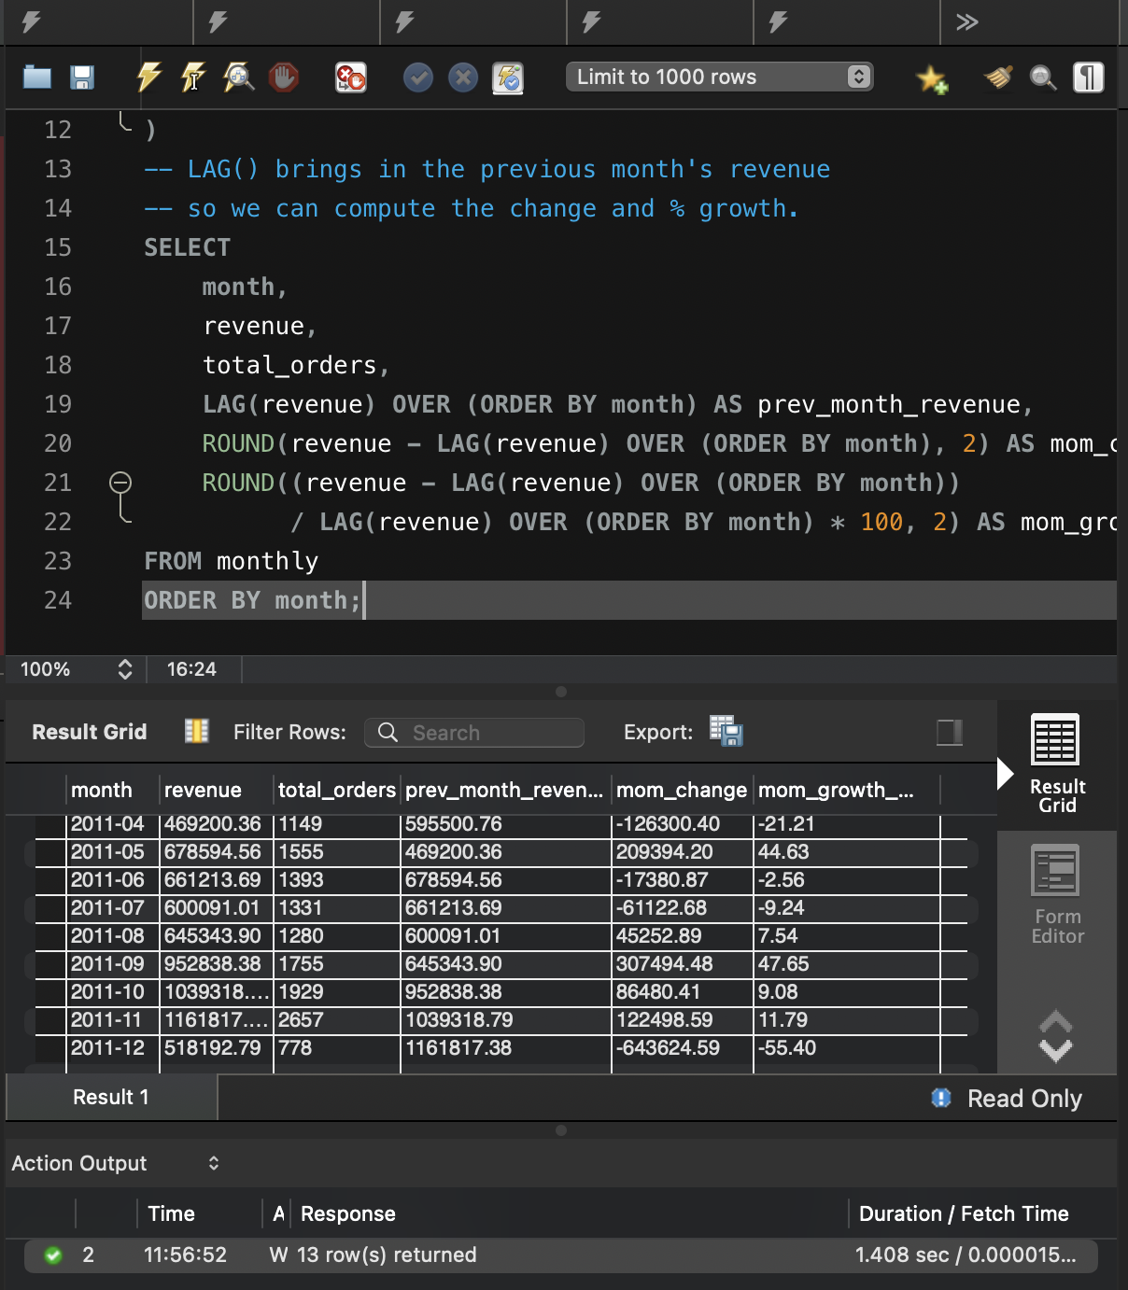
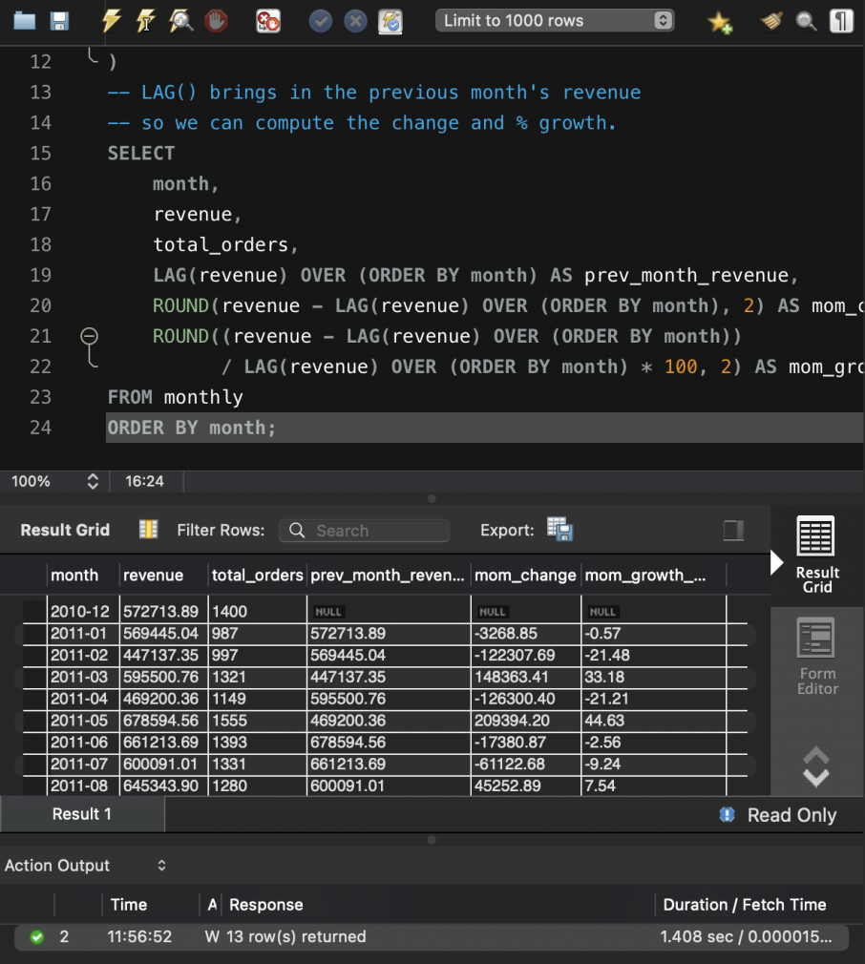
Monthly revenue query result.
Revenue rose from £572,714 in December 2010 to a peak of £1,161,817 in November 2011. Total revenue across the period is £8,911,408. Average monthly revenue in January to June 2011 was about £570,000, compared with about £880,000 in July to November, so the second half was not weaker overall.

Month-on-Month Growth and the Inflection Point
Growth turned negative in February (-21.48%), April (-21.21%), June (-2.56%) and July (-9.24%), plus a marginal dip in January (-0.57%). The slowdown that matters most for the brief is the mid-year one: revenue peaked at £678,595 in May, then fell in June and July to £600,091 before recovering in August (+7.54%).
The real inflection point is September 2011, when revenue jumped 47.65% to £952,838 and stayed above £1 million in October and November. This pattern is consistent with seasonal gift buying ahead of Christmas. The 55.40% fall in December 2011 is not a genuine collapse: the data stops on 9 December, so that month contains only nine days of trading.

Customer Value & Segmentation
For each customer I calculated total revenue, number of orders and most recent purchase date in a CTE. The outer query adds days since last purchase (measured from the last date in the data, 9 December 2011), a RANK() by revenue, and a CASE WHEN segment. My thresholds are High Value at £5,000 or more, Mid Value at £1,000 to £4,999, and Low Value below £1,000.
Rank | CustomerID | Revenue (£) | Orders | Last purchase | Days since | Segment
1 | 14646 | 280,206.02 | 73 | 2011-12-08 | 1 | High Value
2 | 18102 | 259,657.30 | 60 | 2011-12-09 | 0 | High Value
3 | 17450 | 194,550.79 | 46 | 2011-12-01 | 8 | High Value
4 | 16446 | 168,472.50 | 2 | 2011-12-09 | 0 | High Value
5 | 14911 | 143,825.06 | 201 | 2011-12-08 | 1 | High Value
6 | 12415 | 124,914.53 | 21 | 2011-11-15 | 24 | High Value
7 | 14156 | 117,379.63 | 55 | 2011-11-30 | 9 | High Value
8 | 17511 | 91,062.38 | 31 | 2011-12-07 | 2 | High Value
9 | 16029 | 81,024.84 | 63 | 2011-11-01 | 38 | High Value
10 | 12346 | 77,183.60 | 1 | 2011-01-18 | 325 | High Value
11 | 16684 | 66,653.56 | 28 | 2011-12-05 | 4 | High Value
12 | 14096 | 65,164.79 | 17 | 2011-12-05 | 4 | High Value
13 | 13694 | 65,039.62 | 50 | 2011-12-06 | 3 | High Value
14 | 15311 | 60,767.90 | 91 | 2011-12-09 | 0 | High Value
15 | 13089 | 58,825.83 | 97 | 2011-12-07 | 2 | High Value
16 | 17949 | 58,510.48 | 45 | 2011-12-08 | 1 | High Value
17 | 15769 | 56,252.72 | 26 | 2011-12-02 | 7 | High Value
18 | 15061 | 54,534.14 | 48 | 2011-12-06 | 3 | High Value
19 | 14298 | 51,527.30 | 44 | 2011-12-01 | 8 | High Value
20 | 14088 | 50,491.81 | 13 | 2011-11-29 | 10 | High Value
Top 20 customers by lifetime revenue.
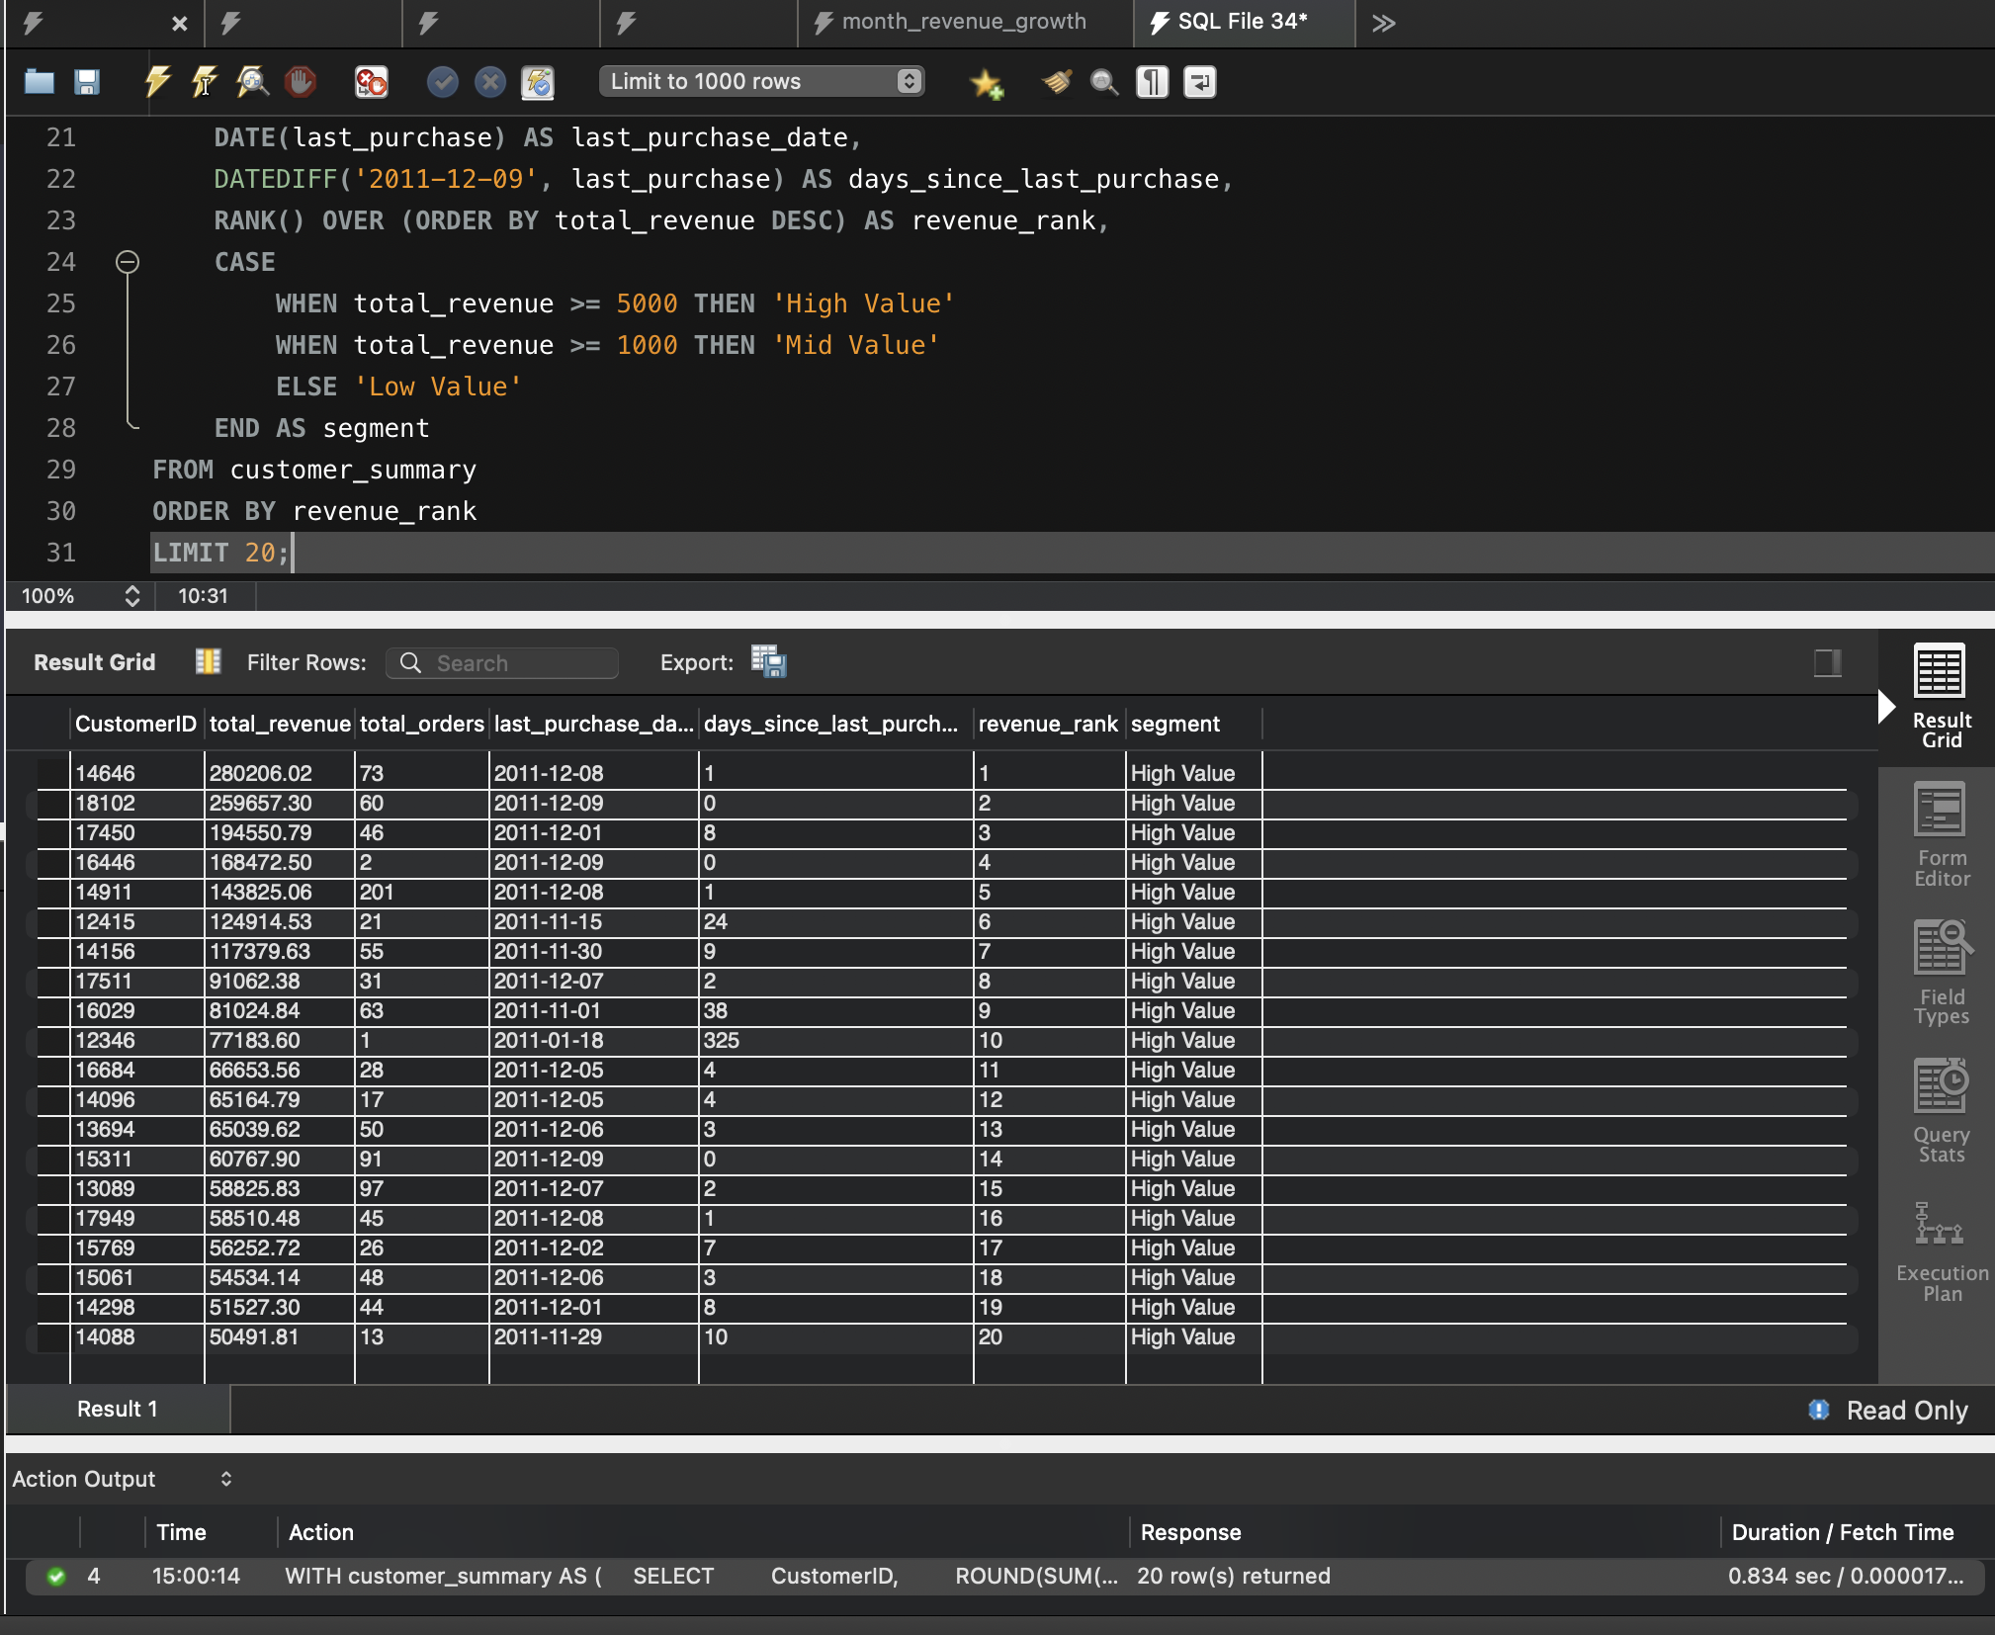
Segment | Customers | % of customers | Revenue (£) | % of revenue
High Value (≥ £5,000) | 275 | 6.3% | 4,801,772 | 53.9%
Mid Value (£1,000 to £4,999) | 1,393 | 32.1% | 3,001,900 | 33.7%
Low Value (< £1,000) | 2,670 | 61.5% | 1,107,737 | 12.4%
Total | 4,338 | 100% | 8,911,409 | 100%
Customers and revenue by segment.

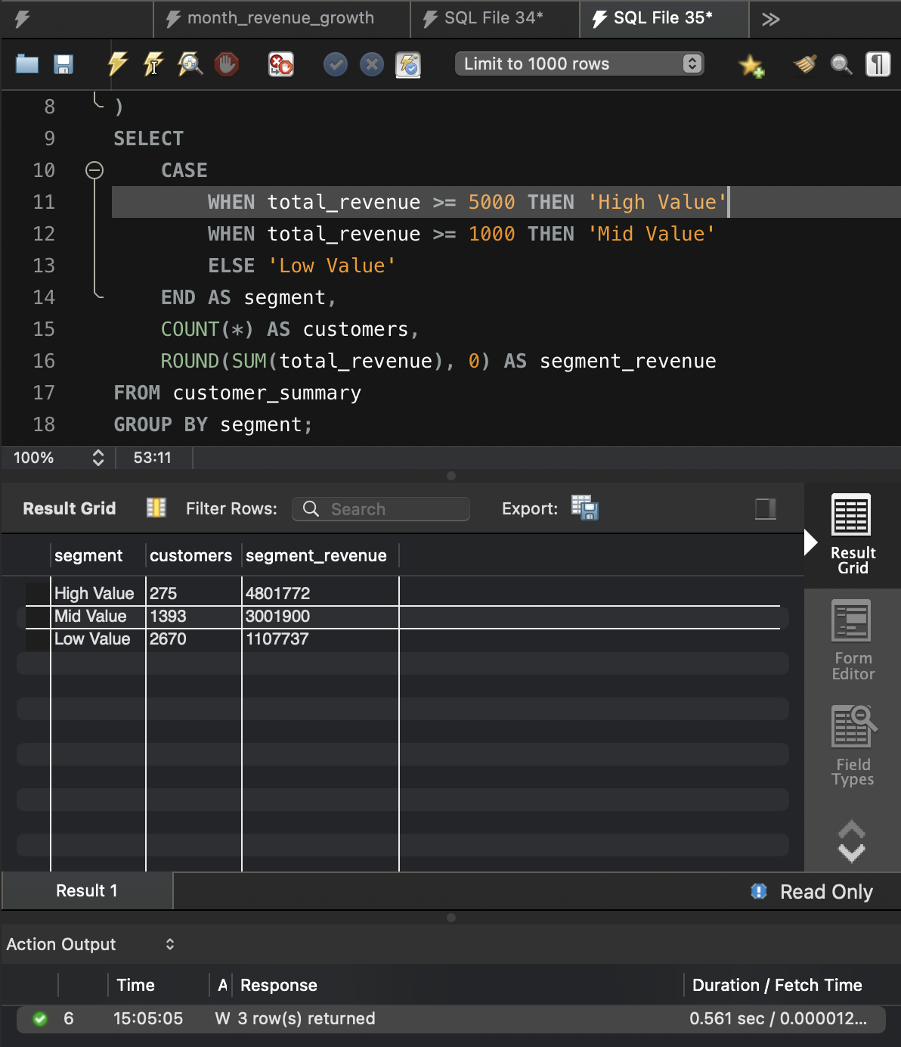
Segment summary query result.
The High Value segment contains 275 customers, 6.3% of the base, yet generates £4.80 million, or 53.9% of total revenue. The top 20 customers alone account for £2.13 million (23.9% of revenue). The top ten are the largest wholesale-style accounts, with spend between £77,000 and £280,000, and several combine very high spend with frequent ordering: customer 14911 placed 201 orders and customers 13089 and 15311 placed 97 and 91.
Recency is encouraging. 17 of the top 20 customers bought within ten days of the dataset ending, so the best customers are still active. Two exceptions need care. Customer 12346 spent £77,184 in a single order and has not returned for 325 days, and customer 16446 spent £168,473 in only two orders. These match the two bulk orders that were later cancelled (Section 7), and because clean_transactions excludes cancellations, their lifetime value is overstated. Dependence on a small number of large accounts is also a revenue risk if they lapse.

Cancellation Deep Dive

Cancellations by month
Two CTEs summarise gross revenue (from clean_transactions) and cancelled revenue (from cancellations), and a JOIN compares them month by month. ABS() converts negative cancelled quantities to positive values.
Month | Gross (£) | Cancelled (£) | Cancelled qty | Net (£) | Cancelled %
2010-12 | 572,713.89 | 74,789.12 | 16,042 | 497,924.77 | 13.06
2011-01 | 569,445.04 | 131,364.30 | 79,845 | 438,080.74 | 23.07
2011-02 | 447,137.35 | 25,569.24 | 2,871 | 421,568.11 | 5.72
2011-03 | 595,500.76 | 34,372.28 | 5,395 | 561,128.48 | 5.77
2011-04 | 469,200.36 | 44,601.50 | 13,645 | 424,598.86 | 9.51
2011-05 | 678,594.56 | 47,202.51 | 5,868 | 631,392.05 | 6.96
2011-06 | 661,213.69 | 70,616.78 | 7,362 | 590,596.91 | 10.68
2011-07 | 600,091.01 | 37,921.08 | 6,028 | 562,169.93 | 6.32
2011-08 | 645,343.90 | 54,333.75 | 12,346 | 591,010.15 | 8.42
2011-09 | 952,838.38 | 38,902.55 | 7,429 | 913,935.83 | 4.08
2011-10 | 1,039,318.79 | 84,274.63 | 24,541 | 955,044.16 | 8.11
2011-11 | 1,161,817.38 | 47,740.08 | 12,621 | 1,114,077.30 | 4.11
2011-12* | 518,192.79 | 205,124.67 | 83,581 | 313,068.12 | 39.58
Gross versus cancelled revenue by month. *December 2011 is a partial month.
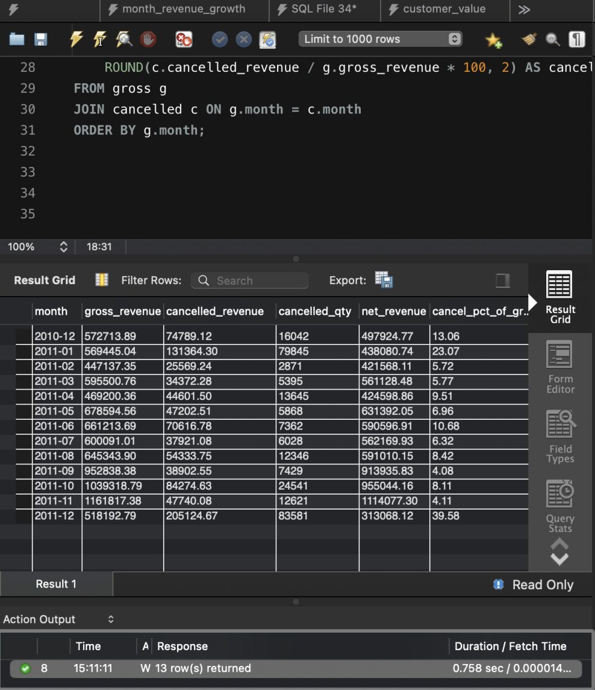
Monthly cancellation query result.
Cancelled revenue totals £896,812, which is 10.1% of gross revenue of £8,911,408 (the check query is Query 6.2 in the Appendix).
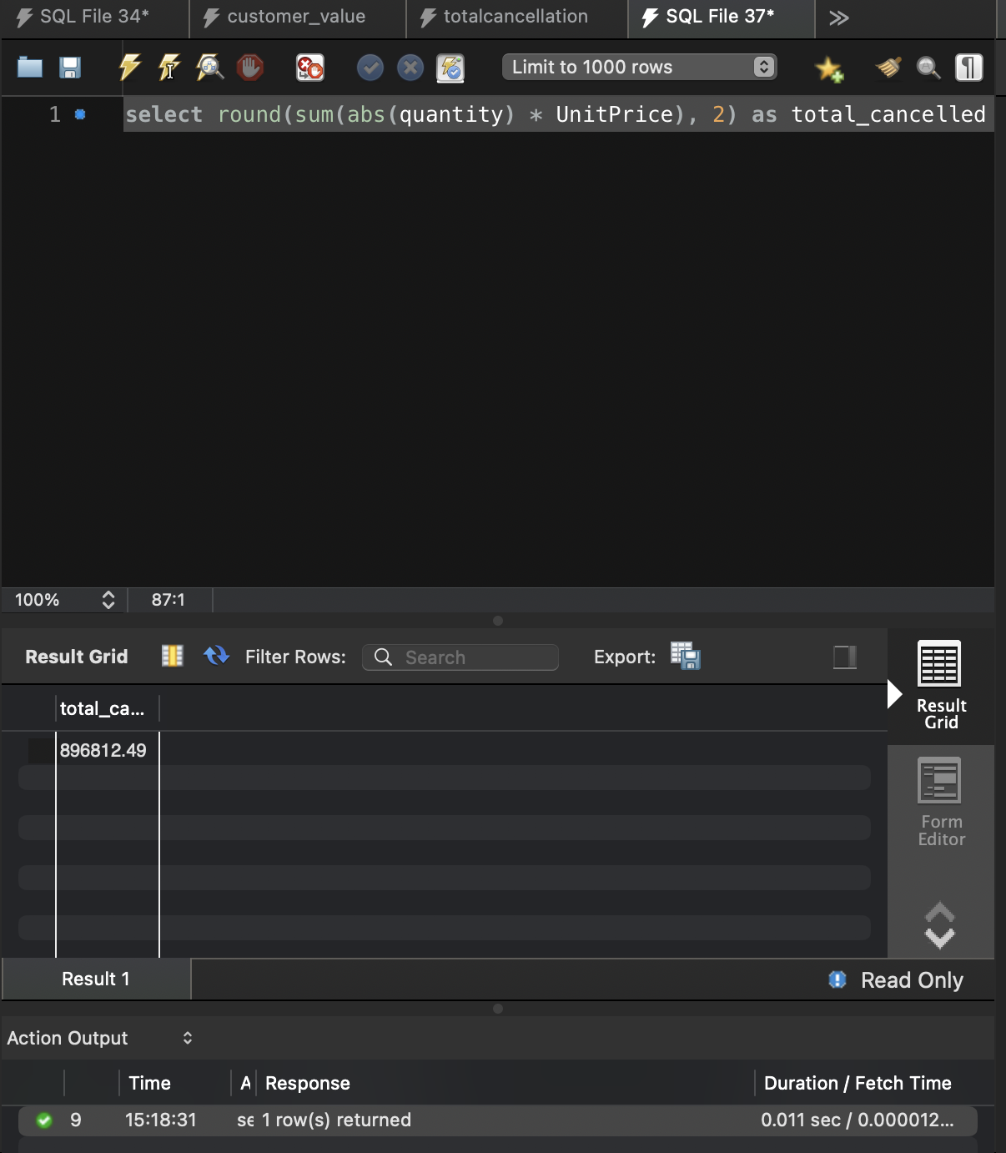
Total cancelled revenue.
By percentage, December 2011 is the worst month at 39.58% (£205,125 cancelled), but it covers only nine days. The worst full month is January 2011, with £131,364 cancelled (23.07% of gross). The cancelled quantities in these two months (79,845 and 83,581 units) are almost entirely explained by two single bulk orders that were placed and reversed, which are examined below. November 2011, the peak revenue month, had one of the lowest rates (4.11%). This does not support the idea that cancellations in November and December wiped out a month of net revenue.

Most-cancelled products
A subquery totals cancelled quantity and revenue per StockCode, and the outer query joins to the products table to add names. Ranked by cancelled revenue without any filtering, the top five stock codes are:
Rank | StockCode | What it is | Cancelled revenue (£)
1 | AMAZONFEE | Marketplace fee adjustment (not merchandise) | 235,281.59
2 | 23843 | Paper Craft, Little Birdie (80,995 units, one order) | 168,469.60
3 | M | Manual adjustment (not merchandise) | 146,784.46
4 | 23166 | Medium Ceramic Top Storage Jar (about 74,000 units, one order) | 77,479.64
5 | POST | Postage (not merchandise) | 11,871.24
Unfiltered top five by cancelled revenue.
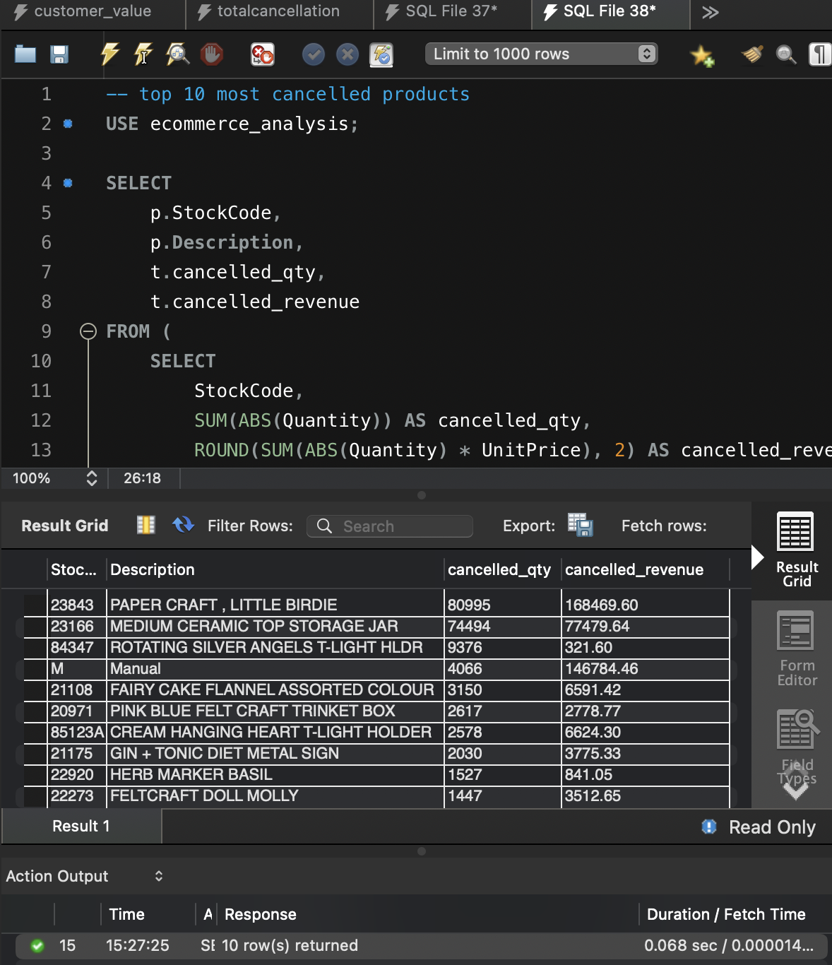
Top 10 cancelled products by quantity.
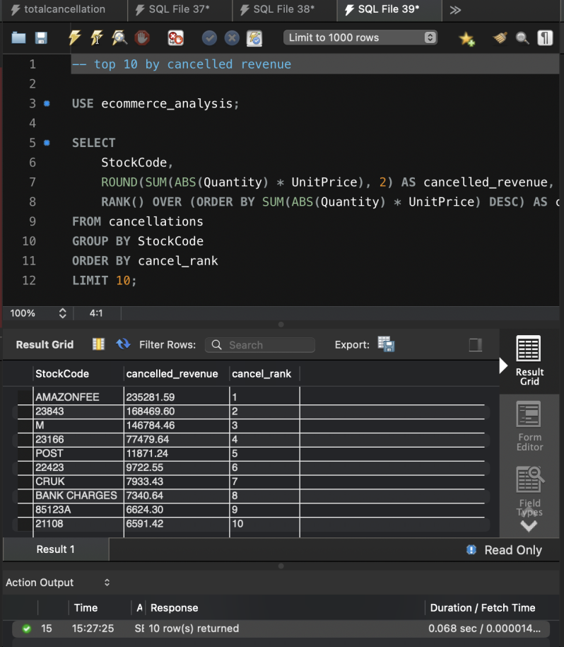
Stock codes ranked by cancelled revenue.
These results show that the largest cancellation figures are not product quality problems. Two products, 23843 and 23166, come from single orders of roughly 80,000 and 74,000 units that were placed and then fully reversed, together about £246,000 (27% of all cancelled revenue). Five of the top ten codes (AMAZONFEE, M, POST, CRUK and BANK CHARGES) are fees and adjustments worth about £409,000 (46%). Together these two groups explain about 73% of cancelled revenue, which leaves roughly £242,000 of ordinary merchandise cancellations, about 2.7% of gross revenue. These shares are approximate because other adjustment codes (D, DOT, S) were not totalled separately.

Problem SKUs (merchandise only)
To find genuine problem products, I excluded fee and adjustment codes and the two outlier orders, then ranked the rest by cancelled revenue.
Rank | StockCode | Product | Cancelled qty | Cancelled (£)
1 | 22423 | Regency Cakestand 3 Tier | 857 | 9,722.55
2 | 85123A | Cream Hanging Heart T-Light Holder | 2,578 | 6,624.30
3 | 21108 | Fairy Cake Flannel Assorted Colour | 3,150 | 6,591.42
4 | 23113 | Pantry Chopping Board | 946 | 4,803.06
5 | 48185 | Doormat Fairy Cake | 674 | 4,554.90
6 | 21175 | Gin + Tonic Diet Metal Sign | 2,030 | 3,775.33
7 | 47566B | Tea Time Party Bunting | 1,424 | 3,692.95
8 | 22273 | Feltcraft Doll Molly | 1,447 | 3,512.65
9 | 71477 | Colour Glass Star T-Light Holder | 1,228 | 3,443.62
10 | 20971 | Pink Blue Felt Craft Trinket Box | 2,617 | 2,778.77
Top 10 problem SKUs after exclusions.
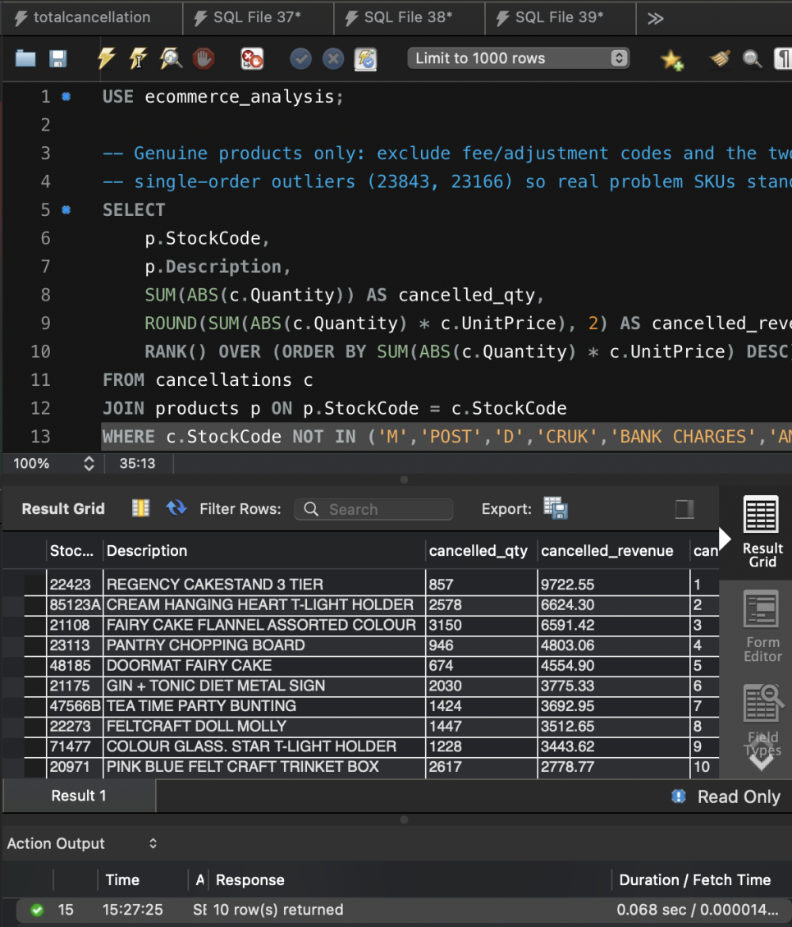
Problem SKU query result.
The Regency Cakestand 3 Tier is the costliest genuine cancellation at £9,723 despite a modest 857 units, because it is a high-priced item. The Cream Hanging Heart T-Light Holder, Fairy Cake Flannel and Pink Blue Felt Craft Trinket Box have high unit counts, but the T-Light Holder is also one of the best-selling lines, so part of its cancellation volume is just sales volume. The ten SKUs together account for £49,499 in cancelled revenue.

Cohort Retention
Each customer is assigned to a cohort based on the month of their first purchase. For each following month I counted how many customers from that cohort bought again, then divided by the cohort size. Month 0 is always 100%.

Cohort | Size | M1 % | M2 % | M3 % | M4 % | M5 % | M6 %
2010-12 | 885 | 36.6 | 32.3 | 38.4 | 36.3 | 39.8 | 36.3
2011-01 | 417 | 22.1 | 26.6 | 23.0 | 32.1 | 28.8 | 24.7
2011-02 | 380 | 18.7 | 18.7 | 28.4 | 27.1 | 24.7 | 25.3
2011-03 | 452 | 15.0 | 25.2 | 19.9 | 22.3 | 16.8 | 26.8
2011-04 | 300 | 21.3 | 20.3 | 21.0 | 19.7 | 22.7 | 21.7
2011-05 | 284 | 19.0 | 17.3 | 17.3 | 20.8 | 23.2 | 26.4
2011-06 | 242 | 17.4 | 15.7 | 26.4 | 23.1 | 33.5 | 9.5*
2011-07 | 188 | 18.1 | 20.7 | 22.3 | 27.1 | 11.2* | n/a
2011-08 | 169 | 20.7 | 24.9 | 24.3 | 12.4* | n/a | n/a
2011-09 | 299 | 23.4 | 30.1 | 11.4* | n/a | n/a | n/a
2011-10 | 358 | 24.0 | 11.5* | n/a | n/a | n/a | n/a
2011-11 | 323 | 11.1* | n/a | n/a | n/a | n/a | n/a
2011-12 | 41 | n/a | n/a | n/a | n/a | n/a | n/a

Cohort retention as % of cohort size. * Final observed month is December 2011, which is partial (9 days), so the figure is artificially low. n/a = not yet observable.
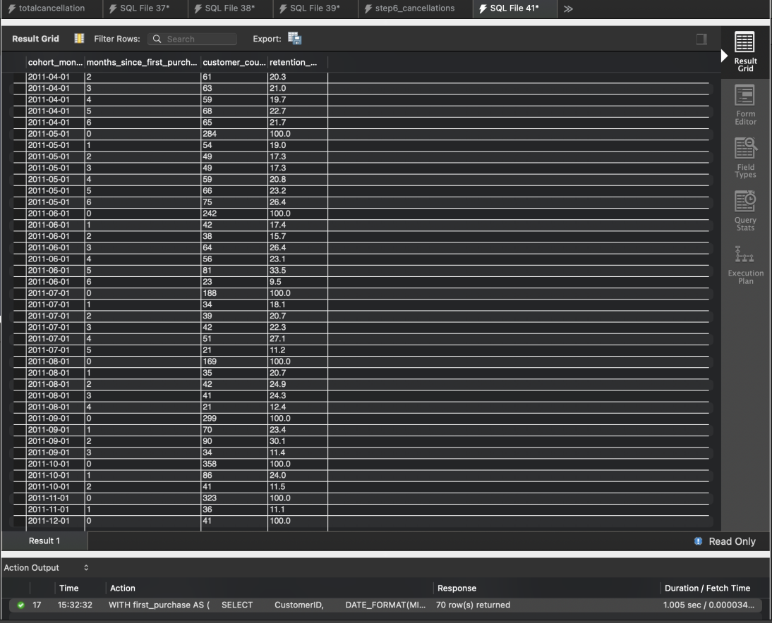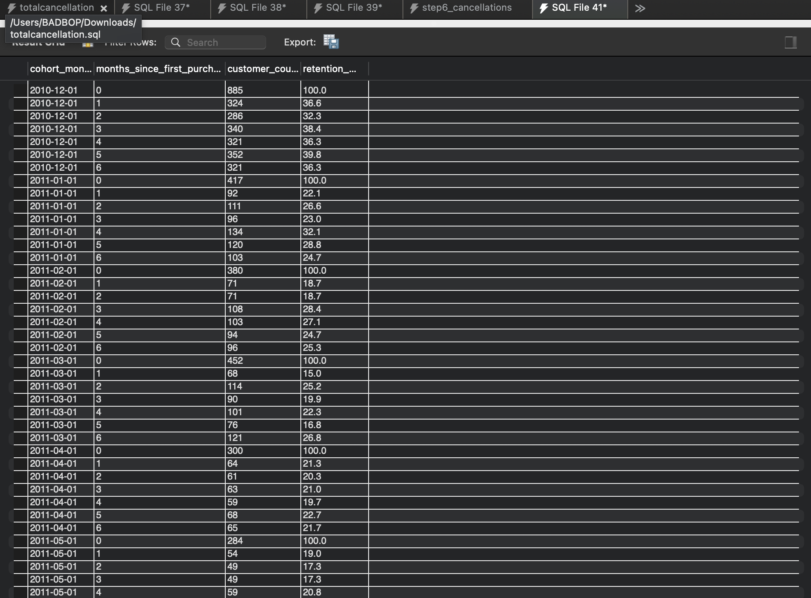
Cohort retention query result (70 rows).

Interpretation
Month 1 retention is the clearest measure of loyalty. The December 2010 cohort of 885 customers stands out: 36.6% returned in Month 1 and between 32% and 40% were active in every month through Month 6. This group needs careful reading, because the data begins in December 2010, so the cohort contains customers who were already buying before the data starts. Their "first purchase" is only the first one we can see, which inflates the apparent loyalty.
Every later cohort retained far less. Month 1 retention was 22.1% for January 2011 and fell as low as 15.0% for March, which means roughly four in five customers acquired in early 2011 did not buy again in the following month. Customers acquired in September and October 2011 did better at 23.4% and 24.0% in Month 1, and the September cohort reached 30.1% in Month 2, probably reflecting Christmas buying. Retention also tends to recover in later months (the June cohort reached 33.5% in Month 5), which suggests customers return on a gift-buying cycle rather than a monthly habit. The business acquires between 170 and 450 new customers a month but converts too few into repeat buyers, which supports leadership's concern about poor retention.

Executive Summary
You asked why revenue growth appeared to stall in the second half of 2011 and which customers or products are responsible. The data points to four findings.
- Revenue did not stall in the second half; it dipped in mid-year. Revenue fell 2.6% in June and 9.2% in July, then surged to a peak of £1.16 million in November, double the £573,000 of December 2010.
Recommendation: Plan summer promotions to avoid a repeat of the June and July lull.
- A small group of customers carries the business. The 275 High Value customers (6.3% of the base) generate 53.9% of revenue, and the top 20 alone generate 23.9%.
Recommendation: Introduce dedicated account management for these customers.
- Cancellations are 10.1% of revenue, but most are not ordinary returns. Of £897,000 cancelled, roughly £409,000 is fees and adjustments and £246,000 is two bulk orders that were placed and reversed. Ordinary product cancellations are only about 2.7% of revenue.
Recommendation: Report fees and products separately and add checks on very large orders.
- Customers rarely come back. Only 15% to 24% of customers acquired in each month of 2011 bought again the following month.
Recommendation: Launch a second-purchase offer within 30 days of a first order.

December 2011 covers only nine days and should not be read as a decline.

All SQL Scripts
All scripts are in MySQL syntax. Green lines are comments explaining what each block does and why.

Database, raw table and import
-- Create the project database and the raw table

CREATE SCHEMA IF NOT EXISTS ecommerce_analysis;
USE ecommerce_analysis;

-- The raw table mirrors the CSV exactly (no cleaning yet).
-- InvoiceNo is VARCHAR because cancellations start with 'C'.
-- InvoiceDate is VARCHAR for now; it is converted to DATETIME in Step 3.
-- CustomerID is VARCHAR because about 135k values are blank.
CREATE TABLE raw_transactions (
InvoiceNo VARCHAR(20),
StockCode VARCHAR(20),
Description VARCHAR(255),
Quantity INT,
InvoiceDate VARCHAR(30),
UnitPrice DECIMAL(10,2),
CustomerID VARCHAR(20),
Country VARCHAR(50)
);

-- The Workbench import wizard stopped early (about 38k rows), so the file
-- was loaded with LOAD DATA LOCAL INFILE instead.
-- NULLIF turns blank CustomerID values into real NULLs.
SET GLOBAL local_infile = 1;

LOAD DATA LOCAL INFILE '/Users/BADBOP/Downloads/data.csv'
INTO TABLE raw_transactions
CHARACTER SET latin1
FIELDS TERMINATED BY ',' OPTIONALLY ENCLOSED BY '"'
LINES TERMINATED BY '\n'
IGNORE 1 LINES
(InvoiceNo, StockCode, Description, Quantity, InvoiceDate, UnitPrice, @cust, Country)
SET CustomerID = NULLIF(@cust, '');

-- Verification: expect 541,909 rows and 135,080 NULL customers.
SELECT COUNT(*) AS total_rows FROM raw_transactions;
SELECT COUNT(*) AS null_customers FROM raw_transactions WHERE CustomerID IS NULL;

Cleaning, cancellations and staging tables
-- Clean and stage the data

USE ecommerce_analysis;

-- clean_transactions: valid sales only.
-- WHERE logic: keep identified customers (CustomerID not NULL), positive
-- quantity and price, and exclude cancellation invoices (InvoiceNo starting 'C').
-- InvoiceDate is converted from text (M/D/YYYY H:MM) to a real DATETIME.

CREATE TABLE clean_transactions AS
SELECT
InvoiceNo,
StockCode,
Description,
Quantity,
STR_TO_DATE(InvoiceDate, '%m/%d/%Y %H:%i') AS InvoiceDate,
UnitPrice,
CAST(CustomerID AS UNSIGNED) AS CustomerID,
Country
FROM raw_transactions
WHERE CustomerID IS NOT NULL
AND Quantity > 0
AND UnitPrice > 0
AND InvoiceNo NOT LIKE 'C%';

-- cancellations: invoices starting with 'C' (negative quantities).
-- Kept in their own table so they can be analysed separately in Step 6.
CREATE TABLE cancellations AS
SELECT
InvoiceNo,
StockCode,
Description,
Quantity,
STR_TO_DATE(InvoiceDate, '%m/%d/%Y %H:%i') AS InvoiceDate,
UnitPrice,
CAST(CustomerID AS UNSIGNED) AS CustomerID,
Country
FROM raw_transactions
WHERE InvoiceNo LIKE 'C%';

-- Staging tables so later queries can JOIN (no single flat file).
-- One row per customer.
CREATE TABLE customers AS
SELECT CustomerID, MIN(Country) AS Country
FROM clean_transactions
GROUP BY CustomerID;

-- One row per product.
CREATE TABLE products AS
SELECT StockCode, MIN(Description) AS Description
FROM clean_transactions
GROUP BY StockCode;

-- Primary keys used in the ERD.
ALTER TABLE customers ADD PRIMARY KEY (CustomerID);
ALTER TABLE products ADD PRIMARY KEY (StockCode);

-- Verification: expect 397,880 clean rows, 4,338 customers, 3,664 products.
SELECT COUNT(*) AS clean_rows FROM clean_transactions;
SELECT COUNT(*) AS cancel_rows FROM cancellations;
SELECT COUNT(*) AS customers FROM customers;
SELECT COUNT(*) AS products FROM products;
SELECT MIN(InvoiceDate) AS first_date, MAX(InvoiceDate) AS last_date FROM clean_transactions;

Monthly revenue and month-on-month growth
-- Monthly revenue with month-on-month growth

USE ecommerce_analysis;

-- CTE: total revenue and number of orders for each month.
-- Revenue = Quantity * UnitPrice; orders = distinct invoices.
WITH monthly AS (
SELECT
DATE_FORMAT(InvoiceDate, '%Y-%m') AS month,
ROUND(SUM(Quantity * UnitPrice), 2) AS revenue,
COUNT(DISTINCT InvoiceNo) AS total_orders
FROM clean_transactions
GROUP BY DATE_FORMAT(InvoiceDate, '%Y-%m')
)
-- LAG() brings in the previous month's revenue so we can compute
-- the change and the percentage growth.
SELECT
month,
revenue,
total_orders,
LAG(revenue) OVER (ORDER BY month) AS prev_month_revenue,
ROUND(revenue - LAG(revenue) OVER (ORDER BY month), 2) AS mom_change,
ROUND((revenue - LAG(revenue) OVER (ORDER BY month))
/ LAG(revenue) OVER (ORDER BY month) * 100, 2) AS mom_growth_pct
FROM monthly
ORDER BY month;

Customer lifetime value, recency and segments
-- Customer lifetime value and recency

USE ecommerce_analysis;

-- CTE: one row per customer with total revenue, order count and
-- the date of their most recent purchase.
WITH customer_summary AS (
SELECT
CustomerID,
ROUND(SUM(Quantity * UnitPrice), 2) AS total_revenue,
COUNT(DISTINCT InvoiceNo) AS total_orders,
MAX(InvoiceDate) AS last_purchase
FROM clean_transactions
GROUP BY CustomerID
)
-- Outer query: rank customers, measure recency and assign segments.
-- Recency is measured from the last date in the dataset (2011-12-09),
-- not today's date, so the numbers are meaningful.
-- Segment thresholds (my own choice): High >= 5,000; Mid >= 1,000; else Low.
SELECT
CustomerID,
total_revenue,
total_orders,
DATE(last_purchase) AS last_purchase_date,
DATEDIFF('2011-12-09', last_purchase) AS days_since_last_purchase,
RANK() OVER (ORDER BY total_revenue DESC) AS revenue_rank,
CASE
WHEN total_revenue >= 5000 THEN 'High Value'
WHEN total_revenue >= 1000 THEN 'Mid Value'
ELSE 'Low Value'
END AS segment
FROM customer_summary
ORDER BY revenue_rank
LIMIT 20;

-- Segment summary: customers and revenue per segment.
WITH customer_summary AS (
SELECT CustomerID, SUM(Quantity * UnitPrice) AS total_revenue
FROM clean_transactions
GROUP BY CustomerID
)
SELECT
CASE
WHEN total_revenue >= 5000 THEN 'High Value'
WHEN total_revenue >= 1000 THEN 'Mid Value'
ELSE 'Low Value'
END AS segment,
COUNT(*) AS customers,
ROUND(SUM(total_revenue), 0) AS segment_revenue
FROM customer_summary
GROUP BY segment;

Cancellation analysis
-- Cancellation analysis

USE ecommerce_analysis;

-- Query 6.1: monthly cancelled revenue versus gross revenue (JOIN of two CTEs).
-- CTE 1: gross revenue per month from valid sales.
WITH gross AS (
SELECT
DATE_FORMAT(InvoiceDate, '%Y-%m') AS month,
SUM(Quantity * UnitPrice) AS gross_revenue
FROM clean_transactions
GROUP BY DATE_FORMAT(InvoiceDate, '%Y-%m')
),
-- CTE 2: cancelled revenue and quantity per month.
-- Quantity is negative in cancellations, so ABS() makes it positive.
cancelled AS (
SELECT
DATE_FORMAT(InvoiceDate, '%Y-%m') AS month,
ROUND(SUM(ABS(Quantity) * UnitPrice), 2) AS cancelled_revenue,
SUM(ABS(Quantity)) AS cancelled_qty
FROM cancellations
GROUP BY DATE_FORMAT(InvoiceDate, '%Y-%m')
)
-- JOIN the two summaries to compare them month by month.
SELECT
g.month,
ROUND(g.gross_revenue, 2) AS gross_revenue,
c.cancelled_revenue,
c.cancelled_qty,
ROUND(g.gross_revenue - c.cancelled_revenue, 2) AS net_revenue,
ROUND(c.cancelled_revenue / g.gross_revenue * 100, 2) AS cancel_pct_of_gross
FROM gross g
JOIN cancelled c ON g.month = c.month
ORDER BY g.month;

-- Query 6.2: total cancelled revenue across the whole period.
SELECT ROUND(SUM(ABS(Quantity) * UnitPrice), 2) AS total_cancelled
FROM cancellations;

-- Query 6.3: top 10 most-cancelled products by quantity (subquery + JOIN).
-- Subquery: cancelled quantity and revenue per product.
-- Outer query: join to products for the name and keep the top 10.
SELECT
p.StockCode,
p.Description,
t.cancelled_qty,
t.cancelled_revenue
FROM (
SELECT
StockCode,
SUM(ABS(Quantity)) AS cancelled_qty,
ROUND(SUM(ABS(Quantity) * UnitPrice), 2) AS cancelled_revenue
FROM cancellations
GROUP BY StockCode
) AS t
JOIN products p ON p.StockCode = t.StockCode
ORDER BY t.cancelled_qty DESC
LIMIT 10;

-- Query 6.4: all stock codes ranked by cancelled revenue (RANK window function).
SELECT
StockCode,
ROUND(SUM(ABS(Quantity) * UnitPrice), 2) AS cancelled_revenue,
RANK() OVER (ORDER BY SUM(ABS(Quantity) * UnitPrice) DESC) AS cancel_rank
FROM cancellations
GROUP BY StockCode
ORDER BY cancel_rank
LIMIT 10;

-- Query 6.5: problem SKUs, merchandise only.
-- Excludes fee/adjustment codes and the two single-order outliers
-- (23843 and 23166) so that genuine problem products stand out.
SELECT
p.StockCode,
p.Description,
SUM(ABS(c.Quantity)) AS cancelled_qty,
ROUND(SUM(ABS(c.Quantity) * c.UnitPrice), 2) AS cancelled_revenue,
RANK() OVER (ORDER BY SUM(ABS(c.Quantity) * c.UnitPrice) DESC) AS cancel_rank
FROM cancellations c
JOIN products p ON p.StockCode = c.StockCode
WHERE c.StockCode NOT IN ('M','POST','D','CRUK','BANK CHARGES','AMAZONFEE','DOT','S')
AND c.StockCode NOT IN ('23843','23166')
GROUP BY p.StockCode, p.Description
ORDER BY cancel_rank
LIMIT 10;

Cohort retention
-- Cohort retention analysis
USE ecommerce_analysis;

-- CTE 1: each customer's cohort month = month of their first purchase.
WITH first_purchase AS (
SELECT
CustomerID,
DATE_FORMAT(MIN(InvoiceDate), '%Y-%m-01') AS cohort_month
FROM clean_transactions
GROUP BY CustomerID
),
-- CTE 2: every month in which each customer made a purchase.
activity AS (
SELECT DISTINCT
CustomerID,
DATE_FORMAT(InvoiceDate, '%Y-%m-01') AS activity_month
FROM clean_transactions
),
-- CTE 3: months elapsed between the cohort month and each activity month.
cohort_activity AS (
SELECT
f.cohort_month,
TIMESTAMPDIFF(MONTH, f.cohort_month, a.activity_month) AS months_since_first_purchase,
a.CustomerID
FROM first_purchase f
JOIN activity a ON a.CustomerID = f.CustomerID
),
-- CTE 4: cohort sizes (customers at Month 0).
cohort_size AS (
SELECT cohort_month, COUNT(*) AS cohort_customers
FROM first_purchase
GROUP BY cohort_month
)
-- Final output: customers active in each month after the first purchase,
-- as a count and as a percentage of the cohort, for Month 0 to Month 6.
SELECT
ca.cohort_month,
ca.months_since_first_purchase,
COUNT(DISTINCT ca.CustomerID) AS customer_count,
ROUND(COUNT(DISTINCT ca.CustomerID) / cs.cohort_customers * 100, 1) AS retention_pct
FROM cohort_activity ca
JOIN cohort_size cs ON cs.cohort_month = ca.cohort_month
WHERE ca.months_since_first_purchase BETWEEN 0 AND 6
GROUP BY ca.cohort_month, ca.months_since_first_purchase, cs.cohort_customers
ORDER BY ca.cohort_month, ca.months_since_first_purchase;

