Usage:

To use this app, run “java -jar Msml_GUI_Fax_Outbound.jar”. The app will appear as below. Enter the local IP address, XMS IP address, and T38 device IP address (SR140). Set the MOML script in Recording state, and enter the script location, “http://” for the http server, or “file://” if in XMS server. Click Start then click Call to place an outbound fax to the T38 device. Once click Start, you can’t change the settings.

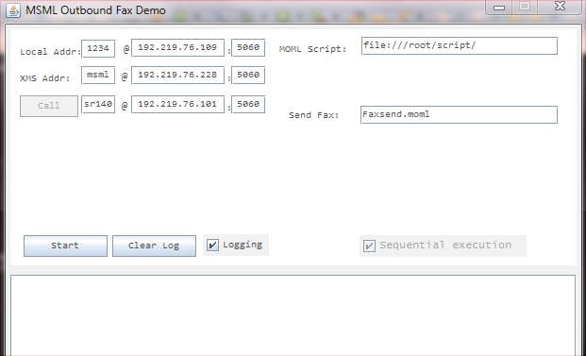

Script to send fax:

<?xml version="1.0" encoding="UTF-8"?>

<moml version="1.0" id="FaxSend" name="FaxSend">

<faxsend id="fax_id" lclid="local_id">

<sendobj objuri="file://sendFax.tif" maxpages="10"/>

<hdrfooter type="header" style="overlay">

<format>This is xms faxsnd footer (%m%d%Y)</format>

</hdrfooter>

<faxstart/>

<faxnegotiate/>

<faxpagedone/>

<faxobjectdone/>

<faxopcomplete/>

</faxsend>

</moml>

This script sends the sendFax.tif image file from XMS server /var/lib/xms/media/en-US folder. It inserts the header in the fax page which includes the month, date and year. 5 events are also subscribed.

SIP call flow:

* To simplify the implementation and troubleshooting, this app only handles outbound fax

* Call flow:

* this AS -> XMS, then

* this AS -> Sr140 (fax over IP T38 device)

* SIP flow:

* Sr140 AS XMS

* ->invite(no sdp)

* <-OK(sdp) call.state=idle

* <-invite(sdp)

* ->OK(sdp) call.state=As2User

* ->ack(sdp)

* <-ACK

* ->INFO(faxsend)

* ->invite(t38)

* ->invite(t38)

* <-OK(t38) or 488(g711), As2XmsReinvite

* <-OK(t38) or 488 (g711)

* ->ack

* ->ack

* <---T38 start between Sr140 and XMS--->

* <-INFO(fax.negotiate event)

* <-INFO(fax.pagedone event, etc)

* <---T38 end--------------------------->

* <-INFO(fax.opcomplete)

* <-INFO(msml.dialog.exit)

* ->BYE

* <-BYE

Implementation:

This is for outbound. This demo (AS) first obtains the media from XMS by sending an INVITE to XMS without SDP. Since this is for fax application, Accept-Contact header needs to set to *;+sip.fax=”t38”. When XMS receives this INVITE, it will reserve fax media port. Once this demo receives the OK with SDP, this app sends INVITE to the T38 fax device (Sr140). After initial SIP call is connected, this demo sends the script to XMS. Sr140 sends re-INVITE for T38 via this demo to XMS. If T3 re-INVITE does not occur in 10 seconds, this call will be in G711 passthru mode.