**Linear Regression**

* Regression is used to determine which variables have impact on a topic of interest
* Linearity is mathematical representation of relationship between variables as a line
* Regression allows us to determine which factors matter most, which factors can be ignored, and how these factors influence each other.
* Core idea is to obtain **BEST FIT** Line
* Best fit line has the total prediction error is as small as possible
* Error is the distance between data point to the Regression line

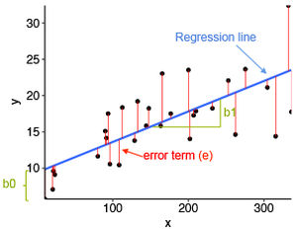

Source:**www.scribbr.com**

* Simple LR- One dependent variable, one independent variable
* Multiple LR- One dependent variable, multiple independent variables

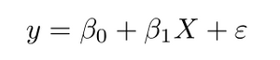

Source:**www.sthda.com**

1. **y** is the predicted value for any given value of the independent variable (**x**)
2. **B0** is the **intercept**, the predicted value of **y** when the **x** is 0
3. **B1** is the regression coefficient – how much we expect **y** to change as **x** increases
4. **x** is the independent variable
5. **e** is the **error** of the estimate, or how much variation there is in our estimate of the regression coefficient

* Goal is to find best fit line by searching for the regression coefficient (B1) that minimizes the total error (e) of the model

**LR Metric**-**MSE**(Mean Squared Error) and it is calculated by

* measuring the distance of the observed y-values from the predicted y-values at each value of x
* squaring each of these distances
* calculating the mean of each of the squared distances

**Real world applications of LR**

* Effect of different training regimens have on player performance
* effect of fertilizer and water on crop yields