**How to Install**

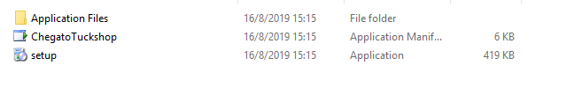

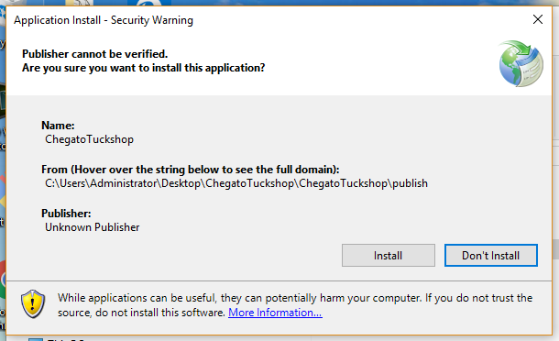

**Login Page**

Default Passwords

Username: admin

Password: password

Username: user

Password: password

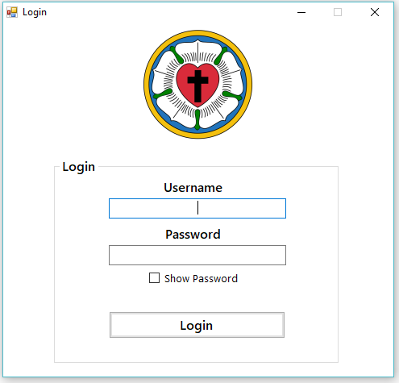

Items Report

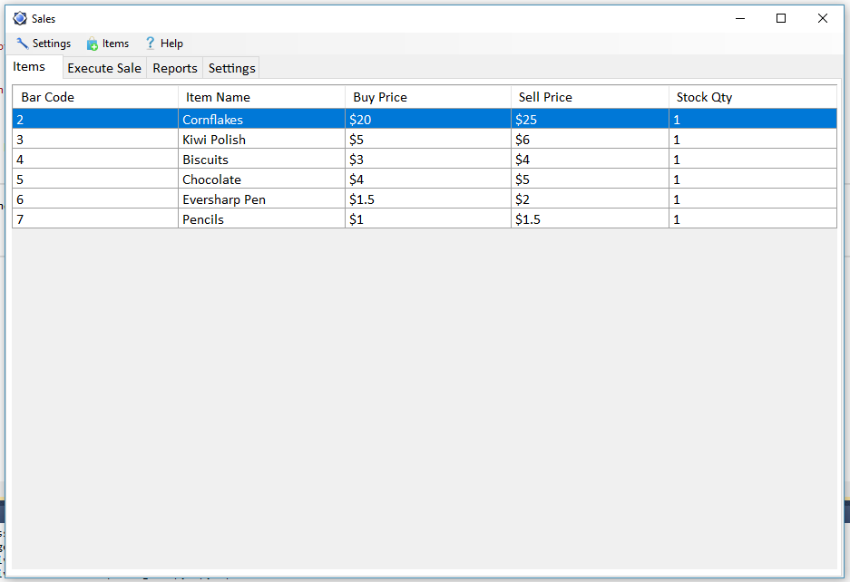

Add Item Form

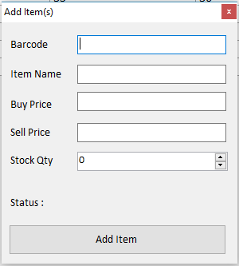

Execute Sale Form

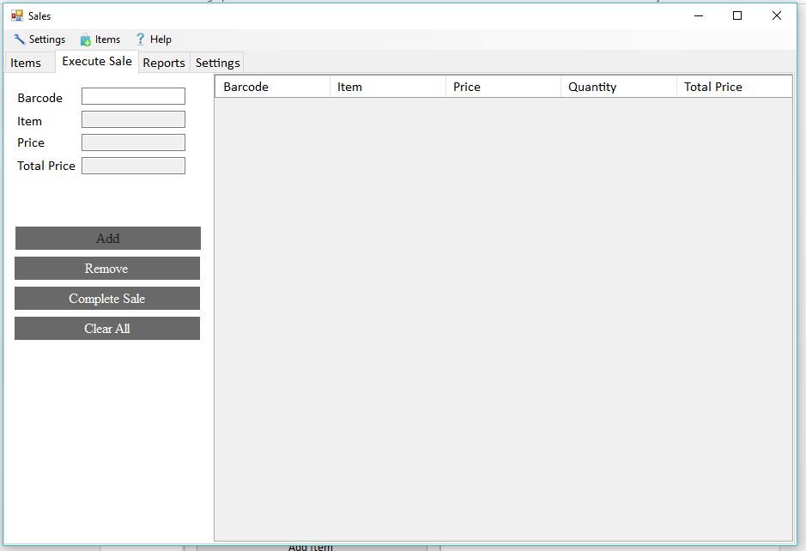

Add User

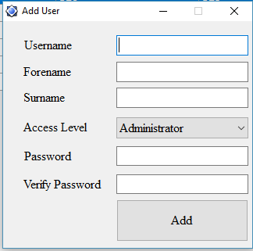

Users Report

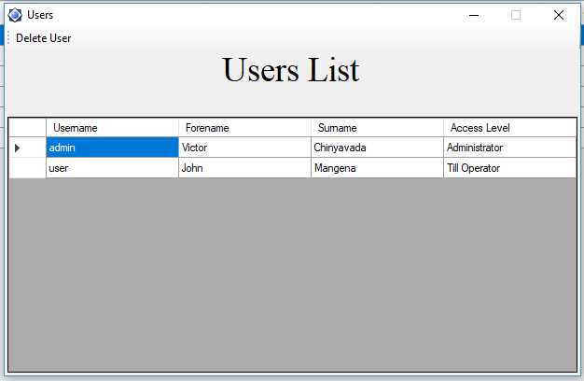

Total Profit For All Time Report

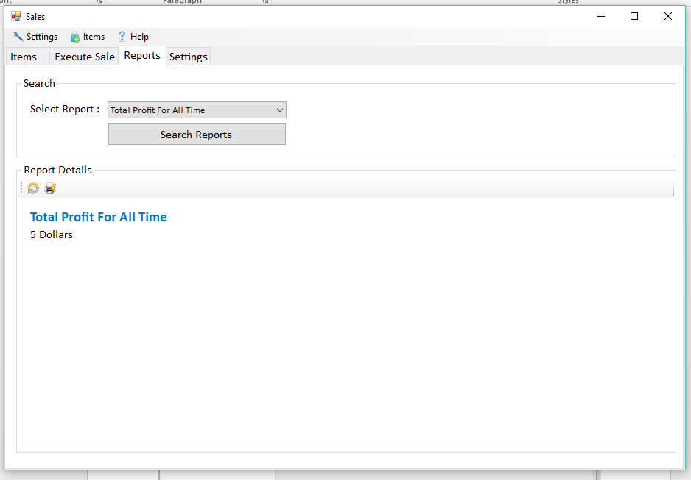

Receipts For All Time Report

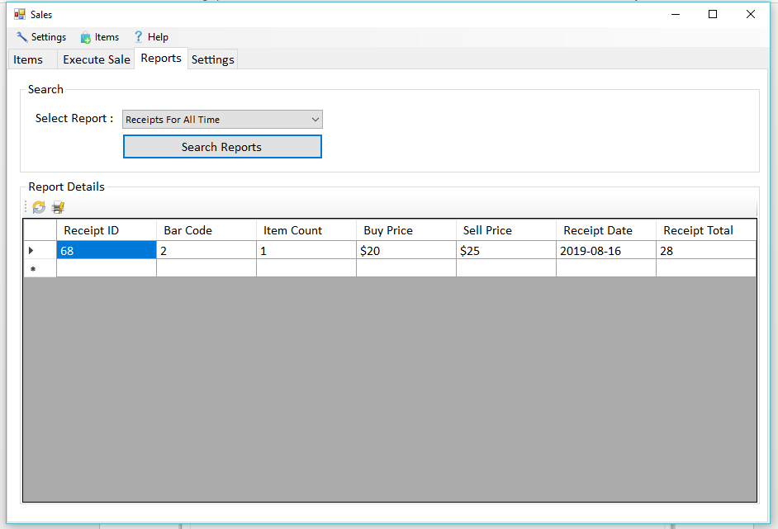

Change Password Form

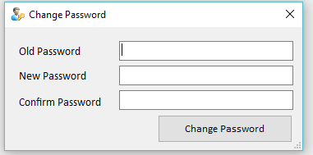

Code to Login

Private Sub btnLogin_Click(sender As System.Object, e As System.EventArgs) Handles btnLogin.Click

If txtusername.Text <> "" And txtpassword.Text <> "" Then

statement = "SELECT * FROM tblusers WHERE fldusername='" & txtusername.Text & "' and fldpassword='" & txtpassword.Text & "'"

Dim response = connection.querySelect(statement, "tblusers")

If response.ToString = "True" Then

Dim index As Integer = 0

If connection.dataset.Tables("tblusers").Rows.Count = 1 Then

txtpassword.Clear()

frmSales.Show()

Me.Hide()

Else

MsgBox("Username or Password is incorrect!", vbExclamation)

End If

Else

MsgBox(response, vbExclamation)

End If

Else

MsgBox("Username or Password cannot be empty!", vbExclamation)

End If

txtpassword.Clear()

txtpassword.Select()

End Sub

Code to **Execute Sale**

Private Sub btnPrintReceipt_Click(sender As System.Object, e As System.EventArgs) Handles btnPrintReceipt.Click

Try

If DataGridView2.Rows.Count <= 0 Then

MsgBox("Please add some items to print", MsgBoxStyle.Exclamation)

Exit Sub

End If

Dim ReceiptId As Integer

Dim receiptdate = Format(Now.Date, "yyyy-MM-dd")

If query("Insert into tblreceipts (ReceiptDate,ReceiptTotal) Values('" & receiptdate & "','" & txtTotalPrice.Text & "')") Then

querySelect("Select max(ReceiptID) as MAXID from tblreceipts", "max")

ReceiptId = connection.dataset.Tables("max").Rows(0).Item(0)

End If

Dim i As Integer

For i = 0 To DataGridView2.Rows.Count - 1

Dim Barcode As String = DataGridView2.Rows(i).Cells(0).Value

Dim BuyPrice As String = DataGridView2.Rows(i).Cells(2).Value

Dim SellPrice As String = DataGridView2.Rows(i).Cells(3).Value

Dim ItemCount As Integer = DataGridView2.Rows(i).Cells(4).Value

query("Insert into tblreceiptdetails values('" & ReceiptId & "','" & Barcode & "','" & ItemCount & "','" & BuyPrice & "','" & SellPrice & "')")

Next

MsgBox("Transaction was successful!", vbInformation)

If Not IsNothing(txtPrinterName.Text) Then

ReceiptImage = DrawReceipt(DataGridView2.Rows, ReceiptId, Format(Now.Date, "yyyy-MM-dd"), txtTotalPrice.Text, txtUnitWidth.Text, txtUnitHeight.Text, txtFontSize.Text)

If PrintDialog1.ShowDialog = Windows.Forms.DialogResult.OK Then

PrintDoc.PrinterSettings = PrintDialog1.PrinterSettings

PrintDoc.Print()

DataGridView2.Rows.Clear()

txtTotalPrice.Clear()

End If

ElseIf PictureBox1.Image Is Nothing Then

MsgBox("Can't Print receipt please check the settings", MsgBoxStyle.Critical)

Else

MsgBox("You did not setup the printer", MsgBoxStyle.Exclamation)

End If

Catch ex As Exception

MsgBox(ex.ToString, MsgBoxStyle.Critical)

End Try

End Sub

Code to **Generate Reports**

Private Sub btnSearchReports_Click(sender As System.Object, e As System.EventArgs) Handles btnSearchReports.Click

Try

If (cboSelectReport.Text = "Total Profit For All Time") Then

PanelShort.Visible = True

PanelLong.Visible = False

PanelDate.Visible = False

Dim response = connection.querySelect("Select SUM((ItemSellPrice-ItemBuyPrice)*ItemCount) from tblreceiptdetails", "sum")

If response.ToString = "True" Then

If connection.dataset.Tables("sum").Rows.Count = 1 Then

profit.Text = connection.dataset.Tables("sum").Rows(0).Item(0) & " Dollars"

head.Text = "Total Profit For All Time"

head.Visible = True

profit.Visible = True

Else

MsgBox("Sales are not enough to generate report!", vbExclamation)

End If

Else

MsgBox(response, vbExclamation)

End If

ElseIf (cboSelectReport.Text = "Receipts For All Time") Then

PanelShort.Visible = False

PanelLong.Visible = True

PanelDate.Visible = False

Dim response = connection.querySelect("Select * FROM qryreceiptdetails", "qryreceipts")

If response.ToString = "True" Then

Dim rowCount As Integer = connection.dataset.Tables("qryreceipts").Rows.Count

Dim count As Integer = 0

headReport.Text = "Receipts For All Time"

DataGridView4.Rows.Clear()

While (count < rowCount)

DataGridView4.Rows.Add()

DataGridView4.Rows(count).Cells(0).Value = connection.dataset.Tables("qryreceipts").Rows(count).Item(0)

DataGridView4.Rows(count).Cells(1).Value = connection.dataset.Tables("qryreceipts").Rows(count).Item(1)

DataGridView4.Rows(count).Cells(2).Value = connection.dataset.Tables("qryreceipts").Rows(count).Item(2)

DataGridView4.Rows(count).Cells(3).Value = "$" + connection.dataset.Tables("qryreceipts").Rows(count).Item(3)

DataGridView4.Rows(count).Cells(4).Value = "$" + connection.dataset.Tables("qryreceipts").Rows(count).Item(4)

DataGridView4.Rows(count).Cells(5).Value = connection.dataset.Tables("qryreceipts").Rows(count).Item(5)

DataGridView4.Rows(count).Cells(6).Value = connection.dataset.Tables("qryreceipts").Rows(count).Item(6)

count = count + 1

End While

End If

End If

Catch ex As Exception

MsgBox(ex.ToString)

End Try

End Sub

Code to **Add Item**

Private Sub Button1_Click(sender As Object, e As EventArgs) Handles btnAddItem.Click

If txtbarcode.Text = "" Or txtitemname.Text = "" Or txtbuyprice.Text = "" Or txtsellprice.Text = "" Then

MsgBox("Please Enter Correct Information", MsgBoxStyle.Critical)

Exit Sub

End If

Try

Dim statement = "INSERT INTO tblitems VALUES('" & txtbarcode.Text & "','" & txtitemname.Text & "','" & txtbuyprice.Text & "','" & txtsellprice.Text & "')"

If connection.query(statement) Then

MsgBox("Item successfully added!", MsgBoxStyle.Information)

status.Text = "One Item(s) Added"

txtbarcode.Clear()

txtitemname.Clear()

txtbuyprice.Clear()

txtsellprice.Clear()

txtbarcode.Focus()

Else

MsgBox("Item could not be added!", vbExclamation)

End If

Catch ex As Exception

MsgBox("Barcode already Exist !", MsgBoxStyle.Exclamation)

End Try

End Sub

**Incorrect Password Error Message**

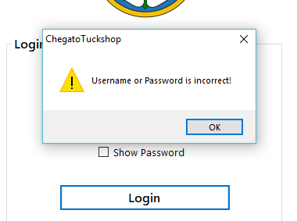

**Invalid Transaction Error Message**

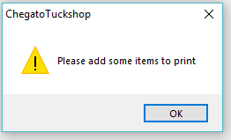

**Password Mismatch Error Message**

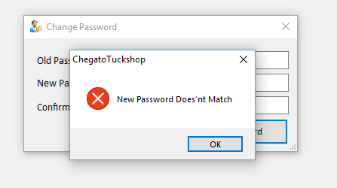

**Transaction Successful Message**

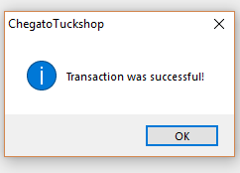

Database

**tblitems**

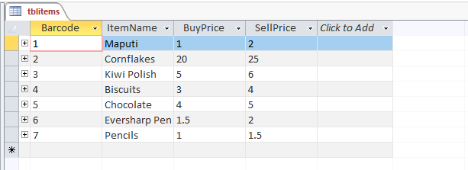

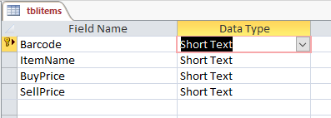

**tblitems**

