2017/11/3



證券市場微結構實務作業二

Aggressive Orders

第一組

財管碩一　　　M064030048　　　廖彥儒

　　產 碩 一　　　M064810009　　　洪志穎

　　產 碩 一　　　M064810014　　　葉登元

摘要

我們將五分鐘內委買委賣量最大的價格當作分界，在其價位之內的交易單選入Aggressive orders(買單為高價買單；賣單為低價賣單)，以比例形式去作為接下來數據呈現及分析，資料時間由2013年1月至4月，公司分別為大中小各二十間總計六十間，最後我們再依照不同的交易人員種類區分為法人及散戶。

內文中分析台灣股票市場中的開盤交易時間時所呈現出的Aggressive orders所占比例差異，也探討了法人與散戶的掛單不同情況，之後我們融合美日的日報酬率加入分析，最後再將每日交易所能構成的獲利以及損失加入討論。

Using three month five minute order flow data, answer the following question(choose the number of sample as you see fit to adequately investigate the question):

1 . Let the best bid ask quotes be the most aggressive, and the fifth quote be the least aggressive orders, estimate the five minute order submission aggressiveness for individual and instituional investors. You can innovate on the estimation. method.

2. Plot the intradaily pattern of average order aggressiveness for individual and institutional investors.

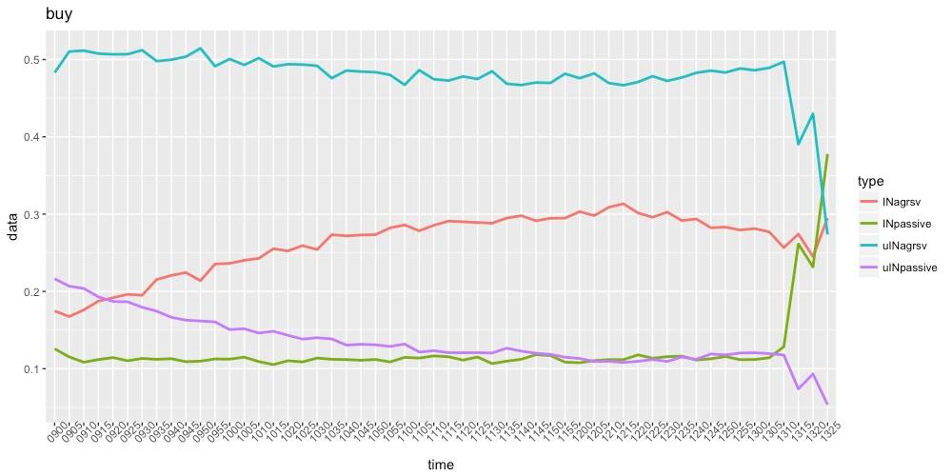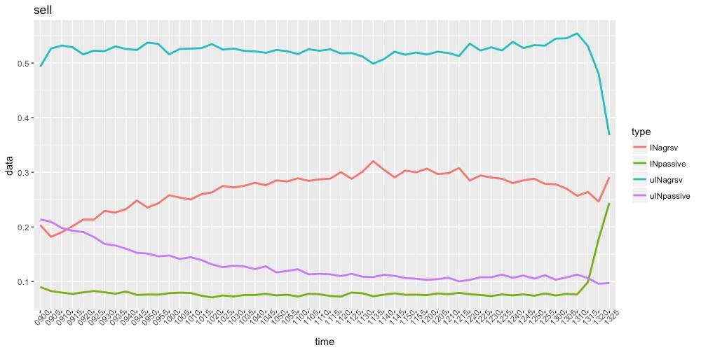

3.What can you observe from the above ?

4. Estimate the end of day return for each executed buy/sell order (closing price - bid/closing or ask - closing / closing) by order aggressiveness

5. What is the profit/loss for the most aggressive compared with less aggressive orders? Do institutional investors use more or less aggressive orders? And is there any intraday difference on order submission and profits?