TechCrush Capstone Project

Prepared by: Igbo Chioma C.

Course: Cybersecurity Capstone Project

Date: June 2026

Project Focus
Building a Secure Small Network

Table of Contents
1. Introduction
2. Project Aim and Objectives
3. Lab Tools and Environment
4. Network Topology Design
5. IP Addressing and Network Zones
6. Security Controls Implemented
7. Testing and Evidence
8. Simulated Threat and Response
9. Network Setup Checklist
10. Challenges and Lessons Learned
11. Conclusion
12. References
Appendix A: Commands Used
Appendix B: Screenshot Checklist

1. Introduction
This capstone project focuses on designing and securing a small office network. The project demonstrates how basic network security controls can reduce common risks such as unauthorized access, exposed services, and uncontrolled communication between network zones.
The network was designed in Cisco Packet Tracer and includes an internet connection, office router, firewall, core switch, office workstations, a file/web server, and a guest laptop. Security testing and analysis were supported with tools such as Nmap/Zenmap and Wireshark.

2. Project Aim and Objectives
Aim: To design a simple small office network and apply basic cybersecurity controls to improve security and reduce common network risks.
- Design a clear small office network topology.
- Apply basic security controls such as password protection, segmentation, firewall/access control, and port hardening.
- Use Nmap/Zenmap to demonstrate port scanning and service discovery.
- Use Packet Tracer ping testing to validate communication and zone isolation.
- Explain how the selected controls help defend against a simulated port scanning threat.

3. Lab Tools and Environment
Tool | Purpose
Cisco Packet Tracer | Used to design and simulate the small office network topology.
Office Router, ASA Firewall, Core Switch | Used to represent network routing, filtering, and internal connectivity.
Packet Tracer PC Command Prompt | Used to test connectivity using ping.
Nmap/Zenmap | Used to demonstrate port scanning and service discovery.
Windows Defender Firewall with Advanced Security | Used as the system firewall to create a custom rule blocking ICMPv4/ping traffic.

4. Network Topology Design
The topology represents a small office network. Cloud-PT represents the internet, the office router connects the office to the external network, the ASA 5505 firewall acts as a security boundary, and the core switch connects internal devices. The internal network is divided into three logical zones: Office Zone, Server Zone, and Guest Zone.
The firewall is placed before the internal switch so that traffic entering or leaving the internal network can be controlled. This layout supports basic access control and helps reduce exposure of internal systems.

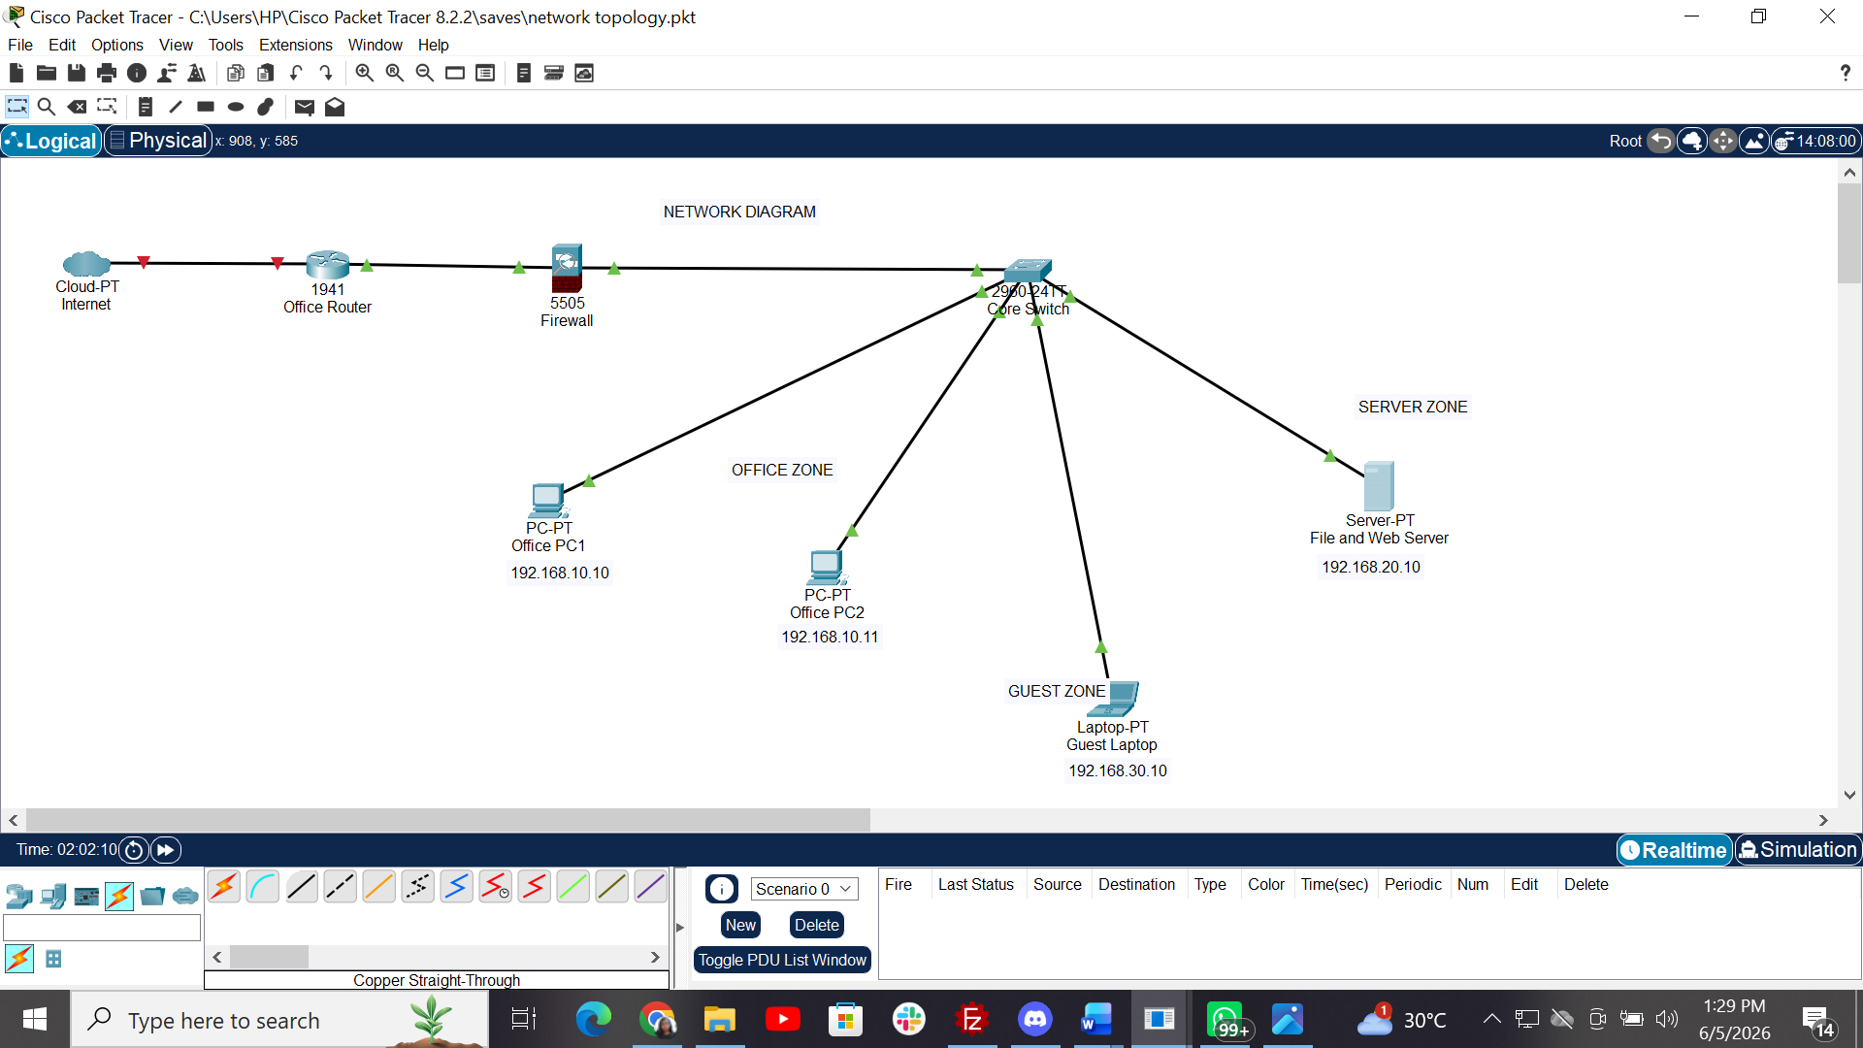

5. IP Addressing and Network Zones
Zone | Device | IP Address | Subnet | Purpose
Office Zone | Office PC1 | 192.168.10.10 | 192.168.10.0/24 | Staff workstation
Office Zone | Office PC2 | 192.168.10.11 | 192.168.10.0/24 | Staff workstation
Server Zone | File/Web Server | 192.168.20.10 | 192.168.20.0/24 | Business services and data
Guest Zone | Guest Laptop | 192.168.30.10 | 192.168.30.0/24 | Guest or visitor access
Using different IP subnets for different zones supports segmentation. This means devices in one zone do not automatically have unrestricted access to devices in another zone unless routing or firewall rules are configured to permit that access.

6. Security Controls Implemented

6.1 Password and Access Control
Password and access control were configured on the office router to prevent unauthorized users from changing network device settings. The router hostname was changed, an enable secret was configured, console access was protected, remote VTY access was password-protected, and password encryption was enabled.
Configuration Item | Purpose
hostname OfficeRouter | Gives the router a meaningful administrative name.
enable secret Capstone123 | Protects privileged EXEC/admin access.
line console 0 / password Console123 / login | Protects local console access.
line vty 0 4 / password Remote123 / login | Protects remote terminal access.
service password-encryption | Encrypts passwords in the running configuration.

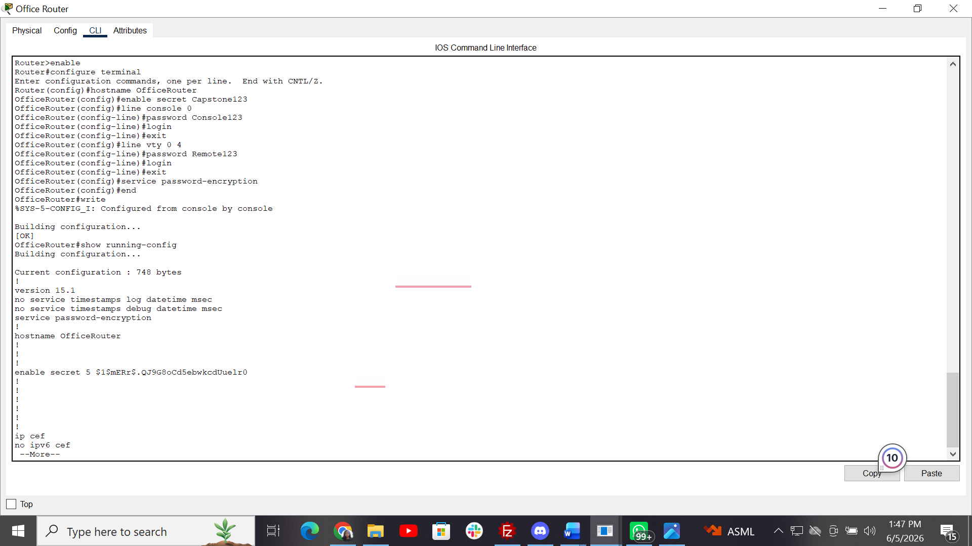

6.2 Network Segmentation
The network was separated into Office, Server, and Guest zones. Each zone uses a different subnet. This separation helps reduce unauthorized access and limits the spread of threats if one device or zone becomes compromised.
In the lab, Office PC1 successfully reached Office PC2 because both devices are in the same Office Zone. Communication from Office PC1 to the Server Zone timed out because no routing/firewall rule was configured to allow traffic between the two zones. This demonstrates zone isolation.

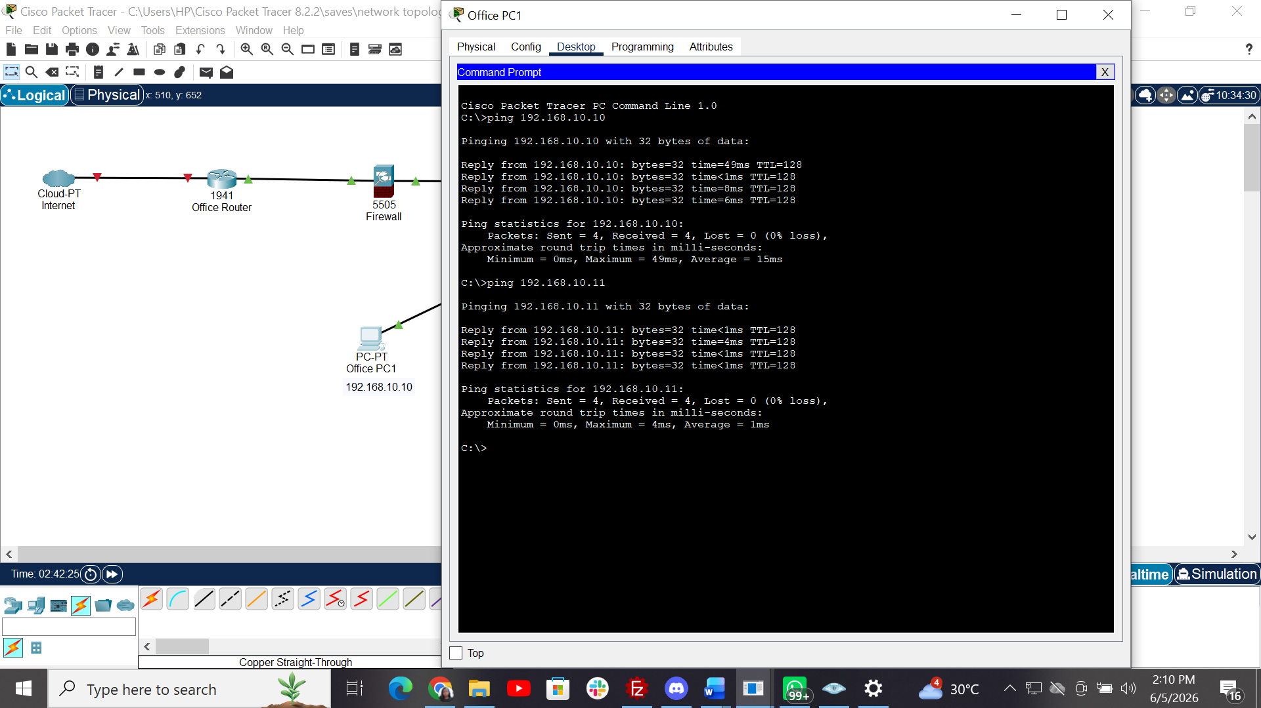

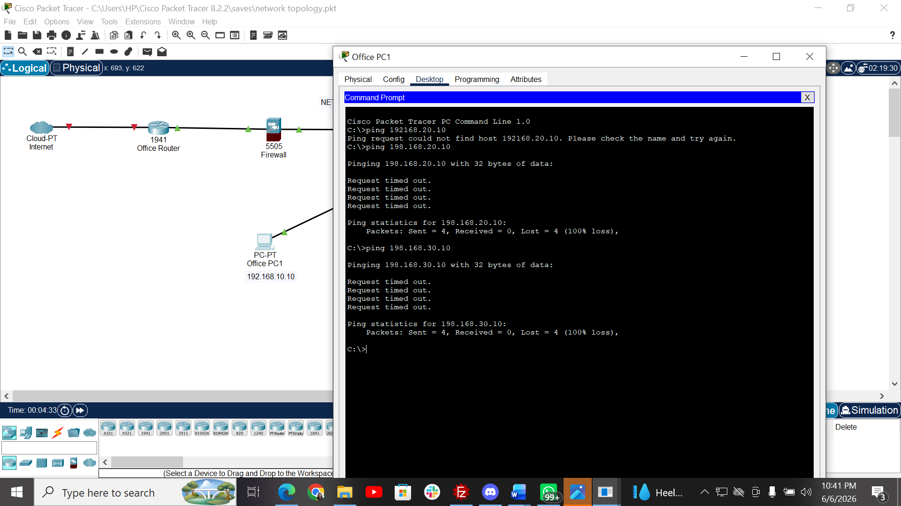

6.3 Firewall Rules and Access Control
Windows Defender Firewall was used to demonstrate firewall rule enforcement on the host system. A custom inbound rule was created to block ICMPv4 Echo Requests, which are commonly used by ping. This does not block a TCP or UDP port; instead, it blocks ICMP traffic used for basic network discovery. Other firewall rules, such as blocking unnecessary inbound traffic, restricting insecure services, and reviewing open ports after Nmap scans, were included as recommended security controls for a small office network.
Rule | Action |  | Reason
Block ICMPv4 Echo Request (Ping) | Block | Implemented | Prevents the system from responding to basic ping/network discovery attempts.
Allow required trusted traffic | Allow | Recommended | Supports normal approved communication needed for legitimate use.
Block unnecessary inbound traffic | Block | Recommended | Reduces exposure to unauthorized access attempts.
Review open ports after Nmap scan | Monitor/Restrict | Implemented as scan/review | Helps identify services that should be disabled, restricted, or protected.
Block insecure services where possible | Block | Recommended | Reduces risk from insecure protocols such as Telnet or unnecessary FTP.
In the network topology, the ASA firewall represents the security boundary between the external network and the internal office network. In the practical implementation, Windows Defender Firewall was used to show how a real system firewall can block specific traffic. Together, these demonstrate both firewall placement and firewall rule enforcement.
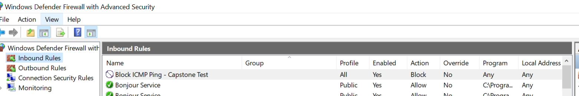

6.4 Port Scanning and Hardening
Nmap/Zenmap was used to demonstrate port scanning. Port scanning helps identify open ports and services on a reachable system. This is useful for defenders because it shows what services are exposed, but it is also used by attackers to discover possible entry points.
A scan against the Packet Tracer server IP showed that the simulated Packet Tracer host was not directly reachable from the Windows host. This is a lab limitation because Packet Tracer devices are simulated. To demonstrate the concept, scans were performed against reachable host IP addresses such as 127.0.0.1 and 172.20.10.5.
SCREENSHOT: Zenmap/Nmap result showing discovered open ports on a reachable host]
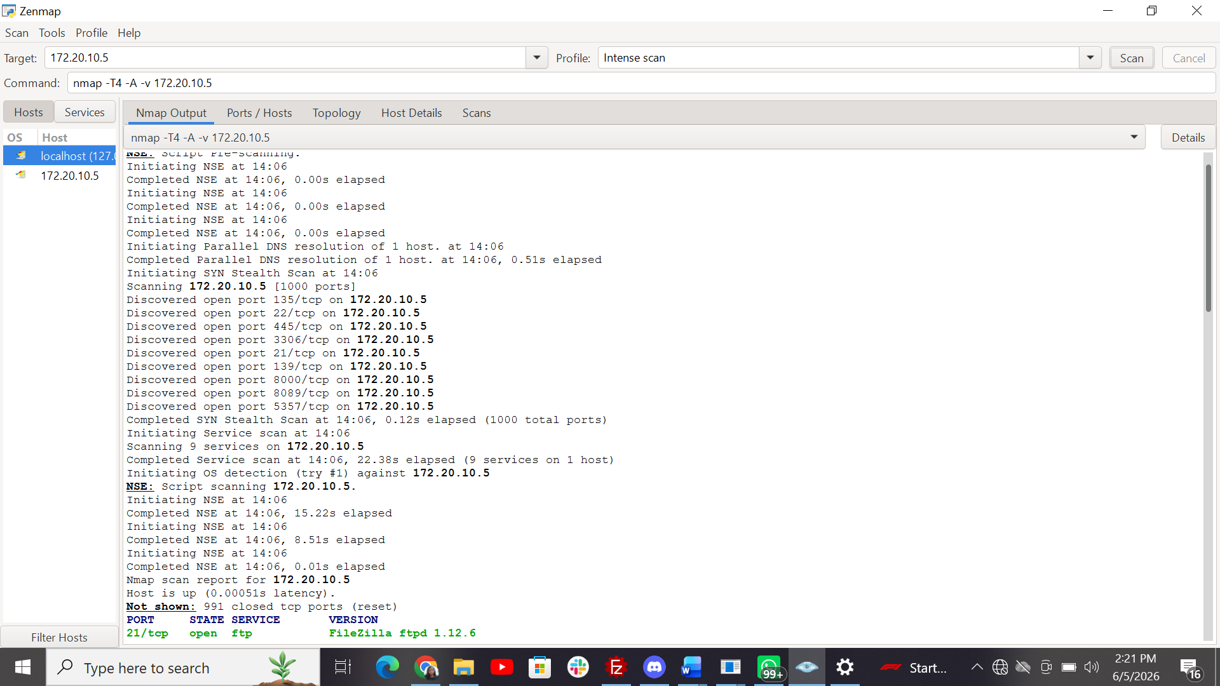
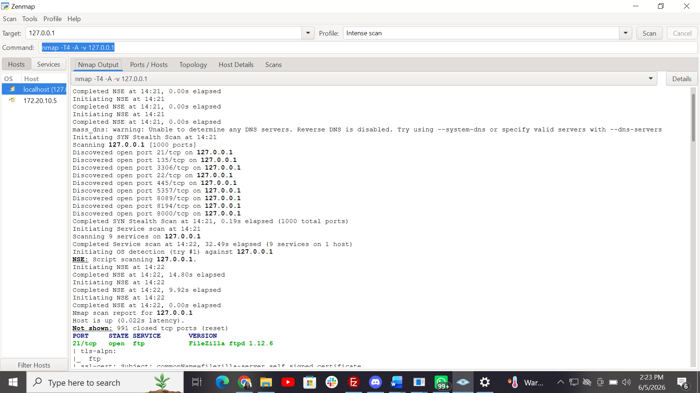

Open Port Example | Security Meaning | Hardening Recommendation
21/tcp | FTP/plaintext file transfer | Disable or replace with SFTP.
22/tcp | SSH remote access | Allow only trusted administrators.
23/tcp | Telnet/insecure login | Block or disable.
80/443 | Web service | Allow only if required.
3306/tcp | Database service | Restrict to trusted hosts only.

7. Testing and Evidence

7.1 Packet Tracer Connectivity Testing
Connectivity testing was performed using the Packet Tracer PC command prompt. Office PC1 successfully pinged Office PC2, confirming communication within the same Office Zone. Attempts to reach devices in other zones timed out because routing/firewall rules were not configured to allow cross-zone traffic.

7.2 Nmap/Zenmap Testing
Nmap/Zenmap was used to simulate how a security analyst or attacker can discover open ports. The test demonstrated that reachable systems may reveal exposed services. The result supports the need for firewall restrictions and service hardening.

7.3 Wireshark Traffic Analysis
Wireshark can be used to capture simple network traffic, such as ICMP packets generated by ping. This helps demonstrate how network traffic can be observed and analyzed for troubleshooting and security monitoring.

8. Simulated Threat and Response

8.1 Threat Selected: Port Scanning Attack
The simulated threat selected for this project was a port scanning attack. Port scanning is commonly used to identify live hosts, open ports, and running services. Attackers may use this information to find vulnerable services or weak access controls.

8.2 How the Threat Could Happen
An attacker connected to a network, or a compromised internal device, could run a tool such as Nmap to scan internal IP addresses. The goal would be to identify exposed services such as FTP, SSH, web services, database ports, or remote access ports.

8.3 How the Controls Reduce the Risk
Security Control | Risk Reduced
Password and access control | Prevents unauthorized users from changing router/switch settings.
Network segmentation | Limits movement between Office, Server, and Guest zones.
Firewall rules | Blocks unauthorized traffic and unnecessary ports.
Port hardening | Reduces exposed services that attackers can target.
Monitoring/Wireshark | Helps observe traffic behavior and investigate suspicious activity.

9. Network Setup Checklist
- Identify all network devices and their purpose.
- Create a clear topology diagram.
- Place firewall/security boundary before internal network devices.
- Assign IP addresses to all devices.
- Separate network into Office, Server, and Guest zones.
- Configure router/switch passwords.
- Enable password encryption on network devices.
- Document firewall/access control rules.
- Scan for open ports using Nmap/Zenmap.
- Disable or restrict unnecessary services.
- Test connectivity between devices.
- Capture network traffic with Wireshark if required.
- Save screenshots for documentation.

10. Challenges and Lessons Learned

10.1 Challenges
- Packet Tracer devices are simulated and not directly reachable from the Windows host using Zenmap/Nmap.
- Different subnets require routing or firewall rules before cross-zone communication can occur.
- Some security controls are easier to demonstrate as design controls in Packet Tracer than as fully functional enterprise configurations.

10.2 Lessons Learned
- A secure network requires both good design and configuration.
- Segmentation helps reduce unauthorized movement between zones.
- Password protection is essential for network administration.
- Port scanning reveals exposed services and supports hardening decisions.
- Documentation and screenshots are important for security reporting.

11. Conclusion
This project demonstrated how to design and secure a small office network using basic cybersecurity principles. The topology included an internet cloud, office router, firewall, core switch, office PCs, a file/web server, and a guest laptop. The network was organized into Office, Server, and Guest zones to support segmentation.
Security controls included password and access control, network segmentation, Windows Defender Firewall rules, port scanning/hardening, and optional traffic analysis. The simulated port scanning threat showed why exposed services and open ports should be identified and restricted. The Windows Firewall rule demonstrated how a system firewall can block ICMPv4 ping traffic to reduce device visibility during basic network discovery.

12. References
- Cisco Packet Tracer documentation
- Nmap/Zenmap documentation
- Wireshark User Guide
- NIST Cybersecurity Framework
- CISA guidance on secure network configuration

Appendix A: Commands Used
Command | Purpose
enable | Enter privileged EXEC mode on router.
configure terminal | Enter global configuration mode.
hostname OfficeRouter | Rename router.
enable secret Capstone123 | Set privileged access password.
line console 0 / password Console123 / login | Protect console access.
line vty 0 4 / password Remote123 / login | Protect remote access lines.
service password-encryption | Encrypt configured passwords.
write | Save router configuration.
ping 192.168.10.11 | Test connectivity from PC1 to PC2.
nmap / Zenmap scan | Discover open ports and services.
Windows Defender Firewall -> Inbound Rules -> New Rule -> Custom -> ICMPv4 -> Block the connection | Creates a system firewall rule to block ping/ICMPv4 echo requests.
C:\Windows\System32\ping.exe 127.0.0.1 | Tests ICMP/ping from the Windows host when PATH does not recognize ping.

Appendix B: Screenshot Checklist
- Final Packet Tracer topology with zone labels
- Router CLI showing password/access control commands
- Ping result showing PC1 to PC2 success
- Ping result showing PC1 to Server Zone timeout
- Zenmap/Nmap scan output
- Windows Defender Firewall inbound rule showing ICMPv4/ping blocking
- Optional Wireshark ICMP traffic capture

