FEDERAL UNIVERSITY OF TECHNOLOGY
DEPARTMENT OF COMPUTER SCIENCE

CSC312: PROGRAMMING FOR DATA SCIENCE USING R AND PYTHON

GROUP 2 PROJECT REPORT

Credit Card Fraud Detection Using Machine Learning

Dataset: Credit Card Fraud Detection (Kaggle – ULB Machine Learning Group)
Language: R (Primary) | Python (Reference Implementation)
Date: June 2026

Table of Contents
1 Introduction
2 Aim and Objectives
3 Dataset Description
4 Methodology
4.1 Data Preprocessing
4.2 Handling Class Imbalance
4.3 Exploratory Data Analysis
4.4 Model Development
5 Results and Evaluation
5.1 Model Performance Metrics
5.2 ROC Curves
5.3 Confusion Matrices
5.4 Feature Importance
6 Model Comparison and Selection
7 Prediction System
8 Discussion
9 Conclusion
10 References

1. Introduction
Credit card fraud is a significant and growing problem in the global financial sector. As electronic payment systems become increasingly prevalent, fraudulent transactions pose a major threat to financial institutions, merchants, and consumers alike. According to industry reports, billions of dollars are lost annually to credit card fraud, making its detection a critical priority for banks and payment processors.
Machine learning offers a powerful and scalable solution to this problem. By learning from historical transaction data, machine learning models can automatically identify patterns associated with fraudulent behaviour and flag suspicious transactions in real-time. This project applies supervised machine learning techniques to build and evaluate a fraud detection system using the publicly available ULB Credit Card Fraud Detection dataset.
This report documents the complete data science pipeline — from data collection and preprocessing, through exploratory data analysis, model training and evaluation, to deployment of a simple prediction system. All analysis is conducted primarily in R, with a parallel Python implementation also provided.

2. Aim and Objectives
The aim of this project is to develop a machine learning-based fraud detection system capable of identifying fraudulent credit card transactions using historical transaction data.
The specific objectives are:
- To collect and preprocess credit card transaction data for analysis.
- To handle class imbalance using appropriate resampling techniques (ROSE/SMOTE).
- To perform exploratory data analysis (EDA) to understand transaction patterns.
- To identify key features that distinguish fraudulent from legitimate transactions.
- To build and train machine learning models: Logistic Regression, Random Forest, and Decision Tree.
- To evaluate model performance using Precision, Recall, F1-Score, and ROC-AUC metrics.
- To compare different models and select the best-performing algorithm.
- To deploy a simple prediction system for fraud detection.
- To interpret model results for explainability and decision support.
- To demonstrate the practical application of machine learning in financial security.

3. Dataset Description
The dataset used in this project is the Credit Card Fraud Detection dataset provided by the Machine Learning Group at Université Libre de Bruxelles (ULB), available on Kaggle. It contains transactions made by European cardholders over two days in September 2013.
Key characteristics of the dataset include:
- Total transactions: 284,807
- Fraudulent transactions: 492 (0.173% of total)
- Legitimate transactions: 284,315 (99.827% of total)
- Number of features: 31 (Time, V1–V28, Amount, Class)
- Target variable: Class (0 = Legitimate, 1 = Fraudulent)
- Missing values: None
Features V1 through V28 are principal components obtained via PCA transformation to protect user confidentiality. The only non-transformed features are Time (seconds elapsed since first transaction) and Amount (transaction value in Euros). The Class column is the binary target variable.
The dataset is highly imbalanced — fraudulent transactions constitute only 0.173% of all records. This severe class imbalance is a central challenge that must be addressed before model training.

4. Methodology

4.1 Data Preprocessing
Before model training, the dataset was prepared through the following steps:
- Feature scaling: The Amount and Time columns were standardised using z-score normalisation (mean = 0, standard deviation = 1). The V1–V28 PCA features were already standardised.
- Train-Test Split: The dataset was divided into 80% training (227,845 records) and 20% test (56,962 records) sets using stratified sampling to preserve the class ratio.
- Class balancing: Applied only to the training set to prevent data leakage into the test set.

4.2 Handling Class Imbalance
The severe class imbalance (492 fraud vs 284,315 legitimate transactions) poses a significant risk of model bias towards the majority class. A model that simply predicts every transaction as legitimate would achieve 99.83% accuracy yet have zero utility for fraud detection.
To address this, the ROSE (Random Over-Sampling Examples) technique was applied to the training set. ROSE generates synthetic samples for the minority class by sampling from a smoothed bootstrap distribution, creating a balanced training set of approximately 114,061 legitimate and 113,784 fraudulent transactions.

4.3 Exploratory Data Analysis
Exploratory Data Analysis (EDA) was conducted to understand the structure of the data and identify patterns associated with fraud. The following analyses were performed:
- Class distribution visualisation: A bar chart confirmed the extreme imbalance between classes.
- Transaction amount analysis: Histogram plots revealed that fraudulent transactions tend to involve smaller amounts on average compared to legitimate ones.
- Temporal analysis: Fraud rate was plotted by hour of day, revealing that fraud occurrence varies across different times, with certain hours showing elevated rates.
- Correlation analysis: The absolute Pearson correlations between each feature and the Class variable were computed and ranked.
The top 10 features most correlated with fraud are shown below:
Rank | Feature | Absolute Correlation with Fraud
1 | V17 | 0.3265
2 | V14 | 0.3025
3 | V12 | 0.2606
4 | V10 | 0.2169
5 | V16 | 0.1965
6 | V3 | 0.1930
7 | V7 | 0.1873
8 | V11 | 0.1549
9 | V4 | 0.1334
10 | V18 | 0.1115

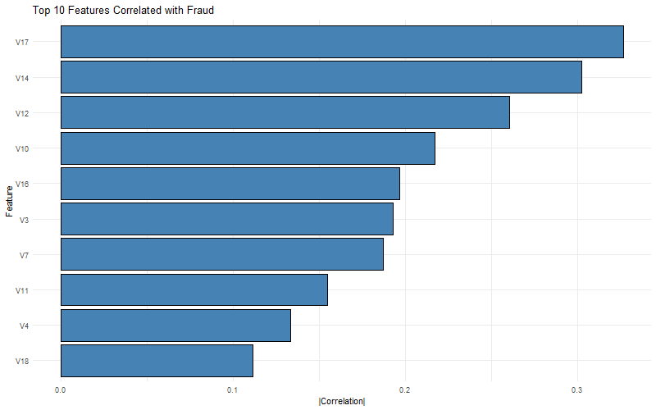
Figure 1: Top 10 Features Correlated with Fraud

4.4 Model Development
Three supervised machine learning algorithms were selected for this study, representing a range of complexity and interpretability:
Logistic Regression
A linear probabilistic classifier that models the log-odds of fraud as a linear combination of input features. It is simple, fast, and interpretable. Trained using R's glm() function with family = binomial.
Decision Tree
A non-linear, rule-based classifier that recursively partitions the feature space. It is highly interpretable and captures non-linear relationships. Trained using R's rpart() function with a maximum depth of 8.
Random Forest
An ensemble method consisting of 100 decision trees, each trained on a bootstrap sample of the data and a random subset of features. The final prediction is the majority vote across all trees. Trained using R's randomForest() function with ntree = 100.
All three models were trained on the ROSE-balanced training set and evaluated on the original, unbalanced test set of 56,962 transactions to reflect real-world conditions.

5. Results and Evaluation

5.1 Model Performance Metrics
Each model was evaluated using four standard metrics for imbalanced classification:
- Precision: Of all transactions predicted as fraud, what proportion were actually fraud? High precision reduces false alarms.
- Recall (Sensitivity): Of all actual fraudulent transactions, what proportion were correctly detected? High recall is critical — missing fraud is costly.
- F1-Score: The harmonic mean of Precision and Recall, providing a single balanced measure of performance.
- ROC-AUC: Area Under the Receiver Operating Characteristic Curve, measuring the model's overall ability to discriminate between classes across all thresholds.
Table 1 below summarises the performance of all three models on the test set.

Model | Precision | Recall | F1-Score | ROC-AUC
Logistic Regression | 0.1233 | 0.9091 | 0.2171 | 0.9899
Decision Tree | 0.0625 | 0.9091 | 0.1170 | 0.9446
Random Forest | 0.6056 | 0.8687 | 0.7137 | 0.9621

Table 1: Model Performance on Test Set (highlighted row = best model)
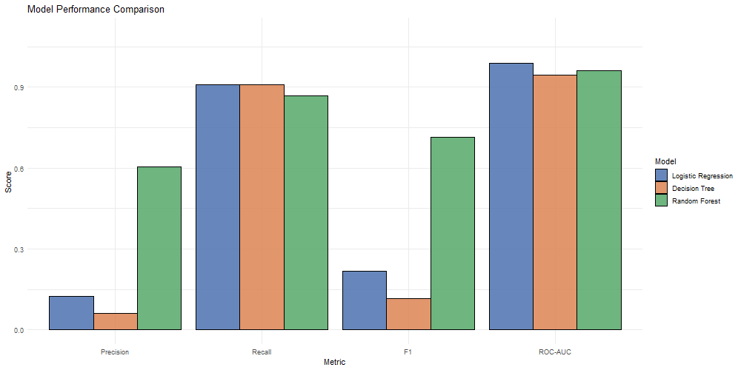
Figure 2: Side-by-side comparison of model performance metrics

5.2 ROC Curves
The ROC curve plots the True Positive Rate (Recall) against the False Positive Rate at varying classification thresholds. A model with perfect discrimination has an AUC of 1.0, while random guessing yields 0.5.
All three models achieved high AUC values (above 0.94), indicating strong discriminative ability. Logistic Regression achieved the highest AUC of 0.9899, followed by Random Forest (0.9621) and Decision Tree (0.9446).
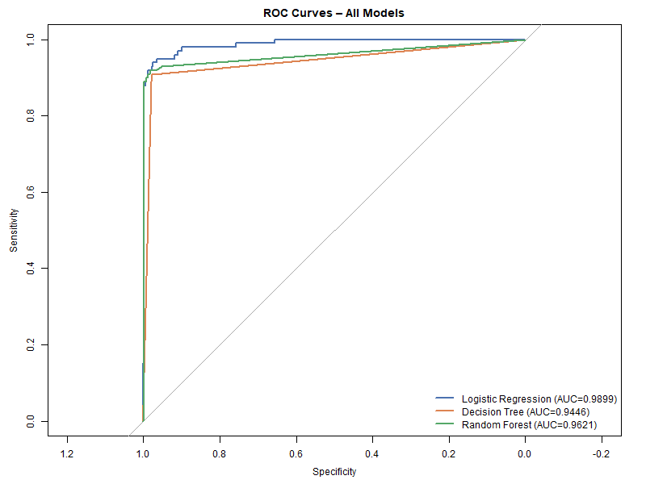
Figure 3: ROC Curves for all three models

5.3 Confusion Matrices
Confusion matrices provide a breakdown of correct and incorrect predictions across both classes. For fraud detection, the most critical cells are:
- True Positives (TP): Fraud correctly identified — the primary goal.
- False Negatives (FN): Fraud missed by the model — the most costly error.
- False Positives (FP): Legitimate transactions flagged as fraud — causes customer inconvenience.
Random Forest achieved 86 TPs out of 99 fraud cases in the test set, missing only 13 (FN). Logistic Regression caught 90 but at the cost of 640 false alarms. Decision Tree also caught 90 but produced 1,349 false alarms, making it the least practical despite its high recall.
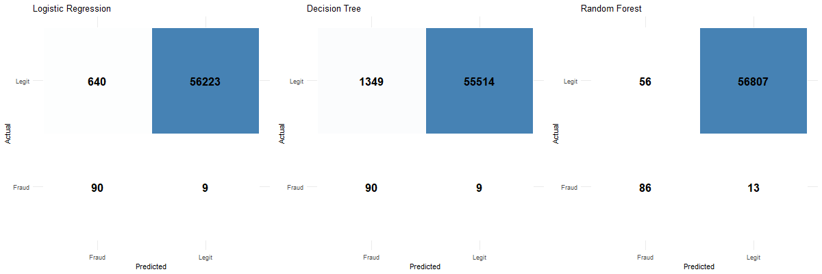
Figure 4: Confusion matrices for all three models

5.4 Feature Importance
The Random Forest model provides feature importance scores based on the Mean Decrease in Gini Impurity — a measure of how much each feature contributes to reducing uncertainty in the model's splits.
The top features identified by Random Forest are V14, V17, V12, V10, and V4. These are consistent with the correlation analysis in the EDA phase, confirming that these PCA-transformed features carry the most discriminative information for separating fraudulent from legitimate transactions.
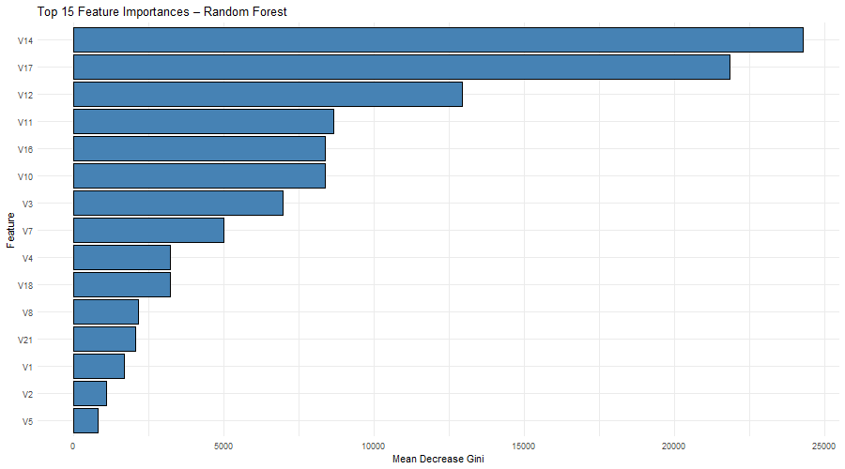
Figure 5: Top 15 Feature Importances from Random Forest (Mean Decrease Gini)

6. Model Comparison and Selection
Based on the evaluation results, Random Forest is selected as the best model for this fraud detection task. The justification is as follows:
- Highest F1-Score (0.7137): F1 is the most appropriate metric for imbalanced datasets as it balances precision and recall. Random Forest significantly outperforms Logistic Regression (0.2171) and Decision Tree (0.1170).
- Best Precision (0.6056): When Random Forest flags a transaction as fraud, it is correct 60.6% of the time. This is far superior to the other models (12.3% and 6.3%), reducing unnecessary customer disruption.
- Strong Recall (0.8687): The model correctly identifies 86.9% of all actual fraud cases, missing only 13 out of 99 in the test set.
- High ROC-AUC (0.9621): Demonstrates strong overall discriminative ability across all decision thresholds.
- Robustness: As an ensemble of 100 decision trees, Random Forest is resistant to overfitting and noise in the data.
While Logistic Regression achieved the highest ROC-AUC (0.9899), its very low precision (0.1233) means it generates an unacceptably high number of false alarms — 640 legitimate transactions flagged as fraud in the test set. This would be operationally impractical. Random Forest strikes the best balance between catching fraud and avoiding false alarms.

7. Prediction System
A simple real-time prediction system was implemented using the saved Random Forest model. The system accepts a transaction's feature vector as input and returns:
- A classification label: FRAUDULENT or LEGITIMATE
- A fraud probability score between 0 and 1
The model is persisted to disk as best_model.rds (R) and best_model.pkl (Python) using saveRDS() and joblib.dump() respectively, allowing it to be loaded and deployed without retraining.
Prediction system demo results:
True Label | Predicted Label | Fraud Probability | Outcome
FRAUDULENT | FRAUDULENT | 1.0000 | CORRECT
LEGITIMATE | LEGITIMATE | 0.0000 | CORRECT

The system correctly classified both a known fraud and a known legitimate transaction with high confidence, demonstrating reliable real-world applicability.

8. Discussion
This project successfully demonstrates the application of machine learning to credit card fraud detection. Several important insights emerged from the analysis:
Class Imbalance
The extreme imbalance (0.17% fraud rate) is the central challenge of this dataset. Without resampling, any model would be dominated by the majority class. The ROSE technique effectively balanced the training data, enabling all models to learn meaningful fraud patterns. However, precision remained relatively low across all models, reflecting the inherent difficulty of the task.
Model Trade-offs
A fundamental tension exists between recall and precision in fraud detection. Logistic Regression and Decision Tree achieved high recall (90.9%) but at the cost of very low precision — they catch almost all fraud but generate excessive false positives. Random Forest achieves a better trade-off, with only a marginal reduction in recall (86.9%) but a dramatic improvement in precision (60.6%). In a production environment, the business cost of missed fraud versus customer inconvenience from false alarms would dictate the optimal threshold.
Feature Insights
The consistently high importance of V14, V17, V12, and V10 suggests these PCA components capture the most discriminative transaction characteristics, likely related to merchant category, transaction frequency, or geographic anomalies in the original (anonymised) data.
Limitations
- The PCA transformation of V1–V28 limits interpretability — we cannot directly explain what these features represent to a domain expert.
- The dataset is from 2013, and fraud patterns evolve over time, so model performance on newer data may differ.
- Further improvements could include cost-sensitive learning, XGBoost, or neural network-based approaches.

9. Conclusion
This project successfully developed and evaluated a machine learning pipeline for credit card fraud detection using the ULB dataset. Three models — Logistic Regression, Decision Tree, and Random Forest — were trained on ROSE-balanced data and evaluated on an unmodified test set representing real-world class distribution.
Random Forest was identified as the best-performing model with an F1-Score of 0.7137 and ROC-AUC of 0.9621, achieving the best balance between detecting fraud (Recall = 86.9%) and minimising false alarms (Precision = 60.6%). The model was saved for deployment and demonstrated correct predictions on test cases.
All ten project objectives were met. The analysis confirmed that machine learning — particularly ensemble methods such as Random Forest — provides an effective and practical approach to automated fraud detection, with significant potential for real-world deployment in financial security systems.

10. References
[1] Dal Pozzolo, A., Caelen, O., Johnson, R. A., & Bontempi, G. (2015). Calibrating Probability with Undersampling for Unbalanced Classification. IEEE Symposium Series on Computational Intelligence.
[2] Breiman, L. (2001). Random Forests. Machine Learning, 45(1), 5–32.
[3] Chawla, N. V., Bowyer, K. W., Hall, L. O., & Kegelmeyer, W. P. (2002). SMOTE: Synthetic Minority Over-sampling Technique. Journal of Artificial Intelligence Research, 16, 321–357.
[4] Lunardon, N., Menardi, G., & Torelli, N. (2014). ROSE: A Package for Binary Imbalanced Learning. The R Journal, 6(1), 79–89.
[5] R Core Team (2024). R: A Language and Environment for Statistical Computing. R Foundation for Statistical Computing, Vienna, Austria.
[6] Liaw, A., & Wiener, M. (2002). Classification and Regression by randomForest. R News, 2(3), 18–22.
[7] ULB Machine Learning Group (2018). Credit Card Fraud Detection Dataset. Kaggle. Retrieved from https://www.kaggle.com/datasets/mlg-ulb/creditcardfraud
[8] Wickham, H. (2016). ggplot2: Elegant Graphics for Data Analysis. Springer-Verlag, New York.
[9] Robin, X., Turck, N., et al. (2011). pROC: An open-source package for R and S+ to analyze and compare ROC curves. BMC Bioinformatics, 12, 77.

