|  |
| --- |
| < Analysis tools of Victoria State Accident> Executive Summary |
| S5288771 Chi Pang Cheng / S5323472 Kwangseok Choi2810ICT Software TechnologiesJuly 10, 2023 |

# Abstract

# This analysis of the 2017 Victorian accident data set reveals important insights into road safety and accident patterns. In 2017, vehicle crashes accounted for 63.62% of all accidents, with Thursday's accident rate being the highest at 15.29%. Hourly trends showed a concentration of incidents between 3 and 5 o'clock. In searches based on keywords such as 'pedestrian', 1,115 pedestrian-related accidents were confirmed, with June being the month with the most. The impact of alcohol on accidents showed a clear pattern, with drunk drivers being more likely to crash into fixed objects between 00:00 and 04:00. Regional analysis shows that the South-East region led in accidents (4,361), followed by the North-West region (4,227). These results provide critical data to policymakers, law enforcement, and safety advocates to guide targeted efforts to enhance roadway safety and accident prevention.

# Introduction

There are five analyzes were conducted based on data taken from the Victoria State Accident Dataset. On the date selected by the user (On this analyze, 2017 was selected. The user can select other years), the effect of alcohol on accidents and analysis of accident patterns by time period, information on accidents that occurred in 2017, accidents containing specific keywords It has the ability to analyze etc. In addition to the five types of analysis, it also provides functions to perform various analyzes on the dataset. The graphs and insights obtained from each analysis can be viewed in detail in the analysis results below.

Analysis 1 < **For a user-selected period (in 2017), display the information of all accidents that happened in the period**>

The image below shows all accidents occurring in 2017. You can receive results by selecting the accident type and day of the week, and other information can be received depending on the user's selection. In 2017, collision with vehicle was the most common accident type at 63.62%. Additionally, Thursday is the day of the week with the most accidents at 15.29 percent.

Analysis 2 < For a user-selected period, produce a chart to show the number of accidents in each hour of the day (on average).>

The graph below uses ACCIDENT_STATUS to show accidents for each hour in 2017. This is the number of incidents that occurred each hour divided by the date range. The average number of accidents was then plotted in hours. Most accidents occur between 3 and 5 o'clock.텍스트, 라인, 그래프, 도표이(가) 표시된 사진

Analysis 3 < For a user-selected period, retrieve all accidents caused by an accident type that contains a keyword (user entered), e.g. collision, pedestrian.>

The graph below shows accidents in 2017 using the keyword pedestrian. The only accidents involving the keyword pedestrian were stuck pedestrians, and 1,115 accidents were recorded in 2017. The month with the most pedestrian accidents is June.라인, 그래프, 도표, 텍스트이(가) 표시된 사진

Analysis 4 < Allow the user to analyze the impact of alcohol in accidents – ie: trends over time, accident types involving alcohol, etc.>

The graph below shows accident types by time of day in 2017. One is alcohol-involved, the other is not alcohol-invloved. Between 00:00 and 04:00, drunk drivers cause more collisions with fixed objects than vehicle collisions.텍스트, 라인, 그래프, 도표이(가) 표시된 사진

Alcohol involved

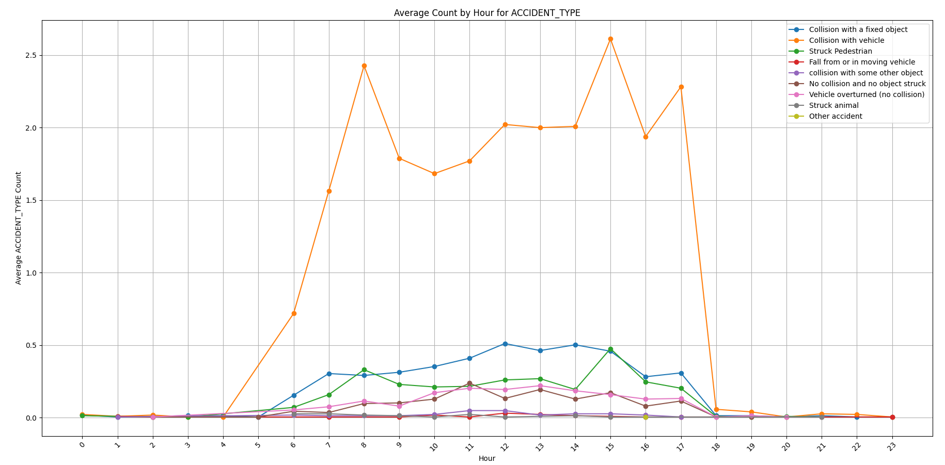

Not alcohol involved

Analysis 5 < analyse the accident frequency in different locations >

The graph below shows the number of accidents by region in 2017. The regions with the most accidents were SOUTH EAST REGION, which ranked first with 4,361 accidents, and NORTH WEST REGION, which ranked second with 4,227 accidents.텍스트, 라인, 도표, 그래프이(가) 표시된 사진
