Project Plan

Analysis tools of Victoria State Accident

S5288771 Chi Pang Cheng

S5323472 Kwangseok Choi

Table of Contents

1.0 Introduction 3

1.1 Problem Background 3

1.2 Scope 3

1.3 Document contents 3

2.0 Work Breakdown Structure 4

3.0 Activity Definition & Estimation 5

4.0 Gantt Chart 6

# Introduction

## 1.1 Background

Data analysis is important for businesses for informed decision making. It helps organizations predict the future by allowing them to discover valuable insights from vast amounts of data. In addition, data analysis helps to assess and mitigate risks, allowing companies to make informed strategic choices.

The project aims to develop software for users to analyze datasets of traffic accidents that occurred from 2015 to 2020 in Victoria, Australia. A data set is vast data consisting of approximately 74,000 rows and 63 columns. The software will make this vast dataset easier for users to analyze.

## 1.2 Scope

The software capabilities, which are proposed at a high level, include the following:

ᆞ For a user selected period, display the information of all accidents that happened in the period.

ᆞFor a user selected period, produce a chart to show the number of accidents in each hour of the day.

ᆞ For a user-selected period, retrieve all accidents caused by an accident type that contains a keyword.

ᆞ Allow the user to analyze the impact of alcohol in accidents

ᆞAllow the user to analyze the accident frequencies in different locations.

## 1.3 Document contents

ᆞIntroduction

Give a brief description of the project's background and dataset. In addition, the scope introduces the core functions of the software.

ᆞWBS

WBS will be represented by a hierarchical diagram. In addition, details about WBS will be covered in the activity definition.

ᆞActivity Definition

Activity Definition is based on WBS. It will explain details of each items in the WBS and includes reasonable time estimates.

ᆞGantt

The Gantt chart is a visualization of the activity definition as a chart. It also shows summary task, critical paths. It will help us to identify the project more easily.

# 2.0 Work Breakdown Structure

The following table indicates the Work Breakdown Structure(WBS) which is the list of activities and tasks used to estimate the work to be done in a project. following table outlines all activities required for the project. The project is divided into five stages and a detailed description will be given in activity definition. Added some tasks under build and test. Tasks are broken down in detail.

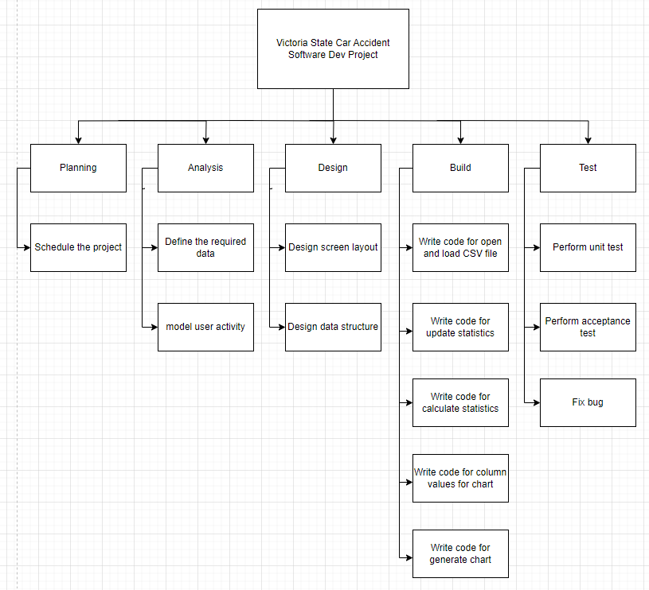

*Table 2a – Work Breakdown Structure(WBS)*

# 3.0 Activity Definition & Estimation

The following table explain details each item in the WBS and includes reasonable time estimates. Allocated the most time to build tasks that are expected to take the most time. Allocated one day per every build tasks. So, the total duration is extended to 28 business days.

|  |  |  |
| --- | --- | --- |
| **Activity Definition** | | |
| Task ID | Description | Duration |
| Project Planning | | |
| 1 | Schedule WBS | 1 day |
| Analysis Tasks | | |
| 2 | Define software requirements | 1 day |
| 3 | Define required data | 1 day |
| 4 | Define use case diagram | 1 day |
| Design Tasks | | |
| 5 | Design GUI | 3 days |
| 6 | Design Data Structure | 1 day |
| 7 | Meeting with team staffs to evaluate | 1 day |
| Build Tasks | | |
| 8 | Write code for open and load CSV file | 3 days |
| 9 | Write code for update statistics | 3 days |
| 10 | Write code for calculate statistics | 3 days |
| 11 | Write code for column values for chart | 3 days |
| 12 | Write code for generate chart | 3 days |
| Test Tasks | | |
| 13 | Perform unit test | 1 day |
| 14 | Perform acceptance tests | 1 day |
| 15 | Fix bugs | 2 days |

*Table 3a – Activity Definition*

# 4.0 Gantt Chart

The following Gantt chart is based on table 3a. Duration is extended to 28 business days to complete.

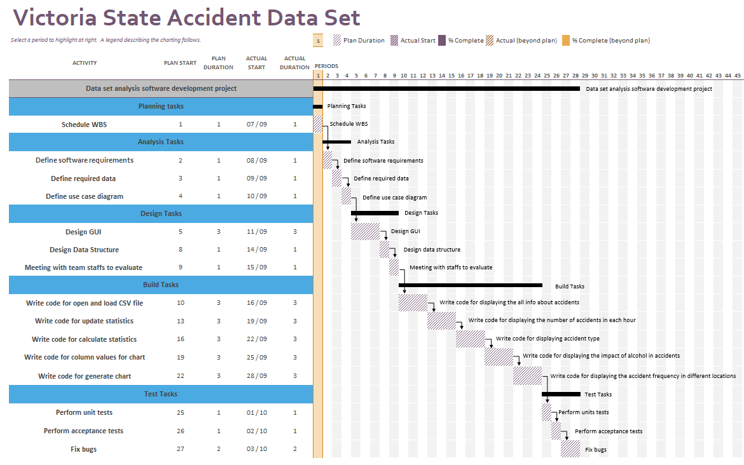

*Table 4a – Gantt Chart*