Project Plan

<Project Name>

Student Names

Table of Contents

1.0 Introduction 3

1.1 Problem Background 3

1.2 Scope 3

1.3 Document contents 3

2.0 Work Breakdown Structure 4

3.0 Activity Definition & Estimation 5

4.0 Gantt Chart 6

# Introduction

## Background

background

We will analyse and visualize Victoria's accident data set. Users will be able to easily obtain the data they want through the graphical user interface, such as incident information within the selected time period, the time when accidents occur the most, and the type of incidents. This data analysis and visualization work will bring great benefits to users.

Scope

ᆞ For a user selected period, display the information of all accidents that happened in the period.

ᆞFor a user selected period, produce a chart to show the number of accidents in each hour of the day.

ᆞ For a user-selected period, retrieve all accidents caused by an accident type that contains a keyword.

ᆞ Allow the user to analyze the impact of alcohol in accidents

ᆞAllow the user to analyze the area with the most accidents.

## Document contents

*Include some background information about the problem, the scope and what this document will contain.*

# Work Breakdown Structure

*This section should include the work breakdown structure for the whole project. The elements from the WBS should be used to generate your activity definition and those activities should then be scheduled in the Gantt Chart. Remember to consider ALL project activities – anything you do or will need to do should be included in the WBS*

*WBS’s are usually presented as some kind of hierarchical diagram/chart etc. The details what is involved each work unit should be provided in section 3:* ***Activity Definition***

*You do NOT need to do a WBS Dictionary for this project – the activity definition (whilst slightly different) will suffice. The WBS is focussed on SCOPE. The Activity definition is focussed on TIME.*

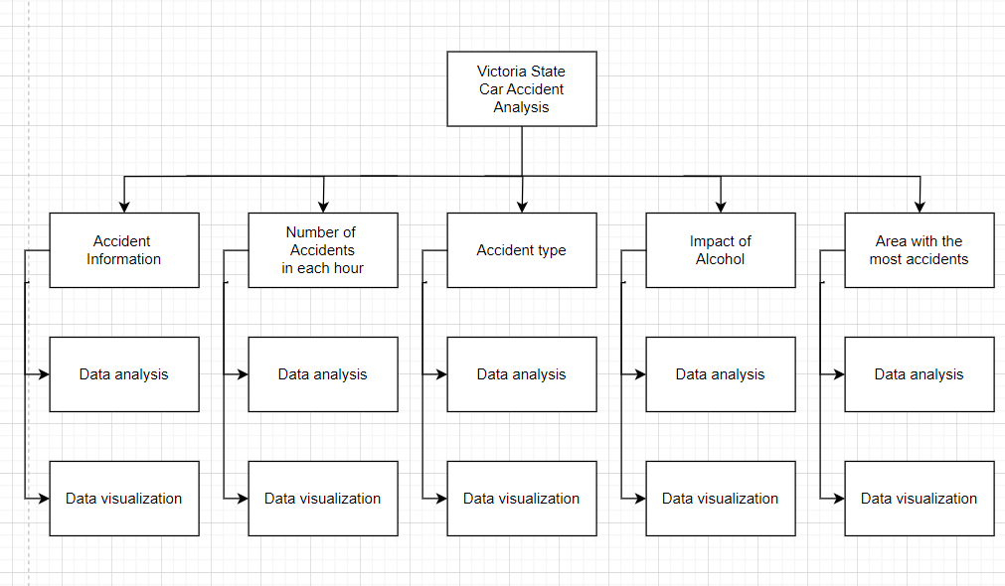

# Activity Definition & Estimation

*From your WBS, define the activities required for your project. You will revise this document and add more detail for part B as you discover more about the project.*

*Each activity should be clearly identified by a number and should match up to your Gantt chart. You should provide some estimations for the time you think each activity will take. This should make it easy to prepare your Gantt chart.*

|  |  |  |  |
| --- | --- | --- | --- |
| **Work Breakdown Structure** | | | |
| Task ID | Description | Duration | Predecessor |
| Project Planning | | | |
| 3 | Schedule WBS | 2 hrs | 2 |
| Analysis Tasks | | | |
| 4 | Meeting with clients to discuss system requirements | 2 hrs | 3 |
| 5 | Meeting with team staffs | 2 hrs | 4 |
| 6 | Define required data | 2 hrs | 4,5 |
| 7 | Model user activities | 2 hrs | 6 |
| Design Tasks | | | |
| 8 | Design database schema | 2 hrs | 7 |
| 9 | Design ERD | 2 hrs | 8 |
| 10 | Design screen layouts | 4 hrs | 9 |
| 11 | Design booking form | 2 hrs | 10 |
| 12 | Design cross links | 2 hrs | 11 |
| 13 | Meeting with team staffs to evaluate | 2 hrs | 10, 11, 12 |
| 14 | Meeting with clients to demonstrate and get confirm | 1 hrs | 13 |
| Build Tasks | | | |
| 15 | Build database for booking subsystem | 4 hrs | 14 |
| 16 | Write program code | 26 hrs | 15 |
| 17 | Link website interface subsystem | 1 hrs | 16 |
| 18 | Link customer account subsystem | 1 hrs | 16 |
| 19 | Build test data | 1 hrs | 18 |
| Test Tasks | | | |
| 20 | Perform acceptance tests | 3 hrs | 19 |
| 21 | Fix bugs | 5 hrs | 20 |
| 22 | Meeting with Clients for approval | 2 hrs | 21 |
| 23 | Write final report | 1 hrs | 22 |

# Gantt Chart

*This section should contain your Gantt chart. The items in the Gantt chart should match the activity definition from section 3. You should also submit your Gantt chart file separately.*