5: Polymorphism with toString()method

We see nothing happened. Cause this is the method toString in obj, that already implemented by java

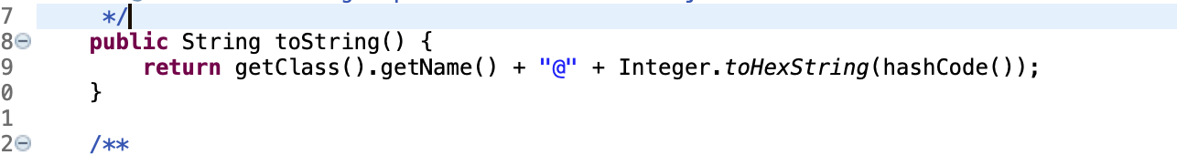

We can see getName(); method in this and our media class have no method getName that why nothing to print out

In previous exercise this is the method for sort in Collections which is have implemented by java

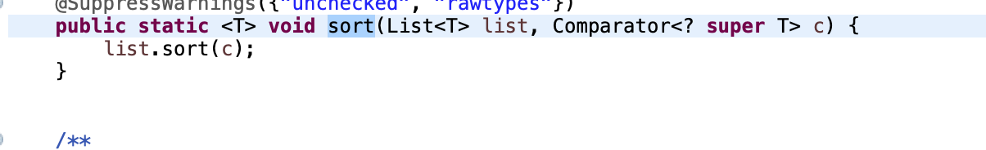

After the List is comparator and we add all attributes that methods need -> it works for previous one