How to Redeploy

- In the AWS Console search for ECS.

- Click on list and search for the cluster, and click on it.

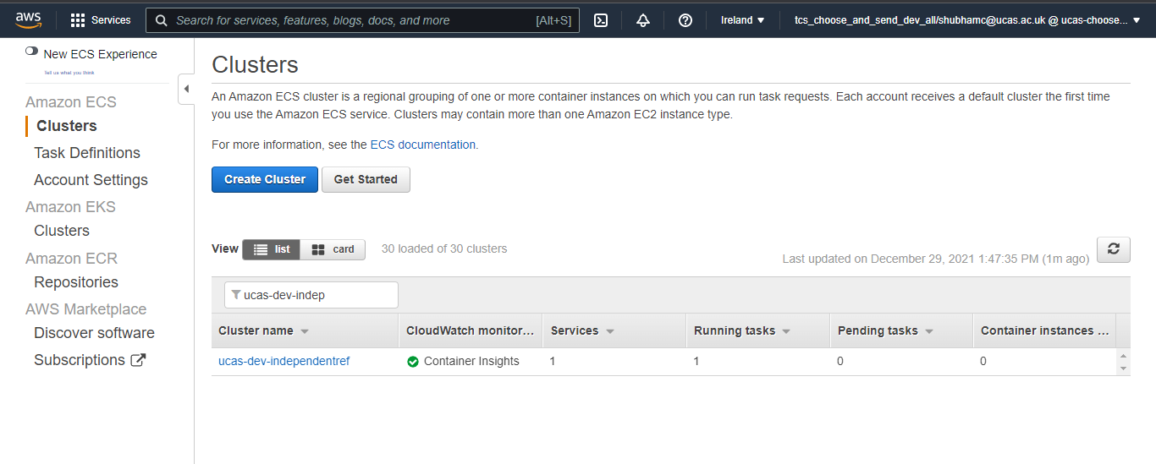
    - Go on Tasks, and click on task definition.

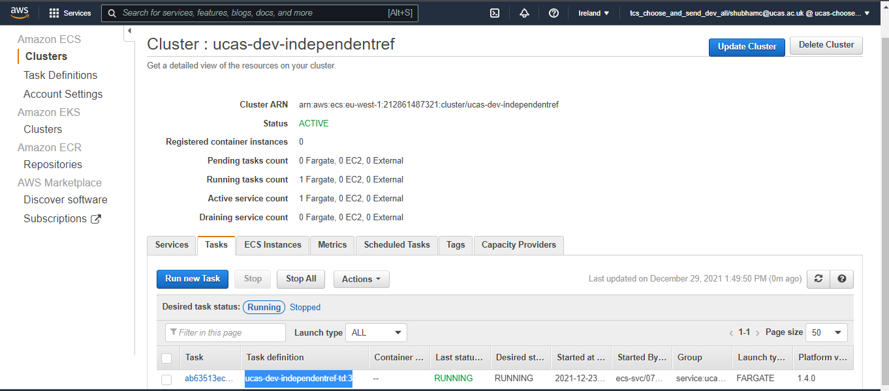

4. Click on create a new revision, go to Container definitions and click on container name.

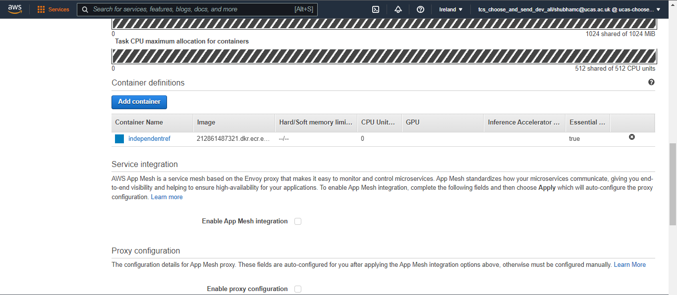
5. Add the image url and click on update.

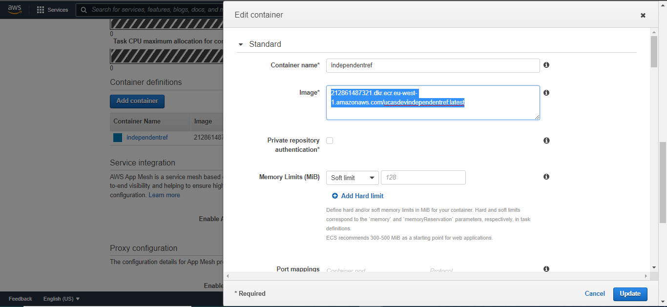

6. Scroll down and click on create.

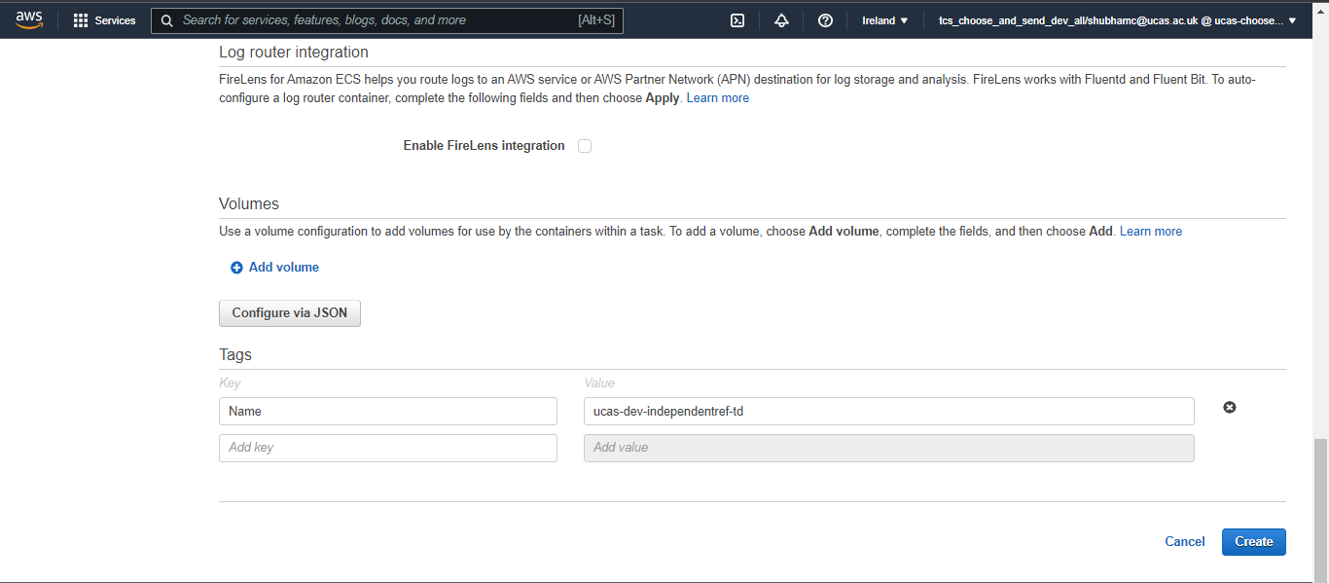
    - The task definition has been created.

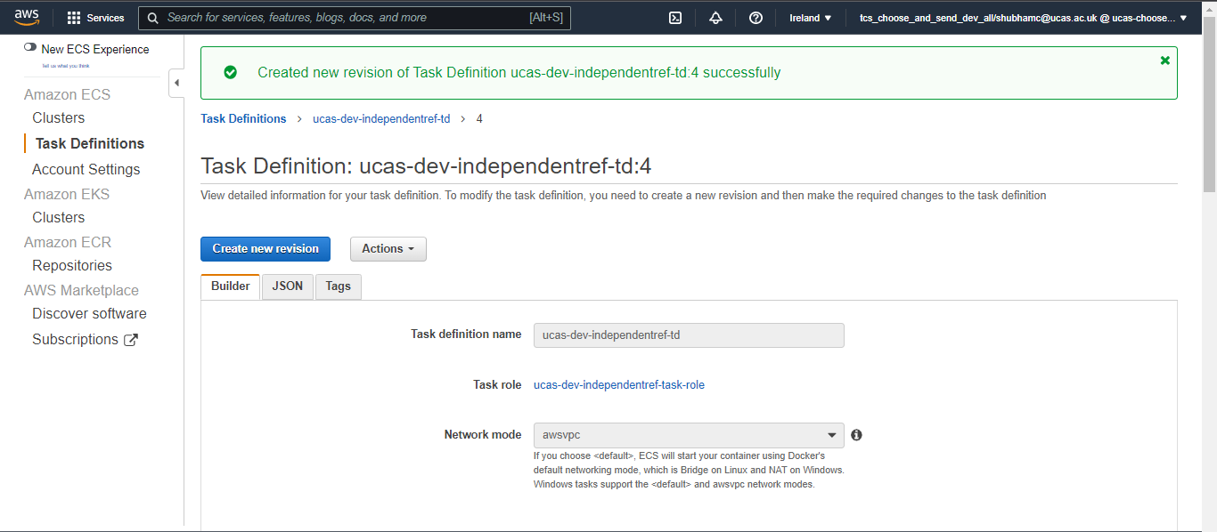

8. Again go to cluster, and select service, click on the service name and click on update.

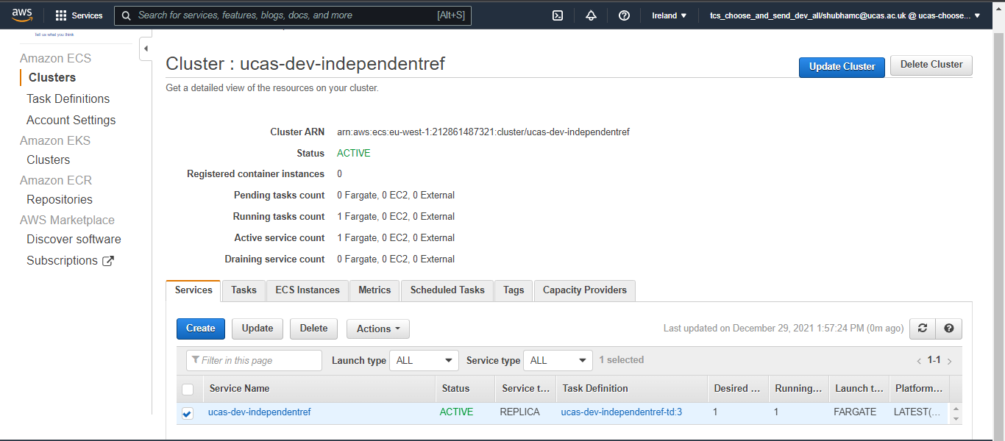
9. Select the latest task definition version which you had just created.

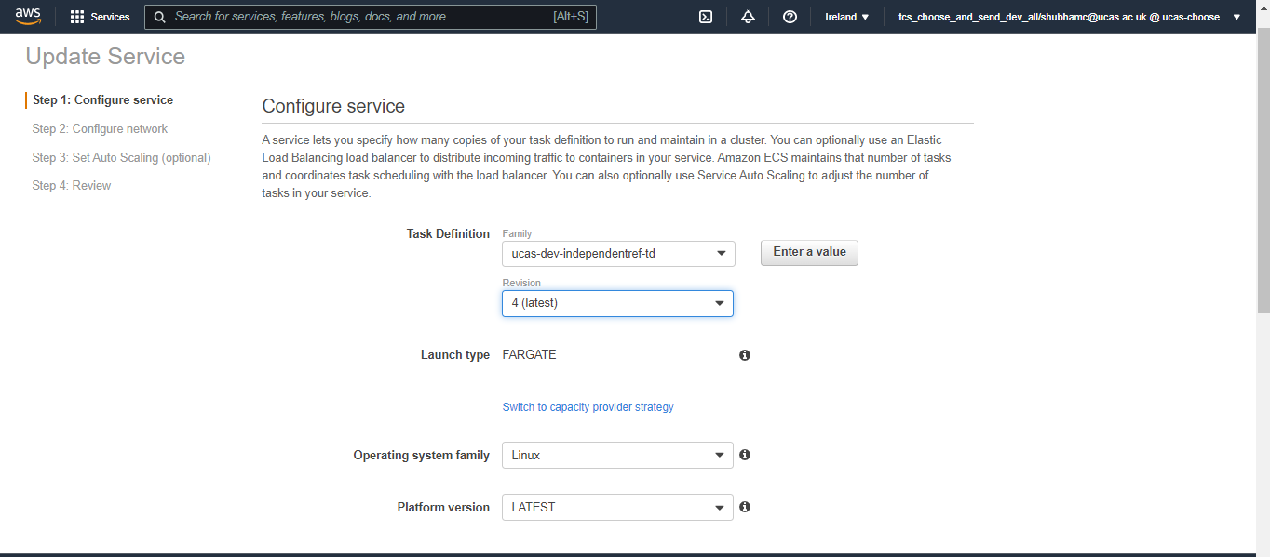
10. Click on Click to review and then click on Update Service, after few minutes the new task definition can been seen in the running state and the previous task definition will be stopped automatically.

11. You can view which task definition is in in running state by clicking on the Task section of the selected cluster.

How To Restart

` 1. In the AWS console search for ECS, click on list and search for your cluster and click on the name of the cluster.

2. Go To Task section, select the checkbox and click on Stop. A new task will be created and its status will be running in few minutes.

