For RHEL 8 and Linux Maybe for some
- Be the root user
$ sudo su -

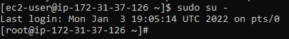
#How to come out of root : $ exit 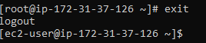

- List all the blocks
$ lsblk
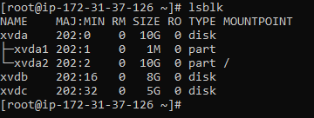
$lsblk -f
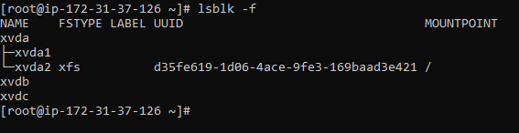
Device xvdb and xvdc does not have file system as we can see, and the root device has xfs file system.

- Check if file system is there on the device xvdb and xvdc
$ file -s /dev/xvdb
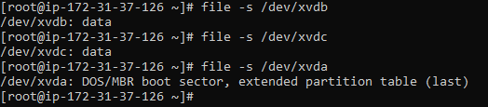
If output is data, it means no file system is there.

- Create file system on the devices
$ file -s /dev/xvdb
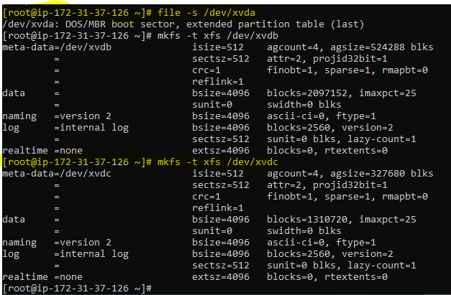

- Get the ids of the devices
$ blkid
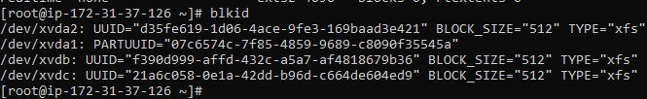

- Make Directories
$ mkdir /arch
$ mkdir /swap
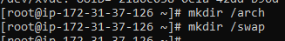

- Open the vi editor [For Permanent Mounting]
$ vi /etc/fstab
And copy
UUID="f390d999-affd-432c-a5a7-af4818679b36" /arch xfs defaults,noatime,nofail 0 0
UUID="21a6c058-0e1a-42dd-b96d-c664de604ed9" swap swap defaults 0 0
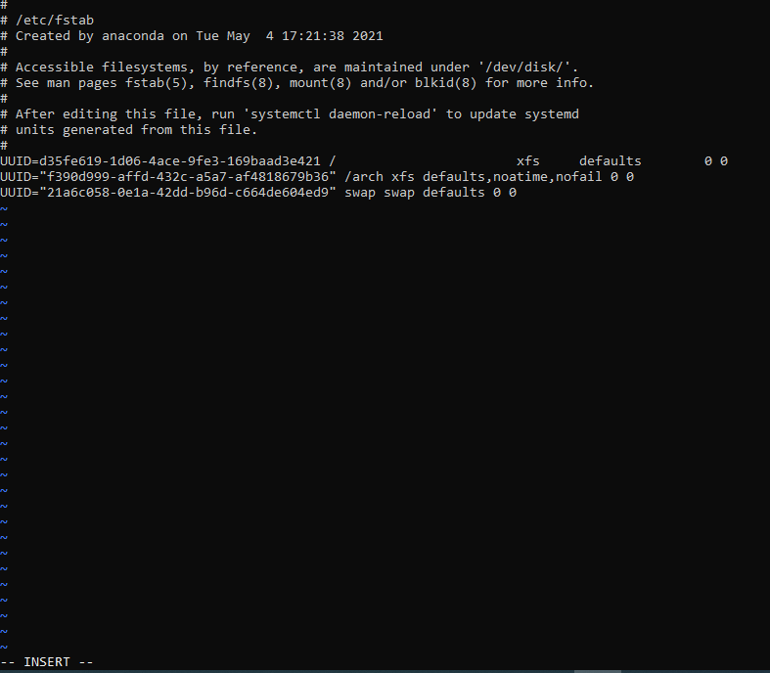
[Go to last 0 of root using cursor, then press i, then copy the 2 above lines, press exit, and enter :wq to save]

- Mount it using $ mount -a
And check the mount point and file system using $ df -hT
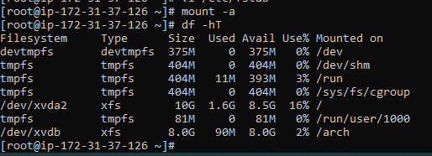

- For swap
$ mkswap /dev/xvdc
$ swapon /dev/xvdc
$ cat /proc/swaps
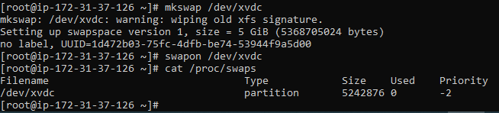

- Check the mount points
$ lsblk -f
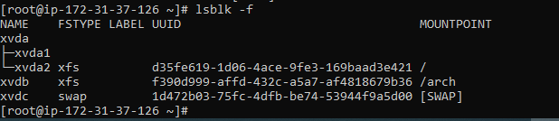

- Create user and assign it to a group
$ useradd oracle
$ groupadd dba
$ usermod -a -G dba oracle
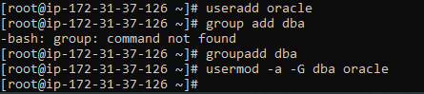

- Permission of all the mount points should be given recursively to oracle:dba[Except Swap]
$chown oracle:dba /arch
$ cd / # Go To root directory
$ ls -la
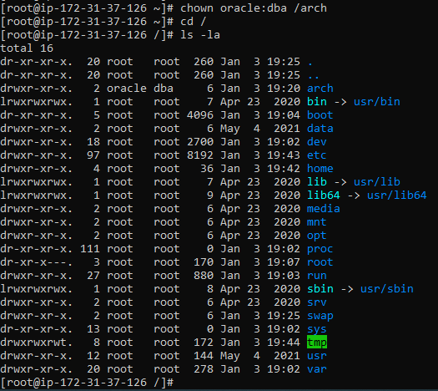

- Install Req packages
$ yum install binutils
$ yum install elfutils-libelf-devel
$ yum install gcc
$ yum install gcc-c++
$ yum install glibc-devel
$ yum install glibc-headers
$ yum install ksh
$ yum install libaio
$ yum install libaio-devel
$ yum install libstdc++-devel
$ yum install make
$ yum install sysstat
$ yum install unixODBC
$ yum install unixODBC-devel
$ yum install libnsl
$ reboot [to reboot and check if the changes still persists]

For Temporary Mounting For UnMounting
$ mkdir /arch $ umount /arch
$ mount /dev/xvdb /arch $ mount -a
$ mount -a
$ df -hT

Raw Sample
1) List all the blocks
$lsblk
nvme0n1 259:0 0 100G 0 disk
├─nvme0n1p1 259:2 0 1M 0 part
└─nvme0n1p2 259:3 0 100G 0 part /
nvme1n1 259:1 0 100G 0 disk /flash
nvme2n1 259:4 0 2T 0 disk /u01
nvme3n1 259:5 0 50G 0 disk /swap
nvme4n1 259:6 0 50G 0 disk /oracle
nvme5n1 259:7 0 500G 0 disk (/arch)

2) Find UUID for each block
$mkfs.xfs /dev/nvme1n1
$cd /dev/disk//by-id/
$blkid
/dev/nvme1n1: UUID="1d2877f3-57dd-4a26-8096-9708969f37cc" BLOCK_SIZE="512" TYPE="xfs" /flash
/dev/nvme2n1: UUID="5834e573-93d0-481b-a993-ab2f6c92355a" BLOCK_SIZE="512" TYPE="xfs" /u01
/dev/nvme3n1: UUID="a0ec8783-b930-44bb-9dd8-28a2b1975d10" BLOCK_SIZE="512" TYPE="xfs" /swap
/dev/nvme4n1: UUID="aa7bda7a-1659-4d40-9914-20f9d5bbdfa5" BLOCK_SIZE="512" TYPE="xfs" /oracle
/dev/nvme5n1: UUID="b0650be0-e7c6-4e86-9725-0fd7110af700" BLOCK_SIZE="512" TYPE="xfs" /arch

3) Make Directories {Req* 1) 2 TB space for data (/u01)
2) 50 GB for Oracle binaries (/oracle)
3) 50 gb for swap space (/tmp)
4) 500gb for Archive (/arch)
5) 100gb for root (/)
6) 100gb for FRA (redo logs files, control files, flashback log files etc) (/flash)}

mkdir /flash
mkdir /u01
mkdir /swap
mkdir /oracle
mkdir /arch

4) Assign mount point to the respective UUID
inside vi editor :
$ vi /etc/fstab [how to save :wq]
UUID="1d2877f3-57dd-4a26-8096-9708969f37cc" /flash xfs defaults,noatime,nofail 0 0
UUID="5834e573-93d0-481b-a993-ab2f6c92355a" /u01 xfs defaults,noatime,nofail 0 0
UUID="aa7bda7a-1659-4d40-9914-20f9d5bbdfa5" /oracle xfs defaults,noatime,nofail 0 0
UUID="b0650be0-e7c6-4e86-9725-0fd7110af700" /arch xfs defaults,noatime,nofail 0 0
UUID="966b58ed-b8f7-4d39-b86b-ca6de08afa81" swap swap defaults 0 0

5) Save it
$mount -a --->mount the dir
$df -h ---> check the mount point

6) For swap
mkswap /dev/nvme3n1
swapon /dev/nvme3n1
cat /proc/swaps

7) Need to create oracle:dba (os user : group) on the newly build server.
useradd oracle #Creating a user
groupadd dba #Creating a grp
usermod -a -G dba oracle # assigning user to grp

8) Permission of all mount points should be given recursively to oracle:dba.
chown oracle:dba /u01
chown oracle:dba /flash
chown oracle:dba /oracle
chown oracle:dba /arch
cd /
ls -la

9) Install Req Packages
{Req*
package binutils is not installed
package elfutils-libelf-devel is not installed
package gcc is not installed
package gcc-c++ is not installed
package glibc-devel is not installed
package glibc-headers is not installed
package ksh is not installed
package libaio is not installed
package libaio-devel is not installed
package libstdc++-devel is not installed
package make is not installed
package sysstat is not installed
package unixODBC is not installed
package unixODBC-devel is not installed
Also sudo yum install libnsl}
1 blkid
2 ll
3 mkfs.xfs /dev/nvme1n1
4 mkfs.xfs /dev/nvme2n1
5 mkfs.xfs /dev/nvme3n1
6 mkfs.xfs /dev/nvme4n1
7 mkfs.xfs /dev/nvme5n1
8 mkfs.xfs /dev/nvme6n1
9 blkid
10 clear
11 mkdir /flash
12 mkdir /u01
13 mkdir /swap
14 mkdir /oracle
15 mkdir /arch
16 vi /etc/fstab
17 df -h
18 mount -a
19 dh -h
20 df -h
21 cat /proc/swaps
22 vi /etc/fstab
23 mkswap /dev/nvme3n1
24 swapon /dev/nvme3n1
25 mount -a
26 cat /proc/swaps
27 reboot
28 df -h
29 cat /proc/swaps
30 vi /etc/fstab
31 mkdir /swap
32 cat /proc/swaps
33 swapon /swap
34 swapon /dev/nvme3n1
35 cat /proc/swaps
36 swapon
37 reboot
38 cat /proc/swaps
39 sudo blkid
40 vi /etc/fstab
41 swapon
42 cat /proc/swaps
43 cat /proc/swaps
44 swapon
45 cat /proc/swaps
46 swapon /dev/nvme3n1
47 cat /proc/swaps
48 reboot
49 cat /proc/swaps
50 cat /proc/swaps
51 cat /proc/swaps
52 cat /proc/swaps
53 cat /proc/swaps
54 cat /proc/swaps
55 cat /proc/swaps
56 cat /proc/swaps
57 cat /proc/swaps
58 sudo blkid
59 cat /proc/swaps
60 ls
61 ls /
62 cd /
63 ls -la
64 chmod 0600 /swap
65 ls
66 ls -la
67 swapon /swap
68 swapoff
69 swapoff /dev/nvme3n1
70 mkfs.xfs /dev/nvme3n1
71 swapoff -a
72 swapon /swap
73 df -h
74 blkid
75 mkfs.xfs -f /dev/nvme3n1
76 blkid
77 vi /etc/fstab
78 mkswap /dev/nvme3n1
79 blkid
80 vi /etc/fstab
81 swapon /dev/nvme3n1
82 cat /proc/swaps
83 reboot
84 cat /proc/swaps
85 useradd ora12c
86 usergroup dba
87 useradd oracle
88 groupadd dba
89 usermod -a -G dba oracle
90 id oracle
91 chown oracle:dba /u01
92 chown oracle:dba /flash
93 chown oracle:dba /oracle
94 chown oracle:dba /arch
95 df -h
96 cd /
97 ls -la
98 hostory
99 history
100 cat /proc/swaps
101 lsblk
102 df -h
103 history

